Cape to Cape Resilience Plan

Inverloch Regional and Strategic Partnership, June 2025
delwp.vic.gov.au

Resilience Plan
  - Cape to Cape Resilience Project






deeca.vic.gov.au
 | 

Author
 |  |  |  | 
 |  |  | 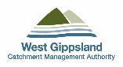 | 

 | P. Bicknell, E. Hodson, S. Doumtsis and A. Brook
 | Final – June 2025
Editor

 C. Philippou, E. Zavadil, K. Hannan, T. Miller-Armstrong
Photo credit
Various - Many of the photos throughout this document have been submitted by community members as part of our engagement activities. We thank them for sharing these images with us for this project.

Note – department changes:
Formerly known as the Department of Environment, Land, Water and Planning (DELWP), the department responsible for marine and coastal management changed to the Department of Energy, Environment and Climate Action (DEECA) in January 2023. The former Department of Transport (DoT) is also now the Department of Transport and Planning (DTP). All references to these departments in this document have been updated to reflect this change.
We acknowledge and respect Victorian Traditional Owners as the original
custodians of Victoria’s land and waters, their unique ability to care for
Country and deep spiritual connection to it.

We honour Elders past and present whose knowledge and wisdom
has ensured the continuation of culture and traditional practices.

DEECA is committed to genuinely partnering with Victorian
Traditional Owners and Victoria’s Aboriginal community
to progress their aspirations.

© The State of Victoria Department of Energy, Environment and Climate Action 2025
This work is licensed under a Creative Commons Attribution 4.0 International licence. You are free to re-use the work under that licence, on the condition that you credit the State of Victoria as author. The licence does not apply to any images, photographs or branding, including the Victorian Coat of Arms, the Victorian Government logo and the Department of Energy, Environment and Climate Action (DEECA) logo. To view a copy of this licence, visit http://creativecommons.org/licenses/by/4.0/
Printed by Department of Energy, Environment and Climate Action - Melbourne
ISBN 978-1-76136-335-1 (print)
ISBN 978-1-76136-336-8 (pdf/online/MS Word)
Disclaimer
This publication may be of assistance to you but the State of Victoria and its employees do not guarantee that the publication is without flaw of any kind or is wholly appropriate for your particular purposes and therefore disclaims all liability for any error, loss or other consequence which may arise from you relying on any information in this publication.
Accessibility
If you would like to receive this publication in an alternative format, please telephone the DEECA Customer Service Centre on 136 186, email customer.service@deeca.vic.gov.au, or via the National Relay Service on 133 677 www.relayservice.com.au. This document is also available on the internet at www.deeca.vic.gov.au.

Contents
1 Introduction 5
1.1 The Inverloch Regional and Strategic Partnership 6
1.2 Our coastline - the Cape to Cape region 7
1.3 Statewide coastal hazard adaptation 8
1.4 Developing the Resilience Plan 9
2 The Cape to Cape coast 15
2.1 The coastal landscape 15
2.2 Coastal values 16
2.3 Towards a resilient coast 17
3 Coastal hazards 18
3.1 Hazards 18
3.2 Coastal erosion 18
3.3 Storm tide inundation 20
3.4 Tidal inundation due to sea level rise 20
3.5 Saline groundwater intrusion 20
3.6 Understanding the local coastal hazards 21
3.7 Current and future hazard impacts 24
3.8 Overview of assets at risk 29
3.9 A step-change in risk 31
3.10 Understanding economic risk (base case) 32
3.11 A regional snapshot 35
4 Approach to adaptation 36
4.1 A strategic approach 36
4.2 Shared roles and responsibilities 36
4.3 Adaptation objectives 37
4.4 Adaptation framework 38
4.5 Determining our adaptation process 41
4.6 Deciding on adaptation 42
4.7 Informing refinement of actions 42
5 Foundational actions 45
6 Regional actions 47
7 Location-specific actions 51
7.1 Adaptation pathways 52
7.2 Cape Paterson-Inverloch Road (Bunurong Road) 53
7.3 Inverloch Surf Beach 58
7.4 Inverloch township (within Anderson Inlet) 64
7.5 Venus Bay and Tarwin Lower 70
8 Implementation and next steps 75
8.1 Implementation 75
8.2 Next steps 77
9 References 78
Glossary of terms 79
Attachment A: Stages of the Cape to Cape Resilience Project 82
Attachment B: Adaptation pathway development 84

Introduction
The coastline around Inverloch, Venus Bay, Tarwin Lower and Anderson Inlet is a beautiful and dynamic part of the landscape. Natural processes such as winds, waves, tides, currents and catchment flows move sand and sediments. These coastal processes have and continue to reshape the coastline over millions of years. When these processes impact negatively on places and things we value, and the way we use the coast, they become coastal hazards.
In response to recent changes seen along the Inverloch coastline and to prepare for expected sea level rise, a Regional and Strategic Partnership (RaSP) was formed. The Partnership is delivering the Cape to Cape Resilience Project. As an outcome of the Project, this Resilience Plan will guide communities and agencies to prepare and proactively plan for future changes to the coastline.
Detailed decisions about the implementation and timing of actions will be made in line with the normal government policy and budget processes.

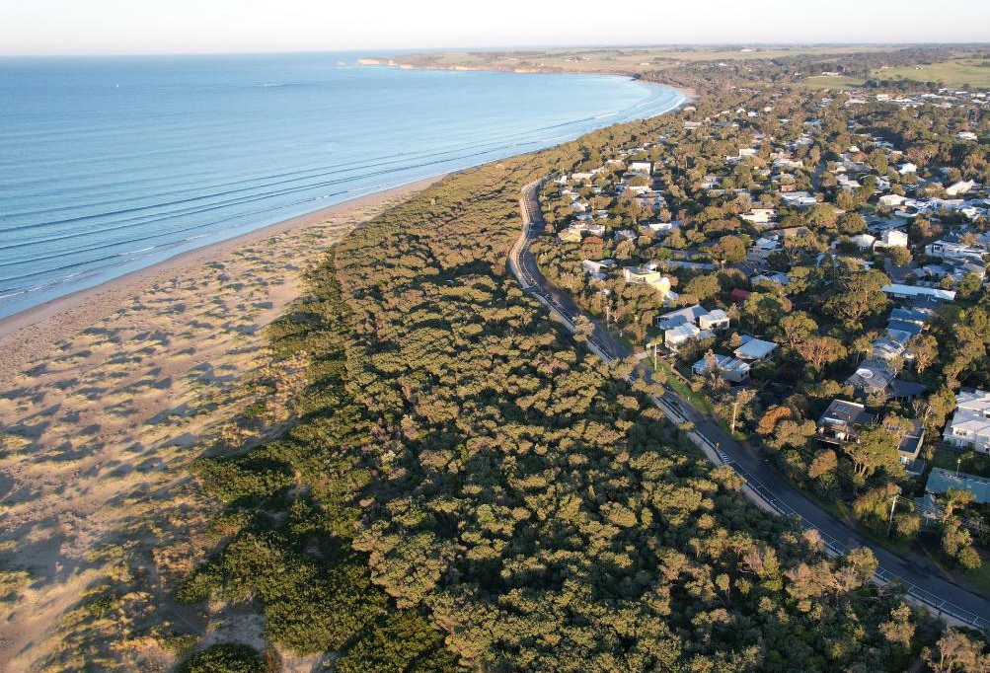
Surf Parade at Point Norman, Inverloch. Source: Alluvium

The Inverloch Regional and Strategic Partnership

Changes along Inverloch’s coastline prompted the establishment of the Inverloch Regional and Strategic Partnership (RaSP) in 2020 - the first RaSP created under the new Marine and Coastal Act 2018.
Led by DEECA (formerly DELWP), the Inverloch RaSP was formally gazetted on 6th August 2020 by the then Minister for Energy, Environment and Climate Change, the Hon. Lily D’Ambrosio.
RaSPs are a tool under the Marine and Coastal Act 2018 that bring stakeholders together on regionally significant issues relating to the marine and coastal environment.
The Inverloch RaSP brings together Traditional Owners and nine agencies (Table 1). Each partner has a role in managing coastal and foreshore values, assets and infrastructure around Inverloch and the Cape to Cape region.
The Cape to Cape Resilience Project is being delivered by this Partnership. This Resilience Plan is a key project outcome and statutory product of the RASP. Minister for Environment, the Hon. Steve Dimopoulos endorsed the final Resilience Plan in December 2025.

Table 1. Inverloch Regional and Strategic Partnership members.
RaSP member |  | Reason for selection
 | Department of Energy, Environment and Climate Action (formerly DELWP) | Lead partner agency
 | Bunurong Land Council Aboriginal Corporation | Registered Aboriginal Party - Traditional Owner responsible for representing Bunurong community and protecting cultural and heritage values as rightsholders
 | Bass Coast Shire Council | Local Government Authority and land manager for parts of the affected coast
 | South Gippsland Shire Council | Local Government Authority and land manager for parts of affected coast
 | Department of Transport and Planning | Manager of adjacent land and infrastructure affected by erosion. Responsible for State-wide planning provisions
 | Parks Victoria | Local land manager for parts of affected coast
 | South Gippsland Water | Manager of land and infrastructure affected by erosion
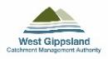 | West Gippsland Catchment Management Authority | Agency responsible for floodplain and waterway management. The Marine and Coastal Act 2018 also states CMAs have a role as a referral authority for inundation and erosion.
 | Heritage Victoria | Manager of non-Indigenous heritage places including the historic shipwreck Amazon (1863)
 | Gippsland Ports | Anderson Inlet waterway manager

Our coastline - the Cape to Cape region

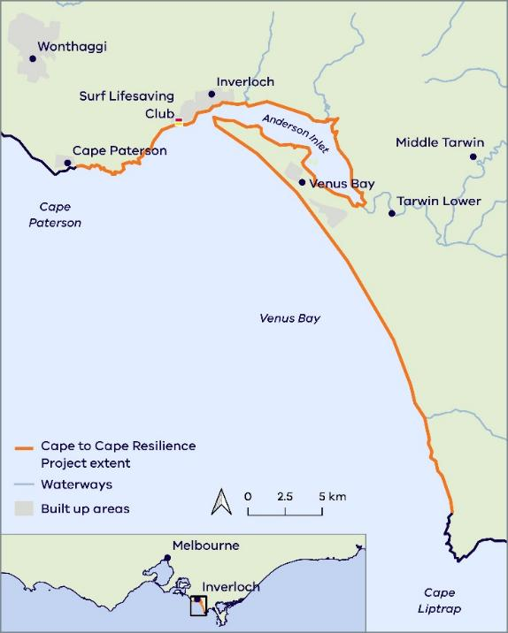
The study area for the Cape to Cape Resilience Project is between Cape Paterson and Cape Liptrap on the South Gippsland coast (Figure 1).
Pound Creek
The study area includes the towns of Inverloch, Venus Bay and Tarwin Lower.
The north and western parts of the study area, west of Pound Creek, lie within the Bass Coast Shire Local Government Area (LGA), while the southern and eastern portions lie within the South Gippsland Shire LGA.
This region covers diverse and unique landscapes and includes:
- The open coast from Cape Paterson west along the coastal cliffs towards Inverloch
- The open foreshore and surf beach at Inverloch
- The dynamic estuaries and tidal mudflats of Anderson Inlet, including Tarwin Lower
- The open coast and dunes of Venus Bay south to Cape Liptrap
- Inland from the coastline, allowing for assessment of estuary and groundwater impacts.
Figure 1. Cape to Cape Resilience Project area.

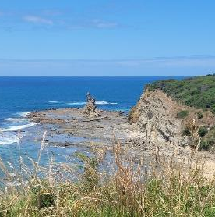 | 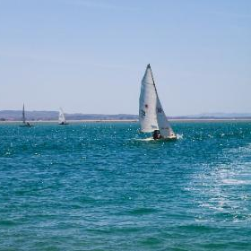 | 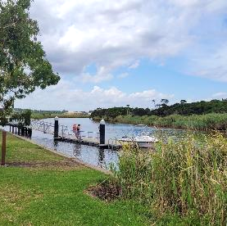
Eagles Nest (Alluvium), Anderson Inlet (Unsplash – Ashlee Morgan), and the Tarwin River (Alluvium)

Statewide coastal hazard adaptation
Coastal management reform in Victoria, led by the Department of Energy, Environment and Climate Action (DEECA), has involved the release of several key pieces of legislation, policies and guidance material over recent years.
The Marine and Coastal Act 2018 and Marine and Coastal Policy (2020) and Strategy (2022) are intended to be the primary management tools to guide coastal management in Victoria.
Development of the Cape to Cape Resilience Plan considers a range of key objectives and guiding principles from the legislation in the planning and management of marine and coastal areas.
Guiding principles of the Marine and Coastal Act 2018 are:

Victoria’s Resilient Coast – Adapting for 2100+
Victoria has a statewide approach to coastal hazard risk management and adaptation.
Victoria’s Resilient Coast framework and guidelines (DEECA 2023) support state and local governments, land managers and communities to adapt to climate change impacts on the coast.
The framework provides a staged approach across the technical, strategic planning and engagement elements of coastal hazard risk management and adaptation.
Figure 2 presents these stages, with relevant chapters of the Cape to Cape Resilience Plan shown in Table 2.
The development and implementation of actions to increase resilience uses an adaptation pathways approach to help inform decision making, planning, triggers and timing of actions.
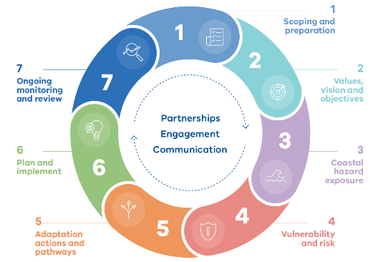

Figure 2. Victoria's Resilient Coast - Adapting for 2100+ framework stages.

Table 2. Victoria's Resilient Coast - Adapting for 2100+ framework stages and relevant chapters within the Cape to Cape Resilience Plan.
Framework stage | Resilience Plan Chapter
Scoping and preparation | Chapter 1. Introduction
Values, vision and objectives | Chapter 2. The Cape to Cape coast
Coastal hazard exposure | Chapter 3. Coastal hazards
Vulnerability and risk | Chapter 3. Coastal hazards
Adaptation actions and pathways | Chapter 4. Approach to adaptation  Chapter 5. Region-wide actions  Chapter 6. Location-specific actions
Plan and implement
Ongoing monitoring and review | Chapter 7. Implementation and next steps

Developing the Resilience Plan
The Cape to Cape Resilience Plan has been:
- Developed to proactively manage the impact of coastal hazards, now and into the future
- Developed in consultation with stakeholders and communities
- Tailored to include our full coastal landscape and communities.

Purpose

The purpose of the Resilience Plan is to:
- Inform future decisions regarding the protection and management of our coast and foreshore
- Inform future land use planning
- Guide the management of public utilities and facilities
- Guide the management of areas of environmental and cultural significance
- Safeguard our coastal values and lifestyle
- Foster collaboration and the shared care of our coastline.

Overseen by the Inverloch RaSP, the Cape to Cape Resilience Project has included a series of studies and activities that sought to:
- Understand community values and vision for the future, including cultural values.
- Understand the coastal processes that have shaped the coastline in the past, and what they may look like in the future.
- Identify coastal hazard areas through a Coastal Hazard Assessment (CHA).
- Understand vulnerabilities and risks to assets, including an economic base case.
- Engage with the community to understand the preferred approaches to adaptation.
- Determine adaptation actions, costs, priorities, and timeframes for implementation, including action modelling and assessment.
- Develop coastal resilience planning and pathways through this Resilience Plan.
Table 3 provides further detail of the stages, purpose, key questions and outputs of the project.

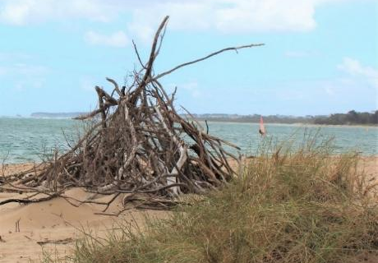
Inverloch tepees. Source: Alluvium

Table 3. Stages of the Cape to Cape Resilience Project. Further details and specific reports listed in Attachment A.
Victoria’s Resilient Coast – Adapting for 2100+ framework Stage and purpose | Key questions | Cape to Cape Resilience Project key deliverables | Additional outputs | Timeline
STAGE 1: Scoping and preparation  Provide a foundation for adaptation planning aligned to best practice guidance. | - Do we need action?  - Who is involved?  - Where’s the study area?  - What’s our study scope? | - Project plan  - Engagement plan | - Website set up  - Project updates 1 and 2  - Factsheets 1: The RaSP and 2: Terminology | Mar-21 to Jul-21
STAGE 2: Values, vision and objectives  Ensure adaptation planning is underpinned by regional and place-based values. | - What do we value?  - As a region and as a State?  - What do we want the future to look like? | - Community values study  - Cultural values assessment | - Engage Victoria online survey 1 & on-site drop in sessions | Oct-21 to Dec-21
STAGE 3: Coastal hazard exposure  Assess coastal hazard exposure, including scenarios that enable best practice approaches to assessing current and emerging risk. | - What processes are occurring and how might these change? | - Inverloch Region Coastal Hazard Assessment (CHA) and attachments | - Factsheets 3: Coastal landscapes and hazards and 4: Modelling.  - Project Update 3  - Summary: CHA Coastal Processes and Inundation | Jun-21 to Mar-22
STAGE 4: Vulnerability and risk  Explore place-based coastal hazard vulnerability and risk, to enable strategic consideration of adaptation needs/priorities. | - How might these processes impact what we value? | - Asset exposure assessment  - Risk and vulnerability assessment  - Economic base case | - Project Update 4  - Hazard maps and explainer  - Video – CHA  - Factsheet 5: Vulnerability and risk  - Summary: Risk and Vulnerability | Apr-22 to May-22
STAGE 5: Adaptation actions and pathways  Identify, assess, consult on and decide which adaptation options and actions are most appropriate for managing current and future coastal hazard risks. Includes a diversity of integrated actions across land management, planning and design, nature based and engineering themes. | - How can we manage and adapt to these impacts? | - Adaptation framework, options and preferences summary  - Adaptation feasibility modelling  - Economic assessment & cost benefit analysis | - Factsheets 6: Coastal Adaptation and 7: Adaptation actions  - Engage Victoria online survey 2 – Adaptation actions  - Project Update 5  - Video – Approach to adaptation.  - Summary: Adaptation Action Technical Assessment | May-22 to Aug-22
STAGE 6: Plan and implement  Confirm the plan of action for coastal hazard risk management and adaptation and commence implementation. Includes priority actions in the adaptation pathways, shared roles and responsibilities, triggers for review and resources/ requirements. | - Which options are feasible and suitable, both now and in the future?  - How can we plan our response strategically? | - Cape to Cape Resilience Plan including implementation plan/s | - Project Update 6 and 7  - Engage Victoria online survey 3 & on-site pop-up and drop in sessions – Adaptation actions and planning  - Project Update 8 – Engagement Outcomes | Sep-22 to Jun-23
STAGE 7: Ongoing monitoring and review  Ensure coastal hazard risk management and adaptation is accompanied by ongoing monitoring and evaluation process that enables effective implementation, learnings and improvement. | - How can our response be adaptive to changing conditions?  - How are we tracking in implementing our plan? | - Cape to Cape Resilience Plan including implementation, monitoring and evaluation |  | Ongoing

The Inverloch Region Coastal Hazard Assessment
Central to the Cape to Cape Resilience Project is the Inverloch Region Coastal Hazard Assessment (CHA).
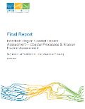
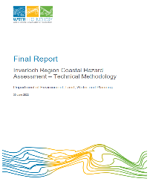
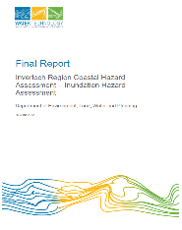
Undertaken by Water Technology, the CHA enhances the understanding of coastal hazards along the coast from Cape Paterson to Cape Liptrap, including inside Anderson Inlet.
The CHA was informed by extensive analyses of the region’s geological formation, local conditions, and historic and recent changes along the coastline. Relevant local and regional data was collated and interrogated, and findings used to shape a robust technical approach and tailored models.
With this understanding, various models were developed to simulate local coastal, estuarine and catchment processes.
Models assessed storm tide inundation, waves, sediment transport and shoreline response (erosion/accretion) for a range of storm event scenarios and planning horizons (including projected sea level rise).
Model results and resulting hazard maps are a core and valuable output from the CHA work. These are described further in Section 3.6.
The Inverloch Region Coastal Hazard Assessment (CHA) produced a suite of technical reports. These have been key to the technical and strategic analysis undertaken to develop this Resilience Plan.
Title | Report reference *
Project Summary Report | Report 1
Data Assimilation and Gap Analysis | Report 2
Technical Methodology | Report 3
Coastal Geomorphology | Appendix to Report 3
Coastal Processes and Erosion Hazards | Report 4
Inundation Hazards | Report 5
Coastal Hazard Asset Exposure Assessment | Report 6
Adaptation Assessment | Report 7
* Refer Attachment A for full references.

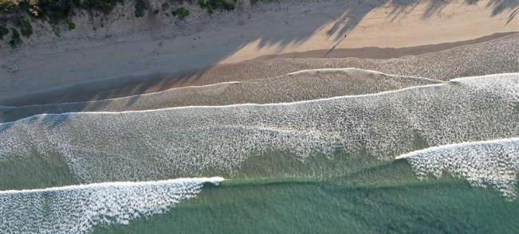
Inverloch Surf Beach. Source: Alluvium

Engagement
The development of the Resilience Plan involved substantial community and stakeholder engagement through:
- understanding key coastal values of the Cape to Cape region, existing awareness of coastal hazards and past experiences, to identify a shared understanding of adaptation needs and opportunities.
- identifying community perspectives on adaptation to gain an appreciation of community supported objectives for coastal management and preferred principles and approaches to adaptation.
- seeking community feedback on the Draft Resilience Plan to refine and finalise.

A dedicated website and engagement platform were built to share information and maps, gather feedback, and engage with the community throughout the project.
Throughout the Cape to Cape Resilience Project, there were over 4,500 visits to the Engage Victoria page, more than 330 survey responses, and over 200 people registered to the project’s mailing list.

 | marineandcoasts.vic.gov.au/  coastal-programs/cape-to-cape-resilience-project
 | engage.vic.gov.au/cape-cape-resilience-project

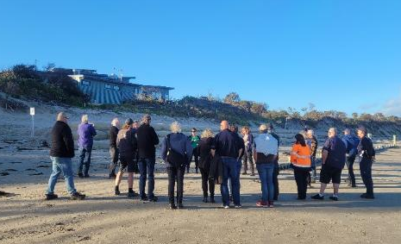
Project Launch with the Stakeholder Reference Group (May 2021). Source: Alluvium
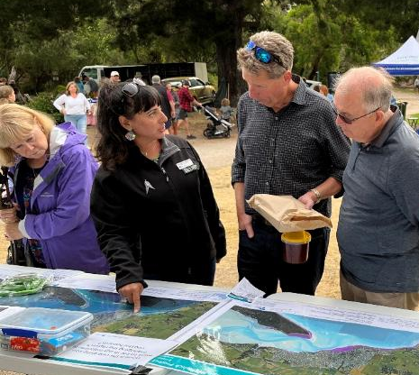
Engagement pop-up at the Inverloch Twilight Market (January 2023). Source: Alluvium
A wide range of community engagement and communication activities occurred over the Plan development period (from early 2021 to early 2025), including:
- Ten face-to-face engagement events
- Online webinar presentations and discussions
- Four online engagement surveys
- Online and in-person values mapping
- 180 pins on our interactive map
- Ten written project updates
- Four summary reports covering the coastal hazard assessment and risk and vulnerability
- Eight factsheets on topics from coastal hazard terminology to vulnerability and risk
- Video explainer for the Resilience Plan
- Six stakeholder reference group meetings
- Four roundtable discussions, combining community and stakeholder representatives
The community engagement activities are described further in Table 4.
 | Community and stakeholder feedback has informed the development and refinement of the Resilience Plan. Public consultation on the Plan, supported by tailored technical summaries and an online video explainer, saw feedback provided via an online survey and through a formal submission process.  This feedback has helped to refine the Resilience plan – leading to further detail on our strategic approach, decisions on adaptation, and how community sentiments have informed the Plan.

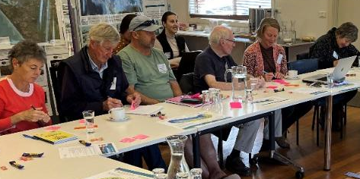
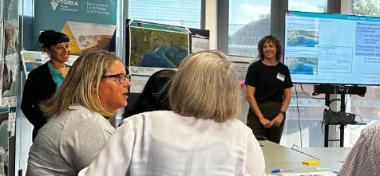
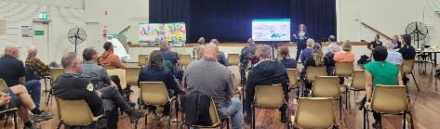
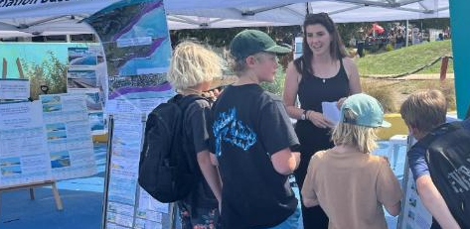
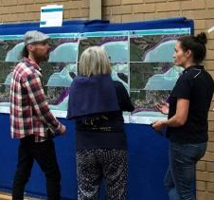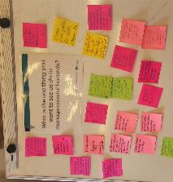
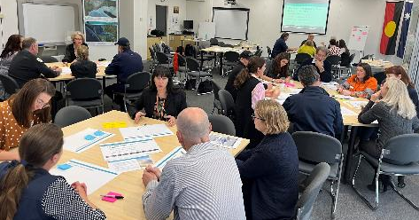
A mix of engagement events from the Cape to Cape Resilience Project. Source: Alluvium
Table 4. Summary of the community engagement activities from the Cape to Cape Resilience project.
 | Attendance / responses | When
Values, experiences, exposure and risk
Survey #1 – Values and experiences | 92 responses, over 2000 website visitors | Jul to Sep 2021
Interactive map | 180 pins | Jul to Sep 2021
Virtual community sessions (2 sessions) | ~ 50 people | Aug 2021
Stakeholder Reference Group (SRG) Workshops (6 sessions)  -incl. RaSP context, project launch, values, hazards, exposure, risk and adaptation | 5 to 10 SRG members at each session | Mar 2021 to Jun 2022
Pop-up open house events (with hazard maps) | ~30 people | Apr 2022
Survey #2 - Risk and adaptation | 65 responses, 660 website visitors | Mar to Apr 2022
Adaptation planning
Summer pop-ups (7 in-person events) | Over 700 people | Jan to Mar 2023
Survey #3 - Adaptation actions | 92 responses, 1500 website visitors | Jan to Mar 2023
Round tables (4 sessions) | ~40 attendees with 20 community members | Feb to Apr 2023
Resilience Plan
Survey #4 – Draft Resilience Plan | 141 surveys,18 submissions, 1,790 website visitors | Aug to Oct 2024
Engagement summaries, the Community Values Study (Alluvium, 2021b) and the Cultural Values Assessment (BLCAC,2021) (both described more in Section 2), present some of the diverse sentiment, experiences and perspectives the community has about the region, its coast and the future. These have helped shape our adaptation objectives and resilience planning for this project.
Community values have informed the technical assessments, management strategies and resilience planning in several ways:
Core community values established and embedded throughout the Project and our future adaptation of coastal areas.
Ideas, feedback and preferences on adaptation informing and refining adaptation and resilience planning.
Local history, experience and knowledge of coastal processes, change and hazards incorporated into the Coast Hazard Assessment.
A tailored risk approach including determining tolerance and defining consequences for coastal hazard impacts.
Economic analyses, targeting local context with focussed case studies.
Increasing community resilience via ongoing conversations, tailored materials and activities. Building capacity and understanding of coastal hazards, implications and adaptation opportunities.
Vision and objectives for a resilient coastal region to guide our approach
How engagement is shaping resilience planning
Community values
Coastal hazards and exposure
Coastal risk and vulnerability
Economic assessment
Adaptation options and actions development
Resilience planning
Engagement and communications
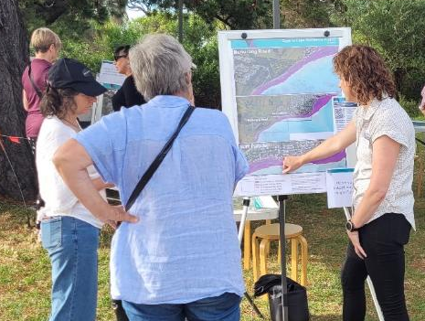
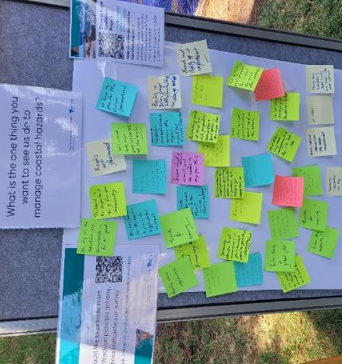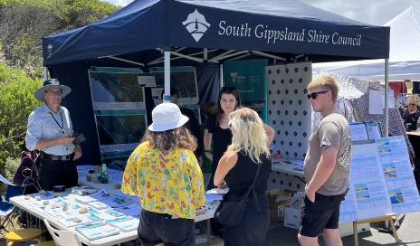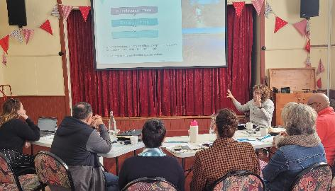
Engagement events and workshops - at the Inverloch Farmers Market, Venus Bay Marketta, and Tarwin Lower hall (January to April 2023). Source: Alluvium and DEECA

The Cape to Cape coast

Land and Sea Country across the Cape to Cape region has been and continues to be nurtured and cared for by Traditional Owners of the region. The Bunurong/Boon Wurrung and Gunaikurnai peoples have lived in and with this Country for thousands of years.
The coast brings people and place together, providing spaces and resources to unite communities and share knowledge, stories and histories.

The coastal landscape
The coastline between Cape Paterson and Cape Liptrap has formed over millions of years. Tectonic movements, wind and wave energy, catchment runoff, sand movement and varying sea levels have all shaped the coast we see today. The diverse landscapes of the current coastline include:
- Hard rock cliffs and shore platforms across the Bunurong coast and Flat Rocks.
- Sandy shores, dunes and ridges across Inverloch Surf Beach, Point Smythe and the Venus Bay open coast.
- Creek mouths and estuaries, including Wreck Creek, Ayr Creek, Screw Creek, Pound Creek, and the Tarwin River.
- Soft rock cliffs and low bluffs around eastern Inverloch and Mahers Landing.
- Tidal channels and estuaries within Anderson Inlet.
- Engineered coast including rock walls, levees and other structures across the region.
These unique landscapes are valued for their ecosystems and habitats, recreational and social value, culturally significant stories, sites and values, and as a driver for economic development of the region. The proximity to the coast and natural beauty of the region makes it a desirable place to live, work and visit.
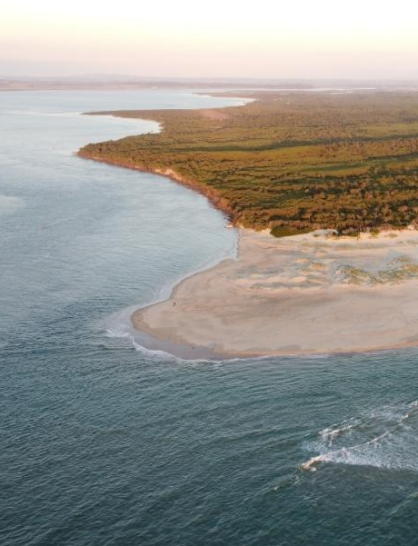
Point Smythe and Anderson Inlet. Source: Alluvium

Community
The towns of Inverloch, Pound Creek, Tarwin Lower and Venus Bay have a combined population of around 7,300 people with 6,500 people living in Inverloch.
Inverloch and Venus Bay are popular with retirees and have around 40-50% of the population in the labour force. The median age for Inverloch is 54 years, while Venus Bay has a median age of 58 years, compared to state median age of 38 years.
Many homes across the region are holiday homes, with around 60-75% of unoccupied dwellings in Inverloch, Pound Creek and Tarwin Lower. In Venus Bay only around a quarter of dwellings were occupied at the time of the 2021 census.
Of the occupied dwellings in the region, most are owned outright or owned with a mortgage, with only around 10-20% of dwellings rented.

Environment
The environment and ecosystems of the Cape to Cape region are diverse, with many unique habitats, supporting rich flora and fauna.
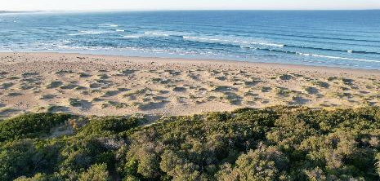
Point Norman and Anderson Inlet. Source: Alluvium
The Inverloch coastal area within the Bass Coast Shire boundary has been declared as a Distinctive Area and Landscape (DAL). This stretch of coast is also partly covered by the new Yallock-Bulluk Marine and Coastal Park. Anderson Inlet is designated a Wetland of National Importance and the Cape Liptrap Coastal Park provides habitat for many threatened flora and fauna species.
The Bunurong Marine National Park covers unique habitats such as extensive intertidal sandstone rock platforms and shallow subtidal rocky reefs. These platforms and reefs are somewhat unique from the rest of Victoria, extending several kilometres from shore.
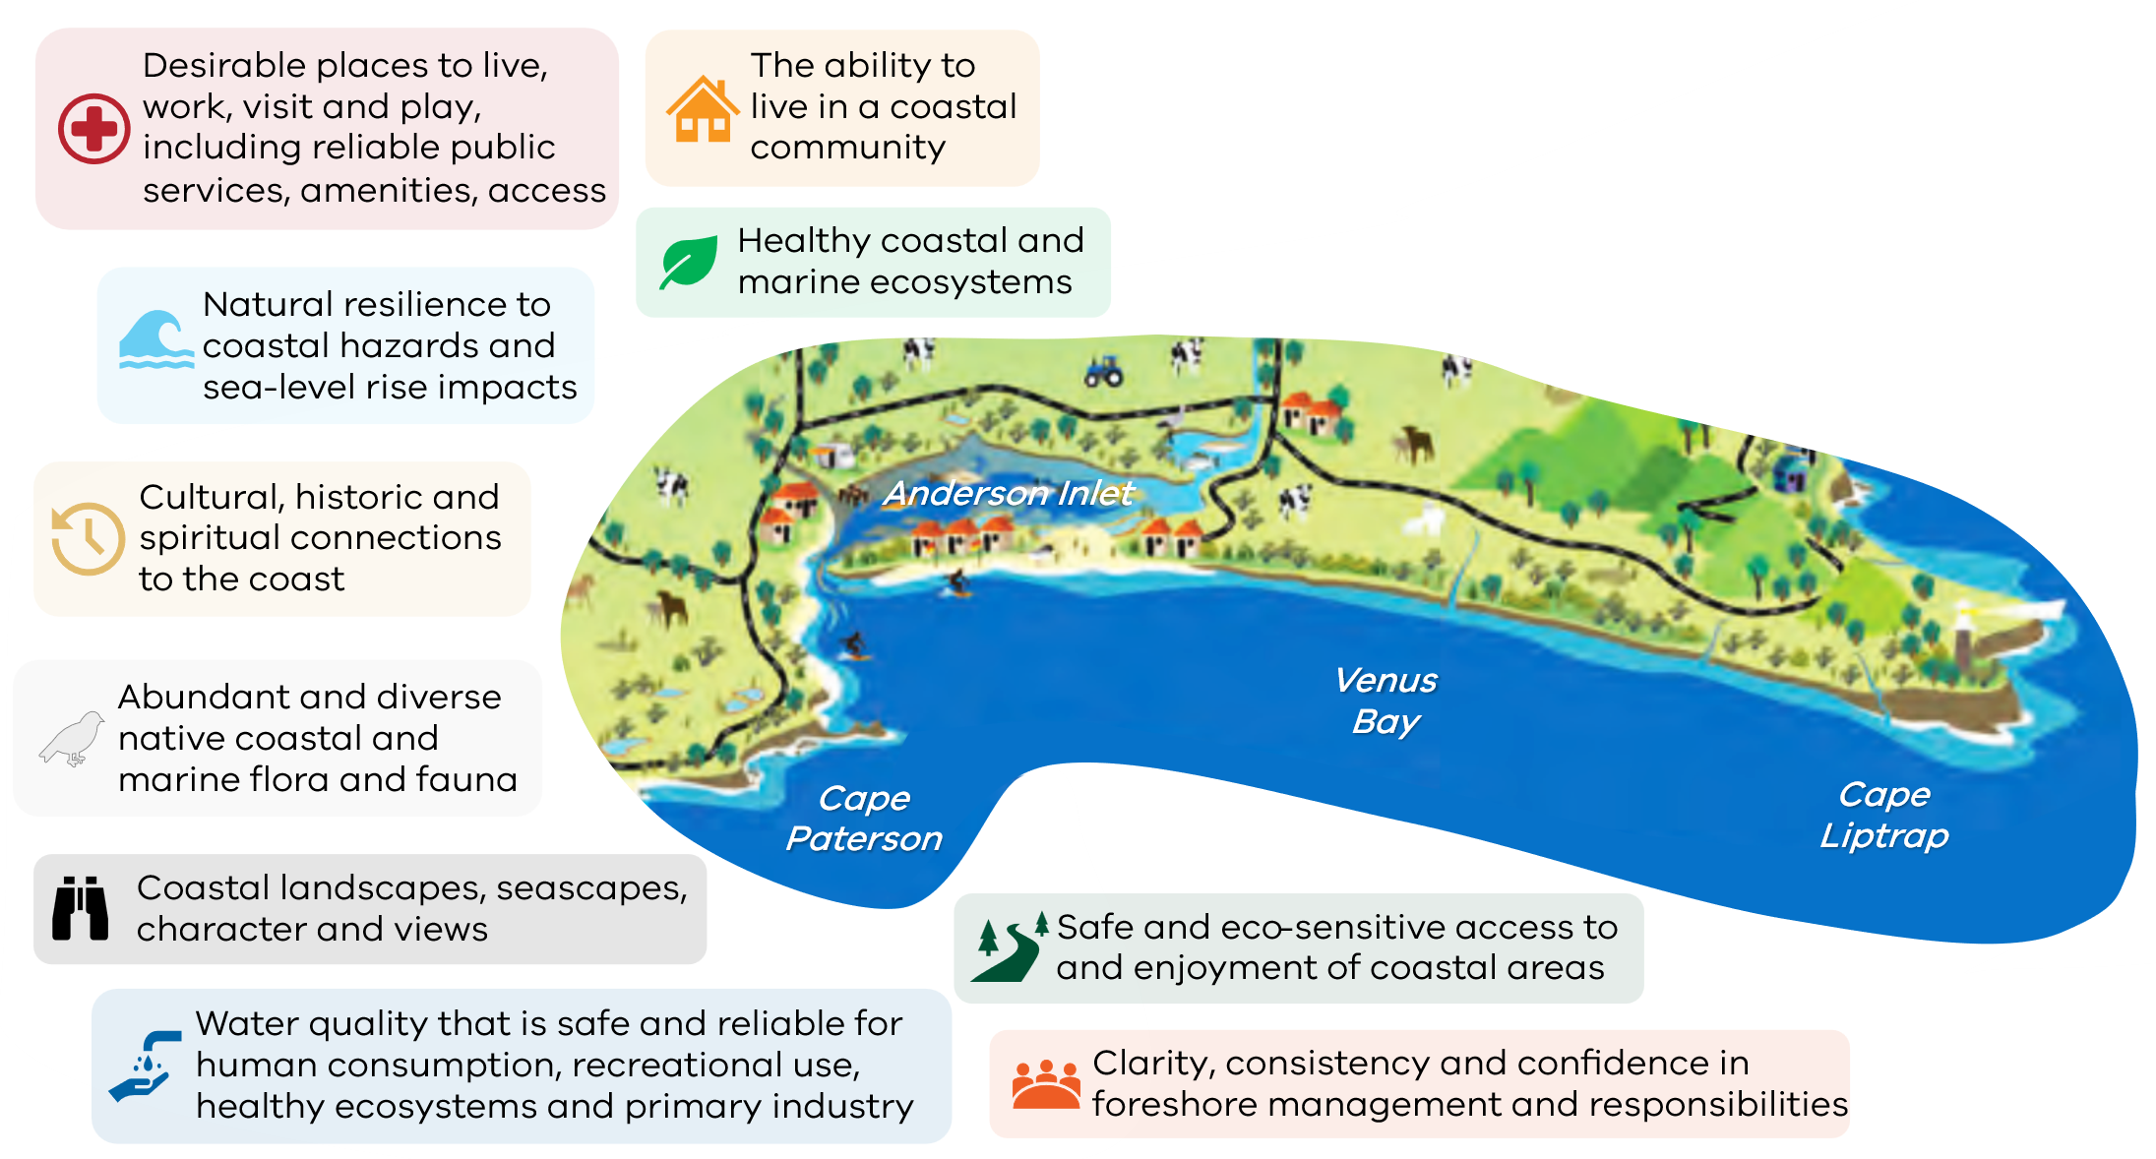

Economy
People living in Inverloch work in hospital, education, supermarket and local government industries. Those living in Pound Creek and Tarwin Lower, work industries are dominated by farming (dairy, beef, and sheep) along with other services such as accommodation, postal services and hospitals. Top industries for people living in Venus Bay support retirees and holiday makers through social assistance services, supermarkets, cafes, restaurants, pubs, bars and gardening services.
Tourism makes an important contribution to the local economy. In the Cape to Cape area, tourism supports around 6-12% of total jobs and generates around 3-9% of total economic output.

Coastal values
Community values have an essential role in developing adaptation and resilience planning. The coastal environment underpins a diversity of environmental, social and cultural values, and supports lifestyle and recreational opportunities.
Extensive community engagement, literature and data review informed the Cape to Cape Resilience Project Community Values Study (Alluvium 2021b), highlighting community values, perceived threats and future aspirations.
Figure 3 provides a summary of these values.

Figure 3. Summary of high-level community values identified for the Cape to Cape region. Further details in the Cape to Cape Resilience Project – Community Values Study (Alluvium 2021b). Image source: WGCMA, 2014.

Towards a resilient coast
The Cape to Cape coastline is dynamic, picturesque and changes every day. Wind, waves, tides and currents constantly move sediment and shape the shoreline.
When these natural coastal processes impact on the values, uses and assets we associate with the coast, we call them coastal hazards. Adapting to these hazards means building resilience to the changes we’re likely to see.
A resilient coast has social, economic and environmental systems in place to avoid, adapt to, manage and mitigate coastal hazard impacts.

 | Resilience is the capacity of social, economic, and environmental systems to cope with a hazardous event, trend, or disturbance, responding or reorganising in ways that maintain their essential function, identity, and structure, while also maintaining the capacity for adaptation, learning, and transformation.

For the Cape to Cape region, coastal adaptation actions reflect the identity and values of the region’s coastal communities and the strategic direction of coastal adaptation across Victoria.

Objectives for adaptation
Based on the unique coastal values for the region, the objectives of adaptation planning through the Cape to Cape Resilience Plan are to:
- Enhance resilience of local coastal values to coastal hazards in the short and longer term
- Avoid actions with negative impacts on key coastal values
- Maintain a safe, accessible sandy surf beach
- Retain the character of the current coastal landscape and environment into the future.

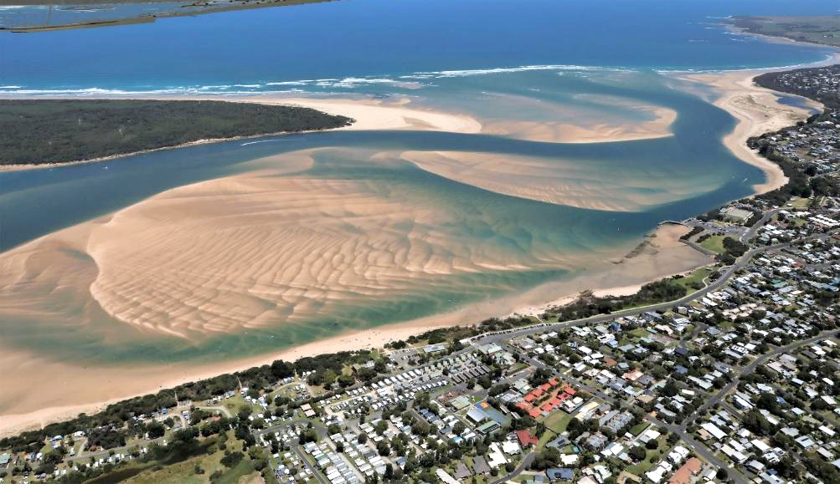
Point Smythe, Anderson Inlet and Inverloch, January 2021. Source: Water Technology

Coastal hazards

Hazards
Natural coastal processes such as short- and long-term erosion and inundation shape the diverse features of the coastal zone, and have done for millennia. These processes are often referred to as coastal hazards when they impact on coastal values and uses, including infrastructure. These adverse impacts may affect safety, environmental, cultural, social and economic values. See the Inverloch Region Coastal Hazard Assessments Reports 1-5 (Water Technology 2022a-2022e) for full details of the hazard assessment.
Coastal hazards considered in adaptation planning for the Cape to Cape region include:
- coastal erosion,
- storm tide inundation,
- permanent inundation, and
- groundwater intrusion.
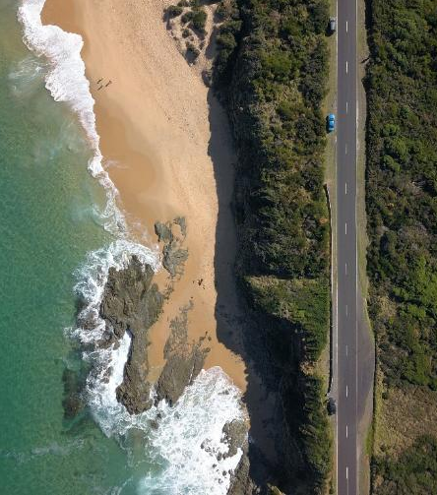
Cape Paterson-Inverloch Road at Undertow Bay. Source: Unsplash – Zac Porter

Coastal erosion
The Cape to Cape coastline is diverse. We consider a range of erosion processes, including across sandy coasts, rocky coasts, and inlet driven processes to understand the erosion hazards for the region.

Sandy coasts
Natural dune systems go through periods of erosion and accretion. Dune vegetation has a key role in assisting dune growth, by helping trap sand.
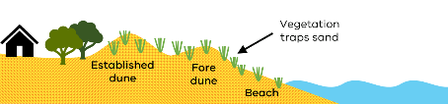
Erosion can occur when winds, waves and coastal currents shift sediment away or along the shoreline, sometimes just offshore. Short term erosion (storm bite) is associated with big storms.
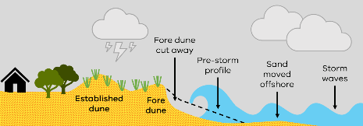
In calm conditions, wind and waves act to transport sand onshore, building up the dune. For a stable beach, most of the sand moved offshore in a storm eventually moves back onto the beach, and the overall shoreline position stays the same over time.
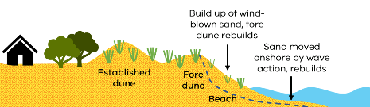
In some cases, changes in sediment supply or climate conditions (such as bigger or more frequent storms), means the beach may not rebuild fully between storm events.
With less sand retained on the beach over time, long-term erosion (recession) may occur; this means the shoreline position (e.g. vegetated dunes and high tide beach) moves incrementally landward (over several decades).
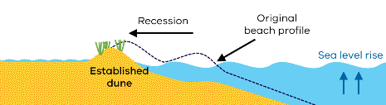

Rocky coasts
Over geological timescales (thousands of years), softer sediments are eroded away, exposing hard rocky coasts. These coasts are more common in areas of high energy (strong wave action).
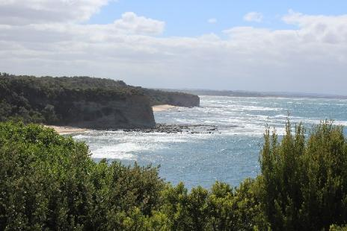
Coastal cliffs along the Bunurong Coast. Source: Alluvium

Hard rock
Hard rock cliff slopes are susceptible to deep-seated mass movements (i.e. cliff fall) that may be initiated by a combination of surface processes (rain, surface runoff) and/or due to marine influences at the base of the cliff (e.g. toe undercutting). Hard rock erosion can occur with little or no warning.
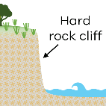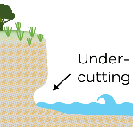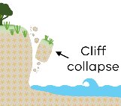
Where a sandy beach is ‘perched’ on a rock platform at the base of a cliff, increasing sea levels and wave energy can result in sand loss, due to limited sand volumes and increased wave reflection off the rocky coast.

Soft rock
Some rocky coastal areas have softer, more erodible rock. These coasts can be more vulnerable to erosion from both surface processes and cliff toe undercutting. Erosion of soft, rocky coasts can occur as both cliff falls and slumping (material movement down its slope).
Rocky coastlines do not ‘recover’ after erosion like sandy coasts do. However, as they have some resistance, they also erode less frequently.

Low earth cliffs
Low earth cliffs are common in low energy environments like Anderson Inlet. Erosion processes are similar to soft rock coastlines, with surface processes and undercutting due to waves driving shoreline recession (moving its position further landward).
The recovery (rebuilding) of a low earth cliff is limited by the available sand in nearshore areas or being moved along the coast. These coastlines are likely to be more susceptible to rising sea levels than rocky coastlines. Being lower in elevation, sea level increases may inundate the landward edge of the cliff, leading to long-term erosion (landward recession) of the coastline.

Tidal channels
The rise and fall of the offshore tide pushes and pulls water into and out of Anderson Inlet. This water exchange results in deep channels forming as water rushes in and out of the Inlet.
The inlet channels move around in the sand within the entrance. Different conditions - such as tidal stages (spring vs neap tides), waves and storm surges and flood flows from the Tarwin River - change the water volume of each tide and the strength and direction of currents which move sediment.
The movement of tidal channels can result in the coastline receding or accreting at different times and places.
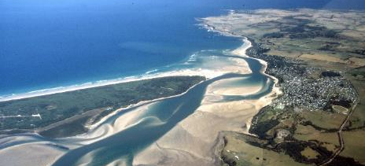
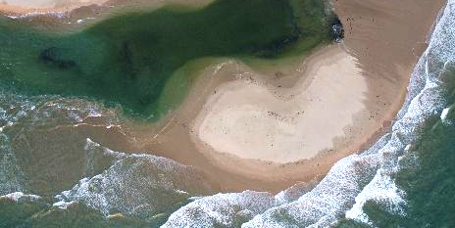
Top: Anderson Inlet 1988 (Source: Neville Rosengren), bottom: Point Smythe, 2022. (Source: Alluvium)

Storm tide inundation
Storm tide inundation is the temporary inundation (flooding) of low-lying coastal land from a locally elevated sea level (storm tide). The storm tide is caused by the combined influence of:
- The predicted tide
- Low pressure air systems causing increases in sea level (storm surge)
- High wind-generated waves associated with a severe storm.
Storm tides inundate low-lying land for periods of hours to days, including coastal wetlands, marshes, inlets and estuaries.
Storm tide inundation can also combine with catchment flooding from severe rainfall events, increasing the extent or depth of inundation in some areas, and the event duration.
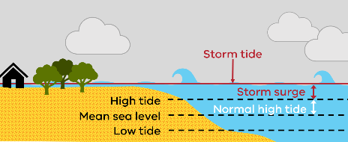

Tidal inundation due to sea level rise
Permanent inundation occurs when low-lying areas become regularly inundated as part of the local tidal cycle, up to and including the Highest Astronomical Tide (HAT). Increases in mean sea level over time will influence the extent of permanently inundated areas.

Saline groundwater intrusion
Saline groundwater intrusion is the movement of saline groundwater into fresh aquifers over time. Increased salinity can affect water quality, including for drinking water and irrigation.
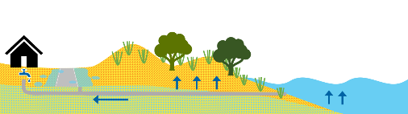
Saline intrusion can occur in many ways, including vertical movement of the water table, and lateral movement of coastal waters. Changes in land use, coastal processes, and mean sea level over time can influence the extent of saline groundwater intrusion.

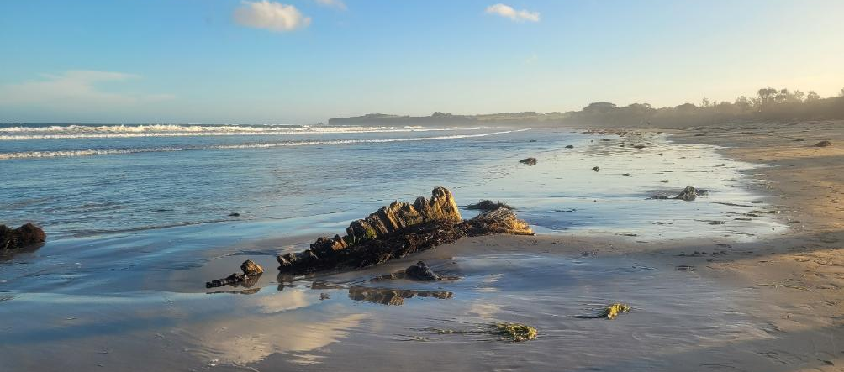
Inverloch Surf Beach and Amazon (1863) shipwreck Source: Alluvium

Understanding the local coastal hazards
New coastal models (computer-based) were developed to estimate current and future erosion, sea level rise and storm tide inundation hazards for the Cape to Cape region.
Aligning with best practice coastal hazard adaptation studies, a series of scenarios were modelled which incorporated a range of:
- Sea levels (planning horizons)
- Coastal hazard ‘events’ (probabilities)
- Urban and catchment flow events.
- Erosion rates
Different combinations of these variables are used to reflect the local present day and future conditions that may be experienced across the region.
Event – Where weather conditions affecting a specific place are notably different from typical, day-to-day conditions normally experienced at that location (e.g. a storm event).
Annual Exceedance Probability (AEP) – on average, the probability of an event occurring in any given year. A higher AEP means it is more likely the event will occur in any one year.
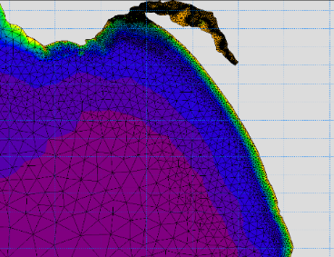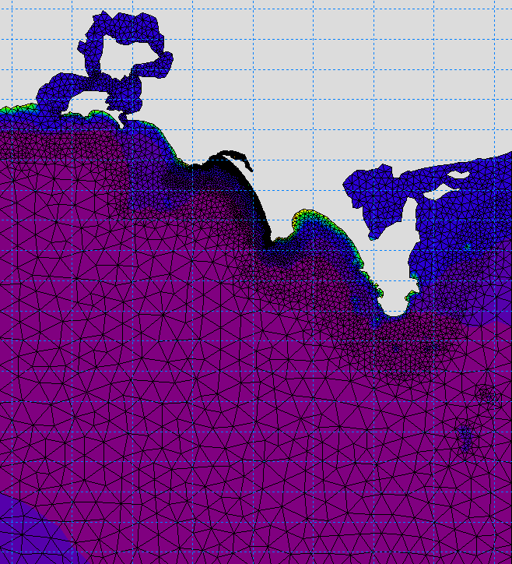
Coastal hazard modelling grids. Source: Water Technology
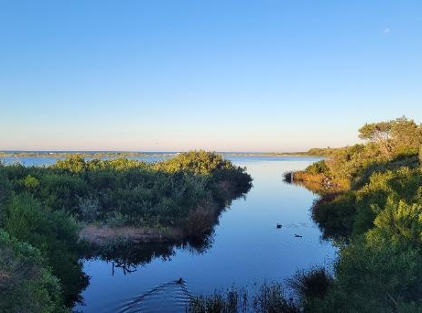
Ayr Creek Lagoon. Source: Alluvium.

Planning horizons
The Marine and Coastal Policy states that when assessing risks and coastal impacts associated with climate change we must:
- plan for sea level rise of not less than 0.8 metres by 2100, and
- allow for the combined effects of tides, storm surges, flooding, coastal processes and local conditions such as topography and geology.
To develop adaptation pathways over the short- and medium-term, and aligning with best-practice, multiple sea level planning horizons have been modelled.
Higher sea level rise projections are included to account for the upper end projections estimated under high-emissions scenarios. Table 5 outlines the modelled sea levels.
Table 5. Planning horizons, including modelled sea levels and indicative years.
 | Sea level rise | Indicative year | Description
Sea level rise | Mean sea level (MSL) | Present day | Base line
Sea level rise | MSL +0.2 m | 2040 | Short term
Sea level rise | MSL +0.5 m | 2070 | Medium term
Sea level rise | MSL +0.8 m | 2100 | Long term
Sea level rise | MSL +1.1 m | 2100 | Sensitivity scenarios
Sea level rise | MSL +1.4 m | 2100 | Sensitivity scenarios

Coastal hazard event probabilities
Storm-tide events (from the coast) driven by wind and waves, can result in coastal flooding and/or erosion.
Multiple coastal hazard event probabilities are modelled for each sea level rise scenario. This helps us understand the likelihood of an event occurring and the damages and losses associated with both larger, infrequent events and smaller, more frequent storm-events. This is important information that shapes our management approach.
We express different events as an Annual Exceedance Probability (AEP). Table 6 outlines the modelled coastal hazard event probabilities.
Table 6. Modelled coastal hazard event probabilities.
 | Annual Exceedance Probability | Description
Coastal hazard event probabilities | 10% AEP | Smaller, more likely coastal storm event
Coastal hazard event probabilities | 5% AEP
Coastal hazard event probabilities | 1% AEP | Larger, less likely coastal storm event

Urban and catchment flow events
Urban and catchment flooding from rainfall and runoff have also been considered. Catchment/ urban flooding events are largely driven by rainfall. This has been combined into storm tide inundation modelling.
A review of local historic storm events found that generally storm events either:
- have a high magnitude storm tide (coastal) component,
OR
- have a higher magnitude (more severe) rainfall.
Analysis as part of the CHA has shown storm events with both high magnitude storm tides and high intensity rainfall are unlikely for this region.
This is reflected in the modelling scenarios where a high magnitude storm tide (e.g. 1% AEP) is modelled with lower magnitude catchment and urban flow events (e.g. 10% AEP and 20% AEP).
Table 7 outlines the modelled urban and catchment flow event probabilities.
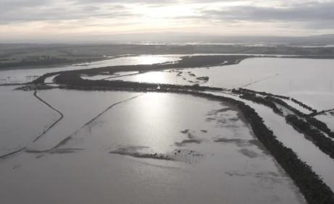
Tarwin River flooding, Aug 2022. Source: Julian Seri / ABC
Table 7. Modelled urban and catchment flow event probabilities.
 | Event type | Annual Exceedance Probability | Description
Urban and catchment flow events | Catchment | 20% AEP | Smaller, more likely flow event from rivers and creeks
Urban and catchment flow events | Catchment | 10% AEP
Urban and catchment flow events | Catchment | 1% AEP | Larger, less likely flow event from rivers and creeks
Urban and catchment flow events | Urban | 20% AEP | Smaller, more likely flow event from urban runoff and drains
Urban and catchment flow events | Urban | 10% AEP
Urban and catchment flow events | Urban | 1% AEP | Larger, less likely flow event from urban runoff and drains

Erosion rates
Erosion modelling combines storm-events (as AEPs), with erosion rates. The erosion coastal hazard modelling analyses aerial imagery of historical shorelines to estimate erosion rates.
Two different erosion rates were considered to estimate erosion rates for long term change:
- ‘Long term rate’ - based on long-term, historic erosion rates observed through aerial imagery and survey data since the 1950s.
- ‘Rapid rate’ - based on more recent, rapid erosion rates observed over the last decade.
The risk analysis uses the long term rate scenarios (in line with best practice methods), with some consideration of the rapid rate scenarios for sensitivity. Table 8 outlines the modelled erosion rates.
Table 8. Modelled erosion rates.
 | Erosion rate | Description
Erosion rate | Long term | ‘Slower’ erosion rate, based on long-term, historical erosion rates observed since the 1950s.
Erosion rate | Short term | ‘Rapid’ erosion rate, based on more recent, rapid erosion rates over the last decade.
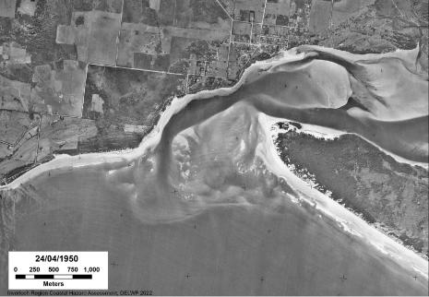
Example historic aerial imagery (1950), used to determine long-term erosion rates. Source: Water Technology

 | Full details of the Coastal Hazard Assessment can be found in the Water Technology reports, with summaries at: marineandcoasts.vic.gov.au/coastal-programs/cape-to-cape-resilience-project

Coastal hazard mapping
The model results provide coastal hazard estimates (“hazard extents”) which can be mapped to help determine areas along the Cape to Cape coastline that may be exposed to coastal inundation, erosion and sea level rise.
Hazard extents and exposure results assume there are no adaptation measures in place. Estimates use local present day ground surface elevations to understand possible flow paths and associated flooding and erosion responses, based on shoreline profiles.

The maps provide an indication of areas that may be exposed to erosion or inundation processes (now or in the future). They do not represent a predicted loss of coastal land. In many cases, the estimated impacts can be avoided, mitigated, or managed through adaptation planning.
Spatial data and maps for erosion, storm tide and permanent inundation hazards include multiple sea levels (planning horizons) and event likelihoods.
Coastal hazard maps and supplementary information can be viewed at:
marineandcoasts.vic.gov.au/coastal-programs/cape-to-cape-resilience-project
 | Interactive maps including coastal hazard layers are available at:  mapshare.vic.gov.au/coastkit/
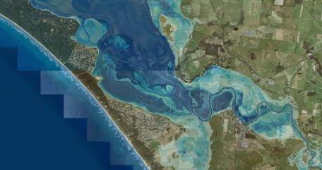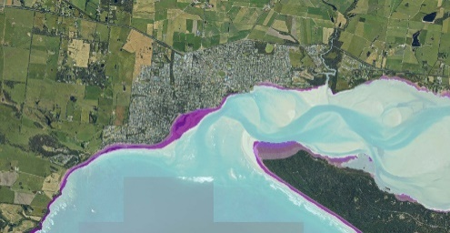
Coastal hazard maps. Source: DEECA

Current and future hazard impacts
Coastal hazards have the potential to have adverse impacts on the Cape to Cape region’s coastal communities, services, lifestyle, and the environment from present day to beyond 2100.
Technical assessments were undertaken to understand coastal hazard exposure, vulnerabilities and risk for values, uses and infrastructure across the region.

Determining what is exposed
Once the coastal hazard extents were mapped, areas and assets that are within hazard extents were identified. See the Cape to Cape Resilience Project - Asset and Values Risk and Vulnerability Assessment (Alluvium 2022a) for more details of exposure, risk and vulnerability.
A spatial database of values, uses and infrastructure data was collated across the Cape to Cape region.
The assessment has included analysis of:
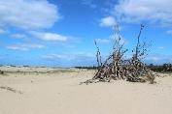 | Beach and foreshore assets  Access, stairs, boardwalks, protection structures, beaches
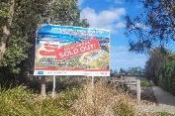 | Planning scheme  Zones and overlays
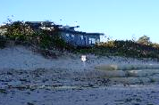 | Buildings and facilities  Building footprints (public and private), surf life saving clubs, amenities, shelters, park and street furniture
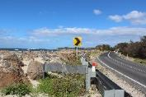 | Transport infrastructure  Roads, bridges, crossing, paths and trails
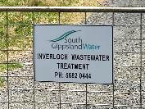 | Other infrastructure and utilities  Water, sewer, electricity, telecoms, gas pipelines
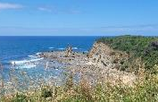 | Land use, environmental and cultural  Dune system, vegetation, habitat, ecosystems, sensitive sites, cultural areas, cultural values (intangible)
Extensive spatial analysis was undertaken to assess which assets (or portions of assets) are exposed to the mapped coastal hazard scenarios.
The exposure and risk information was captured spatially for each asset or land parcel. Summarised by different asset types and localities, this is used to inform adaptation planning and land and asset management.
Three localities were assessed:
- Inverloch: Inverloch township (based on the Inverloch locality boundary).
- Bass Coast: Area surrounding Inverloch within the Bass Coast Shire LGA.
- South Gippsland: Area surrounding Inverloch within South Gippsland Shire LGA.

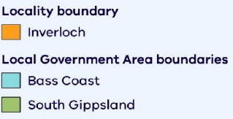
Figure 4. Sub-region split for exposure, risk and vulnerability assessment.

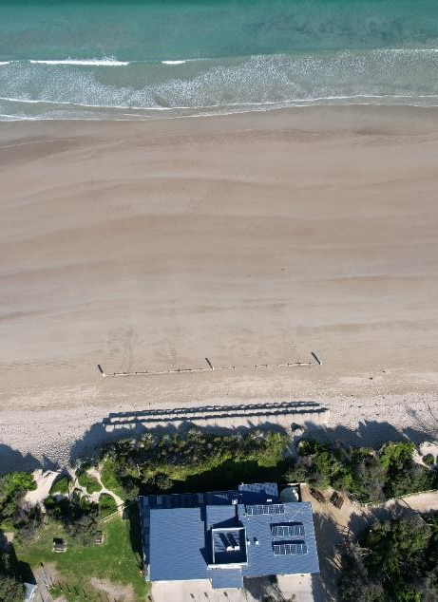
Inverloch Surf Life Saving Club. Source: Alluvium

Establishing what is exposed
Across the Cape to Cape region, planning scheme zones associated with open space, conservation and resource, park and recreation are likely to experience increased exposure to erosion and inundation with 0.8 m sea level rise (by 2100). These zones were the largest exposed areas for all three assessment locations. Region wide, there is a significant increase in exposed areas between the 0.2 m SLR (by 2040) and 0.5 m SLR (by 2070) planning horizons.
Within Inverloch, other zones increasingly exposed included residential, rural and special use zones, while for surrounding Bass Coast and South Gippsland areas, farming, road, low density residential and rural living zones accounted for the more exposed zones.
The spatial data and appreciation for coastal hazard exposure across the range of land and asset types provide a key input into the risk assessment process.

Determining hazard risk
Risk is assessed based on the likelihood of an asset being exposed to a coastal hazard, combined with the consequence of that exposure.
The likelihood was estimated for each hazard scenario considered, based on the probability of occurrence (% AEP). Table 9 details coastal hazard scenarios and corresponding likelihoods.

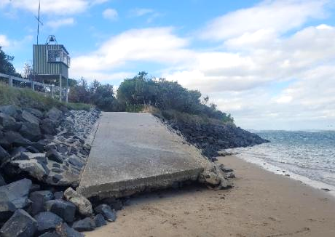
South Gippsland Yacht Club ramp at Inverloch. Source: Alluvium

A tailored approach to assessing consequence was developed and applied to the region’s values, uses and infrastructure. Consequence categories were informed by:
- Existing risk management approaches for DEECA, Victorian State Government and other RaSP members
- Similar assessments for coastal adaptation planning around Australia
- The Community and Cultural Values Studies
- Feedback from RaSP members, including assigning suitable budgets, levels of tolerance and recovery periods relevant for the region.
Consequence classifications in Table 10 are general in nature and represent the typical consequence of erosion or inundation impacts on assets classes and types.

Table 9. Likelihood ratings for inundation and erosion
Likelihood | Temporary inundation  (storm tide and catchment flooding) |  |  |  |  | Erosion  Short term + Long term
Likely | (MHWS + sea level rise) |  |  |  |  | 10% AEP storm tide  + long term erosion rates
Possible | The greater  of the two scenarios |  | 10% AEP storm tide | + | 1% AEP catchment  1% AEP urban flow event | 5% AEP storm tide  + long term erosion rates
Possible | The greater  of the two scenarios |  |  | OR |  | 5% AEP storm tide  + long term erosion rates
Possible | The greater  of the two scenarios |  | 1% AEP storm tide | + | 10% AEP catchment  20% AEP urban flow event | 5% AEP storm tide  + long term erosion rates
Unlikely | The greater  of the two scenarios |  | 5% AEP storm tide | + | 1% AEP catchment  1% AEP urban flow event | 1% AEP storm tide  + long term erosion rates
Unlikely | The greater  of the two scenarios |  |  | OR |  | 1% AEP storm tide  + long term erosion rates
Unlikely | The greater  of the two scenarios |  | 1% AEP storm tide | + | 10% AEP catchment  20% AEP urban flow event | 1% AEP storm tide  + long term erosion rates
Rare | The greater of the two scenarios for two planning horizons ahead |  | 5% AEP storm tide | + | 1% AEP catchment  1% AEP urban flow event | 1% AEP storm tide  + rapid erosion rates
Rare |  |  |  | OR |  | 1% AEP storm tide  + rapid erosion rates
Rare |  |  | 1% AEP storm tide | + | 10% AEP catchment 20% AEP urban flow event | 1% AEP storm tide  + rapid erosion rates

Table 10. Consequence categories

Consequence | Culture and Country | Environment | Community and lifestyle |  |  | Place and planning
Consequence | Cultural landscapes | Environmental values | Lifestyle | Access | Public safety | Property and infrastructure | Economy and growth
Consequence | Specific consideration of traditional cultural values and the ability to maintain and pass on traditional knowledge and practices to future generations | Considers elements such as ecological values, ecosystem services, and cultural and traditional uses. | Considers lifestyle elements of modern and traditional lifestyle such as community services, cultural connection, recreational and social activities, and day to day business activities. | Considers access for recreational activities such as boating and fishing, nature-based activities as well as access to cultural and ceremonial sites. | Considers threats to human health and safety such as injury, disease, mental and physical wellbeing. | Considers the threat of damage to built assets and any interdependencies such as regional access and ability to deliver critical services | Includes existing business and potential economic growth opportunities, especially for locally owned and operated enterprises.
Extreme | Severe and widespread, permanent impact on multiple sites of cultural significance, including loss of land, connection to land, and ability to continue traditional practices.  Recovery unlikely. | Severe and widespread, permanent impact on multiple regionally or nationally significant environmental values of the region.  Recovery unlikely. | Widespread semi-permanent impact (~1 year) to highly utilised community services, wellbeing, or culture of the community with no suitable alternatives. | Widespread and permanent impact on access to key sites and activities.  Recovery unlikely. | Loss of lives and/or permanent disabilities. | Widespread major damage or loss of property or infrastructure with total value >$25 million.  Full recovery/repair may take many years. | Regional economic decline, widespread business failure and impacts on state economy.
Major | Severe and widespread  semi-permanent impact on one or more sites of cultural significance, including loss of land, connection to land, and ability to continue traditional practices.  Full recovery may take many years. | Severe and widespread semi-permanent impact on one or more regionally or nationally significant environmental values of the region.  Full recovery may take many years. | Major widespread long-term  (~1 month) disruption to well-utilised services, wellbeing, or culture of the community with very few alternatives available. | Severe and semi-permanent impact on access to key sites and activities.  Full recovery may take many years. | Widespread serious injuries/ illnesses. | Major damage or loss of property or infrastructure with total value >$10 million.  Full recovery/repair may take several years. | Lasting downturn of local economy with isolated business failures and major impacts on regional economy.
Moderate | Substantial impact on one or more sites of local cultural significance.  Full recovery may take several years. | Substantial impact on one or more locally significant environmental values of the region.  Full recovery may take several years. | Minor medium-to long-term  (~1 week) or major short-term disruption to moderately utilised services, wellbeing, or culture of the community with limited alternatives. | Substantial impact on access to key sites and activities requiring significant works to repair or restore access.  Full recovery may take less than 1 year. | Isolated serious injuries/illnesses and/or multiple minor injuries/ illnesses. | Moderate - major damage to property or infrastructure with total value >$1 million.  Full recovery may take less than 1 year. | Significant impacts on local economy and minor impacts on regional economy.
Minor | Small, contained, and reversible short-term impact on sites of cultural significance.  Full recovery may take less than 1 year. | Small, contained, and reversible short-term impact on isolated ecosystem services and natural features of the region.  Full recovery may take less than 1 year. | Small to medium short-term disruption (~1 day) to moderately utilised services, wellbeing, finances, or culture of the community with some alternatives available, or more lengthy disruption of infrequently utilised services. | Small to medium, short-term disruption of access to key sites and activities which may require some works to repair or restore access. | Minor and isolated injuries and illnesses. | Minor damage to properties or infrastructure with total value >$100,000. | Individually significant but isolated impacts on local economy.
Negligible | Little to no impact on sites of cultural significance. | Little to no environmental impact. | Very small short-term disruption (~1 hour) to services, wellbeing, finances, or culture of the community with numerous alternatives available. | Very little to no impact on access to key or sensitive sites and activities. | Negligible injuries or illnesses. | Minimal damage to properties or infrastructure with total value <$100,000. | Minor short-term impact on local economy.

Assigning risk
To complete the risk assessment:
- The likelihood and consequence of exposure was determined separately for erosion, permanent and temporary inundation.
- Coastal hazard risk was assessed based on the risk matrix (Table 11), separately for erosion, permanent and temporary inundation.
- The risk assessment matrix was tailored for the project, including the mapped hazard scenarios and sensitivity analysis, and informed by leading practice approaches.
- Risk tolerance was also considered for each risk category (Table 12).

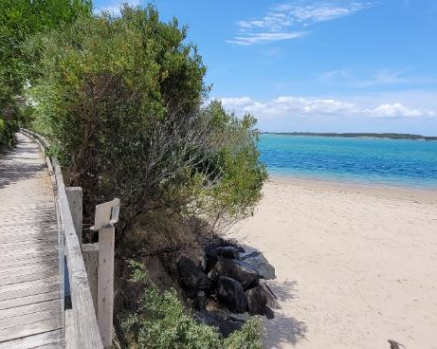
Inverloch Beach boardwalk, near the Glade. Source Alluvium.

Table 11. Tailored risk assessment matrix for the Cape to Cape Resilience Project
 |  | Consequence
Likelihood |  | Negligible | Minor | Moderate | Major | Extreme
Likelihood | Likely | Medium | Medium | Significant | High | High
Likelihood | Possible | Low | Medium | Significant | Significant | High
Likelihood | Unlikely | Low | Medium | Medium | Significant | Significant
Likelihood | Rare | Low | Low | Medium | Medium | Significant

Table 12. Tailored risk tolerance categories for the Cape to Cape Resilience Project
Risk | Risk tolerance | Action required
High | High risk: a risk that, following an understanding of likelihood and consequence, is so high that it requires actions to avoid or reduce the risk. | Immediate and/or ongoing action is needed to treat, eliminate, or reduce risk to acceptable levels
Significant | Medium to significant risk: a risk that, following an understanding of likelihood and consequence, is low enough to allow the exposure to continue, and at the same time high enough to require new treatments or actions to reduce the risk. Society can live with this risk but believe that as much as is reasonably practical should be done to reduce the risks further. | Short term and/or ongoing action is needed to treat, eliminate, or reduce risk to acceptable levels
Medium |  | Short to longer term action is needed to treat, eliminate, or reduce risk to acceptable levels
Low | Low risk: a risk that, following an understanding of likelihood and consequence, is sufficiently low to require no new treatments or actions to reduce the risk further. Individuals and society can live with this risk without feeling the necessity to reduce the risks any further. | Manage and monitor the risk as part of current operations, provide for periodic maintenance/review.

Overview of assets at risk
Risks for the broader Cape to Cape region are largely associated with storm tide inundation and increasing tidal areas. Erosion also poses risks to localised areas, including several locations within Inverloch township, which sees some urbanised areas at increasing hazard risk.

Planning scheme zones
Risk has been summarised across different planning scheme zones.
Presently, more than 7% of land across the Cape to Cape study area is at medium to high risk from coastal hazards. This increases up to over 10% with 0.8 m SLR (by 2100) (Table 13). For this same sea level, at-risk areas for Inverloch township increase from 3% to almost 6%, Bass Coast increases from 2% to over 5%, while South Gippsland increases from 9% to more than 12%.

Table 13. % total area with medium to high coastal hazard risk
% of total area | 0.0 m SLR  Present | 0.2 m SLR  2040 | 0.5 m SLR  2070 | 0.8 m SLR  2100
Cape to Cape region*
Erosion | 0.6 | 0.8 | 1.1 | 1.3
Storm tide | 7.3 | 8.2 | 9.9 | 10.7
Perm Inundation | 1.9 | 3.0 | 5.2 | 6.7
Bass Coast
Erosion | 0.9 | 0.9 | 0.9 | 0.9
Storm tide | 2.1 | 2.8 | 5.1 | 5.4
Perm Inundation | 1.7 | 2.0 | 2.9 | 3.8
Inverloch
Erosion | 1.1 | 1.9 | 2.9 | 3.5
Storm tide | 2.9 | 3.3 | 5.0 | 5.7
Perm Inundation | 0.7 | 1.0 | 1.6 | 2.2
South Gippsland
Erosion | 0.4 | 0.5 | 0.7 | 0.9
Storm tide | 8.7 | 9.7 | 11.4 | 12.3
Perm Inundation | 2.2 | 3.5 | 6.1 | 7.9

*combined planning scheme zones across the Cape to Cape study areas

At present day, the majority of land at medium to high risk are public park and recreation and conservation and resources planning zones (Table 14).

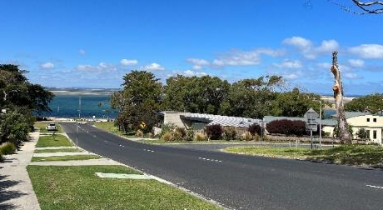
View of Anderson Inlet from Venus Street, Source: Alluvium.
Presently, up to 38% of Inverloch’s public park and recreation areas are at medium to high risk, increasing to up to 67% with 0.8 m SLR (by 2100). Similarly, up to 45% of Inverloch’s public conservation and resource areas are presently at medium to high risk, increasing slightly to up to 47% with 0.8 m SLR (by 2100).
For South Gippsland, farming and rural land accounts for the largest planning zone areas exposed. Some areas already have relatively high exposure and risk to coastal hazards, with 9% of land currently at medium risk or above (over 2,800 Ha) increasing to 12% (almost 3,700 Ha) with 0.8 m SLR (by 2100).
Various planning scheme zones within the region’s coastal areas cover residential and tourism dwellings, and associated facilities. Presently, around 13% of Inverloch’s general residential areas are at medium to high risk from coastal hazards, increasing to ~15% with 0.8 m SLR (by 2100).

Environmental and conservation areas
Mangrove and saltmarsh communities and coastal wetlands are increasingly at risk. Some areas may be able to migrate and re-establish themselves as sea levels rise, particularly where there is sufficient room for these assets to naturally adapt.
A wide range of native vegetation species (including coastal dune scrub, scrub grassland, woodlands and heathlands) are also increasingly at risk, particularly within Anderson Inlet, along the waterways and at the Inverloch Surf Beach dune.
Some sites and areas of recognised cultural significance are also increasingly at risk.
Many of these conservation and natural environment areas are already in at-risk areas. Depth and duration of inundation exposure are likely to increase in some of these areas.

 | Erosion (%) |  |  |  | Storm tide (%) |  |  |  | Permanent inundation (%)
 | 0.0 m Present | 0.2 m 2040 | 0.5 m 2070 | 0.8 m 2100 | 0.0 m Present | 0.2 m 2040 | 0.5 m 2070 | 0.8 m 2100 | 0.0 m Present | 0.2 m 2040 | 0.5 m 2070 | 0.0 m Present
Bass Coast
COMMERCIAL 1 ZONE
COMMERCIAL 2 ZONE
COMPREHENSIVE DEVELOPMENT ZONE - SCHEDULE 1
FARMING ZONE |  |  |  |  | 1 | 2 | 4 | 5 | <1 | <1 | 1 | 2
GENERAL RESIDENTIAL ZONE - SCHEDULE 1
INDUSTRIAL 1 ZONE
PUBLIC CONSERVATION AND RESOURCE ZONE | 17 | 18 | 18 | 18 | 32 | 35 | 41 | 43 | 32 | 35 | 41 | 43
PUBLIC PARK AND RECREATION ZONE | <1 | <1 | <1 | <1 | 1 | 1 | 1 | 1 | <1 | <1 | <1 | <1
PUBLIC USE ZONE - SERVICE AND UTILITY
ROAD ZONE - CATEGORY 1 | <1 | <1 | <1 | <1 |  |  | <1 | <1
ROAD ZONE - CATEGORY 2
RURAL ACTIVITY ZONE
RURAL LIVING ZONE
Inverloch
COMMERCIAL 1 ZONE
FARMING ZONE | <1 | <1 | <1 | 1 | 1 | 1 | 3 | 4 | <1 | 1 | 1 | 2
GENERAL RESIDENTIAL ZONE - SCHEDULE 1 |  | 3 | 11 | 14 | 13 | 14 | 15 | 15 | <1 | 1 | 1 | 2
INDUSTRIAL 3 ZONE
LOW DENSITY RESIDENTIAL ZONE |  |  |  |  | 20 | 20 | 20 | 20
MIXED USE ZONE |  |  | <1 | 5 | 4 | 4 | 4 | 4
PUBLIC CONSERVATION AND RESOURCE ZONE | 38 | 39 | 41 | 41 | 46 | 47 | 47 | 47 | 22 | 24 | 28 | 32
PUBLIC PARK AND RECREATION ZONE | 23 | 52 | 62 | 67 | 38 | 41 | 42 | 45 | 4 | 5 | 9 | 14
PUBLIC USE ZONE - CEMETERY/CREMATORIUM
PUBLIC USE ZONE - EDUCATION
PUBLIC USE ZONE - HEALTH AND COMMUNITY
PUBLIC USE ZONE - LOCAL GOVERNMENT |  |  |  |  | 8 | 8 | 8 | 8 | <1 | <1 | <1 | 1
PUBLIC USE ZONE - OTHER PUBLIC USE |  |  |  |  | 41 | 41 | 41 | 41
PUBLIC USE ZONE - SERVICE AND UTILITY |  |  | <1 | <1 | <1 | <1 | <1 | <1
PUBLIC USE ZONE - TRANSPORT |  |  | 25 | 25 | 8 | 8 | 8 | 8
ROAD ZONE - CATEGORY 1 | 1 | 5 | 6 | 6 | 6 | 7 | 9 | 13 | <1 | <1 | <1 | 1
ROAD ZONE - CATEGORY 2 |  |  |  |  | 1 | 1 | 1 | 1
RURAL ACTIVITY ZONE |  | 1 | 2 | 2 | 1 | 1 | 2 | 2
RURAL LIVING ZONE |  |  |  |  | 1 | 1 | 1 | 1
SPECIAL USE ZONE - SCHEDULE 5 |  | 1 | 11 | 23 | 11 | 16 | 17 | 17
South Gippsland
COMMERCIAL 1 ZONE
FARMING ZONE | <1 | <1 | <1 | <1 | 8 | 9 | 11 | 12 | 2 | 3 | 6 | 7
LOW DENSITY RESIDENTIAL ZONE |  |  |  |  | 16 | 44 | 48 | 48 |  | <1 | <1 | 1
PUBLIC CONSERVATION AND RESOURCE ZONE | 4 | 6 | 8 | 9 | 16 | 16 | 16 | 16 | 6 | 9 | 13 | 14
PUBLIC PARK AND RECREATION ZONE |  |  |  |  | 1 | 1 | 1 | 1 |  | <1 | <1 | <1
PUBLIC USE ZONE - CEMETERY/CREMATORIUM
PUBLIC USE ZONE - SERVICE AND UTILITY |  |  |  |  | 3 | 3 | 3 | 3 |  |  | 1 | 2
ROAD ZONE - CATEGORY 1 |  |  |  |  | 12 | 14 | 15 | 16 | 2 | 2 | 5 | 8
ROAD ZONE - CATEGORY 2 |  |  |  |  | 0 | 1 | 1 | 2 | <1 | <1 | <1 | <1
RURAL CONSERVATION ZONE |  | <1 | 1 | 2 | 4 | 5 | 7 | 7 | <1 | 1 | 3 | 3
RURAL LIVING ZONE | <1 | <1 | 11 | 33 | 74 | 77 | 79 | 79 | 18 | 35 | 53 | 61
SPECIAL USE ZONE - SCHEDULE 7
TOWNSHIP ZONE |  |  |  |  | 1 | 2 | 3 | 3 |  | <1 | <1 | <1
Table 14. Percentage (%) of area at risks (medium to high) by Planning Scheme Zones

Buildings and facilities
A range of buildings and facilities across the region are increasingly at risk from coastal hazards from present day sea level to 0.8 m SLR (by 2100). These are mostly situated in general residential zones or rural and farming zones, and include buildings located in currently built-up urban areas.
A key facility for Inverloch, the Surf Life Saving Club, is increasingly at risk of erosion, reaching significant risk when 0.2 m SLR is realised (2040 onwards). Other key coastal facilities such as the region’s boat ramps are at increasing risk, with decreasing function over time with sea level rise.
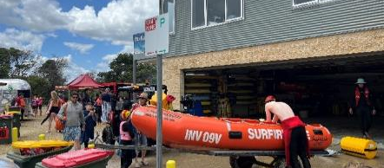
Inverloch Surf Life Saving Club, Source: Alluvium.

Infrastructure - roads and utilities
Roads and utilities are increasingly at risk from coastal hazards. This includes key access routes, and utility supply lines important to the region’s networks.
Notable at-risk access road routes around Inverloch include Cape Paterson-Inverloch Road (Bunurong Road), Surf Parade, and The Esplanade. When 0.2 m SLR is realised (by 2040), ~13 km of Inverloch’s road network is at medium to high risk. This more than doubles to ~15 km with 0.5 m SLR (by 2070), reaching ~20 km at 0.8 m SLR (by 2100) with almost 5 km of road network at significant to high risk).
For South Gippsland, at risk roads include Inverloch-Venus Bay Road both between Venus Bay and Tarwin Lower, and north of Tarwin Lower township. Sections of this key access road are increasingly impacted at and beyond 0.2 m SLR (2040 onwards), potentially cutting access to these townships. Tides will regularly inundate over 3 km of roads within South Gippsland, once 0.8 m SLR is reached (by 2100).
Most transport assets are designed to withstand periods of temporary inundation, and risk is mainly linked to the loss of use/services and broader access disruption. However, erosion or permanent inundation impacts could result in more permanent loss of access.
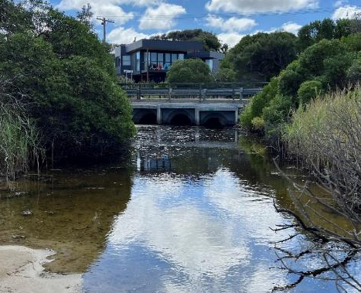
Box culverts at Wreck Creek, Inverloch. Source: Alluvium.
Each of Inverloch’s different utility networks - drainage, drinking water, electricity, gas, sewerage and telecommunication infrastructure - have some level of coastal hazard risk under present day conditions. Critical infrastructure at increasing risk includes major sewer and gas lines, and several sewerage pump stations. Sea level rise may also reduce functionality of some networks, such as drainage.
With 0.8 m SLR (by 2100), most of Inverloch’s utilities networks each have more than 10-20% of their network at medium to high risk. Similarly, risks to electricity and telecommunications networks in South Gippsland areas are increasing, particularly those located alongside key access routes and areas becoming permanently inundated.
While some infrastructure may be designed to withstand regular/permanent inundation, the increasing risk profile indicates the need to ensure necessary upgrades and/or relocation measures are embedded into the relevant asset management programs.

A step-change in risk
The emerging risk profile from 0.0 m to 0.8 m SLR (present day to 2100) is not linear. There is a notable step-change in the risk profile for all hazards and asset types, as the rise in sea levels increases from 0.2 m to 0.5 m (2040 to 2070).
This indicates that there is a good opportunity to undertake adaptation over the coming decades, in a way that can mitigate the step-change before it occurs and avoid (or minimise) the associated impacts.

Understanding economic risk (base case)
In the absence of intervention/adaptation, there are economic costs associated with coastal hazards. Economic analysis is important for determining the best approach to coastal hazard adaptation for different localities. For more details about see the Cape to Cape Resilience Project – Economics Assessments (Stage 1 and 2) (Natural Capital Economics & Alluvium 2022 & 2023).
Economics is used in several ways including to:
- Value assets and key industries
- Define a base case (cost of no action)
- Assess adaptation options.
After assigning monetary values to key infrastructure and natural assets, the foundational step of an economic assessment in coastal hazard adaptation is to define a base case (Figure 5). This means determining the potential economic costs or losses associated with coastal hazards with no additional adaptation/intervention i.e. business as usual. This becomes the baseline for a cost-benefit assessment of implementing adaptation options and actions.
For the Cape to Cape Resilience Project, the economic base case is focused on key components of damages / losses:
Damage to buildings and facilities – Public and private buildings and facilities. This is the financial cost of repairing or replacing these assets.
Damage to other infrastructure and facilities – electricity, gas, telecommunications, sewerage, drainage, and water supply infrastructure.
Damage to transport infrastructure – roads, pathways, and trails. This is the financial cost of repairing or replacing these assets and can also trigger other economic losses where access to key sites is lost. Losses due to access issues are considered in the cost-benefit analysis for high-risk locations.
Damage to beach and foreshore assets – Beach and foreshore assets include recreation facilities, foreshore infrastructure and local tourism assets.
Losses in agricultural production – Agricultural land uses in the region largely relate to grazing modified pastures and broadacre cropping. Reductions of area under these land uses due to erosion or inundation represent a loss of the gross margin that a landholder derives from that land.
Natural asset damages – Land, environmental and cultural assets include natural assets such as salt marshes and coastal forests. This is the lost ecosystem service value from a reduction in extents of these assets.

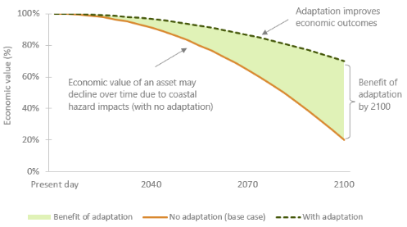
Figure 5. Conceptual diagram - Decline in economic value due to coastal hazards: economic base case (no adaptation) compared to the scenario with adaptation.

Built assets
For the Cape to Cape region, the present day (0.0 m SLR) average annual damages (AAD) associated with combined coastal hazard impacts on built assets is estimated to be in the order of $1.3 million (Figure 7). In absence of adaptation, this may increase up to $2.1 million (AAD) when 0.2 m SLR is realised (by 2040), $4 million (AAD) with 0.5 m SLR (by 2070) and over $8 million (AAD) with 0.8 m SLR (by 2100).
Increasing permanently inundated areas, linked to sea level rise, is the region’s main driver of increasing potential damages over time. Infrastructure, agricultural productivity and private dwellings account for majority of damages. When 0.8 m SLR is reached (by 2100), the largest damages are from buildings and facilities.
Table 15. Annual expected damage ($ million) by hazard type - built assets only.
 | SLR | 0.0 m | 0.2 m | 0.5 m | 0.8 m
Hazard |  | (Present) | (2040) | (2070) | (2100)
Erosion |  | $0.1 | $0.4 | $0.8 | $2.9
Storm-tide |  | $0.6 | $0.6 | $0.6 | $1.1
Permanent inundation |  | $0.6 | $1.1 | $2.6 | $4.0

Figure 6. Annual expected damage ($ million) by hazard type - built assets only.

 | Average annual damages (AAD) - a representation of the damage/loss of coastal values, in monetary terms, averaged to an annual scale.

Table 16. Locality annual expected damage ($ million) by coastal hazard type - built assets only.
 | SLR | 0.0 m | 0.2 m | 0.5 m | 0.8 m
Hazard |  | (Present) | (2040) | (2070) | (2100)
Inverloch
Erosion |  | $0.07 | $0.32 | $0.78 | $2.82
Storm tide |  | $0.59 | $0.59 | $0.63 | $1.13
Permanent inundation |  | $0.02 | $0.05 | $0.52 | $1.07
Bass Coast
Erosion |  | $0.02 | $0.02 | $0.02 | $0.02
Storm tide |  | $0.00 | $0.00 | $0.00 | $0.00
Permanent inundation |  | $0.02 | $0.03 | $0.05 | $0.08
South Gippsland
Erosion |  | $0.00 | $0.02 | $0.03 | $0.07
Storm tide |  | $0.00 | $0.00 | $0.00 | $0.00
Permanent inundation |  | $0.56 | $0.98 | $1.98 | $2.84

Strategic adaptation can assist to avoid, mitigate, accommodate and manage the impacts and potential economic damage associated with coastal hazards.
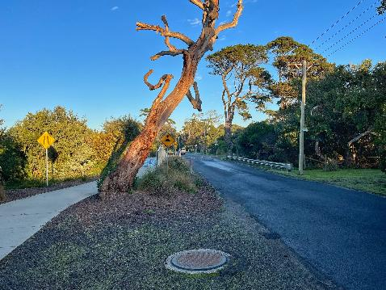
Ramsey Boulevard, Inverloch. Source: Alluvium

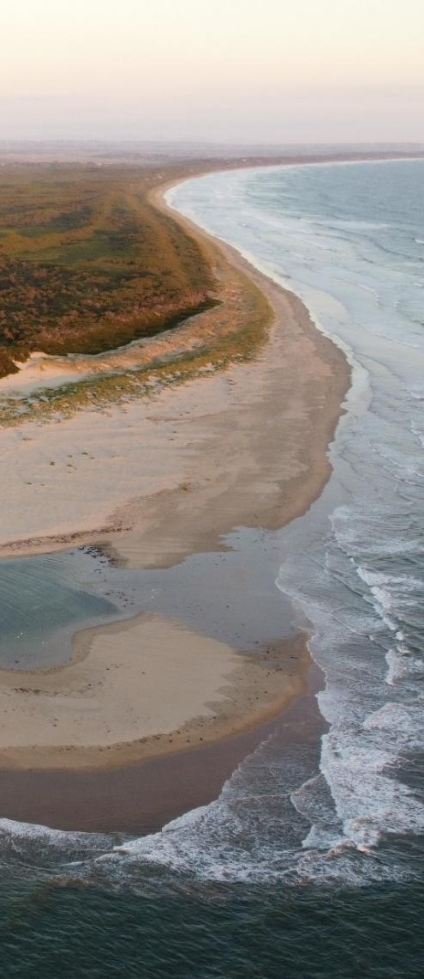
Point Smythe. Source: Alluvium

Natural assets
The natural environment underpins the connection the Cape to Cape community and its visitors have with the region’s coastal and marine areas. Along with beauty and amenity, these natural features provide other ecosystem services, such as biodiversity, habitat and conservation values.
Quantifying risks and damages/losses of natural assets in a similar (but tailored) way to built assets, enables natural values and assets to be incorporated and prioritised in region-wide strategic adaptation.
The present day (0.0 m SLR) AAD associated with coastal hazard impacts on natural assets is estimated to be in the order of $2.6 million annually. In the absence of adaptation, this is likely to increase up to over $11 million with 0.8 m SLR (by 2100).

Table 17. Locality annual expected damage ($ million) by coastal hazard type – natural assets only.
 | SLR | 0.0 m | 0.2 m | 0.5 m | 0.8 m
Hazard |  | Present | 2040 | 2070 | 2100
Inverloch
Erosion |  | $0.62 | $0.71 | $0.80 | $0.87
Permanent inundation |  | $0.00 | $0.36 | $0.46 | $0.56
Bass Coast
Erosion |  | $0.48 | $0.48 | $0.48 | $0.48
Permanent inundation |  | $0.00 | $0.42 | $0.53 | $0.62
South Gippsland
Erosion |  | $1.48 | $2.01 | $2.90 | $3.83
Permanent inundation |  | $0.00 | $3.01 | $4.48 | $4.89

As many of the important ecosystem assets are located in the tidal areas around Anderson Inlet, natural assets in the South Gippsland Shire area of the study region are expected to experience the highest estimated average annual damages across both hazard types and all planning horizons.

A regional snapshot
Bringing together the findings of the exposure, risk and vulnerability, and economic assessments, increases our understanding of coastal hazard risk for assets and land across the region.
This provides a basis to begin targeting our adaptation response and actions (Table 18).

This summary reflects risk, in absence of any intervention to mitigate current and future coastal hazards. The Resilience Plan considers the needs and risk drivers for the different coastal communities of the Cape to Cape region.
Adaptation effort, response and actions can be tailored to location-specific needs (Table 19).

Table 18. Regional risk rating for each locality.
Risk Rating: | Low | Medium | Significant |  | High
 | Erosion |  |  |  |  | Storm tide |  |  |  |  | Permanent inundation
Sea level | 0.0 m | 0.2 m | 0.5 m | 0.8 m |  | 0.0 m |  | 0.2 m | 0.5 m | 0.8 m | 0.0 m |  | 0.2 m | 0.5 m | 0.8 m
Planning horizon | Present | 2040 | 2070 | 2100 |  | Present |  | 2040 | 2070 | 2100 | Present |  | 2040 | 2070 | 2100
Inverloch | Med* | Sign* | Sign | High |  | Med |  | Med | Sign | Sign | Low |  | Low | Med | Med
Bass Coast Shire (ex. Inverloch) | Low | Low | Low | Med |  | Low |  | Med | Med | Sign | Low |  | Low | Low | Med
South Gippsland Shire | Low | Low | Med | Med |  | Med |  | Med | Sign | Sign | Med |  | Med | Sign | Sign
* at some locations within the area

Table 19. Communities and adaptation needs.
Inverloch | - Large and popular coastal settlement.  - Coast and water are central to the region’s tourism-driven economy.  - Various existing erosion hot spots – Inverloch Surf Beach, Cape Paterson-Inverloch Road, east of the Inverloch boat ramp. Risk is anticipated to increase.  - Existing and remnant structures demonstrate a dynamic coastline both in and outside Anderson Inlet.  - Increasing temporary and permanent inundation prone areas.  - Increasing hazard impacts (erosion and inundation) in multiple urbanised areas of township.  - Surf Beach, Cape Paterson-Inverloch Road and various locations within Anderson Inlet in eastern areas of Inverloch township are priority locations for adaptation.  - There is a notable jump in hazard risk between 0.2 m SLR (2040) and 0.5 m SLR (2070) planning horizons.
Bass Coast Shire  (ex. Inverloch) |  | - Temporary inundation is the dominant risk for this sub-region.  - Cliff erosion hazards also pose challenges for this location.
South Gippsland Shire |  | - Large temporary inundation and permanent inundation prone areas.  - Disruption to access routes and services is an increasing, major challenge, along with town and agricultural water supply.  - Liveability of Venus Bay and Tarwin Lower communities is likely to diminish due to hazard impacts.  - Conservation, farming areas and important environmental values impacted – including mangroves, saltmarsh and other coastal and estuarine vegetation.  - Agricultural land and its productivity will likely be impacted.

Approach to adaptation

A strategic approach
Across Australia and internationally, coastal land managers are taking a strategic approach to managing the risk of coastal hazards and enhancing the resilience of our coastal zones.
A tailored adaptation framework has been developed for the Cape to Cape Resilience Project (Cape to Cape Resilience Project – Adaptation Framework Summary Paper (Alluvium 2022c)), based on best-practice approaches to coastal hazard adaptation, including Victoria’s strategic adaptation approach outlined in the Marine and Coastal Policy (2020) and the Victoria’s Resilient Coast (VRC) framework and guidelines (DEECA 2023).
Guided by an appreciation of local adaptation objectives, an understanding of hazard exposure, vulnerability and risk, and the Marine and Coastal Policy (2020), common elements of this strategic adaptation approach include:
- Assessing the available adaptation options that may be suitable in response to identified coastal hazard risks in different locations and over multiple sea level rise scenarios (planning horizons) from present day to 2100+.
- Assessing the range of adaptation actions associated with the different strategic options, that could be used to manage the risk of coastal hazards.
- Developing a strategic plan for coastal adaptation with a view to 2100+, with prioritised actions over a 5-10 year timeframe. This includes the development of adaptation pathways to guide decision making for current and future management.

Adaptation options - different strategic approaches to managing coastal hazard risk.
In Victoria, these are considered in the order of non-intervention, avoid, nature-based, accommodate, retreat and protect.
Adaptation actions - the range of tools, decisions and works that can be implemented to create adaptation pathways aligned to strategic options.
This framework has been informed by:
- Best practice methods as outlined in the VRC framework and aligned with the Marine and Coastal Policy (2020).
- Consultation with stakeholders, including representatives from the Inverloch RaSP, the Stakeholder Reference Group, Victorian Marine and Coastal Council (VMaCC) and broader feedback from the community.
- Values and objectives for different localities across the Cape to Cape region (Community Values Study, Cultural Values Assessment).
- An understanding of vulnerability and risk of coastal hazards for a diversity of values and asset types, across multiple planning horizons (from the Coastal Hazard Assessment and the Risk and Vulnerability Assessment).
- A whole-of-coast perspective of the range of values, uses and pressures in the coastal zone.

Shared roles and responsibilities
Management of coastal hazard risk and increasing the region’s resilience to climate change is a shared responsibility – across the RaSP members, other land and asset managers and users, and the Cape to Cape community.
Each RaSP member has an important role in embedding adaptation and resilience measures into their own systems and processes. This includes using, updating and developing the necessary planning tools to manage land use, and ensure public and private assets are appropriately located, designed, constructed, managed and maintained to enable functionality and accessibility in alignment with agreed pathways.
Integration, coordination, strong leadership and strategic direction will be critical to successful adaptation implementation and building community capacity.

Adaptation objectives
Clarifying adaptation objectives helps to guide appropriate adaptation response/s, and screen adaptation options and actions, across the region and at different localities.
Community perspectives on coastal values and thoughts for the future have informed specific adaptation objectives across the Cape to Cape region (Section 2).

Our objectives for adaptation
- Enhance resilience of local coastal values to coastal hazards in the short and longer term
- Avoid actions with negative impacts on key coastal values
- Maintain a safe, accessible sandy surf beach
- Retain the character of the current coastal landscape and environment into the future.

In line with these established objectives, our adaptation planning also looks to:
- Preserve, maintain and enhance these important values of the Cape to Cape region.
- Use a strategic, adaptive approach informed by an understanding of risk and vulnerability.
- Plan to manage current and emerging coastal hazard risks, with a view out to 2100+.
These objectives for coastal management and adaptation reflect what we are seeking to achieve in our approach. They form the basis for considering and assessing the suitability of different coastal hazard adaptation responses.
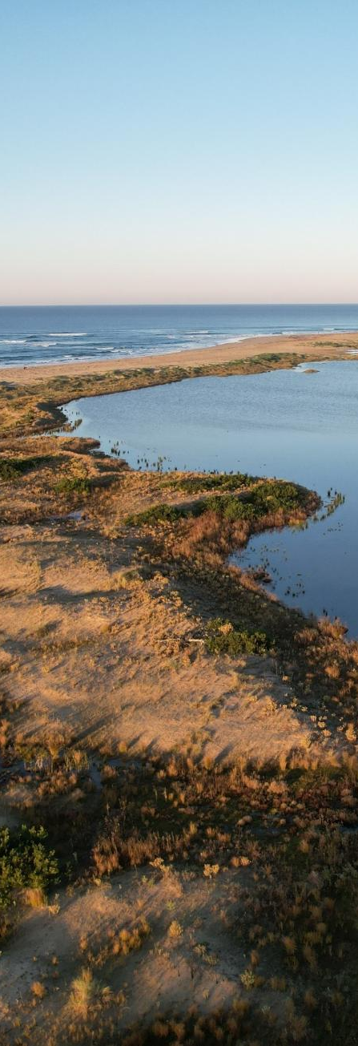
Lagoon at Ayr Creek. Source: Alluvium

Adaptation framework
The Marine and Coastal Policy 2020 re-framed how coastal hazards are managed in Victoria, aiming to facilitate more sustained and holistic management approaches for the long-term benefit of Victoria’s coastline.
Chapter 6 of the Marine and Coastal Policy 2020 requires land managers to consider strategic adaptation options and apply an adaptation pathways approach to determining actions.

Adaptation options
Adaptation options under the Policy (Table 20) are to be considered in the following order:
In the Resilience Plan, the term TRANSITION is consistent with national adaptation terminology and incorporates elements of ‘Retreat’ as defined in the Marine and Coastal Policy (2020).
TRANSITION is a planned/managed process to change how the land in coastal hazard areas is used. This is a proactive adaptation approach. Transition is further defined in Table 19.
Statewide policy updates are underway* to provide guidance for implementing transition pathways for land use and assets in areas impacted by coastal hazards and sea level rise.
*DEECA is leading policy updates over the next three years with Commonwealth funding support.

Table 20. Adaptation options - to be considered in order.
 |  | Non-intervention |  | Allow marine and coastal processes, and the hazards they may pose, to occur.
 |  | Avoid |  | Locate new uses, development and redevelopment away from areas that are or will be negatively impacted by coastal hazards.
 |  | Nature-based |  | Enhancing or restoring natural features to mitigate coastal hazard risk. Includes dune and vegetation enhancement and small-scale renourishment.
 |  | Accommodate | 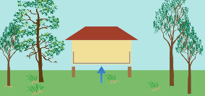 | Structures can be designed to reduce the exposure to, or decrease the impact of, coastal hazard risk, thus ‘accommodating’ the risk.
 |  | Transition |    | A planned/managed process to change how the land in coastal hazard areas is used. This includes gradually moving existing structures, assets, or uses before hazard impacts occur.  Transition provides opportunities for new land uses appropriate for the hazard zone (e.g. recreational uses and assets) that deliver economic, social and environmental values.
 |  | Protect  (major engineering) | 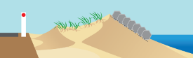   | Existing physical barriers are enhanced, or new ones constructed, to mitigate the impact of coastal hazards. Includes engineered structures (groynes, seawalls, breakwaters) and major dune and beach renourishment.

Adaptation actions
There is a wide range of adaptation actions that align with the six strategic adaptation options in Victoria’s policy.
These actions can be built into tailored adaptation pathways for both regional and location/site specific management.

These are classified under three key categories:

Adaptation actions are not mutually exclusive, and often a suite of measures is required to effectively manage coastal hazard risk.

Table 21. Coastal hazard adaptation actions.
Type | Category | Adaptation action
Land management, planning and design | Land use | Land acquisition or swap
Land management, planning and design | Land use | Controlled access
Land management, planning and design | Land use | Planning scheme zone amendment
Land management, planning and design | Land use | Planning overlays
Land management, planning and design | Land use | Rolling easements
Land management, planning and design | Land use | Relocation of infrastructure
Land management, planning and design | Resilient design / development | Development setbacks
Land management, planning and design | Resilient design / development | Resilient materials / design in new / retrofitted infrastructure
Land management, planning and design | Cultural landscapes | Survey, document, salvage, other*
Nature-based  Nature-Based methods use the creation or restoration of coastal habitats for hazard risk reduction | Coastal vegetation and blue carbon ecosystems | Mangrove forests
 | Coastal vegetation and blue carbon ecosystems | Seagrass meadow
 | Coastal vegetation and blue carbon ecosystems | Salt marsh
 | Coastal vegetation and blue carbon ecosystems | Living shorelines
 | Coastal vegetation and blue carbon ecosystems | Kelp forests
 | Dune ecosystems | Dune protection / vegetation / management
 | Dune ecosystems | Use of on-site natural materials
 | Dune ecosystems | Wet sand fencing
 | Dune ecosystems | Supported littoral vegetation (vegetation along shore/waterlines) **
Engineering | Nourishment** | Localised beach scraping / dune nourishment
Engineering | Nourishment** | Beach nourishment
Engineering | Nourishment** | Sand by-passing systems
Engineering | Reefs** | Shellfish reefs
Engineering | Dredging | Configuration dredging
Engineering | Seawalls | Vertical seawalls
Engineering | Seawalls | Eco engineering of hard structures
Engineering | Seawalls | Rock revetments
Engineering | Seawalls | Geobag revetment / wall
Engineering | Groynes | Groynes
Engineering | Breakwaters | Breakwaters
Engineering | Flood / tidal barriers | Levees / dykes
Engineering | Flood / tidal barriers | Tidal / surge barriers
Engineering | Flood / tidal barriers | Tidal valves on stormwater system
Engineering | Drainage | Saline groundwater intrusion barrier
Engineering | Drainage | Upgrade of drainage network
Engineering | Road network | Upgrade of road network
*As led by Traditional Owners **May be considered a hybrid engineering and nature-based action.
Various adaptation actions have been examined have more in-depth in planning adaptation for the Cape to Cape region (Table 22).
Table 22. Key adaptation actions being considered (with potential suitability by location).
*Locations defined further in Section 7
 |  |  | grey : less suitable |  | ü potentially suitable
Actions | Cape Paterson-Inverloch Road (Bunurong Road) | Inverloch Surf Beach |  | Inverloch township |  | Venus Bay and Tarwin Lower
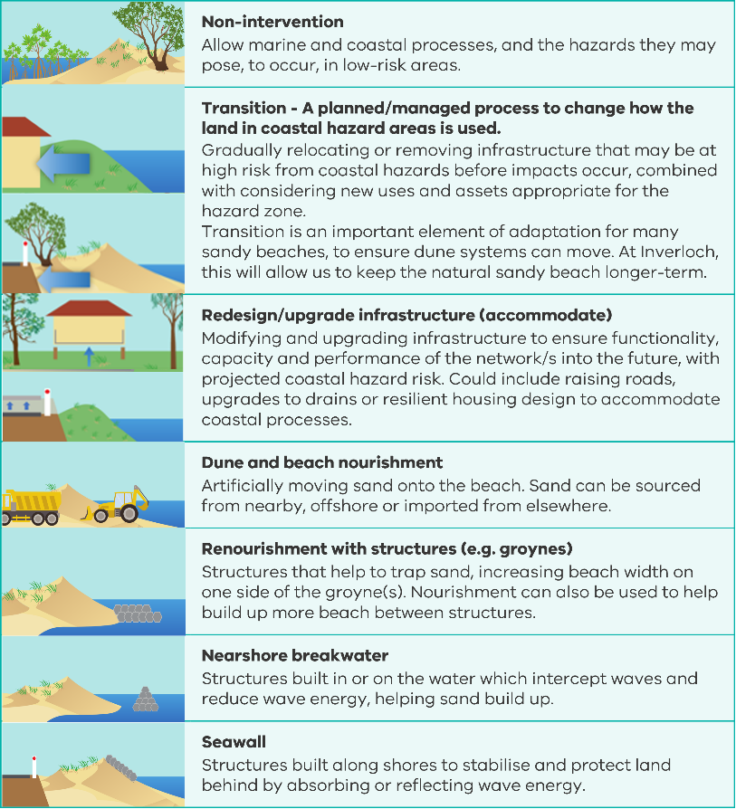 | ü  low risk areas only | ü  low risk areas only |  | ü  low risk areas only |  | ü  low risk areas only
 | ü | ü |  | ü |  | ü
 | ü | ü |  | ü |  | ü
 | ü | ü |  | ü
 |  | ü
 |  | ü
 | ü | ü |  | ü

Adaptation pathways
An adaptation pathway provides a roadmap for adaptation across multiple sea level rise scenarios from present day to 2100+. This approach enables:
- Long-term strategic planning.
- Consideration of multiple potential futures.
- Avoidance of short-term actions that may lead to poor adaptation outcomes.
Adaptation pathways include:
- Clear action sequencing, providing confidence to take short-term action.
- Consideration of lead times required for further investigations, design and approvals.
- Changing feasibility of actions over time.
- Trigger points when a change in action is required.
- consideration of action review and inclusion of further/new information as part of an iterative (adaptive) long-term planning process.
Application of a pathways approach to adaptation has been presented further in Section 7.
Location-specific pathways have been developed to drive adaptation at identified high risk localities for the Cape to Cape region.

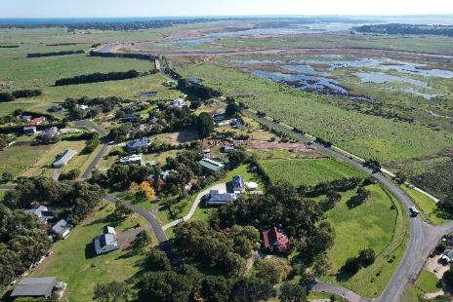
Tarwin Lower. Source: Alluvium

Determining our adaptation process
Guided by the elements of the adaptation framework, the Resilience Plan defines three themes for adaptation actions – Foundation, Regional and Location-specific (Figure 7).
The different action types are integrated, and act together to manage emerging hazard risk and increase the resilience of the Cape to Cape region.

Foundational actions
Section 5
Foundational actions are framed around:
- Community stewardship
- Knowledge-sharing, collaboration and capacity building,
- Monitoring, evaluation and review
- Research and education opportunities
- Funding and approvals
These actions provide strong foundations for strengthening resilience of coastal communities and the success of regional and location-specific initiatives.
Regional actions
Section 6
Regional actions often have relevance across the whole Cape to Cape region (and potentially beyond).
Regional actions also look to provide a broader process, method or framework via which many location-specific actions can be achieved.
Location-specific actions
Section 7
Different locations require site-specific adaptation responses to manage localised risk.
These actions provide the detail for location-specific management and are dependent on local hazard drivers (i.e. erosion or inundation), values and assets at risk, and environmental processes.
Often regional and foundational actions support these actions.
Figure 7. Action structure for the Resilience Plan.

Deciding on adaptation
Strategic coastal hazard adaptation across the whole Cape to Cape region requires a range of actions. Actions across the three action categories (refer back to Table 21) are considered for:
- region-wide scale (see Section 6)
- location-specific scale as part of adaptation response pathways (see Section 7).
The program of priority actions was informed by initial screening of options and a tailored cost-benefit analysis to inform decision making on investment decisions across the coastal localities.
Using tailored criteria, shaped by key community and stakeholder values and objectives, a high-level multi-criteria analysis was undertaken to screen the appropriateness of different adaptation options and actions. More detailed criteria assessment was also undertaken for larger scale engineering actions.
Assessment criteria, aligned with adaptation objectives (refer above), included:
- cost
- feasibility to implement
- level of risk mitigation
- policy alignment
- retainment of natural amenity – including a sandy beach
- retainment of access
- protection of ecosystems and natural assets
- protection of infrastructure assets.

Informing refinement of actions
Targeted analyses were undertaken to further inform the decision-making process for adapting to different hazard types. This included:
- economic assessment, including three economic case studies:
  - the value of a beach
  - blue carbon
  - maintaining access
- coastal modelling and assessment of engineering solutions for targeted at-risk locations – including groynes, nourishment breakwaters and seawalls.
This additional information helped to further inform action development and refinement.
Case study: The value of a beach
Providing swimming, surfing, and other recreation opportunities, Inverloch Surf Beach is a major driver of visitation and inward migration for the Cape to Cape region. It is a key contributor to the local economy, attracting visitors who spend money on accommodation, food, and retail business. Opportunities for coastal living and beach access also drives higher property values.
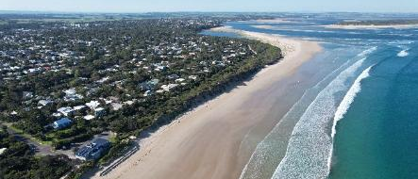
Inverloch Surf Beach. Source: Alluvium
Temporary and permanent beach closures (i.e. “loss of the beach”) could have three major economic impacts on the local economy:
- loss of value associated with the benefit derived from a visit to a beach
- loss of revenue for nearby businesses (cafes, restaurants, accommodation)
- loss of beach amenity associated with property proximity to a beach access point.
To understand these impacts, a reduction in visitation due to temporary closure, and reduction in property prices (and associated rate incomes) due to permanent closure are assessed.
Scenarios also reflect a loss of access (temporary or permanent) to the beach which could occur through other factors as well, such as the loss or closure of a main access road and access facilities.
Losses resulting from temporary closure/loss of access to the beach are in the order of $2.5 to $7.4 million annually. Some of these losses may be captured elsewhere in the region, as people choose another nearby beach, however a substantial loss will likely be incurred.
For permanent closures or loss of access, impacts on property values are by almost 30% for properties with coastal views and 37% for those without.
The potential losses of beach amenity are significant for local residents and businesses. This highlights the economic case for some erosion mitigation and opting for adaptation solutions that can retain a beach. Potential co-investment opportunities (cost contributions from beneficiaries) in shared adaptation initiatives for the coast may also exist.

Case study: Blue carbon
Rising sea levels are predicted to change the composition of Anderson Inlet and its surrounding areas. This provides opportunities for land use transitions, to provide new ecosystem services.
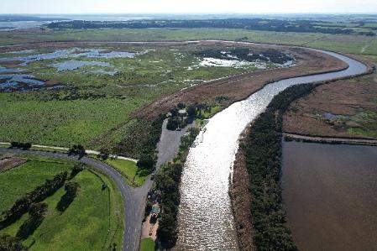
Saltmarsh along the Tarwin River. Source: Alluvium.
Ecosystem services - the range of benefits natural assets provide which contribute to human wellbeing. Estuarine systems, such as Anderson Inlet, provides a range of ecosystem services, including climate regulation, carbon sequestration, flood regulation, habitat, recreation and cultural values.

Anderson Inlet and the surrounding floodplain currently supports a range of land uses including rural and agriculture, conservation, and open space purposes.
Many of these areas are already flood-prone and with rising sea levels, an expansion of areas permanently inundated, is expected. There is an opportunity to transition the land to a wetland system over the next 80 years. These changes will result in an increase of ecosystem services.
Potential for mangrove and saltmarsh communities to migrate and expand into increasing inundating low lying farming areas.
The estimated value of potential blue carbon stock provided by inundated land with 0.8 m SLR (by 2100), is over $10 million per year. The value gained from blue carbon net abatement could be almost 4 times greater than the value of agriculture foregone.
Ecosystem | Value ($million)*
Blue carbon net abatement | $10.3
Wider ecosystem services | $584.4
Agriculture foregone | $2.6
*based on “more likely” estimates
The value of estuarine ecosystem services created by Anderson Inlet expansion well exceed the value of any agriculture lost and strongly supports current transition initiatives.
Case studies: Maintaining access
Coastal hazards have potential to impact on access to and across the Cape to Cape region, with flow on economic impacts. Numerous roads are potentially at risk from inundation or erosion. Notable access routes at risk include Cape Paterson-Inverloch Road (Bunurong Road) and Venus Bay-Inverloch Road.
Cost benefit analysis (CBA) uses the economic value of access loss as a reference to assess the effectiveness of possible adaptation actions and suitability of potential investment.
Cape Paterson-Inverloch Road (Bunurong Road)
Erosion and inundation, particularly to the east, near Wreck Creek impact on this road. Alternate transport routes are available for nearby communities (Cape Paterson), however, local sites, beaches, attractions, properties and critical infrastructure (wastewater treatment), rely upon this route.
Economic assessments examined actions to protect the existing road alignment, compared to several road realignment options, using CBA. A hard protection solution (seawall) was found to be the most economically viable. However, some road realignment options fared well and also offered strong alignment with community values and state policy.
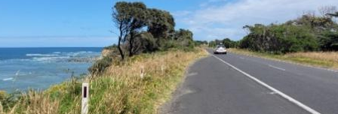
Bunurong Road. Source: Alluvium
Venus Bay-Inverloch Road
Costs of temporary access disruption were estimated, based on foregone income (to local businesses), wages (if unable to get to work), rescue (e.g. medical emergency), and extra travel costs (longer distances).
The cost to the local economy from temporary closure of Venus Bay-Inverloch Road were found to be:
- $5K to $15K per day for Tarwin Lower, with alternate access routes available
- $150K - $1.25 million per 2-5 days for Venus Bay, which experiences complete isolation.
Cost benefit and threshold analyses considered:
- Frequency of temporary access loss (event/yr)
- Proportion of property value loss
Analysis examined various actions for limiting access disruption of the main access route including road raising, road redesign and levees to protect the road.
Scale (length) of these actions means these are expensive and not currently viable. However, multiple actions are economically viable with 0.5 m SLR (by 2070) due to areas of the region becoming permanently inundated.

Modelling and assessment of engineering solutions  Informed by local site context and high-level multi-criteria analysis (described in Section 4.5), some large-scale engineering solutions were shortlisted for more detailed assessment and modelling, as possible actions for targeted at-risk locations. This included both conceptual and numerical (computer) modelling of actions at Bunurong Road, Surf Beach and Tarwin Lower. Concept designs and rendered images were used to understand the scale and visual impact of actions. Detailed cost estimates were also developed.  Shortlisted engineering actions were assessed to review general effectiveness, performance and risk to surrounding environment and adjacent shoreline. Key findings are presented below. |  | 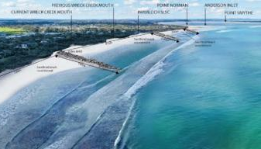  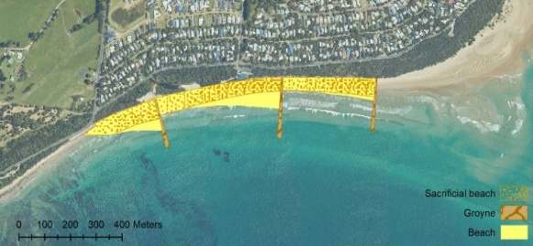  Example photo renders and concept design (groynes and renourishment). Source: Water Technology
Option | Assessment summary
Bunurong Road
Beach renourishment | - 75,000 to 100,000 m3 would be required for a “sacrificial” beach to prevent erosion in a 2% AEP storm, with ongoing renourishment required, potentially annually.  - Allows natural processes with less chance of long-term (irreversible) impacts.  - Renourishment could impact on Anderson Inlet entrance dynamics, intertidal habitats and change the beach character to a high dune, with potential to increase inundation risk.
Seawall | - More than 1 km of seawall would be required to protect the entire length of the beach/road.  - Difficult to remove in the future and significant impacts on beach amenity and access.  - Over wash in a storm could still occur with potential to increase inundation risk.
Inverloch Surf Beach
Groynes and beach renourishment | - Three groynes of 180-210 m long, 4 m high and up to 14 m wide required along Surf Beach, with initial nourishment of 100,000-200,000 m³ and additional groynes in Anderson Inlet over time.  - Significant impact on beach amenity, access and views, with a steep sloping dune.  - Potential impacts to Anderson Inlet entrance dynamics and further erosion to the east.
Nearshore breakwaters | - Conceptual configuration of eight nearshore breakwaters, ranging between 80 m and 145 m long, 4-4.5 m high, placed 150-200 m from the present day shore, with very large rock.  - Significant impact on beach type, surfing conditions and character through changed wave energy.  - Complex and uncertain impacts on entrance dynamics, potential increased recession elsewhere.
Seawall | - More than 1 km of seawall would be required to protect this area.  - A large seawall structure on a dune presents significant terminal scour challenges (‘where to end the wall’).  - Difficult to remove in the future and significant impacts on beach amenity and access.  - Significant impact on beach (reduction and ultimately of loss beach in long-term), amenity, access and views.
Point Norman Long Groyne | - Groyne 300-500 m long required to realign beach and protect coastline at Wreck Creek, with initial renourishment of 100,000 m³, large rock size and complex to construct.  - Significant impact on beach aesthetics and entrance dynamics with potential erosion elsewhere.
Drainage controls | - Tidal controls on Wreck Creek could help minimise flood extents. Preliminary modelling showed multiple flow paths exist through nearby lower sections, meaning any drainage controls would be less effective unless combined with creating of higher dune buffer and/or minor road raising. Outlet design must also limit potential for increased catchment flooding due to outlet control/constriction.
Venus Bay and Tarwin Lower
Road raising and levees  For further information see Water Technology 2022g and Adaptation Actions Technical Assessment Report Summary. | - Catchment hydrology and flood potential of areas the Venus Bay and Tarwin Lower region, levees constructed to limit coastal flooding impacts may pose possible risks for catchment flooding. Any new levees introduced must account for this risk.  - Modelling showed minor road raising may help reduce flood risk, for up to 0.5 m sea level rise. Additional levees or combined road raising and levees could be effective in some areas in the longer term, especially the road route between Venus Bay and Tarwin Lower. Additional levees at/north of Tarwin Lower township (near Inverloch-Venus Bay Road river crossing) may be less effective at reducing flood risk, creating extra catchment flooding challenges.

Foundational actions

Foundational actions are about enhancing the adaptive capacity of Cape to Cape stakeholders and communities and the way we respond to emerging hazard risk. They aim to provide important knowledge, data, skills and tools to enable adaptation approaches to succeed and continue to evolve and adapt to changing conditions. These actions can be integrated with regional and location-specific actions to improve action outcomes.
Table 23 details these foundational actions. Details of agency involvement, roles, responsibilities have been developed as part of further implementation planning for the Resilience Plan delivery by the RaSP.
Foundational actions are framed around:
- Community stewardship
- Knowledge-sharing and collaboration
- Monitoring, evaluation and review
- Research and education opportunities
- Funding and approvals

These actions provide strong foundations for strengthening resilience of coastal communities and the success of regional and location-specific initiatives.

Table 23. Foundational actions to enhance adaptive capacity (priority actions next 5-10 years).
Foundational actions
F1. Community stewardship
Actively engage and empower the community to build coastal hazard resilience | F1.1 Enhance region-wide dune and vegetation enhancement and knowledge building programs and activities, utilising a mix of agency and volunteer time, and similar citizen science initiatives (including involvement of Victorian Coastal Monitoring Program, South Gippsland Conservation Society, Coastcare and Landcare) at priority sites. Align community efforts with State and Regional policies and priorities.
 | F1.2 Investigate options for providing support to local businesses for emergency response and long-term resilience / adaptation planning.
 | F1.3 Investigate long-term options to diversify social and economic identity of the Cape to Cape region and reduce dependency on proximity to the coastline and coastal setting.
F2. Knowledge sharing and collaboration
Facilitate knowledge sharing and education on hazards and adaptation | F2.1 Continue to advance partnerships and collaboration with representatives of the region’s Traditional Owners, to understand their needs, aspirations and involvement in coastal hazard adaptation, including the identification of cultural values, management of significant sites, supporting their ongoing role in caring for Country and informing future adaptation approaches. This is to be undertaken in alignment with Pupangarli Marnmarnepu, DEECA's self-determination reform strategy, and its guiding principles.
 | F2.2 Make the Resilience Plan available and provide tailored communication materials on Plan implementation and broader coastal management.
 | F2.3 Make the spatial coastal hazard layers available via a public, online data repository (such as State Government CoastKit). To be accompanied with appropriate metadata details and communications.
 | F2.4 Enhance community adaptive capacity to coastal hazards, including awareness of increasing coastal hazard exposure/risk and ways to improve individual preparedness and adaptive capacity – through training, education, events.
 | F2.5 Co-ordinate and promote cross-organisational and state-agency information sharing, partnerships and initiatives to enhance resilience and strategic adaptation for the region.
 | F2.6 Establish targeted working groups with key stakeholders (RaSP members, Traditional Owners, industry, research, and community) where necessary, to advise and collaborate on location and/or service-based management.
F2. Knowledge sharing and collaboration (continued)
 | F2.7 Ensure collaboration with the Bunurong Land Council Aboriginal Corporation (BLCAC) for any projects or works within their Registered Aboriginal Party (RAP) area, particularly near recognised culturally sensitive areas and/or registered sites in coastal and marine environments. Includes initiatives which work towards co-management and support BLCAC teams to work on Country.
 | F2.8 Guided by Traditional Owner representatives for the region, investigate and continue to record local Aboriginal cultural heritage, history, values and culturally significant areas, and identify sensitivities to changing coastal hazards and management implications. Seek possible partnerships, collaboration and support opportunities as desired. Bunurong Land Council Aboriginal Corporation (BLCAC) to oversee activities for areas within their Registered Aboriginal Party (RAP) boundaries.
F3. Monitoring, evaluation and review
Monitor changes in coastal hazard risk and effectiveness of adaptation | F3.1 Review, update and expand existing monitoring initiatives (including drone and photo point programs e.g. Fluker Posts, CoastSnap). Regularly communicate key findings and opportunities for community involvement.
 | F3.2 Review, update and expand regular bathymetric survey of Anderson Inlet entrance.
 | F3.3 Annually report on the implementation of the Resilience Plan, including development of and reporting of evaluation metrics.
 | F3.4 Integrate evaluation metrics for implementation of adaptation actions, and effectiveness of actions into existing monitoring programs.
F3.5 Continue to review and update coastal hazard modelling and hazard extents, including consideration of:
- changes to policy environment (e.g. sea level predictions, approach to defining coastal hazard areas)
- updated technical information that may be available (including updated survey, metocean records)
- any new development and landscape changes in the region.
F4. Research opportunities
Boost collaborative opportunities and undertake additional investigations to support adaptation | F4.1 Establish and continue with collaborative opportunities with key universities and research centres. Define key research projects for implementation over the next 5-10 years.
 | F4.2 Investigate local catchment and flooding dynamics, response, and sensitivities to climate change and management implications.
 | F4.3 Investigate local ecosystem responses/sensitivities to changing coastal hazards and management implications.
 | F4.4 Investigate local groundwater dynamics, response, and sensitivities to climate change, and management implications, including impacts to water supply, agriculture, land use and ecosystem health.
 | F4.5 Investigate local post-settlement heritage and archaeological sites and cultural values, and identify sensitivities to changing coastal hazards and management implications. To include partnerships and collaboration opportunities (such as research institutes).
F5. Funding and approvals
Identify funding and approvals mechanisms | F5.1 Seek and apply for funding to establish programs, partnerships and collaboration that supports implementation of the plan, including initiatives that support innovation in adaptation.
Identify funding and approvals mechanisms | F5.2 Investigate mechanisms for funding of coastal hazard adaptation works. To include public and private investment options.

Regional actions

Aligned with the adaptation options hierarchy, priority regional actions are summarised in Table 24, with higher level action themes and detailed action description.
Many of the regional actions are linked to broader initiatives around:
- planning
- current and future asset (infrastructure) management and maintenance
- land-use transition
- resilient design
- enhancement of natural ecosystems.

Regional actions often have relevance across the whole Cape to Cape region (and potentially beyond). Regional actions also look to provide a broader process, method, or framework via which many location-specific actions can be achieved.
Some regional actions have specific relevance at particular locations. Implementation of these regional actions helps to coordinate and drive more specific, location-based actions. The relevance of these regional actions is highlighted in the location-based actions in Section 7.
Details of agency involvement, roles, responsibilities have been developed as part of further implementation planning for the Resilience Plan delivery by the RaSP.
Table 24. Regional actions to enhance adaptive capacity (priority actions next 5-10 years).
 | Adaptation action | Theme | Description
1. Non-intervention |  | Not appropriate given the region-wide risks
2. Avoid
 | R2.1 Planning updates to avoid current and future risk | Land use planning | R2.1.1 Use the Resilience Plan (including coastal hazard mapping and emerging risk information) to inform statutory planning, other strategic plans, and relevant regional planning matters.
 | R2.1 Planning updates to avoid current and future risk | Land use planning | R2.1.2 Identify, define and develop necessary planning tools and mechanisms if required, to embed coastal hazard findings into region wide planning (including controls, overlays and land zoning).
 | R2.1 Planning updates to avoid current and future risk | Land use planning | R2.1.3 Review regional planning controls and tools, such as Distinctive Areas and Landscapes (DALs) and settlement boundaries, and ensure coastal hazard risk information (across all planning horizons) is embedded in their implementation.
 | R2.1 Planning updates to avoid current and future risk | Land use planning | R2.1.4 Review and update planning provisions for land uses located in hazard areas identified in location specific adaptation pathways.
 | R2.1 Planning updates to avoid current and future risk | Land use planning | R2.1.5 Consider implications of Resilience Plan and coastal hazard assessment findings for future development approvals and conditions including:  - existing lots of undeveloped land  - future development approvals and conditions.
 | R2.1 Planning updates to avoid current and future risk | Emergency response / disaster management | R2.2.1 Review and update local emergency response / disaster management planning for the Cape to Cape region, based on updated coastal hazard information and mapping. Includes access considerations identified in location specific adaptation pathways.
3. Nature-based
 | R3.1 Dune, vegetation and ecosystem enhancement |  | R3.1.1 Undertake dune and vegetation protection, enhancement, and management as foundational actions for all areas with existing dune systems. Includes minimising dune disturbance, access controls, maintaining and enhancing vegetation condition and increasing community awareness.
 | R3.1 Dune, vegetation and ecosystem enhancement |  | R3.1.2 Undertake estuarine and marine ecosystem protection, enhancement, and management as a foundational action for all areas with existing sensitive ecosystems (such as wetlands, saltmarsh, mangroves and seagrass communities). Includes minimising disturbance to wetland and intertidal areas, access controls, maintaining and enhancing ecosystem condition and increasing community awareness.
 | R3.1 Dune, vegetation and ecosystem enhancement |  | R3.1.3 Develop an ecosystem transition plan, and identify opportunities to aid and enhance vegetation and habitat connectivity and transition (“make space for nature”).
 | R3.2 Dune and beach nourishment |  | R3.2.1 Undertake investigations to support regional sand sourcing for nourishment, determining sand availability and source locations. To include consideration of range of volumes (small through to large scale). Linked to 6.1.2.
 | R3.2 Dune and beach nourishment |  | R3.2.2 Develop an approach, including triggers, for small-scale sand nourishment and dune enhancement for targeted areas, in response to increasing erosion and inundation exposure and risk.
 | R3.3 Blue carbon |  | R3.3.1 Identify potential blue carbon opportunities across the region, that could enhance ecosystem services, including climate regulation, carbon sequestration, flood regulation, habitat, and recreational and cultural values.
 | R3.4 Planned management approach for culturally significant sites and places |  | R3.4.1 In partnerships and collaboration with representatives of the region’s Traditional Owners, examine, develop and implement environmentally sensitive adaptation responses to care for, manage, preserve, and/or transition areas of significant cultural value, importance and history. Respect Traditional Owner voices and knowledge through planning, management and decision making.
4. Accommodate
 | R4.1 Redesign / upgrade infrastructure | Roads/ utilities networks | R4.1.1 Review and embed coastal hazard risk information (across all planning horizons) into asset planning and management to identify assets at risk and to inform appropriate maintenance requirements, renewal timeframes, potential relocation and future design considerations.
 | R4.1 Redesign / upgrade infrastructure | Roads/ utilities networks | R4.1.2 Use the Resilience Plan to collaborate with RaSP members to deliver co-ordinated planning on future climate resilient infrastructure.
 | R4.1 Redesign / upgrade infrastructure | Roads/ utilities networks | R4.1.3 Review existing planned infrastructure upgrades and renewals, and update design requirements, timing and prioritisation.
 | R4.1 Redesign / upgrade infrastructure | Roads/ utilities networks | R4.1.4 Undertake stormwater and drainage investigations, planning and design upgrades and incorporate into hazard management planning. Includes identified areas in location specific pathways.
4. Accommodate (continued)
 | R4. Build resilience | Private assets | R4.2.1 Promote resilient home upgrades within the community and building sector.
 | R4. Build resilience | Private assets | R4.2.2 Develop suitable planning controls/tools to limit inappropriate development, design, or materials of buildings and structures within at-risk areas. Includes areas identified for transition in location specific pathways.
5. Transition
 | R5.1 Transition planning |  | R5.1.1 Collaborate with relevant agencies, partners and State Government* to explore development of / opportunities for a strategic approach to regional and site-based planned transition, with defined mechanisms to shift/change public and private land uses, infrastructure and utilities.
 | R5.2 Planned relocation of built assets and land use | Public assets and land-use | R5.2.1 Develop a regional planned transition strategy in collaboration with State Government*. Define mechanisms to transition public land, infrastructure and uses/services, as guided by a state-wide process.
 | R5.2 Planned relocation of built assets and land use | Public assets and land-use | R5.2.2 Apply region-wide context and develop a tailored strategy for planned transition of public land and assets at targeted locations. Linked to (R5.1.2).
 | R5.2 Planned relocation of built assets and land use | Public assets and land-use | R5.2.3 Develop strategy, including triggers, for a transition response for relocation or removal of specific public assets / land uses identified in location specific pathways.
 | R5.2 Planned relocation of built assets and land use | Public assets and land-use | R5.2.4 Develop procedures, communications and community assistance to support implementation of planned transition of public land and assets.
 | R5.2 Planned relocation of built assets and land use | Public assets and land-use | R5.2.5 Enhance community adaptive capacity to coastal hazards, including awareness of increasing coastal hazard exposure and risk to public assets and the need for land use transition, to improve individual preparedness and adaptive capacity – through training, education, and events. Linked to R5.2.10.
 | R5.2 Planned relocation of built assets and land use | Private assets and land-use | R5.2.6 Develop a regional planned transition strategy in collaboration with State Government. Define mechanisms to transition private land and assets , as guided by a state-wide process. Links to R5.1.1.
 | R5.2 Planned relocation of built assets and land use | Private assets and land-use | R5.2.7 Apply region-wide context and develop a tailored strategy for planned transition of private land and assets at targeted locations. Linked to R5.2.6.
 | R5.2 Planned relocation of built assets and land use | Private assets and land-use | R5.2.8 Develop strategy, including triggers, for a transition response for relocation or removal of specific private assets / land uses where identified in location specific pathways.
 | R5.2 Planned relocation of built assets and land use | Private assets and land-use | R5.2.9 Develop procedures, communications and community assistance to support implementation of planned transition of private assets
 | R5.2 Planned relocation of built assets and land use | Private assets and land-use | R5.2.10 Enhance community adaptive capacity to coastal hazards, including awareness of increasing coastal hazard exposure and risk to private assets and the need for planned transition, to improve individual preparedness and adaptive capacity – through training, education, and events. Linked to R5.2.5.
6. Protect (major engineering)
 | R6.1 Hazard mitigation through engineering protection |  | R6.1.1 Maintain/manage existing public coastal protection structures as identified in location specific pathways. Includes upgrades for identified protect pathways and protection linked to identified transition pathways.
 | R6.1 Hazard mitigation through engineering protection |  | R6.1.2 Undertake investigations to support implementation of large scale sand sourcing and nourishment for areas identified in location specific pathways. To include consideration of surrounding system impacts, such as water quality and sediment transport consequences. Linked to (R3.2.1).

* Note: DEECA is the relevant State Government lead agency for coastal transition planning for the Cape to Cape Region

Location-specific actions
To enable localised management issues and needs to be addressed, the Cape to Cape study area has been divided into four reporting regions Figure 8.
- Cape Paterson-Inverloch Road (Bunurong Road)
- Inverloch Surf Beach
- Inverloch (within Anderson Inlet)
- Venus Bay and Tarwin Lower
Informed by local context of values, risk and coastal processes, adaptation pathways have been used to guide decision making at this localised scale.
Adaptation pathways include a collective package and sequencing of adaptation actions for managing coastal hazards (erosion, permanent inundation, storm tide inundation) at relevant locations along the coast.
These pathways are adaptive and may be subject to change and actions will be subject to prioritisation across all localities over time as part of ongoing implementation and budget considerations.
Location-specific actions
Different locations require site-specific adaptation responses to manage localised risk.
These actions provide the action detail for location-specific management and are dependent on local hazard drivers (i.e. erosion or inundation), values and assets at risk, and environmental processes.
Often regional and foundational actions support these actions.
Decision-making trigger points have been identified that allow flexibility in adaptation planning.
A trigger point is a pre-determined point that is set to ‘trigger’ the commencement of planning and implementation of an adaptation option and corresponding actions
Many of the regional and foundation actions are needed, to help enable successful implementation of location-specific action.

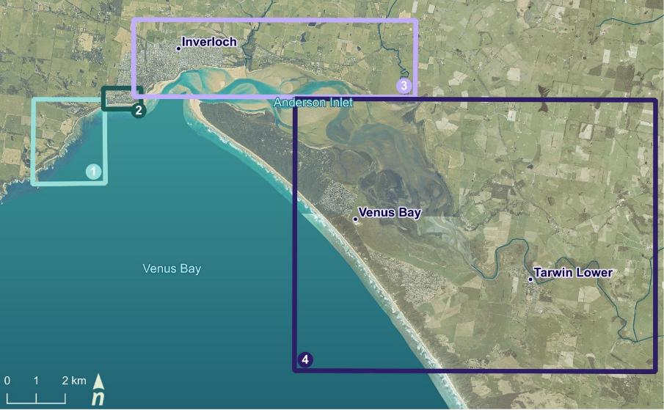
Figure 8. Location-specific management areas within the Cape to Cape region.

Adaptation pathways
Adaptation pathways have been used to examine and communicate a range of location-specific actions and make decisions on technical feasible and preferred pathways.

Detailed pathways used localised context established from a range of technical and strategic assessments, as well as findings from extensive stakeholder and community engagement.

Key elements on the detailed pathways include:
- Location specific
- Emerging risk profile by hazard type. This acts as a proxy time scale aligned with sea level rise. Running along the top of the pathways, actions and feasibility are aligned with this profile / time scale.
- Adaptation options and actions, in order that MAC policy hierarchy and aligned VRC guidance.
- Various activities and assessments required to enable / support action implementation
- Triggers to be used to determine a change in response or adaptation pathway.
- Action performance/efficacy in reducing risk, and how that might diminish over time (with changing risk, and reducing performance due to elapsed time / aging measures)

How to read adaptation pathways
 | Assess | Undertake further assessment of feasibility and/or design of action
 | Trigger | Point where a new decision must be made. Could include new information, updated projections or a threshold is reached.
 | Not feasible | Action is not feasible under current or emerging hazard risk.
 | Monitor and review | Points for monitoring, evaluation, review and update of the pathway.
 | Prepare | Lead time required to prepare for action implementation. Could include detailed design or approvals.
 | Implement | Implementation of action
 | No longer feasible | Actions may become unfeasible over time.
 | Performance / Efficacy | Action performance/ efficacy may change over time

High level, simplified pathways have also been used to convey preferred key actions and their timing at each locality.

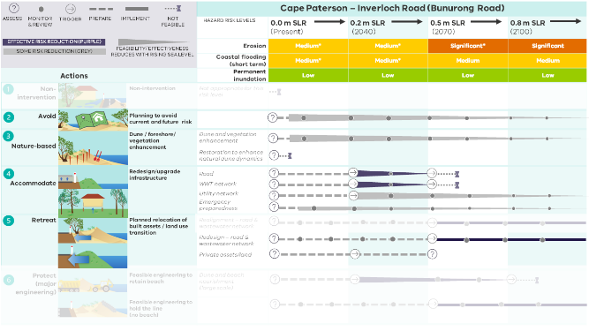
Action effectiveness / decision points and supporting assessments/activities.
Risk rating for each hazard type and planning horizon
Locality
Adaptation option and actions
Figure 9. Example detailed adaptation pathways, with core pathway elements labelled.

Cape Paterson-Inverloch Road (Bunurong Road)
This location focuses on Cape Paterson-Inverloch Road (part of the Bunurong Coastal Drive, sometimes called Bunurong Road) and its surrounding areas, extending from Eagles Nest, Flat Rocks to the west of Wreck Creek’s outlet.

Landscape and values
Cape Paterson-Inverloch Road is the primary thoroughfare connecting the Inverloch and Cape Paterson townships (Figure 10). The road is an important asset facilitating connection, tourism and recreation in the region. The road provides scenic views of the sandy coves, rock platforms and cliffs, and access to beaches and caves for visitors to explore. Many utilities and services also run along the road.
Values, uses and infrastructure in the area include:
- The Yallock-Bulluk Marine and Coastal Park.
- Unique geology and marine environments including reefs, cliffs, shore platforms and other coastal features.
- Sites of national geological significance, including dinosaur fossils and fossil excavation sites
- Geomorphologically and culturally important sites, including Eagles Nest and The Caves.
- Coastal vegetation including coastal banksia.
- Built infrastructure and facilities - roads and utilities infrastructure, including the waste water treatment plant and a major sewerage pipeline running along Cape Paterson-Inverloch Road.
- Rural private dwellings and the RACV Inverloch Resort.
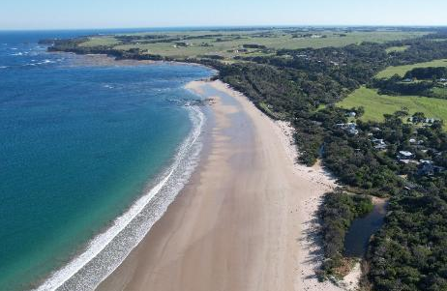
Wreck Creek and Bunurong Road, looking south west towards Eagles Nest. Source: Alluvium
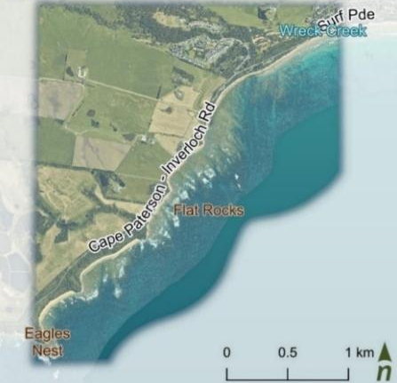
Figure 10. Cape Paterson-Inverloch Road (Bunurong Road).

Coastal hazard exposure and risk
The region will primarily be impacted by erosion and storm tide inundation, with exposure and risk likely to increase into the future (Table 25).
Some sections of the road are naturally more resilient to coastal hazards, on higher land or protected by harder cliffs and shore platforms. Undercutting and cliff collapse also pose risks in some higher cliffed areas.
Sections of the road located on lower elevations have lower resilience and are at risk from coastal erosion and inundation.
Present day hazard risk and management
Erosion and storm tide hazards currently impact a small section of road, at the eastern end of this location, near Bunurong Road and Surf Parade intersection. At times, temporary flooding events cut access along this section, impacting connectivity between Inverloch township and beaches, sites and properties only accessible by Bunurong Road.
Ongoing erosion events have triggered engineering responses including a wet sand fence (2019) and rock revetment (2022).
Table 25. Bunurong Road coastal hazard risk profile.
Cape Paterson-Inverloch Road (Bunurong Road)
SLR | 0.0 m | 0.2 m | 0.5 m | 0.8 m
 | Present | 2040 | 2070 | 2100
Erosion | Med* | Med | Sign* | Sign
Storm tide | Med* | Med* | Med | Med
Permanent inundation | Low | Low | Low | Low
*At some locations within the reporting area.
Future erosion hazards are expected to impact larger portions of Cape Paterson-Inverloch Road, impacting the thoroughfare to Cape Paterson and reducing access to public and private properties, assets and recreational opportunities in this area
Key assets and values increasingly at risk from erosion and temporary inundation include:
- Cape Paterson-Inverloch Road itself and the local access to public and private property, sites, places and tourist attractions
- Adjacent linear infrastructure networks (sewage, telecoms, electricity, water).
- A major sewage pipeline adjacent to Cape Paterson-Inverloch Road and critical access to wastewater treatment plant.
- Unique geological values and dinosaur fossils
- Surrounding environmental assets including coastal banksia woodlands, dune scrubs and grasslands and coastal heathland scrubs.
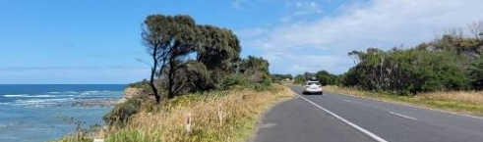
Bunurong Road, looking south west. Source: Alluvium.

Adaptation pathway and actions
The preferred pathway for Cape Paterson-Inverloch Road involves:
- Avoidance of risk through planning updates and development controls, with consideration of longer-term access
- Targeted dune and vegetation enhancement to improve the natural dynamics of the dune system, and provide hazard buffer
- Accommodation of risk through infrastructure (road, water and sewage network) upgrades to increase resilience
With 0.2 m sea level rise (by 2040) or as a trigger is reached, this pathway expands to include:
- Moving infrastructure and assets out of at-risk areas over time (planned transition) including redesign of road network to create local access only and loss of full coastal connection between Cape Paterson and Inverloch.
- Removal of existing coastal structures.
Other potential adaptation pathways considered for Cape Paterson-Inverloch Road (Bunurong Road) are summarised in Attachment B.
Key considerations for this pathway:
 | Retains sandy beach and natural amenity – good alignment with community values.
 | Requires planned transition mechanism/strategy development.
 | Maintains localised access to key assets and attractions.
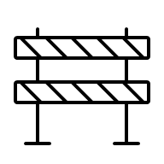 | No longer a full coastal route from Inverloch to Cape Paterson, but potential opportunity for cycling or walking trails in transition periods.
 | Adaptation approach must integrate works for road and wastewater networks.
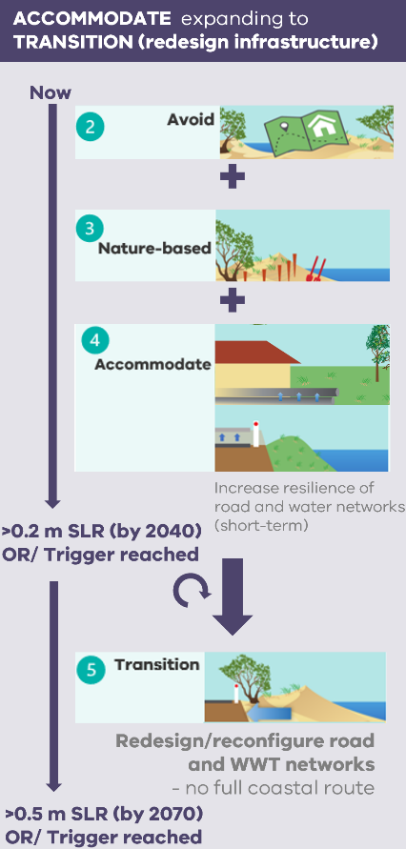
Figure 11. Bunurong Road adaptation pathway overview.
Further adaptation pathway detail including feasible actions, effectiveness and decision points is provided in Figure 12. Table 26 provides detailed actions associated with this pathway.

* at some locations
ACCOMMODATE expanding to TRANSITION (redesign of infrastructure networks)
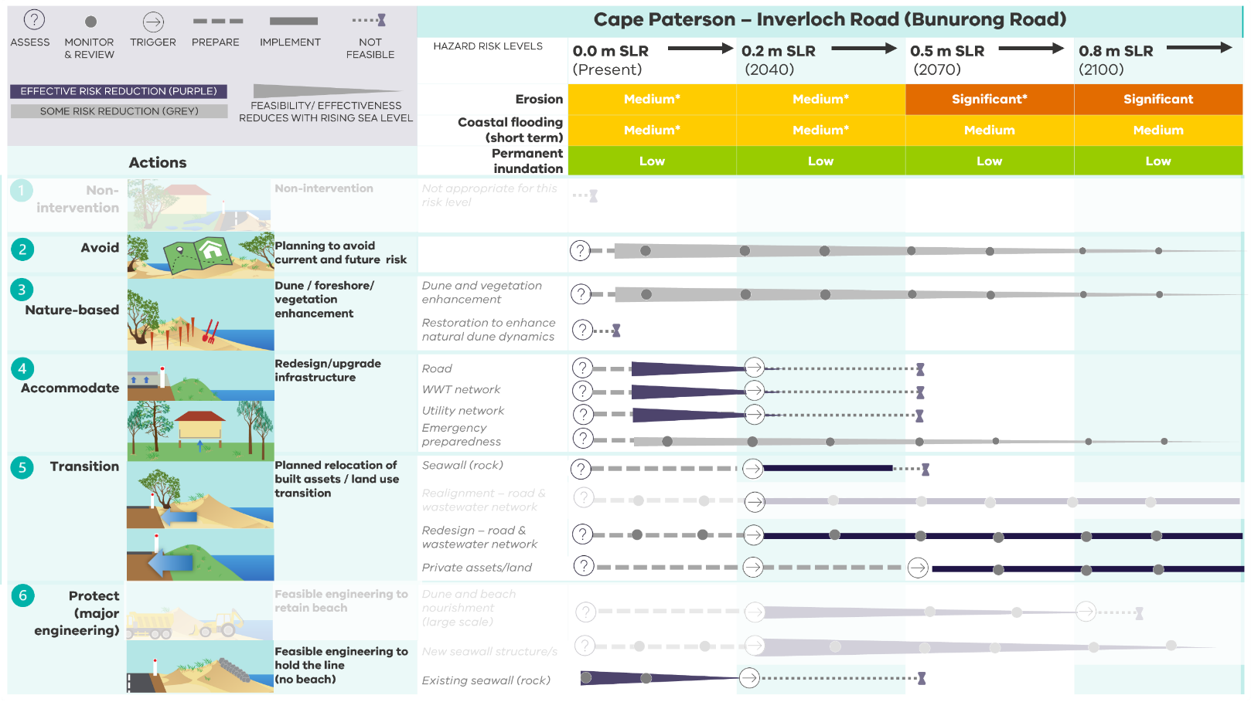
Actions also considered but not selected for the preferred pathway are shown as faded out.

Figure 12. Detailed adaptation pathway for Cape Paterson – Inverloch Road (Bunurong Road).
Table 26. Adaptation actions for Cape Paterson – Inverloch Road (Bunurong Road).
Cape Paterson – Inverloch Road (Bunurong Road) |  |  | 0.0 m SLR (Present) |  | 0.2 m SLR (2040) | 0.5 m SLR (2070) | 0.8 m SLR (2100)
  Trigger |  | Erosion | Medium* |  | Medium | Significant* | Significant
 |  | Storm tide | Medium* |  | Medium* | Medium | Medium
 |  | Permanent Inundation | Low |  | Low | Low | Low
Action commencement: |  |  | Priority actions next 5-10 years |  | Future actions
Adaptation actions
1. Non-intervention |  |  | Not appropriate for this risk level
2. Avoid |  |  | As per region-wide actions
 | Planning updates to avoid current and future risk | Land use planning | L1.2.1 Review, confirm and update planning provisions for land use within coastal hazard areas of the Cape Paterson – Inverloch Road locality (including controls, overlays, land zoning).
 | Planning updates to avoid current and future risk | Emergency management | L1.2.2 Update local emergency management planning for this locality based on updated coastal hazard maps.
3. Nature-based |  |  | As per region-wide actions
 | Dune/ foreshore and vegetation enhancement |  | L1.3.1 Minimise dune/foreshore disturbance, maintain vegetation, access controls/fencing.
 | Dune/ foreshore and vegetation enhancement |  | L1.3.2 Identify opportunities to aid and enhance vegetation and habitat connectivity and transition, including adjacent low-lying coastal wetland areas – adjacent to RACV Club, Wreck Creek.
 | Protection and  enhancement of cultural areas |  | L1.3.3 Using nature-based approaches, explore and implement ways to manage, recognise and protect cultural values and heritage sites along Cape Paterson-Inverloch Road.
4. Accommodate |  |  | As per region-wide actions
 | Redesign/ upgrade infrastructure | Utilities networks | L1.4.1 Review at risk infrastructure and embed hazard risk information into current asset management plans. |  | L1.4.7 Embed hazard risk information into new asset management plans. Linked to road/ infrastructure transition.
 | Redesign/ upgrade infrastructure | Road network | L1.4.2 Review at risk infrastructure and embed hazard risk information into current asset management plans.
 | Redesign/ upgrade infrastructure | Wastewater treatment plant and network | L1.4.3 Review at risk infrastructure and embed hazard risk information into current asset management plans.
 | Redesign/ upgrade infrastructure | Wastewater treatment plant and network | L1.4.4 Implement short/medium term WWTP and critical network to extend life of existing assets in current alignment |  | L1.4.8 End medium term asset management and commence TRANSITION pathway.
 | Build resilience | Private assets | L1.4.5 Advocate for/promote resilient homes within the community.
 | Build resilience | Private assets | L1.4.6 Advocate for/promote emergency preparedness within the community, especially Cape Paterson – Inverloch Road residents.
5. Transition |  |  | As per region-wide actions
 | Planned reconfiguration and / or relocation of built assets | Land use planning | L1.5.1 Collaborating with relevant local stakeholders, develop a planned transition approach for targeted areas (including triggers), aligning with the regional strategy for planned transition.
 | Planned reconfiguration and / or relocation of built assets | Utilities networks | L1.5.2 Review and update asset management plans to develop a planned transition response for at-risk critical utilities/infrastructure, including triggers, approvals, funding mechanisms. |  | L1.5.7 Commence TRANSITION. Implement planned transition for critical utilities/infrastructure.
 | Planned reconfiguration and / or relocation of built assets | Road network | L1.5.3 Review and update asset management plans to develop a TRANSITION (modifying road networks) approach for at-risk critical road infrastructure (Cape Paterson-Inverloch Rd). To be integrated with wastewater network reconfiguration, and to include triggers, detailed engineering design, land acquisition, asset decommissioning, approvals, funding mechanisms. |  | L1.5.8 Commence TRANSITION. Implement planned transition for at-risk critical road infrastructure (Cape Paterson-Inverloch Rd). To be integrated with wastewater network reconfiguration.
 | Planned reconfiguration and / or relocation of built assets | Road network | L1.5.4 Explore opportunities to repurpose decommissioned road asset as pedestrian / cycling route through road reclassification, surface treatment/rehabilitation and trail development as interim measure. |  | L1.5.9 Repurpose Cape Paterson-Inverloch Road as a pedestrian / cycling route as interim measure. Linked to road transition.
 | Planned reconfiguration and / or relocation of built assets | Wastewater treatment plant and network | L1.5.5 Review and update asset management plans to develop a TRANSITION (modifying utility networks) approach at-risk critical wastewater assets (for Cape Paterson-Inverloch Rd). To be integrated with road reconfiguration, and to include triggers, detailed engineering design, land acquisition, asset decommissioning, approvals, funding mechanisms. |  | L1.5.10 Commence TRANSITION. Implement planned transition for at-risk critical wastewater infrastructure. To be integrated with road reconfiguration.
 | Planned reconfiguration and / or relocation of built assets | Private assets | L1.5.6 Develop and communicate suitable procedures, communications and community assistance to support implementation of planned transition of public assets and implications for local users, including new routes/access arrangements.
6. Protect (major engineering) |  |  | As per region-wide actions
 | Management of existing engineered coastal structures | Rock revetment & wet sand fence | L1.6.1 Planned maintenance (short to medium term) of existing public coastal hazard protection structures, while transition approach developed. | L1.6.3 Planned transition of existing public coastal hazard protection structures, including rock seawall.
 | Management of existing engineered coastal structures | Rock revetment & wet sand fence | L1.6.2 Continue to monitor performance of wet sand fence and remove once it becomes ineffective at sand capture, and/or becomes a safety risk.

Inverloch Surf Beach
This location focuses on Inverloch Surf Beach and its surrounding areas, extending from west of Wreck Creek’s outlet to Point Norman.

Landscape and values
Inverloch Surf Beach sits to the south of the township, on Venus Bay’s open coast (Figure 13). Renowned for its natural amenities and coastal seascapes, the Surf Beach is a major tourist destination, drawing avid surfers and holidaymakers during peak summer seasons. It supports a range of recreational values such as such as swimming, surfing, boogie boarding, relaxing, walking and bird watching.
Values, uses and infrastructure in the area include:
- Ecological values including Wreck Creek, coastal dune vegetation and habitat for diverse fauna.
- Recreational opportunities and beach access.
- Archaeological and heritage sites including the Amazon 1863 shipwreck.
- Aboriginal values and archaeological places.
- The Inverloch Surf Life Saving Club and public safety services and recreation opportunities it provides.
- Residential dwellings.
- Roads and adjoining utilities, services and infrastructure, particularly along Surf Parade and including the sewage pumping station.
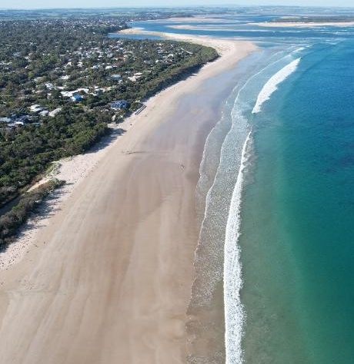
Inverloch Surf Beach, looking east towards Anderson Inlet. Source: Alluvium.
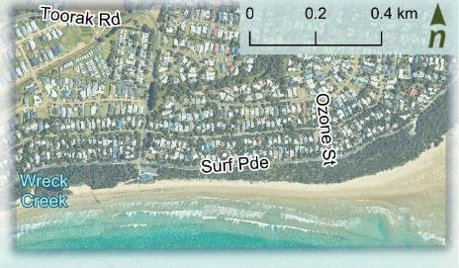
Figure 13. Inverloch Surf Beach.

Coastal hazard exposure and risk
The Surf Beach is exposed to high energy open ocean south-westerly and south-easterly swells originating from Bass Strait. Headlands and offshore bedrock help to dissipate some, but not all, oncoming wave energy.
This region will primarily be impacted by erosion and storm tide inundation. The combination of these hazards means exposure and risk are likely to increase significantly into the future (Table 27).
Present day hazard risk and management
From around 2012-2013, a series of cumulative storm events eroded much of the Surf Beach coastal reserve, narrowing the beach and pushing the dune further inland. Since then, actions have been taken to maintain beach access and protect the Surf Life Saving Club. These actions include beach and dune renourishment, wet sand fencing, and installing a formal geobag wall in front of the Surf Life Saving Club. Some drainage improvements have also been made at Wreck Creek.
The dune still provides a natural buffer against erosion, protecting nearby residences and infrastructure. A citizen science drone program regularly monitors the beach. While storm events continue to impact the area, these measures have helped manage some of the current hazard risks.
Table 27. Inverloch Surf Beach coastal hazard risk profile.
Inverloch Surf Beach
SLR | 0.0 m | 0.2 m | 0.5 m | 0.8 m
 | Present | 2040 | 2070 | 2100
Erosion | Med* | Med* | Sign* | High
Storm tide | Low | Med* | Med | Med
Permanent inundation | Low | Low | Low | Low
*At some locations within the reporting area.
With 0.5 m sea level rise, the erosion hazard extent is likely to expand inland to Surf Parade. This means likely impacts to public facilities such as the Surf Life Saving Club, private dwellings, services, infrastructure, vegetation, cultural assets and the natural dune buffer.
The area is also likely to be increasingly exposed to storm tide inundation in the future. During a storm tide event, the combined effect of increased coastal water levels and rainfall through Wreck Creek’s catchment will cause flooding across adjoining properties, pasture and infrastructure. Permanent inundation hazards are not likely to severely impact this area.
Key assets and values increasingly at risk from erosion and temporary inundation include:
- The Inverloch Surf Life Saving Club
- Surf Parade, including the road itself, residential properties and adjoining utility infrastructure (telecoms, sewage, water)
- Public recreational facilities including beach access, carparks, and access along the road
- Coastal dune vegetation and habitats
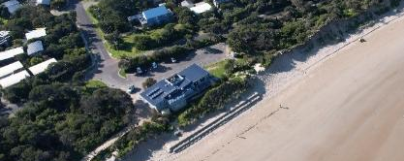
Inverloch Surf Life Saving Club

Adaptation pathway and actions
The pathway for Inverloch Surf Beach (Figure 14) involves:
- Avoidance of risk through planning updates and development controls.
- Dune enhancement and restoration to stabilise and improve natural dune dynamics, through dune maintenance, sand placement and vegetation management.
- Accommodation of coastal hazards through infrastructure modification (including Wreck Creek drainage controls) and resilient design.
With 0.2 m sea level rise (by 2040), or as a trigger is reached, the pathway expands to include:
- Protection through large scale beach nourishment and dune reconstruction
- Moving Inverloch SLSC out of an at-risk area over time (transition)
With 0.5 m sea level rise (by 2070), or as a trigger is reached, the pathway expands to include:
- Moving infrastructure and assets out of at-risk areas over time (transition) including Inverloch SLSC, Surf Parade and associated infrastructure and Surf Parade residents.
- Consideration of feasible engineering that combines nourishment with structures.
Other potential adaptation pathways for Inverloch Surf Beach are summarised in Attachment B.
Key considerations for this pathway:
 | Allows community to retain a sandy beach and natural amenity for as long as possible.
 | Requires transition mechanism/strategy development.
 | Allows natural processes and retains natural setting and appeal of the Surf Beach.
 | Less impacts on surrounding marine and coastal environments by not using large, engineered structures.
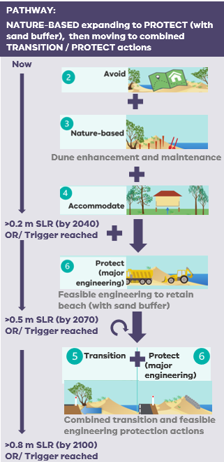
Figure 14. Inverloch Surf Beach adaptation pathway overview.
Further adaptation pathway detail including feasible actions, effectiveness and decision points is provided in Figure 15. Table 28 provides detailed actions associated with this pathway.
NATURE-BASED (dune restoration) expanding to PROTECT (with sand buffer), then moving to combined TRANSITION / PROTECT
* at some locations
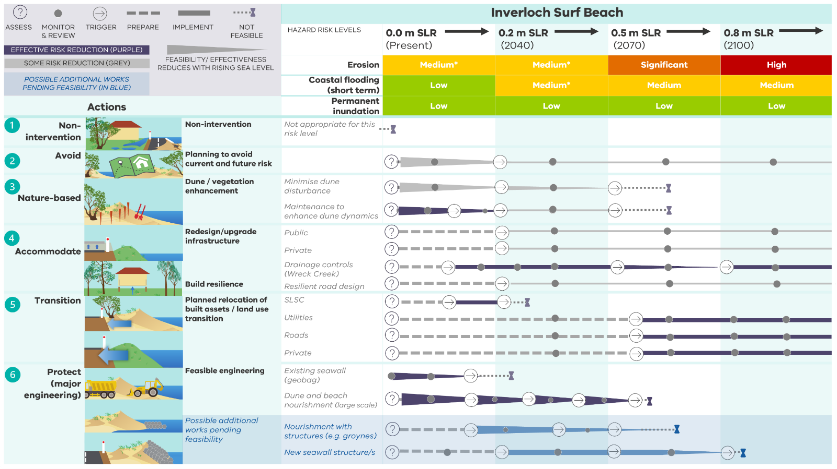
“Possible additional works pending feasibility” are shown in blue. These works will require further impact assessment and timing consideration (See Textbox 1)
Figure 15. Detailed adaptation pathway for Inverloch Surf Beach

Table 28. Adaptation actions for Inverloch Surf Beach.
Inverloch Surf Beach |  |  | 0.0 m SLR (Present) |  |  | 0.2 m SLR (2040) | 0.5 m SLR (2070) |  | 0.8 m SLR (2100)
Trigger |  | Erosion | Medium* |  |  | Medium* | Significant |  | High
 |  | Storm tide | Low |  |  | Medium* | Medium |  | Medium
 |  | Permanent Inundation | Low |  |  | Low | Low |  | Low
Action commencement: |  |  | Priority actions next 5-10 years |  |  | Future actions
Foundational actions
F3. Monitoring, evaluation and review |  |  | As per region-wide actions
 | Monitor and review changes in coastal hazard risk and effectiveness of adaptation |  | Review and update coastal hazard modelling and hazard extents, with updated survey in areas adjacent to Inverloch Surf Beach (including Wreck Creek). Use the results to inform and confirm future adaptation actions for Inverloch Surf Beach and Wreck Creek.
Adaptation actions
1. Non-intervention |  |  | Not appropriate for this risk level
2. Avoid |  |  | As per region-wide actions
 | Planning updates to avoid current and future risk | Land use planning | L2.2.1 Review, confirm and update planning provisions for land use within coastal hazard areas of the Inverloch Surf Beach locality (including controls, overlays, land zoning).
 | Planning updates to avoid current and future risk | Emergency management | L2.2.2 Update local emergency management planning for this locality based on updated coastal hazard maps.
3. Nature-based |  |  | As per region-wide actions
 | Dune and vegetation enhancement | Minimise dune disturbance | L2.3.1 Minimise dune disturbance, maintain vegetation, access controls/fencing.
 | Dune and vegetation enhancement | Minimise dune disturbance | L2.3.2 Identify opportunities to aid and enhance vegetation and habitat connectivity and transition, including adjacent low-lying coastal wetland areas - including Wreck Creek (Make space for nature).
 | Dune and vegetation enhancement | Dune maintenance | L2.3.3 Continue a NATURE BASED approach, including triggers, to maintain the dune system and its natural dynamics at Inverloch Surf Beach, through sand placement and vegetation management, with ongoing monitoring to review effectiveness.
 | Protection and enhancement of cultural areas |  | L2.3.4 Using nature-based approaches, in collaboration with Traditional Owner representatives, explore and implement ways to manage, recognise and protect cultural values and heritage sites.
4. Accommodate |  |  | As per region-wide actions
 | Redesign/ upgrade infrastructure | Utilities networks | L2.4.1 Review at risk infrastructure and embed hazard risk information into current asset management plans. |  |  |  | L2.4.7 End medium term asset management and commence TRANSITION pathway.
 | Redesign/ upgrade infrastructure | Utilities networks | L2.4.2 Review coastal trail/pathway and ensure alignment is situated as landward as possible and/or design is appropriate for siting in a hazard prone area.
 | Redesign/ upgrade infrastructure | Drainage control (Wreck Creek) | L2.4.3 Review and further examine the dynamics of Wreck Creek and its broader catchment, and implications with changing coastal hazard exposure.
 | Redesign/ upgrade infrastructure | Drainage control (Wreck Creek) | L2.4.4 Investigate drainage controls / concept options at Wreck Creek to manage increasing coastal hazards, considering interaction with other adaptation actions (including dune nourishment and road raising) and creek dynamics, and context of longer-term adaptation pathways.
 | Redesign/ upgrade infrastructure | Drainage control (Wreck Creek) | L2.4.5 Using drainage control investigation recommendations, implement feasible drainage control/s at Wreck Creek, incorporating ongoing maintenance and monitoring.
 | Build resilience | Private assets | L2.4.6 Advocate/promote resilient homes within the community. Development and building controls to support resilient design and inhibit inappropriate development
5. Transition |  |  | As per region-wide actions
 | Planned relocation of built assets | Land use planning | L2.5.1 Collaborating with relevant local stakeholders, develop a planned transition approach for targeted areas (including triggers), aligning with the regional strategy for planned transition.
 | Planned relocation of built assets | Surf Life Saving Club | L2.5.2 Develop a planned TRANSITION response for the Inverloch SLSC and its services, including triggers, approvals, funding mechanisms. |  | L2.5.7 Commence TRANSITION. Implement planned transition for surf life saving club.
 | Planned relocation of built assets | Utilities | L2.5.3 Review and update asset management plans to develop a planned TRANSITION response for at-risk critical utilities/infrastructure, including triggers, approvals, funding mechanisms |  |  |  |  | L2.5.8 Commence TRANSITION. Implement planned transition for critical utilities/infrastructure.
5. Transition (continued)
 | Planned relocation of built assets | Road network | L2.5.4 Review and update asset management plans to develop a planned TRANSITION response for at-risk critical road infrastructure (including Surf Parade and Cape Paterson-Inverloch Rd), including triggers, approvals, funding mechanisms. |  |  |  |  | L2.5.9 Commence TRANSITION. Implement planned transition for at-risk critical road infrastructure (including Surf Parade and Cape Paterson-Inverloch Rd).
 | Planned relocation of built assets | Private assets | L2.5.5 Apply regional context for planned transition and develop a tailored approach for planned transition of private land and assets at Surf Pde and Lohr Ave. |  |  |  |  | L2.5.10 Commence TRANSITION. Implement planned transition for at risk properties.
 | Planned relocation of built assets | Private assets | L2.5.6 Develop and use tailored communications and community assistance to support implementation of planned transition of private land and assets.
6. Protect (major engineering) |  |  | As per region-wide actions
 | Feasible engineering | Inverloch Surf Beach | L2.6.1 Develop PROTECT (with sand buffer) approach at Inverloch Surf Beach, with large-scale nourishment and dune reconstruction. To include triggers, detailed engineering design, approvals, funding mechanisms.
 | Feasible engineering | Inverloch Surf Beach | L2.6.2 Commence PROTECT (with sand buffer) with large-scale nourishment and dune reconstruction. |  |  |  | L2.6.7 End PROTECT (with sand buffer) pathway.
 | Feasible engineering | Inverloch Surf Beach | L2.6.3 Monitor and review effectiveness of nourishment in reducing risk.
 | Feasible engineering | Inverloch Surf Beach | L2.6.4 Review additional feasibility of supporting engineering actions at Inverloch Surf Beach (See Textbox 1).
 | Management of existing engineered coastal structures | Geobag wall at Inverloch Surf Life Saving Club | L2.6.5 Planned maintenance/updates (short to medium term) of existing public coastal hazard protection structures, including sand bag wall, while smaller scale renourishment and dune enhancement is underway and transition approach developed. | L2.6.6 Planned transition of existing public coastal hazard protection structures, including sand bag wall.

Textbox 1. Engineering at Inverloch Surf Beach

The detailed adaptation pathway and actions for Inverloch Surf Beach brings together a range of actions across different themes - planning and design, nature-based and engineering.
Figure 16 provides an outline of the recent and future engineering adaptation actions for Inverloch Surf Beach (to 2050). These form a sub-set of the broader adaptation actions outlined in Table 28.
Some engineering actions play a major role in directly reducing hazard risks, such as dune construction or structures.
Others are essential supporting actions that help inform and advance these engineering efforts, including further assessments, modelling, design, and monitoring.
It's important to understand the potential physical changes that engineering actions may bring to the beach and surrounding areas, and how these changes might impact community values when determining the feasibility of engineering actions.
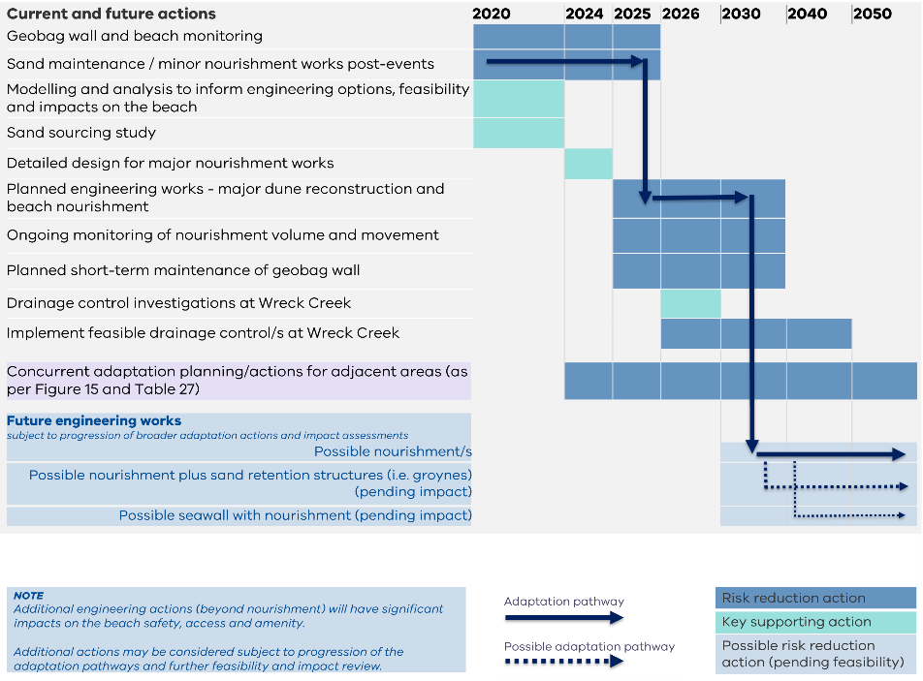
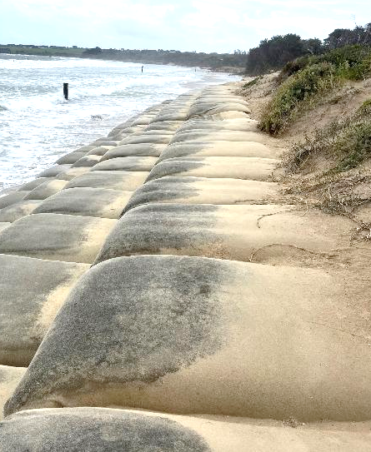
Geobag seawall, Inverloch Surf Beach. Source: Alluvium
Subject to future funding

Figure 16. Engineering adaptation actions at Inverloch Surf Beach (out to 2050).

Inverloch township (within Anderson Inlet)

This location focuses on the Inverloch township inside the inlet, extends from Point Norman at the mouth of Anderson Inlet (Ozone Street) to Pound Creek, including inland surroundings (Figure 17).

Landscape and values
The Inverloch township is situated within Anderson Inlet, Victoria’s largest open barrier estuary, and is home to pristine beaches and breathtaking coastal vistas. The area is valued for varied recreational beach and water activities.
The landscape setting across the Inlet varies and encompasses sand beaches, engineered coasts, mangrove and saltmarsh communities.
Values, uses and infrastructure include:
- Extensive vegetation communities including mangroves, saltmarsh, swamp scrub and coastal heathlands.
- Creek and lagoon habitats, including Ayr Creek, Screw Creek and Pound Creek.
- Recreational facilities including Inverloch and Mahers Landing boat ramps, fishing platforms coastal reserves, and accompanying paths, trails, playgrounds, toilets, and picnic facilities.
- Roads (Ramsay Boulevard, the Esplanade, east end of Surf Parade), adjacent services, and utility infrastructure including stormwater, electricity, water, and telecommunications.
- Private and public buildings and property including caravan parks.
- Recreational clubs and facilities including the Bowling Club, Angling Club, and Yacht Club.

Anderson Inlet
Anderson Inlet is one of Victoria’s largest open barrier estuaries and supports a diversity of ecological and geomorphological values. The Inlet is dynamic, influenced by a combination of wave and riverine processes.
The mouth of Anderson Inlet is a high energy environment as it is situated at the confluence of open-coast and estuarine processes, with interacting ebb and flood tide currents. Within the Inlet riverine processes dominate over open-coast swells.
Sediment transport within the Inlet is primarily driven by a complex network of tidal currents working to redistribute sand around the Inverloch and Point Smythe coastline.

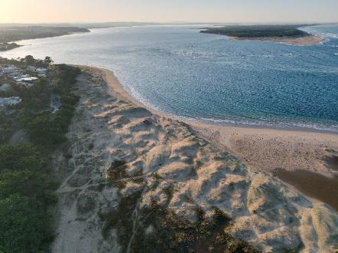
Ayr Creek lagoon (foreground), Point Smythe (top right) and the entrance to Anderson Inlet. Source: Alluvium.

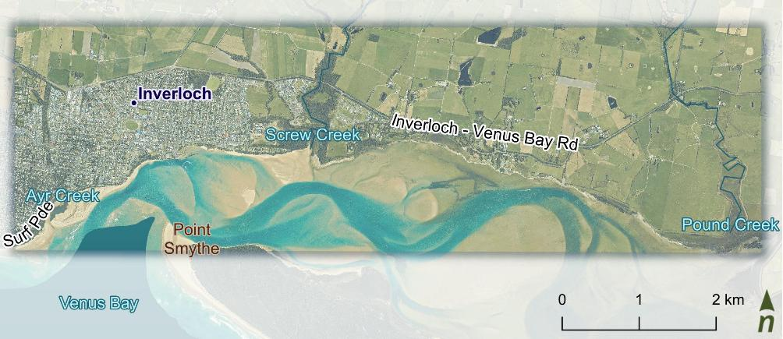
Figure 17. Inverloch townships, inside Anderson Inlet.

Coastal hazard exposure and risk
This region will primarily be impacted by storm tide and permanent inundation, with small areas of the foreshore also likely to be impacted by erosion (Table 29). Channel migration will likely drive some erosion inside the inlet.
Present day hazard risk and management
Sections of the foreshore have been modified by coastal protection structures to reduce public safety risks associated with dune erosion and protect recreational public assets.
The region around the Inverloch boat ramp and Lija Lookout have experienced the greatest modifications to date with revetments and seawalls. Temporary rock bags were also installed along the dog beach in 2022.
Table 29. Inverloch township coastal hazard risk profile.
Inverloch – Inside the Inlet
SLR | 0.0 m | 0.2 m | 0.5 m | 0.8 m
 | Present | 2040 | 2070 | 2100
Erosion | Med* | Med* | Med* | Sign
Storm tide | Low | Med* | Med | Med
Permanent inundation | Low | Med* | Med* | Sign*
*At some locations within the reporting area.

Given the diverse environments and history of coastal change and management across this area, key coastal hazard risks, adaptation pathways and actions are presented for three areas:

Natural areas within Anderson Inlet (including creeks)  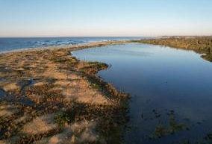  Ayr Creek lagoon | Small areas between the Anderson Inlet entrance and the Glade are exposed to storm tide inundation, particularly:  - the Ayr Creek Lagoon  - adjoining private properties  - road infrastructure (the Esplanade), access and services.  While present day erosion hazards are relatively low, with 0.8 m SLR (by 2100), these assets will also be at increasing risk of erosion. Storm tide inundation generally presents a low risk to many natural areas of coastal reserve, including saltmarsh and mangrove communities, so long as these ecosystems have space to migrate. Permanent inundation presents a low risk and is only expected to fill the lagoon.
Holiday Park  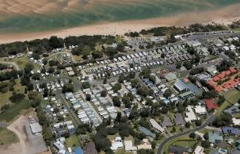  Inverloch Holiday Parks.  Source: Water Technology | The foreshore extending between the Inverloch Holiday Park to Screw Creek and Pound Creek is currently at risk of storm tide inundation and is increasingly at risk of flooding from storm tide and permanent inundation hazards in the future. Assets that increasingly at risk from inundation include:  - Low-lying residential areas around the estuarine swamp scrub and wetland area, including Screw Creek  - Roads (the Esplanade), adjoining infrastructure and utilities  - Foreshore camping areas (including the Holiday Park) and its facilities.  Increasing inundation may also impact sensitive and significant ecological and cultural assets within the region, including shore-bird habitats and habitat corridor passageways. With 0.8 m SLR (by 2100), erosion hazards will increase into adjacent foreshore facilities, the Angling Club and roads.
Pymble Avenue picnic and barbecue area/ dog beach  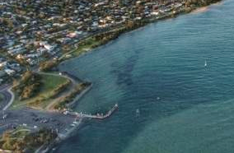  Inverloch Boat ramp and dog beach | The coastal reserve and landscape surrounding Inverloch Boat Ramp is currently and will increasingly be exposed to both storm tide inundation and erosion hazards. Storm tide inundation is likely to impact on:  - Recreational picnic and barbeque facilities  - The South Gippsland Yacht Club and Inverloch Bowling Club  - Parking facilities  - The Esplanade and adjoining utilities (electricity, water, gas, telecoms).  Foreshore assets across the dog beach area fronting Pymble Avenue are increasingly at risk from erosion and inundation. This includes public utilities along The Esplanade such as sewage pump stations, water mains, electricity and telecommunications. With 0.5 m SLR (by 2070), private properties and road will be at increasing risk of erosion. Permanent inundation hazards present low risk to this area, its environment, infrastructure or services.

Adaptation pathways and actions
Adaptation pathways for the three areas are presented below. Further adaptation pathway detail including feasible actions, effectiveness and decision points is provided in Figure 12. Table 26 provides detailed actions associated with these pathways.
Natural areas within Anderson Inlet (including creeks) | Holiday Parks / foreshore camping | Pymble Avenue picnic and barbecue area / dog beach
The pathway (Figure 18) involves:  - Avoiding risk through planning updates and development controls  - Nature-based vegetation migration and land use transition  As a trigger is reached, this pathway expands to include:  - Moving built assets out of at-risk areas over time (transition) to make space for nature. | The pathway (Figure 19) involves:  - Avoiding risk through planning updates  - Small-scale, nature-based foreshore, dune and vegetation enhancement  - Accommodation of coastal hazards through infrastructure upgrades and changes to road and water networks to increase resilience (short term).  With 0.5 m sea level rise, by 2070, or as a trigger is reached, the pathway expands to include:  - Moving built assets including the holiday park out of at-risk areas over time (transition) | The pathway (Figure 20) involves:  - Avoiding risk through planning updates  - Small-scale, nature-based foreshore, dune and vegetation enhancement to create a vegetated buffer  - Accommodation of coastal hazards through infrastructure upgrades and changes to built assets / networks to increase resilience (short term).  With 0.2 m sea level rise, by 2040, or as a trigger is reached, the pathway expands to include:  - Moving built assets including picnic shelters, BBQs and temporary rock bag wall out of at-risk areas (transition)  With 0.5 m sea level rise, by 2070, or as a trigger is reached, the pathway expands to include:  - Moving built assets including built assets (houses/infrastructure) along the Esplanade out of at-risk areas over time (transition)
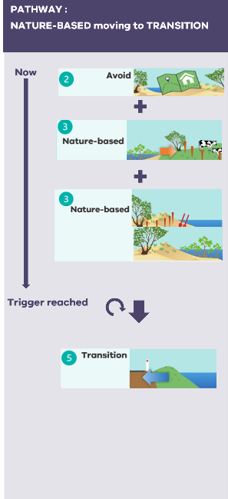  Figure 18. Anderson Inlet (natural areas) adaptation pathway overview. | 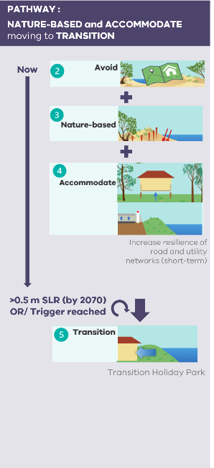  Figure 19. Holiday Parks / foreshore camping adaptation pathway overview. | 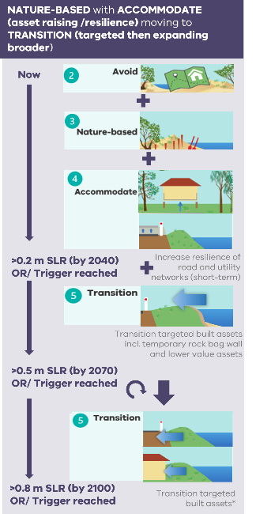  Figure 20. Pymble Avenue area adaptation pathway overview.

PATHWAY: Combination of actions - NATURE-BASED and ACCOMMODATE actions locality wide, moving to TRANSITION at Holiday Park and Pymble Ave/Dog Beach
* at some locations
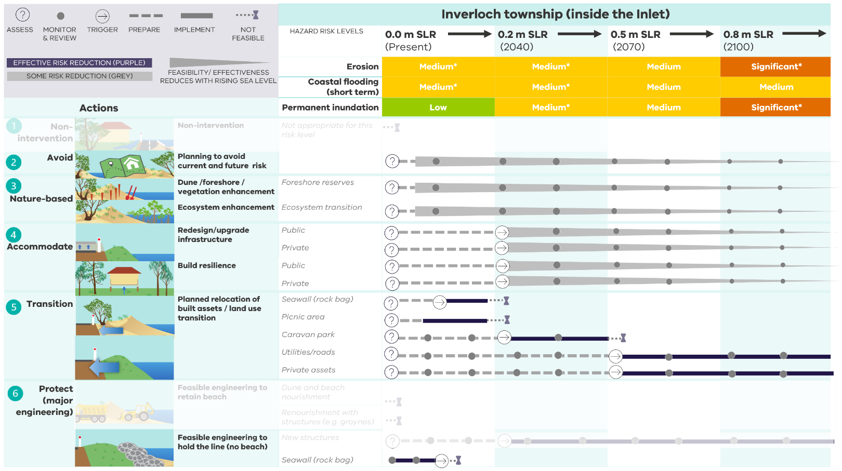
Actions also considered but not selected for the preferred pathway are shown as faded out.
Figure 21. Detailed adaptation pathway for Inverloch township (inside the Inlet).

Table 30. Adaptation actions for Inverloch Township (inside the Inlet).
Inverloch Township – Inside the inlet |  |  | 0.0 m SLR (Present) | 0.2 m SLR (2040) | 0.5 m SLR (2070) | 0.8 m SLR (2100)
Trigger |  | Erosion | Medium* | Medium* | Medium | Significant*
 |  | Storm tide | Medium* | Medium* | Medium | Medium
 |  | Permanent Inundation | Low | Medium* | Medium | Significant*
Action commencement: |  |  | Priority actions next 5-10 years | Future actions
Foundational actions
F3. Monitoring, evaluation and review |  |  | As per region-wide actions
 | Monitor and review changes in coastal hazard risk and effectiveness of adaptation |  | Review and update coastal hazard modelling and hazard extents, with updated survey in areas of Inverloch township (including Broadbeach Estate). Use the results to inform and confirm future adaptation actions for Inverloch township.
Adaptation actions
1. Non-intervention |  |  | Not appropriate for this risk level
2. Avoid |  |  | As per region-wide actions
 | Planning updates to avoid current and future risk | Land use planning | L3.2.1 Review, confirm and update planning provisions for land use within coastal hazard areas of the Inverloch Township locality (including controls, overlays, land zoning).
 | Planning updates to avoid current and future risk | Emergency management | L3.2.2 Update local emergency management planning for this locality based on updated coastal hazard maps.
3. Nature-based |  |  | As per region-wide actions
 | Foreshore and vegetation enhancement |  | L3.3.1 Establish a continuous vegetation buffer at Pymble Avenue picnic area foreshore and Holiday Park, minimising foreshore disturbance through defined, formalised access points, access controls and fencing.
 | Foreshore and vegetation enhancement |  | L3.3.2 Identify opportunities to aid and enhance vegetation and habitat connectivity and transition, including adjacent low-lying coastal wetland areas - including Ayr, Screw and Pound creeks (Make space for nature).
 | Ecosystem enhancement |  | L3.3.3 Minimise disturbance to sensitive foreshore, dune and vegetation areas inside Anderson Inlet.
 | Ecosystem enhancement |  | L3.3.4 Develop and facilitate saltmarsh and mangrove protection and enhancement program on Anderson Inlet foreshore.
 | Ecosystem enhancement |  | L3.3.5 Develop a plan for the long-term transition of inundation prone agricultural areas around Anderson Inlet to wetland ecosystem services.
 | Ecosystem enhancement |  | L3.3.6 Commence NATURE-BASED actions. Implement activities to aid and enhance vegetation and habitat connectivity and transition, including adjacent low-lying estuary areas (Make space for nature).
 | Protection and enhancement of cultural areas |  | L3.3.7 Using nature-based approaches, in collaboration with Traditional Owner representatives, explore and implement ways to manage, recognise and protect cultural values and heritage sites with Anderson Inlet and surrounding catchments.
4. Accommodate |  |  | As per region-wide actions
 | Redesign/ upgrade infrastructure | Road network | L.3.4.1 Review and update asset management plans to develop a planned ACCOMMODATE response for inundation prone critical infrastructure, including triggers, approvals, funding mechanisms. | L3.4.7 Commence ACCOMODATE. Implement planned upgrades for at risk road infrastructure. | L3.4.10 End ACCOMMODATE and commence TRANSITION pathway for at risk road infrastructure.
 | Redesign/ upgrade infrastructure | Utilities networks | L3.4.2 Review and update asset management plans to develop a planned ACCOMMODATE response for inundation prone critical infrastructure (including drainage), including triggers, approvals, funding mechanisms. | L3.4.8 Commence ACCOMODATE. Implement planned upgrades for at risk utilities infrastructure. | L3.4.11 End ACCOMMODATE and commence TRANSITION pathway for at risk utilities infrastructure.
 | Redesign/ upgrade infrastructure | Facilities | L3.4.3 Review and update asset management plans to develop a planned ACCOMMODATE response for inundation prone facilities (including boat ramp), including triggers, approvals, funding mechanisms. | L3.4.9 Commence ACCOMODATE. Implement planned upgrades for at risk facilities. | L3.4.12 End ACCOMMODATE and commence TRANSITION pathway for at risk facilities.
 | Build resilience | Private assets | L3.4.4 Advocate/promote resilient design for Holiday Park / foreshore camping built assets, including demountable/relocatable structures.
 | Build resilience | Private assets | L3.4.5 Advocate/promote resilient homes within the community, particularly for houses in lower lying areas.
 | Build resilience | Private assets | L3.4.6 Enhance community adaptive capacity to coastal hazards, including awareness of increasing coastal hazard exposure and risk (particularly inundation) and ways to improve individual preparedness and adaptive capacity.
5. Transition |  |  | As per region-wide actions
 | Planned relocation of assets | Land use planning | L3.5.1 Collaborating with relevant local stakeholders, develop a planned transition approach for targeted areas (including triggers), aligning with the regional strategy for planned transition.
 | Planned relocation of assets | Coastal structures | L3.5.2 Develop a planned TRANSITION response for the temporary rock bag seawall and timber retaining/seawall.
 | Planned relocation of assets | Coastal structures | L3.5.3 Commence TRANSITION. Implement planned transition for at risk asset.
 | Planned relocation of assets | Facilities | L3.5.4 Develop a planned TRANSITION response for Pymble Avenue picnic area and its facilities. To include site rehabilitation and enhancement linked to L3.3.1.
 | Planned relocation of assets | Facilities | L3.5.5 Commence TRANSITION for Pymble Avenue picnic area and its facilities.
5. Transition (continued) |  |  | As per region-wide actions
 | Planned relocation of assets | Facilities | L3.5.6 Develop a planned TRANSITION response for Holiday Park / foreshore camping and its services, including triggers, approvals, funding mechanisms. | L3.5.11 Commence TRANSITION. Implement planned transition for at risk assets (Holiday Park/ foreshore camping).
 | Planned relocation of assets | Roads | L3.5.7 Review and update asset management plans to develop a planned TRANSITION response for at-risk critical road infrastructure (including The Esplanade and Pymble Avenue), including triggers, approvals, funding mechanisms. |  | L3.5.12 Commence TRANSITION Implement planned transition for at-risk road infrastructure (incl. The Esplanade, Pymble Ave).
 | Planned relocation of assets | Utilities | L3.5.8 Review and update asset management plans to develop a planned TRANSITION response for at-risk critical utilities/infrastructure, including triggers, approvals, funding mechanisms. |  | L3.5.13 Commence TRANSITION. Implement planned transition for critical utilities/infrastructure.
 | Planned relocation of assets | Private assets | L3.5.9 Apply regional context for planned transition and develop a tailored approach for planned transition for inundation and erosion prone private assets (built and land). |  | L3.5.14 Commence TRANSITION. Implement planned transition for at risk properties (land). Linked to land use transition of agricultural areas (NATURE-BASED).
 |  |  |  |  | L3.5.15 Commence TRANSITION. Implement planned transition for at risk properties (built).
 | Planned relocation of assets | Private assets | L3.5.10 Develop and use tailored communications and community assistance to support implementation of planned transition of private land and assets.
6. Protect (major engineering) |  |  | As per region-wide actions
 | Feasible engineering to hold the line (no beach) | Pymble Avenue picnic area / Inverloch dog beach | L3.6.1 Planned maintenance (short term) of existing public coastal hazard protection structures, including rock bag wall and timber retaining/seawall, while long term approach developed.
 | Feasible engineering to hold the line (no beach) | Pymble Avenue picnic area / Inverloch dog beach | L3.6.2 End temporary PROTECT of rock bag structure and timber retaining/seawall at Pymble Avenue picnic area / Inverloch dog beach and commence TRANSITION pathway for area.

Venus Bay and Tarwin Lower

Landscape and values
Tarwin Lower and Venus Bay are located east of the Inverloch township, in South Gippsland Shire (Figure 22). The Tarwin Lower community is situated on the low-lying southern banks of the Tarwin River. The Venus Bay township has two main communities and is located across a large dune barrier system between Anderson Inlet and the open coast of Venus Bay. The dune barrier extends north west to Point Smythe.
Values, uses and infrastructure in the area include:
- Natural and rugged beauty
- Mosaic of coastal vegetation including coastal scrubs grasslands and woodlands, mangroves, salt marsh, swamp scrubs and herb-rich woodlands, and vegetated dunes.
- Large dune barrier system that provides natural hazard resilience and sustains a wide range of cultural, environmental and recreational values.
- Freshwater, estuarine and coastal habitats including Cape Liptrap Coastal Park which provides important nesting and feeding areas for the hooded plover, red-necked stints and sanderling.
- Recreational values including fishing, camping and boating facilities and the surf life saving club.
- Infrastructure and facilities - roads, utilities and infrastructure networks, including Inverloch – Venus Bay Road (the primary thoroughfare into Venus Bay) and major sewage pipeline along Walkerville Road.
- Groundwater bores throughout Venus Bay
- Rural and village properties including farm infrastructure and pasture.
- Ecosystem benefits linked to community-led conservation efforts.
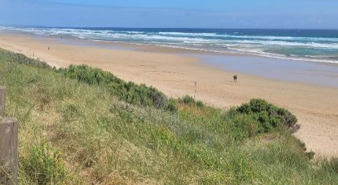
No. 1 Beach, Venus Bay. Source: Alluvium
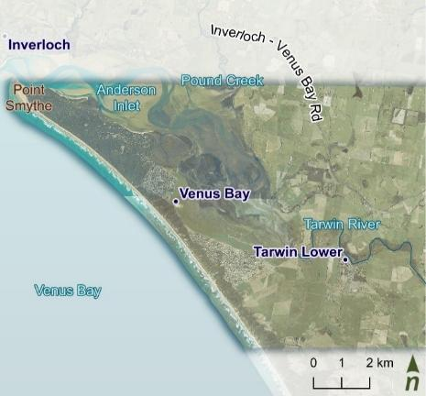
Figure 22. Venus Bay and Tarwin Lower.

Coastal hazard exposure and risk
This area is primarily exposed to storm tide and permanent inundation hazards, with exposure and risk likely to increase into the future (Table 31). Erosion is likely to impact beaches and dunes along the open coast of Venus Bay and small areas of the coastline within the Inlet. However, the large dune system buffers some hazards.
Present day hazard risk and management
Areas of the Tarwin Lower township and Inverloch – Venus Bay Road around the Tarwin River are already impacted by storm tide and catchment flooding events. These events have flooded sections of the road, causing major disruptions and ceasing access along the primary thoroughfare into and between Tarwin Lower and Venus Bay. Farmland and estuarine vegetation is also inundated in storm tide and catchment flood events.
Table 31. Venus Bay and Tarwin Lower coastal hazard risk profile.
Venus Bay and Tarwin Lower
SLR | 0.0 m | 0.2 m | 0.5 m | 0.8 m
 | Present | 2040 | 2070 | 2100
Erosion | Low | Low | Med | Med
Storm tide | Med | Med | Sign | Sign
Permanent inundation | Med | Med | Sign | Sign
*At some locations within the reporting area.
Much of the farmland and saltmarsh surrounding Anderson Inlet is likely to be more regularly or permanently inundated. Some estuarine vegetation communities have capacity to naturally migrate inland. However, physical barriers such as levees and roads can limit this migration.
Assets at increasing risk from temporary and permanent inundation with 0.5 m SLR (from 2070) include:
- Agricultural areas and farm infrastructure surrounding Anderson Inlet
- Environmental assets including freshwater, coastal and estuarine ecosystems, conservation areas and parks
- Parts of the Tarwin Lower township including public and private properties
- Public utilities and infrastructure networks including large sections of Inverloch-Venus Bay Road and a sewage pipeline along Walkerville Road.
Beach access and parking areas are also at risk from erosion along the open coast of Venus Bay.
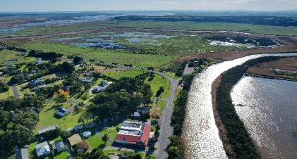
Tarwin Lower and the Tarwin River looking north west to Anderson Inlet and Venus Bay. Source: Alluvium

Adaptation pathway and actions
The preferred pathway for Venus Bay and Tarwin Lower (Figure 23) involves:
- Avoidance of risk through planning updates and development controls, considering access requirements.
- Nature-based vegetation migration and land use transition to make space for nature
- Nature-based dune / vegetation enhancement
- Accommodation of coastal hazards through infrastructure updates/changes (road and water networks) and resilient design
With 0.2 m sea level rise, by 2040, or as a trigger is reached, the pathway expands to include:
- Redesign of some road network (transition) to maintain Tarwin Lower north/east access.
- Major engineering to protect some lengths of the road, from Tarwin Lower to Venus Bay
Further studies, including impacts of levees on catchment flooding, will inform an alternative route and/or options for a levee or raised road.
Other potential adaptation pathways for Venus Bay and Tarwin Lower are summarised in Attachment B.
Key considerations for this pathway:
 | Allows natural migration of important coastal and estuarine ecosystems.
 | Requires further planning for road network and options for raising/protecting the road.
 | Maintains access to coastal communities.
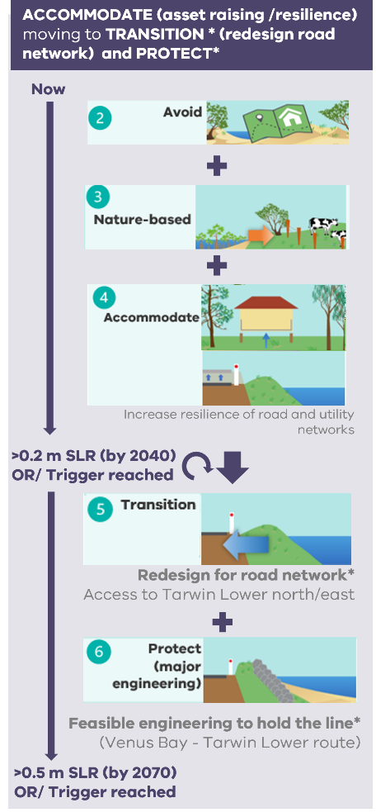
Figure 23. Venus Bay and Tarwin Lower adaptation pathway overview.
Further adaptation pathway detail including feasible actions, effectiveness and decision points is provided in Table 32 provides detailed actions associated with this pathway.

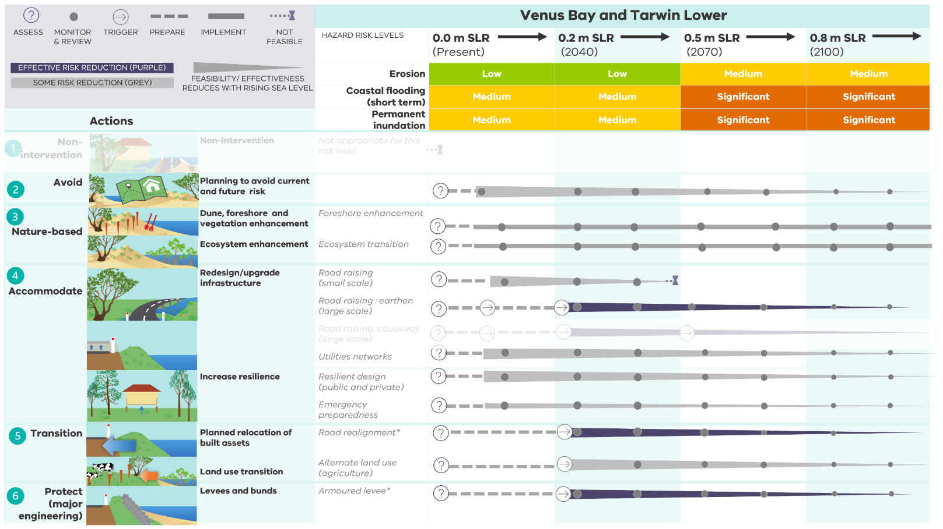
PATHWAY: ACCOMMODATE (asset raising /resilience) expanding to TRANSITION* (redesign road network) and PROTECT*. Includes NATURE-BASED ecosystem enhancement and land use transition.
Actions also considered but not selected for the preferred pathway are shown as faded out.
* at some locations
Figure 24. Detailed adaptation pathway for Venus Bay and Tarwin Lower.
Table 32. Adaptation actions for Venus Bay and Tarwin Lower.
Tarwin Lower / Venus Bay |  |  | 0.0 m SLR (Present) | 0.2 m SLR (2040) | 0.5 m SLR (2070) | 0.8 m SLR (2100)
Trigger |  | Erosion | Low | Low | Medium | Medium
 |  | Storm tide | Medium | Medium | Significant | Significant
 |  | Permanent Inundation | Medium | Medium | Significant | Significant
Action commencement: |  |  | Priority actions next 5-10 years | Future actions
Adaptation actions
1. Non-intervention |  |  | Not appropriate for this risk level
2. Avoid |  |  | As per region-wide actions
 | Planning updates to avoid current and future risk | Land use planning | L4.2.1 Review, confirm and update planning provisions for land use within coastal hazard areas of the Venus Bay and Tarwin Lower locality (including controls, overlays, land zoning).
 | Planning updates to avoid current and future risk | Land use planning | L4.2.2 Review growth areas and future development approvals and conditions for undeveloped land within coastal hazard areas of the Venus Bay and Tarwin Lower locality. Linked to R2.1.4 and R2.1.5.
 | Planning updates to avoid current and future risk | Emergency management | L4.2.3 Update local emergency management planning for this locality based on updated coastal hazard maps.
3. Nature-based |  |  | As per region-wide actions
 | Ecosystem enhancement |  | L4.3.1 Minimise disturbance to sensitive foreshore, dune and vegetation areas inside Anderson Inlet.
 | Ecosystem enhancement |  | L4.3.2 Develop and facilitate saltmarsh and mangrove protection and enhancement program on Anderson Inlet foreshore.
 | Ecosystem enhancement |  | L4.3.3 Continue and expand the dune protection and maintenance at Venus Bay Beach, including minimising disturbance to sensitive areas.
 | Ecosystem enhancement |  | L4.3.4 Develop a plan for the long-term transition of inundation prone agricultural areas around Anderson Inlet to wetland ecosystem services.
 | Ecosystem enhancement |  | L4.3.5 Commence NATURE-BASED actions. Implement activities to aid and enhance vegetation and habitat connectivity and transition, including adjacent low-lying estuary areas (Make space for nature).
 | Protection and enhancement of cultural areas |  | L.4.3.6 Using nature-based approaches, in collaboration with Traditional Owner representatives, explore and implement ways to manage, recognise and protect cultural values and heritage sites with Anderson Inlet and surrounding catchments.
4. Accommodate |  |  | As per region-wide actions
 | Redesign/ upgrade infrastructure | Road network | L4.4.1 Review and update asset management plans to develop a planned ACCOMMODATE response (small scale) for inundation prone sections of Inverloch-Venus Bay Road, including triggers, approvals, funding mechanisms. | L4.4.7 End small scale ACCOMMODATE at Inverloch-Venus Bay Road (north of Tarwin Lower) and commence TRANSITION pathway for road network.
 |  |  |  | L4.4.8 End small scale ACCOMMODATE at Inverloch-Venus Bay Road (between Venus Bay and Tarwin Lower) and commence PROTECT pathway for road network.
 | Redesign/ upgrade infrastructure | Road network | L4.4.2 Commence ACCOMMODATE. Implement planned smaller scale upgrades for at risk road infrastructure.
 | Redesign/ upgrade infrastructure | Road network | L4.4.3 Monitor and review effectiveness of smaller scale upgrades in reducing risk to reliable and safe access.
 | Redesign/ upgrade infrastructure | Utilities networks | L4.4.4 Review and update asset management plans to develop a planned ACCOMMODATE response for inundation prone critical infrastructure (including telecommunication, electricity), including triggers, approvals, funding mechanisms. | L4.4.9 Commence ACCOMMODATE. Implement planned upgrades for at risk infrastructure.
 | Build resilience | Private assets | L4.4.5 Advocate/promote resilient homes within the community, particularly for houses in lower lying areas
 | Build resilience | Private assets | L4.4.6 Enhance community adaptive capacity to coastal hazards, including awareness of increasing coastal hazard exposure and risk (particularly inundation) and ways to improve individual preparedness and adaptive capacity.
5. Transition |  |  | As per region-wide actions
 | Planned relocation of assets | Land use planning | L4.5.1 Collaborating with relevant local stakeholders, develop a planned transition approach for targeted areas (including triggers), aligning with the regional strategy for planned transition.
 | Planned relocation of public assets | Road network and access | L4.5.2 Review and update asset management plans to develop a planned TRANSITION* for Inverloch-Venus Bay Road (north of Tarwin Lower), to redesign road network, including triggers, approvals, funding mechanisms. | L4.5.6 Commence TRANSITION* for Inverloch-Venus Bay Road (between Venus Bay and Tarwin Lower) to redesign road network.
 | Planned relocation of public assets | Road network and access | L4.5.3 Develop and use tailored communications and community assistance to support implementation of planned transition of public land and assets.
 | Planned relocation of private assets | Private assets | L4.5.4 Apply regional context for planned transition and develop a tailored approach for planned transition for inundation prone private assets (built and land). | L4.5.7 Commence TRANSITION. Implement planned transition for at risk properties (land). Linked to land use transition of agricultural areas (NATURE-BASED).
 |  |  |  |  | L4.5.8 Commence TRANSITION. Implement planned transition for at risk properties (built).
 | Planned relocation of private assets | Private assets | L4.5.4 Develop and use tailored communications and community assistance to support implementation of planned transition of private land and assets.
6. Protect (major engineering) |  |  | As per region-wide actions
 | Feasible engineering to protect access road | Road network and access | L4.6.1 Undertake additional flooding assessment on Anderson Inlet and lower reaches of Tarwin River, to determine levees placement and design impacts on catchment hydrology and dynamics, and implications with changing coastal hazard exposure. Use the results to inform and confirm future adaptation actions for Tarwin Lower and Venus Bay.
 | Feasible engineering to protect access road | Road network and access | L4.6.2 Develop PROTECT (raised road and armoured levee)* approach for Inverloch-Venus Bay Road (between Venus Bay and Tarwin Lower), with an engineered armoured levee along access route/s. To include triggers, detailed engineering design, approvals, funding mechanisms and staging of works. | L4.6.3 Commence PROTECT (raised road and armoured levee) *for Inverloch-Venus Bay Road (between Venus Bay and Tarwin Lower).
 |  |  |  | L4.6.4 Monitor and review effectiveness of structure/s and design in reducing risk.

Implementation and next steps

Implementation
The Cape to Cape Resilience Plan will be implemented through a range of mechanisms including:
- An effective Monitoring, Evaluation, Reporting and Improvement (MERI) approach, to enable adaptive management and ensure continual learning and improvement.
- Embedding outcomes and actions from the Resilience Plan into existing processes and activities of each RaSP agency, such as asset management programs, planning processes, policies and legislation.
- Implementing new initiatives from the Resilience Plan.
- Collaborating and coordinating with RaSP members on action delivery.
- Collaborating with State Government and advocating for collaborative delivery of actions and policy to support action delivery.
- Collaborating with Cape to Cape community members on action delivery.

Wave patterns at Inverloch Surf Beach. Source: Alluvium.

Relevant information from the Resilience Plan and key findings from the assessments of the Cape to Cape Resilience Project process should also inform internal process and future projects of RaSP member agencies.
Detailed decisions about the implementation and timing of actions will be made in line with the normal government policy and budget processes.

Reporting, roles and responsibilities
Implementing the plan is a shared responsibility among RaSP members, other stakeholders and the community. Each RaSP member organisation will have specific actions to deliver as part of the plan.
Defining roles and responsibilities for action implementation is important to foster accountability and ensure the right people are involved.
An Implementation Plan has been developed in collaboration with the RaSP agencies. Outlining the operational application of the Resilience Plan, it provides detail on the responsible, delivery and supporting partners for each action.

 | Responsible partners  (Leading role)
These partners take a leading role in action implementation and are responsible and accountable for action delivery. This includes embedding actions in their organisations’ internal policies, procedures and strategies. These partners are critical to action success.
 | Delivery partners  (Active role)
These partners take an active role in delivering actions and will collaborate with the responsible partners to deliver part of or the whole action. These partners are also important in ensuring action success.
 | Supporting partners  (Interest role)
These partners have an interest in action delivery and may contribute to the delivery of some actions as needed. These partners and their roles may become more apparent during implementation.

Further implementation details will be developed by individual agencies and/or targeted working groups, to guide the delivery of actions within the Resilience Plan.
This includes additional detail on:
 | Timeframes for actions
 | Costing for priority 5 – 10 year actions
 | Instruments, plans and processes (existing, modified, new) required to deliver adaptation pathways and actions
 | Potential funding sources
 | Monitoring and evaluation
 | Barriers to implementation and change management actions
 | Partnership opportunities with stakeholders.

Monitoring, Evaluation, Reporting and Improvement (MERI) approach
Various Foundational actions of the Resilience Plan are aimed at supporting the MERI process, including the implementation of the Foundational actions (F3: Monitoring, evaluation and review).
DEECA will assume overarching responsibility for monitoring, evaluation, reporting and improvement of the Resilience Plan. This includes reporting on progress of the actions and implementation of the Plan. Annual reporting is included as Action F3.3.
- An effective Monitoring, Evaluation, Reporting and Improvement (MERI) approach will be developed to support Resilience Plan implementation. This aligns with best practice adaptation planning.
- This MERI approach (plan) includes identifying:
  - action alignment/links with defined values and objectives for the Cape to Cape region
  - performance indicators and the necessary baseline data to measure and track progress
  - roles and responsibilities for delivery of the MERI activities, including mechanisms via which required changes/improvements can be made
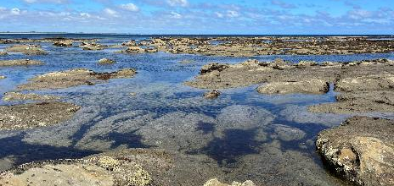
Flat Rocks, Inverloch. Source: Alluvium.

Monitoring
A tailored monitoring program will support adaptation and implementation of the Resilience Plan.
In addition to the actions that monitor physical coastal changes, monitoring can also include:
- changes in condition of values
- changes in vulnerability and risk exposure
- level of partner agency and stakeholder engagement and buy-in
- funds expended
- actions implemented
- benefits and co-benefits delivered.
Further detail on monitoring plan implementation will be developed through overarching MERI arrangements and within RaSP member organisation MERI procedures.

Evaluation
Evaluation of monitoring data collected is important to assess Plan implementation including:
- Impact – the measurable effect of the Plan in achieving its outcomes
- Effectiveness – how well the Plan has delivered its actions
- Appropriateness – the degree to which the Plan meets the needs of the community and reflects the obligations of RaSP members in coastal hazard adaptation
- Efficiency – the extent to which the Plan can demonstrate improvements over time including value for money
- Legacy – the extent to which the impacts of the Plan will continue over time
Key evaluation questions under these themes can be developed as part of the MERI framework. Evaluation metrics are integrated into action implementation through Action F3.4.

Improvement and review
The Resilience Plan is intended to be regularly reviewed (every 5 years). The review will consider (but is not limited to):
Success of implementation to date:
- Integration into RaSP agencies and stakeholder plans and processes.
- Delivery of on-ground activities, in line with nominated adaptation pathways.
- Community perspectives on adaptation effectiveness and its alignment with values.
- Reduction in coastal hazard risk.
- Strengthened coastal resilience.
Triggers for review / update of Resilience Plan:
- Any relevant changes in the policy environment (e.g. sea level rise predictions, approach to defining coastal hazard areas).
- Updated technical information that may be available.
- Any relevant new development and landscape changes in the region.
- Any rapid environmental change imposing limitations on current preferred adaptation pathways, or changes to hazard risk.
- Any relevant changes in community attitudes and risk tolerance.
- Any significant changes to managing agencies and other stakeholders, and their responsibilities and/or abilities to implement the Resilience Plan.
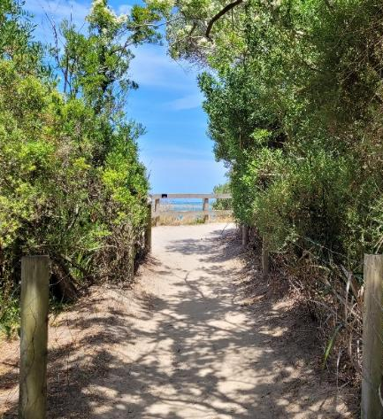
Inverloch Foreshore beach access. Source: Alluvium.

Next steps
This Resilience Plan represents the start of an ongoing process of planned adaptation over time.
Adaptation pathways will be continually informed by stakeholder and community input and ideas, new knowledge and monitoring the effectiveness of actions.

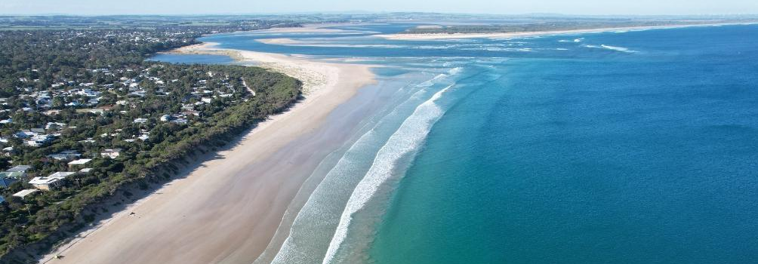
Inverloch Surf Beach and Anderson Inlet Entrance. Source: Alluvium.

References
Alluvium 2021a. Cape to Cape Resilience Project Engagement Plan, Victoria, March 2021
Alluvium 2021b. Cape to Cape Resilience Project Community Values Study – Engagement Report -Values and Experiences, Victoria, October 2021
Alluvium 2022a. Cape to Cape Resilience Project - Asset and Values Risk and Vulnerability Assessment, May 2022.
Alluvium 2022b. Cape to Cape Resilience Project Adaptation Options - Engagement Report - Adaptation Engagement Outcomes, Victoria, May 2022
Alluvium 2022c. Cape to Cape Resilience Project – Adaptation Framework Summary Paper, Victoria, June 2022.
BLCAC 2021. Bunurong Land Council Aboriginal Corporation Cultural Values Assessment: Cape to Cape Project, Victoria, December 2021.
DEECA 2023. Victoria’s Resilient Coast framework and guidelines. Guideline document developed through Victoria’s Resilient Coast – Adapting or 2100+ program by the Department of Energy, Environment and Climate Action 2023.
DELWP 2021. Inverloch Regional and Strategic Partnership Project Plan, Victoria, March 2021. Document developed by the Department of Environment, Land, Water and Planning 2012.
Natural Capital Economics & Alluvium, 2022. Cape to Cape Resilience Project – Economics Assessment, June 2022.
Natural Capital Economics & Alluvium, 2023. Cape to Cape Resilience Project – Economic Case Studies, 2023.
Rosengren, N. & Miner, T., 2021. Inverloch Region Coastal Hazard Assessment – Coastal Geomorphology, Appendix A in Water Technology 2022c, Inverloch Region Coastal Hazard Assessment Report 3: Technical Methodology, Victoria, 2021.
Water Technology 2022a. Inverloch Region Coastal Hazard Assessment – Report 1 – Project Summary Report, Victoria, June 2022.
Water Technology 2022b. Inverloch Region Coastal Hazard Assessment - Report 2 - Data Assimilation and Gap Analysis, Victoria, June 2022.
Water Technology 2022c. Inverloch Region Coastal Hazard Assessment - Report 3 - Technical Methodology, Victoria, June 2022.
Water Technology 2022d. Inverloch Region Coastal Hazard Assessment - Report 4 - Coastal Processes and Erosion Hazards, Victoria, June 2022.
Water Technology 2022e. Inverloch Region Coastal Hazard Assessment - Report 5 - Inundation Hazards, Victoria, June 2022.
Water Technology 2022f. Inverloch Region Coastal Hazard Assessment - Report 6 - Coastal Hazard Asset Exposure Assessment, Victoria, June 2022.
Water Technology 2022g. Inverloch Region Coastal Hazard Assessment - Report 7 - Adaptation Assessment, Victoria June 2022.
WGCMA, 2014. West Gippsland Waterway Strategy 2014-2022: Part D – Work Program, West Gippsland Catchment Management Authority, access at https://www.wgcma.vic.gov.au/wp-content/uploads/2015/01/WaterStrategy2014-2022-web-pt4.pdf

Glossary of terms
Coastal hazard terminology
AEP | Annual Exceedance Probability – on average, the probability of an event occurring in any given year. A higher AEP means it is more likely the event will occur in any one year. The 10%, 5% and 1% AEPs have been modelled for the following sea level rise scenarios and indicative time periods (planning horizons): 0.0 m SLR (present), 0.2 m SLR (2040), 0.5 m SLR (2070), 0.8 m SLR (2100), 1.1 m and 1.4 m SLR (2100 sensitivity scenarios).
Coastal erosion | The process of winds, waves and coastal currents shifting sediment away from a localised area of the shoreline. For the Cape to Cape Resilience Project, coastal erosion is estimated based on short term (storm event) erosion and long term erosion from both historic change and future changes due to sea level rise.
Coastal hazards | Natural coastal processes that may negatively impact on the marine and coastal environment, including impacts on human use, values, property or infrastructure. Hazards include coastal erosion and inundation (flooding) due to storm tide and sea level rise.
Event | Where weather conditions affecting a specific place are notably different from typical, day-to-day conditions normally experienced at that location (e.g. a storm event). Coastal storm events are driven by a wide variety of natural processes, combining meteorology (weather) such as wind, rainfall and temperature, and oceanography (conditions of the sea) such as tides, currents, and waves. An event might include high winds, high tides and/or rainfall leading to high catchment (river) flow and can cause inundation (flooding) and/or erosion. Events vary in magnitude (size) and duration (time). They may last from hours up to several days.
MHWS | Mean High Water Springs - the highest water level reached by spring tides, under average meteorological conditions.
Permanent inundation | Regular inundation from tides, increasing with sea level rise.
Planning horizon | A planning horizon is an indicative timeframe by which a projected sea level rise scenario is anticipated to occur. While each sea level rise projection has been linked to a time period, the stated time is indicative and may need to be revised as more localised sea level projections are developed and/or updated. For example, Victoria’s policy setting requires planning for not less than 0.8 m sea level rise by 2100, however, recent global estimates suggest a 1.1 m to 1.4 m sea level rise could be expected by 2100.
SLR | Sea Level Rise - An increase in the mean level of the ocean. Relative sea level rise occurs where there is a local increase in the ocean level relative to the land, which might be due to ocean rise and/or land subsidence.
Storm tide inundation | Inundation resulting from storm activity, combining storm surge and the predicted tide height. For the Cape to Cape Resilience Project, storm tide inundation modelling also includes a rainfall (catchment and urban) component contributing to flooding. This combined scenario is referred to as temporary inundation for this assessment.
Coastal hazard adaptation terminology
Adaptation | The process of adjustment to actual or expected disturbances such as coastal hazards. In human systems, adaptation seeks to proactively manage or avoid harm or make use of beneficial opportunities. Some natural systems may benefit from human intervention in helping to facilitate these adjustment process.
Coastal adaptation | Future modification of behaviour through a change in coastal land management, land-use or infrastructure, that reduces or prevents adverse impacts associated with coastal hazards.
Coastal vulnerability | The susceptibility of people and places along the coast to adverse impacts from coastal hazards. Includes the degree of exposure, and ability to cope with, respond to and adapt to coastal hazards.
Coastal hazard adaptation terminology (continued)
Risk assessment | A systematic process of evaluating the potential risks (likelihood and consequence) of coastal hazards, helping to inform a response and adaptation actions.
Likelihood | Likelihood of exposure to coastal hazards is determined by the probability (chance) of an event occurring. For this assessment, we have various scenarios from more frequent to rarer events, and multiple sea level rise scenarios as well as different catchment flows. Likelihood can be expressed as annual exceedance probability (AEP).
Consequence | The consequence (impact/outcome) of a value or use being exposed to coastal hazard/s are tailored based on local stakeholder and community feedback and informed by the Cultural and Community Values studies. Consequence ratings can also vary for hazard types (erosion and inundation) and consider short and long term impacts.
Resilience | The capacity of social, economic, and environmental systems to cope with a hazardous event, trend, or disturbance, responding or reorganising in ways that maintain their essential function, identity, and structure, while also maintaining capacity for adaptation, learning, and transformation
Transition | A planned / managed process to transition land use in areas that are (or will be) at risk from hazards. This includes moving or decommissioning existing structures and assets, such as houses and roads, before they are impacted by hazards. This may also include opportunities for new land uses appropriate for the hazard zone (e.g. recreational uses and assets) that enhance economic, social and environmental values. Transition is likely to be a gradual process over time and mitigating hazards for a period is part of the transition process. A range of adaptation actions will be part of transition processes. Also known as planned/managed retreat.
Community engagement terminology
Community | A group of individuals who share a common sense of belonging and where there is a level of trust between members:  - Geographic – based around where people live, such as neighbourhood, suburb, town, or region  - Interest – based around common interests such as conservation, community connection and improvement or recreation interest  - Identity – based on sharing a common identity such as age, culture, or lifestyle  The Cape to Cape community encompasses everyone who lives, works, visits, or cares for the region.
Community engagement | Refers to the planned and unplanned ways we (DEECA and consultants) interact and relate to our project partners, stakeholders and communities. Community engagement is undertaken across many parts of the project to achieve a range of outcomes, including capturing of values and aspirations; participation in decisions, actions, or outcomes; building and maintaining relationships; and increasing community capacity for planning, action and learning.
Community values | For the Community Values Study, a value is something that is important and meaningful to someone. A coastal value exists when an aspect of the coast is significant (of value) to a stakeholder. This can include cultural, environmental, social and/or economic aspects.
Registered Aboriginal Parties (RAP) | Body corporates approved to deal with Aboriginal heritage matters on behalf of the relevant Traditional Owners within the RAP area. The members of the body corporate are Traditional Owners. Registered Aboriginal Parties for the entire study area have not been determined by the Aboriginal Heritage Council. Bunurong Land Council is the Registered Aboriginal Party for parts of the Cape to Cape coastal and estuarine areas.
Stakeholders | Described as any individual, group of individuals, organisation, or political entity with an interest or stake in the outcome of a decision.
Traditional Owners | People with traditional and customary rights in a particular part of the land. Some Aboriginal Traditional Owner groups have also had these rights recognised by the Australian legal system under a Native Title determination (Commonwealth) or a Traditional Owner Settlement Agreement (Victoria).
Other agencies and acronyms
RaSP | Regional and Strategic Partnerships (RaSP) are a tool under the Marine and Coastal Act 2018. RaSPs bring stakeholders together on regionally significant issues. The Inverloch RaSP is the first created under the new Act, gazetted on 6 August 2020. The RaSP brings together Traditional Owners and nine agencies. They each have a role in managing coastal and foreshore values, assets and infrastructure around Inverloch and in the study area.
CFA | Country Fire Authority
DEECA | Department of Energy, Environment and Climate Action (formerly Department of Environment, Land, Water and Planning – DELWP)
BLCAC | Bunurong Land Council Aboriginal Corporation
BCSC | Bass Coast Shire Council
DTP | Department of Transport and Planning (formerly Department of Transport – DoT)
GLaWAC | Gunaikurnai Land and Waters Aboriginal Corporation
GP | Gippsland Ports
HV | Heritage Victoria (an agency within DTP)
IPCC | Intergovernmental Panel on Climate Change
PV | Parks Victoria
SES | State Emergency Service
SGSC | South Gippsland Shire Council
SGW | South Gippsland Water
VCMP | Victorian Coastal Monitoring Program
VMaCC | Victorian Marine and Coastal Council
WGCMA | West Gippsland Catchment Management Authority
Further definitions of terms relevant to coastal hazard adaptation and the Cape to Cape Resilience Project can be found on the Cape to Cape Resilience Project website:
marineandcoasts.vic.gov.au/coastal-programs/cape-to-cape-resilience-project

Attachment A: Stages and outputs of the Cape to Cape Resilience Project
Victoria’s Resilient Coast – Adapting for 2100+ framework | Purpose | Key questions | Cape to Cape Resilience Project key deliverables | Timeline | Document citation | Additional products
STAGE 1  Scoping and preparation | Provide a foundation for adaptation planning aligned to best practice guidance. | - Do we need action?  - Who is involved?  - Where’s the study area?  - What is our study scope? | Project plan | Mar-21 | DELWP 2021, Inverloch Regional and Strategic Partnership Project Plan, Victoria, March 2021. | Website establishment and content. DELWP & Alluvium. May 2021.
STAGE 1  Scoping and preparation |  |  | Engagement plan | Mar – Jul-21 | Alluvium 2021, Cape to Cape Resilience Project Engagement Plan, Victoria, March 2021. | Project Update 1 - Introducing the Cape to Cape Resilience Project. DELWP & Alluvium. May 2021
 |  |  |  |  |  | Fact Sheet 1 - Project scene setting, introducing the RaSP. DELWP & Alluvium. May 2021.
 |  |  |  |  |  | Project Update 2 - Data gathering, gap analysis, engagement commencement. DELWP & Alluvium. July 2021.
 |  |  |  |  |  | Fact Sheet 2 - Coastal adaptation and hazards technical terminology. DELWP & Alluvium. July 2021.
STAGE 2  Values, vision and objectives | Ensure adaptation planning is underpinned by regional and place-based values. | - What do we value?  - As a region and as a State?  - What do we want the future to look like? | Community values study | Oct-21 | Alluvium 2021, Cape to Cape Resilience Project Community Values Study - Engagement Report - Values and Experiences, Victoria, October 2021. | Engage Victoria online survey 1 & on-site drop in sessions - Community values and perspectives
STAGE 2  Values, vision and objectives |  |  | Cultural values assessment | Dec-21 | Bunurong Land Council Aboriginal Corporation 2021, BLCAC Cultural Values Assessment: Cape to Cape Project, Victoria, December 2021.
STAGE 3  Coastal hazard exposure | Assess coastal hazard exposure, including scenarios that enable best practice approaches to assessing current and emerging risk. | - What processes are occurring and how might these change? | Inverloch region coastal hazard assessment | Jun-21 – Mar-22 | Water Technology 2022, Inverloch Region Coastal Hazard Assessment - Report 1 - Project Summary Report, Victoria, June 2022. | Fact Sheet 3 - Understanding coastal landscape context, processes and hazards. DELWP & Alluvium. October 2021.
 |  |  |  |  | Water Technology 2022, Inverloch Region Coastal Hazard Assessment - Report 2 - Data Assimilation and Gap Analysis, Victoria, June 2022. | Fact Sheet 4 - Understanding coastal hazard modelling. DELWP & Alluvium. October 2021.
 |  |  |  |  | Water Technology 2022, Inverloch Region Coastal Hazard Assessment - Report 3 - Technical Methodology, Victoria, June 2022. | Project Update 3 - Technical work (LiDAR, models, Assessment work), engagement update. DELWP & Alluvium. November 2021.
 |  |  |  |  | Rosengren, N. & Miner, T., 2021, Inverloch Region Coastal Hazard Assessment – Coastal Geomorphology, Appendix A in Water Technology 2022c, Inverloch Region Coastal Hazard Assessment Report 3: Technical Methodology, Victoria, 2021. | Geomorphology Technical Note. DELWP. April 2022.
 |  |  |  |  | Water Technology 2022, Inverloch Region Coastal Hazard Assessment - Report 4 - Coastal Processes and Erosion Hazards, Victoria, June 2022. | Summary Report - CHA Coastal Processes Report Summary. DELWP. October 2022
 |  |  |  |  | Water Technology 2022, Inverloch Region Coastal Hazard Assessment - Report 5 - Inundation Hazards, Victoria, June 2022. | Summary Report – CHA Inundation Report Summary. DELWP. October 2022
STAGE 4  Vulnerability and risk | Explore place-based coastal hazard vulnerability and risk, to enable strategic consideration of adaptation needs/priorities. | - How might these processes impact what we value? | Coastal hazard asset exposure assessment | Apr – May-22 | Water Technology 2022, Inverloch Region Coastal Hazard Assessment - Report 6 - Coastal Hazard Asset Exposure Assessment, Victoria, June 2022. | Project Update 4 - Technical work update (hazard mapping, values, economics), engagement update. DELWP & Alluvium. April 2022.  Erosion, storm tide and permanent inundation hazard maps (region, Inverloch, Venus Bay and Tarwin Lower). Water Technology & DELWP. September 2022.  Hazard Map Information Sheet. Alluvium & DELWP. September 2022.  Video – Coastal Hazard Assessment. Water Technology. April 2022
STAGE 4  Vulnerability and risk |  | - How might these processes impact what we value? | Coastal hazard risk and vulnerability assessment | Apr – May-22 | Alluvium 2022, Cape to Cape Resilience Project - Asset and Values Risk and Vulnerability Assessment, May 2022. | Fact Sheet 5 – Vulnerability and Risk. DELWP & Alluvium. April 2022  Summary Report – Risk and Vulnerability Report Summary. DELWP. October 2022
STAGE 4  Vulnerability and risk |  | - How might these processes impact what we value? | Economic base case | Apr – May-22 | Natural Capital Economics & Alluvium, 2022, Cape to Cape Resilience Project – Economics Assessment, June 2022.
STAGE 5  Adaptation actions and pathways | identify, assess, consult on and decide which adaptation options and actions are the most appropriate for managing the current and future coastal hazard risks in the study area.  This includes a diversity of integrated actions across land management, planning and design, nature based and engineering themes. | - How can we manage and adapt to these impacts? | Adaptation options and preferences | May – Aug-22 | Alluvium 2022, Cape to Cape Resilience Project Adaptation Options - Engagement Report - Adaptation Engagement Outcomes, Victoria, May 2022 | Fact Sheet 6 – Coastal Adaptation. DELWP & Alluvium. April 2022  Engage Victoria online survey 2 – Adaptation actions  Project Update 5 – Community engagement: adaptation actions survey outcomes. DELWP & Alluvium. July 2022  Video – A strategic approach to adaptation. Alluvium. April 2022.
STAGE 5  Adaptation actions and pathways |  | - How can we manage and adapt to these impacts? | Adaptation framework summary paper | May – Aug-22 | Alluvium 2022, Cape to Cape Resilience Project – Adaptation Framework Summary Paper, Victoria, June 2022. | Fact Sheet 7 – Adaptation Actions. DELWP & Alluvium. April 2022
STAGE 5  Adaptation actions and pathways |  | - How can we manage and adapt to these impacts? | Adaptation feasibility modelling | May – Aug-22 | Water Technology 2022, Inverloch Region Coastal Hazard Assessment - Report 7 - Adaptation Assessment, Victoria June 2022 | Summary Report – Adaptation Action Technical Assessment Report Summary. DELWP. October 2022  Photo montages (various) of engineering adaptation actions. Water Technology. March 2023.
STAGE 5  Adaptation actions and pathways |  | - How can we manage and adapt to these impacts? | Economic assessment & cost benefit analysis | May – Aug-22 | Natural Capital Economics & Alluvium, 2022, Cape to Cape Resilience Project – Economics Assessment, June 2022.  Natural Capital Economics & Alluvium, 2023, Cape to Cape Resilience Project – Economic Case Studies, 2023.
STAGE 6  Plan and implement | Confirm the plan of action for coastal hazard risk management and adaptation and commence implementation.  This includes priority actions in the adaptation pathways, shared roles and responsibilities, triggers for review and resources/ requirements. | - Which options are feasible and suitable, both now and in the future?  - How can we plan our response strategically? | Cape to Cape Resilience Plan | Sep-22 – Jun-23 | DEECA 2023, Cape to Cape Resilience Plan, prepared by Alluvium and DEECA - June 2023 | Project Update 6 – Stage 1 recap (summary reports) and Stage 2 launch, engagement update. DELWP & Alluvium. October 2022  Engage Victoria online survey 3 & on-site pop-up and drop in sessions – Adaptation actions and planning  Project Update 7 – Adaptation actions and engagement update. DEECA & Alluvium. March 2023  Project Update 8 – Engagement outcomes. DEECA & Alluvium. April 2023.  Project Update 9 – Resilience Plan update. DEECA & Alluvium. June 2023.  Resilience Plan summary, DEECA & Alluvium. June 2023  Resilience Plan summary – Video explainer, Alluvium June 2023
STAGE 6  Plan and implement |  |  | Cape to Cape Implementation plan/s |  | DEECA 2023, Cape to Cape Resilience Plan: Implementation Plan, prepared by Alluvium and DEECA - June 2023
STAGE 7  Ongoing monitoring and review | Ensure coastal hazard risk management and adaptation is accompanied by ongoing monitoring and evaluation process that enables effective implementation, learnings and improvement. | - How can our response be adaptive to changing conditions?  - How are we tracking in implementing our plan? | Cape to Cape Resilience Plan including implementation, monitoring and evaluation

Attachment B: Adaptation pathway development
Adaptation pathways have been used to examine and communicate a range of location-specific actions and make decisions on technical feasible and preferred pathways. A range of potential adaptation pathways were considered for each location. The following section outlines a description of the various pathways and identifies a preferred pathway for each location, including a basis for its selection. It also highlights other key considerations for adaptation planning at each location.
Cape Paterson-Inverloch Road (Bunurong Road)
Pathway | Description
Pathway 1 | Accommodating coastal hazard risk through increasing resilience of road and water networks in the short term, moving to transition parts of road and water networks through adopting a similar to current alignment, set further landward, maintaining the coastal route. |  | All pathways include planning to avoid current and future risk and nature-based dune and vegetation enhancement.
Pathway 2 | Accommodating coastal hazard risk through increasing resilience of road and water networks in the short term, moving to transition parts of road and water networks through entire design/reconfiguration of the network with no full coastal route.
Pathway 3 | Accommodating coastal hazard risk through increasing resilience of road and water networks, expanding to protection with a sand buffer (sand renourishment), moving to transition of road and water networks through entire design/reconfiguration of the network with no full coastal route.
Pathway 4 | Accommodating coastal hazard risk through increasing resilience of road and water networks, expanding to protection with a sand buffer (sand renourishment), moving to protection with hard protection (e.g. seawall), with no beach.
Pathway 5 | Accommodating coastal hazard risk through increasing resilience of road and water networks, expanding to protection with hard protection (e.g. seawall), with no beach.
Preferred pathway: | Pathway 2 – ACCOMMODATE then moving to TRANSITION (redesign infrastructure) targeted infrastructure networks
- Provides good alignment with community values through retaining beach and natural amenity.
- Supports tourism, local economy and the value of the beach.
- Limits impacts to adjacent sensitive and significant ecosystems, sites and places (Yallock Bulluk Marine and Coastal Park).
- Retains access for those who need it most and retains critical services to support liveability.
- Aligns with the Marine and Coastal Policy through:
  - Supporting transition options where possible for this location, before ‘protect’ options.
- Retains public benefit, whilst retaining access for residents and assets.
Additional considerations:
Traffic studies | Traffic usage data doesn’t demonstrate the road as an essential route. Local access is important, but retaining full route (in Pathways 1, 4 and 5) is less critical.
Coastal modelling | Seawall and nourishment designs (Pathways 3, 4 and 5) are feasible in terms of functionality but would need to be very large scale to integrate into site and conditions to mitigate at risk areas.
Economic analysis | Assessment slightly favours a rock seawall (Pathways 4 and 5) compared to road redesign (benefit-cost ratio just above 1).
Cliff instability | There are broader cliff instability uncertainties and geotechnical challenges with this region.
Co-benefits | Opportunities exist to provide for alternative use (pedestrianisation and cycle route) as part of transitioning road alignment, with community support for this.

Potential pathways for Cape Paterson-Inverloch Road (Bunurong Road)
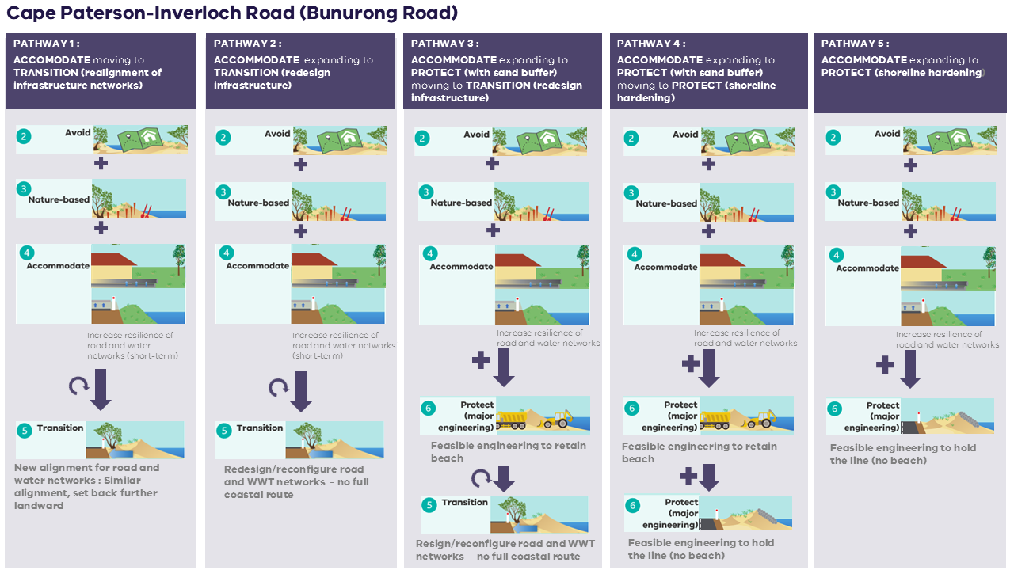
Preferred pathway
>0.2 m SLR (by 2040)
OR/ Trigger reached
Now
>0.5 m SLR (by 2070)
OR/ Trigger reached
Inverloch Surf Beach
Pathway | Description
Pathway 1 | Nature-based small-scale dune nourishment, moving to transition of built assets over time, including Inverloch Surf Lifesaving Club, Surf Parade infrastructure and residents. | All pathways include planning to avoid current and future risk, some nature-based dune and vegetation enhancement, and accommodating risk through utilities, drainage and building upgrades.
Pathway 2 | Nature-based small-scale dune nourishment, moving to protection with larger-scale sand renourishment, and then transition of built assets over time, including Inverloch Surf Lifesaving Club, Surf Parade infrastructure and residents.
Pathway 3 | Nature-based small-scale dune nourishment, moving to protection with larger-scale sand renourishment and structures (e.g. groynes), transitioning to protection with hard protection (e.g. seawall), with no beach.
Pathway 4 | Nature-based small-scale dune nourishment, moving to protection with larger-scale sand renourishment, moving to protection with hard protection (e.g. seawall), with no beach.
Pathway 5 | Nature-based small-scale dune nourishment, moving to protection with larger-scale sand renourishment, moving to a combination of transition and protection (e.g. structures).
Preferred pathway: | Pathway 5 – NATURE-BASED (dune restoration) expanding to PROTECT (with sand buffer), then moving to combined TRANSITION / PROTECT
- Provides good alignment with community values through retaining beach and natural amenity.
- Retains the valued sandy beach in a more natural state for longer, supporting tourism, local economy and the value of the beach.
- Allows existing built assets and properties to be retained in current locations for a bit longer (but not indefinitely)
- Aligns with the Marine and Coastal Policy through:
  - Supporting transition options where possible for this location, before ‘protect’ options.
- Retains broader public benefit (the beach).
Additional considerations:
Coastal modelling | Engineering structures (Pathways 3, 4 and 5) are feasible but would potentially need to be very large scale to manage site conditions and mitigate risk. Structure size/scale would significantly change the landscape, local conditions and beach experience, impacting tourism and amenity of the region.  Larger scale nourishment without structures to retain the sand will not remain feasible in the long term.
Economic analysis | Losses resulting from temporary closure/loss of access to the beach (associated with Pathways 2, 3, 4 and 5) are in the order of $2.5 to $7.4 million annually. This shows the importance of retaining a sandy beach for as long as possible.
Community surveys | Engagement showed a clear preference for nature-based solutions and dune renourishment over ‘hard’ infrastructure.
Drainage | Addressing catchment flooding is also important for this area. Further assessment is required to understand the dynamics of Wreck Creek, its broader catchment, and implications with changing coastal hazard exposure
Dredging | The approach, sand sourcing and impacts of large scale dredging and sand renourishment will need to be assessed further at a regional scale.
Transition | A land-use transition strategy must be developed for public and private assets. This includes consideration of asset maintenance, development controls and adaptable approaches. For example, lifesaving club facilities and services with the ability to transition with the coast.  Time is needed to develop this approach to regional and site-based planned transition and develop a state-wide planned transition strategy. Pathways 2 and 5 provide more time to develop this, compared to Pathway 1.

Potential pathways for Inverloch Surf Beach
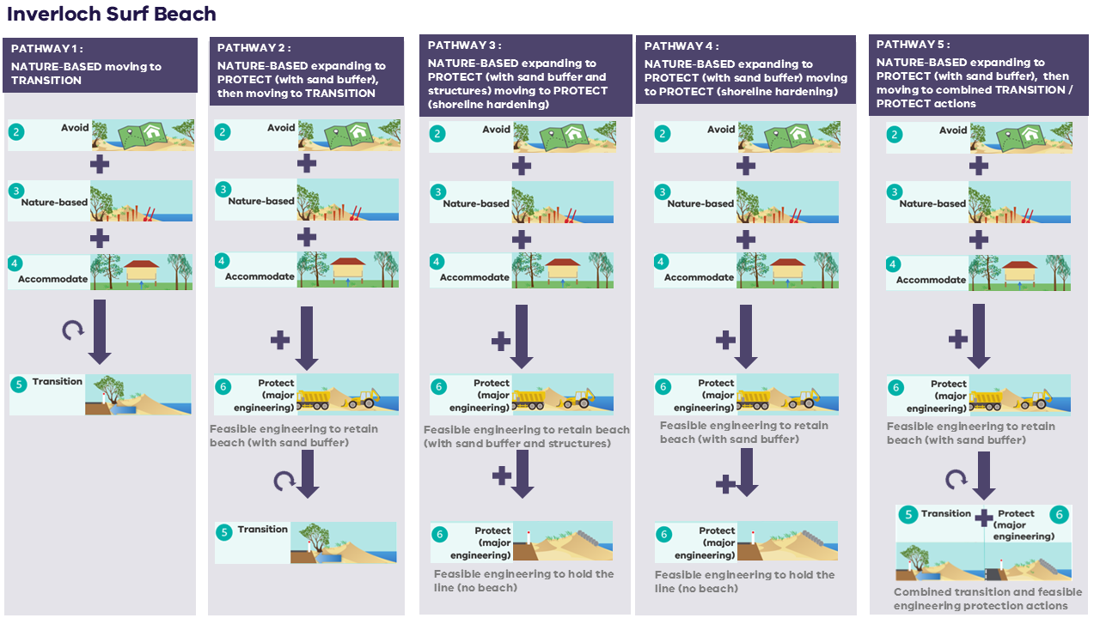
>0.2 m SLR (by 2040)
OR/ Trigger reached
Now
>0.5 m SLR (by 2070)
OR/ Trigger reached
>0.8 m SLR (by 2100)
OR/ Trigger reached

Preferred pathway

Inverloch township (inside the inlet)
Pathway | Description
Natural areas within Anderson Inlet (including creeks) |  | All pathways include planning to avoid current and future risk, some nature-based foreshore and vegetation enhancement.
Pathway 1 | Nature-based vegetation migration and land-use transition, moving to transition of built assets out of at-risk areas over time to make space nature.
Holiday Park
Pathway 1 | Nature-based small-scale foreshore, dune and vegetation enhancement and accommodation of coastal hazard risk through infrastructure upgrades to road and water network, moving to transition of built assets out of at risk areas over time, including Holiday Parks and foreshore camping facilities.
Pymble Avenue picnic and barbeque area / dog beach
Pathway 1 | Nature-based small-scale foreshore, dune and vegetation enhancement to create a vegetated buffer; accommodation of coastal hazard risk through upgrades to built assets and networks; and transition of built assets out of at risk areas, including picnic shelter/BBQ and temporary rock bag wall. Moving to transition of further built assets, including houses and infrastructure across The Esplanade.
Pathway 2 | Nature-based small-scale foreshore, dune and vegetation enhancement to create a vegetated buffer and small-scale renourishment across temporary rock bag structure to better-integrate; accommodation of coastal hazard risk through upgrades to built assets and networks; and transition of built assets out of at risk areas, including picnic shelter/BBQ. Moving to transition over time of rock bag structure and further built assets, including houses and infrastructure across The Esplanade.
Pathway 3 | Nature-based small-scale foreshore, dune and vegetation enhancement to create a vegetated buffer; accommodation of coastal hazard risk through upgrades to built assets and networks; and protection with an engineered seawall.
Preferred pathways: | Pathway 1 – NATURE BASED with ACCOMMODATE (asset raising/resilience) and TRANSITION of selected assets, then expanding to broader TRANSITION
- Provides good alignment with community values through retaining natural amenity.
- Enhances natural resilience through making space for nature
- Retains access and critical services, maintaining liveability of the area
- Aligns with the Marine and Coastal Policy through:
  - Supporting nature-based solutions to increase natural resilience through enhancement, access control and transitioning land-use to make space for nature.
  - Supporting accommodate actions, where possible, before ‘transition’ and ‘protect’ options
  - Supporting transition options where possible for targeted locations, before ‘protect’ options including consideration of other available open space and alternative access.
Additional considerations:
Coastal modelling | Erosion at the dog beach is largely driven by channel migration processes. Detailed modelling was not undertaken, but engineering principles remain similar to other locations.  Significant land form changes (fill through development) has occurred, particularly in eastern areas of the township. Inundation mapping needs to be updated.
Landscape | Low lying areas across the eastern township means protection (hold the line) options become limited in the long term in some areas.
Community engagement | There is scope to utilise the dog beach site as an engagement opportunity to communicate the value of proactive planning (rather than reactive), implications of reactive measures and need for balance/compromise on implementing high-cost engineered solutions everywhere.
Approvals | Planning updates and development approvals moving forward must be carefully considered.

Potential pathways for Inverloch township (inside the Inlet)

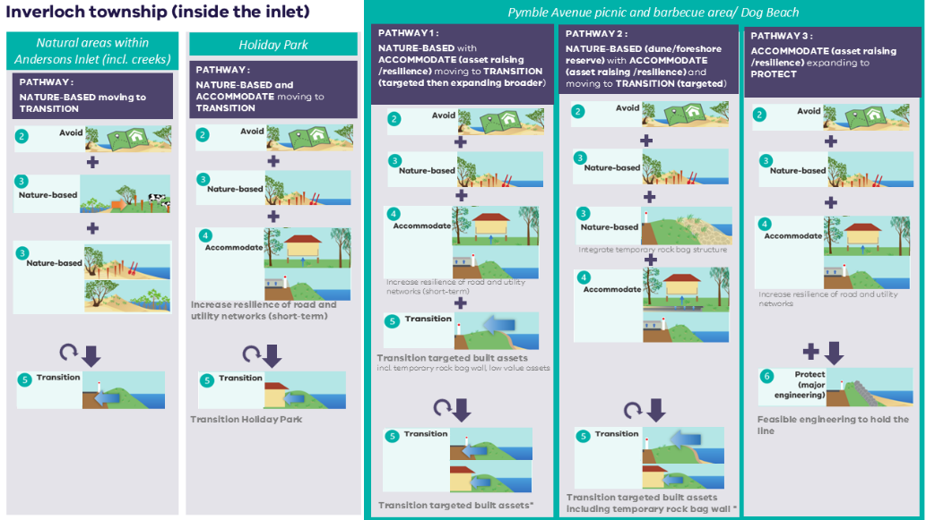

>0.2 m SLR (by 2040)
OR/ Trigger reached
Now
>0.8 m SLR (by 2100)
OR/ Trigger reached
Preferred pathway
Preferred pathway
Preferred pathway

Venus Bay and Tarwin Lower
Pathway | Description
Pathway 1 | Accommodating coastal hazard risk through infrastructure upgrades to road and water networks and asset (building) raising in at-risk areas to increase resilience in the short term, moving to accommodating risk through major road raising (e.g. causeway) at Inverloch-Venus Bay Road across the existing road alignment and other asset (buildings) raising in additional at-risk locations. | All pathways include planning to avoid current and future risk; nature-based vegetation migration and enhancement; and accommodation to increase resilience of road and utility networks.
Pathway 2 | Accommodating coastal hazard risk through infrastructure upgrades to road and water networks and asset (building) raising in at-risk areas to increase resilience in the short term, expanding to transitioning parts of the road network (Inverloch-Venus Bay Road), resulting in no road access to Venus Bay and transition of this isolated township and targeted at-risk properties across Tarwin Lower.
Pathway 3 | Accommodating coastal hazard risk through infrastructure upgrades to road and water networks and asset (building) raising in at-risk areas to increase resilience in the short term, expanding to transitioning parts of the road network (Inverloch-Venus Bay Road) along an altered alignment to maintain access to Venus Bay and of targeted at-risk properties across Tarwin Lower.
Pathway 4 | Accommodating coastal hazard risk through infrastructure upgrades to road and water networks and asset (building) raising in at-risk areas to increase resilience in the short term, expanding to transitioning parts of the road network (Inverloch-Venus Bay Road) north of Tarwin Lower along an altered alignment and protecting Inverloch-Venus Bay Road between Tarwin Lower and Venus Bay with feasible engineering (e.g. an armoured levee) to maintain access.
Pathway 5 | Accommodating coastal hazard risk through infrastructure upgrades to road and water networks and asset (building) raising in at-risk areas to increase resilience in the short term, expanding to protecting Inverloch-Venus Bay Road across at-risk areas with feasible engineering (e.g. an armoured levee) to maintain access.
Preferred pathways: | Pathway 4 – ACCOMMODATE (asset raising/resilience) expanding to TRANSITION (redesign) parts of road network, and PROTECT
- Provides good alignment with community values through retaining natural amenity.
- Enhances natural resilience through making space for nature
- Retains access and critical services, maintaining liveability of the area
- Aligns with the Marine and Coastal Policy through:
  - Supporting nature-based solutions to increase natural resilience through opportunities for blue carbon, and transitioning land-use to make space for nature.
  - Focussing on ‘accommodate’ measures for as long as possible, before ‘transition’ and ‘protect’ options
  - Acknowledging that viable ‘transition’ options become limited as risk increases
Additional considerations:
Coastal and catchment modelling | Further work to examine levee options and impacts on both coastal and catchment dynamics is underway. Catchment processes must be integrated and influence feasibility and level of risk mitigation for options. A causeway option would limit impacts to hydrodynamics but is more expensive. More immediate action may be viable when catchment flooding is considered.
Economic analysis | Demonstrates that large scale works become financially viable by 2070 due to increasing permanent inundation risks, so planning must occur before this to work toward emerging risk.  Preliminary work favoured large scale protection measures (armoured levees) rather than rerouting or major road raising (causeway).
Traffic studies | Further studies on road usage and traffic counts could inform options and alternatives (e.g. ferry).
Landscape | Low lying areas across this whole region make road rerouting options limited in the long term
Timing | Large-scale solutions must be implemented in a timely manner, with risk significantly increasing and reducing viability of options at 0.5 m SLR.

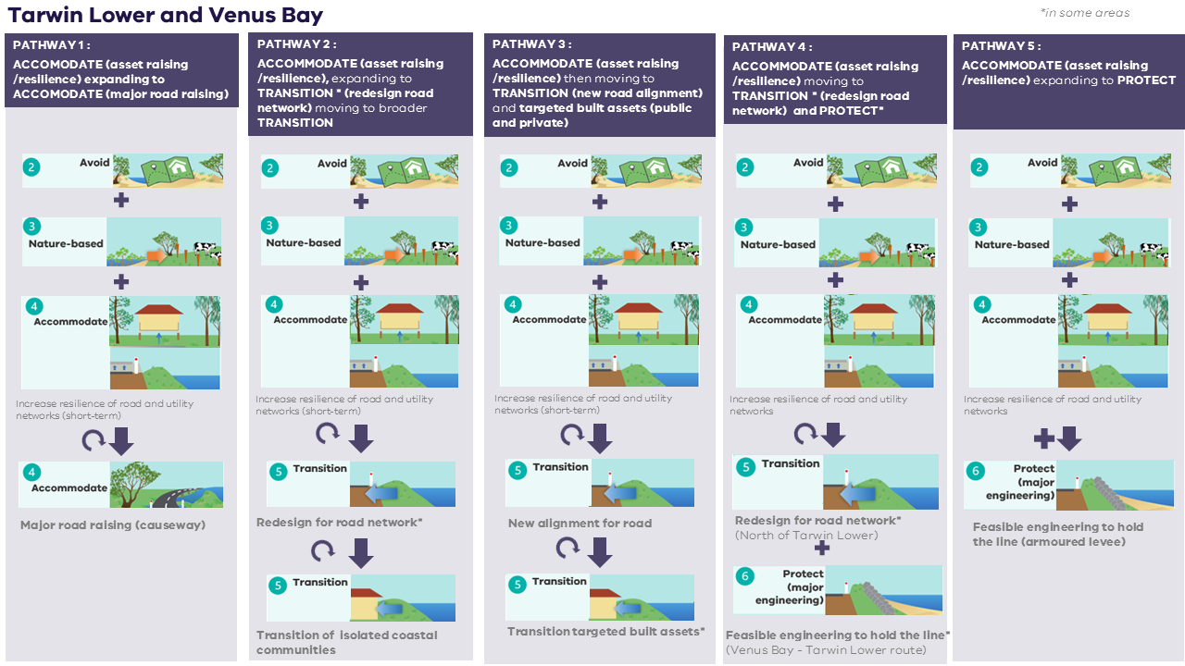
Potential pathways for Venus Bay and Tarwin Lower
>0.2 m SLR (by 2040)
OR/ Trigger reached
Now
>0.5 m SLR (by 2070)
OR/ Trigger reached
>0.8 m SLR (by 2100)
OR/ Trigger reached
Preferred pathway

2021 Census Data – Australian Bureau of Statistics abs.gov.au/census/find-census-data/search-by-area
REMPLAN, 2021. Economy, Jobs and Business Insights for Bass Coast Shire and South Gippsland Shire
Based on IPCC Assessment Report 6 - subject to future updates in sea level rise benchmarking
1950 is the earliest available aerial image, used for digitising historic shorelines
Based on best available local data at time of data gathering and analysis (2021). Planning Scheme data does not include more recent amendments.
The assessment was undertaken on a spatial sub-set of values and assets for the Cape to Cape region and does not account for entire LGA areas. Further information is provided in Alluvium, 2022a.
Permanent inundation (MHWS + sea level rise) also assigned likely
For example, present day uses the 0.5 m SLR (2070) hazard extents, while 2040 would utilise the 0.8 m SLR (2100) hazard extents
Damages for each hazard type have been assessed independently and do not account for interaction and/or timing of different hazard types (i.e. erosion and inundation damage as part of the same storm event will only require one lot of repair/replacement work).

