**Coastal Custodians, Citizens & Scientists: Answers**

**Activity 1: Quiz**

1. Where does the Barwon River flow from and to?

1. Geelong to Barwon Heads
2. Queenscliff to Barwon Heads
3. **The Otway ranges to Bass Strait**
4. Bass Strait to the Otway Ranges

2. What is the name of the Aboriginal people who are the traditional owners of Barwon Bluff?

1. **Wadawurrung (also spelled Wathaurong)**
2. Kurnai (Wilsons Promontory to Point Hicks)
3. Boonwurrung (Melbourne to Wilsons Promontory)
4. Wiradjuri (Wagga Wagga to Dubbo)

3.  What type of rocks support the intertidal habitat in the Barwon Bluff Marine Sanctuary?

1. Boulders and rock-pools
2. Reefs and cliffs
3. Smooth and rough
4. **Basalt and limestone**

4. What do Friends of the Bluff group do to help protect and maintain the Barwon Bluff?

1. Provide education, fundraising and putting up signs
2. **Weeding, collect litter and provide education**
3. Take tours, collect litter and lobby the government
4. Count animals, collect litter and fundraising

5. Which of these is a citizen science program that people can join at the Barwon Bluff?

1. Sea Search
2. Sea Slug Census
3. Bio Blitz
4. **All of the above**

6. What kind of rockpool creature did Isabelle get to learn about and touch?

1. Elephant seal
2. **Elephant snail**
3. Barnacle
4. Chiton

7. Who is allowed to use iNaturalist to record biodiversity at the Barwon Heads?

1. Scientists
2. Friends of the Bluff members
3. **Citizen scientists**
4. Park rangers

8. What are some dangers of exploring the Barwon Bluff Marine Sanctuary?

1. **Blue ringed octopus and big waves**
2. Leaving litter and damaging the rocks
3. Blue ringed octopus and elephant snails
4. Big waves and sunburn

9. What is the primary ecosystem protected by the Barwon Bluff Marine Sanctuary?

1. **Intertidal reef ecosystem**
2. Beach ecosystem
3. Cliffs ecosystem
4. Marine ecosystem

10. Which statement is most true?

1. There are dangerous creatures in rockpools, you must not explore them
2. There are no dangerous creatures in rockpools, you can touch anything you find
3. **Some creatures are dangerous, and some are not, you need to know the difference to explore**
4. Some creatures are dangerous, but you can touch them if you are counting them in a survey

**Activity 2: Sea Slug Census**

Answers based on Melbourne Sea Slug Census March 2024 project page (update to date as of May 2025).

* 1. How many citizen scientists (OBSERVERS) helped record sea slugs?

30 observers

* 1. How many SPECIES of sea slugs were recorded in this census?

105 species

* 1. How many OBSERVATIONS (sightings of sea slugs) were recorded in this census?

626 observations

* 1. Why are those two numbers different?

Common species are observed many times. The number of observations is the sum of all of the times each species is seen, so it is higher than the number of species.

Click into SPECIES tab to answer the following questions:

* 1. What was the most commonly observed sea slug around Victoria?

Record the common name and the scientific name.

Short-tailed Ceratosoma, *Ceratosoma brevicaudatum*

* 1. How many species were observed only once during the whole census?

28 species were observed only once

* 1. In the introduction slides we saw that there are two main groups of sea slugs, Dorid and Aeolid. Which group does the most common Melbourne sea slug belong to? How can you tell?

Dorid. The Short-tailed Ceratosoma has gills in a tuft on its back, and not as row along its back (cerata).

**Activity 3: Scientific Sampling - Survey**

We are going to do a BioBlitz, using the Barwon Bluff rockpool print out.

**STEP 1**: Count every species you can see on the rockpool print out and enter the data into the TOTAL COUNT row in your RESULTS table.

*Neptune’s necklace seaweed has been counted for you. It is recorded as the number of 25cm x 25cm grid squares the seaweed covers on your rockpool print out.*

It would be very hard to count every species on a real life rockpool platform. Instead, scientists count a subset of the rockpool area (called a **survey**) and then multiply their answer to estimate the total number of species. A 1m x 1m survey square called a **quadrat**, is used to count the subset.

**STEP 2:** Use a random number generator to create coordinates for each of your ten quadrats and record them here.

|  |  |  |  |  |  |  |  |  |  |
| --- | --- | --- | --- | --- | --- | --- | --- | --- | --- |
| **Quadrat coordinates 1-8 x A-F: Teacher example coordinates** | | | | | | | | | |
| **1:** | **8C** | **2:** | **4C** | **3:** | **4D** | **4:** | **3A** | **5:** | **6A** |
| **6:** | **1F** | **7:** | **5D** | **8:** | **3F** | **9:** | **7E** | **10:** | **8F** |

**STEP 3:** Outline a 1m x 1m quadrat at each of your ten coordinates, and label them 1-10.

**STEP 4:** Count each animal or grid square with seaweed in it, and record in your RESULTS table.

**RESULTS:** These example results match the quadrats shown on Slide 19.

|  |  |  |  |  |  |
| --- | --- | --- | --- | --- | --- |
| **Species** | **Shore Crab** | **Eight-armed Sea Star** | **Free Vectors | White Tasuki NudibranchNudibranchs** | **Elephant Snail** | Neptunes Necklace | Fishing Tasmania**Neptune’s Necklace Seaweed** |
| **TOTAL COUNT** | **35** | **30** | **10** | **15** | **420 grid squares** |
| **Quadrat 1** | **1** | **1** | **-** | **1** | **7** |
| **Quadrat 2** | **1** | **1** | **-** | **-** | **5** |
| **Quadrat 3** | **-** | **-** | **-** | **-** | **14** |
| **Quadrat 4** | **1** | **1** | **-** | **-** | **5** |
| **Quadrat 5** | **1** | **1** | **-** | **1** | **5** |
| **Quadrat 6** | **-** | **1** | **-** | **1** | **12** |
| **Quadrat 7** | **2** | **-** | **-** | **1** | **9** |
| **Quadrat 8** | **-** | **1** | **-** | **-** | **5** |
| **Quadrat 9** | **-** | **1** | **1** |  | **-** |
| **Quadrat 10** | **1** | **1** | **-** | **-** | **11** |

**Use your results to estimate the total population of organisms in the rockpools.**

The rockpool platform is 8m across x 6m down.

How many 1m square quadrats would it take to survey the whole reef? 48 x 1m squares

Now that we have completed our survey, we have ten subsets of the total population. Through multiplication these counts can be used to estimate the total population. You will investigation how the estimate changes when you use counts from 1, 5 and 10 quadrats [Slide 20 - worked example].

**STEP 5:** Add together each organism you counted in 1, 5 and 10 quadrats. Enter the answers into the corresponding rows of the ESTIMATE table.

**STEP 6**: Calculate your multipliers.

How much of the total rockpool area is 1 quadrat? **48 ÷ 1 = [_48_] A**

Multiply the number of species from quadrat 1 by answer A

How much of the total rockpool area is 5 quadrats? **48 ÷ 5** = [**_9.6_] B**

Multiply the number of species from 5 quadrats by answer B

How much of the total rockpool area is 10 quadrats? **48 ÷ 10 =** [_**4.8**_] **C**

Multiply the number of species from 10 quadrats by answer **C**

**ESTIMATE**: [Q = quadrat]

|  |  |  |  |  |  |
| --- | --- | --- | --- | --- | --- |
| **Species** | **Shore Crab** | **Eight-armed Sea Star** | **Free Vectors | White Tasuki NudibranchNudibranchs** | **Elephant Snail** | **Neptune’s Necklace Seaweed** |
| **TOTAL COUNT** | **35** | **30** | **10** | **15** | **420 grid squares** |
| **Number in Q1** | **1** | **1** | **-** | **1** | **7** |
| **Multiply x A**  **48** | **48** | **48** | **0** | **48** | **336** |
| **Number in Q1+2+3+4+5** | **4** | **4** | **0** | **2** | **36** |
| **Multiply x B**  **9.6** | **38** | **38** | **0** | **19** | **345** |
| **Number in**  **Q1+2+3…+9+10** | **7** | **8** | **1** | **4** | **73** |
| **Multiply x C**  **4.8** | **33** | **38** | **4** | **19** | **350** |

**Discussion: What happens to your estimate as you add more data?**

They become more accurate – closer to the total population number. Inaccuracies occur from low count numbers because the multiplier is so large, and because many organisms are absent from some quadrats. Abundant organisms, like the seaweed, can be estimated more accurately than rare ones.

**Review Questions**

1. What is the main difference between a scientific diagram and a scientific colour illustration? (2 marks)

Diagrams are black and white line drawings, which do not show any colour, shading or texture.

An illustration includes colour which can help with species level representation.

2. What are some differences between the two main groups of nudibranchs, Dorid & Aeolid? (3 marks)

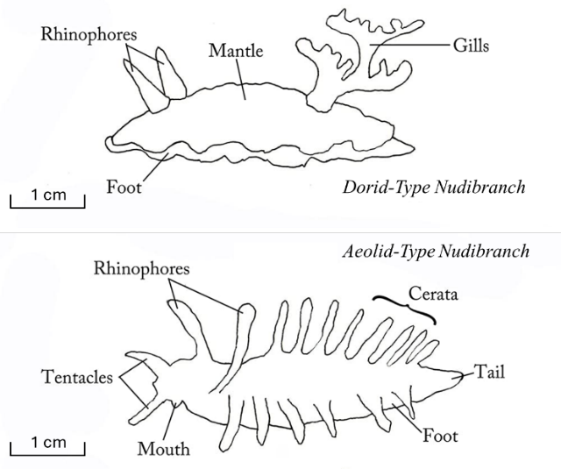Use sketches if you like.

Gills in a plume towards the tail

No tentacles

Gills arranged in cerata: a mohawk along the back

Tentacles on the front

3. Why do scientists count a subset and not the total number of organisms in an environment? (4 marks)

It is impossible to count all of the organisms in an environment, because they are hidden, and because there are too many to count. Counting a subset of organisms through a survey allows for accurate population estimates – if enough counts are gathered.

4. What are some reasons you would choose to use an infographic to communicate a subject? (4 mark)

When the subject is complex and can be broken down into several parts.

When some parts can be better explained with an illustration or a diagram.

When some words can be replaced with graphic design elements.