Victoria State Government

Victoria’s Marine Planning Areas

Acknowledgement of Traditional Owners
Traditional Owners have never surrendered rights to Country. The Victorian Government acknowledges Aboriginal people as Australia’s first people, and as the Traditional Owners and custodians of the land on which we work and live. We recognise the strength of Aboriginal people and the need for reconciliation and genuine partnerships to address the negative impacts of the past.
Traditional Owners have an unbroken custodianship of the land and seas that extends back tens of thousands of years. Their knowledge, understanding, and relationships to Country are fundamental to the health of the environment and the success of any strategy to manage that environment.
We recognise and value the ongoing contribution of Aboriginal people and communities to Victorian life and how this enriches us all. We recognise that Aboriginal cultures and communities are diverse, and the value we gain in celebrating these cultures and communities. We embrace the spirit of reconciliation, working towards the equality of outcomes and ensuring an equal voice. We have distinct legislative obligations to Traditional Land Owner groups that are paramount in our responsibilities in managing Victoria’s resources.
The following Registered Aboriginal Parties / Traditional Owners have contributed to the development of these guidelines:
- Bunurong Land Council Aboriginal Corporation
- Eastern Maar Aboriginal Corporation RNTBC
- Gunaikurnai Land and Waters Aboriginal Corporation
- Gunditj Mirring Traditional Owners Aboriginal Corporation RNTBC
- Wadawurrung Traditional Owners Aboriginal Corporation
- Wurundjeri Woi Wurrung Cultural Heritage Aboriginal Corporation
Note: This document has used the term Traditional Owners in reference to rightsholders with cultural obligations and inherent responsibilities for managing and protecting Country.

Contents
Background 2
Statewide approach 3
Marine planning areas 5
Marine planning area characteristics 7
Marine Planning Area 1 10
Marine Planning Area 2 12
Marine Planning Area 3 14
Marine Planning Area 4 17
Marine Planning Area 5 19
Marine Planning Area 6 21
Marine Planning Area 7 24
Marine Planning Area 8 26

Background
Victoria’s Marine and Coastal Act 2018 (the Act) sets objectives and guiding principles for the planning and management of the State’s marine and coastal environment. Under the Act, the Marine and Coastal Policy 2020 (the Policy) details the policies for achieving these objectives. The Act requires a Marine Spatial Planning Framework (MSP Framework) that provides guidance and a process for achieving integrated and coordinated planning and management of the marine environment.
The MSP Framework is included in the Policy and sets out Victoria’s approach to Marine Spatial Planning (MSP) (see Box 1).
The MSP Framework consists of two parts:
- Part A provides an overarching structure and policies to guide planning, management and decision making in the marine environment, whether undertaking MSP or not
- Part B sets out the process to initiate and undertake MSP in Victoria.
The MSP Framework designates the Minister responsible for the Act as the lead Minister for MSP. Given MSP crosses multiple interests, the lead Minister will seek approval from all ministers with portfolio interests in a marine planning area before authorising the commencement of a MSP process, and approving any proposed marine plan. Continued implementation of the MSP Framework links with actions in the Marine and Coastal Strategy 2022 and requires input from across government, Traditional Owners, licence and permit holders, marine stakeholders, and the community.

Box 1
Marine Spatial Planning (MSP) in Victoria
Victoria’s marine environment is an active place and how we use and enjoy it continues to grow and change. MSP is a practical way to understand and organise the interactions between human uses and between these uses and the marine environment.
MSP considers how uses and activities occurring in the marine environment are spatially organised, providing a structure for integrated management, and an approach to manage current or potential conflicts through existing legislation, policies, and plans.
Undertaking MSP can have significant benefits, including identifying marine habitats that can be recovered or enhanced, supporting the growth of Victoria’s blue economy, promoting environmental and socio-economic resilience, and supporting climate change adaptation responses across marine sectors. These benefits support long-term planning for existing marine uses (for example, fisheries and aquaculture, tourism, Marine transport), emerging uses (for example, offshore wind and ocean energy), and the marine environment.
DECCA is leading the implementation of the MSP Framework in Victoria, engaging with Traditional Owners, industry, marine users, and government agencies. Learn more about MSP in Victoria (marineandcoasts.vic.gov.au/marine/marine-spatial-planning).

Statewide approach
The first stage in commencing implementation of Part B of the MSP Framework, was the undertaking of a statewide ‘first-pass’ (this document) that divided Victoria’s marine environment into 8 marine planning areas for future MSP processes.
As MSP is an adaptive process it is not intended that this ‘first pass’ will be repeated. Rather a more detailed look at Victoria’s marine environment, including all values and uses/activities, would occur as part of a MSP process. In determining the boundaries and size of the marine planning areas, a number of factors were considered (Figure 1).
The boundaries of the marine planning areas are indicative, with the inner and outer boundaries mapped according to the ‘marine environment’ definition in the Act (see Box 2). As this is a statewide approach, further refinement of the boundaries may be required as part of undertaking a MSP process.

Figure 1 Factors considered when determining the boundaries and size of marine planning areas
- Guidance set out in the MSP Framework
- Traditional Owners’ knowledge, rights, interests, cultural values, uses and objectives for the marine and coastal environment
- Size of marine planning areas in other jurisdictions (e.g. Europe, New Zealand, South Australia)
- Input from multi‑sector stakeholders
- Processes, uses, activities, values, threats, management and legislative arrangements in interstate and Commonwealth waters that influence or are relevant to Victoria’s marine environment
- Spatial distribution of current and planned recreational and commercial activities and uses
- Environmental characteristics including ecological systems
- Recognised current and future threats
- Key environmental values
- Management and legislative arrangements that occur in Victorian and adjacent coastal environments
- Jurisdictional boundaries
- Current and anticipated future conflicts and compatibilities between activities, uses and values

Supporting documents
Information and data obtained in the following reports was also used to inform the boundaries and size of the marine planning areas:
- Victorian Environmental Assessment Council’s (VEAC’s) Assessment of the Values of Victoria’s Marine Environment (2019) Report
- Victorian Environmental Assessment Council’s (VEAC’s) Assessment of the Values of Victoria’s Marine Environment (2019) Atlas
- Victorian marine habitat mapping and biogeographical classification
- Victorian marine asset mapping
- Coastal sediment compartment mapping
- Technical Report to support identification of statewide marine planning areas and areas of interest for Marine Spatial Planning (2021)

Box 2 Victoria’s marine environment
The ‘marine environment’ is defined in the Act as extending from the high-water mark for three nautical miles, or 5.5km, to the edge of the State’s jurisdiction. It includes all bays, inlets, estuaries, and the Gippsland Lakes. This extends to a depth of 200m below the seabed, and includes the biodiversity associated with both land and water.

Marine planning areas
A marine planning area (Figure 2) is the area to which a marine plan and its identified management actions (determined through the MSP process) will apply. Given the dynamic and interconnected nature of marine ecosystems, boundaries of the marine planning areas are indicative. It is therefore important to consider adjacent marine planning areas in Victoria and what is occurring in adjoining waters managed by the Commonwealth, South Australia and New South Wales. Interactions and connectivity across the land, sea and catchment interface are also essential to consider when undertaking MSP (refer to the MSP Guidelines for more information). Whilst a marine plan applies to an entire marine planning area, there may be locations that require a more intensive focus when undertaking a MSP process (for example, due to the intensity of uses/activities differing across the marine planning area).

Figure 2 Victoria’s marine planning areas
Figure shows Registered Aboriginal Party (RAP) boundaries as recognised under the Aboriginal Heritage Act 2006. Traditional Owners have interests in areas outside of RAP boundaries. Inner and outer boundaries of the marine planning areas are mapped according to the ‘marine environment’ definition in the Marine and Coastal Act 2018. As this is a statewide approach, further refinement of the boundaries may be required as part of undertaking a MSP process.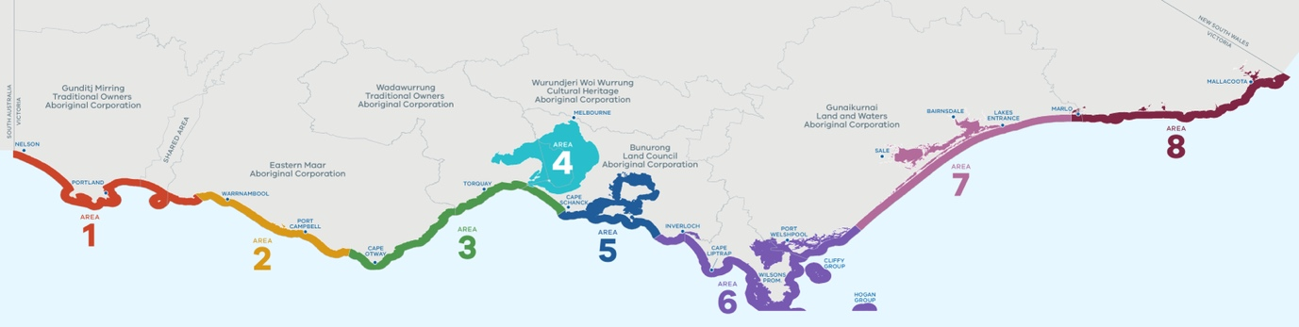

Undertaking a first MSP process
Not all marine planning areas may require a MSP process, with some benefiting from other integrated planning and management approaches, such as ecosystem-based management, environmental impact assessments and/or marine protected area planning. Determining where to undertake a first MSP process will be guided by:
- the presence of multiple stakeholders and users with interests in the area
- clearly identifiable issues or opportunities in the area, including:
  - the degradation of marine environmental values
  - new or emerging activities being proposed, with a need to decide on an appropriate location to enable sustainable and long-term development
  - existing or anticipated threats or risks to environmental, economic, social or cultural sustainability, or to sites, species or areas of significance
  - the existence, or likely existence, of conflict between existing and/or emerging human activities or uses
  - altering ecological processes, or uses and activities, in response to the impacts of climate change.
Consideration will also be given to areas that are under immediate pressure (for example, areas where there is an urgency to act) and/or areas where the greatest opportunity to act exists (for example, areas with existing high quality relevant data, areas with existing community/stakeholder support). Consultation with stakeholders highlighted that other key factors when determining where to undertake MSP include: capacity of rightsholders and stakeholders, timeframes required to undertake the MSP process, and funding for both the MSP process and implementation of the resulting marine plan. Where to undertake a first MSP process in Victoria will be further explored and determined through implementation of the Marine and Coastal Strategy.

Marine planning area characteristics
For each of the marine planning areas, high-level characteristics are included in the sections that follow.
The information provides an overview to broadly describe each marine planning area and, given the statewide nature of implementing this first step in the MSP Framework, is not intended to be a comprehensive list. Further information and data to assess and analyse the physical, biological, cultural, social, and economic characteristics of the marine planning area would be required when undertaking a MSP process.
VEAC’s Assessment of the Values of Victoria’s Marine Environment Atlas (2019) provides more detailed information regarding marine values across the State and, in conjunction with the information below, should be used to inform baseline information required as part of any MSP process (refer to MSP Guidelines).
For each of the 8 marine planning areas, the following high-level characteristics are provided.

Location
Outlines the extent of the marine planning area, to which a marine plan and its identified actions (determined through a MSP process) will apply. Note: the inner and outer boundaries are mapped according to the ‘marine environment’ definition in the Act.

Traditional Owner Cultural landscape and some areas of significance
This section details the Registered Aboriginal Party (RAP) with responsibilities for managing and protecting Aboriginal cultural heritage on Sea Country. It also acknowledges some areas of interest; however, it should be noted that the entire cultural landscape is of cultural significance. Information on the cultural landscape and areas of significance has been collated from VEAC’s Assessment of the Values of Victoria’s Marine Environment Atlas (2019), Traditional Owner Country plans, the Victorian Traditional Owner Cultural Landscapes Strategy and other documentation and input as available. Note: it is a principle of the MSP Framework that the importance of Sea Country must be recognised and integrated into marine planning and management through self-determination.

Biounits
Lists the biounits within the marine planning area, linking to information on the marine habitats and physical processes present. Biogeographic units, referred to as biounits, are a means of describing, mapping, and monitoring biological communities, abiotic structural habitat components and ecosystem types. Biounits were previously identified as part of statewide mapping of Victoria’s marine environment, with 26 biounits delineated across the State, each characterised by dominant physiographical settings including oceanography and geomorphology (processes).

Coastal sediment compartments
Lists the secondary sediment compartments within the marine planning area, linking to information on sediment movement and coastal types which is important given the interconnected nature of marine and coastal ecosystems. Coastal sediment compartments, based on landforms and patterns of sediment (sand and other beach material) movement, were identified as part of previous mapping, with 23 secondary compartments determined along Victoria’s coastline.

Designated areas of importance
This section highlights existing areas designated as having ecological or biological importance, including Marine National Parks and marine sanctuaries within the marine planning area. Other areas designated as having ecological or biological features adjacent to the marine planning area, for example, Australian Marine Parks, are also included to reflect the dynamic and interconnected nature of marine ecosystems. This section is not intended as a comprehensive list; further consideration for significant areas of ecological, biological, geological and historical importance (for example, breeding sites, rookeries, feeding grounds, species of national/international significance, sites of historical heritage) would be required when undertaking a MSP process.

Human uses/activities
This section details present and emerging uses/activities within the marine planning area as identified at the time of assessment. Uses/activities were grouped into broad categories (refer Table 1), with definitions shaped by uses defined in FeAST. An additional category ‘Traditional Owner cultural values and uses’ was included in partnership with Traditional Owners. Note: these categories do not represent all uses/activities occurring within the marine planning area and are likely to change over time, with additional information required to be considered when undertaking a MSP process.
Additional uses/activities to be investigated when undertaking a MSP process, including cultural heritage as required under the Aboriginal Heritage Act 2006, are defence and national security, research, waste management activities, and extraction (and disposal) of non‑living resources.

Table 1 Human use/activity categories

Traditional Owner cultural values and uses
Sea Country is part of the interconnected cultural landscape that includes land and waters. A cultural landscape includes Traditional Owner cultural values and uses for Sea Country, which are deeply held spiritual, cultural, social, economic, environmental, of land and water form, place-based, practice-based, wellbeing, future use, identity connections, and any others as determined by Traditional Owners.

Recreation, leisure, and tourism
Recreational and leisure pursuits (includes activities such as, swimming, whale watching, bird watching, boating, tour boat operations, sailing, surfing, scuba diving, search and rescue).

Extraction of living resources
The extraction of living marine resources (presently includes only commercial fishing activities, however must include recreational fishing as part of any MSP process).

Production of living resources
The production of living marine resources (presently includes only aquaculture).

Marine transport
Transport such as vessel movements or relating to the support of transport activities (including vessel moorings, maritime navigation aids).

Coastal infrastructure and management activities
The development and maintenance of coastal infrastructure such as ports and harbour developments, and the management of coastal sites (including jetties and boat ramps).

Energy generation
The development, operation, maintenance, and decommissioning of structures and wider developments which generate energy or are related to energy generation (including anticipated development). This includes offshore petroleum releases, oil and gas fields, oil and gas pipelines, oil spill response and proposed offshore renewable energy.
Additional human use/activity categories to be investigated when undertaking a MSP process
- Defence and national security
  - Infrastructure and activities associated with defence and national security (including Commonwealth defence areas and exclusion zones).
- Research
  - Activities relating to the investigation and study of the marine environment for scientific and exploratory purposes (including seismic surveys).
- Waste management activities
  - Activities relating to the discharge of waste (for example, sewage and industrial wastewater discharge).
- Extraction and disposal of non-living resources
  - The extraction and disposal of non-living resources (including dredging).

Marine Planning Area 1

Location
From the border with South Australia to east of Port Fairy, including estuaries (Glenelg River, Wattle Hill Creek, Surrey River, Fitzroy River, Lake Yambuk and Moyne River).
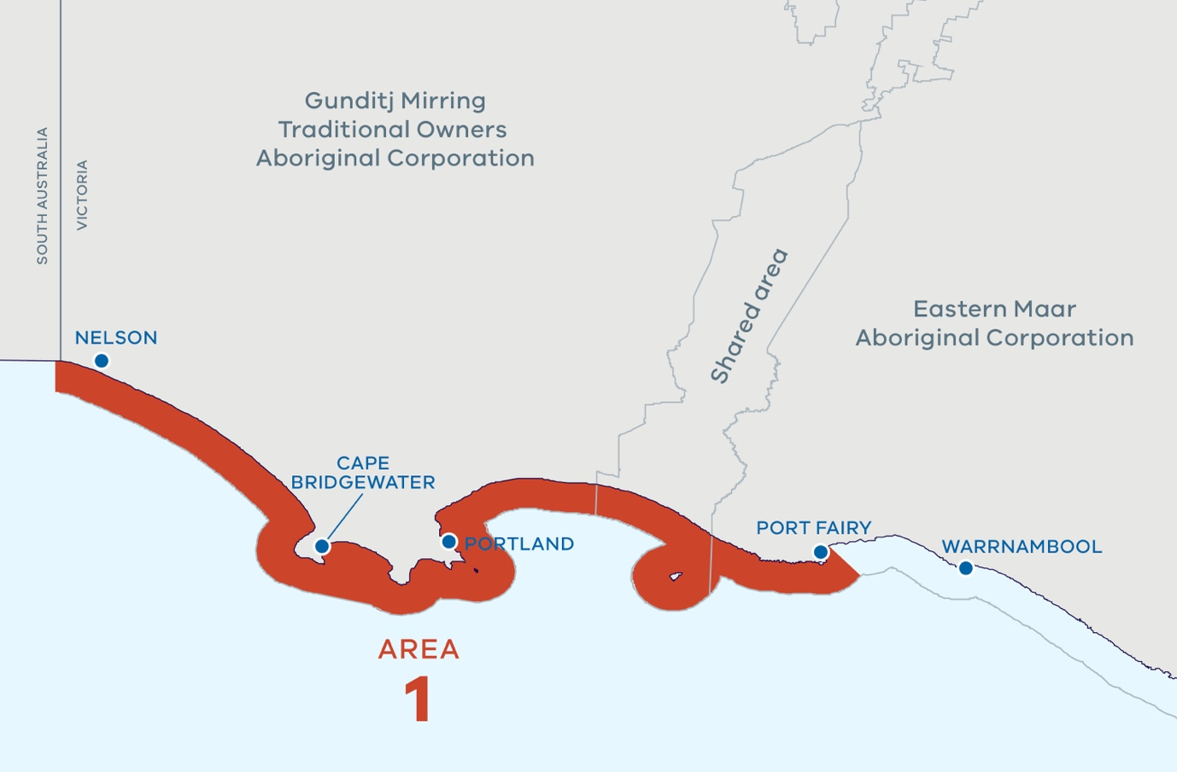

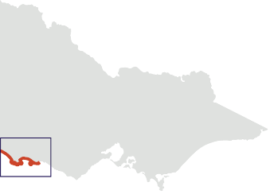

Use and activity categories
- Traditional owner cultural values and uses
- Recreation, leisure, and tourism
- Extraction of living resources
- Production of living resources
- Marine transport
- Coastal infrastructure and management activities
- Energy generation (Emerging)

Traditional Owner cultural landscape and some areas of significance
Registered Aboriginal Party
- Gunditj Mirring Traditional Owners Aboriginal Corporation RNTBC (Prescribed Body Corporate under the Native Title Act 1993)
- Eastern Maar Aboriginal Corporation RNTBC (Prescribed Body Corporate under the Native Title Act 1993)
- Section of the marine planning area is a shared native title determination area between Gunditj Mirring and Eastern Maar.
- The whole Sea Country is highly significant.
- Part of UNESCO World Heritage-listed Budj Bim Cultural Landscape.
- A Gunditjmara Sea Country Indigenous Protected Areas is being explored within this marine planning area.
- Submerged cultural heritage.
- Deen Maar (Lady Julia Percy Island) is highly sacred and significant.

Biounits
- Glenelg
- Discovery Bay
- Cape Nelson

Coastal sediment compartments
- Discovery Bay
- Portland Bay

Designated areas of importance
- Bonney coast upwelling
- Marine National Parks (Discovery Bay Marine National Park)
- Ramsar site (Glenelg Estuary and Discovery Bay Ramsar site)
- Nelson reefs, Lawrence Rocks, Julia Reef, Noble Rocks
- Adjacent: Discovery Bay Coastal Park, Lower South East Marine Park (South Australian jurisdiction), Nelson Marine Park (Commonwealth jurisdiction)

Marine Planning Area 2

Location
From east of Port Fairy to west of Cape Otway, including estuaries (Merri River, Hopkins River, Curdies River, Port Campbell Creek, Sherbrook River, Gelibrand River).
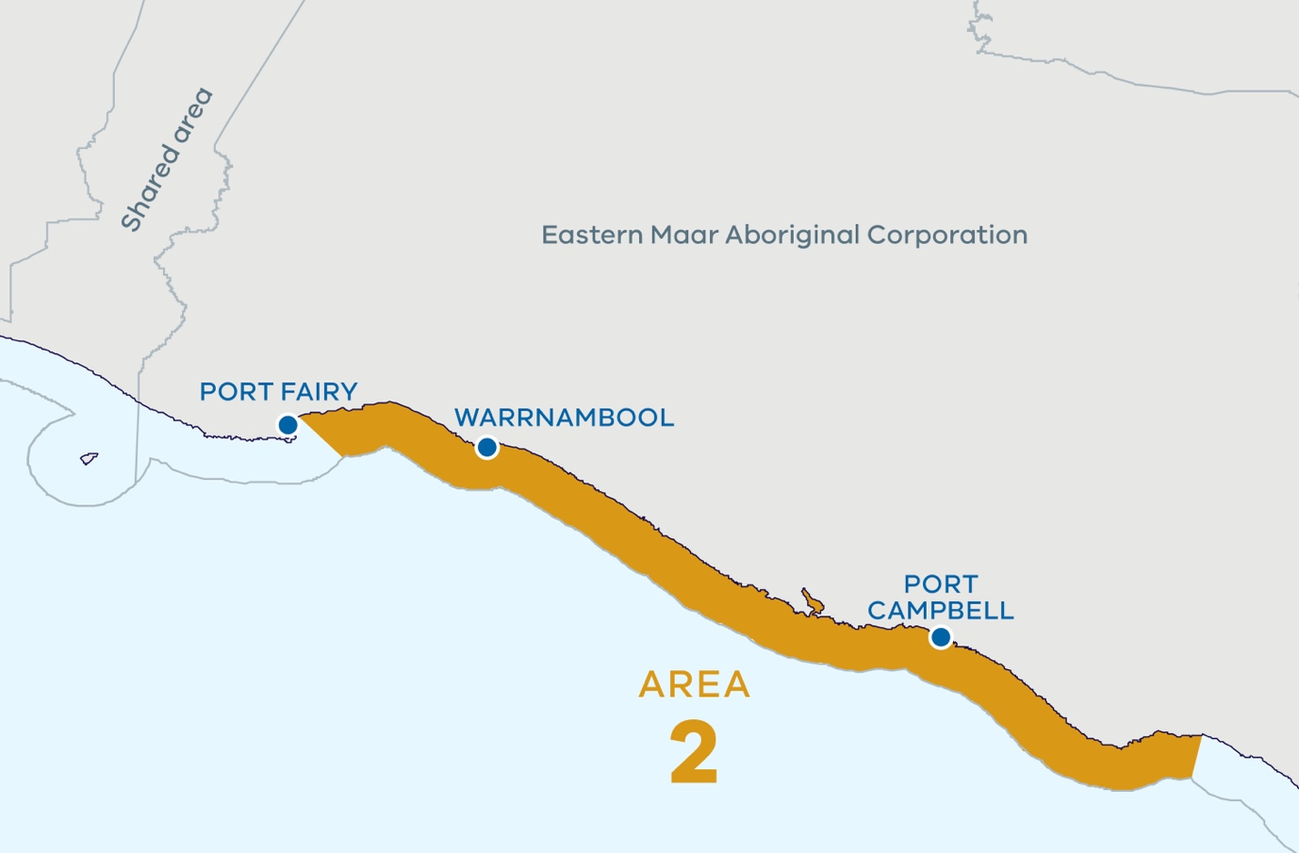
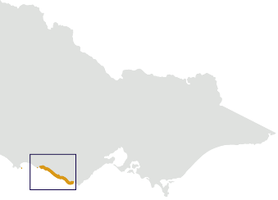

Use and activity categories
- Traditional owner cultural values and uses
- Recreation, leisure, and tourism
- Extraction of living resources
- Production of living resources
- Marine transport
- Coastal infrastructure and management activities

Traditional Owner cultural landscape and some areas of significance
Registered Aboriginal Parties
- Eastern Maar Aboriginal Corporation RNTBC (Prescribed Body Corporate under the Native Title Act 1993)
- The whole Sea Country is highly significant.
- Submerged cultural heritage.
- Southern Right Whale nursery (Logan’s Beach).
- Point Richie – Moyjil Aboriginal Place.

Biounits
- Shipwreck Coast
When undertaking a process in this area consideration should be given to the Cape Otway biounit.

Coastal sediment compartments
- Discovery Bay
- Warrnambool
- Port Campbell

Designated areas of importance
- Marine National Parks (Twelve Apostles Marine National Park)
- Marine Sanctuaries (Merri Marine Sanctuary, The Arches Marine Sanctuary)
- Middle Island, Helen Rock
- Adjacent: Bay of Islands Coastal Park, Port Campbell National Park, Great Ocean Road

Marine Planning Area 3

Location
From west of Cape Otway to west of Cape Schanck, including Aireys Inlet and estuaries (Aire River, Elliot River, Anderson Creek, Barham River).
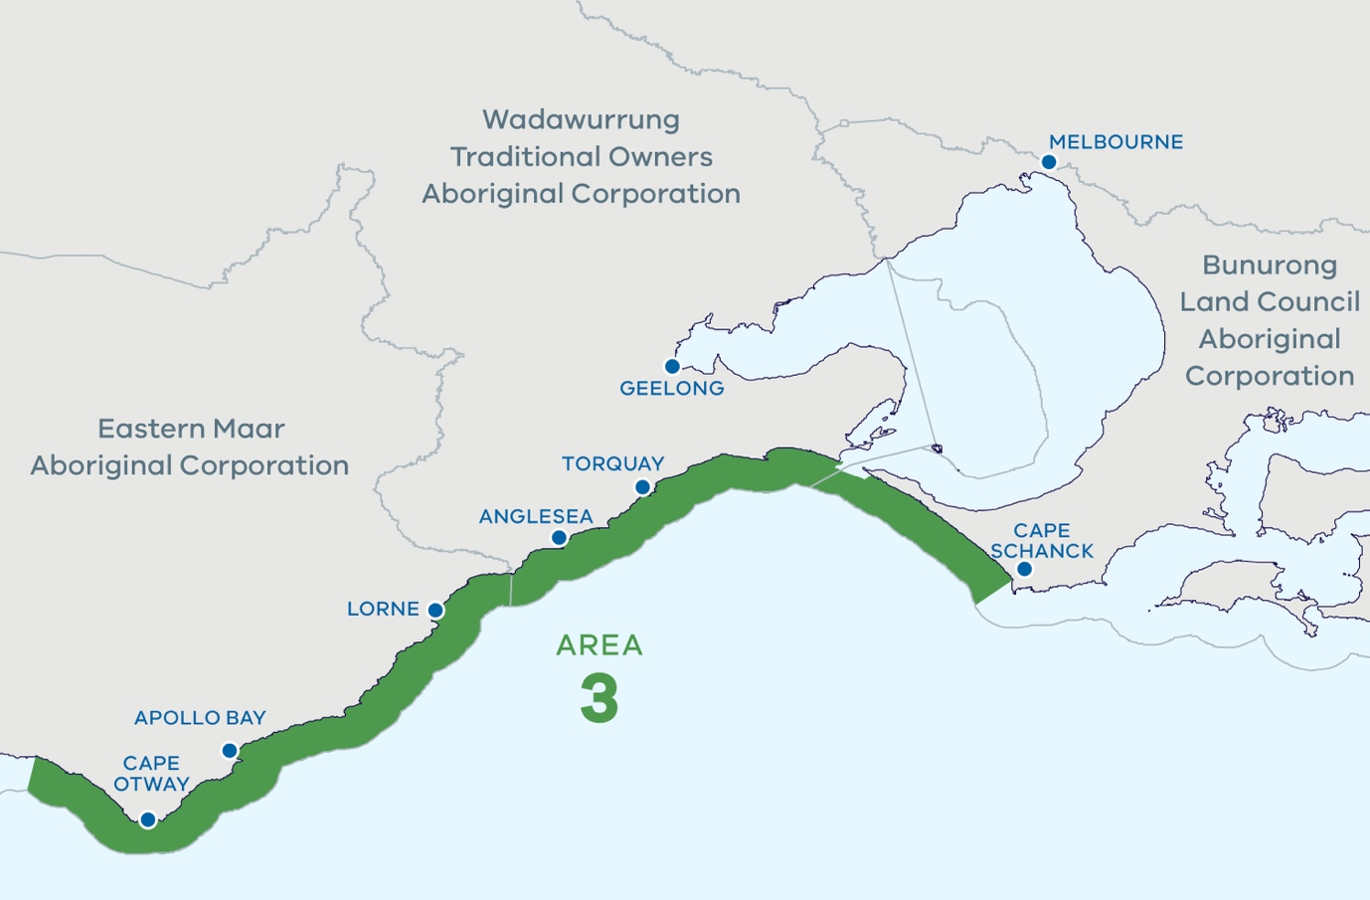

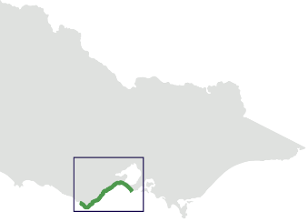

Use and activity categories
- Traditional owner cultural values and uses
- Recreation, leisure, and tourism
- Extraction of living resources
- Marine transport
- Coastal infrastructure and management activities

Traditional Owner cultural landscape and some areas of significance
Registered Aboriginal Parties
- Eastern Maar Aboriginal Corporation RNTBC (Prescribed Body Corporate under the Native Title Act 1993)
- Wadawurrung Traditional Owners Aboriginal Corporation
- Bunurong Land Council Aboriginal Corporation
- All Sea Country is significant.
- Short-finned eel are a particularly important cultural species along the whole coastline.
- Evidence of dinosaur fossils along entire coastline.
- Living areas with middens, ochre pits, burial grounds, fish traps, cultural places, cultural resources, and intangible cultural heritage along the entire coastline and within the submerged cultural landscape in Sea Country including, but not limited to:
  - near Eagle Rock Marine Sanctuary, Point Addis Marine National Park, Point Danger Marine Sanctuary, Barwon Bluff Marine Sanctuary and Port Phillip Heads Marine National Park including Swan Bay and Point Nepean
  - near Marengo Reefs Marine Sanctuary contain turban shells and abalone.
  - Point Addis a likely burial site.
  - Painkalac Creek area is highly significant, possible burial site.

Biounits
- Cape Otway
- Surf Coast
- Bellarine-Mornington

Coastal sediment compartments
- Port Campbell
- Great Ocean Road
- Torquay
- Port Phillip Bay (mouth)
- Nepean Peninsula

Designated areas of importance
- Marine National Parks (Point Addis Marine National Park, Port Phillip Heads Marine National Park)
- Marine Sanctuaries (Marengo Reefs Marine Sanctuary, Eagle Rock Marine Sanctuary, Point Danger Marine Sanctuary, Barwon Bluff Marine Sanctuary)
- Ramsar site (Port Phillip Bay (Western Shoreline) and Bellarine Peninsula Ramsar site)
- Cape Otway reef, Barwon River Estuary and Painkalac Creek Estuary
- Adjacent: Great Otway National Park, Great Ocean Road, Mornington Peninsula National Park, Point Nepean National Park, Buckley Park Foreshore Reserve, Apollo Marine Park (Commonwealth jurisdiction)

Marine Planning Area 4

Location
From south of the Great Sands at the extent of the tidal currents and covers the entire embayment of Port Phillip Bay, Geelong Arm and Corio Bay.
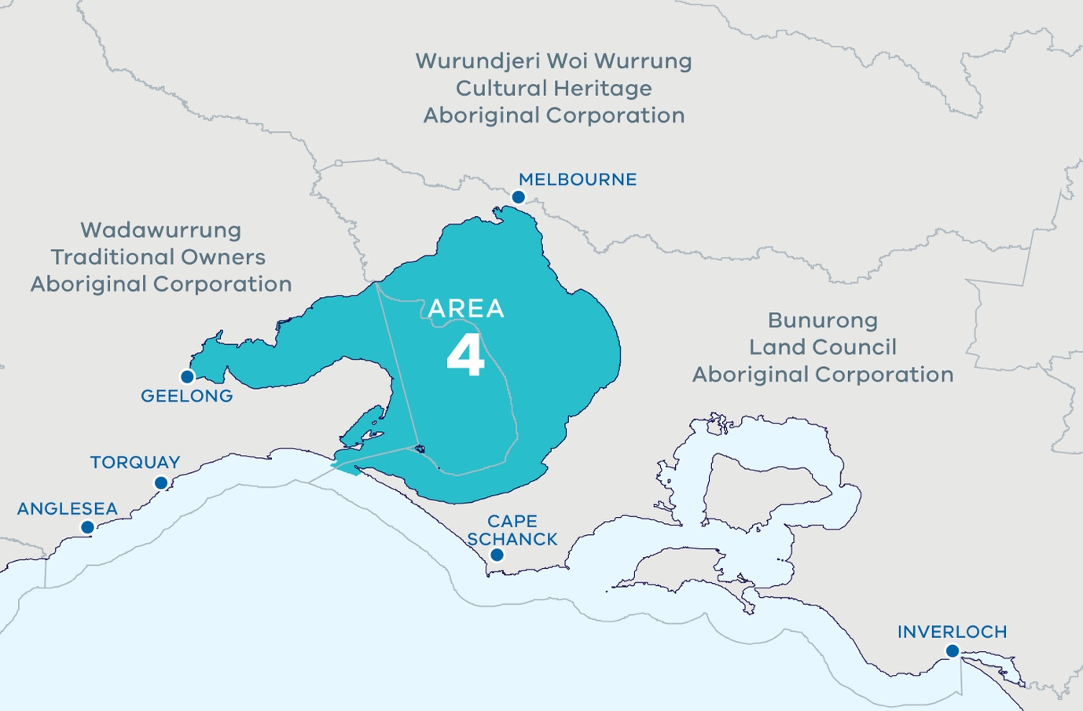

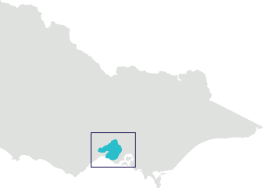

Use and activity categories
- Traditional owner cultural values and uses
- Recreation, leisure, and tourism
- Extraction of living resources
- Production of living resources
- Marine transport
- Coastal infrastructure and management activities
- Energy generation

Traditional Owner cultural landscape and some areas of significance
Registered Aboriginal Parties
- Wadawurrung Traditional Owners Aboriginal Corporation
- Bunurong Land Council Aboriginal Corporation
- Wurundjeri Woi Wurrung Cultural Heritage Aboriginal Corporation
- Section of the marine planning area is yet to be registered.
- Living areas with middens, burials sites, fish traps, cultural places and resources along Port Phillip Bay from Werribee River adjoining the Avalon coastal reserve, including Geelong arm and Corio/Corio Bay as a more recently submerged cultural landscape.
- At end of last interglacial phase, about 6000 years ago, sea level rose to flood large flat plains of Port Phillip where Aboriginal communities hunted animals and collected food.
- Over 200 Aboriginal archaeological sites recorded in Point Nepean National Park and Mornington Peninsula National Park, predominantly shell middens, stone artefacts.
- Large shell middens recorded at Buckley Park Foreshore Reserve and Swan Bay shoreline.
- Middens, burial sites, rock wells and stone tools along coast between Williamstown and Werribee, in Jawbone Marine Sanctuary, Beaumaris coast.

Biounits
- Port Phillip Heads
- Port Phillip Bay
When undertaking a process in this area consideration should be given to the Bellarine‑Mornington biounit

Coastal sediment compartments
- Port Phillip Bay (mouth)
- Port Phillip Bay (east)
- Port Phillip Bay (west)

Designated areas of importance
- Marine National Parks (Port Philip Heads Marine National Park)
- Marine Sanctuaries (Point Cooke Marine Sanctuary, Jawbone Marine Sanctuary, Ricketts Point Marine Sanctuary)
- Ramsar site (Port Phillip Bay (Western Shoreline) and Bellarine Peninsula Ramsar site)
- UNESCO Mornington Peninsula and Western Port Biosphere Reserve
- Swan Bay, Mud Islands, Point Lonsdale, Point Nepean, Popes Eye, Portsea Hole, Schnapper Deep, Capel Sound, Lonsdale Bight, Nepean Bay, Corio Bay northern shoreline, Point Wilson Pier, Great Sands eastern bank
- Ticonderoga Bay sanctuary zone
- Adjacent: Point Nepean National Park

Marine Planning Area 5

Location
From western Cape Schanck to west of Harmers Haven including estuaries (Hanns Inlet, Hastings Bight, Watsons Inlet, Rutherford Inlet, Sawtells Inlet, Bass River, Swan Bay, Powlett River).
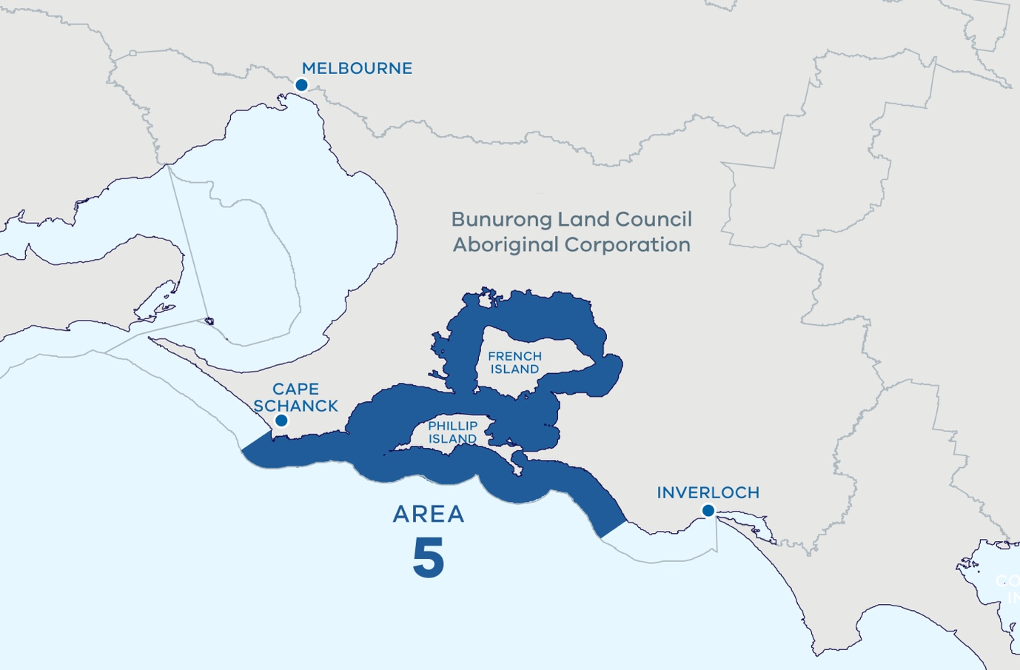

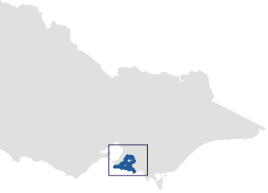

Use and activity categories
- Traditional owner cultural values and uses
- Recreation, leisure, and tourism
- Extraction of living resources
- Production of living resources
- Marine transport
- Coastal infrastructure and management activities
- Energy generation

Traditional Owner cultural landscape and some areas of significance
Registered Aboriginal Party
- Bunurong Land Council Aboriginal Corporation
- 217 registered sites in Phillip Island Nature Parks, mostly on southern coastline.
- Three shell middens near Mushroom Reef Marine Sanctuary and fish trap in intertidal reefs.
- Middens identified around Coal Point and Wonthaggi Heathlands Reserve.

Biounits
- Schanck-Woolamai
- Western Port
- Wonthaggi
When undertaking a process in this area consideration should be given to the Bellarine-Mornington biounit and the Bunurong Biounit.

Coastal sediment compartments
- Nepean Peninsula
- Cape Schanck-Flinders
- Western Port
- Phillip Island (south)
- Cape Woolamai – Cape Paterson

Designated areas of importance
- Marine National Parks (Churchill Island Marine National Park, Yaringa Marine National Park, French Island Marine National Park)
- Yallock-Bulluk Marine and Coastal Park
- Marine Sanctuaries (Mushroom Reef Marine Sanctuary)
- UNESCO Mornington Peninsula and Western Port Biosphere Reserve
- Ramsar site (Western Port Ramsar site)
- French Island, Phillip Island, Sandstone Island, Quail Island, Chinaman Island, Barrallier Island, Pelican Island, Elizabeth Island, Reef Island, Churchill Island, Seal Rocks, Pyramid Rock, Cape Schanck reefs
- Adjacent: Mornington Peninsula National Park, Phillip Island Nature Park, French Island National Park

Marine Planning Area 6

Location
From east of Coal Point to east of Nooramunga, including estuaries (Anderson Inlet, Shallow Inlet, Darby River, Tidal River, Corner Inlet, Franklin River, Agnes River, Chinamans Creek, Albert River, Tarra River) and the Cliffy Group and Hogan Group of islands.
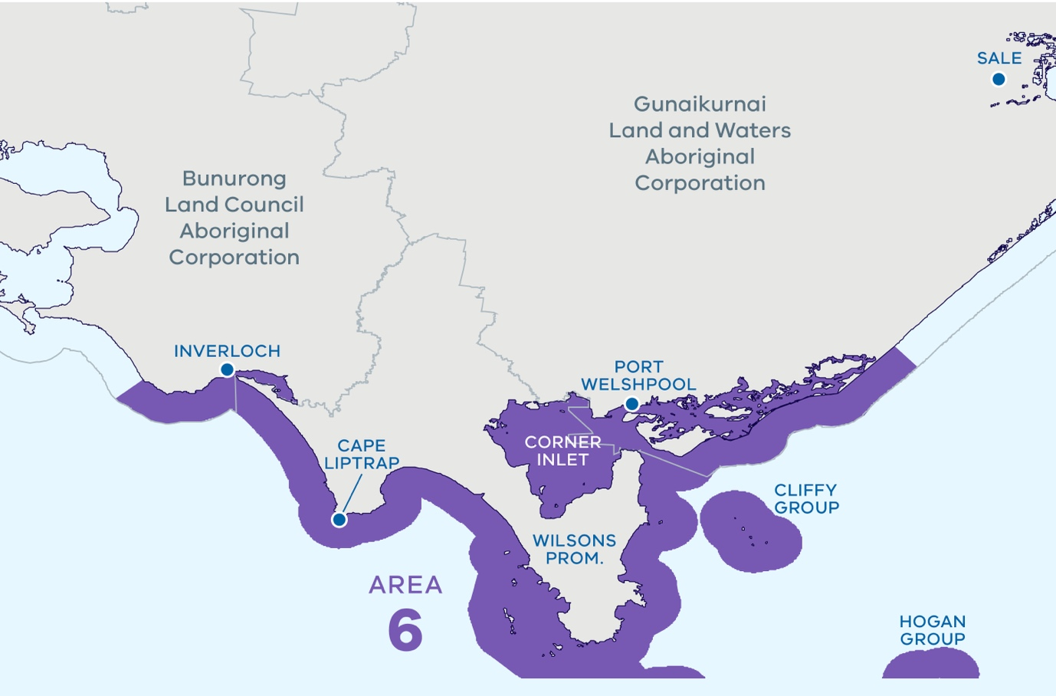

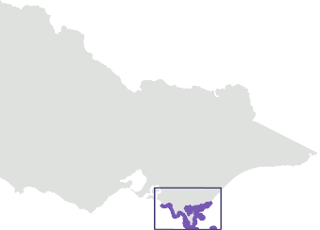

Use and activity categories
- Traditional Owner cultural values and uses
- Recreation, leisure, and tourism
- Extraction of living resources
- Marine transport
- Coastal infrastructure and management activities
- Energy generation

Traditional Owner cultural landscape and some areas of significance
Registered Aboriginal Party
- Bunurong Land Council Aboriginal Corporation
- Section of the marine planning area is yet to be registered.
- Gunaikurnai Land and Waters Aboriginal Corporation (Prescribed Body Corporate under the Native Title Act 1993).
- Numerous archaeological sites include occupation sites at Morgan Creek, near Point Smythe, at Ten Mile Creek, Five Mile Creek and near Bell Point.
- The unregistered area is of interest to the Gunaikurnai Land and Waters Aboriginal Corporation and Gunaikurnai people.
  - The entire marine planning area including from coastal areas to marine is Sea Country for the Gunaikurnai: the Gunaikurnai cultural landscape is interconnected and includes land, sea and water.
  - Cultural places and objects in the area show evidence of the Gunaikurnai people living there and using the natural resources at least 6500 years ago.
- Significant intangible cultural heritage associated with the area, including but not limited to elements such as song, dance, stories, places – and living bio-cultural values – such as culturally significant plants and animals.
- Cultural places and objects, including in areas that are submerged due to sea level rise since the last glacial period.
- Cultural significance of the Wilsons Promontory and surrounding areas – land and sea – make it a very valuable place to the Gunaikurnai People.
- Many cultural heritage sites including ancestral remains, shell middens, artefact scatters found through cultural heritage survey, and many areas yet to be surveyed.
- Recent surveys by GLaWAC in the Corner Inlet and Nooramunga Marine Park area identified that of the 47 sites surveyed, 36 were at extreme risk of inundation by 2024.
- The waterways, lakes system and open ocean were the maritime routes for the Gunaikurnai ancestors.
- The entire marine planning area including from coastal areas to marine is Sea Country for the Gunaikurnai: the Gunaikurnai cultural landscape is interconnected and includes land, sea and water.
- Islands off Yiruk (Wilsons Promontory) are especially significant – White Rock (Seal Group) and Rabbit Island.

Biounits
- Bunurong
- Cape Liptrap
- Wilsons Prom West
- Wilsons Prom East
- Cliffy Group
- Hogan Group North
- Corner Inlet
- Nooramunga
When undertaking a process in this area consideration should be given to the Wonthaggi biounit and the boundary between the Nooramunga biounit and Ninety Mile Beach biounit.

Coastal sediment compartments
- Cape Woolamai – Cape Paterson
- Venus Bay
- Waratah Bay
- Wilsons Promontory (southwest)
- Wilsons Promontory (east)
- Corner Inlet

Designated areas of importance
- Marine National Parks (Bunurong Marine National Park, Wilsons Promontory Marine National Park, Corner Inlet Marine National Park)
- Yallock-Bulluk Marine and Coastal Park
- Little Snake Island, Sunday Island, Saint Margaret Island, Snake Island, Clonmel Island, Box Bank, Dream Island
- Shallow Inlet Marine and Coastal Park
- Wilsons Promontory Marine Park
- Wilsons Promontory Marine Reserve
- Corner Inlet Marine and Coastal Park
- Nooramunga Marine and Coastal Park
- Ramsar site (Corner Inlet Ramsar site)
- Rabbit Island, Cliffy Group and Hogan Group
- Adjacent: Cape Liptrap Coastal Park, Wilsons Promontory National Park, Corner Inlet Marine National Park, Beagle Marine Park (Commonwealth jurisdiction)

Marine Planning Area 7

Location
From east of Nooramunga to west of the Snowy River mouth, including the Gippsland Lakes.
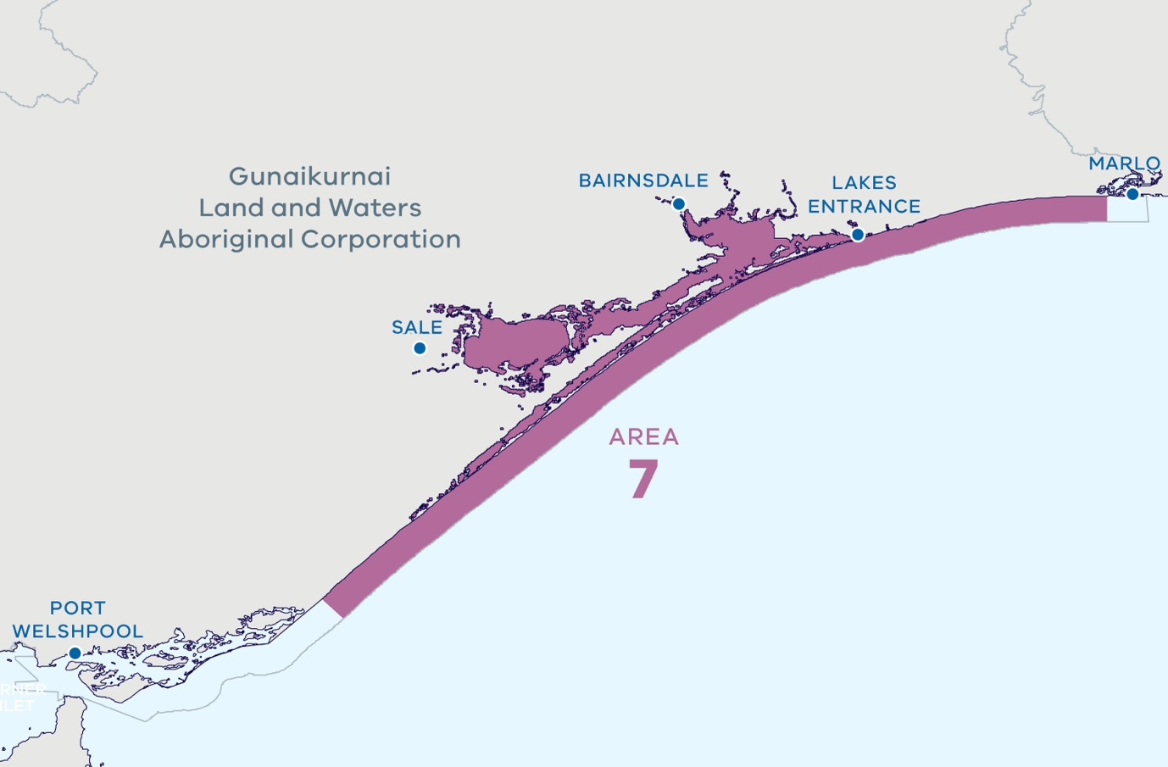

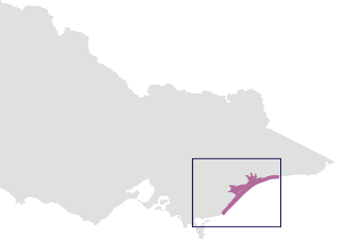

Use and activity categories
- Traditional Owner cultural values and uses
- Recreation, leisure, and tourism
- Extraction of living resources
- Marine transport
- Coastal infrastructure and management activities
- Energy generation

Traditional Owner cultural landscape and some areas of significance
Registered Aboriginal Party
- Gunaikurnai Land and Waters Aboriginal Corporation (Prescribed Body Corporate under the Native Title Act 1993):
  - Brataualung Country
  - Tatungalung Country
  - Krauatungalung Country.
- This Area is linked to very high settlement patterns, evidenced by having one of the highest recorded incidences of Aboriginal tangible cultural heritage sites in Victoria, including middens with shellfish remains, charcoal, scorched pebble, burial grounds, scar trees, artefact scatters and massacre sites.
- The entire marine planning area including from coastal areas to marine is Sea Country for the Gunaikurnai: the Gunaikurnai cultural landscape is interconnected and includes land, sea and water.
- Key areas of interest include but are not limited to:
  - Burnt Bridge Reserve in Lake Tyers, a popular gathering place and ochre site, and tangible cultural heritage including scar trees, artefact scatters, birthing places and burial sites.
  - The towns of Lakes Entrance, Metung and Paynesville which were developed on the camping grounds of the Gunaikurnai ancestors.
  - Caves, shelter places and burial grounds throughout Mitchell River where human remains have been found.
  - The maritime routes, for example Gunaikurnai old people travelling from Pelican Bay and Sperm Whale Head, and to the islands in the marine environment.
  - Significant intangible cultural heritage associated with the area, including but not limited to elements such as song, dance, stories, places – and living bio-cultural values – such as culturally significant plants and animals.

Biounits
- Ninety Mile Beach
- Gippsland Lakes
When undertaking a process in this area consideration should be given to the boundary between the Nooramunga biounit and Ninety Mile Beach biounit and the boundary between the Ninety Mile Beach biounit and the Cape Conran biounit.

Coastal sediment compartments
- Corner Inlet
- Gippsland Lakes
- Snowy River

Designated areas of importance
- Marine National Parks (Ninety Mile Beach Marine National Park)
- Ramsar site (Gippsland Lakes Ramsar site)
- Jack Smith Lake and Lake Tyers
- Latrobe River, Avon River, Mitchell River, Nicholson River, Tambo River
- Adjacent: Gippsland Lakes Coastal Park

Marine Planning Area 8

Location
West of the Snowy River mouth to the New South Wales border.
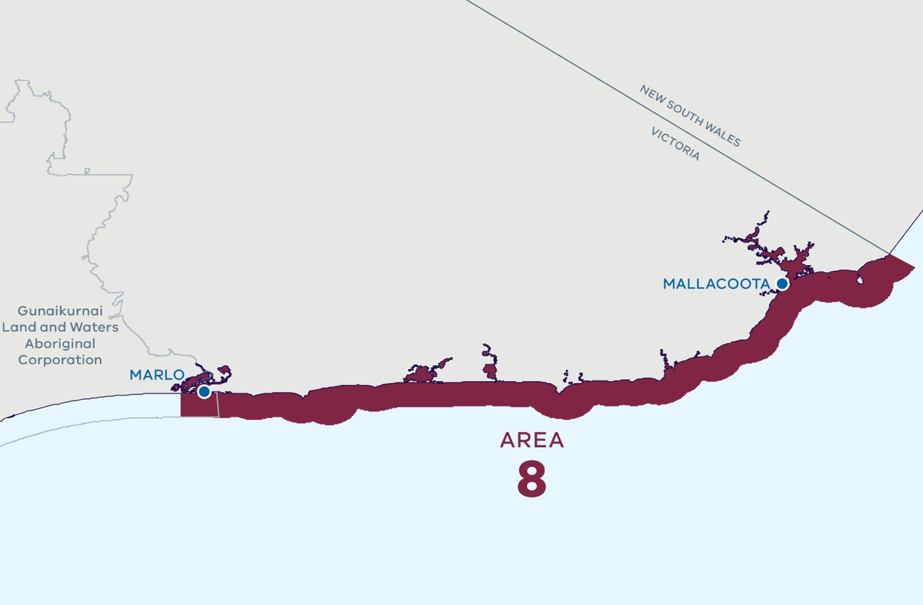

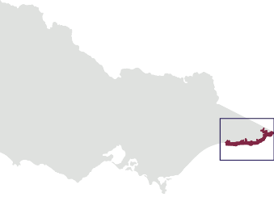

Use and activity categories
- Traditional Owner cultural values and uses
- Recreation, leisure, and tourism
- Extraction of living resources
- Marine transport
- Coastal infrastructure and management activities
- Energy generation

Traditional Owner cultural landscape and some areas highly significant to Gunaikurnai people
Registered Aboriginal Party
- Gunaikurnai Land and Waters Aboriginal Corporation (Prescribed Body Corporate under the Native Title Act 1993)
- Traditional Owners of Far East Gippsland assert rights and interests in the area.
- Krauatungalung Country along the coast from Snowy River to Mallacoota back to the coastal range.
- Extensive sites with middens and stone tools.

Biounits
- Cape Conran
- Point Hicks
- Croajingolong
- Gabo-Howe
When undertaking a process in this area consideration should be given to the boundary between the Ninety Mile Beach biounit and the Cape Conran biounit.

Coastal sediment compartments
- Snowy River
- Cann River
- Mallacoota Inlet

Designated areas of importance
- Marine National Parks (Point Hicks Marine National Park, Cape Howe Marine National Park)
- Marine Sanctuaries (Beware Reef Marine Sanctuary)
- Bemm River upwelling
- Snowy River, Yeerung River, Sydenham Inlet, Tamboon Inlet, Thurra River, Mueller River, Wingan Inlet, Easby Creek, Red River, Benedore River, Shipwreck Creek, Betka River, Mallacoota Inlet
- Gabo Island, Tullaberga Island
- Cape Conran, Point Hicks Cape, Everard Canyon
- Adjacent: Cape Conran Coastal Park, Croajingolong National Park
The new Department of Energy, Environment and Climate Action (DEECA) was established on 1 January 2023. This department includes the previous functions of the Department of Environment, Land, Water and Planning, excluding the Planning portfolio and those areas supporting it which are now part of the New Department of Transport and Planning.
© The State of Victoria Department of Energy, Environment and Climate Action 2023
This work is licensed under a Creative Commons Attribution 4.0 International licence. You are free to re-use the work under that licence, on the condition that you credit the State of Victoria as author. The licence does not apply to any images, photographs or branding, including the Victorian Coat of Arms, the Victorian Government logo and the Department of Energy, Environment and Climate Action (DECCA) logo. To view a copy of this licence, visit http://creativecommons.org/licenses/by/4.0/
ISBN 978-1-76136-081-7 (pdf/online/MS word)

Disclaimer
This publication may be of assistance to you but the State of Victoria and its employees do not guarantee that the publication is without flaw of any kind or is wholly appropriate for your particular purposes and therefore disclaims all liability for any error, loss or other consequence which may arise from you relying on any information in this publication.

Accessibility
If you would like to receive this publication in an alternative format,
please telephone the DECCA Customer Service Centre on 136186, email customer.service@delwp.vic.gov.au, or via the National Relay Service on 133 677 relayservice.com.au. This document is also available on the internet at delwp.vic.gov.au.

Victorian Environmental Assessment Council (VEAC) (2019) Assessment of the Values of Victoria’s Marine Environment – Report. Victorian Environmental Assessment Council, Melbourne
Victorian Environmental Assessment Council (VEAC) (2019) Assessment of the Values of Victoria’s Marine Environment– Atlas. Victorian Environmental Assessment Council, Melbourne
Edmunds, M. and Flynn, A. (2018) Victorian marine biogeographical settings, Australian Marine Ecology Report No. 559. Report to the Department of Environment, Land, Water and Planning, Melbourne
Kent, J. and Jenkins, G.P. (2012) Ecological descriptions of the significant marine environmental assets of Victoria: Interim Report. Fisheries Victoria Technical Report No. 177. Department of Primary Industries, Queenscliff
Thom, B. (2015) Coastal compartments project summary for policy makers. Report by Geoscience Australia for the Department of Environment, Canberra
University of Tasmania (2021) Technical report to support identification of statewide marine planning areas and areas of interest for marine spatial planning. Report for the Department of Environment, Land, Water and Planning, Melbourne
The State of Victoria Department of Energy, Environment and Climate Action (DEECA) (2023) Marine Spatial Planning Guidelines
Victorian Environmental Assessment Council (VEAC) (2019) Assessment of the Values of Victoria’s Marine Environment– Atlas. Victorian Environmental Assessment Council, Melbourne.
Victorian Environmental Assessment Council (VEAC) (2019) Assessment of the Values of Victoria’s Marine Environment– Atlas. Victorian Environmental Assessment Council, Melbourne.
Federation of Victorian Traditional Owner Corporations (2021) Victorian Traditional Owner Cultural Landscapes Strategy
Edmunds, M. and Flynn, A. (2018) Victorian marine biogeographical settings, Australian Marine Ecology Report No. 559. Report to the Department of Environment, Land, Water and Planning, Melbourne
Thom, B. (2015) Coastal compartments project summary for policy makers. Report by Geoscience Australia for the Department of Environment, Canberra
Edmunds, M., Flynn, A., Nordinson, A., Ferns, L., Holden, R., Hobley, T., Cecino, G., Mazor, T. (2021). Feature Activity Sensitivity Tool (FeAST), qCore database and CoastKit. Department for Environment, Land, Water and Planning (DELWP)

