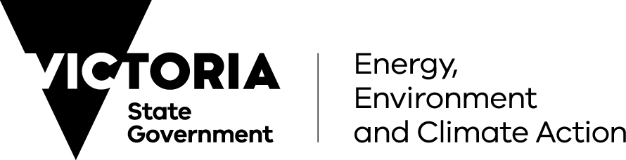

Coastal and Marine Management Plan Guidelines

2023
Acknowledgment*
Traditional Owners have never surrendered rights to Country. The Victorian Government acknowledges Aboriginal people as Australia’s first people, and as the Traditional Owners and custodians of the land on which we work and live.
We recognise the strength of Aboriginal people and the need for reconciliation and genuine partnerships to address the negative impacts of the past.
Traditional Owners have an unbroken custodianship of the land and seas that extends back tens of thousands of years. Their knowledge, understanding, and relationships to Country are fundamental to the health of the environment and the success of any strategy to manage that environment.
We recognise and value the ongoing contribution of Aboriginal people and communities to Victorian life and how this enriches us all. We recognise that Aboriginal cultures and communities are diverse, and the value we gain in celebrating these cultures and communities.
We embrace the spirit of reconciliation, working towards the equality of outcomes and ensuring an equal voice.
We have distinct legislative obligations to Traditional Owner groups that are paramount in our responsibilities in managing Victoria’s resources.
Note: This document has used the term Traditional Owners in reference to all Traditional Owners/Registered Aboriginal Parties along the Victorian coast.
*The Marine and Coastal Strategy 2022
© The State of Victoria Department of Energy, Environment and Climate Action 2023
Creative Commons
This work is licensed under a Creative Commons Attribution 4.0 International licence. You are free to re-use the work under that licence, on the condition that you credit the State of Victoria as author. The licence does not apply to any images, photographs or branding, including the Victorian Coat of Arms, the Victorian Government logo and the Department of Energy, Environment and Climate Action (DEECA) logo. To view a copy of this licence, visit the Creative Commons website.
Printed by Finsbury Green, Melbourne.
ISBN 978-1-76136-279-8 (print)
ISBN 978-1-76136-280-4 (pdf/online/MS word)
Disclaimer
This publication may be of assistance to you but the State of Victoria and its employees do not guarantee that the publication is without flaw of any kind or is wholly appropriate for your particular purposes and therefore disclaims all liability for any error, loss or other consequence which may arise from you relying on any information in this publication.
Accessibility
If you would like to receive this publication in an alternative format, please telephone the Department of Energy, Environment and Climate Action Customer Service Centre on 136186, email Customer Service, or contact National Relay Service on 133 677. This document is also available on our website.
Contents
Part 1: Introduction 3
About these guidelines 3
Coastal and Marine Management Plans 3
Legislative and policy context 4
Why prepare a CMMP 5
What must be included in a CMMP 5
The Planning and Decision Pathway 6
Where the guidelines apply 8
Who is responsible for preparing a CMMP 9
Land managers 9
Other agencies with intersecting responsibilities 9
Local governments 10
Parks Victoria 10
Waterway managers, harbour managers and port operators 10
Catchment Management Authorities 11
Part 2: Quick reference guide 12
Preparing a CMMP 12
1. Identify the scope 13
1.1 Engage with the local DEECA office 13
1.2 Contact Traditional Owners 14
1.3 Determine the CMMP area 15
1.4 Establish governance and advice arrangements 15
1.5 Plan stakeholder engagement 17
2. Determine values, impacts and opportunities 18
2.1 Gather information on values 18
2.2 Gather information on issues and risks 20
2.3 Confirm values, impacts and issues with stakeholders 22
3. Prepare and finalise the CMMP 22
3.1 Write the draft CMMP 22
3.2 Consult on the draft CMMP 25
3.3 Finalise the CMMP 26
3.4 Gain approval for the CMMP 26
4. Implement, monitor, evaluate, report and improve 27
4.1 Implementation 27
4.2 Monitor, evaluate, report and improve 27
Part 3: Additional guidance 29
Additional guidance – identify the scope 31
Plan stakeholder engagement (1.5) 31
Additional guidance – determine values, impacts and opportunities 33
Gather information on values (2.1) 33
Gather information on issues and risks (2.2) 38
Confirm values, impacts and options with stakeholders (2.3) 40
Additional guidance – prepare and finalise the CMMP 40
Write the draft CMMP (3.1) 40
Gain approval for the final CMMP (3.4) 52
Additional guidance – implement, monitor, evaluate, report and improve 52
Ongoing monitoring, evaluation, reporting and improvement (4.2.1) 52
Appendices 54
Appendix 1: Planning hierarchy of documents, decision making and advice under the Marine and Coastal Act 2018 54
Appendix 2: Definitions and acronyms 54
Appendix 3: Links to the Marine and Coastal Policy 2020 56

Part 1: Introduction

About these guidelines
These Coastal and Marine Management Plan Guidelines (the guidelines) have been developed by the Department of Energy, Environment and Climate Action (DEECA) to assist land managers in preparing Coastal and Marine Management Plans (CMMPs).
They replace the 2017 Guidelines for Coastal Management Plans and have been designed to support land managers to comply with the Act and the Policy with a step-by-step process for the development of CMMPs.
The guidelines include:
- an emphasis on working with Traditional Owners
- a focus on responding to climate change, population growth and ageing infrastructure
- consideration of the impacts of current and future use and development of the marine and coastal environment
- an emphasis on engagement
a process for consultation and approvals, including with local government, DEECA, the Victorian Marine and Coastal Council (VMaCC) and the Minister responsible for the Act.
The guidelines are divided into three parts:
Part 1: Introduction
Provides an overview of key information relating to CMMPs, including why a land manager would prepare a CMMP, what must be included in a plan and where the guidelines apply.
Part 2: Quick reference guide
Describes the steps of preparing and implementing a CMMP.
Part 3: Additional guidance
Provides further information and detail for completing a CMMP.

Coastal and Marine Management Plans
A Coastal and Marine Management Plan (CMMP) is a local-scale strategic plan that acts as the primary tool for the management of marine and coastal Crown land.
A CMMP is prepared by a marine and coastal Crown land manager (a land manager) appointed to manage an area of marine and coastal Crown land.
A CMMP is a mechanism for land managers to implement an agreed vision for an area of the marine and coastal environment. CMMPs are a way to prioritise and manage demand and conflicting uses now and in the future. They also translate objectives, aspirations and values for an area into on-ground action.
A CMMP’s priorities come from legislation and policy, as well as engagement with Traditional Owners and stakeholders including the local community.
A CMMP can cover multiple reserves with different land managers. CMMPs are approved by the Minister for Environment under the Marine and Coastal Act 2018 (the Act) and must be reviewed every 5 years after commencement.

Legislative and policy context
The Act establishes a whole-of-government approach for protecting and managing our marine and coastal environment.
The Act’s objectives include recognising Traditional Owner knowledge, rights and aspirations for land and sea Country and promoting the resilience of ecosystems and communities to climate change. A CMMP will implement these objectives at the local scale.
The Marine and Coastal Policy 2020 (the Policy), made under the Act sets a 15-year vision:
“for a healthy, dynamic and biodiverse marine and coastal environment that is valued in its own right, and that benefits the Victorian community, now and in the future.”
A CMMP realises this vision through place-based management of marine and coastal Crown land.
In line with the Policy, a CMMP should reflect Traditional Owner needs, priorities and assertions, encourage planning and management at a landscape scale, and facilitate integration of planning and management across the marine and coastal environment.
Appendix 1 provides detail on the legislative, policy and planning framework for preparing CMMPs.

Why prepare a CMMP
All marine and coastal Crown land should have a CMMP. The purpose of a CMMP is to provide direction for the future local management of an area of marine and coastal Crown land. The Act enables the Minister to specify that a CMMP must be made for a particular area of marine and coastal Crown land.
Developing a CMMP is an opportunity for land managers to engage with rights holders (including Traditional Owners), the community, agencies and other stakeholders. This engagement informs a shared understanding of values, knowledge and aspirations for the CMMP area. Using this understanding, land managers can prioritise management actions in line with the Policy.
An approved CMMP shows how a land manager will achieve the management vision for an area of marine and coastal Crown land, which:
- protects and enhances the environmental, social, cultural and economic values of the marine and coastal environment now and in the future
- balances competing uses of finite, unique and sensitive resources
- enhances the benefits of ecosystem goods and services provided by the marine and coastal environment
ensures collaboration with other land managers and agencies to align objectives and outcomes.

What must be included in a CMMP
A CMMP must include the following components which are assessed by DEECA in the review and approvals process (Table 1). The assessment will consider if the CMMP is consistent with policies, strategies and the legislative framework outlined in the Act (Part 7 (59)).
Table 1: Components that must be included in a CMMP
Component | Description
Area | The area covered by the plan
Vision | An agreed 15+ year vision for the area to extend beyond the 5-year span of the CMMP. Note: the vision is to set out priorities for the area that go beyond the life of the CMMP
Collaboration | Arrangements for working with Traditional Owners, the community, adjacent land managers, landowners and stakeholders in delivering and reviewing the plan
Values | Values of the area (natural, cultural, social and economic) determined in consultation with rights holders and stakeholders
*Description of use and development | A description of the proposed use, development and works for the area to which the plan applies, including both low-impact and major developments
Challenges | Current and future challenges and issues, and how these affect the area, including: marine and coastal hazards, climate change, pollution, pests, weeds and vegetation management, conflicting uses, population change, ageing infrastructure and habitat loss
Objectives | The objectives for the 5-year life of the CMMP (aligned with the long-term vision)
Actions | Actions required to achieve the objectives of the CMMP
Planning | How and when the actions will be implemented (e.g. precinct planning, priority recreation and activity nodes, master plans)
*Implementation plan | An implementation plan, including proposed timeframes for implementation of actions and agencies responsible for delivering those actions
Resourcing | How implementation of the actions will be resourced
*Monitoring, evaluation, reporting and implementation framework | A framework to monitor, evaluate and report on the implementation of the plan
* Components required by the Act

The Planning and Decision Pathway
The Policy includes a Planning and Decision Pathway (Figure 1) that sets out how the objectives and guiding principles of the Act are to be used in decision making for the marine and coastal environment. Applying the Planning and Decision Pathway in developing a CMMP assists land managers to protect and enhance the values of the marine and coastal environment, devise sustainable responses to increasing demand from human activity, prioritise funding and adapt to future risks.
The Planning and Decision Pathway should be considered at all decision points of the CMMP development process.
The Process on a Page (refer Figure 4 in Additional Guidance) shows some of the links between the Planning and Decision Pathway and the process of developing a CMMP.
Figure 1: Planning and Decision Pathway from the Marine and Coastal Policy 2020
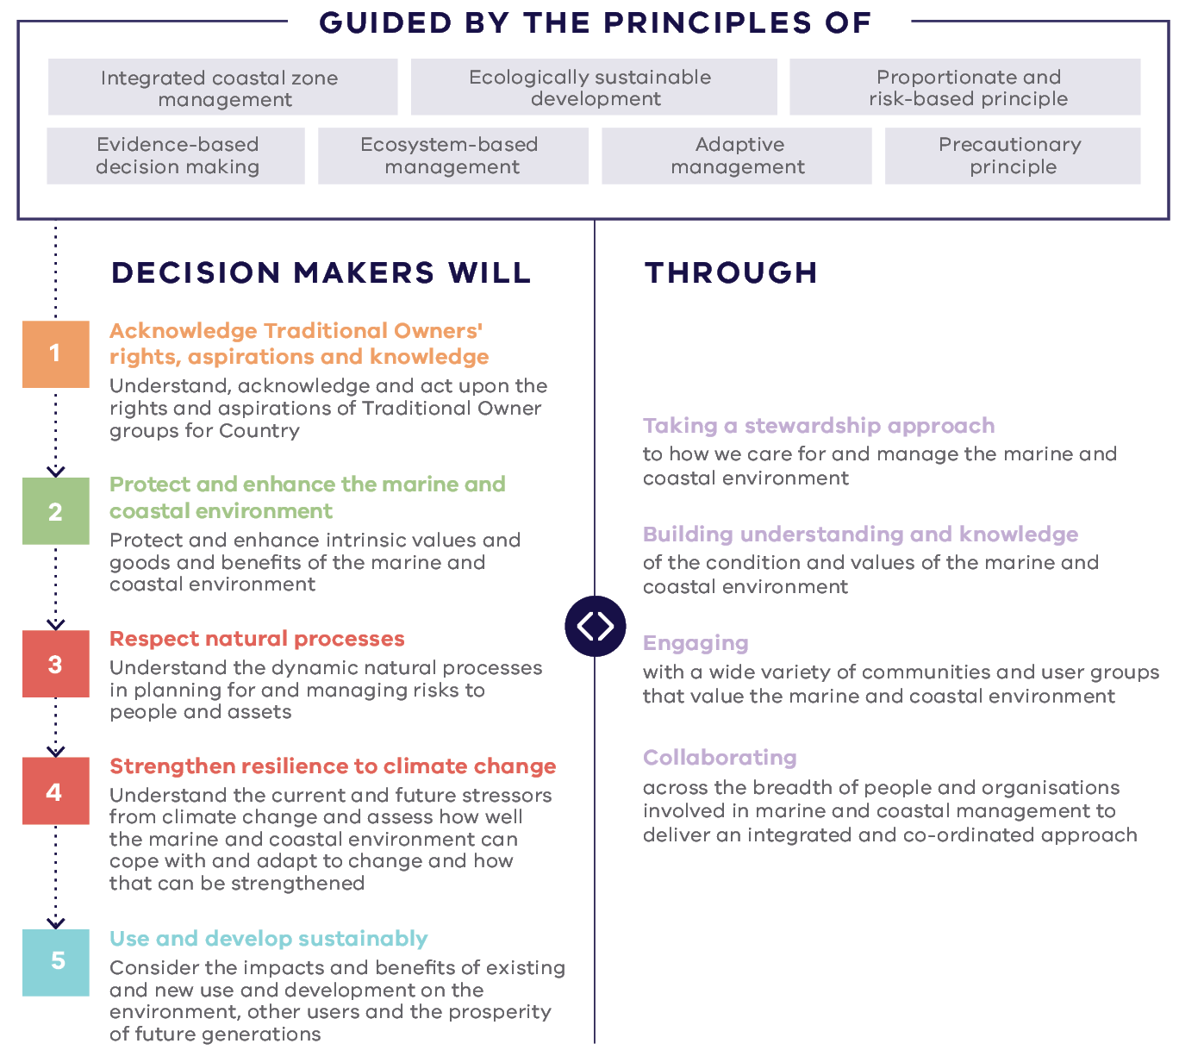
Guided by the principles of:
- Integrated coastal zone management
- Ecologically sustainable development
- Proportionate and risk-based principle
- Evidence-based decision making
- Ecosystem-based management
- Adaptive management
Precautionary principle
Decision makers will:
- One: Acknowledge Traditional Owners’ rights, aspirations and knowledge. Understand, acknowledge and act upon the rights and aspirations of Traditional Owner groups for Country
- Two: Protect and enhance the marine and coastal environment. Protect and enhance intrinsic values and goods and benefits of the marine and coastal environment.
- Three: Respect natural processes. Understand the dynamic natural processes in planning for and managing risks to people and assets.
- Four: Strengthen resilience to climate change. Understand the current and future stressors from climate change and assess how well the marine and coastal environment can cope with and adapt to change and how that can be strengthened.
Five: Use and develop sustainably. Consider impacts and benefits of existing and new use and development on the environment, other users and the prosperity of future generations.
This will be done through:
- Taking a stewardship approach to how we care for and manage the marine and coastal environment
- Building understanding and knowledge of the condition and values of the marine and coastal environment
- Engaging with a wide variety of communities and user groups that value the marine and coastal environment
Collaborating across the breadth of people and organisations involved in marine and coastal management to deliver an integrated and co-ordinated approach

Where the guidelines apply
The Act enables a CMMP to be made for any area of marine and coastal Crown land and adjoining Crown land. Marine and coastal Crown land is defined in the Act (section 57 (2)) as the area up to 200 metres inland from the high-water mark (Figure 2).
Land managers can determine and advise the Minister on the area of marine and coastal Crown land to be covered by a CMMP.
The guidelines provide instruction on how the CMMP area should be determined (see 1.3 in Part 1: Quick reference guide).
Figure 2: Areas where the Policy applies. A CMMP can be made for any area of marine and coastal Crown land (indicated by the light blue arrows).
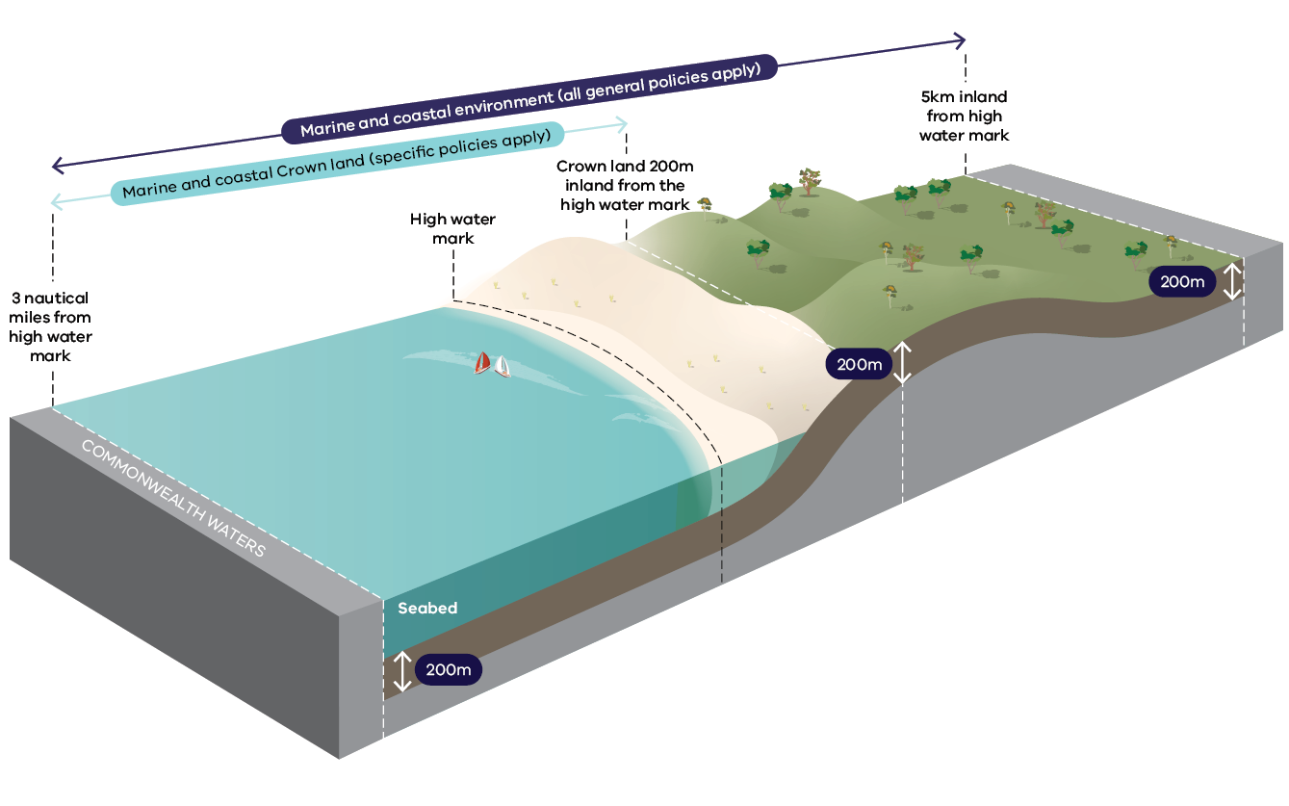

Who is responsible for preparing a CMMP

Land managers
A CMMP is prepared by a land manager appointed to manage a coastal and/or marine area.
The size and scope of a CMMP will reflect the complexity of that area. A CMMP may be made for a single reserve or for an area where a land manager is responsible for the management of multiple reserves. CMMPs may also be made for areas that cross multiple land management boundaries. CMMPs can extend into the marine environment, e.g. to include the management of marinas, piers or jetties.
When multiple land managers work together to prepare a CMMP, one of the land managers will assume the lead role. Generally, the lead agency will be the land manager who has the resources and capacity to prepare a CMMP.

Other agencies with intersecting responsibilities
Collaboration is fundamental to the preparation of a CMMP. While a land manager may be appointed to manage a coastal reserve, there will be other public agencies and asset managers with intersecting responsibilities.
Land managers must work with adjoining land and water managers to plan for integrated and coordinated management across the marine and coastal environment.
Comprehensive engagement with other agencies in the CMMP preparation process will assist in developing and delivering joint objectives and shared outcomes that are aligned to each agency’s role and responsibilities. These agencies and asset managers must be included in decision making and CMMP project governance.
Land managers need to understand the impacts that works may have on the marine and coastal environment and existing infrastructure, including land adjacent to the CMMP area. Many issues considered in a CMMP cross traditional administrative boundaries, for example:
- coastal processes
- habitat corridors, wildlife movement and food change management
- invasive species management
- asset management
visitor use.
Sharing data and resources across agencies will improve the management of these issues, as well as the overall condition and ecological connectivity of habitats.

Local governments
Local governments are responsible for municipal services such as drainage and stormwater infrastructure. They may also be the land manager for some of the reserves and infrastructure nearby or along the coast.

Parks Victoria
Parks Victoria is responsible for the management of marine national parks and sanctuaries, national parks, and conservation reserves along the coast. Parks Victoria also manages Port Phillip Bay, Western Port Bay and Yarra waterways, as well as most piers and jetties around Port Phillip Bay and Western Port Bay.

Waterway managers, harbour managers and port operators
Waterway managers are responsible for the operation of ports and infrastructure that is accessed via the coast including harbours, piers, jetties, moorings and berths.
Waterway managers, harbour managers and port operators have obligations to dredge and maintain channels and berths to allow the safe navigation of vessels through port waters.
Engaging with these managers and operators is important in developing a CMMP to ensure their obligations can be integrated.

Catchment Management Authorities
Catchment Management Authorities (CMAs) are responsible for the integrated planning and coordination of land, water and biodiversity management in a catchment area. CMMPs can help identify actions to address the impacts from the broader catchment on the marine and coastal environment. CMMPs can also help to deliver Regional Catchment Strategies.

Part 2: Quick reference guide

Preparing a CMMP
This section outlines the recommended process for preparing a CMMP. A range of factors affect the time required to prepare a CMMP. The resources, needs and capacity of land managers and rights holders will influence timeframes. The scope, scale and complexity of the CMMP will also influence timing. Figure 3 provides an overview of the process.
The steps below can be scaled up or down to suit the needs and capacity of land managers and the complexity of the CMMP. Some of these steps can occur concurrently (for a more detailed diagram of the process, see Figure 4 in Part 3: Additional guidance)
Figure 3: Overview of stages in the preparation of a CMMP
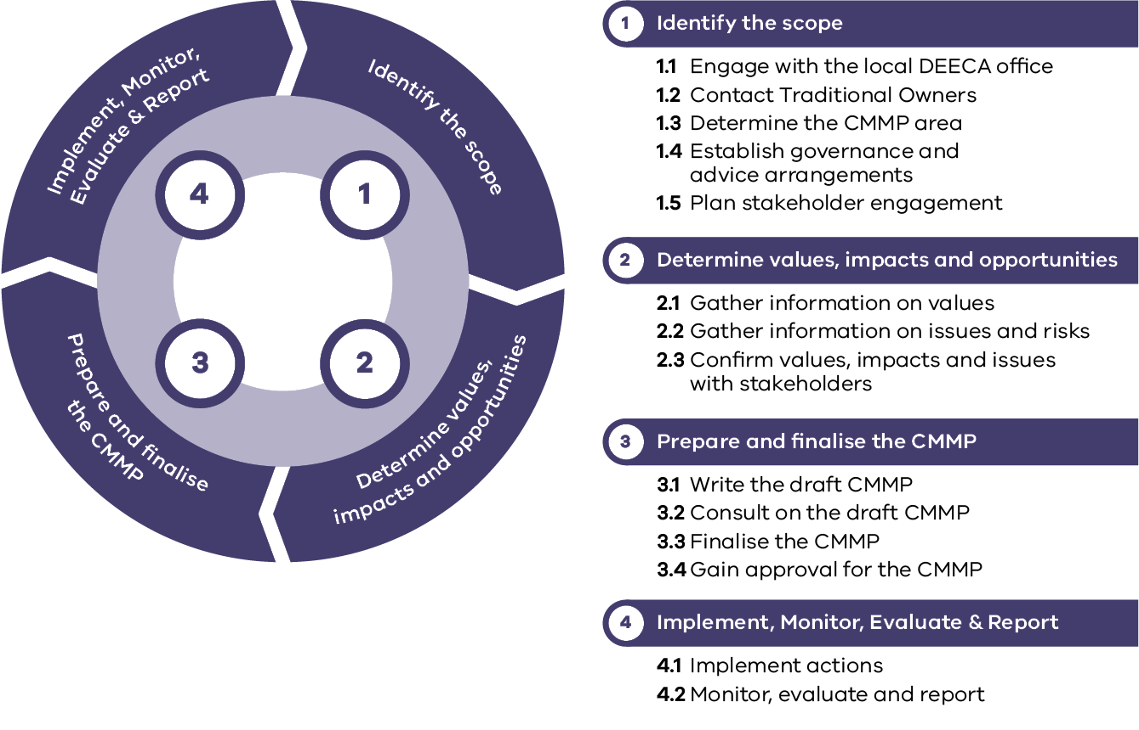
1 Identify the scope
1.1 Engage with the local DEECA office
1.2 Contact Traditional Owners
1.3 Determine the CMMP area
1.4 Establish governance and advice arrangements
1.5 Plan stakeholder engagement
2 Determine values, impacts and opportunities
2.1 Gather information on values
2.2 Gather information on issues and risks
2.3 Confirm values, impacts and issues with stakeholders
3 Prepare and finalise the CMMP
3.1 Write the draft CMMP
3.2 Consult on the draft CMMP
3.3 Finalise the CMMP
3.4 Gain approval for the CMMP
4 Implement, Monitor, Evaluate and Report
4.1 Implement actions
4.2 Monitor, evaluate and report

1. Identify the scope

1.1 Engage with the local DEECA office
Contact the local DEECA office to discuss your plans and seek advice on preparation of the CMMP
DEECA staff can provide advice on public land, biodiversity, heritage, stakeholder engagement and other matters. Initial discussions may cover:
- working with Traditional Owners
- project governance, including DEECA’s representation on the steering group
- Victorian Government policy, research, data and projects
- identifying funding options and opportunities
- consent processes for use, development or works proposals under the Act
other aspects such as stakeholder engagement.
Checking in with DEECA at key stages of the CMMP preparation will help to ensure consistency with the Act, the Policy and the Marine and Coastal Strategy 2022 (the Strategy).

1.2 Contact Traditional Owners
Contact relevant Traditional Owner groups and ask how they would like to be involved in preparing the CMMP
The guidelines use the term Traditional Owners for all Traditional Owners, Registered Aboriginal Parties and Aboriginal Victorians along the Victorian coast.
Traditional Owners are rights holders. A CMMP must acknowledge and reflect Traditional Owners’ needs, priorities, assertions, and knowledge of Country.
The way in which Traditional Owners are involved will need to be self-determined in relation to the scope of the CMMP. Therefore, only general advice can be provided in the guidelines.
Aspects of successful partnerships may include:
- working with Traditional Owners early in the process and asking if and how they would like to be involved, or partner, in each stage of the process
- planning for and allowing appropriate lead times
- being respectful of existing engagement processes established by Traditional Owners
- supporting self-determination
- respecting data sovereignty and intellectual property rights
- maintaining relationships throughout the project
- seeking assistance and advice from the local DEECA office
- referring to DEECA’s framework, Engaging with Traditional Owners and the Victorian Aboriginal Community (deeca.vic.gov.au)
- referring to any relevant Country Plan or Sea Country Plan that must be recognised in the CMMP, including reference to cultural landscapes identified in these plans
identifying opportunities to partner with Traditional Owners and integrate caring for Country knowledge and practice in the CMMP.

1.3 Determine the CMMP area
Determine the marine and coastal Crown land to be covered by the CMMP and include a map defining that area
A CMMP can apply to marine and coastal Crown land and adjoining Crown land. When determining the area to be covered by the CMMP, consider:
- systems, flows and processes in the marine and coastal environment which may go beyond management boundaries (e.g. broader sediment and coastal compartments as well as marine systems beyond the management boundary)
- adjacent Crown land, particularly if it forms part of a geomorphological coastal compartment
- integrated management of marine and coastal ecosystems and transboundary issues such as invasive species management
- the marine environment as well as the coastal environment, including structures such as piers, jetties, marinas, dive facilities, and parking for visitors using offshore facilities
study area extent for relevant data sources and models, and areas covered by relevant plans or strategies (e.g. species/ecosystem management, infrastructure, climate adaptation, other).
It is important to engage with adjoining land managers to determine whether to create a joint CMMP, or how adjoining CMMPs and similar management plans will align. Marine managers should also be engaged to determine how the CMMP will align with marine planning and management.
The CMMP area can also be further refined later in the process.

1.4 Establish governance and advice arrangements

1.4.1 Appoint a project manager
Appointing a project manager is one of the first steps in the development of a CMMP. The project manager is the direct point of contact for rights holders and stakeholders, and is responsible for:
- overall project delivery
- managing the day-to-day work program, timing and budget
- reporting to the Project Steering Group (PSG)
- stakeholder and rights holder relationships, including development of the terms of reference for the PSG, and Community Reference Groups where relevant
- maintaining the project risk register and integrating risk treatments and control activities into project plans
managing any contracts relevant to the development of the CMMP.

1.4.2 Appoint a consultant if required
An external consultant can assist land managers with preparing a CMMP, including stakeholder consultation, and drafting and finalising the plan.

1.4.3 Identify the secretariat/administrative support required
Secretariat or administrative support will be required for governance groups to ensure smooth planning, organisation and minute-taking.
It is important to identify how this support will be resourced in terms of funding and/or in-kind support from within your committee or partners.

1.4.4 Appoint a Project Steering Group
A Project Steering Group (PSG) will be required to oversee the management of larger and more complex CMMPs.
The PSG is appointed by the project manager in consultation with DEECA to take carriage and ownership of the project generally, and specifically to:
- confirm the scope of the CMMP (including confirming the CMMP area)
- advise on the stakeholder consultation process (including approving engagement and communication plans)
- decide on inclusions and exclusions at all stages of development of the CMMP
- identify and consult with relevant community reference and focus groups as required
- ensure consistency and quality assurance of documents
- advocate for the development of the CMMP
- provide agency-specific points of contact for rights holders, stakeholders and consultants as required.
- The PSG should include a representative from each of the following, where relevant:
- each land manager with responsibilities to manage land that will be included in the CMMP area
- DEECA
- Traditional Owners (if that is the role that has been self-determined)
- local government (regardless of land manager status)
- Parks Victoria (if it is the land manager of adjoining land or assets, e.g., jetties, piers, marine national parks and sanctuaries)
- port authority/waterway manager (if within or adjacent to the CMMP area)
- the CMA, Melbourne Water or other water authorities (if they have planning or management responsibilities within or adjacent to planning area)
any other managers of land or water adjacent to the planning area.

1.5 Plan stakeholder engagement

1.5.1 Identify stakeholders
Including stakeholders throughout the process promotes ownership of the CMMP, enables land managers to gather information on important values, issues and opportunities for a CMMP area, and builds support to ensure that the CMMP achieves its objectives.
It is important to identify all parties with an interest, connection or existing right associated with the marine and coastal environment within or near the CMMP area.
In all cases, the local community will be a key stakeholder in the preparation of a CMMP.
The inclusion of some stakeholders is dictated by the Act (e.g. responsible Ministers of applicable Acts, the Victorian Marine and Coastal Council (VMaCC), Registered Aboriginal Parties, municipal councils, etc.) whereas others will depend on the scope of the CMMP in question. DEECA can advise on the best approach for engaging with stakeholders required by the Act.
See 1.5.1 in Part 3: Additional guidance for details.

1.5.2 Write stakeholder engagement plan
The development of an engagement plan is critical to effective stakeholder engagement and an essential part of preparing a CMMP.
Stakeholder engagement includes engaging with communities. It is important to ensure that all parties have ownership of the CMMP during its creation, to generate greater collective investment in implementing the final CMMP.
The plan should address engagement with all stakeholders identified in the previous step.
The engagement plan should detail engagement objectives and address how stakeholders will be engaged at all stages of the CMMP preparation process.
It should include processes for feeding back to stakeholders and testing information and assumptions at key points in the development of the CMMP, e.g. through summary papers or consultation papers.
Consideration should be given to the time and resources that may be required to engage and consult with rights holders and stakeholders.
Engagement can cover topics relating to the CMMP area such as extent, values, uses, impacts and issues, as well as opportunities for management.
Implementation of the engagement plan will occur alongside the application of the guidelines as a CMMP is developed. The engagement plan can be revised as required throughout the process.
Land managers may find it helpful to procure the services of an engagement consultant. For detailed information refer to 1.5 in Part 3: Additional guidance

2. Determine values, impacts and opportunities

2.1 Gather information on values

2.1.1 Acknowledge Traditional Owners’ rights, obligations and assertions for Country
Traditional Owners have an unbroken custodianship of the land and sea that extends back tens of thousands of years. Their knowledge, understanding and relationships to Country are fundamental to the health of the environment and the success of any plan or strategy to manage that environment.
Aboriginal culture is living and is inherent throughout the Victorian landscape. It includes connection to and caring for Country, Aboriginal languages, Creation stories, and traditional knowledge and practices.
Acknowledging the rights of Traditional Owners to manage their cultural intellectual property and maintain data sovereignty is an essential principle in this step and throughout the preparation of a CMMP.
A CMMP must align with needs priorities and assertions of Traditional Owners and Aboriginal Victorians for the land and sea Country. It must also include information about the Traditional Owner groups for the area and Native Title holder rights. These can be gathered from discussions with Traditional Owners and Aboriginal Victorians as well as relevant Country Plans.
For more information refer to 2.1.1 in Part 2: Additional guidance.

2.1.2 Identify the values of the CMMP area and their current condition
The CMMP must identify values (natural, cultural, social and economic) and describe the condition or health of these values.
Building knowledge and understanding of the CMMP area’s values and their current condition, is a key part the Policy’s Planning and Decision Pathway. This information-gathering stage will assist land managers in making management decisions about the CMMP area later in the CMMP development process.
The process of identifying values will depend on the details and complexity of the CMMP area. Gathering information and knowledge of values ensures that the CMMP is informed by the best available information.
A description of current condition can help form the baseline by which actions to protect and enhance the marine and coastal environment can be determined.
A detailed description of marine and coastal values and data sources is available in 2.1.2 in Part 3: Additional guidance

2.1.3 Identify marine and coastal processes of the CMMP area
Interrelated physical, geological and chemical actions – such as wave action, erosion, accretion, tidal currents and chemical weathering – shape the marine and coastal environment. These processes occur at regional and local scales.
Coastal compartments are used to delineate an area of interest based on landforms and sediment transport processes. They also provide a foundation for understanding coastal processes. Primary, secondary and, where available, tertiary coastal compartments should be identified and used to refine study areas for CMMPs.
Coastal compartments are described in Chapter 6 of the Policy. Further detail and guidance on understanding the geomorphic setting and coastal delineation is provided in Victoria’s Resilient Coast Guidelines

2.1.4 Identify uses and reservation statuses
Marine and coastal Crown land is valued by Victorians and used in many ways. To properly understand the CMMP area, the activities, uses and any reservation statuses must be identified, including:
- existing uses and developments such as recreational uses, commercial uses and infrastructure e.g. services, walking tracks, car parking, sea walls and boat ramps
- a list of any agreements with third parties to occupy and use the CMMP area (under lease, licence or use permitted by the reserve regulations) including expiry dates and program for renewal
- Crown land reservation status and purpose under the Crown Land Reserves Act 1978 (the local DEECA office can be contacted for this information)
any relevant statuses under other legislation or agreements, e.g. Environmental Protection and Biodiversity Conservation Act 1999 (Cth), Aboriginal Heritage Act 2006, Native Title Act 1993 (Cth), Flora and Fauna Guarantee Act 1988 (refer to Appendix 2 of the Policy for other relevant legislation, plans, guidelines and assessments).
Any relevant existing activities, statuses, uses and development on Crown land adjoining the CMMP area should also be considered.
Marine and coastal Crown land is often the access point for water-based activities such as fishing, boating and surfing. The CMMP area may provide facilities for a range of uses that occurs outside the area, such as boat ramps. Therefore, uses of adjacent areas should also be considered.

2.1.5 Identify current and future broader management priorities and needs
Seek out broader management priorities and needs for the marine and coastal environment from sources, such as:
- relevant strategies and plans, e.g. Sea Country Plans or Country Plans, Joint Management Plans, Regional Catchment Strategies, Environmental Management Plans, National Park Management Plans, Protecting Victoria's Environment – Biodiversity 2037, local port or waterway management plans, local government plans and nearby CMMPs
- marine plans prepared under the marine spatial planning process
- relevant research and projects by government and research institutions
- evidence and decision support tools e.g. CoastKit, coastal inundation and erosion spatial data, and biodiversity data
Victorian Environment Assessment Council (VEAC) assessments.
Refer to Appendix 2 in the Policy for a comprehensive list of resources that outline management priorities.

2.2 Gather information on issues and risks

2.2.1 Identify issues and risks
The CMMP should include an identification of any issues and risks as they relate to the values outlined for the CMMP area.
An understanding of risks to values will inform the development of objectives and management actions in future steps. Risk assessment and management planning are integrated processes.
Understanding the issues and risks in the CMMP area will also support land managers in applying the Policy’s Planning and Decision Pathway.
Examples of issues to consider include:
- coastal hazards (detailed below)
- pollution and contaminants
- pests, weeds and vegetation management
- degradation of marine values
- conflicting uses
- visitor impacts
public safety.
These issues become risks when they impact on the values identified.
A risk management approach is an effective way to identify and prioritise management actions.
A risk assessment process, at a minimum:
- identifies risks
- analyses the risks
- evaluates the risks.
Refer to Victoria’s Resilient Coast Guidelines for further guidance on risk assessment processes.

2.2.2 Identify coastal hazard risk
Natural marine and coastal processes include a wide range of complex, evolving and interrelated physical, geological and chemical actions that shape the marine and coastal environment. The rate and intensity of change in these processes is expected to increase with climate change.
When marine and coastal processes have the potential to negatively affect environmental, social, cultural or economic values, they pose coastal hazard risks (such as flooding of coastal settlements, storms damaging coastal habitats and erosion of midden sites).
Managing coastal hazard risk and associated adaptation planning requires technical assessments and strategic planning for broad coastal landscape areas that are typically beyond the boundaries of a CMMP.
The CMMP can, however, include a high-level overview of:
- known coastal hazard areas (based on available information)
- known coastal hazard risks
- any existing planning and actions underway to manage coastal hazard risks
- known gaps and adaptation planning needs
proposed actions to address risks and progress adaptation planning.
Where local adaptation or resilience planning has been completed, the CMMP should seek to implement those plans as relevant.
Refer to Victoria’s Resilient Coast Guidelines for further guidance.

2.3 Confirm values, impacts and issues with stakeholders
After gathering information on values, impacts and issues, confirm what you have found with stakeholders through a process of consultation. This should be done according to the detail in the stakeholder engagement plan.
The level of consultation and the methods used to engage at this stage will depend on several factors including the scale of the CMMP and the level of interest from stakeholders.
For more information refer to 2.3 in Part 3: Additional guidance

3. Prepare and finalise the CMMP

3.1 Write the draft CMMP
Draft the CMMP to outline the vision, objectives and actions based on the initial consultation and information gathering process.
The draft CMMP should reflect rights holder and stakeholder information gathered in Step 2 and include the points outlined below.

3.1.1 Provide the background
Provide the background for the CMMP, including:
- a spatial representation of the CMMP area (as either a map or illustrated aerial photograph). For more information refer to 3.1.1 in Part 3: Additional guidance
- Traditional Owner needs, priorities and assertions for Country
- a summary of stakeholders and the engagement process undertaken to this point
- an outline of uses, values, issues, risks and opportunities
any points relating to the scope of the CMMP.

3.1.2 Articulate the 15+ year vision
The CMMP should have a vision which is a guiding statement for the area. The vision:
- describes the desired future state of the marine and coastal environment within the CMMP area, and goes beyond the life of the CMMP
- clearly articulates what the CMMP area will look like when the plan has been implemented, written in present tense (already achieved)
- is informed by rights holder and stakeholder information gathered in Step 2
- relates to current values of the CMMP area by addressing the needs and values of the environment and stakeholders
- should align and contribute to achieving the vision of the Policy
- forms the basis for objectives, actions and priorities in the CMMP
may change with future CMMPs.

3.1.3 Set management objectives for the plan
Using the vision as a starting point, set specific, measurable objectives for the CMMP. These objectives will guide specific actions in the plan relating to the protection of identified values and management of risks to these values. For more information refer to 3.1.3 in Part 3: Additional guidance

3.1.4 Identify options for meeting the objectives
Identify potential management options to meet the objectives of the plan. Management options will be specific to each CMMP. Examples of management options may include planning, activities, events or on-ground works.
Following the information-gathering stage, the land manager should have a sound understanding of policy and legislative requirements, the values and uses of the CMMP area, and what impacts and issues need to be planned for and managed. The engagement process should also have provided the land manager with an understanding of rights holder and stakeholder priorities.
Management options should be relevant to the CMMP’s vision and objectives, and achievable within the review period of 5 years. Options should seek to maintain or improve the values of the CMMP area. Options can also focus on addressing issues or mitigating risks to those values.
The first phase of the identification process is to generate options based on the information gathered about values, issues and risks in the CMMP area. The second phase of the process is to use an evaluation process to select preferred management options.
The process of evaluating management options will involve several important considerations such as risk, capacity for implementation, cost, and whether the option meets and stakeholder expectations. Applying the Policy’s Planning and Decision Pathway will assist land managers in evaluating how management options align with the Policy.
For more information refer to 3.1.4 in Part 3: Additional guidance

3.1.5 Write preferred options as action statements
Options should be written as action statements which enable the land manager to achieve the CMMP’s objectives. Actions statements must be specific, measurable, achievable, realistic and time-bound (SMART). Examples of SMART actions are below:
- Revegetate the landward section of the dune system between the surf lifesaving club and the campground, using native species that will provide erosion protection to the CMMP area, by December 2023.
- Work with the waterway manager to determine requirements for upgrades to the boat ramp and agree on the outcome, by September 2024.
Identify under-utilised urban or grassed areas of the CMMP area that could be used for an events space, by June 2024.

3.1.6 Plan for how the actions will be implemented
The CMMP must incorporate an implementation plan which includes timeframes for the implementation of actions and identifies who is responsible for implementing those actions.
It can state whether the actions outlined in the plan are funded or not, and whether they are short-term, medium-term or long-term proposals. This will help manage expectations as the plan is being implemented.
The implementation plan must also include a framework to monitor, evaluate and report on implementation of the CMMP.
For more information refer to Part 3: Additional guidance

3.1.7 Ensure the draft CMMP includes all mandatory content
A CMMP should include each of the parts referred to in What must be included in a CMMP (Table 1)
The DEECA representative on the PSG can help ensure that the CMMP aligns with relevant legislation, policy and processes before it goes to the full PSG for review.
The CMMP can also include details of where proposed actions will require consent under section 70 of the Act.
For some CMMPs, an executive summary may be a useful tool for communicating with stakeholders and the community about key matters including the CMMP area and map, vision, objectives and actions.

3.1.8 Check that language is clear and free of jargon
Clear and concise language will make the CMMP accessible to a wide range of stakeholders. The level of detail may vary from one CMMP to another, dependent on the scale, resources, time and knowledge available to the land manager.
For more complex CMMPs it may be helpful to engage a professional editor to refine the draft before it is finalised for consultation.

3.2 Consult on the draft CMMP
Consultation on the draft CMMP should be done according to the detail in your stakeholder engagement plan.
The PSG should agree with the contents of the draft CMMP before it is released for consultation.

3.2.1 Publish a notice in the Government Gazette and in a state-wide newspaper
The Act requires a notice to be published in the Government Gazette and in a newspaper that generally circulates throughout Victoria, with details of the draft CMMP. This notice must:
- summarise the contents of the draft CMMP
- specify where a copy of the draft CMMP can be obtained
state that submissions on the draft CMMP may be made to the land manager on or before a specified date, being at least 28 days after publication.

3.2.2 Seek stakeholder feedback on the draft CMMP
Invite feedback on the draft CMMP via an online platform and use a range of additional engagement methods as detailed in the stakeholder engagement plan.

3.2.3 Consider and acknowledge submissions
After the consultation period has closed, consider submissions received from stakeholders and the community to help shape the final CMMP.
Acknowledge and thank stakeholders for their submissions. Advise how their feedback has been considered in the drafting process and reflected in the final draft CMMP.

3.3 Finalise the CMMP

3.3.1 Prepare the final draft CMMP
Write the final draft for PSG endorsement, using feedback from consultation, ensuring priority issues and actions raised by stakeholders are considered.
When writing the final draft, land managers should apply the Policy’s Planning and Decision Pathway to ensure any changes are consistent with the Policy. Changes to the CMMP should be discussed with the PSG before the final draft is completed.

3.4 Gain approval for the CMMP
The endorsement and approval process is as follows:
- Provide a close-to-final draft CMMP to DEECA for review and feedback. The DEECA PSG representative may seek advice or clarification from other areas of DEECA or other government agencies if any new policy issues have arisen during development or consultation.
- Consult with VMaCC. DEECA will refer the draft to VMaCC.
- Update the draft following DEECA advice and VMaCC consultation.
- Gain PSG endorsement of the final draft CMMP.
- Provide the final draft CMMP to DEECA to seek Ministerial approval.
- The DEECA contact will prepare a brief to the Minister (or delegate) seeking approval of the CMMP and, if applicable, consent for use and development proposals included in the CMMP.
For more information refer to 3.4 in Part 3: Additional guidance
The timeframe for approval will depend on the complexity of the CMMP.
Once approved, the Minister or delegate will publish a notice of approval of the CMMP in the Government Gazette. The CMMP comes into operation on the date on which the notice is published in the Gazette. A copy of the approved CMMP must be published on the DEECA website.

4. Implement, monitor, evaluate, report and improve

4.1 Implementation
Once the CMMP has been approved, it must be implemented.
The land manager may continue to work with the PSG and community reference groups to oversee implementation of the CMMP.
In some cases, it may be useful to establish an implementation committee including members from the PSG and the Community Reference Group (if there are specific actions to be led by user or community groups).
An implementation committee enables the land manager to stay in contact with the stakeholder groups and make sure there is continued community support for implementation of actions. It is recommended that the implementation committee meets at least once a year to monitor progress.

4.2 Monitor, evaluate, report and improve

4.2.1 Ongoing monitoring, evaluation, reporting and improvement
It is important to plan for monitoring and evaluation when developing the CMMP, and to facilitate data collection and reporting on progress during the implementation phase.
Regular monitoring, evaluation and reporting on the CMMP will help keep it on track and demonstrate that the vision and objectives are being met.
The CMMP’s implementation plan will contain a framework to monitor, evaluate, report and improve on implementation.
For more information refer to 4.2.1 in Part 3: Additional guidance

4.2.2. Review the CMMP every 5 years
In accordance with the Act (section 64 (1)), a land manager must review a CMMP no more than 5 years after the commencement of the plan. The focus of the review is to consider:
- whether the vision, objectives and actions are still relevant to the CMMP area
how progress has been made against the implementation plan.
The review can also be used to look at specific questions such as whether the CMMP is providing enough direction for effective decision making in the CMMP area, as well as clarity around appropriate use and development.
The review phase should not be onerous if the process to develop the vision, objectives and actions of the CMMP was comprehensive. The review does not require the CMMP to be rewritten. However, if amendments are required, the Minister may approve these in accordance with the Act.

Part 3: Additional guidance
Figure 4: Detailed process for developing a CMMP
Guidelines Section | Project management, governance and content steps | Engagement process steps
Identify the scope | - Determine the CMMP area.  - Establish governance and advice arrangements including appointing a project manager and PSG, as well as a consultant and secretariat support, if required. | - Engage with local DEECA office about preparation of CMMP  - Engage with Traditional Owners to understand how they would like to be involved in preparing the CMMP.  - Develop a stakeholder engagement plan.  - Implement stakeholder engagement plan.
Determine values, impacts and opportunities | - Identify and describe the CMMP area’s values. His process develops an understanding of Traditional Owner rights, obligations and assertions for Country, current conditions of marine and coastal values, marine and coastal processes, uses, reservation statuses, broader management priorities and needs.  - Identify issues and risks as they relate to the values identified for the CMMP area including coastal hazard risk. | - Identify needs, priorities and assertions of Traditional Owners for Country.  - Engage with stakeholders to understand their perspectives on values for the area.  - Consult with stakeholders to confirm values, expectations, issues and opportunities.
Prepare and finalise the CMMP | - Write the draft CMMP. Provide background information about the CMMP area. Articulate a long-term vision. Identify and evaluate management options based on the outcomes of the previous stage of the process. Develop an implementation plan.  - Consider and acknowledge submissions. Prepare final CMMP by updating draft CMMP based on consultation findings. | - Undertake public consultation on the draft CMMP, including a public notice in the government gazette and a newspaper.  - Develop and release a consultation summary.
Approval of CMMP | - Submit updated draft CMMP to PSG for endorsement  - Make any final changes based on feedback from DEECA and VMaCC  - Gain endorsement on final draft CMMP  - Provide endorsed CMMP to DEECA for Ministerial or delegate approval, and if applicable consent for proposed use and development.  - Secure approval of CMMP | - Provide draft CMMP to DEECA for review and feedback. DEECA will consult with VMaCC and may seek comment from other government agencies.
Implementation of CMMP | - Use framework within the CMMP to guide monitoring, evaluation, reporting and improvements.  - Review CMMP every 5 years. | - Continue working with PSG members and stakeholders to oversee implementation.

Additional guidance – identify the scope

Plan stakeholder engagement (1.5)

Identify stakeholders (1.5.1)
In the preparation of a CMMP, a key stakeholder group will always be the local community.
At a minimum, the Act requires the land manager to consult the following parties who may be affected by the CMMP:
- the responsible Ministers of applicable Acts (through relevant Victorian Government departments and agencies)
- specified Aboriginal parties
- municipal councils
- licence holders or lessees
VMaCC (note: DEECA will consult with VMaCC on behalf of the land manager once the plan has been developed).
In addition, it is important to collaborate with:
- adjacent land managers
- parties that have an interest, connection or existing rights associated with the adjacent marine environment
- parties that have planning, management or regulatory responsibility for the marine and coastal environment and its associated uses, including managers of assets such as piers and boat ramps, etc
- tenure holders (lease and licence holders, e.g. yacht clubs, lifesaving clubs, restaurants)
- residents of adjoining land
- regular user groups, e.g. campers, holiday makers, schools, friends’ groups, Landcare groups, Coastcare groups, recreational boaters and fishers
- port operators, fisheries industry, boating associations
- Parks Victoria
Better Boating Victoria, Department of Jobs, Skills, Industry and Regions, Department of Justice and Community Safety.
These parties need to be consulted on the area to which the CMMP will apply. Some will need to be part of the PSG and others will need to be part of reference groups and focus groups.
Traditional Owners are rights holders and should be invited to partner in the development of the CMMP from the beginning in a way that is determined by those groups.

Write stakeholder engagement plan (1.5.2)
Stakeholder input should provide the basis for the scope and development of the CMMP.
Bringing the community and stakeholders together promotes ownership of the CMMP, enables land managers to gather information on important values, issues and opportunities for a CMMP area, and builds support so that the CMMP achieves its objectives and meets the expectations of its stakeholders.
The development of an engagement plan is essential to effective and thorough community and stakeholder engagement.
Engagement is a good opportunity to:
- raise awareness and inform people about current management practices and values of the CMMP area
- understand what they value about the CMMP area
- gauge whether the community and stakeholders are satisfied with the current management of the CMMP area
- canvas improvements they would like to see
- help determine how each stakeholder group would prefer to be engaged in preparation of the CMMP
encourage the community to get involved in managing the CMMP area.
Key elements of successful engagement include:
- developing a stakeholder engagement plan (endorsed by the PSG) that clearly articulates what is within and out of the scope of the CMMP and outlines engagement processes for each stage of the CMMP
- establishing strong working relationships with stakeholders to build trust in the process
- using diverse methods of engagement to reach different audiences at different stages of the process
planning for a feedback loop to stakeholders at the conclusion of each engagement phase so that they know how their feedback was used to shape the CMMP.
Consultation can use a mix of:
- surveys (e.g., through social media, email, post, in local shops, cafes, etc.)
- community meetings, drop-in sessions
- direct contact (email, phone, face-to-face)
- establishment of community reference groups and focus groups.
- Community reference groups and focus groups can help to:
- represent the objectives and views of stakeholder groups through member representation
- provide updates from member representatives to stakeholder groups
- advise the PSG regarding areas for priority focus and processes for communication and engagement
understand, and be respectful of, diverse views and acknowledge the potential need for negotiation on conflicting views.
Stakeholder engagement should be consistent with the Victorian Auditor-General’s Office (VAGO), Public Participation in Government Decision-making – Better Practice Guide.

Additional guidance – determine values, impacts and opportunities

Gather information on values (2.1)

Acknowledge Traditional Owners’ rights, obligations and assertions for Country (2.1.1)
It is important to ensure an understanding of the priorities inherent in Country Plans and Sea Country Plans, where available, and through ongoing discussions with Traditional Owners.
The Victorian Aboriginal Heritage Register keeps records of known Aboriginal cultural heritage places and objects. However, not all sites are registered, and engagement with relevant Traditional Owner groups is necessary to ensure cultural values are not negatively impacted.
The marine and coastal environment is considered culturally sensitive. A Cultural Heritage Management Plan (CHMP) may be required as part of an application for consent to use and develop marine and coastal Crown land under the Act. The trigger for the preparation of a CHMP depends on the proposed use or development of a particular site.
The following questionnaire on Aboriginal Victoria’s website can assist in determining if a CHMP is required for the CMMP area: Activities Questionnaire – Page 1 (www.firstpeoplesrelations.vic.gov.au/cultural-heritage-management-plans)
If a CHMP is required, consent for use and development of marine and coastal Crown land under the Act will not be considered until a copy of the approved CHMP is provided.
Advice on Native Title determination and future Act requirements can be provided by the local DEECA office.
First Peoples – State Relations provides a range of resources to assist with the identification and protection of Aboriginal heritage objects and sites. Further information is available at First People's State Relations

Identify the values of the CMMP area and their current condition (2.1.2)
Values include a diversity of intrinsic values as well as goods and services provided by the marine and coastal environment. This includes fisheries, aquaculture, tourism, recreation, natural coastal defences and carbon storage. Identifying the values provided by these goods and services will assist in prioritising management options when drafting the CMMP.
Sources of information about natural, cultural, social and economic values include:
- knowledge and cultural practice of Traditional Owners
- local knowledge from the community and stakeholders
- past plans and assessments in the CMMP area
- research and data relevant to the CMMP area
- Victoria’s marine planning areas
- the CoastKit web portal CoastKit
- Victorian Coastal Monitoring Program
- products from Distinctives Areas and Landscapes projects
- reports by the Commissioner for Environmental Sustainability (CES), including:
- State of the Environment 2018 Report – CES
- State of the Marine and Coastal Environment 2021 Report – CES
- relevant recommendations made by the Victorian Environment Assessment Council (VEAC) and/or the former Land Conservation Council (LCC) and Environment Conservation Council (ECC). Refer to VEAC’s website for the most up-to-date assessments and investigations
demographic data Refer to Coastal Demographics in Victoria 2020 Marine and Coastal Council VMACC Reports
Special investigations that may be particularly relevant include:
- Assessment of Victoria’s Coastal Reserves (VEAC 2020)
- Assessment of the Values of Victoria’s Marine Environment (VEAC 2019) Previous VEAC Assessments & Advice – VEAC | Victorian Environmental Assessment Council
- Remnant Native Vegetation Investigation (VEAC 2011) Previous VEAC Investigations – VEAC – Victorian Environmental Assessment Council
- Marine, Coastal and Estuarine (ECC 2000) Investigation Previous VEAC Investigations – VEAC – Victorian Environmental Assessment Council
Rivers and Streams (State-wide) (LCC 1991) Previous VEAC Investigations – VEAC – Victorian Environmental Assessment Council
For key values:
- determine the condition and trend
- clearly identify sources of information
- address gaps in information to more accurately establish the condition and trend of the value
- determine broad management objectives to protect and/or improve values of the CMMP area (these broad objectives will guide specific actions within the plan)
develop specific and measurable targets and management objectives that protect these values, consistent with the vision for the CMMP area (see relevant reports by the Comissioner for Environmental Sustainability).

Natural values
Natural values can include the following:
- terrestrial ecosystems: salt marsh, mangroves, coastal wetlands, sand dunes and beaches, coastal cliffs and escarpments, rocky headlands, coastal woodlands, coastal heathlands, native animals and listed species
- marine ecosystems: reef systems, seagrass beds, kelp forests, sponge gardens, intertidal rock platforms, bays, inlets, estuaries, native marine life and listed species
sites of geological or geomorphological significance: these can be of international, national, state, regional or local significance.
The health of the natural environment will influence how well it can resist pressures such as a changing climate, erosion, private development and increased use.
Sites of geological or geomorphological significance can be identified through the database of the Victorian division of the Geological Society of Australia. These sites should be protected and managed in a way that reflects their level of significance and ensures their ongoing integrity, e.g., through land use zones or management techniques that minimise damage.
Information on appropriate management techniques may be available from the Geological Society of Victoria.

Cultural values and heritage sites
The CMMP must identify and describe places, objects and landscapes that have cultural heritage significance and describe why they are important.
Cultural or heritage values incorporate aesthetic, historic, scientific, social and spiritual qualities of a place. Some of these are embodied in buildings, landscapes, shipwrecks and artefacts. Others are intangible, including connections to place-based traditions.
Cultural values and heritage sites in the marine and coastal environment play an important role in creating a sense of place, telling Victoria’s unique stories and forming a core part of the identity of many Victorians.
The local municipal planning scheme can determine whether a heritage overlay applies to the marine and coastal environment in the CMMP area. Where a heritage overlay is in place, the planning scheme provides reasons for heritage significance and measures that must be taken to protect heritage values. Planning schemes can be accessed at Planning Vic.

Social values
The marine and coastal environment holds social value to many coastal communities and visitors. The marine and coastal environment provides visual amenity and recreational opportunities for a range of activities including fishing, boating, surfing, snorkelling, sports, running, walking, socialising, swimming and sightseeing.
Social values refer to associations with a place and what it means to people. For example, the place may be an important local marker or symbol; it may be important as part of the identity of the community or a cultural group; or it may be significant because of associations and meanings developed from use over a long period or from a notable event.
Social values may be present in a built asset such as a jetty or meeting place. In relation to intangible assets, they might describe the attachment of the local and wider community. A CMMP must identify and describe places of social importance to be maintained, upgraded or replaced (only where appropriate and practical) (refer to Chapter 11 of the Policy).
Feedback from community engagement will help identify places and landscapes of value to the local and/or wider community, social values attached to the CMMP area, and how places are used.

Economic values
The CMMP needs to identify key economic values of the area by considering:
- ecosystem goods and services (refer Marine and Coastal Policy 2020, Appendix 3)
- assets (both natural and built) that draw people to the CMMP area
- whether assets within the CMMP area provide a direct financial gain to assist in its management
- situations where adaptation planning has identified relocation or retreat options
whether there are assets within the CMMP area that have economic benefit to the wider community.
To identify economic values:
- consider the overall economic value of the CMMP area by using a range of factors, such as whether the use of the area is considered cost effective, revenue neutral or incurs costs
- if the CMMP area provides an important revenue source, note the period over which revenue is received and sustained
- consider these factors separately and then combine all the values to determine whether the revenue is adequate to meet basic management objectives
- determine the economic value of the CMMP area by direct revenue sources (e.g. camping, lease and licence fees paid to land managers) and through an assessment of indirect economic impacts for the surrounding area (e.g. boating, fishing, retail and tourism industries)
- discuss the economic benefit of the marine and coastal environment to the wider community. Acknowledge the value of the environment and use this to inform decision making on management of the area
consider if there is potential for the management of the CMMP area to become financially self-sustaining.
Note that Chapter 5 of the Policy states that leasing, licensing, rentals, fees and taxes for commercial use of marine and coastal Crown land should be competitively neutral to discourage use of the land as a cheap alternative to private land. Fees and charges may also be appropriate at certain locations to manage carrying capacity (Chapter 13 of the Policy).

Gather information on issues and risks (2.2)

Identify coastal hazard risk (2.2.2)

Hazard areas
Where there has been a Local Coastal Hazard Assessment (LCHA) (or equivalent), the findings from the assessment need to be included in the CMMP by reviewing maps of the hazard extents and comparing that with the values of the CMMP area. The CMMP may then identify priority areas for managing risk and contributing to adaptation planning.
Where there is no Coastal Hazard Assessment, the land manager should consult with DEECA, rights holders and stakeholders, including the community, on what information is available to inform coastal hazards risk (such as CoastKit or other resources) to help inform the priority areas for adaptation planning.

Identify hazard risk
Actions in the CMMP should identify and respond to the highest priority risks to values during the life of the plan, as well as outline longer-term adaptation planning needs.
When presenting proposed actions to mitigate coastal hazard risk, these should be presented in the CMMP as adaptation pathways consistent with the Policy (refer to Chapter 6 of the Policy). Pathways may be preliminary and subject to refinement through future adaptation planning actions.
The pathway approach considers all options and identifies triggers for when new decisions will need to be made. It is adaptable and forward-looking, recognises the dynamic nature of climate change impacts and aims to ensure the most effective management tools are being used at the most appropriate time.
Priorities for adaptation planning need to balance the broad range of values at risk from coastal hazards including the social, cultural and economic values as well as the intrinsic value of the environment.
All coastal hazard risk management and adaptation planning in the CMMP should inform and align with broader adaptation planning within the local and regional area (beyond the CMMP area) and the associated state-wide guidelines for long-term adaptation planning, Victoria’s Resilient Coast – Adapting for 2100+
The CMMP will help adaptation planning across public and private boundaries by:
- identifying roles and responsibilities for those involved in adaptation planning
- ensuring that known risks are addressed by those who are best placed to manage them
ensuring those most impacted by decisions have an opportunity to be involved in the decision-making process.

Sources
Victoria’s Resilient Coast – Adapting for 2100+ provides a strategic approach for coastal hazard risk management and adaptation. This includes a framework, guidelines and funding support.
Local DEECA staff can help identify challenges that land managers are likely to face and can advise on how to plan for coastal hazards and incorporate the appropriate information into the CMMP.
The Policy, Country Plans or Sea Country Plans, Regional Catchment Strategies, Environmental Management Plans, LCHAs and Regional Coastal Plans are good starting points to identify the challenges and issues that are relevant to the CMMP area (some Regional Coastal Plans may be out of date but still provide useful information).
CoastKit provides marine and coastal scientific project data, images and resources for land managers and researchers. Information is available on the predicted extent of climate change impacts up to 2100. Traditional or local information about historical changes to the coast or aerial and satellite imagery may also be available.
The Victorian Coastal Hazard Assessment 2017 assessed the likely impact of climate change on assets along the Victorian coast.
LCHAs provide detailed coastal mapping and information for specific areas of coastline. This information can help Victorians understand and plan for climate change risks along the coast by providing better information on storm surges and sea level rise impacts. Information from these assessments should be referenced if it is relevant to the location CMMP area. Further information on LCHAs can be found at:
- Barwon South West
- Bellarine Peninsula – Corio Bay
- Gippsland Lakes
- Port Fairy
- Western Port Local Coastal Hazard Assessment
- Port Phillip Bay: A local coastal hazard assessment is underway
- Inverloch: The Cape to Cape Resilience Project – building coastal resilience from Cape Paterson to Cape Liptrap
CoastKit Coastal Hazard report areas: CoastKit (Select layers: Coastal Hazard Assessment > Report Areas).

Confirm values, impacts and options with stakeholders (2.3)
This should be done according to the detail in the stakeholder engagement plan prepared earlier.
A Consultation Summary or an Issues and Opportunities paper are useful tools to record outcomes of engagement to this point and invite feedback. They can also:
- confirm community values, issues and expectations
- provide an opportunity for positive discussions with the community
- uncover broader community aspirations to help shape the vision for the CMMP area
- inform the community about the land manager's capacity to deliver projects in the short, medium and longer term, dependent on funding and resources
- clarify expectations about what is and is not possible
describe requirements set out in legislation, government policy and any other parameters.
Consider all submissions and keep a record of comments and ideas, as well as notes about how the issues raised will be addressed in the CMMP.
This can be shared with stakeholders later to demonstrate that you have listened and considered their feedback.

Additional guidance – prepare and finalise the CMMP

Write the draft CMMP (3.1)
This section provides information on different approaches that can be used in a CMMP to clearly identify actions that address its vision and objectives. Not all these tools may be needed for every CMMP.

Provide the background (3.1.1)

Divide the CMMP area into management units
For a CMMP that covers a large area it can be helpful to divide the area into smaller management units.
A management unit is a continuous section of coast used to help implement the plan. The number and shape of management units should be determined by the land manager based on their operational needs. The size of the units will depend on the size of the CMMP area and the complexity of management actions attached to it. Broad units of larger scale may be appropriate for larger CMMP areas.
Management units can be characterised by common features including:
- existing activity and recreation nodes (Figure 5)
- landforms
- intensity of development
- visual character
- diversity of vegetation, wildlife or habitats
- types of activities
how these areas are valued by the community.
Coastal compartments may be within these management units or go beyond their boundaries.
One example of how to use management units in a CMMP would be to:
- divide the CMMP area into separate management units
- name the units for ease of reference (e.g. use local landmarks as names and/or highlight the type of unit such as urban, natural, recreation, etc.)
- highlight the key values and threats for each unit (this can be done visually on maps, etc.)
- list the overall objectives for each unit
- provide a list of key actions that will be undertaken within the unit over the life of the plan
- consider the role of the units in the townships and how they relate to other activity areas, for example commercial zones
- display these units visually within the CMMP to assist public consultation and engagement
- identify management objectives for each unit. These objectives can be based on the identified values and threats and/or capability of the precinct to accommodate further development or expansion. These management objectives will translate to management actions that help achieve the vision and objectives for the CMMP area.
- within each unit identify:
- cultural, environmental, social and economic values
- areas unsuitable for development or use
- coastal hazards
- coastal infrastructure
- access points, car parking and walking paths
- other infrastructure.

Defining activity and recreation nodes
The Policy (Chapter 11) defines recreation and activity nodes as follows:
Recreation and activity nodes are a strategic planning tool for identifying and improving current and future activity and recreation developments in the marine and coastal environment. They are identified in CMMPs and are informed by relevant strategic documents (such as boating strategies). Identifying recreation and activity nodes creates efficient relationships between buildings and structures and minimises development impacts on the coast.
Activity nodes provide for community recreation facilities and tourism activities. They are within settlements and are adjacent to activity centres in planning schemes. They include public and private land.
Recreation nodes are located on marine and coastal Crown land outside activity nodes (Figure 5). They provide access and infrastructure for recreation and water-related activities. Use and development that supports access or the functioning of coastal-dependent activities may be sited in recreation nodes.
It should be noted that boating and fishing access points will be located and managed in line with relevant strategic plans, frameworks and strategies.

Figure 5: How activity nodes and recreation nodes might appear in a coastal context
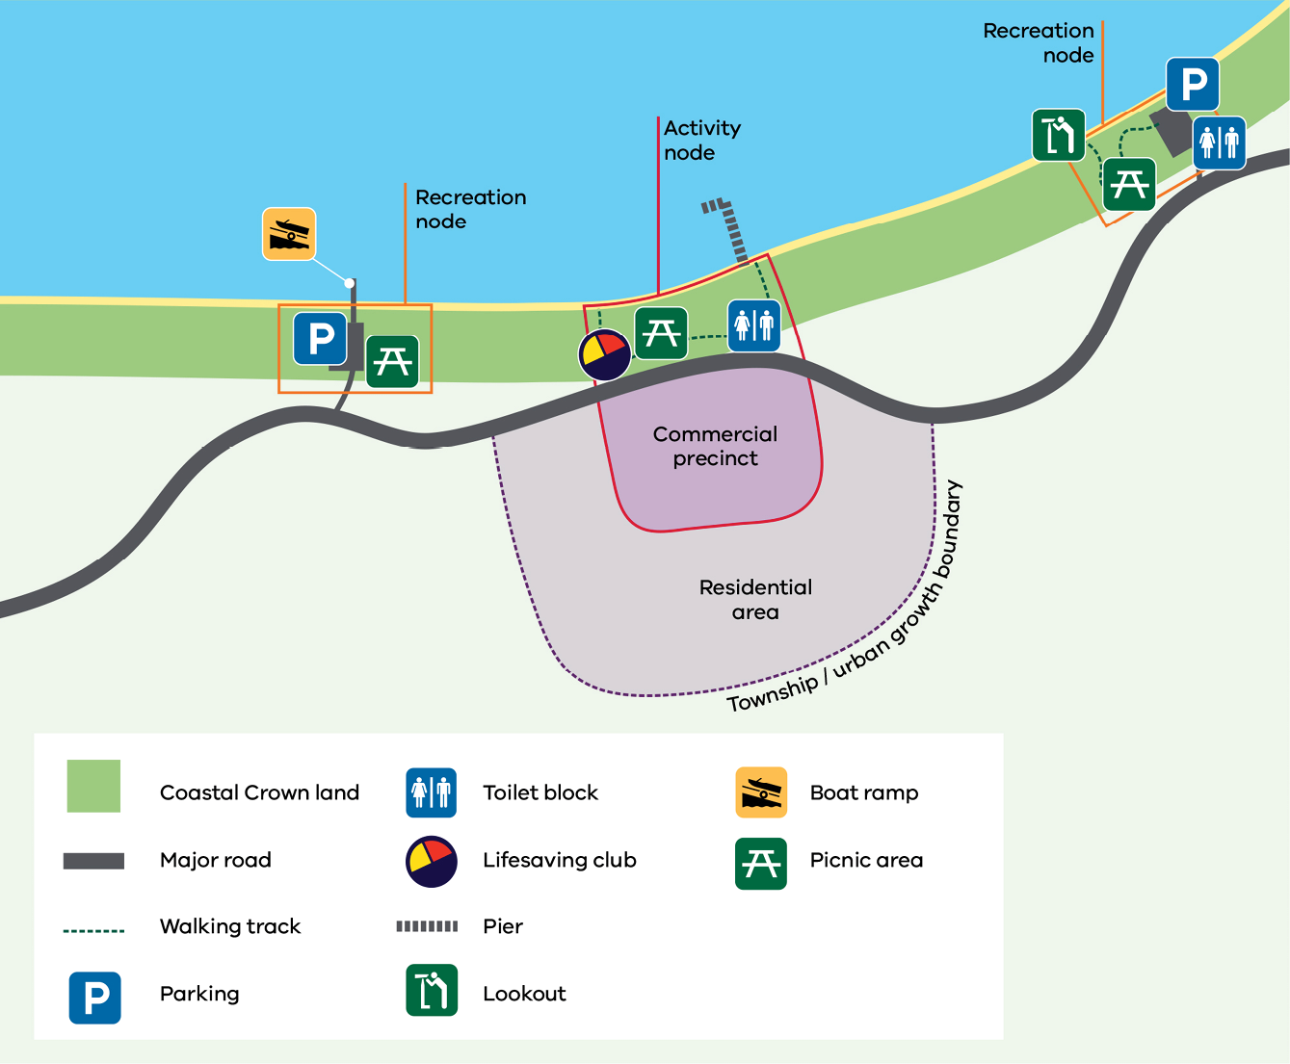
A CMMP should:
- focus recreation or activity nodes on resilient areas that can recover from seasonal changes
minimise access to those areas that are more vulnerable due to coastal processes, dynamic dune systems, unstable cliffs or the presence of rare and endangered vegetation.

Set management objectives for the plan (3.1.3)
Aspects of this process include:
- understanding the needs, priorities and assertions of Traditional Owners, the Aboriginal community and the broader community for the future of the CMMP area and managing expectations for the delivery of actions in the plan
- identifying objectives to protect the known values and address the challenges and issues described above
- adding the land manager’s strategic response to coastal adaptation and implementation, maps of areas vulnerable to climate change and a list of priority adaptation projects
- outlining the adaptation response to coastal hazards as they relate to the values that are threatened.
- Examples of objectives that might be relevant to include in a CMMP:
- Protecting the natural coastal dune system and enhancing the natural values of the CMMP area (including retaining remnant vegetation)
- Ensuring the provision of ecosystem goods and services is maintained or improved
- Providing direction and opportunities for appropriate and sustainable development in specific locations considering the impacts of climate change
- Managing coastal assets in consideration of the need to adapt to coastal hazards
- Ensuring that cultural and historic values are protected and enhanced where appropriate
- Planning for access and enjoyment of the coast by the public and defining these through activity and recreation nodes
Ensuring that use, development and works demonstrate a net community benefit.

Master plans
A master plan may be appropriate for CMMPs that include or are connected with development projects (such as boat ramp facilities).
A master plan shows an overall development concept that includes urban design, landscaping, infrastructure, service provision, circulation, present and future land use and built form. It consists of plans, 3D images, text, diagrams, statistics, reports, maps and aerial photos that describe and graphically illustrate how a specific location will be developed.

Identify and evaluate options (3.1.4)
When developing management options, it is important to consider:
- alignment with the Policy’s Planning and Decision Pathway
- any thresholds or decision points identified in previous management plans for the CMMP area, and whether they have been reached
- any unacceptable risks identified through the risk assessment process and potential risk treatment options
- whether the option is best implemented by the land manager or in partnership with other levels of government, organisations, industry groups or community groups
- the time needed to plan and implement the management option
- life expectancy of assets and infrastructure
- potential impacts of the option on cultural, environmental, economic and social values within the CMMP area
- whether the option would potentially increase exposure to, or likelihood of, known risks in the CMMP area or is potentially maladaptive
- expected changes in coastal processes, ecosystems and use of the CMMP area over the life of the plan
- staging and sequencing of management options
- initial and long-term costs of the option
- benefits and beneficiaries of implementing the option
level of uncertainty related to the option’s outcome.
Once an initial list of options has been generated, the land manager should evaluate which options are preferred.
Evaluation of options can be done by assessing which options best meet the objectives of the CMMP. Risk analysis and/ or cost-benefit analysis can also be used to support evaluation of the preferred management options. As part of the evaluation, consider the following:
- How feasible is the option? Will it be effective? Does it align with the Planning and Decision Pathway? What approvals would the option require?
- Is the option viable? (estimated costs and benefits)
- Does the option meet stakeholder expectations? Are its benefits fair and equitable?
Can the option be completed within the CMMP’s timeframe?
Types of management options to consider:
- Non-intervention: allowing marine and coastal processes, and the hazards they may pose to occur. For managing risks and values not related to coastal hazards, non-intervention options include monitoring changes and setting thresholds for responses and low-risk responses
- Planning for future impacts: strategically planning for use and development in areas where there is a low risk of adverse impacts on values of the CMMP area
- Intervention: management options that actively seek to protect or maintain the values of the CMMP area or treat risks that are perceived as having a likelihood or consequence that is unacceptable
Emergency response: management options that are urgently required to address immediate threats to the values of the CMMP area.

Integrating land uses
The CMMP needs to recognise the relationship between private land and marine and coastal Crown land. It is important to consider the following land types within and adjacent to the CMMP area when setting strategic directions:
- private freehold land (including freehold Council reserves)
- Crown land reserves (including adjoining non-marine and coastal reserves and National Parks)
- water catchments (rivers and estuaries)
- the marine environment
unreserved Crown land.

Private land
The CMMP needs to consider the impact of neighbouring private land use, assets and development on the CMMP area, such as:
- stormwater infrastructure (urban run-off)
- sewerage networks
- road networks, car parking and access
- retail hubs
coastal protection structures.
Road infrastructure and utilities can affect the adjoining land, with stormwater and sewerage networks commonly located in the CMMP area.
The private/public land interface is an important consideration in the development of a CMMP. Private freehold land that adjoins the CMMP area could be either residential or commercial. Often, the adjoining private land will have a high financial value due to its coastal location.
Commercial competition to occupy buildings on private land adjacent to marine and coastal Crown land is usually high as these areas are a focal point for tourism, visitation and businesses that capitalise on this passive marketing.

Water
The CMMP should describe both the positive and negative impacts that the CMMP area may have on the marine, estuarine and freshwater environment. Impacts can be direct, such as dredging to facilitate recreational boating, or indirect, such as run-off from car parks and pathways flowing into the marine environment and on to the foreshore.
The marine environment supports a diverse range of habitats, as well as goods and services that deliver benefits to all Victorians including fisheries and aquaculture, tourism, recreation, natural coastal defences and carbon storage. The health and sustainability of these goods and services are largely dependent on the management of the marine and coastal environment.
Marine and coastal Crown land is often the access point for water-based activities, such as fishing, boating and surfing. Some of these activities occur outside of the CMMP area and rely on facilities located within the CMMP area. These uses must be considered as part of the CMMP development process.

Events
Marine and coastal Crown land can be a valued location for events and festivals (generally short-term temporary use).
A CMMP may identify event spaces with criteria that are consistent with the reservation purposes of the marine and coastal Crown land and identified recreation and activity nodes. Appropriate uses for the CMMP area and the process for assessing event applications should be included. As a principle, marine and coastal Crown land should only be used for these types of activities where private land is unavailable.
There are two types of events that generally occur on marine and coastal Crown land:
- Community events are associated with not-for-profit groups such as Lions Club markets and not-for-profit sporting events where the entry fee is low or free of charge.
Commercial events may involve community groups, but the primary purpose is to generate revenue, e.g. music festivals and carnivals.
The suitability of the CMMP area to host these events will depend on several factors, including community support for the proposal and potential impacts on the marine and coastal Crown land and values of the CMMP area.
A commercial arrangement for these types of events is required to formalise the tenure of the proposed site and for the proponent to meet their risk management objectives and obligations.
The land manager may charge a fee for the exclusive use of this site over the period of occupation.
The tenure allocation process must be fair, open and impartial. To avoid competition with established local businesses, a competitive allocation process is recommended, with appropriate fees that are consistent with rentals in the retail shopping or other local commercial operations or other comparable areas or councils in the area.
Consent may also be required under the Act. To confirm whether consent is required for events, contact the relevant DEECA regional office.

Assets and infrastructure
In Victoria, many coastal assets such as groynes, sea walls, jetties and piers have been built over the past 100+ years. The assets may be the responsibility of DEECA, Parks Victoria, port managers or land managers. They support the ongoing use and enjoyment of marine and coastal Crown land.
The CMMP needs to document existing assets and infrastructure in the area, including any that are identified as needing repair, removal or replacement.
In 2018, a report by VAGO Protecting Victoria's Coastal Assets – Victorian Auditor-General's Office estimated between 20-30% of coastal assets were in poor condition and 30-50% were thought to have less than 10 years’ useful life remaining. The impacts of coastal processes, storms, erosion and climate change are likely to cause further damage to these assets. Their consideration is important in the CMMP.

Siting and design of any proposed development
Any proposed use or development needs to be listed in the CMMP. These proposals should be consistent with the Siting and Design Guidelines for Structures on the Victorian Coast 2020.
These guidelines outline examples of how to site and design development appropriately in the marine and coastal environment (Figure 6).
Figure 6: Prioritising the fundamentals from Siting and Design Guidelines for Structures on the Victorian Coast 2020
Step | Consideration | Fundamental
1 | Is there a demonstrated need for the proposed structure (including all or any of its elements) to be on marine and coastal Crown land? | First principles – need, purpose, climate change and adaptation, physical footprint.  Do not proceed if the first principles cannot be met (inline with the Marine and Coastal Policy)
2 | Does the proposal ensure the protection of environmental and cultural values?  Does the siting of the proposed development identify and avoid locations of coastal vulnerability and hazard? | - Aboriginal cultural heritage  - Coastal processes  - Geology  - Morphology (form and time)  - Hydrology  - Vegetation and ecology  - Climatic conditions
3 | Is the proposal sympathetic to the local coastal character and sense of place?  Does the proposed development provide positive public benefit, access and/or amenity? | - Views  - Public open space  - Local character and sense of place  - Heritage  - Public access
4 | Does the proposed development ensure more efficient use of the site and contribute positively to the environment for the future? | - Increased function and adaptability  - Sustainability  - Materials and finishes

Plan for implementation (3.1.6)

Implementation plan
The Act requires that an implementation plan be included in a CMMP. The implementation plan will be guided by the overall vision and objectives outlined in the CMMP, and the actions drafted in the CMMP issued for public consultation.
The implementation plan needs to detail who is responsible for each action, timelines for delivery and how each will be resourced. Each action should have an identified lead and may nominate other partner agencies who will play a supporting role.
The implementation plan should be evaluated and updated annually as priorities shift and funding is sourced. The updated plan can demonstrate how the land manager is progressing towards implementation of the CMMP and outline barriers to the implementation of outstanding actions. If progress is slow, then corrective actions can be taken.
For some CMMPs, an implementation committee may be required to oversee and report on implementation and update the implementation plan annually. Membership could include members of the Project Steering Group and Community Reference Group who helped guide the preparation of the CMMP.
Resourcing for implementation can be challenging as land managers face competing demands to fund planning and management for marine and coastal Crown land, alongside other priorities. The Policy provides a process for identifying funding needs and future demands for management of marine and coastal Crown land (Figure 7).
Chapter 13 of the Policy has further guidance on funding for sustainable management of marine and coastal Crown land. It outlines how a CMMP implementation plan can be the basis for collaboration between the land manger, the Victorian Government and other partners to identify alternative funding options and opportunities.
Figure 7: Process for identifying funding needs and future demands for management of marine and coastal Crown land (Chapter 13 of the Policy)
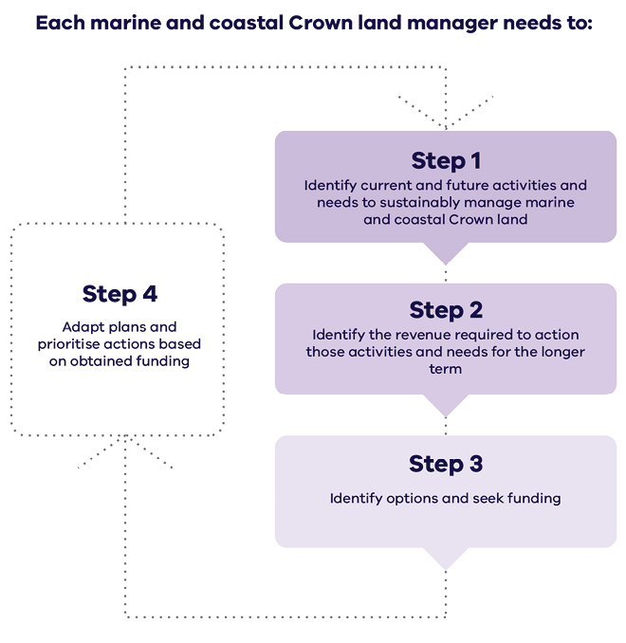
Each marine and coastal Crown land manager needs to:
- Step 1: Identify current and future activities and needs to sustainably manage marine and coastal Crown land
- Step 2: Identify the revenue required to action those activities and needs for the longer term
- Step 3: Identify options and seek funding
Step 4: Adapt plans and prioritise actions based on obtained funding.
Return to Step 1.

Reporting on implementation plans
Where practical, incorporate the CMMP implementation plan into existing reporting requirements, such as annual reports, annual capital works reporting etc. Doing this will minimise and streamline duplicate reporting.

Ensure the draft CMMP includes all mandatory content (3.1.7)

Consider if consent for any use, development or works in the plan can be requested along with the request for CMMP approval
At a broad level, all proposed use, development or works should be included in the CMMP.
When approving a CMMP, the Minister (or delegate) may give consent for proposed use, development or works in the area to which the plan applies (the Act section 62). This will only be for small scale and low-risk proposals, where enough detail is available.
Advice regarding whether the consent can be requested with the plan approval can be sought from the DEECA representative on the PSG.
Approval for the use, development or works in the plan will be subject to any conditions DEECA might include, any regulations made under the Act and any other approvals required. To assist DEECA in assessing whether the CMMP’s proposed use, development or works can be granted consent during the CMMP approval process, the minimum information required includes:
- a description of the proposed use, development or works
- location of the use, development or works within reserve name or Crown land parcel number
- written endorsement from the public land manager
- planning requirements (e.g. is a planning permit or cultural heritage management plan required?)
- proposed start and finish dates
- estimated cost
description of how the proposed use or development aligns with Policy.
Based on the information provided, DEECA staff will advise whether further information is required and if consent can be granted at the time of CMMP approval.
Some use and development may be covered by the General Consent or the Marine and Coastal Act Regulations (Exemptions) which are currently being prepared and will replace the General Consent once released. Where this is the case, consent is not required for the use, development or works.
Where the CMMP proposes significant use, developments or works (e.g. large scale dredging operations) a separate application for consent under the Act will be required, after the CMMP has been approved. This approach is appropriate for use, development or works that require other approvals such as a permit under the Planning and Environment Act 1987.

Gain approval for the final CMMP (3.4)
In accordance with the Act, the Minister (or delegate) may approve the CMMP with or without amendments or may refuse to approve the CMMP.
CMMPs developed by a Category 1 CoM require ministerial approval. For most other CMMPs, approval of the CMMP has been delegated to the Secretary of DEECA by the Minister.
The timeframe for approval of the CMMP will depend on the delegation for approval and complexity of the CMMP.
DEECA staff may be able to provide an indicative timeframe for approval when the CMMP is provided to DEECA for review.
Once the CMMP is approved, the Minister or delegate must publish notice of the approval of the CMMP in the Government Gazette, and publish a copy on the DEECA website.
Please note that in order to publish a copy on the DEECA website, both a PDF and Word version of the approved CMMP is required for accessibility purposes.
The CMMP comes into operation on the date on which the notice is published in the Government Gazette.

Additional guidance – implement, monitor, evaluate, report and improve

Ongoing monitoring, evaluation, reporting and improvement (4.2.1)
It is important to know what is working, what is not and why, and to be able to demonstrate the extent to which the vision and objectives of the CMMP are being achieved.
Monitoring and evaluation help with CMMP revision and adaptation if things are not going as expected or as external factors change. Ultimately, monitoring, evaluating and reporting will help the CMMP succeed and communicate its success.
Monitoring ensures that key objectives in the plan are being met and actions are being implemented while providing information on what changes have occurred over time.
Evaluation assesses the efficiency, effectiveness and appropriateness of actions in meeting the CMMP vision and objectives.
As part of the monitoring and reporting cycle, the implementation plan needs to be reviewed and updated annually by the land manager to ensure actions remain relevant and achievable.
Land managers responsible for preparing a CMMP will have different reporting requirements. For example, CoMs appointed under the Crown Land (Reserves) Act 1978 report annually on their operations and financial expenditures, based on a categorisation framework established by DEECA. Local governments and Parks Victoria have a separate reporting framework. Where practical, reporting should be via existing mechanisms to avoid duplication.

Appendices
- Planning hierarchy of documents, decision making and advice
- Definitions and acronyms
- Links to the Marine and Coastal Policy 2020

Appendix 1: Planning hierarchy of documents, decision making and advice under the Marine and Coastal Act 2018
Table 2: Planning hierarchy of documents, decision making and advice under the Marine and Coastal Act 2018 – taken from the Marine and Coastal Policy 2020

Appendix 2: Definitions and acronyms
Adaptation: is defined by the IPCC as ‘the process of adjustment to actual or expected climate and its effects’. This definition differentiates between human and natural systems. In human systems, adaptation seeks to moderate or avoid harm or exploit beneficial opportunities. In some natural systems, human intervention may facilitate adjustment.
Implementation plan: outlines the actions required to deliver the CMMP. It describes who is responsible for each action, timelines and how each will be resourced.
Marine and coastal Crown land: is defined in the Marine and Coastal Act 2018 as all Crown land and waters between the outer limit of Victorian coastal waters and 200 metres inland of the high-water mark of the sea, including:
- Crown land (whether or not covered by water) to a depth of 200 metres below the surface of that land
- any water covering the land referred to in paragraph (a) from time to time.
In addition, marine and coastal Crown land includes Crown land that extends more than 200 metres inland of the high-water mark of the sea where it has been reserved under the Crown Land (Reserves) Act 1978 for the purposes of the protection of the coastline.
For this purpose, it includes land (whether or not covered by water) and any water covering that land to a depth of 200 metres below the surface of that land.
Marine and coastal environment: is defined in the Marine and Coastal Act 2018 as the following between the outer limit of Victorian coastal waters and 5 kilometres inland of the high-water mark of the sea –
- the land (whether or not covered by water) to a depth of 200 metres below the surface of that land
- any water covering the land referred to in paragraph (a) from time to time
- the biodiversity associated with the land and water referred to in paragraphs (a) and (b).
Marine environment: is defined in the Marine and Coastal Act 2018 as the following between the outer limit of Victorian coastal waters and the high-water mark of the sea –
- the land (whether or not covered by water) to a depth of 200 metres below the surface of that land
- any water covering the land referred to in paragraph (a) from time to time
- the biodiversity associated with the land and water referred to in paragraphs (a) and (b).
Table 3: Acronyms used in the guidelines
CES | Commissioner for Environmental Sustainability
CHMP | Cultural Heritage Management Plan
CMA | Catchment Management Authority
CMMP | Coastal and Marine Management Plan
CoM | Committee of Management
DEECA | Department of Energy, Environment and Climate Action
ECC | Environment Conservation Council
IPCC | Intergovernmental Panel for Climate Change
LCC | Land Conservation Council
LCHA | Local Coastal Hazard Assessment
PSG | Project Steering Group
VAGO | Victorian Auditor-General’s Office
VEAC | Victorian Environment Assessment Council (Previously ECC and LCC)

Appendix 3: Links to the Marine and Coastal Policy 2020
Table 4: Links between guidelines and Marine and Coastal Policy chapters
The Policy must be applied in its entirely throughout the development and implementation of a CMMP. This table identifies some of the key points where Policy chapters may be particularly relevant to the process.
 | Marine and Coastal Policy chapters
CMMP Guidelines chapters | 1. Traditional Owner rights, aspirations, and knowledge | 2. Ecosystems and habitats | 3. Natural features and landscapes | 4. Cultural values and heritage sites | 5. Values of marine and coastal Crown land | 6. Managing coastal hazard risk | 7. Emergency response and preparedness | 8. Coastal settlements | 9. Marine and coastal industries | 10.Recreation and tourism | 11. Buildings, structures and access | 12.Stewardship and collaborative management | 13.Funding for sustainable management of marine  and coastal Crown land | 14. Marine Spatial Planning Framework
1.1 Engage with the local DEECA office |  |  |  |  |  |  |  |  |  |  |  | ü | ü
1.2 Contact Traditional Owners | ü |  |  |  |  |  |  |  |  |  |  | ü
1.3 Determine the CMMP area | ü | ü | ü | ü | ü | ü | ü | ü | ü | ü | ü | ü |  | ü
1.4 Establish governance and advice arrangements | ü |  |  |  |  |  |  |  |  |  |  | ü
2.1 Gather information on values | ü | ü | ü | ü | ü |  |  | ü | ü | ü | ü | ü |  | ü
2.2 Gather information  on issues and risks | ü | ü | ü | ü | ü | ü | ü | ü | ü | ü | ü | ü | ü | ü
2.3 Confirm values, impacts and issues with stakeholders | ü | ü | ü | ü | ü | ü | ü | ü | ü | ü | ü | ü | ü | ü
3.1 Write the draft CMMP | ü | ü | ü | ü | ü | ü | ü | ü | ü | ü | ü | ü | ü | ü
3.2 Consult on the draft CMMP | ü |  |  |  |  |  |  |  |  |  |  | ü
3.3 Finalise the CMMP | ü |  |  |  |  |  |  |  |  |  |  | ü
3.4 Gain approval for the CMMP | ü |  |  |  |  |  |  |  |  |  |  | ü
4 Implement, monitor, evaluate, review and improve | ü |  |  |  |  |  |  |  |  |  |  | ü | ü

In this document, the term ‘land managers’ refers to Committees of Management, local government and Parks Victoria.
As required by the Act section 59(3)
For more information visit: First People's State Relations

