# Cape to Cape Resilience Project Inverloch on-ground works

Initial Dune Reconstruction and Beach Nourishment On-Ground Works Project Update #3: September 2025

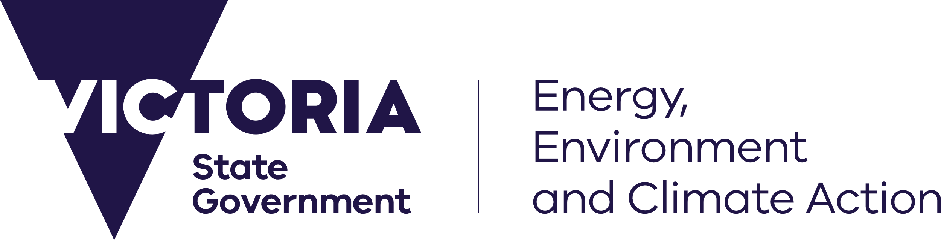

## Contractor appointed for the Initial Dune Reconstruction & Beach Nourishment Works

[deeca.vic.gov.au](https://delwpvicgovau.sharepoint.com/Users/fionadurante/Downloads/deeca.vic.gov.au)

**The Department of Energy, Environment and Climate Action (DEECA) is pleased to announce the engagement of a contractor for the delivery of dune reconstruction and beach nourishment works, scheduled to commence in February 2026.**

These works were scheduled to occur this Spring however, timing of on-ground works has been influenced by contractor vessel and machinery availability, and careful consideration given to avoiding undertaking works during the peak school holiday period.

DEECA is now working closely with the contractor to finalise the details of the works. We are committed to keeping the community informed and will share further updates as planning progresses.

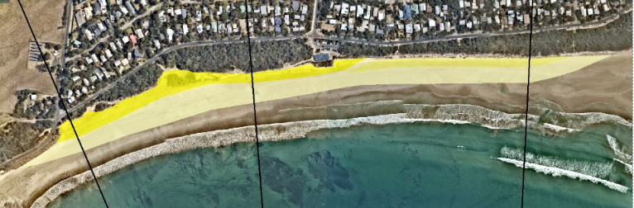

**Image 1: Inverloch Surf Beach sand nourishment concept**

## Inverloch Surf Beach Sandbag Seawall

The sandbag seawall in front of the Inverloch Surf Life Saving Club on Surf Beach will be repaired and extended to address damage resulting from the significant storm event in August last year. The Victorian Government has

allocated funding for the works and detailed designs are now complete.

The construction works will be delivered by Bass Coast Shire Council (BCSC) and will create a larger buffer between the extended wall and Surf Life Saving Club building. The wall will be buried under the reconstructed dune and beach nourishment which will provide additional protection. DEECA continue to partner with BCSC to ensure collaborative delivery of this project, and the dune reconstruction and beach nourishment works.

The timing of repair and extension works to the Surf Life Saving Club Sandbag Seawall is expected to take place prior to Christmas, subject to logistics, contractor availability and favourable weather and conditions.

The timing of dune reconstruction and beach nourishment works is currently expected to occur following the summer school holidays, commencing in February 2026.

**Once these dates are verified with contractors, we will provide an update to the community.**

## Surf Beach Update

Fortunately, conditions have been milder than those experienced this time last year, ahead of the dune reconstruction and major beach renourishment works. BCSC continue to manage the terminal scour either side of the seawall and the Inverloch Interagency Working Group continues to monitor the site.

As is typical during the winter months, there has been sand loss at Inverloch Surf Beach due to storm activity and high tides. This is mostly concentrated on the eastern side of the sandbag seawall.

Victorian Government departments and agencies will continue to monitor and assess conditions at Wreck Creek to inform future management.

Revegetation activities have been scheduled to follow the dune reconstruction project, with funding secured to support the first year of implementation.

## Keeping you informed

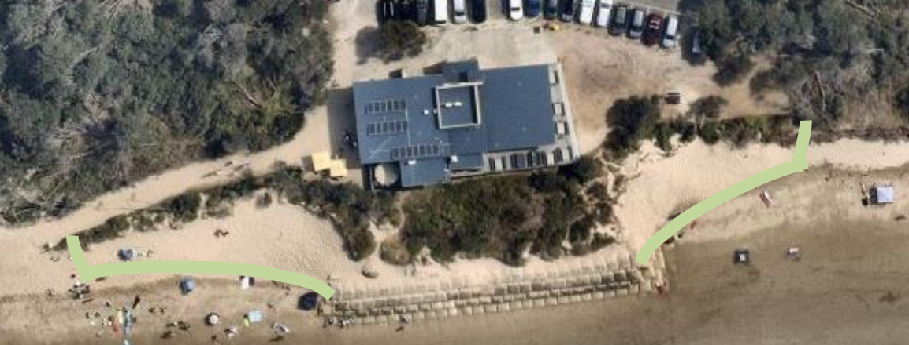Details for a community information session planned for mid-October will be shared soon. The session will present the dune reconstruction and beach renourishment design and outline upcoming on-ground works.

###### Image 2: Inverloch Surf Life Saving Club proposed extension to sandbag wall footprint

You can keep up to date on the latest works at Inverloch by joining our mailing list. Send us an email at [capetocape.project@deeca.vic.gov.au](mailto:capetocape.project@deeca.vic.gov.au) to be added to the list.

**You can also visit the** [**Cape to Cape Resilience Project**](https://www.marineandcoasts.vic.gov.au/coastal-programs/cape-to-cape-resilience-project) **webpage for more information about this project and any upcoming engagement.**

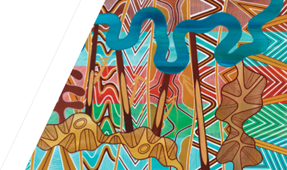

We acknowledge Victorian Traditional Owners and their Elders past and present as the original custodians of Victoria’s land and waters and commit to genuinely partnering with them and Victoria’s Aboriginal community to progress their aspirations.

© The State of Victoria Department of Energy, Environment and Climate Action September 2025

Creative Commons

This work is licensed under a Creative Commons Attribution 4.0 International licence, visit the [Creative Commons website](http://creativecommons.org/licenses/by/4.0/) (<http://creativecommons.org/licenses/by/4.0/>).

You are free to re-use the work under that licence, on the condition that you credit the State of Victoria as author. The licence does not apply to any images, photographs or branding, including the Victorian Coat of Arms, and the Victorian Government and Department logos.

**ISBN** 978-1-76176-627-5 (print)   
**ISBN** 978-1-76176-627-5 (pdf)

Disclaimer

This publication may be of assistance to you but the State of Victoria and its employees do not guarantee that the publication is without flaw of any kind or is wholly appropriate for your particular purposes and therefore disclaims all liability for any error, loss or other consequence which may arise from you relying on any information in this publication.

Accessibility

To receive this document in an alternative format, phone the Customer Service Centre on 136 186, email [customer.service@delwp.vic.gov.au](mailto:customer.service@delwp.vic.gov.au), or contact National Relay Service on 133 677. Available at [DEECA website](http://www.deeca.vic.gov.au/) (www.deeca.vic.gov.au).