Altona Seawall Remediation
Works to stabilise the Altona seawall and protect the foreshore









deeca.vic.gov.au

DEECA in collaboration with Hobsons Bay City Council carried out works at the Altona foreshore in November 2025 to stabilise a section of the Altona seawall near Laverton Creek. The works were undertaken to protect the seawall and reduce risks to nearby public assets including the Bay Trail, The Esplanade and the iconic Norfolk Island pine trees.

Background

Changing coastal conditions
Over many years, a sand spit from the mouth of the Laverton Creek has migrated east along the Altona shoreline. In 2025 the spit moved towards the Altona seawall near G.H. Ransom Reserve narrowing the opening of the Laverton Creek. Historical mapping shows the spit has moved at rates of around 30-60 metres per year, with peaks of up to 80-100 metres per year (figure 1).
Figure 1. Migration of the Laverton Creek sand spit between 2009 and 2025

Scour and undercutting of the seawall
As the creek outlet moved towards the seawall and narrowed, tidal flows became concentrated between the sand spit and the seawall, eroding away the sandy beach in front of the seawall (figure 2). Due to the strength of water flow in this area, sand was removed from the base of the seawall, causing erosion.

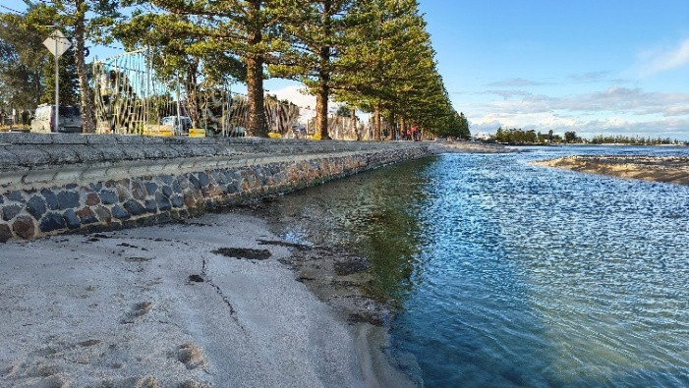Figure 2. Flows from Laverton Creek undercutting the Altona seawall

Investigations and response
A coastal engineering specialist was engaged to investigate changing coastal conditions near the mouth of Laverton Creek. A coastal processes study was undertaken to understand the migration of the Laverton Creek sand spit, changes to creek flows and the resulting erosion.

Engineer investigations found significant undercutting of the seawall caused by creek flows eroding material from underneath the base of the seawall. The undercutting extended more than 40 metres along the seawall and up to 1.4 metres beneath the wall leaving a section of the seawall foundation undermined and at risk of collapse if no action was taken (figure 3).
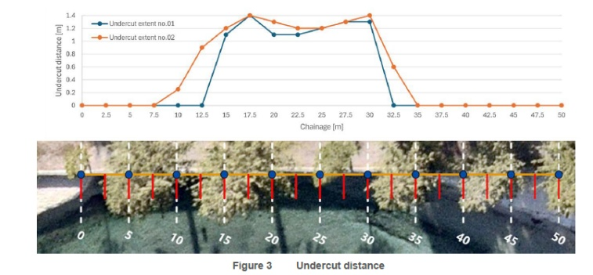
Figure 3. Extent of scour and undercutting along a section of the Altona seawall
Structural inspections and risk assessments were also undertaken to understand the condition of the seawall and the potential consequences of continued erosion. A risk assessment of the seawall identified a very high-risk of failure due to further erosion along the length of the wall. This posed a risk to nearby public assets including the Bay Trail, The Esplanade and the Norfolk Island pines located behind the seawall. The coastal engineering specialists recommended remediation works to redirect creek flows away from the seawall and restore the beach to stabilise the seawall and foreshore.

Works undertaken
Remediation works were carried out at the Altona foreshore in November 2025. The works focused on redirecting creek flows away from the seawall to reduce ongoing erosion and protect the seawall.
Key actions included:
- cutting a new outlet through the sand spit to redirect flows from Laverton Creek away from the seawall
- constructing a geotextile training wall to stabilise the new channel (figure 4)
- reinstating the foreshore using sand sourced from the site (figure 5)
- infilling the discontinued channel next to the seawall to reduce erosion at the base of the wall.
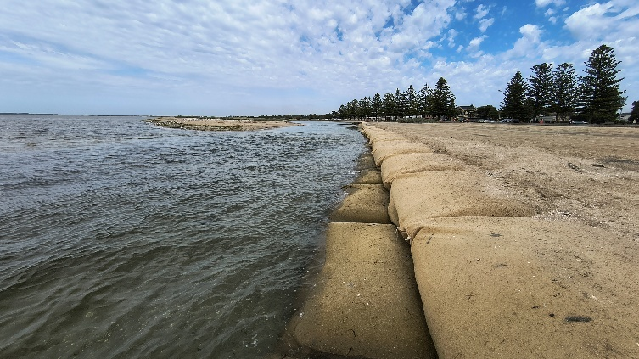
Figure 4 Recently constructed geotextile training wall to redirect flows away from Altona seawall
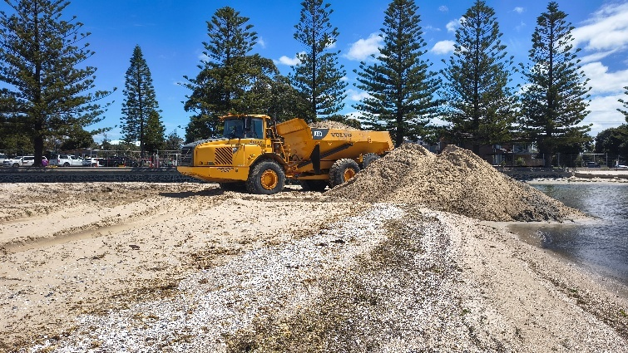Figure 5. November 2025 construction works, including reshaping of the Altona foreshore

Additional Information

What is seaweed (wrack)?
Seaweed is a natural accumulation of marine plants and other organic material that washes ashore along beaches. It forms when seaweed is detached by waves, tides or storms and carried toward the shoreline by wind and currents.
As seaweed breaks down it can sometimes produce a noticeable odour, particularly during warm weather. While it may appear messy, seaweed is a natural part of coastal environments and can provide habitat and nutrients for coastal plants, birds and other marine life.

Beach Cleaning
Seaweed accumulation at Altona Beach is a recurring issue that requires ongoing collection and disposal.
Hobsons Bay City Council operates a regular seaweed management program to minimise buildup onsite. Approximately 2,500 tonnes of seaweed is collected each year from Altona Beach, with collections undertaken weekly during peak periods and fortnightly at all other times. This servicing can vary at times due to weather and tidal conditions.

This ongoing work supports the enjoyment of Altona Beach by the local community and visitors, helping to balance natural coastal processes with a clean and pleasant beach environment.
Did the scour remediation works cause the seaweed buildup?
Wrack deposits occur naturally and are influenced by tides, wind conditions and seasonal coastal processes. The migration of the sand spit has changed the location of where seaweed may accumulate. DEECA and Hobsons Bay City Council continue to monitor conditions at the site.
Weather conditions and creek flows
The recent warm weather conditions with low rainfall have influenced the creek outlet flow resulting in very low flows from the Laverton Creek catchment. This combined with seasonal south-west winds pushed large amounts of wrack (seaweed and organic material) toward the shoreline.
Some wrack temporarily accumulated in the outlet channel, reducing water exchange and contributing to occasional odour as the material breaks down (figure 6). These changes are not unusual in dynamic coastal environments, where creek flows, tides, winds and sediment movement regularly reshape the shoreline and creek entrance (figure 7). Seaweed decomposition is a natural process. The Environment Protection Authority has advised that the chemicals in decomposing seaweed can have a ‘rotten egg’ or ‘cabbage-like’ odour. People can smell these chemicals at levels lower than would harm health.

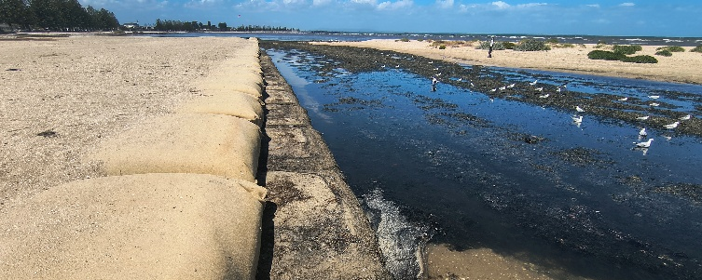Figure 6. Laverton Creek outlet during a dry period prior to recent rainfall
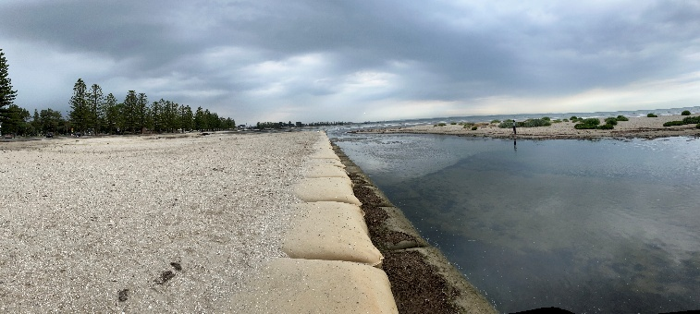Figure 7. Laverton Creek outlet following rainfall, showing increased creek flows and a cleared outlet channel

Ongoing monitoring and management
The Laverton Creek spit is a highly dynamic coastal feature and will continue to change over time. DEECA and Hobsons Bay City Council continue to monitor conditions at the site including regular inspections of the seawall and the flow of the Laverton Creek outlet to inform if further work is required.
DEECA and Hobsons Bay City Council will continue to work together to monitor conditions along the foreshore and respond to any emerging issues.

Coastal Hazard Adaptation- Find out more about Adapt West

Longer-term planning for the Laverton Creek spit and Altona foreshore is progressing through the Adapt West – Shaping our Shores project, led by the Port Phillip Bay Western Shoreline Regional and Strategic Partnership (RaSP).

The project involves development of a Coastal Hazard Adaptation and Resilience Plan (CHARP) aligned to the seven stages of the Victoria’s Resilient Coast (VRC) framework. This includes:
- cultural, ecological, social and economic values studies
- building understanding of local coastal processes and hazards
- coastal risk and vulnerability assessment
- coastal resilience planning.

The project includes a range of opportunities for community engagement. To learn more and participate visit https://engage.vic.gov.au/adapt-west.

