Coastcare Victoria School Kit

School Kit Answers

 | 

Acknowledgements

Coastcare Victoria would like to acknowledge all our video presenters and individuals who reviewed or assisted with the creation of the Coastcare Victoria School Kit.
Author
Coastcare Victoria and Ocean Imaging.
Photo credit
Ocean Imaging.

Acknowledgment
We acknowledge and respect Victorian Traditional Owners as the original custodians of Victoria's land and waters, their unique ability to care for Country and deep spiritual connection to it. We honour Elders past and present whose knowledge and wisdom has ensured the continuation of culture and traditional practices.
We are committed to genuinely partner, and meaningfully engage, with Victoria's Traditional Owners and Aboriginal communities to support the protection of Country, the maintenance of spiritual and cultural practices and their broader aspirations in the 21st century and beyond.

Sanctuaries and Sea Creatures: Ricketts Point Answers

Ricketts Point Quiz
1. What year was the sanctuary established?
- 1999
- 2002
- 2005
- 2013

2. How many sanctuaries are there in the north of Port Phillip Bay?
- Granite
- Sandstone
- Limestone
- Metamorphic

3. What type of rock are the rocky reefs made of?
- Granite
- Sandstone
- Limestone
- Metamorphic

4. How large can the banjo ray grow?
- .5m
- 1m
- 1.5m
- 2m

5. What animals migrate to Ricketts point at the beginning of summer?
- Birds
- Fish
- Sharks
- Turtles

6. Why do these animals migrate to Ricketts Point?
- To mate
- To lay eggs
- Both a and b
- Neither a or b

7. Which fish were shown as juveniles in the video?
- Dusky morwong and sea sweep
- Banjo rays and Port Jackson sharks
- Leatherjackets and moonlighters
- Magpie perch and hulafish

8. The flathead is ‘top dog’ in which habitat?
- Rocky reef
- Kelp forest
- Seagrass
- Caves

9. Which of these fish were not mentioned in the video?
- Hulafish
- Magpie Perch
- King George Whiting
- Sweep

10. The plants and animals at Ricketts point are part of an interconnected reef system known as?
- The Great Barrier Reef
- The Great Ocean Road
- The Great Southern Reef
- The kelp forest highway.

Marine Life Bingo
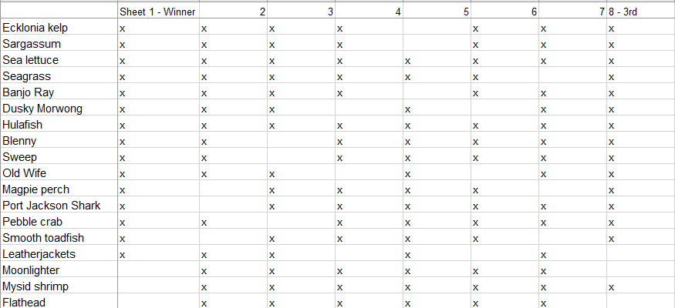
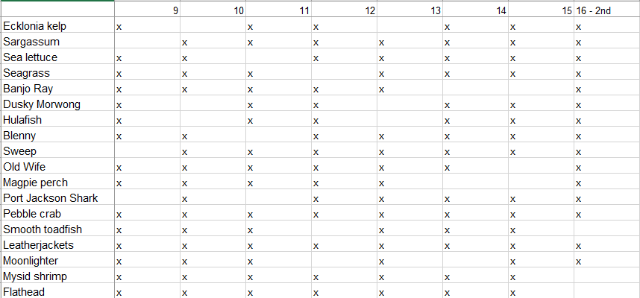
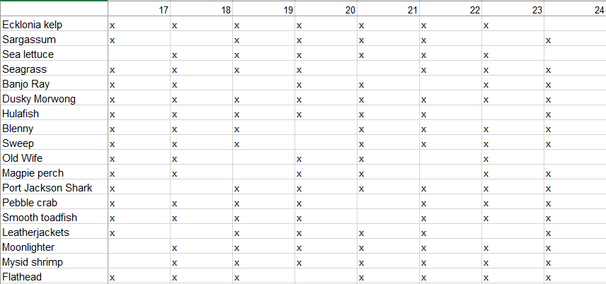
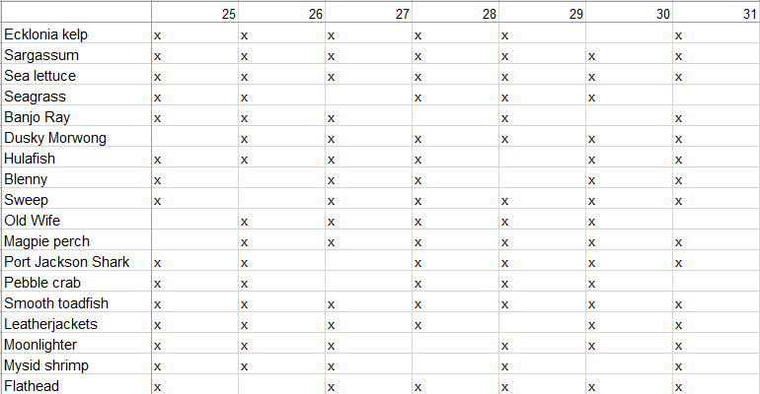

Habitats and Adaptations

- Which of your bingo cards are habitats?
Habitat cards are Ecklonia, Sargassum, Sea Lettuce and Seagrass

- How do other organisms benefit from the habitat?
Food, a place to lay eggs, a place to hide from predators, a place to get out of the strong current / waves, provides oxygen in the water.

- Living things have special features called adaptations that help them to survive in their environment. For example, a cuttlefish may release a cloud of ink to escape from a predator. Choose two more species featured in the video. What features might help these organisms survive in this environment?
Various answers but could include things like:
- Banjo Ray - flattened body for gliding over sandy sea floor in search of prey
- Pebble Crab - large pincer claw for breaking open shells.
- Ecklonia kelp - broad flattened leaves for large surface area to capture sunlight
- Port Jackson Shark - thick skin for protection. Strong jaw and molar like teeth for crushing prey.

- There are three different categories for adaptations. Write a definition for each type in the space below:
Behavioural - responses made by an organism that help it to survive/reproduce.
Physiological - a body process that helps an organism to survive/reproduce.
Structural - a feature of an organism's body that helps it to survive/reproduce.

- Put a letter B, P or S next to your answers in Q3 to identify the type of adaptation e.g., B for behavioural.

Classification Worksheet
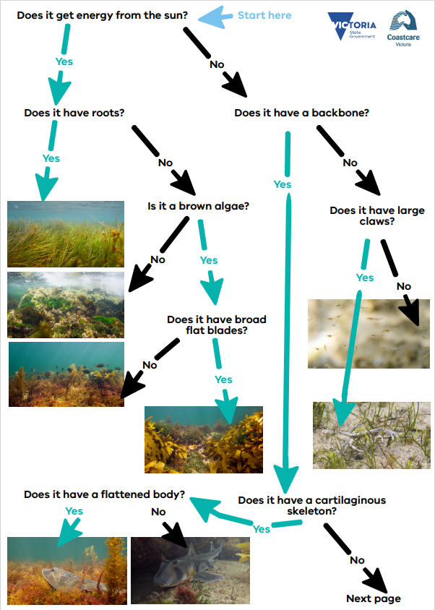

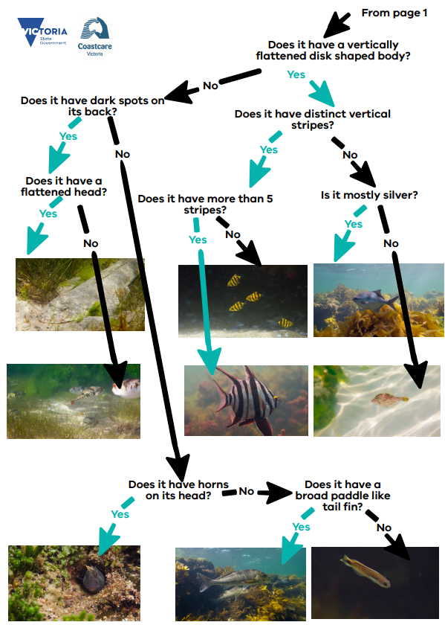

Marine Sanctuaries Investigation
- What activities are not permitted in a marine sanctuary? [2 marks]
- Catching or attempting to catch fish - i.e., fishing lines in water.
- Taking any marine life
- Being in the water with a spear gun
- Extractive or damaging uses
- aquaculture
- exploration drilling
- oil and gas extraction
- Dredging
- waste disposal

- What activities are permitted in a marine sanctuary? [2 marks]
- Recreation
- Tourism
- Snorkelling and scuba diving
- Education
- Research
Note that some activities such as research or filming may require a permit.

- Why are marine sanctuaries important areas? [2 marks]
- act as nursery areas for small fish to grow
- provide a safe place for fish to breed
- provides a place for large fish and animals to grow. These large individually may be ‘super breeders’
- creates a baseline for scientists to compare other areas and monitor impact
- takes care of the habitat
- Acts an educational tool

- What is the difference between a marine park and a marine sanctuary? [2 marks]
- All marine sanctuaries are marine parks but not all marine parks are sanctuaries.
- Marine parks have multiple zones - some of these allow various activities like fishing.
- In sanctuaries no fishing or extractive activities are allowed

- How many other marine parks and sanctuaries are in Victoria? [2 marks]
- Victoria has 13 marine parks and 11 marine sanctuaries

Ricketts Point Review Answers

- What is a habitat? (1 mark)
A place where a plant or animal lives.

- Why do organisms need a habitat? (2 marks)
The habitat may provide food, shelter, a place to lay eggs, a place to live

- What is an adaptation? (1 mark)
A special skill or characteristic which helps an animal to survive.

- Behavioural adaptations are things organisms do to survive or reproduce. For example - a cuttlefish may release a cloud of ink to escape from a predator. Give one other example of a behavioural adaptation and describe how it benefits the organism. (2 marks)
Answers may vary.

- A physiological adaptation is a body process that helps an organism survive / reproduce. For example - a blue ringed octopus makes venom. Give one other example of a structural adaptation and describe how it benefits the organism (2 marks)
Answers may vary.

- A structural adaptation is a physical feature that helps an organism survive / reproduce. For example - a rock lobster has a hard exoskeleton and long antenna for protection. Give one other example of a physiological adaptation and describe how it benefits the organism (2 marks)
Answers may vary.

- Name two biotic factors that may impact marine life (2 marks)
Any two or more of: Abundance of predators / prey, abundance of food, parasites, competition for space and food

- Name two abiotic factors that may impact marine life (2 marks)
Any two or more of: Sunlight, salinity, pH, nutrients, water movement, temperature, oxygen, carbon dioxide.

- You are a marine park manager and creating a guide for visiting researchers learning to identify marine life in the area. Describe some of the unique physical characteristics of each species
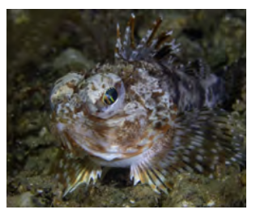 | Gurnard Perch  Large eyes  Large dorsal spines  Large head  Shiny, mottled skin
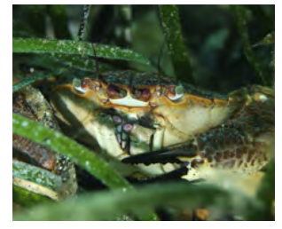 | Brown crab  Large claws  Horizontally flattened body
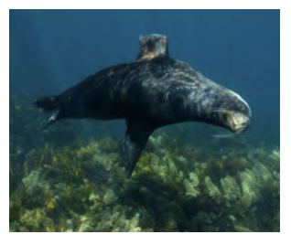 | Seal  Whiskers  Flippers  Mostly grey body
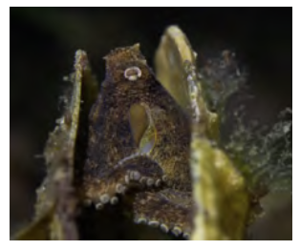 | Octopus  Camouflaged body  Flexible body  Tentacles with suckers
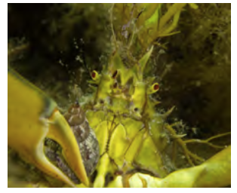 | Golden decorator Crab  Yellow body  Large claws  Red eyes
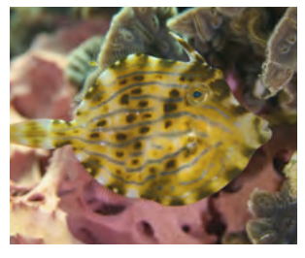 | Leatherjacket  Vertically flattened body  Disk / dinner plate shaped body  Spots and lines  Disproportionately small tail  Spike on head

10. Create a classification key for these species using yes/no questions and draw the flowchart.
Answers may vary. One example as follows
- Flattened body?
Yes
- Vertically flattened?
Yes - Leatherjacket fish
No - Brown crab
No - go to 2.
- Tentacles with suckers?
Yes - Octopus
No go to 3.
- Mostly grey body?
Yes -Seal
No go to 4.
- Yellow body?
Yes - Golden decorator crab
No - go to 5.
- Large eyes
Yes - Gurnard perch

11. Describe how classification may be useful to marine park managers and researchers?
Answers may vary. Example answers such as:
Helps researchers know which species there may be more / less of and monitor trends.
Park managers will be able to know which species live in the park and help manage them.
It will help managers and researchers know if other new species arrive in the area.
It helps to create laws and rules around fishing regulations for example.
Researchers will be able to focus their studies on specific species and understand them better.

