**Islands & Invasive Species Answers**

**Quiz**

1.What is the goal of the volunteers?

1. To remove every trace of humans from Gabo Island
2. The chance to see wildlife
3. **To make Gabo Island weed free**
4. To pick up all the litter from Gabo Island

2.  What type of rock is Gabo Island

1. Oceanic
2. **Granite**
3. Sandstone
4. Basalt

3.  Where did the Mirror Bush weed come from?

1. Seeds dropped by birds
2. **Escaped from gardens**
3. Sealers introduced it
4. Aboriginal people introduced it

4. What is the scientific name of Mirror Bush?

1. Diosma
2. Woody weed
3. **Coprosma**
4. None of the above

5. Mirror Bushcompetes with native ________ for space on Gabo Island?

1. **Plants**
2. Mammals
3. Birds
4. Rocks

6. How often does weeding on Gabo Island need to be done?

1. Once every ten years
2. Just once
3. **Three times a year**
4. All the time

7.  What is another reason that the volunteers were weeding on Gabo Island?

1. To make it beautiful
2. To watch whales
3. To protect native plants
4. **All of the above**

8. Can Gabo Island ever be free of Mirror Bush?

1. **Yes**
2. No
3. Maybe
4. I don’t know

9. Which of these is a native plant which belongs on Gabo Island?

1. Feather fern
2. Cutting grass
3. ***Downy zieria***
4. Mirror bush

10. Which of these weeding techniques did you NOT see the volunteers using?

1. Weeding by hand
2. **Covering weeds with matting**
3. Cutting branches with secateurs (snips)
4. Cutting branches with power tools

**Mirror Bush Identification: Observable Traits primer**

|  |  |
| --- | --- |
| CAT Traits | DOG Traits |
| **4 legs** | **4 legs** |
| **Covered in fur** | **Covered in fur** |
| **Head at the front** | **Head at the front** |
| **Tail at the back** | **Tail at the back** |
| Average size? Small | Average size? Large |
| Ear shape? Pointed/ Upright | Ear shape? Rounded/ floppy |
| What noise do they make? “Meow” | What noise do they make? “Woof” |

**Mirror Bush Weed Map: Spot the Difference**

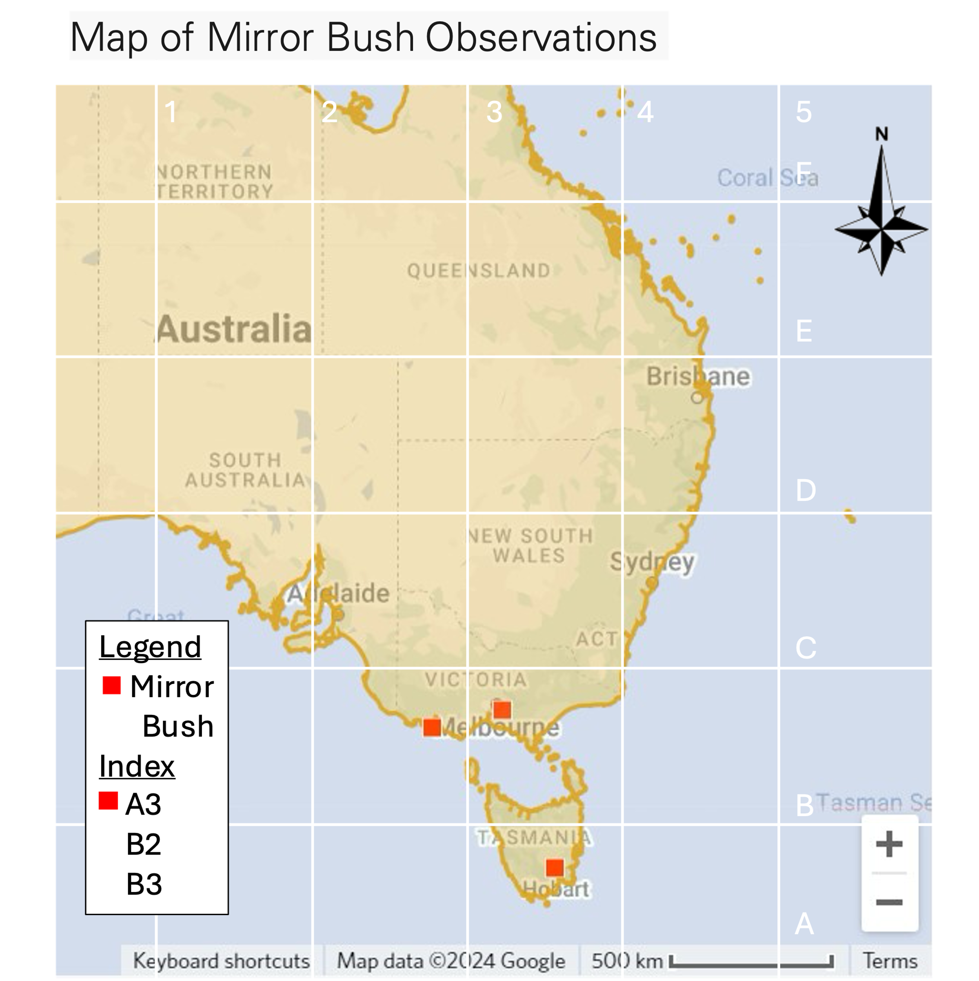

**Investigation 1: What Makes a Species Invasive?**

Answers included in slide deck for students to check their learning against.

**Investigation 2: Island Ecosystems**

Island similes table

|  |  |
| --- | --- |
| A lake is like an island of water | in an ocean of land |
| A cave is like an island of deep, dark, cool | in an ocean of bright and light |
| A mountain is like an island of high elevation | in an ocean of low land |
| An oasis is like an island of green | in an ocean of desert |
| A nunatak is like an island of rock | in an ocean of ice |

Nested lakes and islands like Yathkyed, are named: recursive

**Review Questions**

Write a one sentence definition of stewardship (3 marks)

Stewardship is a sense or feeling that a person develops as they grow close to a place. It makes them want to do work to protect and improve that place.

Describe two life history traits which makes a species more likely to be invasive? (4 marks)

Abundant reproduction, fast growth, eats a variety of food, high tolerance to destruction, and able to live in many environments.

List two of the features which make an accurate map [DOGSTAILS] (2 marks)

Date, Orientation, Grid, Scale, Title, Author, Index, Legend, Sources.

Describe a trait of islands and how it impacts plants or animals in the island ecosystem? (4 mark)

Islands are small; therefore, a lot of the area is exposed to salt from the sea, therefore species need to be salt tolerant. Because they are salt tolerant, they can live in most places on the island and may become dominant.

Why is an island the best place to do a weed eradication program? (2 marks)

Because islands are isolated from the mainland, they are protected from a reintroduction of weeds. Once a weed has been removed it can be kept off the island forever.