delwp.vic.gov.au

|  |
| --- |
| 2022-23 Coastcare Victoria Community Grants Guidelines    Title  Subtitle |

|  |  |
| --- | --- |
|  |  |

# Warning: Health and safety is paramount

You must put in place relevant Work Health Safety policies and procedures to ensure the safety of those undertaking grant activities. You must comply with all public health measures and directions in relation to coronavirus (COVID-19). Stay up to date at <https://www.dhhs.vic.gov.au/coronavirus> and <https://www.coronavirus.vic.gov.au/>

# Acknowledgements

|  |  |  |  |
| --- | --- | --- | --- |
|  |  |  |  |

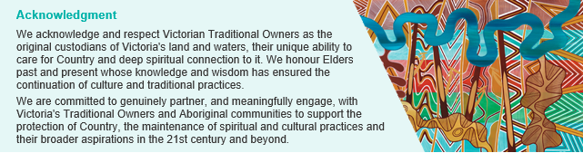

### Our commitment to inclusion and diversity

Coastcare Victoria supports liveable, inclusive and sustainable communities. Coastcare Victoria supports a volunteering culture diverse in ability, gender, sexuality, age, socio-economic status, ethnicities and religious beliefs. Coastcare Victoria believes everyone has the right to feel safe, welcome and have their life experience valued. Fostering diversity and inclusion helps people to learn from each other and develop new ways to work effectively. At Coastcare Victoria we are connected to liveable, inclusive and sustainable communities; we are diverse; we are inclusive and flexible; we are safe and respectful.

© The State of Victoria Department of Environment, Land, Water and Planning 2019.

LogoThis work is licensed under a Creative Commons Attribution 4.0 International licence. You are free to re-use the work under that licence, on the condition that you credit the State of Victoria as author. The licence does not apply to any images, photographs or branding, including the Victorian Coat of Arms, the Victorian Government logo and the Department of Environment, Land, Water and Planning (DELWP) logo. To view a copy of this licence, visit http://creativecommons.org/licenses/by/4.0/

Disclaimer This publication may be of assistance to you but the State of Victoria and its employees do not guarantee that the publication is without flaw of any kind or is wholly appropriate for your particular purposes and therefore disclaims all liability for any error, loss or other consequence which may arise from you relying on any information in this publication.

## Accessibility

If you would like to receive this publication in an alternative format, please telephone the DELWP Customer Service Centre on 136186, email customer.service@delwp.vic.gov.au or via the National Relay Service on 133 677 www.relayservice.com.au. This document is also available on the internet at [www.delwp.vic.gov.au](http://www.delwp.vic.gov.au).

|  |
| --- |
|  |

CONTENTS

Warning: Health and safety is paramount 2

Acknowledgements 2

Accessibility 2

CONTENTS 3

Overview 5

What is the 2022-23 Coastcare Victoria Community Grants program? 5

How much funding is available? 5

When do applications close? 5

What types of grants are available? 6

1. Stewardship and Education Grants: 6

2. Strengthening Our Volunteer Groups Grants: 6

3. Supporting Traditional Owner Self-Determination Grants: 6

Eligibility 6

Applicant Eligibility - Who can apply? 6

Applicant Eligibility – Financial Governance 7

Applicant Eligibility - Who can sponsor (auspice) an applicant? 7

Applicant Eligibility - Ineligible applicants 7

Project Eligibility - Budget 8

Project Eligibility - Ineligible activities and budget items 8

Project Eligibility - What supporting documents will need to be provided? 9

Assessments of Applications 11

Assessments 11

Does the applicant need to co-contribute to their project’s budget? 11

How do I calculate the value of our volunteer contribution? 11

How to apply 11

Stream 1: Stewardship and Education 12

Objectives 12

Assessment criteria and weighting 12

What sort of projects will be funded? 12

Stream 2: Strengthening Our Volunteer Groups (marine and coastal volunteering) 13

Objectives 13

Assessment criteria and weighting 13

What sort of projects will be funded? 14

Stream 3: Supporting Traditional Owner Self-Determination 14

Objectives 14

Assessment criteria and weighting 14

What sort of projects will be funded? 15

MapShare Instructions 15

Terms and conditions 18

DELWP Grants Online 19

Registration & login 19

Starting a new application 19

Accessing existing draft & submitted applications 19

Site navigation 20

Communicate with Program representatives 20

Additional information and enquiries 20

What is the notification process? 20

Checklist 20

Contact Details 21

Frequently Asked Questions 22

Key Information 22

Submitting Applications 22

Land Manager Support and Consent 24

Volunteer contributions 24

Budgets and GST 25

Biodiversity Information 25

Funded Projects Standards 25

# Overview

## What is the 2022-23 Coastcare Victoria Community Grants program?

The Coastcare Victoria Community Grants program supports community organisations to protect and enhance the coastal and near-shore marine environment. The 2022-23 grants program is funded by Victoria’s Great Outdoors which seeks to build community capacity, support community adaptation, and improve ecosystem resilience to climate change. The 2022-23 Grants Program aims to support the three pillars in the *Coastcare Victoria Strategy 2021-2026*:

**Marine and Coastal Stewardship** - conservation, rehabilitation, restoration and preventative actions for Victoria’s coastal and marine ecosystems.

**Thriving Marine and Coastal Community Groups and Networks** – supporting community organisations to diversify, plan for the future and be responsive to change.

**Victorians Valuing the Coast** - supporting community participation, engagement and education to enhance community knowledge and understanding of coastal and marine management.

## How much funding is available?

The Victorian government is providing funding up to $375,000 for the 2022-23 Coastcare Victoria Community Grants program.

In 2022, small grants of up to $10,000 per project are available.

Multiple grant applications may be submitted. However, only one application per group across all streams may be deemed successful in the 2022-23 Coastcare Victoria Community Grants.

Each application you submit must be separate (not reliant on another project) and must not be a scaled up or scaled down version of another application. Activities (or components of projects) that have already been funded on the same site by other sources are not eligible.

## When do applications close?

Make sure your application is submitted by **5pm Melbourne Local Time on 9 March 2022.**

**Key dates**

|  |  |
| --- | --- |
|  | |
| Applications open | Wednesday, 19 January 2022 |
| Applications close | Wednesday, 9 March 2022, 5pm |
| Successful applicants notified | June 2022 |
| Agreements signed (milestone 1) and payments made | July/August 2022 |
| Job Safety Plan due (milestone 2) | 31 December 2022 (or 14 days prior to the first event/activity, whichever is earlier) |
| Final report due (milestone 3) and project completed | 31 May 2023 |

## What types of grants are available?

Three streams of grants are available in 2022-23:

1. Stewardship and Education

2. Strengthening Our Volunteer Groups

3. Supporting Traditional Owner Self-Determination

## 1. Stewardship and Education Grants:

* To build community capacity, support community adaptation and improve ecosystem resilience to climate change through actions which:
  + Conserve, rehabilitate, restore and protect Victoria's coastal and marine ecosystems
  + Support community participation, engagement and education to enhance community knowledge and understanding of coastal and marine management.

## 2. Strengthening Our Volunteer Groups Grants:

* To build community capacity and support community adaptation to climate change through actions which:
  + Expand, diversify and increase inclusivity of volunteer bases e.g. encourage participation of volunteers from different backgrounds, cultures, nationalities, abilities and youth
  + "Reimagine volunteering" to attract more/ different volunteers e.g. flexible, casual, event-based or short-term volunteering
  + Improve volunteer recruitment and retention
  + Succession planning for your group.

## 3. Supporting Traditional Owner Self-Determination Grants:

* To support Traditional Owner capacity and support community adaptation to climate change through actions which:
  + Recognise Traditional Owners longstanding and deep knowledge and connection to Country
  + Recognise and support Traditional Owners’ role in leading healing and ongoing care and use of Country
  + Support Traditional Owners in restoring marine and coastal cultural knowledge and practice
  + Support two-way capability and capacity building to improve the effectiveness of working relationships and build a shared understanding between Traditional Owners and other marine and coastal land managers.

# Eligibility

Applicants should complete the self-assessment checklist to ensure they meet the eligibility criteria. Applications that don’t meet one or more of the applicant eligibility criteria and project eligibility criteria will be set aside and will be considered as ineligible.

## Applicant Eligibility - Who can apply?

The following community groups and organisations with a focus on marine and coastal environs are eligible for funding:

* Coastcare Victoria groups
* Aboriginal groups and organisations, land councils, trusts and co-operatives working on-country
* Landcare groups
* ‘Friends of’ groups
* Field naturalist groups
* Non-government community organisations
* Community service organisations and clubs
* Coastal Committees of Management
* Educational institutions including schools and universities (recommended to partner with local coastal volunteer group).

## Applicant Eligibility – Financial Governance

To be eligible for funding applicants must be:

* an incorporated association registered through Consumer Affairs Victoria (check here: www.consumer.vic.gov.au) or other state incorporating agency; or
* a registered as a not-for-profit organisation with the Australian Charities and Not-for-profits Commission (check here: ACNC www.acnc.gov.au); or
* a coastal Committee of Management incorporated under the *Crown Land (Reserves) Act 1978*; or
* a Registered Aboriginal Party under the *Victorian Aboriginal Heritage Act 2006, or*
* an educational institution.

AND

* submission of certificate of insurance demonstrating provision of sufficient insurance as determined by the appointed land manager to safeguard volunteers and participants involved in the funded activities, including public liability insurance of at least $10million and personal accident insurance.

Groups and organisations that do not meet the above requirements can still apply for funding but must operate under the auspices of a sponsor organisation. You will be required to supply written approval (such as supporting letter) from your auspice (sponsor) as part of your application.

## Applicant Eligibility - Who can sponsor (auspice) an applicant?

An auspice/sponsoring group is only accepted when the Applicant is unable to meet the above financial governance requirements. An auspice/sponsoring group or organisation must:

* a State Government statutory body/authority or local government, or be one of the community groups and organisations listed above *and* be incorporated through Consumer Affairs Victoria (www.consumer.vic.gov.au) or other state incorporating agency, or registered as a not-for-profit with ACNC (www.acnc.gov.au);
* submission of certificate of insurance demonstrating provision of insurance sufficient as determined by the appointed land manager to safeguard volunteers and participants involved in the funded activities, including public liability insurance of at least $10 million and personal accident insurance;
* agree to take responsibility for the management and safety of the group’s volunteers and participants; and
* sign the funding agreement, receive the grant payment and be accountable for the delivery and reporting of the project.

## Applicant Eligibility - Ineligible applicants

* Commonwealth Government agencies
* Private companies or trusts
* Private individuals
* Catchment Management Authorities
* Industry bodies
* State Government statutory bodies/authorities (acceptable auspice/sponsor to applicant)
* Water Authorities
* Local government (acceptable auspice/sponsor to applicant)
* Previous recipients (as Applicant, not Auspice) of an active Coastcare Victoria Community Grant with outstanding project milestones, at the time of grant closing deadline, are ineligible for further funding. Outstanding milestones include progress reports, completion reports, job safety plans and any special condition milestones.

## Project Eligibility - Budget

Your application must fully and clearly define project costs, including any GST on supply items required to deliver your project (for example nursery plants or contractor services).

The program will support the following categories of expenditure:

* Advertising
* Environmental assessments*;
* Equipment hire or purchase directly related to project's on-ground components**
* Materials (e.g. chemicals, plants, etc)
* Printing / design
* Rubbish removal (if necessary, prior to site restoration)
* Site preparation
* Training and certification (if directly related to funded activity)
* Contractors*
* Exclusion fencing
* Personal protective equipment (e.g. gloves, goggles and masks)
* Postage
* Project coordination*^
* Signage
* Site security
* Pilot projects
* Costs of permits, Cultural Heritage checks etc directly related to the project.

*MUST explain how contractors, environmental assessment and/or project coordination are essential to facilitate the on-ground works component of the project and why your group is unable to carry out the tasks.

** Capital items must become a registered asset of the entity.

*^ A maximum of 15% of total grant funding can be used for incurred costs for project coordination (e.g. management of resources, meetings, information, project plans and schedules, administrative tasks, risk assessment and management, reporting, stakeholder management).

## Project Eligibility - Ineligible activities and budget items

Funding is NOT available for the following:

* Wages of staff – for example, hiring an employee as the person delivering training/education is an ineligible activity; listing ‘contractors’ when those contractors are the same organisation as the Applicant (ie, same ABN), contractors must be from an external party.
* Summer by the Sea Program activities
* Works on or for the benefit of private land, such as asset protection and seawall structures
* Development of recreation facilities or projects primarily focused on improving amenity
* Any activity involving clearing of native vegetation, unless it is a declared environmental weed in your area and appropriate permits are obtained
* Revegetation works using species which are not local indigenous species
* Removal of exotic trees from coastal foreshore areas where there is little or no remnant vegetation
* Large infrastructure or engineering works, such as coastal asset protection erosion mitigation activities
* Activities (or components of projects) that have already been funded on the same site by other sources
* The purchase or production of goods or merchandise which are considered to be environmentally damaging e.g. plastics (hard or soft), polystyrene, single use items (e.g. stickers, plastic cutlery and plates)
* Goods or services for competitions, prizes, gifts, vouchers or alcohol
* General operating or travel costs not directly associated with a project/event
* Sand/beach renourishment
* Activities involving the use of fire-arms, tranquilisers, explosives, trapping, ferreting or harbour destruction for animal control.
* Feral cat control
* Any activity required as an offset (as a condition of a permit to clear native vegetation)
* Projects not relating to Victoria’s marine and coastal environments
* Using LPG devices, ferreting or harbor destruction for rabbit control
* Shooting animals
* Trapping animals

Projects assessed as not meeting the eligibility and or assessment criteria will not be funded.

**Project Eligibility – Project timelines**

Projects must be completed (including the submission of acquittal documentation to Coastcare Victoria) by the end date stated in the funding agreement, which will be 31 May 2023.

## Project Eligibility - What supporting documents will need to be provided?

Depending on your group and project activities, applicants must provide all the following relevant documents with the application for it to be eligible. Failure to provide one of the following relevant documents with the application will result in the application being set aside and considered ineligible.

|  |  |
| --- | --- |
| **Project Activity** | **Supporting Documentation Required** |
| **If you need an auspice (sponsor)** | * Written approval (such as a supporting letter or email) from your auspice (sponsor), confirming the following, that they:   + are one of the community groups and organisations listed above and be incorporated through Consumer Affairs Victoria (www.consumer.vic.gov.au) or other state incorporating agency, or registered as a not-for-profit with ACNC (www.acnc.gov.au); or a State Government statutory body/authority or local government;   + submit a certificate of insurance demonstrating provision of insurance sufficient as determined by the appointed land manager to safeguard volunteers and participants involved in the funded activities, including public liability insurance of at least $10 million and personal accident insurance;   + agree to take responsibility for the management and safety of the group’s volunteers and participants; and   + sign the funding agreement, receive the grant payment and be accountable for the delivery and reporting of the project. |
| **If your project involves on-ground work, changing a site in some way and/or holding events or activities on a site** | * Map of proposed work area/site/event locations/s (see MapShare instructions in this document). * Written support from the relevant public land manager/s to undertake the activity. (At the application stage, we are only asking for evidence of support. If successful, formal consents, permits and cultural heritage requirements will be required.) * Submission of certificate of insurance demonstrating provision of sufficient insurance as determined by the appointed land manager to safeguard volunteers and participants involved in the funded activities, including public liability insurance of at least $10million and personal accident insurance. * Current condition photo(s) of the area for pre and post work monitoring purposes. |
| **If your project includes a partner/s** | * Letter/s of support from partner organisation/s. |

Supporting documents must be in an acceptable file type, such as Word, Excel, PDF, or JPEG. The maximum file size for each file is 10MB.

**Late applications**

The DELWP Grants online portal does not allow late applications. If a late application is submitted by email or hard copy, the Coastcare Victoria Grants Officer will:

1. confirm receipt and notify the applicant in writing of their potential ineligibility for consideration, and
2. confirm the final decision about the eligibility of their application.

When it is not clear, the Assessment Panel Chair will make a determination as to the actual time that an application is lodged. That determination is final.

Late applications will only be considered where: the applicant can clearly demonstrate (to the satisfaction to the Assessment Panel Chair) that late lodgement resulted from an error or failure in the application lodgement processes or was hindered by a major unforeseen incident; **and** the integrity (both real and perceived) of the application process would not be compromised by accepting the application after the closing time.

The Assessment Panel Chair will consult with the Probity Advisor and seek advice on probity implications of accepting any late submission.

All applications lodged after the closing time will be recorded by the Coastcare Victoria Grants Officer.

**Incomplete Application**

If an application is incomplete, the Assessment Panel Chair in consultation with probity advisor, may exercise their discretion to request the missing information from the applicant within a specified time **or** the application will be assessed based on the documents submitted.

**Errors in Applicant Documentation**

An applicant must notify the Coastcare Victoria Grants Officer immediately when they become aware of an error in their applications after the closing date.

If there is an error (as opposed to an omission) in an application the Assessment Panel Chair, in consultation with the Probity Advisor, may exercise their discretion to allow the applicant to correct the error **or** the application will be assessed as lodged. Should a correction be allowed, the applicant is to provide the corrected information only, within a specified timeframe. The Assessment Panel shall note the effect of any correction in the Assessment Report.

**File Errors in Applicant Documentation**

If a required document has been submitted by the applicant but is unable to be accessed/opened for some reason (such as incorrect file type) then the applicant will be asked to contact the Coastcare Victoria Grants Officer within 48 hours to provide access to their documentation.

The applicant will be contacted in writing and asked to email the problematic file, saved as an accepted file type, to the [Coastcare.Victoria@delwp.vic.gov.au](mailto:Coastcare.Victoria@delwp.vic.gov.au) email address. If the document is still unable to be accessed/opened it may not be considered as part of the assessment process and could render an application ineligible.

# Assessments of Applications

## Assessments

Applications will be assessed by a panel of Coastcare Victoria and other Department of Environment, Land, Water and Planning (DELWP) staff based on the criteria set out in this document (pages 12-14).

In the event the grants program is oversubscribed, the assessment process will also aim to ensure appropriate geographic and grants streams spread using the principles and the methodology laid out below:

**Principles:**

1. Port Phillip Bay Coastcare Victoria region projects should aim to account for no more than 50% of all grants allocated (assuming there are sufficient applications of similar merit available to expend funding from other regions).
2. Stream 2 projects should aim to account for at least 20% of recommended projects (assuming there are sufficient applications of similar merit available to reach this quota).
3. Stream 3 projects (Traditional Owner Self Determination) should aim to account for at least 10% of recommended projects (assuming there are sufficient applications of similar merit available to reach this quota).

Projects with a final score that are less than 1.99 may not be recommended for funding.

## Does the applicant need to co-contribute to their project’s budget?

* Applicants do not have to contribute funding to their project, however, a project that can demonstrate in-kind contributions provides greater value for money to Coastcare Victoria. Contributions can be in various forms including time, resources or funds.

## How do I calculate the value of our volunteer contribution?

* Volunteer time contributions should be valued at $40 per hour. Multiply the number of volunteers by the hours they will spend on your project, then multiply by $40.
* Example: 35 volunteers x 10 hours each x $40 = $14,000 in volunteer time contribution.

## How to apply

Applications consist of:

Step 1 – Completion of an online form. See our website for a MS Word document template of this form for drafting your application prior to copying it into the online form.

Step 2 – Completion of a multi-tab MS Excel spreadsheet. This needs to be uploaded to the DELWP Grants Online portal.

Step 3 – Supporting documentation uploaded to the DELWP Grants Online portal.

Applications are submitted online using the DELWP Grants Online portal. Use the links below to start your application:

Stream 1. Stewardship and Education, go to: <https://delwp1.force.com/publicform?id=a0h8u000000OjKA>

Stream 2. Strengthening our Volunteer Groups, go to: <https://delwp1.force.com/publicform?id=a0h8u000000OjKV>

Stream 3. Supporting Traditional Owner Self-Determination, go to: <https://delwp1.force.com/publicform?id=a0h8u000000OjKaS3>

To access existing drafts or submitted applications, go to: <https://delwp1.force.com/>

You will need to register for an account prior to commencing your application. You will receive an application number after you apply online. Please quote this number in all communications with DELWP relating to your application.

Applicants can attach documents to an online application as long as they are in an acceptable file type and don’t exceed the maximum file size. Important tips:

* when submitting an application online, applicants should check carefully to ensure all your attachments have been uploaded.
* the system has a file size limit of 10MB each, up to a total of 10 documents.

Make sure your application is submitted by **5pm Melbourne Local Time on 9 March 2022.**

Also see below DELWP Grants Online section for further information.

**If you require assistance submitting your application online, contact the DELWP Grants Information Line on 1300 366 356 or** [**grantsinfo@delwp.vic.gov.au**](mailto:grantsinfo@delwp.vic.gov.au)**.**

# Stream 1: Stewardship and Education

## Objectives

To build community capacity, support community adaptation and improve ecosystem resilience to climate change through actions which:

* Conserve, rehabilitate, restore and protect Victoria’s coastal and marine ecosystems
* Support community participation, engagement and education to enhance community knowledge and understanding of coastal and marine management in the face of climate change.
* **Note: Project must focus primarily on marine and coastal volunteering in Victoria**

## Assessment criteria and weighting

Applications MUST address ALL the following criteria:

|  |  |  |
| --- | --- | --- |
| Criteria | Value | Description |
| Legacy of project | 10% | The ongoing legacy of this project. Level of effectiveness in how well this legacy is maintained after the funding ends |
| Environmental outcome | 40% | Extent to which the project will directly help to, or educate about how to, conserve, rehabilitate, protect or enhance the coastal or near shore marine environment |
| Community involvement | 30% | Extent to which project involves volunteers or the community in on-ground action, engagement or education |
| Risk management | 10% | Application identifies potential risks to the project and adequate actions to remove, manage or reduce the risks |
| Budget | 10% | Project represents good value for money by delivering multiple outcomes, high public benefit, reasonable costings and adequate in-kind contribution |

## What sort of projects will be funded?

Examples of applications Coastcare Victoria is seeking include projects which:

* Protect, rehabilitate and enhance coastal and marine habitats, waterways and wetlands by stabilising dunes, mitigate the effects of coastal erosion, establishing wildlife corridors or enhancing/protecting high quality remnant native coastal habitat
* Establish or contribute to long term community based ‘citizen science’ programs for monitoring of coastal or marine environments as well as marine species
* Protect critical habitat for coastal and marine species, e.g. nesting sites, feeding sites, roosting sites, aggregation sites, from the impacts of threats including pest animals and domestic animal disturbance
* Increase participation of individuals and communities in coastal and marine conservation projects, including enhancing skills and knowledge and raising community awareness
* Reduce or control marine plastic pollution
* Foster new partnerships between community groups and organisations working to protect the coast
* Educate the community about caring for Victorian marine and coastal environments. Focus will be on how communities understand dynamic coastal landscapes, and how they can adapt to climate change.

**Case Study 1: Apollo Bay Ocean Care, Marengo coastal rehabilitation and community workshops**

This grant will support workshops on shell identification, seaweed identification, fish identification and Indigenous cultural use of the area as well as efforts to support and maintain coastal biodiversity through revegetation, environmental weed control and rubbish collection around the Marengo Reefs Marine Sanctuary. Our group will conduct beach shell surveys, and develop marine identification booklets for the community to use while snorkeling at Marengo Reefs Marine Sanctuary.

**Case Study 2: Werribee River Association, Restoration Plantings at Grahams Wetlands Project**

The Restoration at Grahams Wetlands Project will deliver restoration and shoreline erosion plantings, citizen science monitoring, community engagement events, use communication tools to further educate and raise awareness of the value of the saltmarsh ecosystem, revive the Friends of Werribee South, and seek to build capacity for ongoing work in coast care in partnership with various stakeholders.

# Stream 2: Strengthening Our Volunteer Groups (marine and coastal volunteering)

## Objectives

To build community capacity and support community adaptation to climate change through actions which:

* Expand, diversify and increase inclusivity of volunteer bases e.g. encourage participation of volunteers from different backgrounds, cultures, nationalities, abilities and youth
* “Reimagine volunteering” to attract more/ different volunteers e.g. flexible, casual, event-based or short-term volunteering
* Improve volunteer recruitment and retention
* Succession planning for your group
* Further reading – Victorians Volunteering for Nature Environmental Volunteering Plan, State Government of Victoria, 2018, **pages 8-13**: [www.environment.vic.gov.au/biodiversity/victorians-volunteering-for-nature](http://www.environment.vic.gov.au/biodiversity/victorians-volunteering-for-nature)

## Assessment criteria and weighting

Applications MUST address ALL the following criteria:

|  |  |  |
| --- | --- | --- |
| Criteria | Value | Description |
| Legacy of project | 10% | The ongoing legacy of this project. Level of effectiveness in how well this legacy is maintained after the funding ends |
| Volunteer resilience outcome | 40% | Extent to which project helps to strengthen marine and coastal volunteering |
| Innovation | 30% | Application demonstrates willingness to try something new or do something in a different way |
| Risk management | 10% | Application identifies potential risks to the project and adequate actions to remove, manage or reduce the risks |
| Budget | 10% | Project represents good value for money by delivering multiple outcomes, high public benefit, reasonable costings and adequate in-kind contribution |

## What sort of projects will be funded?

This grants category for Coastcare Victoria is designed to support the second strategic pillar of the Coastcare Victoria Strategy 2021-2026:

***Thriving Marine and Coastal Community Groups and Networks*** *– supporting community organisations to diversify, plan for the future and be responsive to change.*

Coastcare Victoria is looking forward to receiving a diverse range of innovative applications. Below is a case study which provide examples of suitable projects:

**Case Study: Bairnsdale Urban Landcare Group, Small numbers making a big difference**

With more than 20 years of planting along the Mitchell River, Bairnsdale Urban Landcare Group (BULGInc) has worked hard to remove exotic woody weeds (predominately Poplar species) and revegetated our urban Mitchell River frontage. To support this work, we would like to purchase a BULGInc trailer, customised for transporting water, plants, mulch and our group's gear. We would also like to purchase more group owned revegetation and weed control gear. We will also purchase 300 indigenous plants to infill and improve biodiversity and to assist our established sites become more resilient to weed infestation.

# Stream 3: Supporting Traditional Owner Self-Determination

## Objectives

* To support Traditional Owner capacity and support community adaptation to climate change through actions which:
  + Recognise Traditional Owners longstanding and deep knowledge and connection to Country
  + Recognise and support Traditional Owners’ role in leading healing and ongoing care and use of Country
  + Support Traditional Owners in restoring marine and coastal cultural knowledge and practice
  + Support two-way capability and capacity building to improve the effectiveness of working relationships and build a shared understanding between Traditional Owners and other marine and coastal land managers
* **Note: Project must focus on the marine and coastal environments in Victoria**

## Assessment criteria and weighting

Applications MUST address ALL the following criteria:

|  |  |  |
| --- | --- | --- |
| Criteria | Value | Description |
| Legacy of project | 10% | The ongoing legacy of this project. Level of effectiveness in how well this legacy is maintained after the funding ends |
| Supporting Self-Determination | 30% | Extent to which project helps to strengthen and support Traditional Owner Self-Determination |
| Environmental outcome | 20% | Extent to which the project will help to conserve, rehabilitate, protect or enhance the coastal or near shore marine environment |
| Community involvement | 20% | Extent to which project involves volunteers or the community in on-ground action, engagement or education |
| Risk management | 10% | Application identifies potential risks to the project and adequate actions to remove, manage or reduce the risks |
| Value for money | 10% | Project represents good value for money by delivering multiple outcomes, high public benefit, reasonable costings and adequate in-kind contribution |

## What sort of projects will be funded?

This is a new grants stream for Coastcare Victoria, and is designed to support the Traditional Owner Self-Determination actions of the Coastcare Victoria Strategy 2021-2026:

***Thriving Marine and Coastal Community Groups and Networks*** *– supporting community organisations to diversify, plan for the future and be responsive to change.*

Coastcare Victoria is looking forward to receiving a diverse range of innovative applications. Below are two case studies which provide examples of suitable projects:

**Case Study 1: Gunditj Mirring Traditional Owners Aboriginal Corporation RTNBC,** Gunditjmara Nyamat Mirring

This application is for Gunditjmara knowledge and skills workshops and trips on Nyamat Mirring. It is also to put together a book and poster to share with mob and use for education. GMTOAC have been funded by DELWP for Nyamat Mirring planning which covers the formal planning process. This application is for mob time and resources.

**Case Study 2: Tag For Life, Marine Species and Traditional Communities of Bass Strait**

The project will be a partnership between Tag For Life/CSIRO and the Eastern Maar and Gunditj mirring traditional owner organisations (TOs) in SW Victoria. The initial phase will focus on relationship building that will combine the expertise of scientists with historical knowledge and traditional culture that will dovetail into both the sea ranger and research programs. The second phase of the project will be on-ground activities and training of participants from the TO groups supporting self-determination. Phase three will be evaluating and providing data to the groups for TOs to own and use for public extension programs, or as they see fit.

# MapShare Instructions

If your project involves on-ground work, changing a site in some way and/or holding events or activities on a site then you must include a Mapshare map to meet eligibility criteria.

Below are the instructions for using Mapshare to identify the location/s of your project. If your activity is occurring in multiple locations please identify all relevant locations.

To begin, please open MS Edge and then go to [MapshareVic via this link](https://mapshare.vic.gov.au/mapsharevic/) (or search https://mapshare.vic.gov.au/mapsharevic/) and complete the following:

1. Agree to the disclaimer

2. Click the 'Drawing' tab on the top green bar

3. Click the drop-down arrow above 'Point' and select 'Polygon' to draw a custom shape on the map

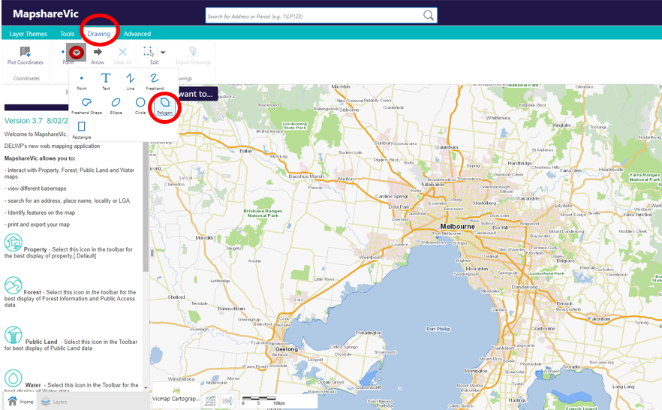

4. Zoom in to your desired location using the ‘+’ symbol and your mouse to navigate and click the boundaries of your project area to define the polygon shape



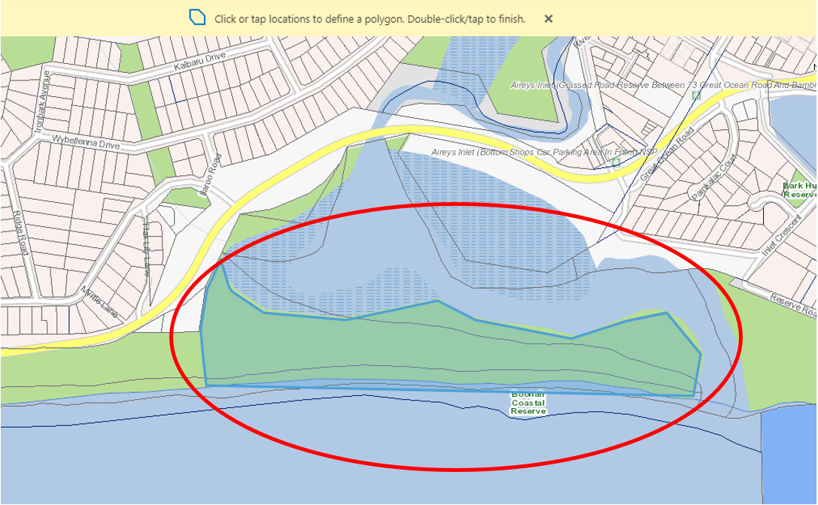

5. Double click to finish the polygon

6. If your project has multiple locations, please add additional polygons by repeating steps 4 and 5 as required

7. Once finished click 'Export Drawings' on the 'Drawing' toolbar. This will download a zipped folder containing the shapefiles you have just created to your device. Click OK. If it prompts you to open or save the file – choose Save. You can locate the Zipped folder in your Downloads in your File Explorer.

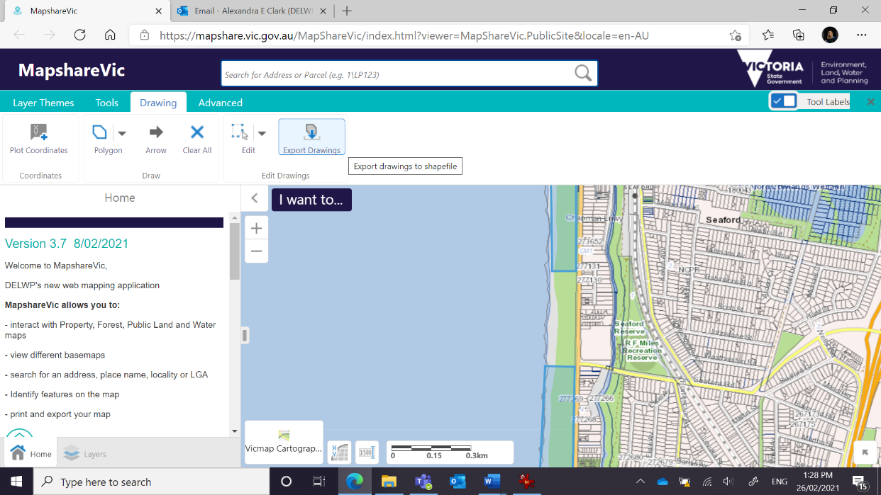



8. Upload the downloaded zipped folder in the “Supporting Documents- Sites” section of your grant application via Grants Online.

If you have difficulty with downloading the Zipped File try the steps again using a different internet browser, such as Firefox.

If you experience any problems with MapShare please contact a Coastcare Facilitator listed in Contact Details below.

# Terms and conditions

Also see the below section ‘Funded Projects Standards’, which will form part of your funding agreement. Prior to receiving funding, successful applicants will be required to enter into a Victorian Common Funding Agreement.

### Funding Agreements

Successful applicants must enter into a Victorian Common Funding Agreement with DELWP. It is recommended that applicants review the terms and conditions before applying. Information about the Victorian Common Funding Agreement is available on <https://www.vic.gov.au/victorian-common-funding-agreement>

This round will utilise the Short Form template, however, successful applicants may be subject to additional Coastcare Victoria specific funding agreement conditions.

### Tax Implications

Applicants should consult the Australian Taxation Office or seek professional advice on any taxation implications that may arise from this grant funding.

Successful applicants without an ABN will need to provide a completed Australian Taxation Office form ‘Statement by a Supplier’ so that no withholding tax is required from the grant payment.

### Acknowledging the Victorian Government’s support

Successful applicants are expected to acknowledge the Victorian Government’s support and promotional guidelines (<https://www2.delwp.vic.gov.au/grants>) will form part of the funding agreement. Successful applicants must liaise with Coastcare Victoria to coordinate any public events or announcements related to the project.

### Payments

Payments will be made if:

* a signed copy of the funding agreement has been received, and
* other terms and conditions of funding are met.

### Monitoring

* Grant recipients are required to comply with project monitoring and reporting requirements as outlined in the funding agreement. This may include progress reports, photos, site inspections, completion reports and acquittal documentation.

### Privacy

* Any personal information about you or a third party in your application will be collected by DELWP for the purposes of administering your grant application and informing Members of Parliament of successful applications. Personal information may also be disclosed to external experts, such as members of assessment panels, or other Government Departments for assessment, reporting, advice, comment or for discussions regarding alternative or collaborative grant funding opportunities. If you intend to include personal information about third parties in your application, please ensure that they are aware of the contents of this privacy statement.
* Any personal information about you or a third party in your correspondence will be collected, held, managed, used, disclosed or transferred in accordance with the provisions of the *Privacy and Data Protection Act 2014* and other applicable laws.
* DELWP is committed to protecting the privacy of personal information. You can find the DELWP Privacy Policy online at www.delwp.vic.gov.au/privacy.

Requests for access to information about you held by DELWP should be sent to the Manager Privacy, P.O. Box 500 East Melbourne 8002 or contact by phone on 9637 8697.

# DELWP Grants Online

DELWP Grants Online - for Community Users. The DELWP Grants Online Portal ‘GEMS’ is used to accept applications for the Coastcare Victoria Community Grants. This Portal is used across all DELWP grants programs.

## Registration & login

If you will be creating/submitting grant applications on behalf of your community group, it is highly recommended that you register an account with an organisational generic email address, so that account login details can be shared across the organisation.

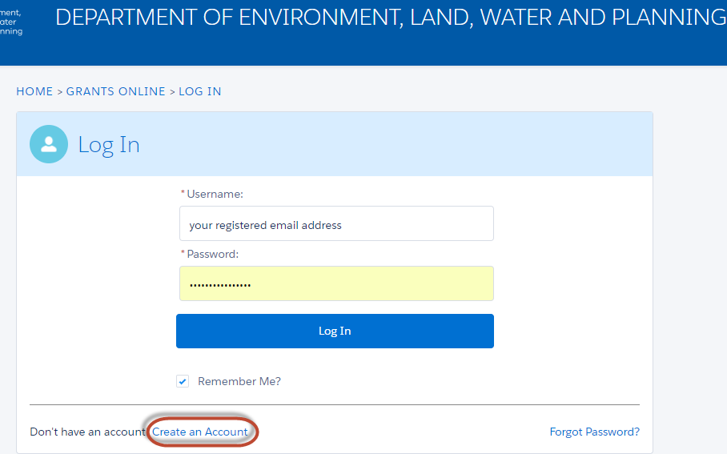

## Starting a new application

The ‘Create new application’ link will be available from the relevant DELWP website, as well as the Grants Victoria website, for example:

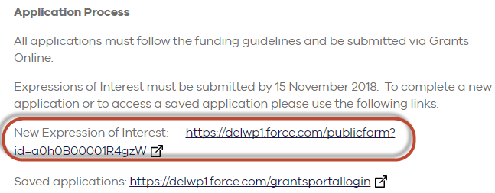

## Accessing existing draft & submitted applications

A unique application reference number is generated by the system when your application is saved as draft, the application number starts with “GA-F” and looks like “GA-F12345-1234”. It is important that you include your application reference number in any communication with this grant program.

There are three ways to access existing draft and submitted applications:

1. Login to <https://delwp1.force.com/GrantsPortalLogin> to access all your draft and submitted applications.
2. Using the link provided on the Coastcare Victoria Grants webpage and this document under “How to apply” section
3. Using the link provided in notification email you received after creating a new draft.

## Site navigation

1. The side navigation bar helps you to quickly navigate to the page you have worked on. The navigation bar colour changes from grey to green once the page is completed. And you can only jump to a page that is in green colour.
2. When you click on **Save as Draft** button, your application form is saved.
3. When you click on **View as PDF** button, you can view the entire application form.
4. When you click on **Next Page** button, the previous page content is saved automatically.

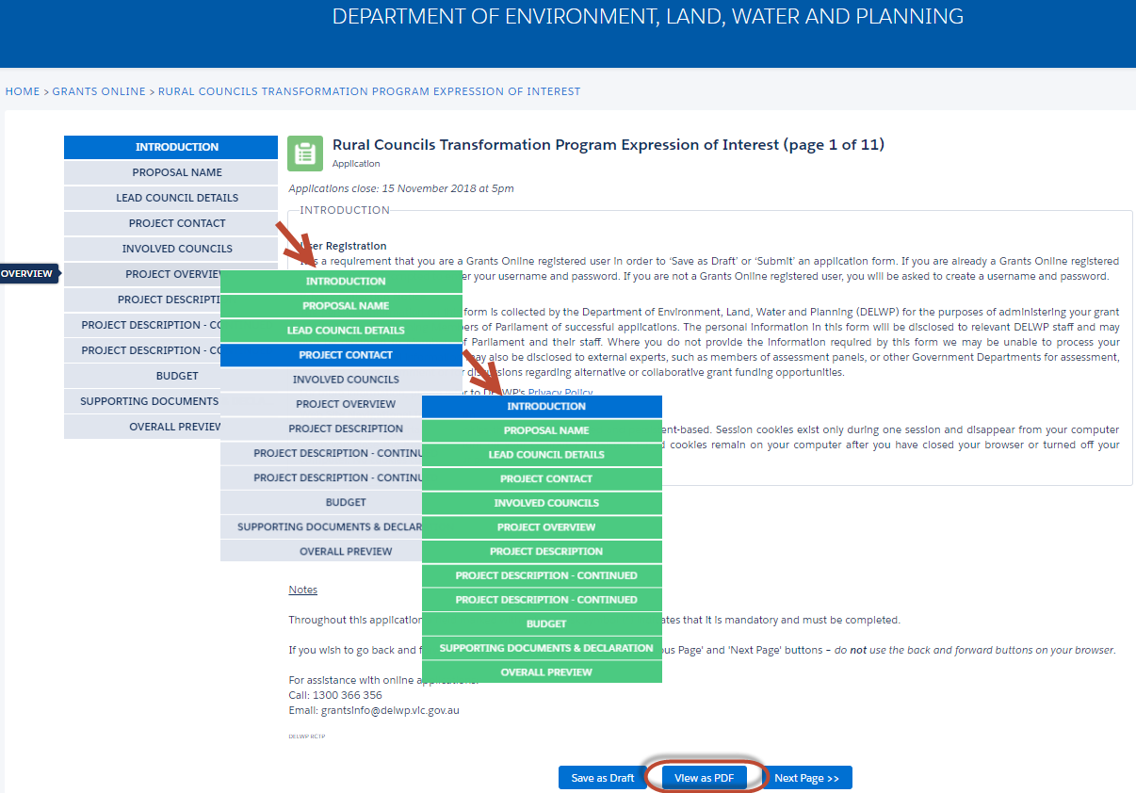

## Communicate with Program representatives

When communicating with program representatives (Coastcare facilitators), for example, emailing [coastcare.victoria@delwp.vic.gov.au](mailto:coastcare.victoria@delwp.vic.gov.au), please include the program name abbreviation, your application reference number, and program staff name if known in the subject line.

# Additional information and enquiries

Additional information is available at the program web page: [https://www.marineandcoasts.vic.gov.au/coastal-programs/Coastcare Victoria](https://www.marineandcoasts.vic.gov.au/coastal-programs/coastcare)

After reading these Guidelines if you have any questions, please contact your local Coastcare Victoria Facilitator – see contact details below. Coastcare Victoria requires you to discuss your project with your Facilitator before submitting your application to ensure your project has the best chance of success.

## What is the notification process?

Successful and unsuccessful applicants will be notified in writing after the assessment and approval of recommended projects to be funded processes are both complete. All decisions are final and are not subject to further review. Unsuccessful applicants can request feedback on their application.

## Checklist

Before applying via Grants Online, please complete the following checklist.

Have you:

 read these guidelines carefully?

 checked if your group/organisation is eligible for this grant funding?

 checked if your project is eligible for this grant funding?

 spoken to a Coastcare Victoria facilitator about your project?

 spoken to and obtained written support from relevant land managers for your project?

 spoken to and obtained written support from your auspice/sponsor for your project?

 prepared the required and appropriate supporting documents and checked they are appropriate file types?

 completed your application in the MS Word template first?

|  |  |
| --- | --- |
| **Far South West**  Adam Taylor  Coastcare Victoria Facilitator  Phone: 0427 316 324  Email: [adam.taylor@delwp.vic.gov.au](mailto:adam.taylor@delwp.vic.gov.au)  **Bellarine and Surf Coast**  Madison Cassie  Coastcare Victoria Facilitator  Phone: 0436 604 127  Email: madison.cassie@delwp.vic.gov.au  **Port Phillip Bay and Westernport**  Johanna Tachas  Coastcare Victoria Facilitator  Phone: 0427 268 169  Email: [johanna.tachas@delwp.vic.gov.au](mailto:johanna.tachas@delwp.vic.gov.au) | **South Gippsland**  Tracey Miller-Armstrong  Coastcare Victoria Facilitator  Phone: 0427 441 013  Email: [tracey.miller-armstrong@delwp.vic.gov.au](mailto:bethany.hunting@delwp.vic.gov.au)  **East Gippsland**  Bethany Hunting  Coastcare Victoria Facilitator  Phone: 0436 629 941  Email: [bethany.hunting@delwp.vic.gov.au](mailto:bethany.hunting@delwp.vic.gov.au)  **Coastcare Victoria Coordinator**  Jacqui Pocklington  Coastcare Victoria Statewide Coordinator  Phone: 0417 463 532  Email: [jacqueline.pocklington@delwp.vic.gov.au](mailto:jaqueline.pocklington@delwp.vic.gov.au) |

## Contact Details

# Frequently Asked Questions

## Key Information

### How much funding is available for each grant?

This year there will be up to $10,000 available per project.

### Can we submit more than one application?

* Multiple grant applications may be submitted. However, only one application per group across all streams may be deemed successful in the 2022-23 Coastcare Victoria Community Grants.
* Each application you submit must be separate (not reliant on another project) and must not be a scaled up or scaled down version of another application. Activities (or components of projects) that have already been funded on the same site by other sources are not eligible.

### Will we be required to match funding?

Applicants do not have to contribute funding to their project, however, a project that can demonstrate in-kind contributions provides greater value for money to Coastcare Victoria and therefore will receive a higher score against the Budget criteria. Contributions can be in various forms including time, resources or funds.

### How long do successful applicants have to complete their project?

Projects must be completed (including the submission of acquittal documentation to Coastcare Victoria) by the end date stated in the funding agreement, which will be 31 May 2023.

### Who should we talk to about the project?

Coastcare Victoria requires you to discuss your project with a Coastcare Victoria facilitator before submitting your application to ensure your project has the best chance of success.

Please see Coastcare Victoria Facilitator contact details above.

You are also **strongly encouraged** to discuss your project with your relevant Traditional Owners before submitting your application to ensure your project has the best chance of delivery within the timeframes. A facilitator, in partnership with the relevant regional DELWP Inclusion Officer, can assist in brokering this relationship if you are unsure how to commence discussions.

### Can we apply for a grant if we have received Coastcare Victoria funding in the past?

Yes, as long as all your reports, including progress, completion and acquittal reports, from previously funded projects are up to date or have been submitted by the due date as required in your previous funding agreement.

Coastcare Victoria will not fund activities (or components of projects) that have already been funded on the same site by other sources

## Submitting Applications

### How do we apply?

Applications consist of:

1 – Completion of an online form. See our website for a MS Word document template of this form for drafting your application prior to copying it into the online form.

2 – Completion of a multi-tab MS Excel spreadsheet. This needs to be uploaded to the DELWP Grants Online portal.

3 – Supporting documentation uploaded to the DELWP Grants Online portal.

Applications are submitted online using the DELWP Grants Online portal. Use the links below to start your application:

1. Stewardship and Education, go to: <https://delwp1.force.com/publicform?id=a0h8u000000OjKA>

2. Strengthening our Volunteer Groups, go to: – <https://delwp1.force.com/publicform?id=a0h8u000000OjKV>

3. Supporting Traditional Owner Self-Determination, go to: <https://delwp1.force.com/publicform?id=a0h8u000000OjKaS3>

To access existing drafts or submitted applications, go to: <https://delwp1.force.com/>

### Can we view previous applications?

Yes, so long as you use the same Grants Online portal login as last time.

### We are having trouble with the online application - where do we go for help?

If you require assistance submitting your application online, contact DELWP on 136 186 or [grantsinfo@delwp.vic.gov.au](mailto:grantsinfo@delwp.vic.gov.au) or contact a Coastcare Victoria Facilitator.

### Is there a word count for the application?

Please pay attention to the word count as detailed in the relevant sections. These are also stated in the MS Word version template of the application. We encourage you to use the word document to draft your application prior to copying into the Grants Online portal form.

### Does the application form auto-save or should we save it manually?

* Auto-saves when going to the next page.
* If you wish to go back and forward between pages, you should use the ‘Previous Page’ and ‘Next Page’ buttons – do not use the back and forward buttons on your browser.
* If you press the save button you will need to log back into the application.

### What kind of supporting documentation should we submit?

Check the Project Eligibility section above for supporting documentation that can be submitted. Other documentation such as strategies, plans, detailed methodology, and quotes are not required for this year’s grants application.

### How many attachments can we submit?

Applicants can submit up to 10 attachments via the online GEMS Grants system, with the system having a file size limit of 10MB each.

### DELWP Grants Online Portal Hints

* Do not use the Internet Explorer browser – choose Firefox, Chrome or another browser as these browsers are more stable with the DELWP Grants Online Portal.
* When you register, note down the email and password you used. You will need it to access your application later. If your application is successful it will form part of your funding agreement.
* After you start your application, you will receive a notification email with a link to return to the application form. It is easiest to continue accessing your application via this link.
* If completing your application in the supplied MS Word template first, keep formatting simple to assist with copying work across to the DELWP Grants Online Portal.
* If converting your application to a PDF document, there are known alignment issues. Apologies, there has been no known resolution to this issue.
* Two people logging into the same grant application may cause issues such as data loss. You are encouraged to only have one person working in the application at any one time.
* Refer to the DELWP Grants Online Information Sheet available on the Coastcare Victoria website.

### How long does it take to apply?

Based on feedback from previous applicants you should allow around 3 full working days across the application open period to plan your grant application and around 1-1.5 working days to complete your application ready for submission.

## Land Manager Support and Consent

### Do we need consent from a land manager?

If your project involves changing a site in some way, you will need consent from the land manager for your application to be eligible. This includes (but is not limited to) revegetation, clearing weeds or rubbish, minor works such as fences or paths and the installation of signage.

If your project involves holding events or activities on a site, you should seek land manager consent.

If you have any queries about land manager consent, seek advice from the land manager or from a Coastcare Victoria facilitator.

When submitting your application, you are required to attach written support from relevant land managers. Formal consent can be obtained later if your application is successful.

It is advised to check the land manager status of your project site with a Coastcare Victoria facilitator as this can sometimes be unclear where borders cross and can even change. Keep in mind that your site may be managed by more than one land manager.

### What is the difference between a letter of support and formal consent?

A letter of support shows that your land manager has given in principle support to your project. It can be a simple letter or email from a land manager representative with appropriate authority. If your project involves changing a site in some way and/or holding events or activities on a site then you will need to provide a letter of support with your application.

Formal consent involves gaining official approval to work on the site. Your land manager will check that your project meets relevant obligations, which could include cultural heritage, planning overlays and risk management. Formal consent is comprehensive, takes time and may cost money. You should include time and relevant costs for consents and permits when planning and budgeting for your project.

### Do we need consent from all land managers?

Yes. You will need consent from all relevant land managers that own or manage a site you intend to work on.

### We are not sure who the land manager/s is/are – do we need consent?

Yes. If you need assistance determining the land manager of your site, please contact a Coastcare Victoria facilitator.

### We have never needed consent from a land manager before – do we need it now?

If your project involves changing a site in some way and/or holding events or activities on a site then you will need consent – even if you haven’t needed (or had) it for similar activities before.

## Volunteer contributions

### What is the volunteer contribution rate?

$40 per hour for all volunteers and all activities they undertake for your project. This standard rate allows applications to be considered in a consistent way and is based on an average rate that was calculated by the Australian Bureau of Statistics in 2010, which we have corrected for inflation.

### Can we use a higher rate for volunteers with professional skills worth more than $40?

No. $40 per hour is a standard rate that values the contribution that all volunteers make to your project.

### What kind of volunteer activities can count towards in kind support?

Any activity that your volunteers undertake as part of the project can count. This could include:

* Physical work, such as planting, building or litter collection
* Planning the logistics for the project
* Preparing educational material
* Coordinating an event, such as corporate or school volunteering, or running an information session

Volunteers may be members of your group, corporate volunteers or members of the public – they all count, as long as they are actively doing something to assist in delivering your project.

## Budgets and GST

### What do we do if we think one of our activities or budget items is ineligible?

If you think one of your activities or budget items may fall under one of the types listed under ‘ineligible activities and budget items’, but you’re not sure, contact a Coastcare Victoria facilitator with your scenario so they can confirm whether the activity or budget item is ineligible.

### Do we need to have an ABN?

A group should provide its ABN if it has one. If a group does not have an ABN, then an Australian Tax Office form (Statement by a supplier) will be provided to you to complete if your application is successful.

### Do we need to be registered for GST?

Applicants do not need to be registered for GST.

### Do we include GST in the budget when costing the project?

Yes. Applicants will need to list the actual costs of the activities or materials you are seeking to be funded. This may include taxable supply items which include a GST charge such as nursery plants or contractor services. Include each item you are requesting grant funding for and its total cost, including GST.

### Does the grant payment include GST?

If you have an ABN and are registered for GST, your grant payment will be taxable and GST will be added to the total amount of funding you have requested/has been approved.

If you are not registered for GST, your grant payment will not be taxable, so will not include GST.

## Biodiversity Information

### How can we find out what species are indigenous to my project area?

You can visit DELWP’s NatureKit website for more information on native vegetation in your area.

<https://www.environment.vic.gov.au/biodiversity/naturekit>

Zoom to the location of your project (1:25,000 scale), open the Ecological Vegetation Classes (EVC) Map Layer on the right for the EVC for your area to be shown.

To find out what species make up the EVC, see the EVC Benchmarks at <https://www.environment.vic.gov.au/biodiversity/bioregions-and-evc-benchmarks>

Use the map to find the Bioregion your project is in, click on the Bioregion name, then select the relevant EVC/s and view a PDF of the recommended species for your site.

It is also strongly recommended that you consult with your land manager for advice and approval to ensure alignment with any site management plan or preferences in species chosen.

# Funded Projects Standards

These standards are designed to help you identify and comply with all legal requirements of your agreement.  Please keep this document as a reference and contact a Coastcare Victoria Facilitator if you need further direction or assistance.

|  |  |
| --- | --- |
| General | |
| Acknowledgment and publicity guidelines for Victorian Government funding support | You must acknowledge the government’s funding support on written materials and in speeches and other forms of presentations, such as signage.  Any written acknowledgement statement in published or printed materials associated with the funded project or initiative should include one of the statements below:  • The [name of program/s/projects/s/ initiative/s] was/were or is/are supported by Coastcare Victoria and the Victorian Government.  • [Name of organisation] acknowledges the support of Coastcare Victoria and the Victorian Government.  At all openings, launches and events supported by or associated with government funding support, you must prominently display Coastcare Victoria and Victorian Government signs or banners, if available. Coastcare Victoria signs and banners can be borrowed from DELWP. Your organisation is responsible for organising for their collection and their prompt return.  You must use both the Coastcare Victoria and Victorian Government logo.  Further detail is found in the ‘Acknowledgment and publicity guidelines for Victorian Government funding support’ document attached. A breach of these guidelines is considered a breach of your funding agreement with Coastcare Victoria and DELWP.  To access the logos, or to seek advice on use, please contact your Coastcare Facilitator. |
| Media and Communications Reporting | For each Coastcare Victoria funded grant, recipients are required to provide:  • At least five photos with permissions to reproduce.  • Copies of any communication activities targeting the general community.  • Copies of any publications, signage or similar produced as a result of your grant.  We will ask for copies of these materials in your progress and final reporting, but if you have something great or opportune, please forward it at any time.  Further detail is found in the ‘Coastcare Victoria Community Grants Standards - Media and Communications Reporting for your Coastcare Victoria Community Grant’ document attached. |
| Funding agreement conditions, milestones and dates | Please ensure you have read and understood all conditions in your funding agreement. It is your legal responsibility to ensure you comply.  You must deliver and complete the milestones by the due date specified in your agreement, unless otherwise approved in writing by Coastcare Victoria. |
| Ineligible activities and budget items | Funding is NOT permitted to be used for the following:   * Wages of staff – for example, hiring an employee as the person delivering training/education is an ineligible activity; listing ‘contractors’ when those contractors are the same organisation as the Applicant (ie, same ABN), contractors must be from an external party. * Summer by the Sea Program activities * Works on or for the benefit of private land, such as asset protection and seawall structures * Development of recreation facilities or projects primarily focused on improving amenity * Any activity involving clearing of native vegetation, unless it is a declared environmental weed in your area and appropriate permits are obtained * Revegetation works using species which are not local indigenous species * Removal of exotic trees from coastal foreshore areas where there is little or no remnant vegetation * Large infrastructure or engineering works, such as coastal asset protection erosion mitigation activities * Activities (or components of projects) that have already been funded on the same site by other sources * The purchase or production of goods or merchandise which are considered to be environmentally damaging e.g. plastics (hard or soft), polystyrene, single use items (e.g. stickers, plastic cutlery and plates) * Goods or services for competitions, prizes, gifts, vouchers or alcohol * General operating or travel costs not directly associated with a project/event * Sand/beach renourishment * Activities involving the use of fire-arms, tranquilisers, explosives, trapping, ferreting or harbour destruction for animal control. * Feral cat control * Any activity required as an offset (as a condition of a permit to clear native vegetation) * Projects not relating to Victoria’s marine and coastal environments * Using LPG devices, ferreting or harbor destruction for rabbit control * Shooting animals * Trapping animals |
| Capital items | Capital items and equipment are those that have a usable lifespan beyond one year and therefore would need to be maintained on an asset register by an organisation to be depreciated over several accounting periods. This includes items such as for example tree planters and photographic, video and motion sensor cameras.  All capital items or equipment should be registered as an asset with your organisation.  Please ensure that where possible, assets are hired or borrowed and shared between organisations / groups rather than purchased for one-off projects. |
| Insurance | Insurance is required from the start date of your funding agreement. You must maintain effective and appropriate insurance coverage for your operational and business risks for the duration of your funding agreement. |
| For On-Ground Works | |
| Aboriginal cultural heritage | See attached ‘Aboriginal Cultural Heritage Guide for Landcare and environmental volunteering groups and networks’.  Where proposed activities may impact Aboriginal cultural heritage, you must seek advice from the relevant Registered Aboriginal Party or Aboriginal Victoria.  Before commencing any works, you must meet requirements of the *Aboriginal Heritage Act 2006*and obtain authorisation from the relevant approval authority where proposed activities may require a cultural heritage management plan or cultural heritage permit.  Read up on processes under the Aboriginal Heritage Act 2006 for managing and protecting Aboriginal cultural heritage, including cultural heritage management plans (CHMP), permits, agreements and tests at <https://www.aboriginalvictoria.vic.gov.au/cultural-heritage-management-plans-permits-agreements-and-tests>  For further information refer to the Aboriginal Heritage Council website:  [https://www.aboriginalheritagecouncil.vic.gov.au](https://www.aboriginalheritagecouncil.vic.gov.au/)  <https://www.aboriginalheritagecouncil.vic.gov.au/victorias-registered-aboriginal-parties>  [https://www.aboriginalvictoria.vic.gov.au/report-and-protect-possible-aboriginal-place-or-object](https://www.aboriginalheritagecouncil.vic.gov.au/victorias-registered-aboriginal-parties) |
| Animal ethics approvals | All research proposals involving animals, for example live-capture and release; bird or bat banding (ABBBS), marking; radio tracking; taking of tissue samples; call playback, baited remote sensing cameras, may first require Animal Ethics Committee (AEC) approval in accordance with the Prevention of Cruelty to Animals Act 1986 (POCTA), POCTA Regulations 2019 and the Australian Code for the care and use of animals or scientific purposes. The purpose of the POCTA Act is to prevent cruelty to animals; to encourage the considerate treatment of animals; and to improve the level of community awareness about the prevention of cruelty to animals.  For further information regarding animal ethics approvals and requirements refer to Agriculture Victoria's website: <https://agriculture.vic.gov.au/livestock-and-animals/animal-welfare-victoria/animals-used-in-research-and-teaching>  And Animal Ethics Committee (AEC): <https://agriculture.vic.gov.au/livestock-and-animals/animal-welfare-victoria/animals-used-in-research-and-teaching/animal-ethics-committees>  You may require a Scientific Procedures Premises License issued by AEC. Please seek advice from the Licensing Officer regarding requirements: sp.licensing@ecodev.vic.gov.au  Please ensure you allow enough time for approvals/licenses as these need to be in place before on-ground project activities commence.  In addition, you may require a permit for projects relating to pest animals. Visit <https://agriculture.vic.gov.au/biosecurity/protecting-victoria/legislation-policy-and-permits/managing-pest-animals> |
| Contractors | You must ensure that any contractors have current and adequate insurance, licenses, permits and approvals for all works before commencing. Contractors must have insurance that is appropriate for the risk and scale of the works to be conducted. |
| Land manager Consent | You must seek and obtain the written consent of all property owner/s or land manager/s prior to starting any activity on the land they own or manage. |
| Legislative and regulatory requirements | It is your responsibility to ensure that your project complies with all requirements set out in any applicable State, Commonwealth, territory and local government legislations and regulations, including that all necessary planning, approvals and/or permits are or will be in place prior to the commencement of on ground activities for the project. Speak to the relevant land manager for advice on requirements specific to your project.  Commonwealth and state/territory legislations and regulations include but are not limited to those listed below:   * *Aboriginal Heritage Act 2006* * *Aboriginal Heritage Amendment Act 2016* * *Aboriginal Heritage Regulations 2018* * *Environment Protection and Biodiversity Conservation Act 1999* * *Flora and Fauna Guarantee Act 1988* * *Marine and Coastal Act 2018* * *Native Title Act 1993* * *Occupational Health and Safety Act 2004* * *Planning and Environment Act 1987* * *The Privacy Act 1988 (Commonwealth)* * *The Freedom of Information Act 1982* * *Traditional Owner Settlement Act 2010* * *Victoria’s Child Safe Standards* * *Working with Children Act 2005* |
| Occupational Health and Safety | You must ensure Occupational Health and Safety requirements are met including developing a Job Safety Plan (or equivalent) and undertaking a Site Safety Survey before work commences.  You must ensure there is appropriate supervision and training of staff, volunteers and contractors, and safe equipment and PPE available.  For volunteer organisations – please ensure you liaise with your OHS Responsible Officer in planning your project delivery.  If you are unsure which land manager is your Responsible Officer, please discuss this with Coastcare Victoria as soon as possible. |
| Permits – General | Funding of an Activity does not constitute a permit from DELWP, Coastcare Victoria or from Local Government Authorities. You are responsible for obtaining all necessary permits required in relation to the Activity including but not limited to the following:   * Any planning permits that are required * Any building permits that are required * Any heritage approvals that are required |
| Permit - Fisheries Act | For some projects a license, permit or authorisation may be required under the Fisheries Act 1995.  For further information contact Victorian Fisheries Authority general enquiries 136 186, or online at <https://vfa.vic.gov.au/about/contact-us> |
| Permit - Marine and Coastal Crown Land | If any of your project activities will be carried out on Marine and Coastal Crown land you may require approval under the Marine and Coastal Act 2018: <https://www.marineandcoasts.vic.gov.au/marine-and-coastal-act>  Before commencing any works, you must obtain approval to use or develop marine and coastal Crown land. You must comply with the conditions of any consent provided.  For more information contact DELWP general enquiries on 136 186 or contract your local DELWP office |
| Permit - Research / Survey  Assessment and monitoring of wildlife and plants | For some projects a permit or authorisation may be required under the Wildlife Act 1975, Flora and Fauna Guarantee Act 1988 (FFG Act) or the National Parks Act 1975.  For projects that involve the capture, collection or interference with wildlife, including fauna surveys; live-capture and release; bird or bat banding (ABBBS), marking; radio tracking; taking of tissue samples; call playback, baited remote sensing cameras, retaining wildlife for education; collection of dead specimens (bones, skin, feathers, teeth, etc.); or any other handling of wildlife, and collection of listed terrestrial invertebrates under the FFG Act you may require an authorisation or permit under the Wildlife Act 1975.  For projects that involve native vegetation surveys, any taking of protected flora, direct (picking) or indirect (trampling) including collection of herbarium specimens; collection of vegetation samples; collection of seed or propagation material and research in protected communities, taking or surveying of protected fish, collection / taking of any FFG Act listed aquatic invertebrates you may require an authorisation or permit under the FFG Act 1988.  An authorisation or research permit is required for all research conducted on Parks Victoria managed land: <https://www.parks.vic.gov.au/get-into-nature/conservation-and-science/science-and-research/research-permits>  You may also require a permit from the Department of Environment, Land, Water and Planning: <https://www.wildlife.vic.gov.au/wildlife-research-tourism-and-cinema/flora-and-fauna-research-permits>  Please ensure you allow enough time for permit approvals as these need to be in place before on- ground project activities commence. |
| Planned Burn | Planned burning is not eligible for use of funding under this contract. |
| Project site address identified as a vegetation offset | No funds are to be allocated for or used within a native vegetation offset (covenanted sites) under an existing contract. |
| Revegetation | Species need to be indigenous to the site. Seek expertise to identify appropriate species and source plants or seed from healthy, viable and robust populations.  Contact your local indigenous nursery to assist with identifying appropriate plants and planting lists.  Funding is not to be used on non-indigenous or advanced plants (Note: indigenous tube stock or smaller cell plants and seeds are eligible). |
| For Weed and Pest Animal Control | |
| General – Pest animal control | In relation to vertebrate pest control activities, ensure that all legal and animal welfare requirements are met and that you obtain any permits required.  Please visit:   * Agriculture Victoria <https://agriculture.vic.gov.au/biosecurity/protecting-victoria/legislation-policy-and-permits/managing-pest-animals> * Animal Welfare Victoria (a part of Agriculture Victoria) <https://agriculture.vic.gov.au/livestock-and-animals/animal-welfare-victoria/pocta-act-1986/humane-vertebrate-pest-control>   Note: where pest management activities are to be conducted on public land, you must apply the relevant Codes of Practice (COPs) and Standard Operating Procedures (SOPs). |
| General – Weed control | In relation to weed control activities, ensure that all weeds are disposed of and transported in a manner that ensures they will not be spread as a result of disposal or transport and that you obtain any permits required for transporting declared weeds.  For information on roles and responsibilities relating to weed control please refer to: <https://agriculture.vic.gov.au/biosecurity/weeds>  and <https://agriculture.vic.gov.au/biosecurity/weeds/prescribed-measures-for-the-control-of-noxious-weeds>  Refer also Legal responsibilities for managing invasive species: <https://agriculture.vic.gov.au/biosecurity/protecting-victoria/legislation-policy-and-permits/legal-responsibilities-for-managing-invasive-species>  The Weeds at the Early Stage of Invasion Project provides useful tools for weed management on public land in Victoria: <https://www.environment.vic.gov.au/invasive-plants-and-animals/early-invaders> |
| Baiting (application of bait products registered for pest animals in Victoria) | Only products registered for use against pest animals in Victoria can be used under this contract.  Only an appropriately 'authorised person' can conduct baiting programs and must have all appropriate licenses and permissions. People conducting baiting must adhere to all label instructions including notification requirements and implement baiting according to the Directions for Use for 1080 and PAPP in Victoria and relevant codes of practice and standard operating procedures.  For information on the use of chemicals including 1080 refer to Information on pest animal bait <https://agriculture.vic.gov.au/farm-management/chemicals/requirements-for-using-1080-and-PAPP-animal-bait>  Ensure that all legal and animal welfare requirements are met and that you obtain any permits required.  Please visit:   * Agriculture Victoria <https://agriculture.vic.gov.au/biosecurity/protecting-victoria/legislation-policy-and-permits/managing-pest-animals> * Animal Welfare Victoria (a part of Agriculture Victoria) <https://agriculture.vic.gov.au/livestock-and-animals/animal-welfare-victoria/pocta-act-1986/humane-vertebrate-pest-control> |
| Herbicide application | People undertaking the application of registered herbicides for weeds must comply with all the controls on the use of agricultural chemicals which include requirements for keeping records of chemical applications and compliance with product labels. The product label is important in determining the appropriateness of chemical use and must be followed at all times.  Other controls include the requirement to possess an Agricultural Chemical User Permit (ACUP) to allow use of certain chemical products and restrictions of use of certain chemical products in Agricultural Chemical Control Areas.  It is the responsibility of the user to be familiar with this legislation.  For more detailed information on the use of chemicals see: <https://agriculture.vic.gov.au/farm-management/chemicals> |
| Rabbit control | Warren fumigation is an eligible activity and you must ensure all label instructions and requirements are met, and all Agriculture Victoria permits and animal welfare requirements are met. |
| For Public Events | |
| COVID-19 Safety | Please make a COVID Safe Plan for any face-to-face activities and include this as part of your Job Safety Plan/s. Further information and templates can be found online at <https://www.coronavirus.vic.gov.au/covidsafe-plan>  Keep up to date and comply with current restrictions by checking the following sites <https://www.coronavirus.vic.gov.au/> and <https://www.dhhs.vic.gov.au/coronavirus>  Your event may be required to be registered as a public community event, to find out use the self assessment tool here <https://www.coronavirus.vic.gov.au/public-event-self-assessment-tool> and then register here <https://www.coronavirus.vic.gov.au/register-your-public-event> |
| Litter data | Any litter data you obtain through the course of your project should be entered into LitterWatch Victoria, an online web portal to input and manage litter data.  LitterWatch Victoria provides users the ability to view and compare data on litter across different areas and time periods.  Please email [LitterWatch.Victoria@delwp.vic.gov.au](mailto:LitterWatch.Victoria@delwp.vic.gov.au) to organise any training or assistance needed.  Further information can be found online at [https://www.litterwatchvictoria.org.au](https://www.litterwatchvictoria.org.au/) |
| Working with Children | Under the Working with Children Act 2005 people engaging in “child-related work” must apply for and pass the Working with Children (WWC) Check. The Organisation (its staff and volunteers) must meet all requirements of the WWC Check that are relevant to this Activity.  Victoria’s Commission for Children and Young People has recently introduced mandatory Child Safe Standards which organisations must implement and comply with.  Please visit <https://ccyp.vic.gov.au/child-safe-standards/> |