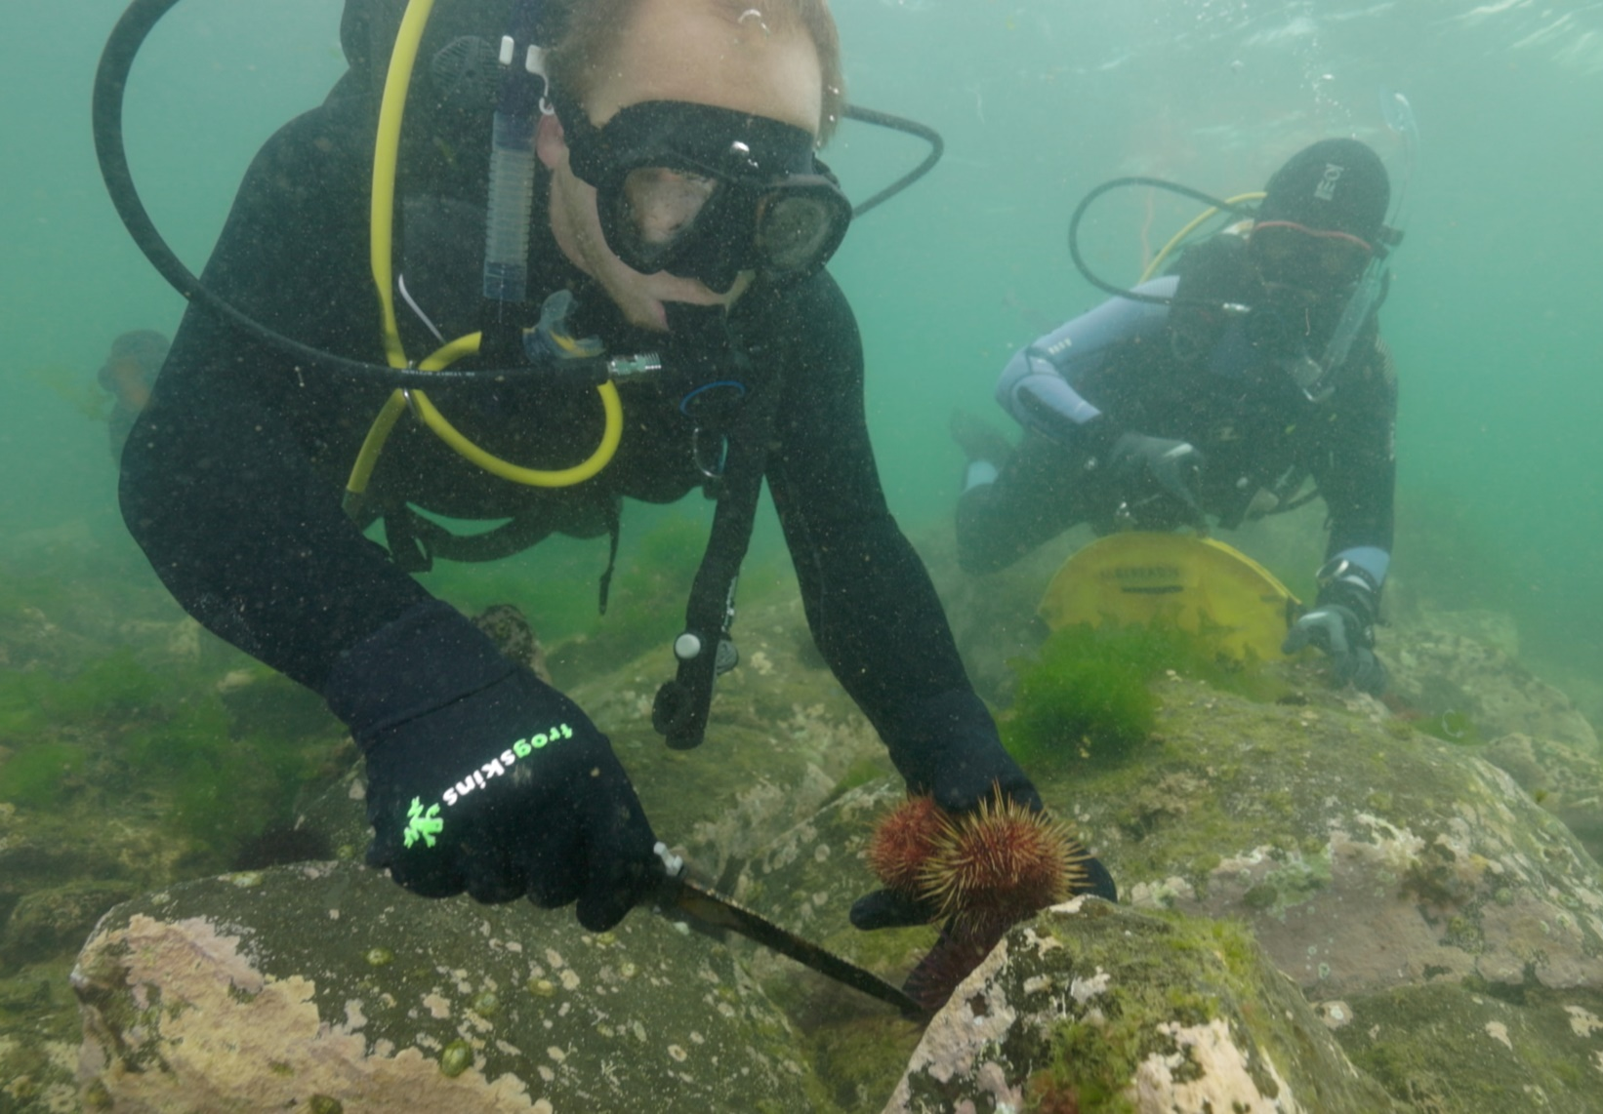

Coastcare Victoria School Kit

Ecosystem and Edible Urchins Worksheets

Acknowledgements

Coastcare Victoria would like to acknowledge all our video presenters and individuals who reviewed or assisted with the creation of the Coastcare Victoria School Kit.
Author
Coastcare Victoria and Ocean Imaging.
Photo credit
Ocean Imaging.

Contents
Ecosystems and Edible Urchins Quiz 1
What’s the Problem? Activity 3
Urchin Comic Strip with Text 4
Urchin Comic strip with Pictures 8
Urchin Sampling Investigation 12
Sustainable Seafood 19
Urchin Adaptation Investigation 21
Urchin adaptation Types Investigation 23
Top-Down Systems Year 5-6 Quiz 24
Top-Down System Year 7-8 Quiz 26

Ecosystems and Edible Urchins Quiz
Circle the correct answer

1. For how many years have Paul and his colleagues been surveying this reef at Williamstown?
- 2
- 4
- 6
- 12

2. What three things were the divers measuring in the surveys?
- Urchin diversity, fish densities and kelp cover
- Kelp cover, seaweed diversity and urchin densities
- Rock distance, seaweed height and number of urchins removed
- Distance from shore, ocean temperature, food abundance.

3. Which urchin species was being collected on the dive?
- Long spined sea urchin
- Short spined sea urchin
- Black spikey sea urchin
- Rough edged sea urchin

4. What do sea urchins usually eat?
- Zooplankton
- Phytoplankton
- Drifting seaweed
- Small starfish

5. What factor caused the seaweeds to grow prolifically in the 1950’s and 1960’s?
- Temperature
- Sunlight
- Nutrients
- Currents

6. What helped the urchin populations increase so dramatically?
- Lack of predators
- Abundance of food
- Lack of seaweed
- Warm temperatures

7. Why did the urchins change from ’couch potato’ mode to ‘army mode’?
- Less seaweed around so they needed to fight for it
- Chemicals in the water
- Huge appetite brought on by temperature
- Battle with the other urchin species

8. How many short spined urchins can a recreational fisher with a license catch in a day?
- 20
- 30
- 40
- 80

9. What part of the sea urchin is eaten?
- The short spines
- The mouth muscle
- The eyes
- The roe (eggs)

10. What rule needs to be considered when catching urchins?
- Must be caught below 2m deep
- Must be caught with gloves
- Must be cooked within 2 hours
- Must be taken from a sanctuary zone.

What’s the Problem? Activity
As the video plays underline biotic (living) factors and circle abiotic (non-living factors)

What we think has happened over time is a combination of all of the nutrients actually coming into Port Phillip Bay, with all of the sewerage wastewater that's been coming in, in here since the 50s and 60s. And that has basically driven a change in this ecosystem from the bottom up.

And all of those excess nutrients in the water actually drove a whole lot of other weedy seaweed species to massively proliferate. And when you have a whole lot of food, then other species will come along and make the most of that. And so sea urchins love to sit there on a rock and eat whatever drifting bits of seaweed are coming by, and so with all this extra seaweed that was now out there and floating around it built a larger sea urchin population in the bay.

But then what happened, we got to the Millennium drought, which was from the end of the 1990s, and through the 2000s. So, a long period of increased temperatures, but also reduced nutrients that were actually now coming into the bay. And so, now all of a sudden, we had less nutrients in the bay, and less seaweed that was now growing and proliferating because of it.

And that meant we had way more urchins. So, we had really high urchin numbers. And the seaweed populations were down here. So, they switched from couch potato mode to actually active foraging, kind of army mode. And instead (of waiting for food), moving around and eating and clearing all of the seaweeds and the kelps off the reef.”

Urchin Comic Strip with Text
What we think has happened over time is a combination of all of the nutrients actually coming into Port Phillip Bay, with all of the sewerage wastewater that's been coming in here since the 50s and 60s. And that has basically driven a change in this ecosystem from the bottom up

All of those excess nutrients in the water actually drove a whole lot of other weedy seaweed species to massively proliferate.

And when you have a whole lot of food, then other species will come along and make the most of that. And so sea urchins love to sit there on a rock and eat whatever drifting bits of seaweed are coming by, and so with all this extra seaweed that was now out there and floating around it built a larger sea urchin population in the bay

Then what happened, we got to the Millennium drought which was from the end of the 1990s, and through the 2000s. So a long period of increased temperatures, but also reduced nutrients that were actually now coming into the bay. And so, now all of a sudden, we had less nutrients in the bay, and less seaweed that was now growing and proliferating because of it.

Urchin Comic strip with Pictures
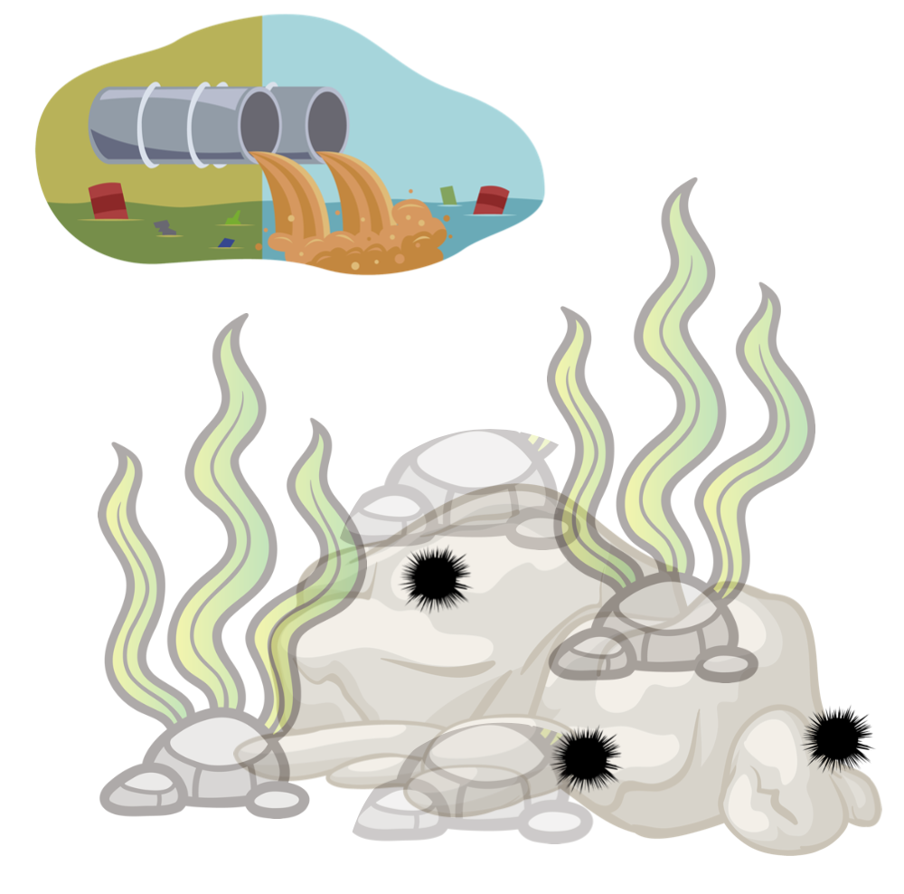

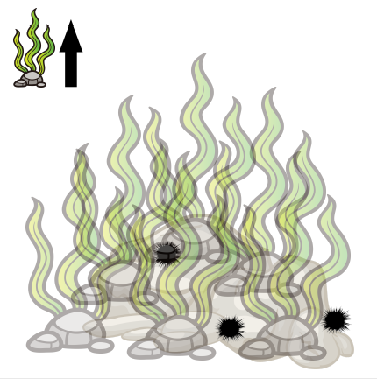

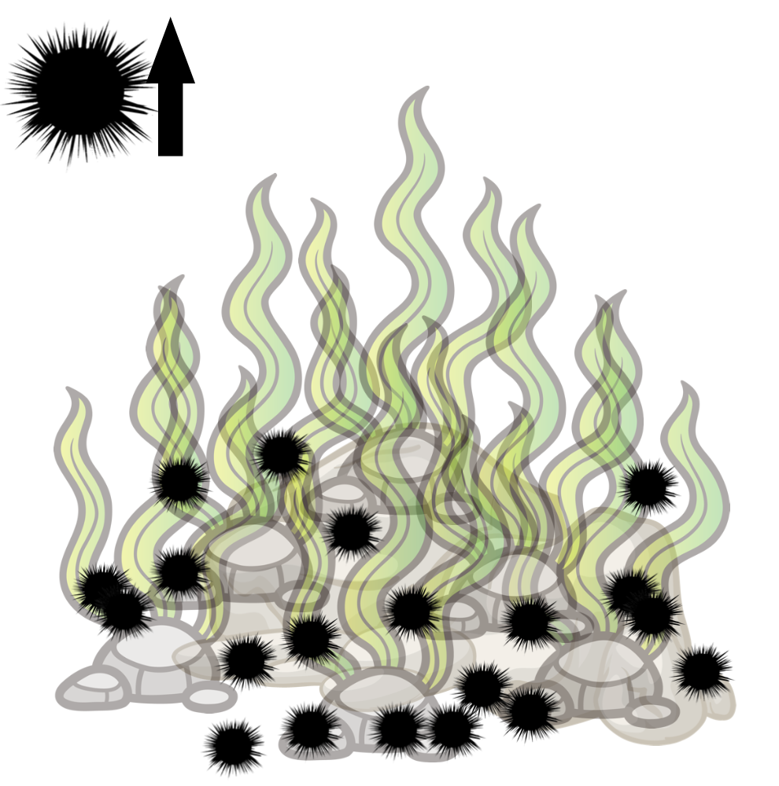

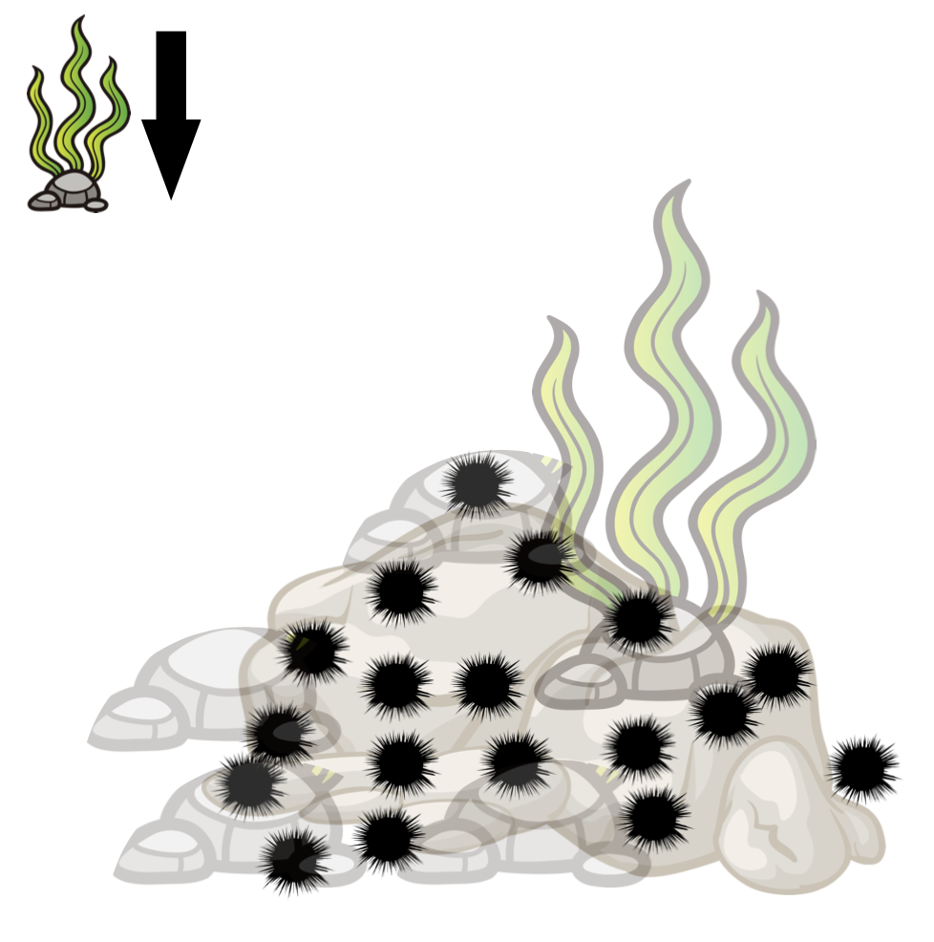

Urchin Sampling Investigation
Just like Paul and his colleagues were sampling the reef, now it’s your turn to collect data on the urchin densities in five different reefs.
Scientists use a square called a quadrat to count organisms of interest in an area. They can then extrapolate to make predictions about the broader densities of that organism over the area of the reef.

- Look at the reef worksheets. On each reef the total grid is 50 by 40 squares. How many total squares are over the entire reef?

- If each square is 20cm long, how big is the reef area?

- What is the total area of the reef? *Make sure to include units*

- Rather than counting all the urchins in the area, you have been tasked to count 10%. How much area will you need to sample?

- How many 100cm x 100cm quadrats (5 by 5 squares) would you need to count?

It's almost time to start sampling but first, you need to choose a method of laying your quadrats.
The reefs have been divided into a square grid of 8 x 10, labelling letters A-H along the short edge and 0-9 on the long edge. You can then use a ‘battleship’ style system to randomly drop the quadrats using a random alpha numeric generator like this one. (See tips on next page)

Sample | Reef A | Reef B | Reef C | Reef D | Reef E
1
2
3
4
5
6
7
8
9
Average
Reef Estimate

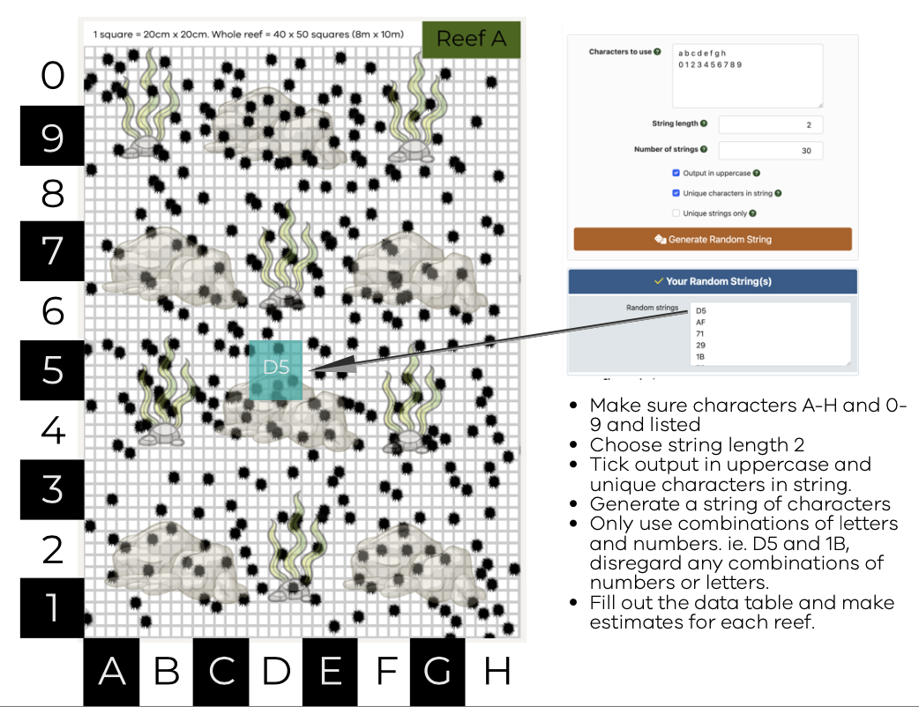
Reef A

Randomly Generated Coordinates | Count
Total
Average:

Reef B
Randomly Generated Coordinates | Count
Total
Average:

Reef C
Randomly Generated Coordinates | Count
Total
Average:

Reef D
Randomly Generated Coordinates | Count
Total
Average:

Sustainable Seafood

Marine species | Species name | Diet | Prey size | Trophic Level | Sustainability prediction | Sustainability
Blacklip abalone | Haliotis rubra
Sea Urchin | Heliocidaris erythrogramma
Bluethroat wrasse | Notolabrus tetricus
Blue Mussel | Mytilus planulatus
Oysters | Saccostrea glomerata
Luderick | Girella tricuspidata
Australian Sardine | Sardinops sagax
Southern Calamari | Sepioteuthis australia
King George Whiting | Siliagnodes punctata
Australian Salmon | Arripis trutta
Southern Rock Lobster | Jasus edwardsii
Snapper | Pagrus auratus
Yellowfin Tuna | Thunnus albacares
Gummy Shark | Mustelus antarcticus
Swordfish | Xiphias gladius

Urchin Adaptation Investigation
Urchins are highly successful animals that can be found in all of the world’s oceans. There are 950+ species worldwide. Only an animal highly suited (adapted) to its environment could be so successful. In this activity you will investigate the various adaptations of sea urchins and their adaptations.
Use the internet to research the following questions

1. What characteristics do all sea urchins have in common that make them well suited to their environment?

2. In the space below, draw a labelled diagram of a sea urchin. (if doing online, create, save and paste an image in space below).

3. What Sea creatures are sea urchins closely related to?

4. How do sea urchins move?

5. How do sea urchins reproduce?

6. Choose another ocean animal. Record and compare their adaptations to the sea urchin in the space below

Urchin adaptation Types Investigation
Urchins are highly successful animals that can be found in all of the world’s oceans. There are 950+ species worldwide. Only an animal highly suited (adapted) to its environment could be so successful. Some of their adaptations are outlined below.
Scientists classify adaptations in three main categories.
Behavioural: things organisms do to survive or reproduce
Physiological: a body process that helps an organism survive /reproduce.
Structural: a physical feature that helps an organism survive /reproduce.

Record the category(s) of adaptation in the space below: Note some adaptations may have multiple categories.
- They can survive in low food environments by shrinking their shell size (if you are smaller, you need less food)

- They put less investment in reproduction in low food environments. Less energy in the roe (eggs and gonads)

- Spines - protects them from predators and they can also use them to catch bits of seaweed as they float past. They also use the spines to pass food to the underneath side where their mouth is.

- Mouth on the bottom - this means they can graze along the rock and eat anything that’s attached there. The mouth is called an Aristotle’s lantern and looks a bit like a beak.

- Sea urchins move by walking, using their many flexible tube feet.

Top-Down Systems Year 5-6 Quiz
Trophic levels are an organism's position in the food web. In the top-down control, the populations of the organisms at lower trophic levels (bottom of the pyramid) are controlled by the organisms at the top.

1.Use the following words to match the letters with the correct trophic levels below:
primary consumer, primary producer, secondary consumer, tertiary consumer
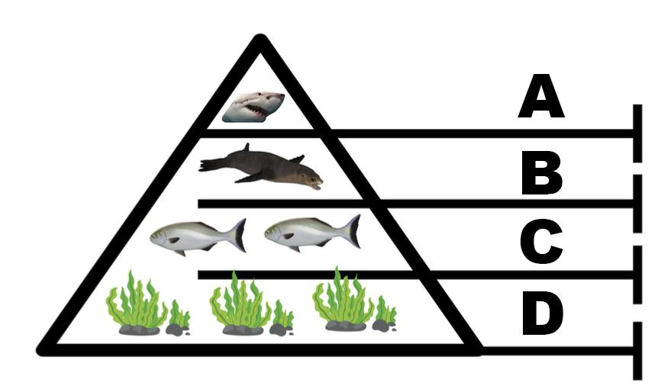
A =
B =
C =
D =

(4 marks)

2.The above diagram shows a top-down control. Which species control the sea lion population numbers? (1 mark)

3. In a top-down system, populations of the organisms lower trophic levels (bottom of the pyramid) are controlled by the organisms at the top. In the above situation, what may happen if there were not enough sea lions? (2 marks)

4. Finish this sentence: (1 mark)
In the diagram below, the ecosystem is controlled from

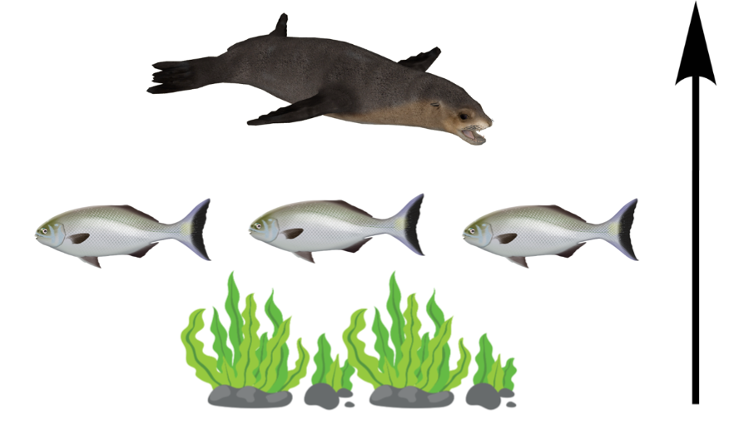

5. What is likely to control the number of fish that may be able to live in this ecosystem? (1 mark)

6. Name one factor that may impact the amount of seaweed that is able to grow in this ecosystem? (1 marks)

Top-Down System Year 7-8 Quiz

Trophic levels are an organism's position in the food web. In the top-down control, the populations of the organisms at lower trophic levels (bottom of the pyramid) are controlled by the organisms at the top.

1.Use the following words to match the letters with the correct trophic levels below:
primary consumer, primary producer, secondary consumer, tertiary consumer
A =
B =
C =
D =

(4 marks)

2. The top-down control of an ecosystem is also called the predator-controlled food web. Explain why. (2 marks)

3. In a top-down controlled ecosystem like the one above, what might happen if predator numbers go down? (3 marks)

4. Finish this sentence: (1 mark)
In the diagram below, the ecosystem is controlled from

5. What is likely to control the number of fish that may be able to live in this ecosystem? (1 mark)

6. Name three factors that may impact the amount of seaweed that is able to grow in this ecosystem? (1 marks)

7. What might happen if the amount of seaweed was to be reduced in this ecosystem? (1 mark)

