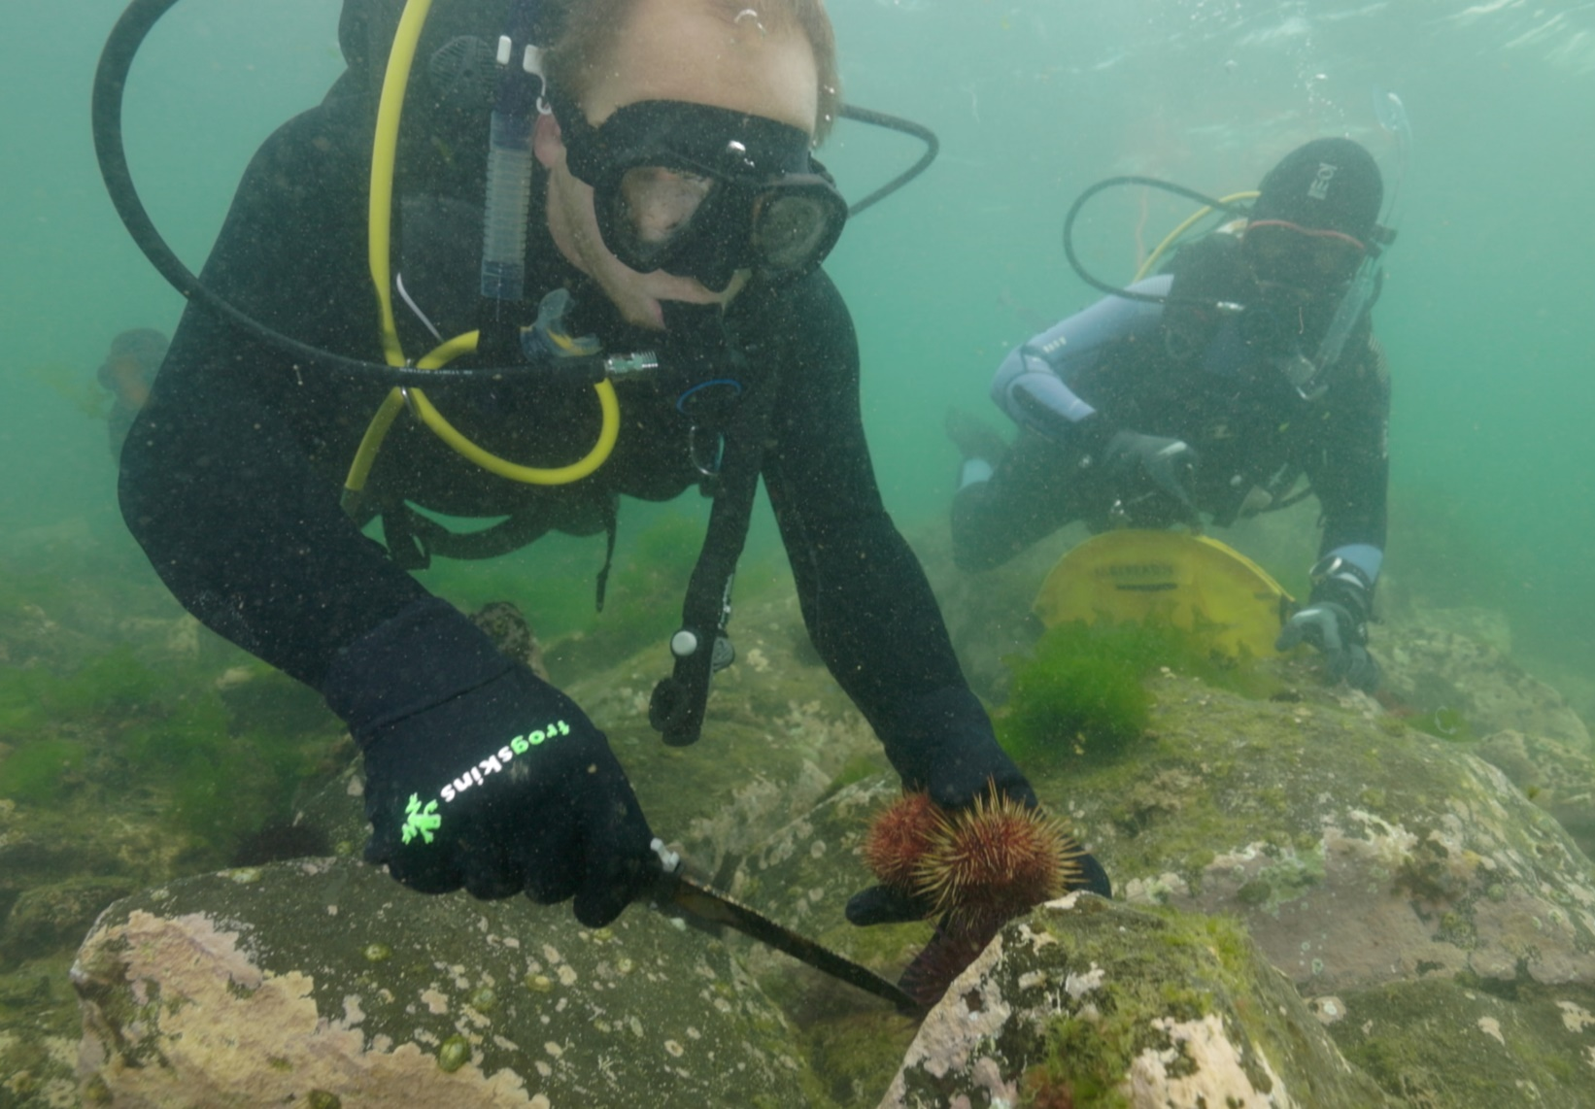
Ecosystem and
Edible Urchins

Worksheets

Coastcare Victoria School Kit

Ecosystem and Edible Urchins Worksheets

 | 

Acknowledgements

Coastcare Victoria would like to acknowledge all our video presenters and individuals who reviewed or assisted with the creation of the Coastcare Victoria School Kit.
Author
Coastcare Victoria and Ocean Imaging.
Photo credit
Ocean Imaging.

Contents
Activity 1: Quiz 1
Activity 2: What’s causing the problem? 3
Activity 3: Urchin population - Comic strip 4
Activity 4: Urchin population sampling 6
Investigation 1: Urchin adaptations 12
Investigation 2: Sustainable seafood 14
Review questions 16

Activity 1: Quiz
1. For how many years have Paul and his colleagues been surveying this reef at Williamstown?
- 2
- 4
- 6
- 12

2. What three things were the divers measuring in the surveys?
- Urchin diversity, fish densities and kelp cover
- Kelp cover, seaweed diversity and urchin densities
- Rock distance, seaweed height and number of urchins removed
- Distance from shore, ocean temperature, food abundance

3. Which urchin species was being collected on the dive?
- Long spined sea urchin
- Short spined sea urchin
- Black spikey sea urchin
- Rough edged sea urchin

4. What do sea urchins usually eat?
- Zooplankton
- Phytoplankton
- Drifting seaweed
- Small starfish

5. What factor caused the seaweeds to grow prolifically in the 1950’s and 1960’s?
- Temperature
- Sunlight
- Nutrients
- Currents

6. What helped the urchin populations increase so dramatically?
- Lack of predators
- Abundance of food
- Lack of seaweed
- Warm temperatures

7. Why did the urchins change from ’couch potato’ mode to ‘army mode’?
- Less seaweed around so they needed to fight for it
- Chemicals in the water
- Huge appetite brought on by temperature
- Battle with the other urchin species

8. How many short spined urchins can a recreational fisher with a license catch in a day?
- 20
- 30
- 40
- 80

9. What part of the sea urchin is eaten?
- The short spines
- The mouth muscle
- The eyes
- The roe (eggs)

10. What rule needs to be considered when catching urchins?
- Must be caught below 2m deep
- Must be caught with gloves
- Must be cooked within 2 hours
- Must be taken from a sanctuary zone

Activity 2: What’s causing the problem?
As the video plays underline biotic (living) factors and circle abiotic (non-living) factors

“What we think has happened over time is a combination of all of the nutrients actually coming into Port Phillip Bay, with all of the sewerage wastewater that's been coming in, in here since the 50s and 60s. And that has basically driven a change in this ecosystem from the bottom up.
And all of those excess nutrients in the water actually drove a whole lot of other weedy seaweed species to massively proliferate. And when you have a whole lot of food, then other species will come along and make the most of that. And so sea urchins love to sit there on a rock and eat whatever drifting bits of seaweed are coming by, and so with all this extra seaweed that was now out there and floating around it built a larger sea urchin population in the bay.
But then what happened, we got to the Millennium drought, which was from the end of the 1990s, and through the 2000s. So, a long period of increased temperatures, but also reduced nutrients that were actually now coming into the bay. And so, now all of a sudden, we had less nutrients in the bay, and less seaweed that was now growing and proliferating because of it.
And that meant we had way more urchins. So, we had really high urchin numbers. And the seaweed populations were down here. So, they switched from couch potato mode to actually active foraging, kind of army mode. And instead (of waiting for food), moving around and eating and clearing all of the seaweeds and the kelps off the reef.”

Activity 3: Urchin population - Comic strip
The text of our comic strip is in the correct order but the pictures at the bottom of the page are not. Cut out the pictures and stick them on in the right order.
When our comic is in the correct order, are the sea urchins in the ecosystem experiencing top-down, or bottom-up control?

What we think has happened over time is a combination of all of the nutrients actually coming into Port Phillip Bay, with all of the sewerage wastewater that's been coming in here since the 50s and 60s. And that has basically driven a change in this ecosystem from the bottom up | All of those excess nutrients in the water actually drove a whole lot of other weedy seaweed species to massively proliferate. | And when you have a whole lot of food, then other species will come along and make the most of that. And so sea urchins love to sit there on a rock and eat whatever drifting bits of seaweed are coming by, and so with all this extra seaweed that was now out there and floating around it built a larger sea urchin population in the bay | Then what happened, we got to the Millennium drought, which was from the end of the 1990s, and through the 2000s. So a long period of increased temperatures but also reduced nutrients that were actually now coming into the bay. And so, now all of a sudden, we had less nutrients in the bay, and less seaweed that was now growing and proliferating because of it.

Cut the pictures out and stick them on in the right order.

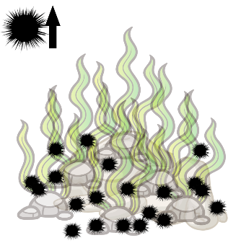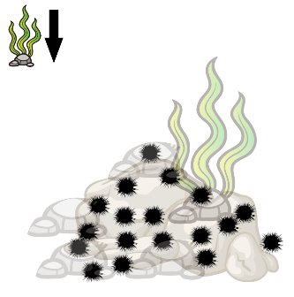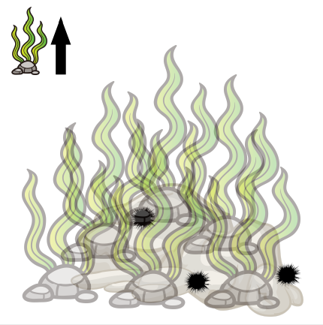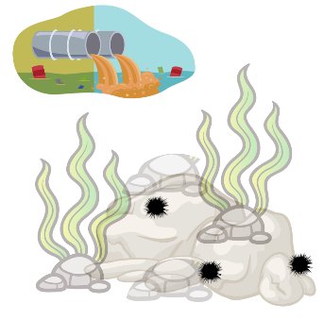

Make your own comic about populations.

Title:

First But Then Now

First

Activity 4: Urchin population sampling
It’s your turn to collect data on urchin populations, just like Paul and the other marine biologists. You have five different paper reefs to sample.
Counting every urchin on a reef is very difficult – so scientists use a 1m square, called a quadrat, to help them count a sub-set of the total population. Research shows that if we sample 10% of our population, we can correctly estimate the total population.

Calculate the total area of the reef so that we can calculate 10% of the area.
- Each small grid square is 20cm x 20cm (a 20cm square)
- How many grid squares together make a 1m square?
m long X m wide = m²
- How many meters square is each reef?
m² ÷ = m²
- Calculate 10% of the 80m² reef sheet:
- We need to count the urchins in x 1m² quadrats to estimate our population
Random sampling
If we choose where to put our survey squares, we might pick the ‘best looking’ locations. This will make our data biased and create inaccurate results. It is impossible not to be biased, it’s just how the human brain works. Therefore, scientists use a random number generator.
- Random coordinates have been generated to help you place your quadrats on your paper reefs.
- Use your ruler to outline the quadrats you are going to sample.
- Count the urchins inside each quadrat and record them next to your coordinates.

Population calculation
- Calculate the average of your eight quadrat counts – this tells you how many urchins are living on an average 1m² of this reef.
- Multiply the urchin average by the total area of the reef – this is an estimate of how many urchins are living on the reef.

Random Coordinate | Urchin population count
H8
D8
G7
E6
F4
5A
A7
9C
AVERAGE
POPULATION ESTIMATE
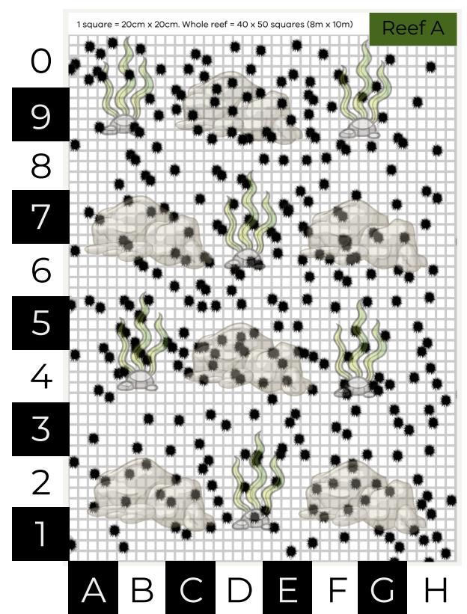
Reef A

Random Coordinate | Urchin population count
A6
F2
7B
46
7A
8C
F4
3D
AVERAGE
POPULATION ESTIMATE
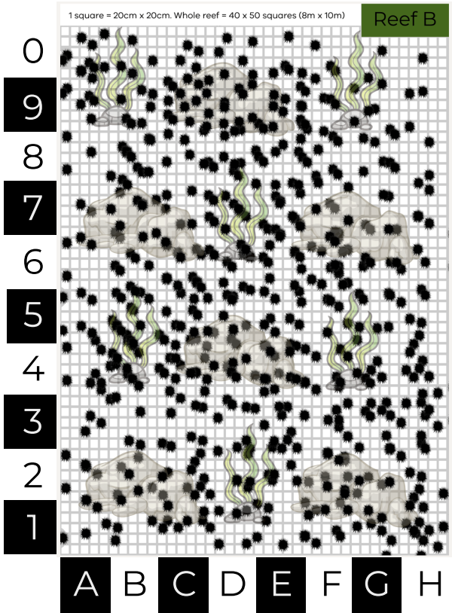
Reef B
Reef A

Random Coordinate | Urchin population count
A4
B7
4D
G3
0C
5D
1E
1F
AVERAGE
POPULATION ESTIMATE
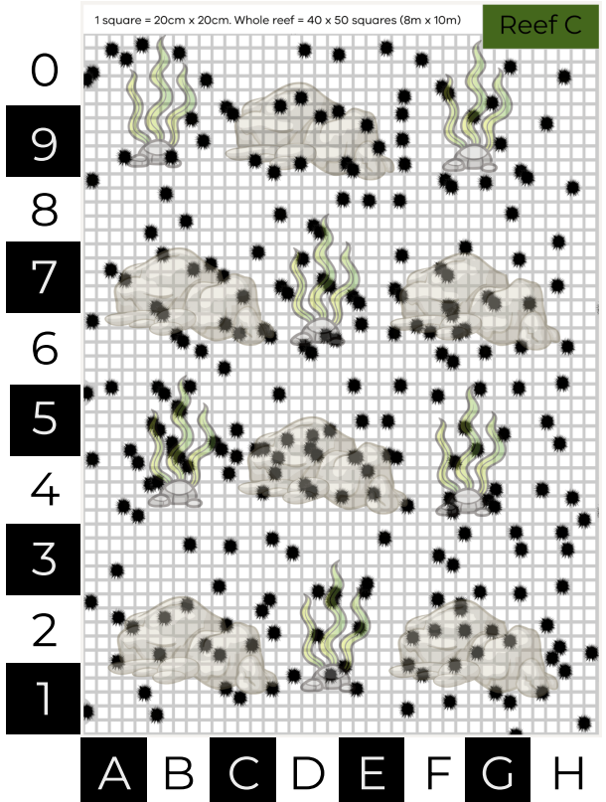
Reef C
Random Coordinate | Urchin population count
A5
3D
6C
A8
F9
F6
4B
7F
AVERAGE
POPULATION ESTIMATE
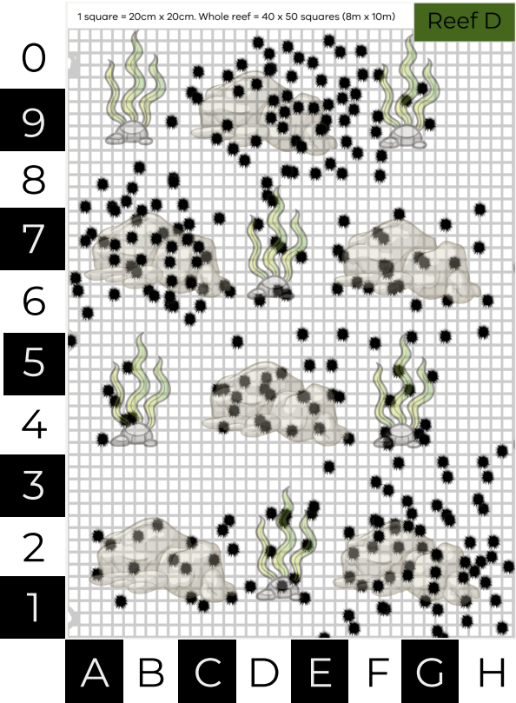
Reef D

Random Coordinate | Urchin population count
A5
F6
G0
B1
A2
6G
D3
6E
AVERAGE
POPULATION ESTIMATE
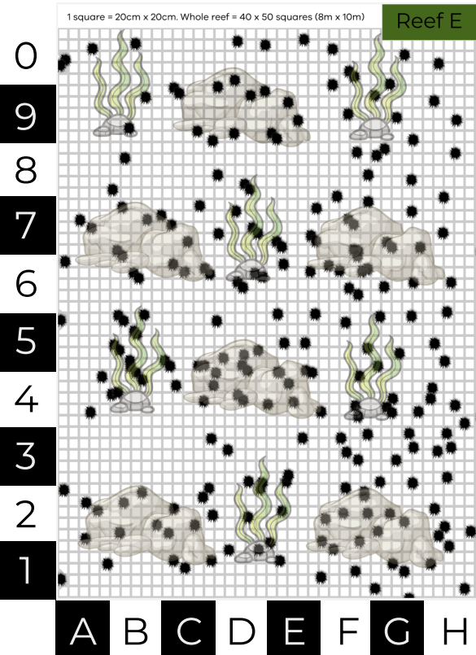
Reef E

Investigation 1: Urchin adaptations
Circle the category(s) of adaptation in the space below: Note some adaptations may have multiple categories.
- They can survive in low food environments by shrinking their shell size (if you are smaller, you need less food).
Behavioural Physiological Structural

- They put less investment in reproduction in low food environments. Less energy in the roe (eggs and gonads).
Behavioural Physiological Structural

- Spines - protects them from predators and they can also use them to catch bits of seaweed as they float past. They also use the spines to pass food to the underneath side where their mouth is.
Behavioural Physiological Structural

- Mouth on the bottom - this means they can graze along the rock and eat anything that’s attached there. The mouth is called an Aristotle’s lantern and looks a bit like a beak.
Behavioural Physiological Structural

- Sea urchins walk using their many flexible tube feet, meaning that they can find food.
Behavioural Physiological Structural

- Investigate another ocean animal. Record some of their adaptations:
- Structural

- Behavioural

- Physiological

Use the internet to research the following questions.

  - What characteristics do all sea urchins have in common?

  - What sea creatures are sea urchins closely related to?

  - How do sea urchins move?

  - How do sea urchins reproduce?

  - In the space below, draw a labelled diagram of a sea urchin.

Investigation 2: Sustainable seafood

Marine species | Species name | Diet | Prey size | Pyramid Level | Sustainability prediction | Sustainability (green, orange or red)
Blacklip abalone | Haliotis rubra
Sea Urchin | Heliocidaris erythrogramma
Bluethroat wrasse | Notolabrus tetricus
Blue Mussel | Mytilus planulatus
Oysters | Saccostrea glomerata
Luderick | Girella tricuspidata
Australian Sardine | Sardinops sagax
Southern Calamari | Sepioteuthis australia
King George Whiting | Siliagnodes punctata
Australian Salmon | Arripis trutta
Southern Rock Lobster | Jasus edwardsii
Snapper | Pagrus auratus
Yellowfin Tuna | Thunnus albacares
Gummy Shark | Mustelus antarcticus
Swordfish | Xiphias gladius

Review questions
- Match the labels with the correct letter in the population pyramid:
primary consumer, primary producer, secondary consumer, tertiary consumer
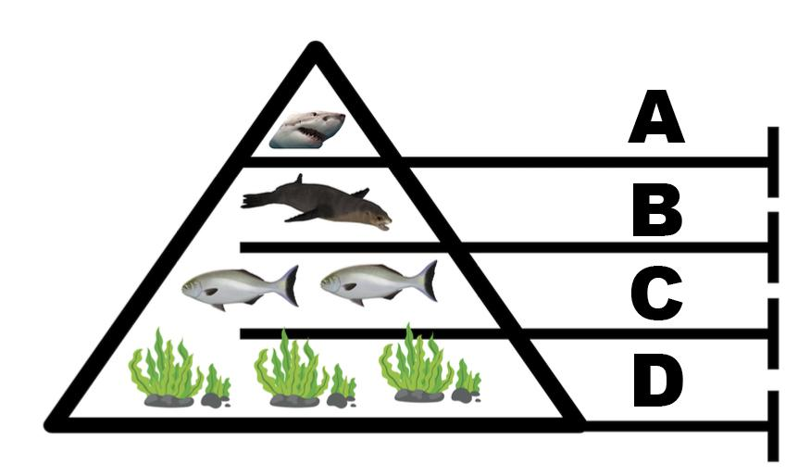
A =
B =
C =
D =

(4 marks)

- The above diagram shows a top-down control. Which species control the sea lion population numbers? (1 mark)

- In a top-down ecosystem, what may happen if there were not enough sea lions? (2 marks)

- Finish this sentence: (1 mark)
In the diagram below, the ecosystem is controlled from

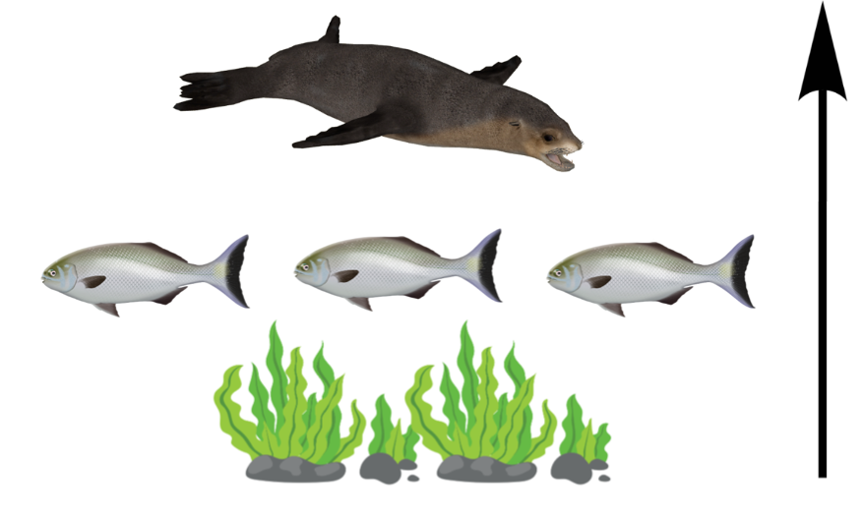

- What is likely to control the number of fish that may be able to live in this ecosystem? (1 mark)

- Name one factor that may impact the amount of seaweed that is able to grow in this ecosystem. (1 marks)

- What might happen if the amount of seaweed was reduced in this ecosystem? (1 mark)

