# Cape to Cape Resilience Project Inverloch On-ground Works

Initial Dune Reconstruction and Beach Nourishment On-Ground Works Project Update #2: July 2025

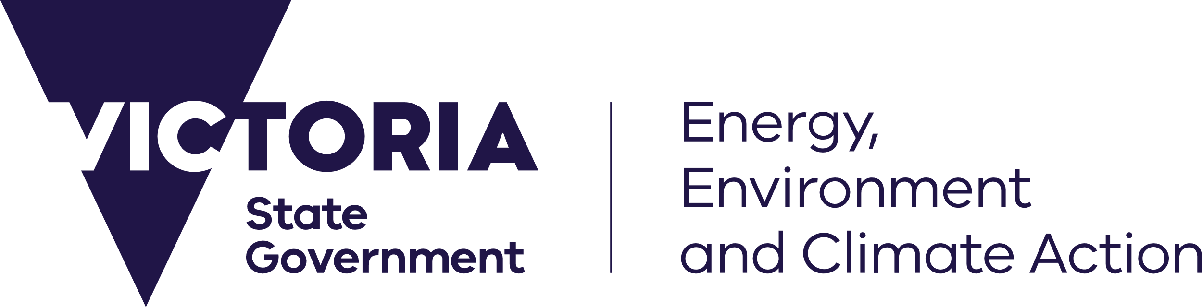

[dedeeca.vic.gov.au](https://delwpvicgovau-my.sharepoint.com/Users/fionadurante/Downloads/deeca.vic.gov.au)

Coastal engineers have finalised detailed designs for dune reconstruction and major beach nourishment at Inverloch Surf Beach.

## Dune reconstruction and major nourishment works

Designs have been prepared for on-ground works to nourish a 1km extent of Inverloch Surf Beach. Approximately 150,000m3 of sand will be sourced from Anderson Inlet and placed according to designed profiles to reconstruct the dunes and beach.

The final works designs have been developed by registered professional coastal engineers including a process of peer review.

These major on-ground works are the first step in a pathway of adaptation actions to provide a safe, accessible beach for the Inverloch community and retain environmental and community values. These works are funded through the $3.3M federal grant from the Coastal and Estuarine Risk Mitigation Program.

**Dredging Location**

Anderson Inlet has been identified as the source of sand for the dune reconstruction. The sand bars inside the inlet have coarse sand which is better at holding the designed shape of the dune and staying in place on the beach. This will provide a greater level of protection for the dune and foreshore. Environmental assessments have been completed along with modelling of the area to be dredged to confirm the works are unlikely to increase impacts of

storm and flood events or adversely impact marine and coastal flora and fauna. All required permits have been submitted for approval.

*Images showing example nourishment zones (top image) and source location in Anderson Inlet (bottom image).*

**Engagement of Contractor**

A request for quote to engage an appropriate contractor has gone out to market, tender submissions are to be prepared by contractors and submitted to the Department of Energy Environment and Climate Action (DEECA).

## Inverloch Surf Beach Sandbag Seawall

The sandbag seawall in front of the Inverloch Surf Life Saving Club on Surf Beach will be repaired and extended to address damage resulting from the significant storm event in spring last year.

As expected with hard structures against sand dunes, there has been terminal scour at the ends of the wall and Bass Coast Shire Council has been regularly backfilling this area to maintain ongoing protection, while preparations continue for seawall repair and extension. DEECA has allocated funding for the seawall works, and detailed designs are now complete.

The sandbag seawall repair and extension construction works will be delivered by Bass Coast Shire Council (BCSC). This will deliver greater protection for the Surf Life Saving Club building. The sandbag wall will be buried under the reconstructed dune and major beach nourishment, and DEECA will be working with BCSC to ensure collaborative delivery for all on-ground works.

## Timeframes

## On-ground works are planned to take place in late spring and to be completed prior to Christmas, subject to logistics and favourable weather and conditions.

## Operation during this time may take place 24 hours a day, seven days per week. Allowing the contractor to work to this schedule will result in fewer delays and less impact to community.

## Wreck Creek Management

DEECA has funded detailed designs to extend and further protect the Wreck Creek culvert under Cape Paterson – Inverloch Road. The Department of Transport and Planning is working with Parks Victoria, West Gippsland Catchment Management Authority, Bass Coast Shire Council and DEECA to secure funding to deliver the works in 2026.

The eastern branch of Wreck Creek (under Surf Parade) is being managed through the major beach nourishment design which includes a lowered nourishment level and dune berm to help manage catchment runoff flowing out to sea.

## Community Engagement

An online information session will provide an opportunity for consultants Water Technology to present the engineering that supports the dune reconstruction and beach nourishment design. This session will take place prior to on-ground works commencing.

The session will provide details regarding construction operations, times, dredging operation and impacts on beach access. The beach may be closed in stages as the nourishment works move along the site.

The time and date of the information session will be provided when confirmed, and community members will be invited to register to attend.

For those unable to attend, a recording of the session will be made available on the Cape to Cape website.

**Visit the website** for updates on the Cape to Cape Resilience Project: [marineandcoasts.vic.gov.au/coastal-programs/cape-to-cape-resilience-project](https://delwpvicgovau.sharepoint.com/sites/ecm_204/CoastalProjects/Inverloch%20Nourishment_Dune%20Reconstruction/marineandcoasts.vic.gov.au/coastal-programs/cape-to-cape-resilience-project).

**Sign-up** to receive progress updates or to ask us a question by email [capetocape.project@deeca.vic.gov.au](mailto:capetocape.project@deeca.vic.gov.au).



We acknowledge Victorian Traditional Owners and their Elders past and present as the original custodians of Victoria’s land and waters and commit to genuinely partnering with them and Victoria’s Aboriginal community to progress their aspirations.

© The State of Victoria Department of Energy, Environment and Climate Action July 2025.

Creative Commons

This work is licensed under a Creative Commons Attribution 4.0 International licence, visit the [Creative Commons website](http://creativecommons.org/licenses/by/4.0/) (<http://creativecommons.org/licenses/by/4.0/>).

You are free to re-use the work under that licence, on the condition that you credit the State of Victoria as author. The licence does not apply to any images, photographs or branding, including the Victorian Coat of Arms, and the Victorian Government and Department logos.

**ISBN** 978-1-76176-380-9 **(pdf/online/MS word)**

Disclaimer

This publication may be of assistance to you but the State of Victoria and its employees do not guarantee that the publication is without flaw of any kind or is wholly appropriate for your particular purposes and therefore disclaims all liability for any error, loss or other consequence which may arise from you relying on any information in this publication.

Accessibility

To receive this document in an alternative format, phone the Customer Service Centre on 136 186, email [customer.service@delwp.vic.gov.au](mailto:customer.service@delwp.vic.gov.au), or contact National Relay Service on 133 677. Available at [DEECA website](http://www.deeca.vic.gov.au/) (www.deeca.vic.gov.au).