|  |
| --- |
| Cape to Cape Resilience Project  FACTSHEET 1 The Inverloch Regional and Strategic Partnership (RaSP) |

## What are Regional and Strategic Partnerships?

Regional and Strategic Partnerships (RaSPs) can be established under the *Marine and Coastal Act 2018* to respond to a regional issue relating to or affecting the marine and coastal environment. A RaSP can be between two or more agencies who produce a product to respond to the regionally significant issue.

RaSPs facilitate work across multiple agencies and across different marine and coastal land. Partner agencies can be government or non-government bodies with interest in or connection to marine and coastal environments. They may include DELWP, Traditional Owners, public land managers and other major asset owners.



## The Inverloch RaSP

The Inverloch Regional and Strategic Partnership (Inverloch RaSP) is the first to be created under the new Act and was formally gazetted on August 6, 2020.

The Inverloch RaSP brings together Traditional Owners with nine agencies (Table 1), each with a role in the management of coastal and foreshore values, assets and infrastructure around Inverloch. Together they have committed to working collaboratively on long term strategies in response to the issues of erosion and inundation facing the Inverloch community, now and into the future.

Table 1. Inverloch RaSP member agencies

|  |  |  |
| --- | --- | --- |
| RaSP member | | Reason for selection |
| DELWP logo | Department of Environment, Land, Water, and Planning | Lead partner agency |
|  | Bunurong Land Council Aboriginal Corporation | Registered Aboriginal Party - Traditional Owner responsible for representing Bunurong community and protecting cultural and heritage values |
|  | Bass Coast Shire Council | Local government authority and land manager for parts of the affected coast |
|  | Department of Transport | Manager of adjacent land and infrastructure affected by erosion |
|  | Gippsland Ports | Anderson Inlet waterway manager |
|  | Heritage Victoria | Manager of non-Indigenous heritage places including the historic shipwreck *Amazon* (1863) |
|  | Parks Victoria | Local land manager for parts of affected coast |
|  | South Gippsland Shire Council | Local government authority and land manager for parts of affected coast |
|  | South Gippsland Water | Manager of land and infrastructure affected by erosion |
|  | West Gippsland Catchment Management Authority | Agency responsible for providing coastal erosion advice under the *Marine and Coastal Act 2018* |

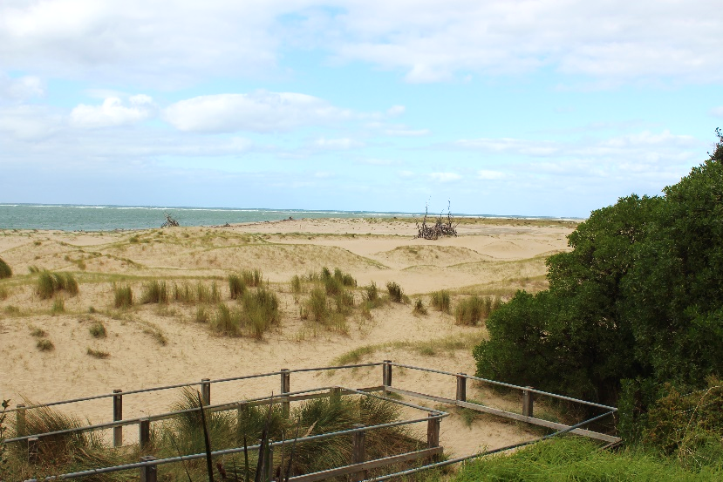

## The Inverloch RaSP project area

The project area extends from Cape Paterson to Cape Liptrap on the Bass Coast in Gippsland (Figure 1). The extent reflects the secondary coastal compartment*, based upon linked coastal processes and landforms. This scale is suitable for regional planning and engineering decisions.

*[coastadapt.com.au/how-to-pages/use-sediment-compartments-regional-coastal-management](https://coastadapt.com.au/how-to-pages/use-sediment-compartments-regional-coastal-management)

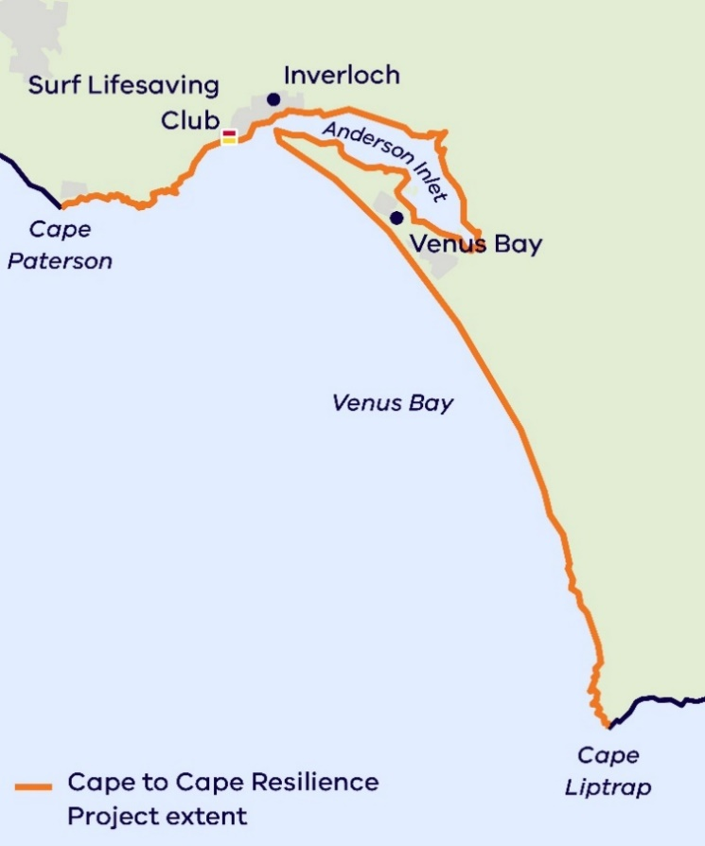

Figure 1. Inverloch RaSP project area

## What will the Inverloch RaSP be doing?

As part of the RaSP, various technical investigations and engagement activities are being delivered via the **Cape to Cape Resilience Project**. Aimed at increasing resilience of the region, the project will build knowledge of local coastal hazards, inform strategic decisions and guide investment in adaptation. This includes:

|  |
| --- |
| **A local coastal hazard assessment** to look at the influences on the coast such as storm tides and surges, wave climate, previous shorelines, groundwater, and sea level rise. Modelling will be used to help us understand past, present and future coastal processes. It will also explore opportunities available to respond and adapt to future changes on the coast. |
| **Extensive community engagement** that will help us understand community values, how they feel about the changes, and their thoughts on what can and should be done to respond to the erosion and inundation issues. Community engagement will help the partnership decide on future use and management of the Inverloch coastline. |
| **A coastal risk and vulnerability assessment** to apply the work from the hazard assessment and engagement to determine what, when and how values and assets may be at risk from erosion and inundation. |
| **Coastal resilience planning** which will use these new assessments to inform and guide the partner agencies in the development of their own strategic implementation plans. These plans will guide the future use and management of values and assets they individually have responsibility for. |

|  |
| --- |
| **How can I get involved?** To ensure you keep up to date with the Cape to Cape Resilience Project and upcoming events and activities:   * Visit the project website at [marineandcoasts.vic.gov.au/coastal-programs/cape-to-cape-resilience-project](http://www.marineandcoasts.vic.gov.au/coastal-programs/cape-to-cape-resilience-project) * Sign-up to receive progress updates and notifications – email capetocape.project@delwp.vic.gov.au * Read our latest project updates at the website * Ask us a question – email capetocape.project@delwp.vic.gov.au |

|  |  |
| --- | --- |
| © The State of Victoria Department of Environment, Land, Water and Planning 2021  LogoThis work is licensed under a Creative Commons Attribution 4.0 International licence. You are free to re-use the work under that licence, on the condition that you credit the State of Victoria as author. The licence does not apply to any images, photographs or branding, including the Victorian Coat of Arms, the Victorian Government logo and the Department of Environment, Land, Water and Planning (DELWP) logo. To view a copy of this licence, visit http://creativecommons.org/licenses/by/4.0/  **ISBN** 978-1-76105-572-0 **(pdf/online/MS word)**  Disclaimer  This publication may be of assistance to you but the State of Victoria and its employees do not guarantee that the publication is without flaw of any kind or is wholly appropriate for your particular purposes and therefore disclaims all liability for any error, loss or other consequence which may arise from you relying on any information in this publication. | Accessibility  If you would like to receive this publication in an alternative format, please telephone the DELWP Customer Service Centre on 136186, email [customer.service@delwp.vic.gov.au](mailto:customer.service@delwp.vic.gov.au), or via the National Relay Service on 133 677 [www.relayservice.com.au](http://www.relayservice.com.au). This document is also available on the internet at [www.delwp.vic.gov.au](http://www.delwp.vic.gov.au). |