|  |
| --- |
| Inverloch Coastal Hazard Assessment Geomorphology Technical Note |

This technical note provides an overview of the key findings of the coastal geomorphology report.

## Introduction

The coastal geomorphology report assesses the geology, geomorphology, and evolution of the coastline around Inverloch, Venus Bay, and Anderson Inlet to provide context for understanding current and potential coastal changes. The assessment will inform erosion modelling of future coastline changes under various climate change and sea level rise scenarios.

The Inverloch Coastal Hazard Assessment commenced in December 2020 as part of the Cape to Cape Resilience Project. The project is developing a long-term plan to manage future changes to the coastline around Inverloch, Venus Bay and Anderson Inlet.

The approach is informed by the latest science, technical assessments and community aspirations. More information about the project is available on the [Cape to Cape Resilience Project](https://www.marineandcoasts.vic.gov.au/coastal-programs/cape-to-cape-resilience-project) webpage.

The Inverloch Coastal Hazard Assessment, including the geomorphology report, includes several technical investigations that inform the project.

## Coastal Hazard Assessment Summary

The coastal geomorphology report presents a detailed assessment of the geology and geomorphology of the study area. It reviews the evolution of the landscape to provide context for understanding current and potential coastal changes and assist in developing adaptation strategies.

The report provides an analysis of coastline sensitivity to change driven by climate change, sea level rise, sediment supply, and ecological responses.

## Study Area

The study area is the South Gippsland coast between “The Oaks” (2.5 km east of Cape Paterson) and the southern end of Morgan’ Beach (3.5 km north of Cape Liptrap) and includes Anderson Inlet estuary shoreline and the tidal reach of the Tarwin River (Figure 1).

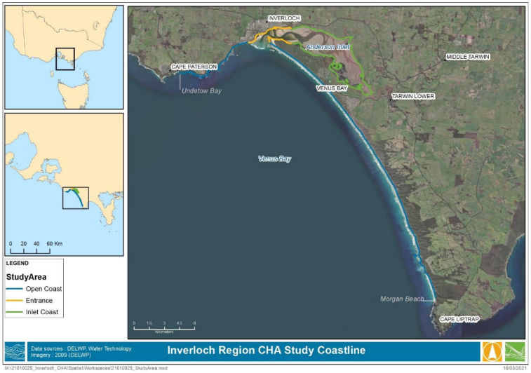**Figure 1: Study area coastline between 'The Oaks' and Morgans Beach (Base image World Imagery 2017)**

## Contents

The geomorphology report includes the following components:

1. Review of the geology and geomorphology of the study area.
2. Review of the evolution of the coastal landscape.
3. Classification of coastal landforms.
4. Identification of 27 ‘Coastal Geomorphic Domains’ (GD). These are defined as reaches of coastline with similar coastal landforms and geomorphic processes.
5. Identification of 192 ‘Coastal Geomorphic Sectors’ (CGS). These are defined as discrete lengths of coast with similar landforms and materials.
6. Identification of four key drivers of ongoing and likely future coastal change: climate change, sea level rise, sediment supply, and ecological responses.
7. Recognition of sixteen ‘Geomorphic Sensitivity Domains’ (GSD). These group the response of the coastal landform to the four key drivers of coastal change.

## Geology, geomorphology, and coastal landforms

The report presents a detailed and technical assessment of the geology and geomorphology of the study area, a review of the evolution of the coastal landscape, and classification of coastal landforms. Due to the technical nature of these topics, further detail is not included here.

The report concluded that, from an historical and contemporary view, the inherent character of much of the study area is rapid change in shoreline position. The report found that understanding any past stable coastal configuration, and predicting future coastal landforms is challenging and highly uncertain. It must be viewed within the context of the insight gained from a historical geomorphic perspective.

## Coastal Geomorphic Domains and Sectors

The report categorises the study area into discrete *Coastal Geomorphic Domains* (larger scale), and *Coastal Geomorphic Sectors* (smaller scale) to inform predictive erosion modelling.

|  |
| --- |
| A geomorphic type is a particular physical form of the landscape, such as a hard rock cliff, sand beach, or estuary. |

Geomorphic processes are the physical, chemical, and ecological processes that shape the surface of the earth.

A *Coastal Geomorphic Domain* (CGD) is a reach of coastline with a limited number of coastal geomorphic types and associated geomorphic processes.

The geomorphic types of one area of Anderson Inlet for example, include a bluff, shore platform and saline tidal wetlands. The *Coastal Geomorphic Domains* are later used to frame the assessment of coastal sensitivity to change.

*Coastal Geomorphic Sectors* (CGS)are used to classify the study area in more detail. A CGSis a length of coast that can be mapped as a discrete unit and has key differences to adjacent sectors. A key difference is how each sector responds to coastal processes, changed water levels, and wave energy. Each sector includes two or more landform categories, such as a sandy beach in front of a low coastal bluff or a shore platform at the base of a hard rock cliff.

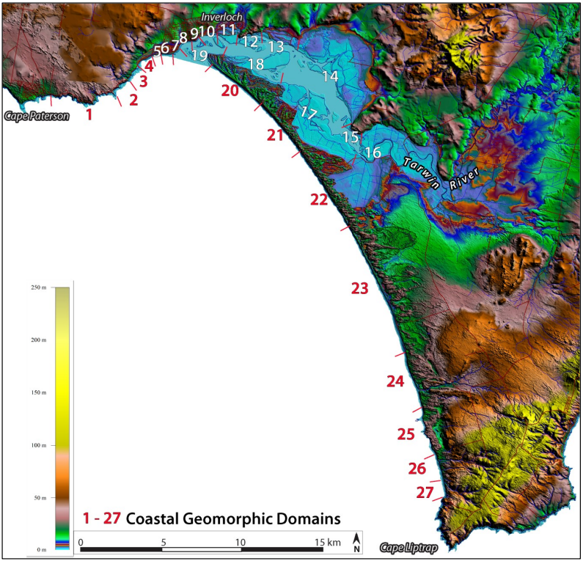

Figure 2. Coastal Geomorphic domains across the study area. (Base: LiDAR).

## Drivers of Coastal Landform Change

The report identifies four key drivers of coastal landform change and then applies these to each of the *Coastal Geomorphic Domains* described above. The key drivers are climate change, sea level rise, sediment supply and ecological responses.

### Climate Change

Climate change will influence landform change through more frequent high energy storm-driven waves, changed waves heights, directions and frequency, and wind directions. Additional effects of climate change include high temperatures, increased high intensity rainfall events, changes in runoff and sediment supply caused by droughts and altered coastal ecosystem processes.

Examples of climate change impacts in the study area include:

* Increased incidence of storm surges and foredune recession at Inverloch Surf Beach.
* Changed wind direction affecting sand supply to the backshore and rates of foredune building along all ocean sandy shorelines.
* Realignment of inlet beaches (north of Point Norman).
* Decreased runoff in Tarwin River, causing increased salinity in lower Tarwin River.
* Higher winter temperature and reduced frost, allowing mangroves to increase in spread.

### Sea level Rise

|  |
| --- |
| Sea level rise is expected to continue and impact the length of the study area with impacts determined by the sensitivity of coastal landforms. |

Examples of the sea level rise impacts in the study area include:

* Increased erosion and lowering of ocean sand beaches
* Increased scarping of foredunes and landward movement of the high-water mark
* Increased submergence times of shore platforms on Bunurong Coast and Arch Rock
* Long-term reversal of foredune growth on Surf Beach and northern Venus Bay
* Increased tidal influence upstream of Anderson Inlet and erosion of Point Smythe and Inverloch inlet beaches
* Overwash of foredunes at Wreck Creek and the low northern shorelines of Anderson Inlet east of Point Hughes
* Increased extent of mangrove and submergence of saltmarsh communities

### Sediment Supply

Sediment or sand supply is the movement and distribution of sand to and along the coastline. Although sand is increasing in some areas, such as the beaches adjacent to and inside the entrance to Anderson Inlet, this is largely due to a re-distribution of existing sand deposits. The study area has limited and scattered sands along the coastline and has limited inputs from other sources such as rivers and cliff erosion. The supply and availability of sand to nourish eroding beaches is expected to be an ongoing issue.

### Ecological Responses

The interaction of individuals, colonies and communities of plants and animals with landforms are an integral component of coastal change. Change is a two-way process: an ecological response where biological communities respond to changes to physical environments and a geomorphic response where landforms are altered by biological processes.

Examples of the impacts of ecological responses include:

* Introduced *Spartina* grasses in Anderson Inlet displacing native species and altering natural tidal flows.
* The type and spread of introduced sand-binding plant species alters the morphology of sand dunes.

The presence of seagrass and macroalgae on submerged reefs influences the mobility and availability of submerged sands for beach nourishment.

## Coastal Landform Sensitivity

To assess the sensitivity of the coastline to the drivers of change described above, the report groups the study area into 16 *Sensitivity Domains* (SD) based on the *Coastal Geomorphic Domains.* Each SD is assigned a qualitative sensitivity to a change in each of the four drivers of coastal geomorphic change: Extremely Sensitive (ES), Very Sensitive (VS), Sensitive (S), Not Very Sensitive (NVS), and Not Sensitive (NS).

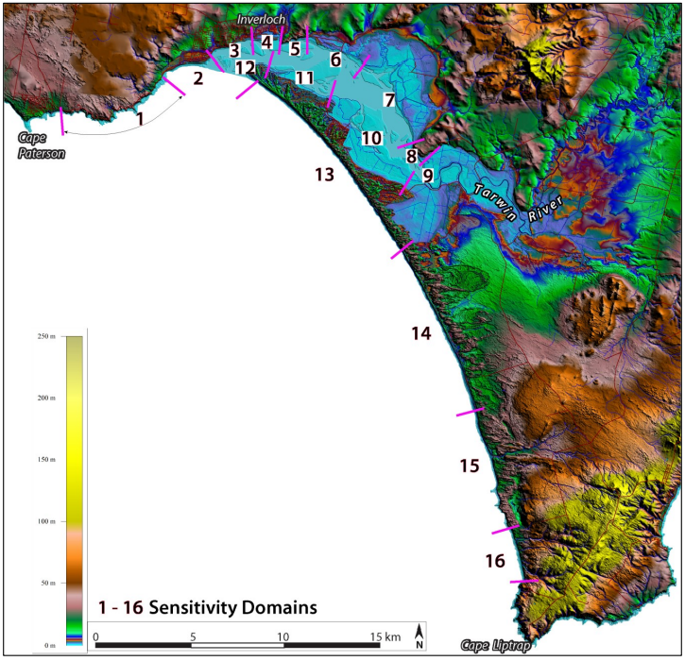

**Figure 3: Geomorphic Sensitivity Domains**

**Table 1: Geomorphic Sensitivity Domains**

|  |  |  |  |  |  |  |  |
| --- | --- | --- | --- | --- | --- | --- | --- |
| **SD** | **GD** | **LANDFORMS** | **SENSITIVITY INDEX: ES, VS, S, NVS, NS** | | | | **SUMMARY & COMMENTS** |
| **Climate Change** | **Sea-level rise** | **Sediment supply** | **Biogenic changes** |
| 1 | 1-3 | Hard shore cliff, shore platform, beach | NVS | S | NVS | NVS | Low sensitivity but remains an active cliffed coast with rockfall and cave collapse. |
| 2 | 4-7 | Beach, foredunes, estuary | ES | ES | ES | S | Extremely sensitive and responsive to small changes in drivers. |
| 3 | 8-10 | Beach, lagoon, estuary, engineered | ES | ES | VS | NVS | Extremely sensitive and responsive to small changes in drivers. |
| 4 | 11 | Soft-rock cliff, beach, estuary | ES | ES | VS | S | Extremely sensitive and responsive to small changes in drivers. |
| 5 | 12 | Hard rock cliff, bluff | NVS | S | NS | NS | Low overall sensitivity basal hard rock cliff. |
| 6 | 13-14 (part) | Soft rock cliff, engineered | S | VS | NVS | S | Soft rock cliffs, low elevation, some engineered ineffective structures. |
| 7 | 14 (part) | Mangrove, saltmarsh, soft rock cliff, engineered | S | S | NVS | S | Soft rock cliffs, low elevation, some engineered ineffective structures, potential for increase in fringing intertidal vegetation will buffer sea-level rise. |
| 8 | 15 | Hard rock cliff | NS | NVS | NS | NS | Low sensitivity basal hard rock cliff. |
| 9 | 16 | Soft rock cliff, estuary | VS | ES | NVS | S | Soft rock cliffs, low elevation, Tarwin River flood inundation. |
| 10 | 17 | Mangrove, saltmarsh, soft rock cliff | S | VS | S | S | Soft rock cliffs, low elevation, some engineered ineffective structures, potential for increase in fringing intertidal vegetation will buffer sea-level rise. |
| 11 | 18 | Beach, foredunes, saltmarsh | VS | ES | ES | NVS | Unconsolidated sand backshore extremely sensitive to sea-level and climate change. |
| 12 | 19 | Beach, foredunes | ES | ES | ES | S | Beach and backshore extremely sensitive to sea-level and climate change. |
| 13 | 20-22 | Beach, foredune, transgressive dune | VS | ES | S | S | Sea-level rise breaching foredunes and initiating blowouts. Climate change increase risk of fire and destruction of vegetation and reactivation of transgressive dunes. |
| 14 | 23 | Beach, foredune, transgressive dune | VS | S | S | S | Sea-level rise breaching foredunes and initiating blowouts. Climate change increase risk of fire and destruction of vegetation and reactivation of transgressive dunes. |
| 15 | 24-25 | Soft rock cliff, shore platform, cliff-top dunes | NVS | S | NVS | S | Increase in cliff recession with sea-level rise. |
| 16 | 26-27 | Beach, soft-rock cliff, cliff-top dunes | NVS | S | S | S | Beach erosion, increase in cliff recession with sea-level rise. |

Table 1 shows that the entrance to Anderson Inlet (SD 2-4 and 11-12) is most sensitive to change, with each SD in this area assessed as extremely sensitive to multiple drivers of change.

Areas that are assessed as least sensitive (sensitive and below) are the cliff and shore platforms east of Cape Paterson (SD 1), the shoreline north of Cape Liptrap (SD 15 & 16), and most of the cliff and shore platform areas within the estuary (SD 8, 7 & 5).

The sensitivity to change assessment provides context for modelling of future coastline changes under various climate change, sea level rise, sediment supply and ecological response scenarios.

### Conclusions

This is a dynamic and highly variable study area. Change of shoreline position and landforms are occurring on a range of spatial and temporal scales for some common and locally different reasons. There can be no single approach for management authorities and individuals to accommodate contemporary and

anticipated changes. The table below summarises the changes in each of the broad geographical regions of the study area.

##### **Table 2. Geomorphic changes and management issues.**

|  |  |  |
| --- | --- | --- |
| **STUDY AREA UNIT & SENSITIVITY DOMAINS** | **CHANGES** | **MANAGEMENT ISSUES** |
| Bunurong Coast SD 1 | Rock fall, cave collapse, shore platform beach erosion | Hazard to cliff base pedestrians, locally to road, reduced beach amenity. |
| Inverloch Coast SD 2, 3, 4 | Ongoing widespread erosion and episodes of local accretion | Minimal dry beach, ecological losses, access limitations, public asset protection/relocation. |
| Andersons Inlet North SD 6,7,8 | Shoreline recession, minimal accretion, inundation | Asset protection (mainly private), maintain public amenity by engineering structures. |
| Tarwin River Delta SD 9 | Flooding, bank erosion, increase in floodplain salinity | Flood protection (mainly private) by engineering structures. |
| Andersons Inlet South SD 10, 11 | Island and shoreline accretion, channel shallowing and migration | Maintaining ecological values including Spartina control |
| Point Smythe and Venus Bay North SD 12, 13, 14 | Shoreline erosion, loss of foredunes, weed invasion, transgressive dunes | Beach access and safety, public land ecological values |
| Venus Bay South SD 15, 16 | Shoreline erosion, locally cliff recession | Beach access and walking safety, public land ecological values. |

Any view as to what constituted a past stable coastal configuration and predictions regarding possible coastal forms is challenging at best and highly uncertain and must be viewed within the context of the understanding and the insight gained from a historical geomorphic perspective.

|  |  |
| --- | --- |
| © The State of Victoria Department of Environment, Land, Water and Planning 2022  LogoThis work is licensed under a Creative Commons Attribution 4.0 International licence. You are free to re-use the work under that licence, on the condition that you credit the State of Victoria as author. The licence does not apply to any images, photographs or branding, including the Victorian Coat of Arms, the Victorian Government logo and the Department of Environment, Land, Water and Planning (DELWP) logo. To view a copy of this licence, visit http://creativecommons.org/licenses/by/4.0/  ISBN 978-1-76105-959-9 (pdf/online/MS word)  Disclaimer  This publication may be of assistance to you but the State of Victoria and its employees do not guarantee that the publication is without flaw of any kind or is wholly appropriate for your particular purposes and therefore disclaims all liability for any error, loss or other consequence which may arise from you relying on any information in this publication. | Accessibility  If you would like to receive this publication in an alternative format, please telephone the DELWP Customer Service Centre on 136186, email [customer.service@delwp.vic.gov.au](mailto:customer.service@delwp.vic.gov.au), or via the National Relay Service on 133 677 [www.relayservice.com.au](http://www.relayservice.com.au). This document is also available on the internet at [www.delwp.vic.gov.au](http://www.delwp.vic.gov.au). |