# DEECA marine and coasts newsletter

Issue 15 June 2023

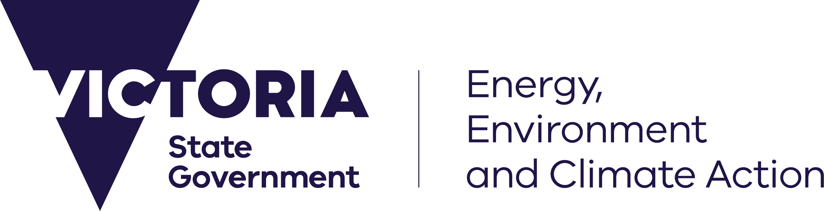

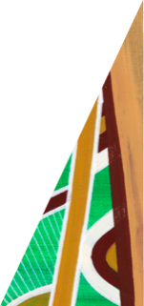

[deeca.vic.gov.au](https://delwpvicgovau.sharepoint.com/Users/fionadurante/Downloads/deeca.vic.gov.au)

Welcome to the Department of Energy, Environment and Climate Action’s (DEECA’s) quarterly marine and coasts newsletter.

## In this issue

* State Budget 2023-24
* Marine and coastal environmental-economic account
* Repairs to Portland’s Dutton Way
* Loch Sport Foreshore Erosion
* Port Welshpool eastern seawall remediation
* Bullock Island coastal processes and Seamec rock revetment adaptation study
* Launch of the new Feature Activity Sensitivity Tool (FeAST) for planning and approvals
* VCMP longshore sediment transport modelling
* Inspecting Victoria’s coastal protection structures
* Cape to Cape Resilience Project draft Resilience Plan
* Coastcare Victoria’s ‘Coastline’

Email [marine.coasts@delwp.vic.gov.au](mailto:marine.coasts@delwp.vic.gov.au) to subscribe or unsubscribe or for more information.

## State Budget 2023-24

The Victorian Budget 2023-24 was announced on 23 May 2023. The budget has a strong focus on preparing Victoria for and responding to the effects of climate change.

The VicCoasts funding initiative has been allocated $13.7 million in 2023-24, which will allow DEECA to:

* strengthen coastal protection at critical locations
* support [committees of management](https://www.deeca.vic.gov.au/boards-and-governance/committees-of-management) to improve coastal access and address risk issues
* build volunteer capacity through [Coastcare Victoria](https://www.marineandcoasts.vic.gov.au/coastal-programs/coastcare-victoria)
* implement [Victoria’s Resilient Coast framework](https://www.marineandcoasts.vic.gov.au/marine-coastal-management/victorias-resilient-coast-adapting-for-2100) and facilitate development of coastal adaptation plans
* engage stakeholders to implement Victoria’s [Marine Spatial Planning Framework](https://www.marineandcoasts.vic.gov.au/marine-coastal-management/marine-spatial-planning) at a priority area
* increase the capabilities of the [Victorian Coastal Monitoring Program](https://www.marineandcoasts.vic.gov.au/marine-and-coastal-knowledge/victorian-coastal-monitoring-program) to better understand and anticipate coastal hazards
* improve the [Marine and Coastal Knowledge Framework](https://www.marineandcoasts.vic.gov.au/marine-and-coastal-knowledge/marine-and-coastal-knowledge-framework) through further development of [CoastKit](https://www.marineandcoasts.vic.gov.au/marine-and-coastal-knowledge/coastkit).

An additional $3.9 million over three years has been provided to continue implementation of the Great Ocean Road Management Reforms, which will boost tourism, local employment and economic development, and better protect land and seascapes from the impacts of severe weather events and climate change.

For more information, visit the budget website: [budget.vic.gov.au/](https://www.budget.vic.gov.au/)

## Marine and coastal reforms

### Marine and coastal environmental-economic account

DEECA’s [Marine and Coastal Strategy 2022](https://www.marineandcoasts.vic.gov.au/marine-coastal-management/marine-and-coastal-strategy) includes an action to deliver a baseline environmental-economic account (EEA) for Victoria’s marine and coastal environment to understand the value of marine and coastal ecosystems and the goods and services they provide.

DEECA’s economics and land policy teams will develop a baseline ecosystem account reporting on the current status of marine and coastal ecosystem assets within Victoria and the importance of these assets in supporting health, wellbeing and livelihoods.

This will cover assets such as seagrass beds, saltmarsh, mangroves, rocky reefs and soft sediments.

Ecosystem accounts are a type of EEA that take stock of current ecosystem assets – in terms of their extent, location, and condition – and quantify and value the flow of ecosystem services that these assets generate for people who enjoy benefits from them. This will cover ecosystem services such as coastal protection, carbon storage, recreation and food. Figure 1 sets out the ecosystem accounting framework.

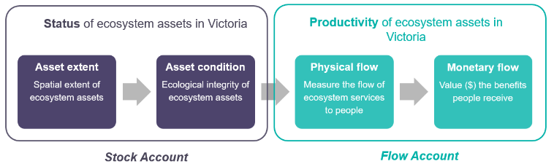

Figure 1. Environmental-economic accounts – ecosystem accounting framework.

The account will provide an evidence base to understand how the distribution of ecosystem service provision and value varies across Victoria.

The information compiled in the account could be used to communicate the value of Victoria’s marine and coastal ecosystem assets, and to support the business case for investment to maintain the current extent and condition of ecosystems to sustain the flow of ecosystem services over time.

Work will begin in July 2023 with a scoping exercise. The account will be delivered by end 2024. If you would like more information or have research that may be relevant to the work, please contact Ziggy Gelman, [ziggy.gelman@delwp.vic.gov.au](mailto:ziggy.gelman@delwp.vic.gov.au).

## Coastal projects

### Barwon South West

#### Repairs to Portland’s Dutton Way

Dutton Way is known for its scenic views and long stretches of coastline. Along Dutton Way there are 8.6 kilometres of rock revetments built at different times and of varying quality.

This physical armouring of the coastline began in the late 1950s when erosion issues started occurring shortly after the Port of Portland breakwater was constructed. To reduce the impact of the erosion on assets in the area, extensive sections of predominantly basalt rock revetment were built.

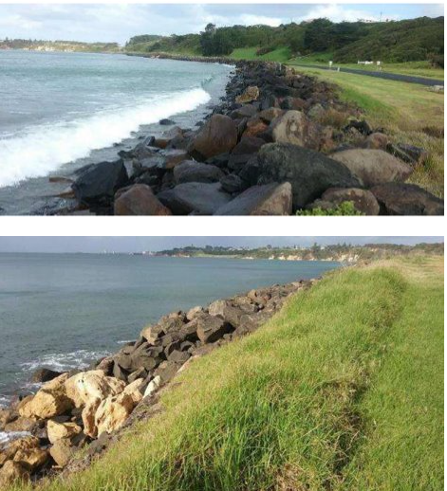Section of rock revetment along Dutton Way.

This year, an engineering report identified several sections of the revetment to be in poor condition and requiring repair.

DEECA is collaborating with the Department of Transport and Planning (DTP) to repair a small but significant 55 metre section of rock revetment which was eroding and threatening the road connecting Dutton Way to Portland.

Further planning is underway to remediate additional sections of the rock revetment.

For more information about coastal projects in the Barwon South West region, visit [marineandcoasts.vic.gov.au/coastal-programs/barwon-south-west](https://www.marineandcoasts.vic.gov.au/coastal-programs/barwon-south-west)

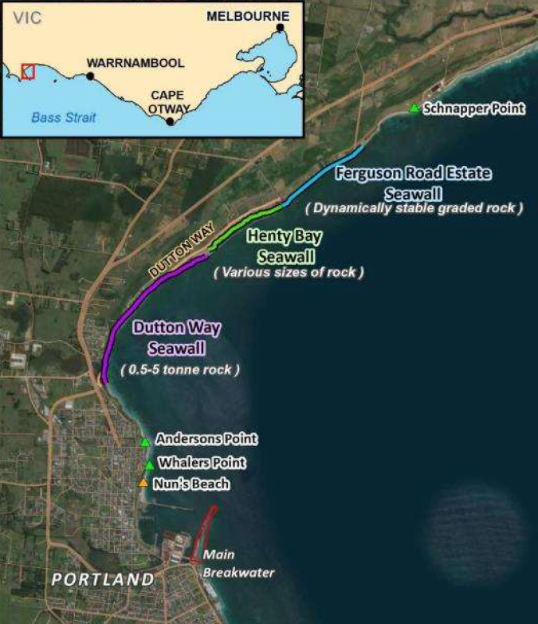

Extent of Dutton Way revetment stretching from the south (purple line) to the north (light blue line). Image by Water Technology.

### Gippsland

#### Loch Sport Foreshore coastal erosion

The Loch Sport Foreshore is experiencing moderate erosion, largely concentrated around the Seagull Drive area of Lake Victoria.

Following the completion of the Loch Sport Foreshore Coastal Processes and Options Assessment Report in 2022, a consultant has been engaged to undertake a detailed survey, geotechnical investigations and detailed design to implement works to address erosion issues identified in the 2022 report.

The initial focus will be on conducting the survey to enable the design and specification process for immediate on-ground works.

The survey will include the use of drones for detailed photography and digital modelling. This survey will provide the basis of design for immediate works, as well as essential information to help make decisions on longer term adaptation pathways.

This stage is expected to be completed by November 2023. Loch Sport faces many challenges related to coastal erosion. DEECA is working with community and other agency stakeholders to address immediate issues and to put in place longer term, sustainable solutions to the coastal erosion in this part of Victoria.

A landscape view of the Loch Sport Foreshore.


Loch Sport Foreshore

#### Port Welshpool eastern seawall remediation

Recent studies of the eastern seawall at Marginal Wharf, Port Welshpool have revealed it to be in poor condition and requiring remediation works to extend its serviceable life.

Designs for the works have been prepared and DEECA’s Gippsland Land and Built Environment team have been working through the planning and approvals process, with suppliers to be engaged in the coming months.

Remediation works on the seawall will improve public safety, have a reduced impact on coastal processes and protect public assets behind the wall.

The eastern seawall at Port Welshpool, shown to be in poor condition.


Port Welshpool eastern seawall.

#### 

#### Bullock Island coastal processes and Seamec rock revetment adaptation study

Water Technology Pty Ltd recently completed a coastal processes study on Bullock Island in the Gippsland Lakes.

The study looked at the coastal processes affecting this significant location. Bullock Island is a natural sand spit whose shoreline has been stabilised by constructed works over the past century.

The main hazards impacting the island are river and tidal currents, wave action and inundation.

The study provides an adaptation pathway for the rock revetment at the Seamec educational facility which will form the basis of engagement and eventual design for the replacement of the rock revetment.

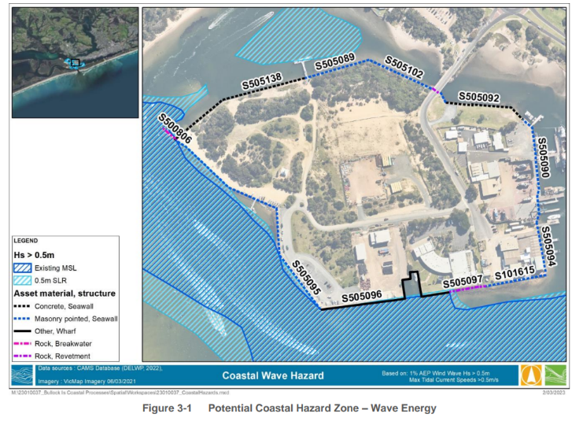

Potential Coastal Hazard Zone – Wave Energy

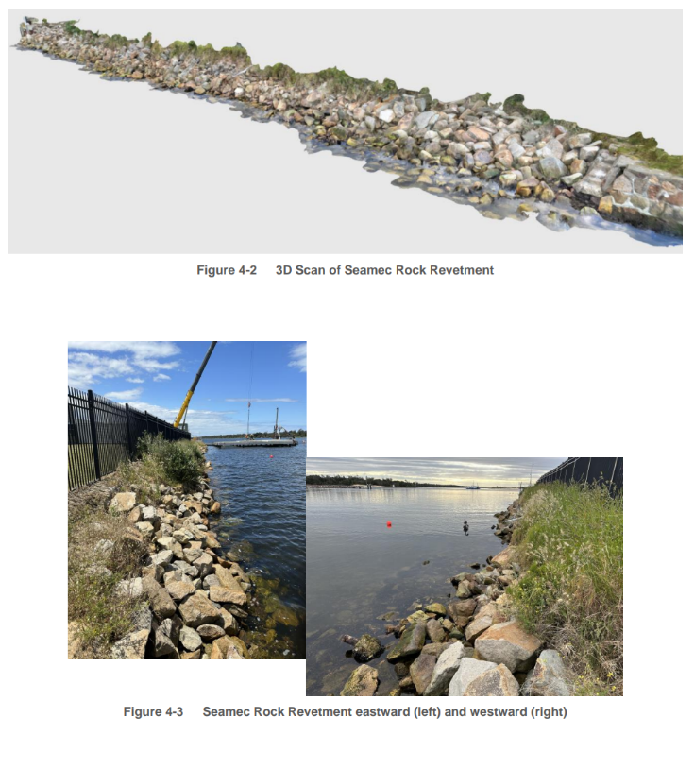

Top: Scan of Seamec rock revetment. Bottom: Seamec rock revetment eastward (left) and westward (right).

For more information about coastal projects in the Gippsland region, visit [marineandcoasts.vic.gov.au/coastal-programs/gippsland-projects](https://www.marineandcoasts.vic.gov.au/coastal-programs/gippsland-projects)

## Marine and coastal knowledge

### Launch of the new Feature Activity Sensitivity Tool (FeAST) for planning and approvals

Last month the Feature Activity Sensitivity Tool (FeAST) was successfully released on Victoria’s marine and coastal web-mapping portal [CoastKit](https://mapshare.vic.gov.au/coastkit/?view=feast), with accompanying online guidelines now available at [marineandcoasts.vic.gov.au/marine-and-coastal-knowledge/feature-activity-sensitivity-tool](http://www.marineandcoasts.vic.gov.au/marine-and-coastal-knowledge/feature-activity-sensitivity-tool).

Graphic of the FeAST logo.


FeAST: Victoria's new tool for assessing environmental risk

FeAST is a free online planning and approvals support tool that evaluates desktop-based information to generate first-pass environmental risk assessments for proposed developments, activities, uses, or works in Victoria’s marine and coastal areas.

The tool has been designed to be used by all members of the public. It has been developed to support the *Marine and Coastal Act 2018* (MACA) and has direct applications to the planning approval process.

FeAST is fully integrated in CoastKit and uses the best-available data stored on the online mapping portal. The tool requires minimal user input to run the assessment and produces a standardised report within 30 seconds ready for download.

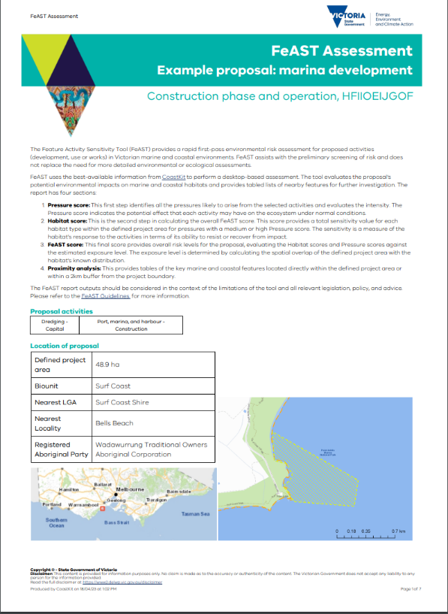

Example FeAST report generated by the tool on CoastKit.

The FeAST report provides detailed information on the expected level of risk that an activity may pose on a habitat, and lists priority features, key environmental values and other activities that may occur in or near to the project area.

The FeAST report is now a requirement for all *Marine and Coastal Act 2018* consents and can assist with the identification of mitigation measures, further scientific investigation, or the development of conditions. FeAST does not replace the need for more detailed assessments and should be used as a preliminary risk screening tool.

For more information contact us at [Coastkit@delwp.vic.gov.au](mailto:Coastkit@delwp.vic.gov.au).

### VCMP longshore sediment transport modelling

Recently, high-resolution wave models have been developed to investigate the wave climate of Victorian coastal waters and Port Phillip Bay. However, the understanding of longshore sediment transport, a crucial factor for understanding shoreline change, remains limited in this region.

To address this knowledge gap, the [Victorian Coastal Monitoring Program](https://www.marineandcoasts.vic.gov.au/marine-and-coastal-knowledge/victorian-coastal-monitoring-program) (VCMP) team has developed a long-term dataset spanning the last 40 years (1981-2020), specifically focusing on longshore sediment transport.

This comprehensive dataset provides information on offshore and breaking wave conditions as well as longshore sediment transport, encompassing hourly time series data for 40 VCMP sites and statistics for the entire Victorian coast and Port Phillip Bay.

The findings of this study reveal the presence of powerful, long-period Southern Ocean swells that propagate towards western Victoria and the Great Ocean Road. These regions boast extreme wave heights and high-volume longshore sediment transport. Other areas, such as Port Phillip Bay, exhibit seasonal variation in longshore transport, leading to ‘beach rotation’.

The data is now readily available by contacting [vcmp@delwp.vic.gov.au](mailto:vcmp@delwp.vic.gov.au).

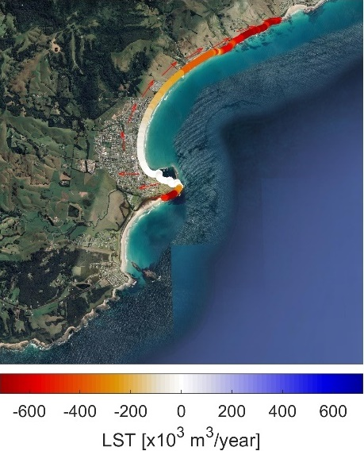

Annual mean values (colours) and directions (arrows) of longshore sediment transport of Apollo Bay over the period 1981-2020.

### 

### Inspecting Victoria’s coastal protection structures

DEECA oversees the performance of more than 1,500 ‘Coastal Protection Structures’ (CPS) on public land. These structures, which include seawalls, groynes, breakwaters and revetments, provide recreational value to the community and help protect the coast from waves, erosion, and climate change sea level rise.

Most of these structures are getting old with a significant proportion of them in poor or very poor condition. To mitigate the high risks associated with some of these structures, DEECA has engaged experienced and qualified coastal engineers to inspect and undertake thorough examinations of these structures across each of our coastal regions - Barwon South West, Gippsland and Port Phillip.

The inspections provide a thorough understanding of the condition of the structures, identifying any potential problems and propose appropriate and cost-effective remediation measures for each structure as required. Once implemented, this will bring the level of risk to an acceptable level.

This project will extend into early 2024.

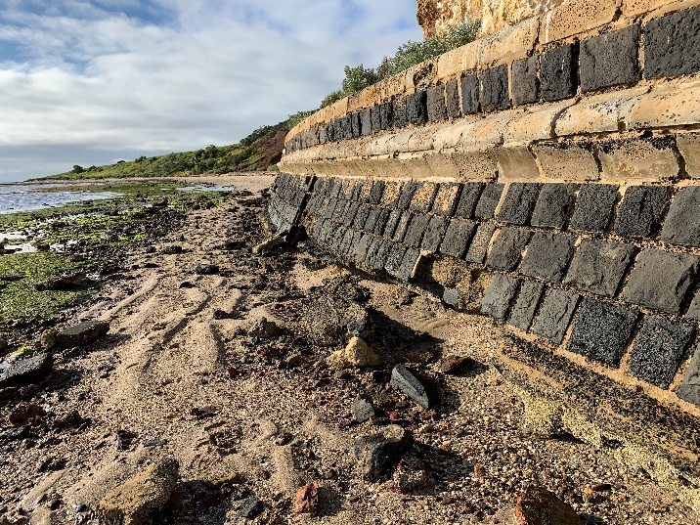

Coastal Protection Structures include seawalls (pictured), groynes, breakwaters and revetments.

### Cape to Cape Resilience Project draft Resilience Plan

DEECA’s Cape to Cape Resilience Project is helping to pave the way for increasing coastal hazard resilience in Victoria.

Stage 2 of the Cape to Cape Resilience Project involves developing a Resilience Plan to allow the management of coastal hazards strategically. Extensive community and stakeholder engagement is helping to inform the Resilience Plan.

Over January to March 2023, DEECA ran a series of engagement events and activities to gather input from residents, visitors and stakeholders on adaptation planning.

In particular, perspectives were gathered on:

* coastal hazard risk and outcomes from the Coastal Hazard Assessment and Risk and Vulnerability Studies
* adaptation action preferences and appropriate actions for different locations
* additional actions or feedback on building coastal resilience in the Cape to Cape communities.

Groups of people sitting around tables in a meeting room. They are discussing draft Resilience Plan adaptation pathways and actions in the Regional and Strategic Partnership workshop.



Regional and Strategic Partnership workshop, discussing draft Resilience Plan adaptation pathways and actions.

Engagement for Stage 2 of the project has included a range of activities including seven community pop-up events, an online survey, four round table discussions, and targeted briefings and workshops with Traditional Owners, agencies and authorities.

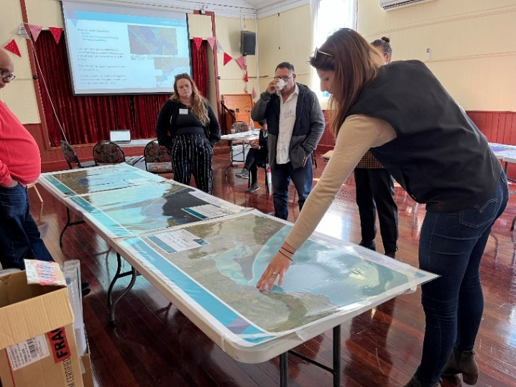

Traditional Owner on Country workshop, reviewing coastal hazard mapping.

DEECA also talked to a range of community members over the past couple of months, chatting in person to over 500 people through the pop-up and drop in events, around 70 attendees to round-table workshop sessions and 92 survey submissions. Our Engage Victoria page received approximately 2,000 page visits, with over 600 unique visitors over the survey period.

Hearing ideas and perspectives from the Cape to Cape communities remains an important part of this project and community and stakeholder feedback helps to inform how DEECA adapt to and manage the region’s coastal hazards in the future.

All feedback will be incorporated into developing the draft Resilience Plan. The draft Plan includes:

* adaptation actions for the entire region
* preferred adaptation pathways for each location
* further detail on actions and implementation.

The draft Resilience Plan is being circulated and reviewed by our project partners, and there will be opportunities for the community to provide feedback on the draft Cape to Cape Resilience Plan.

Do you want to know more? Check out the hazard maps and read our latest updates, visit the project website: [marineandcoasts.vic.gov.au/coastal-programs/cape-to-cape-resilience-project](https://www.marineandcoasts.vic.gov.au/coastal-programs/cape-to-cape-resilience-project).

Keep reading for Coastcare Victoria’s ‘Coastline’!

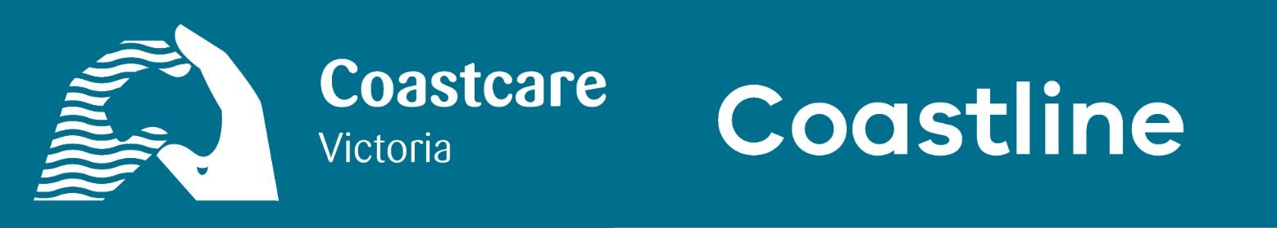

## In this issue of Coastline

* Spotlight on volunteer grants
* Traditional Owner led Sea Country workshops
* Inclusive volunteering guide

### Spotlight on volunteer grants

A bustling application round for the 2023 Coastcare Victoria Community Grants concluded at the end of March.

The Coastcare Victoria team read proposals for some fantastic projects covering environmental stewardship, community engagement and Traditional Owner Self-Determination.

Keep an eye on the [Coastcare Victoria Community Grants](https://www.marineandcoasts.vic.gov.au/grants/coastcare-victoria-community-grants) webpage for news on successful 2023 grant recipients.

The 2021 and 2022 grant rounds were finalised in May, with 32 project completion reports submitted for 2021, and 27 reports for 2022. These reports detail the amazing work grant recipients have delivered with their funding. From interpretive signage to mangrove planting to collaborative workshops, volunteers across Victoria have been doing a massive job for our shared coastline.

A big thank you to each and every volunteer!

### Traditional Owner led Sea Country workshops

Coastcare Victoria will soon be releasing a number of Sea Country workshop sessions available to marine and coastal volunteers across Victoria.

The sessions will be led by Traditional Owners from their respective areas and open to all Coastcare Victoria community networks.

Sessions will run from June to August 2023. They will involve important dialogue about working in relationship with Country, and how we as volunteers, community, and environmental stewards, can contribute to caring for Sea Country.

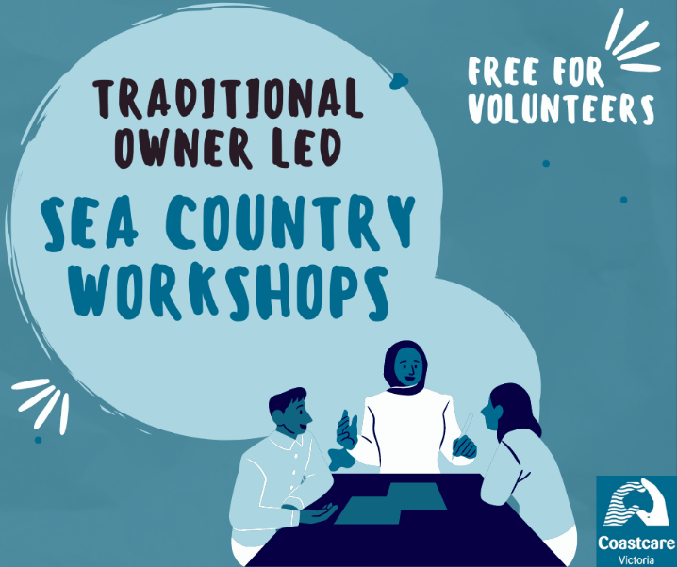

The Sea Country workshop sessions are free for volunteers.

Marine and coastal community groups can enrol their volunteers in Sea Country workshops via registration links sent out by email to our mailing list. To sign up, please email [coastcare.victoria@delwp.vic.gov.au](mailto:coastcare.victoria@delwp.vic.gov.au).

### Inclusive volunteering guide

Bellarine Catchment Network has recently published an Inclusive Volunteering Guide.

This in-depth, practical guide aims to provide community and environment groups with a framework to make volunteering inclusive.

The guide dives deep into four different communities: First Nations and the Wadawurrung, Culturally and Linguistically Diverse (CALD) communities, people with disabilities and people who are LGBTIQA+.

It features background information, links and resources and practical tips from planning events, advertising and facilitating volunteering opportunities.

The guide was supported by the Victorian Government's 'Emerging Stronger' grants program. It offers all readers (volunteer-based or not), the opportunity to learn about how we can all contribute to creating more inclusive communities.

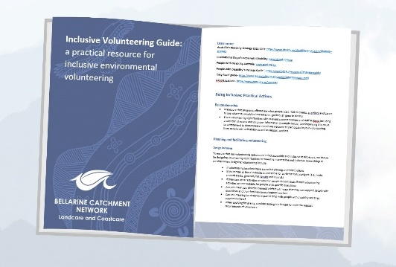Access the guide via the Bellarine Catchment Network’s [Resources and Guides](https://www.environmentbellarine.org.au/cb_pages/resources_and_guides.php) webpage – please share with your volunteering networks!

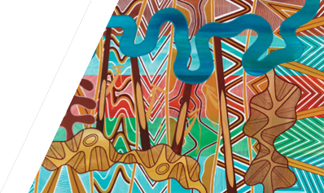

We acknowledge Victorian Traditional Owners and their Elders past and present as the original custodians of Victoria’s land and waters and commit to genuinely partnering with them and Victoria’s Aboriginal community to progress their aspirations.

© The State of Victoria Department of Energy, Environment and Climate Action June 2023.

Creative Commons

This work is licensed under a Creative Commons Attribution 4.0 International licence, visit the [Creative Commons website](http://creativecommons.org/licenses/by/4.0/) (<http://creativecommons.org/licenses/by/4.0/>).

You are free to re-use the work under that licence, on the condition that you credit the State of Victoria as author. The licence does not apply to any images, photographs or branding, including the Victorian Coat of Arms, and the Victorian Government and Department logos.

Disclaimer

This publication may be of assistance to you but the State of Victoria and its employees do not guarantee that the publication is without flaw of any kind or is wholly appropriate for your particular purposes and therefore disclaims all liability for any error, loss or other consequence which may arise from you relying on any information in this publication.

Accessibility

To receive this document in an alternative format, phone the Customer Service Centre on 136 186, email [customer.service@delwp.vic.gov.au](mailto:customer.service@delwp.vic.gov.au), or contact National Relay Service on 133 677. Available at [DEECA website](http://www.deeca.vic.gov.au/) (www.deeca.vic.gov.au).