|  |
| --- |
| DEECA Biodiversity Environment and Community Grants |
| Fact Sheet 4 of 4  Mapping instructions for your application |

This fact sheet will guide you through how to map your proposed project area as part of your application for the Port Phillip Bay Fund grant.

# Mapping your proposed project

As part of your application, we require you to map the location of your proposed project and include this as an attachment to your application.

## These instructions will show you how to:

1. Map your project activity in Mapshare **(see pages 1-3)**
2. Save your map as a shapefile **(see pages 4- 5)**
3. Save your map as a PDF **(see pages 5-8)**

We understand you may not know the exact location of project sites at this stage, which is why we are only asking that you map the entire extent of your project (i.e., one shape) as opposed to individual shapes for each activity.

## Before opening MapshareVic, please read our troubleshooting tips below to ensure a smooth setup:

* We recommend using Google Chrome to run MapshareVic
* Check that your Chrome settings are not [blocking pop-ups](https://urldefense.proofpoint.com/v2/url?u=https-3A__support.google.com_chrome_answer_95472-3Fco-3DGENIE.Platform-253DDesktop-26hl-3Den-2DGB&d=DwMCaQ&c=JnBkUqWXzx2bz-3a05d47Q&r=Y_J8vATfIQWShdSBhqGD0ad_OW6SwePZrdJhG3QFgyCggOo2ut5gNGcL5c9WpQpQ&m=8oOele3f_fWRmJwm_qGB9K_mJVdfU2vCszInGQOHD6w&s=kjxZS4iNU2SoPku4Hl66HzHoN46mabEHaNsIkJmEnrs&e=)
* Check that mixed content for the webpage is enabled (i.e., not blocked). See instructions [here](https://urldefense.proofpoint.com/v2/url?u=https-3A__aus01.safelinks.protection.outlook.com_-3Furl-3Dhttps-253A-252F-252Furldefense.proofpoint.com-252Fv2-252Furl-253Fu-253Dhttps-2D3A-5F-5Faus01.safelinks.protection.outlook.com-5F-2D3Furl-2D3Dhttps-2D253A-2D252F-2D252Fexperienceleague.adobe.com-2D252Fdocs-2D252Ftarget-2D252Fusing-2D252Fexperiences-2D252Fvec-2D252Ftroubleshoot-2D2Dcomposer-2D252Fmixed-2D2Dcontent.html-2D253Flang-2D253Den-2D2523task-2D5FFF297A08F66E47A588C14FD67C037B3A-2D26data-2D3D04-2D257C01-2D257Cjanes-2D2540bellarinebayside.com.au-2D257C75f563e53a3f482aac4b08d8ee577563-2D257C215f45bfbce5469da7eaa62e8f9811b8-2D257C0-2D257C0-2D257C637521406695451280-2D257CUnknown-2D257CTWFpbGZsb3d8eyJWIjoiMC4wLjAwMDAiLCJQIjoiV2luMzIiLCJBTiI6Ik1haWwiLCJXVCI6Mn0-2D253D-2D257C1000-2D26sdata-2D3DN6lmOe-2D252FbkD4zOy0f2uPgwolT4JrrJC4lqxhHX1ylp4g-2D253D-2D26reserved-2D3D0-2526d-253DDwMFAg-2526c-253DJnBkUqWXzx2bz-2D3a05d47Q-2526r-253DIRcqMagoC9W9ewy6-2DrXKdvmCE8OLpsUAQwxHPVbptwI-2526m-253DXgU4zEjEWSWe-2D1JkQq6Mkoyvo5mMT5eGdsUanqcLb3o-2526s-253D-2DD5dQjdpA5dFlwD-2D7rkSlA-2DoMw-2DrTJUeFb1nKcuBv4Q-2526e-253D-26data-3D04-257C01-257Cjanes-2540bellarinebayside.com.au-257C069ac2fc465b41a6839308d8ee5cd881-257C215f45bfbce5469da7eaa62e8f9811b8-257C0-257C0-257C637521429839724242-257CUnknown-257CTWFpbGZsb3d8eyJWIjoiMC4wLjAwMDAiLCJQIjoiV2luMzIiLCJBTiI6Ik1haWwiLCJXVCI6Mn0-253D-257C1000-26sdata-3DXK1WupvgiSONi-252FUgU-252BQnVIQScXWdZm7qudwhzqYmbXo-253D-26reserved-3D0&d=DwMFAg&c=JnBkUqWXzx2bz-3a05d47Q&r=IRcqMagoC9W9ewy6-rXKdvmCE8OLpsUAQwxHPVbptwI&m=MSlDnDOO-85CBKHCz8_Mv59bAZx_5k6lEryVMBubT2o&s=MwLJ1CozNk8kqGuUrUEqpKTv86ecA15UIUOuPwEunUY&e=)(scroll down to 'Enabling mixed content in Google Chrome' heading).

1. **Map your activity in Mapshare**
2. Open MapshareVic in your Google Chrome browser using the following URL <https://mapshare.vic.gov.au/MapShareVic/>
3. Agree to the disclaimer (see image below)

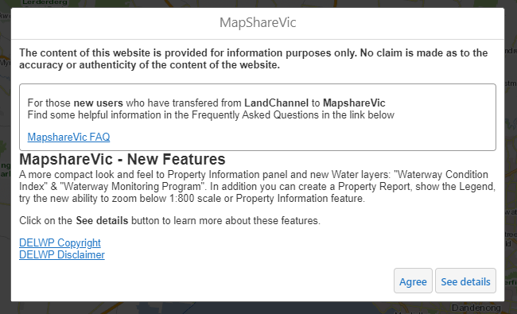

1. Find your project location by:
   1. Zooming in to the project location using your mouse scroll wheel, or
   2. Entering the address into the search bar at the top of the window

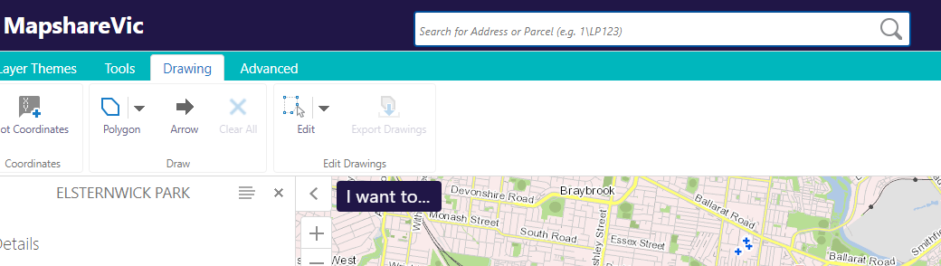

1. Now that you have found your project area, you are ready to map your project location. At this stage you can change the map to the satellite view if that is easier for you to visually see your project area. To do this, you will need to go to the bottom ribbon, click on ‘Vicmap Cartographical’, this will extend the menu to the right of the screen, you can then select the ‘Vicmap Overlay’ base map option.



1. The base layer of your map should now have changed to ‘Vicmap Overlay’.

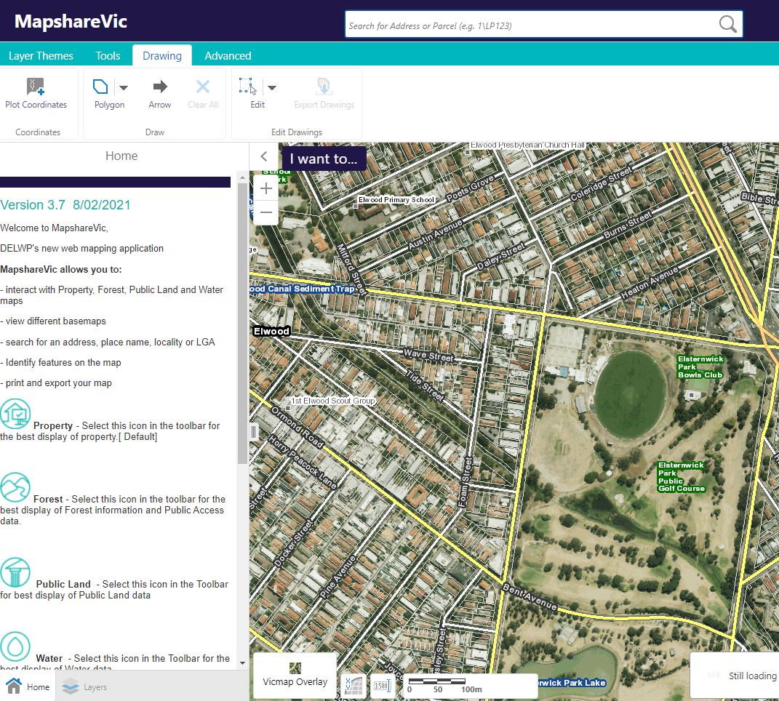

1. Click the 'Drawing' tab on the top green bar

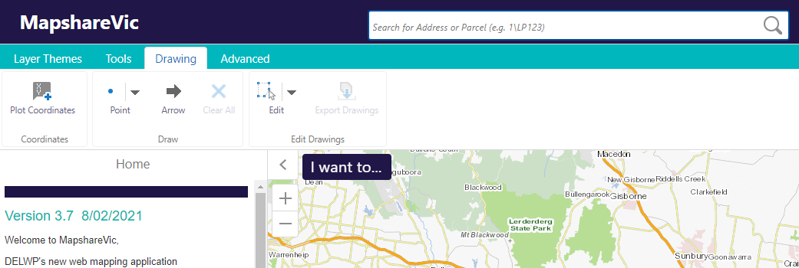

1. Click the drop-down arrow next to 'Point' and select 'Polygon' to draw a custom shape on the map

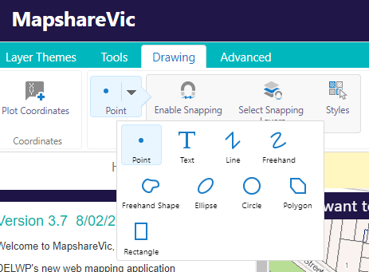

1. Left-click the boundaries of your project area to define the polygon shape. Remember to select the entire outline of your project area. You will need to double click to ‘finish’ your shape. As you can see in my example, I have used four clicks to draw the boundary of my project area.

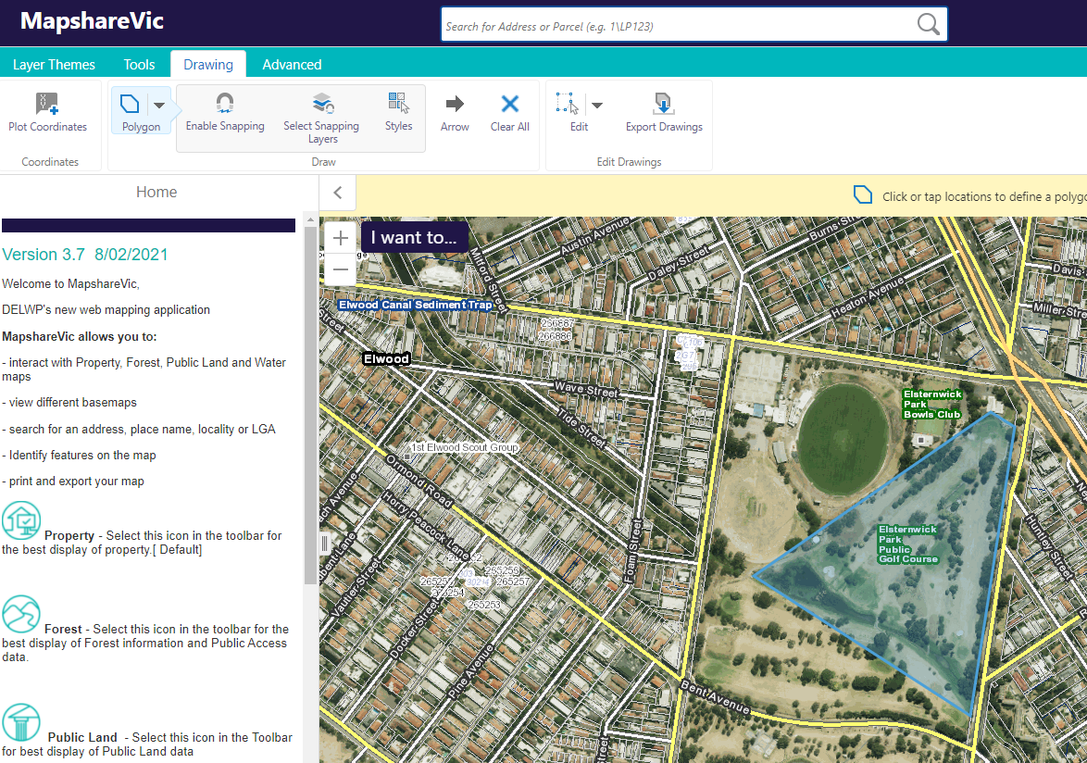

**2**

**1**

**3**

**4**

1. To erase a polygon, left-click the drop-down arrow next to the ‘edit’ icon and then select ‘erase’ from the menu that pops up.

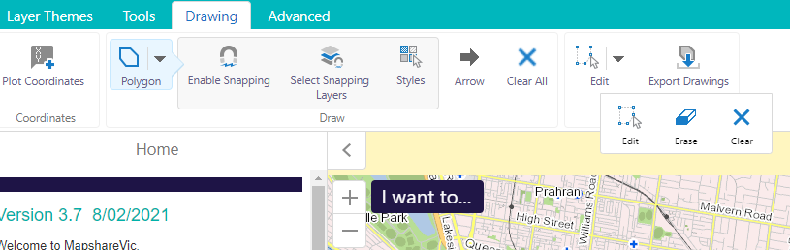

1. Once you have selected ‘erase’ you can left-click on any polygon you wish to remove, and it will be erased.
2. You have now finished drawing your polygon. It should capture the geographic location of your project area. See **Step B** for instructions on saving your polygon as a shapefile.
3. **Save your map as a shapefile**
4. Click 'Export Drawings' on the 'Drawing' toolbar

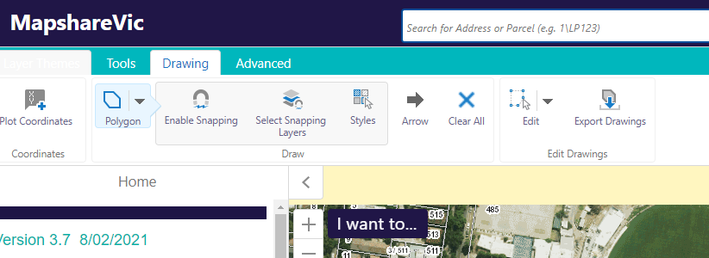

1. Click ‘OK’ on the pop-up. This will download a zipped folder to your device containing the shapefiles you have just created.

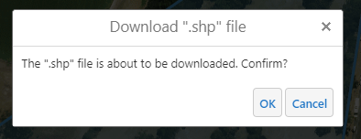

1. You should see a zipped folder appear in the bottom ribbon of your internet browser titled ‘Export.zip’. If you do not see this, check your ‘Downloads’ folder on your desktop to see if the folder is there or try our troubleshooting tips at the start of this document

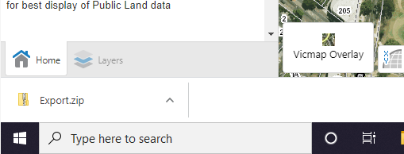

1. Rename the zipped folder to [ApplicationNumber]_shapefiles.zip – e.g., **GA-F12345-6789_shapefiles.zip**. You will need to rename the folder in your ‘Downloads’ folder on your desktop.

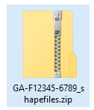

1. The zipped folder is now ready to be attached to your application. See **Step C** for instructions on saving your map as a PDF.
2. If you wish to come back and view the shapefile you have just created at a later date, right-click on the ‘upload data’ icon under the ‘tools’ tab.

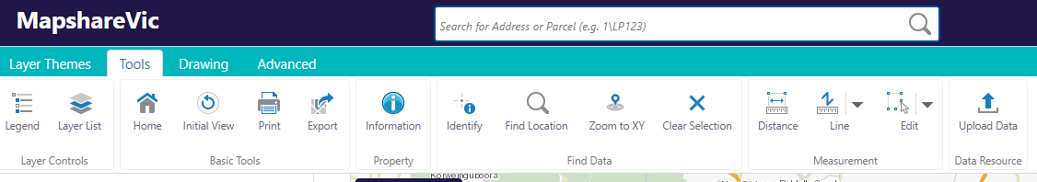

1. A pop-up box will appear. Right-click ‘choose files’ and select the zipped folder you created in Step 1-6 above. Then select ‘upload’. Once loaded, you can view your shapefile.

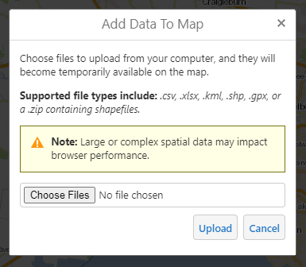

1. **Save your map as a PDF**
2. Click the ‘Tools’ tab on the top green bar

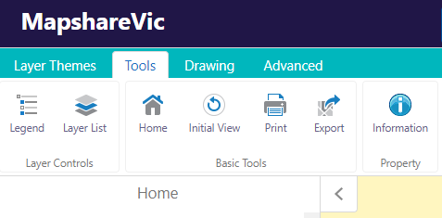

1. Click the ‘Print’ button underneath the top green bar, a ‘Print Map’ pane should appear to the left of the window once clicked.



1. Zoom in to the extent of your project area (i.e., the polygon you just mapped).
2. From the drop-down options in the ‘Print Map’ pane to the left of the window, select the following options under the relevant headings:

* Select Layout: A4 Landscape – DEECA
* Output Format: Pdf
* Resolution: High (216dpi)
* Grid: Latitude / Longitudell
* Map Scale: Current Extent
* Title: [ApplicationNumber]

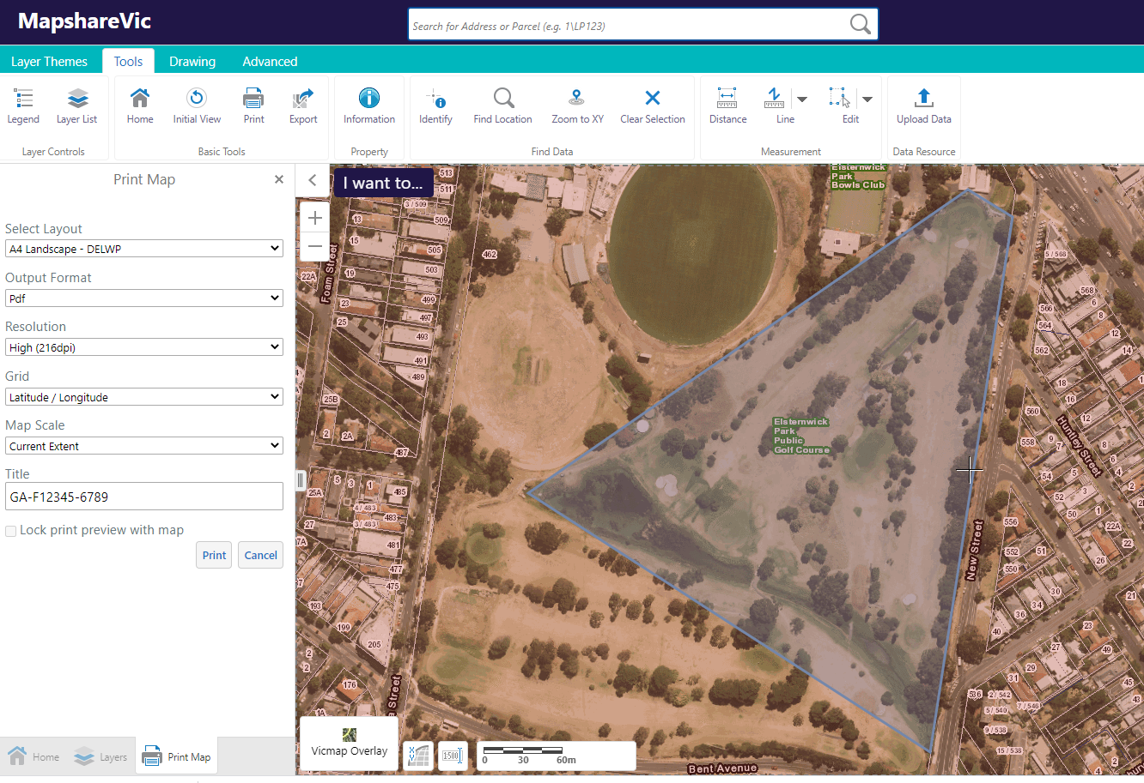

Insert your application number which you will be given when you start your application.

1. In the ‘Print Map’ pane click ‘Print’ – this will generate a PDF map document.

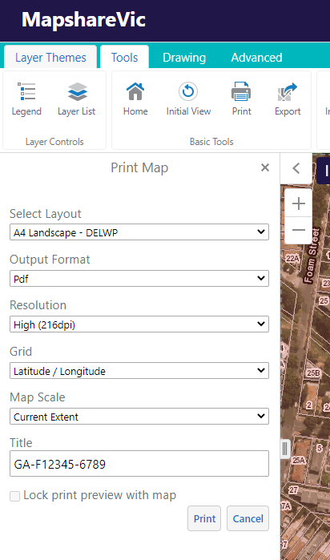

1. It can take a couple of minutes for the map to generate. Once the map has generated, you will be able to click ‘Open File’. This will open the PDF map in a new tab.

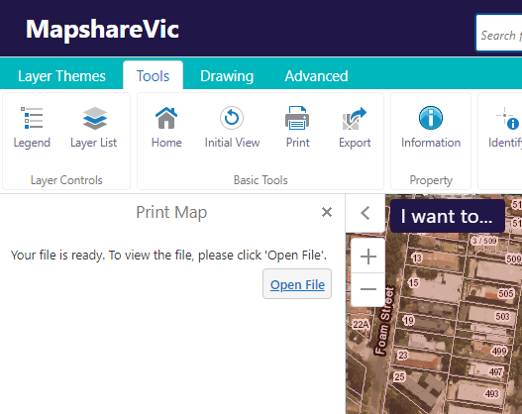

1. The completed map should look something like this example.

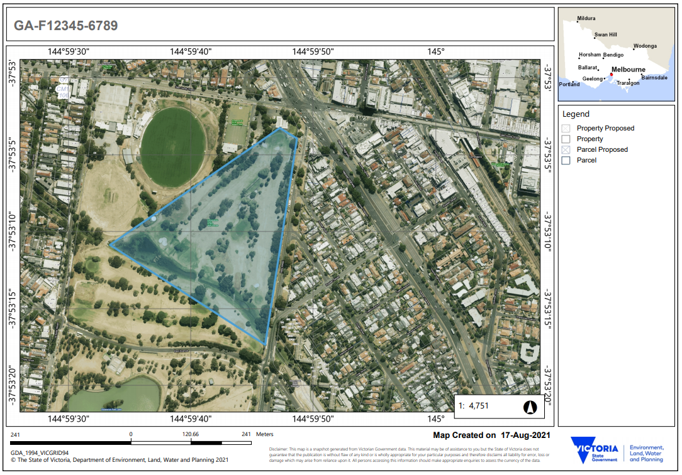

Application number

Longitude / latitude

1. Download your PDF map

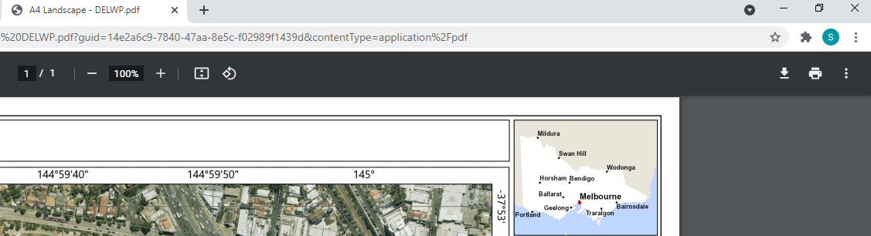

1. Rename the PDF to [ApplicationNumber]_Map.pdf – e.g., **GA-F12345-6789_Map.pdf.** The PDF copy of your map is now ready to be uploaded to your application.

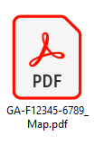

# Contact us

## Mapping assistance

If you require mapping assistance or are having issues producing a pdf map or shapefiles, please contact the Community Programs team directly via email at [enviro.grants@delwp.vic.gov.au](mailto:enviro.grants@delwp.vic.gov.au).

## Program enquiries

If you have any queries, or require more information, please contact the Community Programs team via email at [enviro.grants@delwp.vic.gov.au](mailto:enviro.grants@delwp.vic.gov.au) or contact the DEECA Customer Contact Centre on 136 186 and quote your application number and the grant program.

|  |  |
| --- | --- |
| © The State of Victoria Department of Energy, Environment and Climate Change 2024  Creative Commons BYThis work is licensed under a Creative Commons Attribution 4.0 International licence. You are free to re-use the work under that licence, on the condition that you credit the State of Victoria as author. The licence does not apply to any images, photographs or branding, including the Victorian Coat of Arms, the Victorian Government logo and the Department of Energy, Environment and Climate Change (DEECA) logo. To view a copy of this licence, visit http://creativecommons.org/licenses/by/4.0/  ISBN 978-1-76105-853-0 (**pdf/online/MS word**)  **Disclaimer**  This publication may be of assistance to you, but the State of Victoria and its employees do not guarantee that the publication is without flaw of any kind or is wholly appropriate for your particular purposes and therefore disclaims all liability for any error, loss or other consequence which may arise from you relying on any information in this publication | Accessibility  If you would like to receive this publication in an alternative format, please telephone the DEECA Customer Service Centre on 136186, email customer.service@delwp.vic.gov.au or via the National Relay Service on 133 677 www.relayservice.com.au. This document is also available on the internet at www.deeca.vic.gov.au |

## Technical difficulties

If you require technical assistance submitting your application online email [grantsinfo@delwp.vic.gov.au](mailto:grantsinfo@delwp.vic.gov.au) or call the DEECA Customer Contact Centre on 136 186 during normal business hours.

Please quote your application number and the grant program in your communications with DEECA.