DEECA marine and coasts newsletter
Issue 18 March 2024
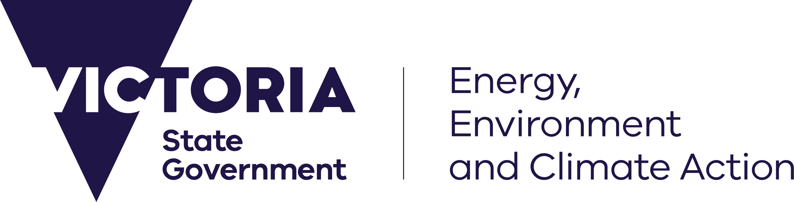
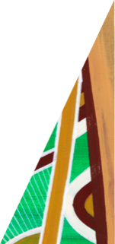
deeca.vic.gov.au

Welcome to the Department of Energy, Environment and Climate Action’s (DEECA’s) marine and coasts quarterly newsletter.

In this issue
- Mounts Bay beach nourishment complete
- Port Welshpool seawall complete
- Silverleaves Coastal Process Study
- Port Phillip Bay Fund – applications now open!
- Improving access to Victoria’s coastline
- A Bay-wide coastal hazard assessment to help us plan for the future
- Marine Biosecurity Program at SEA LIFE Melbourne Aquarium
- Coastcare Victoria’s ‘Coastline’
Email marine.coasts@delwp.vic.gov.au to subscribe or unsubscribe or for more information.

Coastal projects

Barwon South West

Mounts Bay beach nourishment complete
In response to coastal erosion impacts, the Great Ocean Road Coast and Parks Authority (GORCAPA) and DEECA have completed crucial beach nourishment works at Mounts Bay.
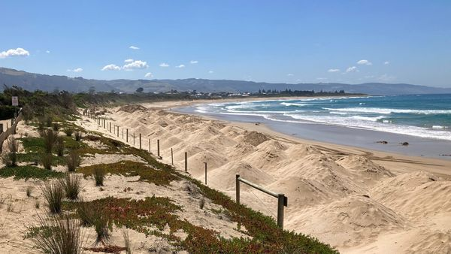
Beach nourishment at Mounts Bay.
The southern part of Mounts Bay on Eastern Maar Country has experienced increasing rates of erosion from the 1990s. Several beach nourishment and dune stabilisation works have been used over time to slow dune erosion and prevent damage to the Great Ocean Road, which runs along the primary dune.
For this latest nourishment, 12,000 m³ of sand was relocated from a large sand deposit at Point Bunbury to Mounts Bay.
The nourished area is being actively monitored. Safeguarding this spectacular stretch of the coastline is of great importance, and DEECA continues to work alongside GORCAPA, Department of Transport and Planning, Barwon Water and the National Broadband Network Co to develop an adaptation plan for the Mounts Bay beach area.
For more information, visit the Mounts Bay Adaptation Plan Engage Victoria site – https://engage.vic.gov.au/mountsbayadaptationplan.
Find out more about coastal adaptation plans, beach nourishments and other management options for coastal erosion at marineandcoasts.vic.gov.au/marine-coastal-management/coastal-erosion.

Gippsland

Port Welshpool Seawall complete
Construction of the Port Welshpool Seawall is complete!
Inspection of the original masonry seawall in 2022 revealed much of it to be in very poor condition, with erosion occurring behind the wall. The seawall’s poor condition threatened road access to the jetty and ferry terminal – a hub for public recreation and commercial activities.
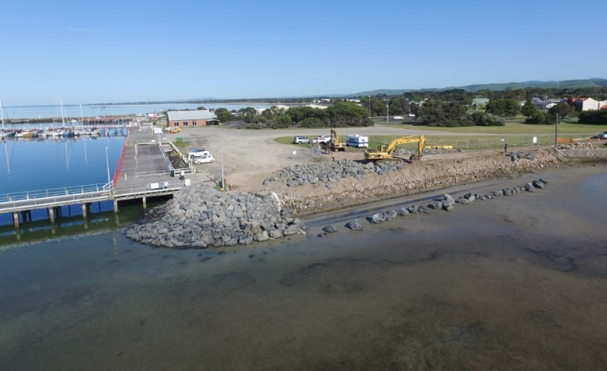
Port Welshpool Seawall, during construction.
The chosen design for the new seawall involved a full rock revetment remediation. This would reduce impacts on coastal processes due to higher energy absorption capability and less wave reflection.
Construction of the seawall remediation works began in August 2023 and were completed in December 2023. The local community had a keen interest in the project, watching trucks deliver large quantities of rock to progress the build.
Aligned with the original masonry seawall, the new seawall is approximately 114 metres long and has a design life of 50+ years. It ensures the continued use of the jetty for both recreational and commercial use. Additionally, the new design provides a more diverse habitat compared to the previous masonry seawall.
The project was funded through the VicCoasts program as part of the 2022-23 State Budget.
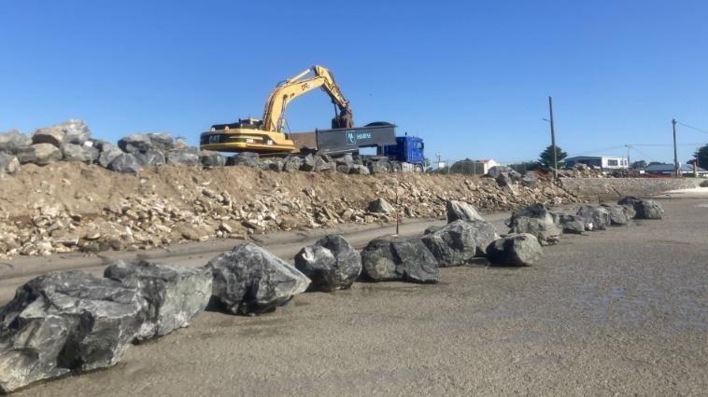
Port Welshpool Seawall, during construction.
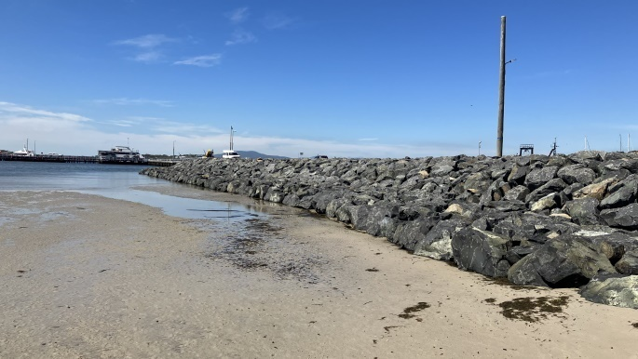
Port Welshpool Seawall, construction completed. December 2023.

Silverleaves Coastal Process Study
Coastal Process Studies are underway for 21 sites in the west of Gippsland, including the Silverleaves Foreshore.
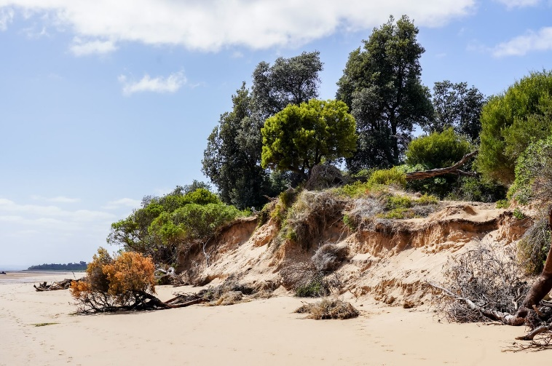
Erosion at Silverleaves Foreshore, February 2024.
Silverleaves has been heavily impacted by coastal erosion. The Coastal Process Study will provide a scientific understanding of the coastal processes at the site, which will help determine appropriate adaptation options in line with the Marine and Coastal Policy and Victoria’s Resilient Coast – Adapting for 2100+ framework and guidelines.
The study will assess risk, erosion and inundation, existing coastal protection assets, coastal processes and management options for coastal hazards.
Engaging with the community as part of this project is essential, providing a better understanding of the community’s values, priorities and perspectives in the context of adaptation and resilience.
A site meeting was held at Silverleaves Foreshore Reserve on 15 February 2024. DEECA, alongside the consultant and Bass Coast Shire Council, engaged with the local community to discuss their knowledge of the foreshore environment. It provided a great opportunity to learn about the area’s values, site history, and coastal erosion observations, with a range of perspectives gathered to inform the Coastal Process Study.
Visit marineandcoasts.vic.gov.au/coastal-programs/gippsland-projects for more information.

Marine and coastal grants

Port Phillip Bay Fund – applications now open!
Port Phillip Bay is one of Victoria’s most precious natural assets, providing a valuable habitat for many plant and animal species.
Grants are now available through the Port Phillip Bay Fund to support community efforts to protect and conserve the Bay’s unique coastal habitats and marine ecosystem.
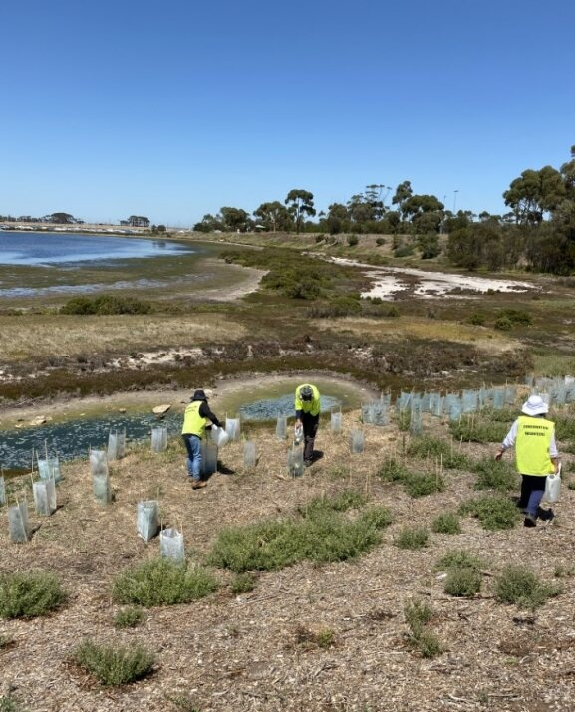
Hobsons Bay Mangrove Restoration – Conservation Volunteers Australia.
Organisations can apply for up to $300,000 for multi-year large-scale projects and up to $25,000 for local, one-year projects.
Projects must be located within the Bay itself, or up to five kilometres inland, to ensure that the project will have a direct benefit to the health of the Bay.
Environmental and community groups, non-government organisations, Traditional Owner groups, state agencies, research institutes, local councils, and schools are all encouraged to apply.
Applications close at on Thursday 18 April 2024 3:00pm AEST.
For more information and to apply online visit marineandcoasts.vic.gov.au/grants/port-phillip-bay-fund
For questions about the program, please email enviro.grants@delwp.vic.gov.au
Since its launch in 2016, the Port Phillip Bay Fund has provided more than $13.9 million in grants across 187 projects addressing key issues affecting Port Phillip Bay.

Improving access to Victoria’s coastline
Coastal Crown land managers are set to share in more than $1 million to improve safety and coastal access at beaches along Victoria’s coast.
The Victorian Government’s 2023-24 Coastal Public Access and Risk Grants program supports projects that reduce coastal risk through identification, mitigation and monitoring, and improve beach and foreshore access.
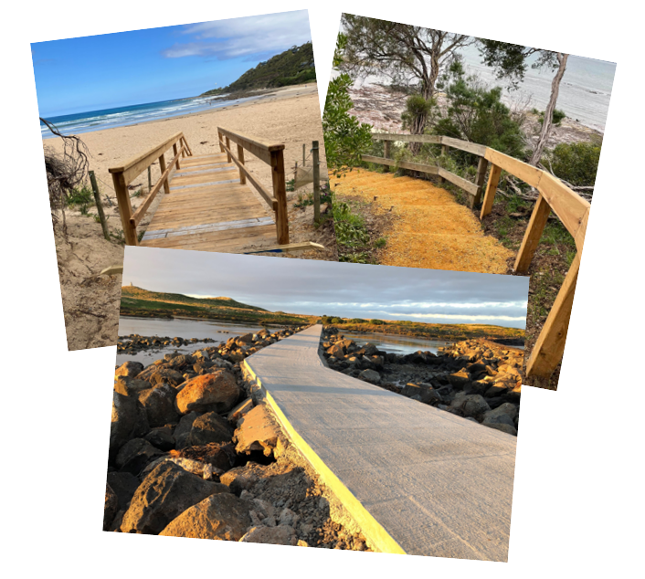
A few completed Coastal Public Access and Risk Grant projects.
The 13 projects, delivered by committees of management and local governments, are being supported with grants of up to $150,000 each.
Among this year’s successful projects are:
- Port Phillip region: Mornington Peninsula Shire Council - Hawker Beach Retaining Wall and Lookout Upgrade: upgrading the retaining wall around the lookout and along the path to Hawker Beach at Mt Martha
- Gippsland region: Phillip Island Nature Parks Board of Management - South Coast Stairways Project: designing upgrades or redevelopments of six beach access stairways
- Barwon South West region: Bellarine Bayside Foreshore Committee of Management - Portarlington All Abilities Beach Access: New accessible paths, a raised pedestrian crossing, disabled parking, all abilities beach matting to safely link a Changing Places toilet on the foreshore to the beach.
Other grant recipients will use funds for works such as replacing access tracks, stairs and ramps, fencing and retaining wall upgrades, signage audits and upgrades, and beach access feasibility studies.
For a full list of grant recipients, visit marineandcoasts.vic.gov.au/grants/coastal-public-access-and-risk-grants.
Since 2015, the grants program has delivered $7.2 million in funding to coastal Crown land managers. This year’s program is funded through the Victorian Government's $13.7 million VicCoasts initiative.

Marine and coastal knowledge

A Bay-wide coastal hazard assessment to help us plan for the future
Planning for future climate change scenarios is one step closer with the release of the Port Phillip Bay Coastal Hazard Assessment (PPBCHA) findings.
Funded by the Victorian Government, the assessment findings will improve understanding of coastal hazards on Victoria’s most populous coastlines, for coastal land managers and their communities.
The Victorian Government is investing in a range of coastal hazard management projects along Victoria’s coastlines. This includes assessments that are helping us understand, plan for and manage the impacts of increasing coastal hazard impacts due to climate change.
Port Phillip Bay’s shorelines and nearby coastal areas are home to 1.3 million Victorians. With diverse and unique landscapes, the Bay attracts visitors and residents from all over the world.
Extending from Point Lonsdale through to Point Nepean, the PPBCHA examined current and future coastal hazards for Port Phillip Bay. These included inundation, erosion and changes in groundwater.
Looking at both present day conditions and predicted future changes, such as rising sea levels and changing wind and wave climates, more sophisticated models than previously used, examined how the coastline might change and respond overtime. This was for a range of hazard types, storm events and sea level rise scenarios.
The PPBCHA modelling, analyses and hazard maps provides a regional perspective of coastal processes and areas potentially exposed to coastal hazards around the Bay. These results provide the foundation for more in-depth, localised (site-based) assessments and adaptation planning.
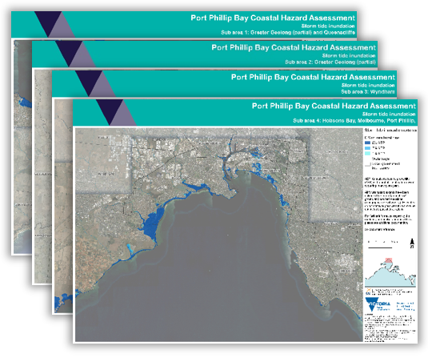
Port Phillip Bay Coastal Hazard Assessment maps.
Now shared with land managers and the community, the findings of the Bay wide assessment will help inform the development of possible adaptation responses to effectively manage coastal hazard risk in our coastal communities.
For more information, visit marineandcoasts.vic.gov.au/coastal-programs/port-phillip-bay-coastal-hazard-assessment
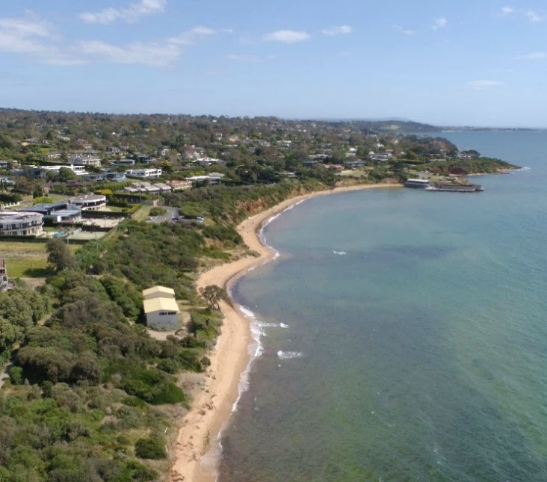
Canadian Bay (Mount Eliza).

Marine Biosecurity Program at SEA LIFE Melbourne Aquarium
The invasive marine species team at Agriculture Victoria has teamed up with SEA LIFE Melbourne Aquarium to launch a campaign focused on marine biosecurity. The initiative aims to raise awareness about the importance of protecting our marine ecosystems and preventing the spread of invasive marine species.
The program, which will be hosted at the SEA LIFE Melbourne Aquarium, will provide visitors with an immersive and educational experience. Through dedicated exhibits and activities, participants will learn about the critical role of biosecurity in safeguarding Victorian marine biodiversity.
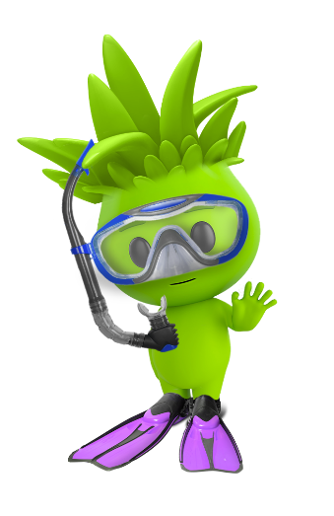
Aggie, Agriculture Victoria’s Great Biosecurity Quest mascot.
As part of the program, visitors will be able to explore the aquarium's different marine habitats and discover the incredible diversity of marine life. They will also learn about ways in which invasive marine species can be introduced into Victoria and how they can impact native ecosystems. More importantly, the program will seek to educate audiences on high-risk invasive species and how to report them, to ensure we all help protect Victorian marine environments.
The campaign will be open to visitors of all ages throughout the month of May.
Stay tuned for more information about the program at https://www.visitsealife.com/melbourne/ and make sure to visit SEA LIFE Melbourne this May!
You can also learn more about marine biosecurity at https://agriculture.vic.gov.au/biosecurity/marine-pests.

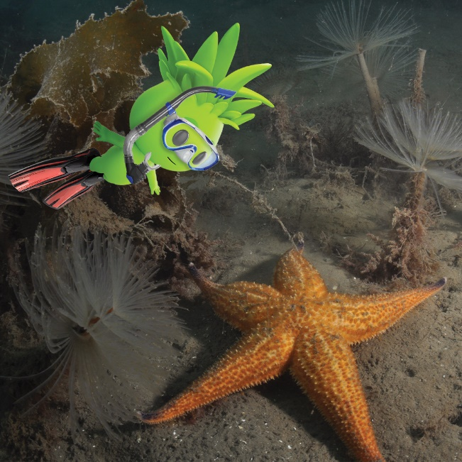
Aggie and two marine invasive species present in Victoria: Northern Pacific Seastar (Asterias amurensis) at the front and European fan worm (Sabella spallanzanii) at the back.
Keep reading for Coastcare Victoria’s ‘Coastline’!

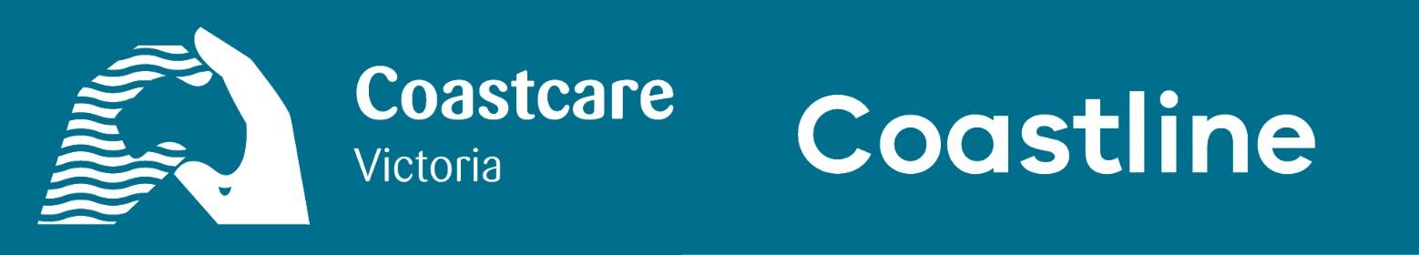

In this issue
- Applications closed for the 2024 VicCoasts Coastcare Victoria Community Grants
- Wrapping up 2023-24 Coastcare Victoria Community Grants with a Seaweed Symposium

Applications closed for the 2024 VicCoasts Coastcare Victoria Community Grants
Applications have officially closed for the 2024 VicCoasts Coastcare Victoria Community Grants round.
The Coastcare Victoria team thoroughly enjoyed hearing from the fantastic marine and coastal volunteer community and discussing a variety of unique project ideas.
Thank you to everybody who submitted applications. The team is always looking to make our processes more streamlined and user-friendly, so please feel free to send feedback on your experience to coastcare.victoria@delwp.vic.gov.au.
Successful candidates will hear from us in July. Until then, all the best and take care.

Wrapping up 2023-24 Coastcare Victoria Community Grants with a Seaweed Symposium
Edible Gardens Group, a recipient of Coastcare Victoria Community Grants Program 2023-24, held an educational afternoon titled: Campfire Conversation: A seaweed symposium by Lichen Kelp & the Seaweed Appreciation Society.
The event was an opportunity to learn about all things seaweed, including macroalgae found along the southwest coastline and how it can be used in everyday diets. Participants even shared damper threaded with local seaweed varieties, whilst discussing the importance of seaweed to coastal ecosystems.
In the words of participants Trev Salvado and Cindy Bohan: ‘From academic to creative, from novice to experienced, from curious to knowledgeable, the circle of participants engaged in 90 minutes of conversation curated by Lichen Kelp from the Seaweed Appreciation Society. Zoe Brittain chatted about her ecological and anthropological research titled Indigenous Use of Seaweed in Temperate Australia and Alecia Bellgrove discussed edible seaweeds and nutrition, as well as the role seaweeds can play in the mitigation of climate change.’
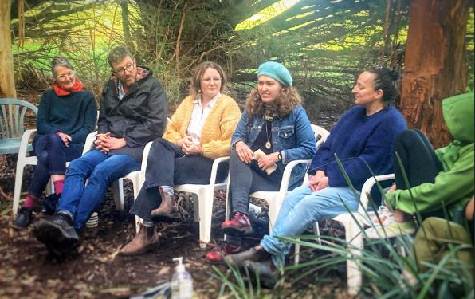
Seaweed symposium 1– Learning from Lichen Kelp & the Seaweed Appreciation Society.
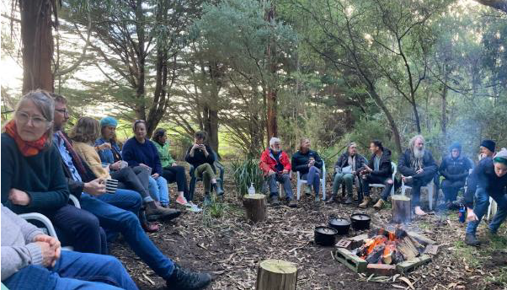
Seaweed symposium 2 – Participants gather around the campfire, delving into discussion and seaweed damper.
A massive congratulations to Edible Gardens Group for hosting a well-attended, highly educational event!
Thank you to Southern Otway Landcare Network and participants for the basis of this article. This project is supported by Coastcare Victoria and the Victorian Government.

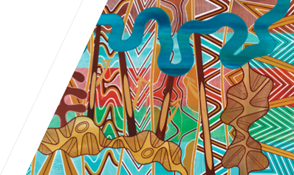
We acknowledge Victorian Traditional Owners and their Elders past and present as the original custodians of Victoria’s land and waters and commit to genuinely partnering with them and Victoria’s Aboriginal community to progress their aspirations.
© The State of Victoria Department of Energy, Environment and Climate Action March 2024.
Creative Commons
This work is licensed under a Creative Commons Attribution 4.0 International licence, visit the Creative Commons website (http://creativecommons.org/licenses/by/4.0/).
You are free to re-use the work under that licence, on the condition that you credit the State of Victoria as author. The licence does not apply to any images, photographs or branding, including the Victorian Coat of Arms, and the Victorian Government and Department logos.
Disclaimer
This publication may be of assistance to you but the State of Victoria and its employees do not guarantee that the publication is without flaw of any kind or is wholly appropriate for your particular purposes and therefore disclaims all liability for any error, loss or other consequence which may arise from you relying on any information in this publication.
Accessibility
To receive this document in an alternative format, phone the Customer Service Centre on 136 186, email customer.service@delwp.vic.gov.au, or contact National Relay Service on 133 677. Available at DEECA website (www.deeca.vic.gov.au).

