**Coastal Custodians, Citizens & Scientists Worksheets**

Coastcare Victoria School Kit

|  |
| --- |
| Ecosystem and Edible Urchins Worksheets |

****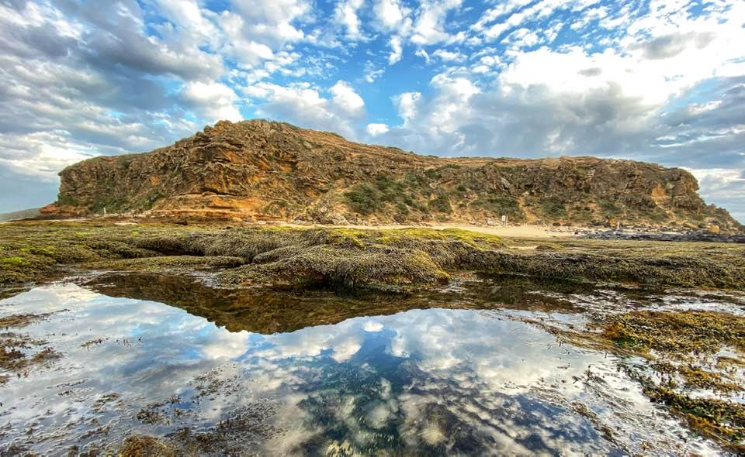

Acknowledgements

|  |  |  |  |
| --- | --- | --- | --- |
|  |  |  |  |

Coastcare Victoria would like to acknowledge all our video presenters and individuals who reviewed or assisted with the creation of the Coastcare Victoria School Kit.

Author

Contents

Coastcare Victoria and Ecolinc Science and Technology Innovations Centre.

Photo credit

Tim Goddard via Friends of the Barwon Bluff.

Activity 1: Quiz 3

Activity 2: Sea Slug Census 5

Activity 3: Scientific Sampling - Survey 7

Investigation 1: The Science in Language 9

Investigation 2: Scientific Poster 10

Coastal Custodians Review Questions 12

# Activity 1: Quiz

1. Where does the Barwon River flow from and to?

1. Geelong to Barwon Heads
2. Queenscliff to Barwon Heads
3. The Otway ranges to Bass Strait
4. Bass Strait to the Otway Ranges

2. What is the name of the Aboriginal people who are the Traditional Owners of Barwon Bluff?

1. Wadawurrung
2. Kurnai
3. Boonwurrung
4. Wiradjuri

3.  What type of rocks support the intertidal habitat in the Barwon Bluff Marine Sanctuary?

1. Boulders and rock-pools
2. Reefs and cliffs
3. Smooth and rough
4. Basalt and limestone

4. What do Friends of the Bluff group do to help protect and maintain the Barwon Bluff?

1. Provide education, fundraising and putting up signs
2. Weeding, collect litter and provide education
3. Take tours, collect litter and lobby the government
4. Count animals, collect litter and fundraising

5. Which of these is a citizen science program that people can join at the Barwon Bluff?

1. Sea Search
2. Sea Slug Census
3. Bio Blitz
4. All of the above

6. What kind of rockpool creature did Isabelle get to learn about and touch?

1. Elephant seal
2. Elephant snail
3. Barnacle
4. Chiton

7. Who is allowed to use iNaturalist to record biodiversity at the Barwon heads?

1. Scientists
2. Friends of the Bluff members
3. Citizen scientists
4. Park rangers

8. What are some dangers of exploring the Barwon Bluff Marine Sanctuary?

1. Blue ringed octopus and big waves
2. Leaving litter and damaging the rocks
3. Blue ringed octopus and elephant snails
4. Big waves and sunburn

9. What is the primary ecosystem protected by the Barwon Bluff Marine Sanctuary?

1. Intertidal reef ecosystem
2. Beach ecosystem
3. Cliffs ecosystem
4. Marine ecosystem

10. Which statement is most true?

1. There are dangerous creatures in rockpools, you must not explore them
2. There are no dangerous creatures in rockpools, you can touch anything you find
3. Some creatures are dangerous, and some are not, you need to know the difference to explore
4. Some creatures are dangerous, but you can touch them if you are counting them in a survey

# Activity 2: Sea Slug Census

Use the iNaturalist website and the Melbourne Sea Slug Census project page to answer the following questions.

* 1. How many citizen scientists (OBSERVERS) helped record sea slugs?
  2. How many SPECIES of sea slug were recorded in this census?
  3. How many OBSERVATIONS (sightings of sea slugs) were recorded in this census?
  4. Why are those two numbers different?

Click into the SPECIES tab to answer the following questions:

* 1. What was the most commonly observed sea slug around Victoria?

Record the common name and the scientific name.

* 1. How many species were observed only once during the whole census?
  2. In the introduction slides we saw that there are two main groups of sea slugs, Dorid and Aeolid. Which group does the most common Melbourne sea slug belong to? How can you tell?

**Look at all of the sea slugs from around Melbourne. Pick your favourite – you are going to draw it!**

In the space below, draw and label a scientific diagram of your favourite nudibranch from the Melbourne Sea Slug Census.

* Include labels (with ruled lines) of all the important physical features.
* Pay close attention to drawing the unique shapes of your chosen sea slug.
* Can you find out how big your species is? Add a scale bar to your diagram.

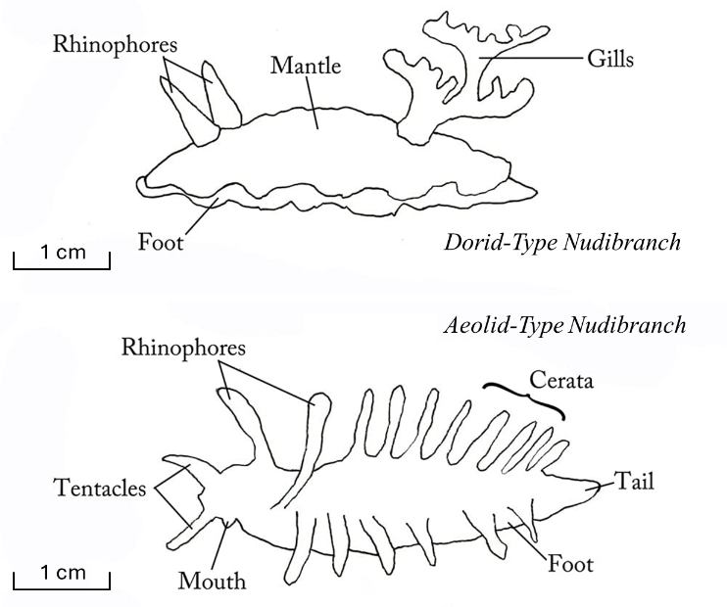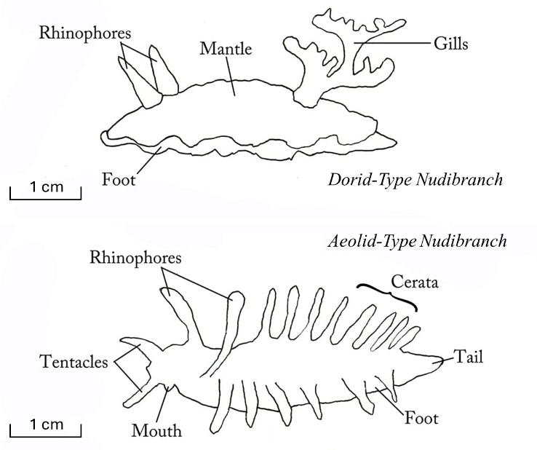

# Activity 3: Scientific Sampling - Survey

We are going to do a BioBlitz, using the Barwon Bluff rockpool print out.

**STEP 1**: Count every species you can see on the rockpool print out and enter the data into the TOTAL COUNT row in your RESULTS table.

*Neptune’s necklace seaweed has been counted for you. It is recorded as the number of 25cm x 25cm grid squares the seaweed covers on your rockpool print out.*

It would be very hard to count every species on a real life rockpool platform. Instead, scientists count a subset of the rockpool area (called a **survey**) and then multiply their answer to estimate the total number of species. A 1m x 1m survey square called a **quadrat**, is used to count the subset.

**STEP 2:** Use a random number generator to create coordinates for each of your ten quadrats and record them here.

|  |  |  |  |  |  |  |  |  |  |
| --- | --- | --- | --- | --- | --- | --- | --- | --- | --- |
| **Quadrat coordinates 1-8 x A-F** | | | | | | | | | |
| **1:** |  | **2:** |  | **3:** |  | **4:** |  | **5:** |  |
| **6:** |  | **7:** |  | **8:** |  | **9:** |  | **10:** |  |

**STEP 3:** Outline a 1m x 1m quadrat at each of your ten coordinates, and label them 1-10.

**STEP 4:** Count each animal or grid square with seaweed in it, and record in your RESULTS table.

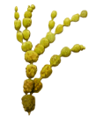**RESULTS:**

|  |  |  |  |  |  |
| --- | --- | --- | --- | --- | --- |
| **Species** | **Shore Crab** | **Eight-armed Sea Star** | **Free Vectors | White Tasuki NudibranchNudibranchs** | **Elephant Snail** | **Neptune’s Necklace Seaweed** |
| **TOTAL COUNT** |  |  |  |  | **420 grid squares** |
| **Quadrat 1** |  |  |  |  |  |
| **Quadrat 2** |  |  |  |  |  |
| **Quadrat 3** |  |  |  |  |  |
| **Quadrat 4** |  |  |  |  |  |
| **Quadrat 5** |  |  |  |  |  |
| **Quadrat 6** |  |  |  |  |  |
| **Quadrat 7** |  |  |  |  |  |
| **Quadrat 8** |  |  |  |  |  |
| **Quadrat 9** |  |  |  |  |  |
| **Quadrat 10** |  |  |  |  |  |

**Use your results to estimate the total population of organisms in the rockpools.**

The rockpool platform is 8m across x 6m down.

How many 1m square quadrats would it take to survey the whole reef? 8 x 6 =

Now that we have completed our survey, we have ten subsets of the total population. Through multiplication these counts can be used to estimate the total population. You will investigate how the estimate changes when you use counts from 1, 5 and 10 quadrats.

**STEP 5:** Add together each organism you counted in 1, 5 and 10 quadrats.

Enter your answers into the corresponding rows of the ESTIMATE table.

**Try visualising!**

>Data we have

>Data we are predicting

**STEP 6**: Calculate your multipliers.

How much of the total rockpool area is 1 quadrat? **48 ÷ 1 = A**

Multiply the number of species from quadrat 1 by answer A



How much of the total rockpool area is 5 quadrats? **48 ÷ 5** =  **B**

Multiply the number of species from 5 quadrats by answer B



How much of the total rockpool area is 10 quadrats? **48 ÷ 10** = **C**

Multiply the number of species from 10 quadrats by answer C

**ESTIMATE**:

|  |  |  |  |  |  |
| --- | --- | --- | --- | --- | --- |
| **Species** | **Shore Crab** | **Eight-armed Sea Star** | **Free Vectors | White Tasuki NudibranchNudibranchs** | **Elephant Snail** | **Neptune’s Necklace Seaweed** |
| **TOTAL COUNT** | **35** | **30** | **10** | **15** | **420 grid squares** |
| **Number in Q1** |  |  |  |  |  |
| **Multiply x A** |  |  |  |  |  |
| **Number in Q1+2+3+4+5** |  |  |  |  |  |
| **Multiply x B** |  |  |  |  |  |
| **Number in**  **Q1+2+3…+9+10** |  |  |  |  |  |
| **Multiply x C** |  |  |  |  |  |

Discuss: What happens to your estimate as you add more data?

# Investigation 1: The Science in Language

**Create an infographic.** Find three coastal words with shared sounds or meanings. Include definitions, illustrations and facts to explain the connections between these words in an infographic style.

# Investigation 2: Scientific Poster



By:

Title:

**Methods**

**References**

**Results**

**Materials**

**Aim**

**Conclusion**

**Discussion**

# Coastal Custodians Review Questions

1. What is the main difference between a scientific diagram and a scientific colour illustration? (2 marks)
2. What are some differences between the two main groups of nudibranchs, Dorid & Aeolid? (3 marks)

Use sketches if you like.

1. Why do scientists count a subset and not the total number of organisms in an environment? (4 marks)
2. What are some reasons you would choose to use an infographic to communicate a subject? (4 mark)