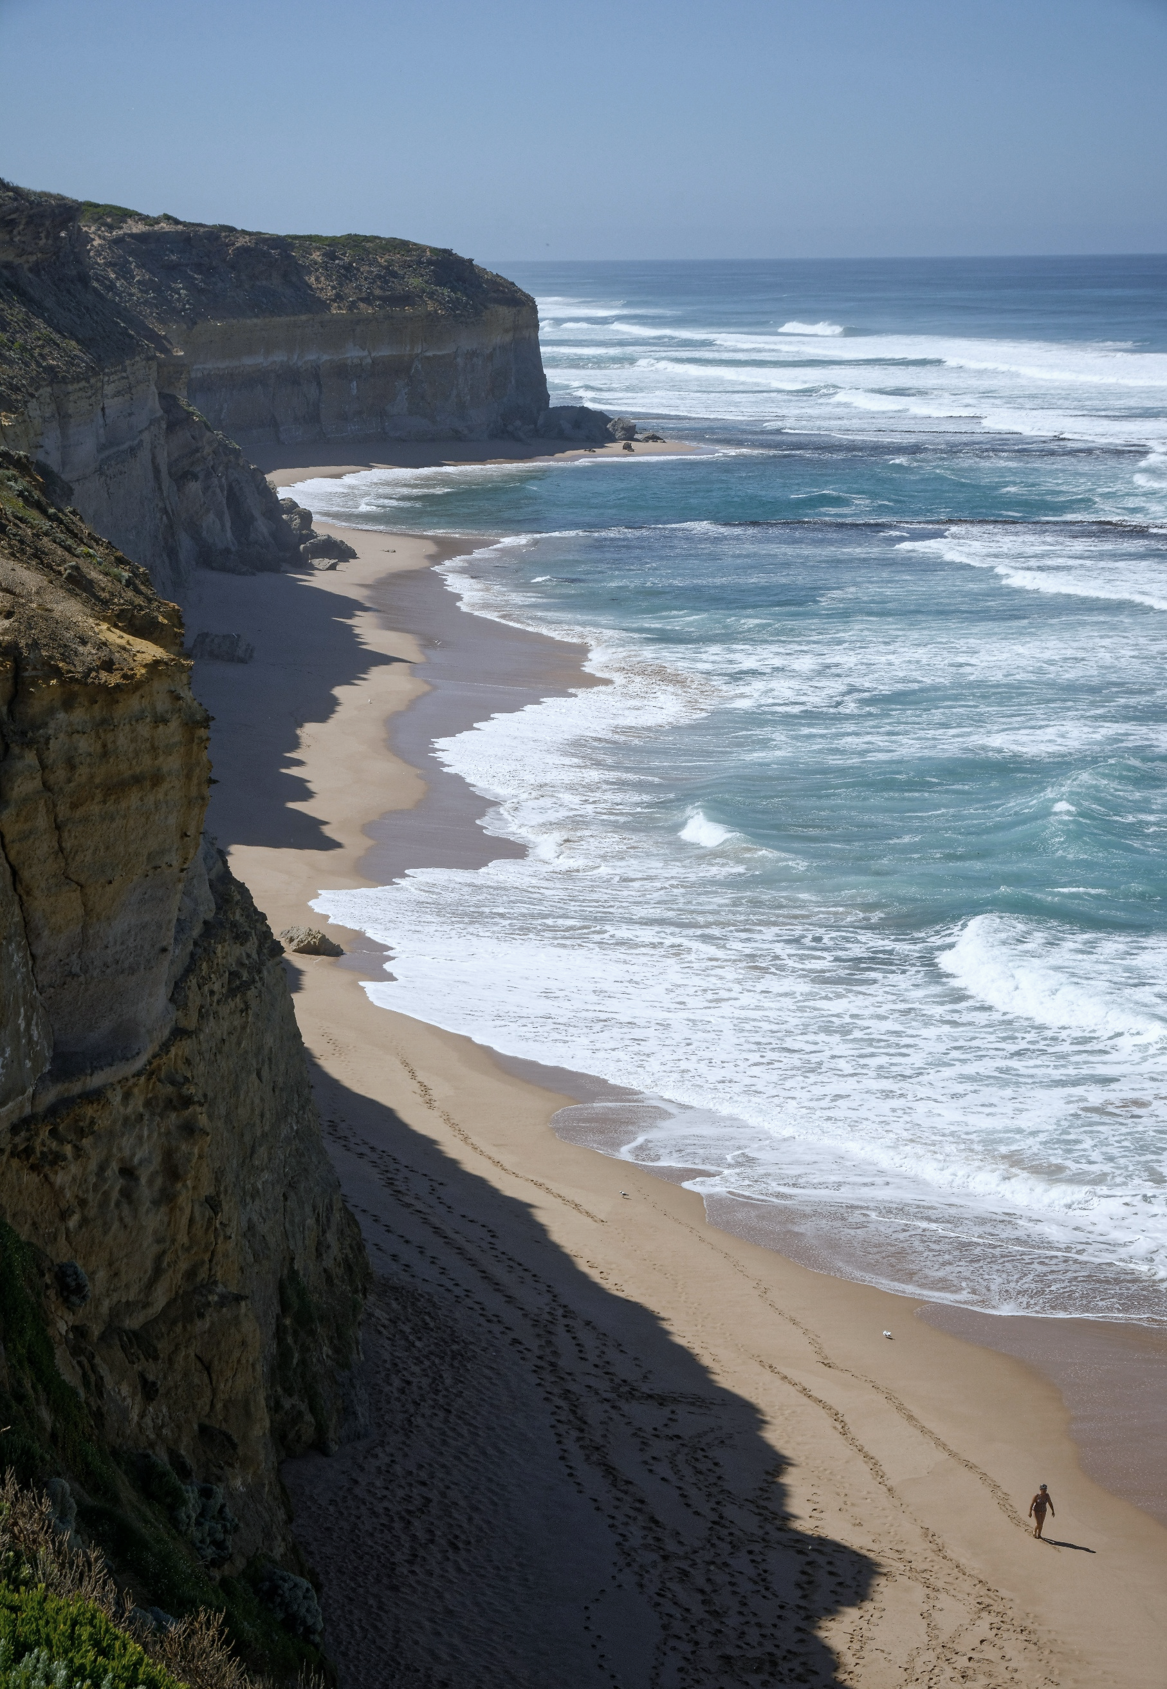
Coastal and Marine Attitudes and Behaviours
Wave 6 - Main Report
September 2025




Quantum Market Research is an independent market research agency based in Melbourne, Victoria (on Wurundjeri Woi Wurrung land).
Quantum acknowledges the Traditional Owners of Country throughout Australia. We pay our respect to them, their culture and their leaders, past and present.
Quantum is accredited to the International standard for market, social and opinion research, ISO 20252:2019.
All images are sourced under licence through Unsplash.
qmr.com.au

Contents

1. Executive Summary 4
2. Introduction 6
2.1 Background and Objectives 6
3. Coastal visitation and experience 9
3.1 Coastal visitation 9
3.2 Coastal destinations visited 10
3.3 Coastal visitation – day trips 11
3.4 Coastal visitation – overnight trips 14
3.5 Who Victorians visit the coast with 15
3.6 Natural tourism 16
3.7 Activities undertaken at coastal and marine environments 20
3.8 Coastal experience 22
3.8.1 Importance of, and satisfaction with individual aspects of the experience 24
3.9 Likelihood to visit the coast or marine environment 26
Attitudes towards, and concerns about, Victoria’s coastal environment 29
4. Attitudes towards, and concerns about, Victoria’s coastal environment 30
4.1 Coastal attitudes 30
4.2 Importance of coastal and marine functions 31
4.3 Issues and concerns 32
4.4 Visitation and awareness of Marine Protected Areas (MPAs) 35
4.5 Support for methods to adapt to environmental challenges 36
Planning and management of Victoria’s coastal environment 37
Planning and management of Victoria’s coastal environment 37
5. Planning and management of Victoria’s coastal environment 38
5.1 Perceptions of management 38
5.2 Belief in responsibility to manage 40
5.3 Support of usage of coastal and marine environments 41
6. Appendix 44
6.1 Methodology 44
6.2 Sampling and Recruitment 45

Executive Summary

This report presents the findings from a state representative online survey of n=2000 Victorians aged 18 years or over, and 4 qualitative focus groups with Victorians. Although part of the ‘Wave’ series, Wave 6 is a standalone pulse check rather than a continuation of longitudinal data.

Victorians have a deep affinity for our coastal and marine environments​
- Eight in ten Victorians have visited a Victorian coastal or marine area in the past 12 months.
- Day trips to a coastal area within reasonable driving distance are popular, and fit in with current lifestyles.
- The majority of Victorians agree coastal and marine environments are the state's most important natural feature.
Victorians seek fun, exploration and adventure, but current economic and financial constraints have them searching for shorter, low-cost solutions.

Victorians seek 'untouched' natural environments, but expect basic amenities​
- Six in ten Victorians prioritise natural beauty and untouched environments over tourism and recreation activities.
- Top decision factors for visiting coastal and marine areas include natural beauty, peace and quiet, and access to core amenities such as car parking, food, and toilet/shower blocks.
- The diversity of Victoria’s coastal and marine environments enables Victorians to connect with these places in ways that suit their preferences.
For Victorians the coast is an antidote to daily grind, offering calm, simplicity, and a slower pace. The easier the experience, less to carry, shorter walks, a smooth trip home, the more it delivers the peace they are after.

Proximity to the coastline influences the depth of coastal connection​
Residents within 1km of the coast engage differently with coastal and marine environments compared to those 1-5km away.
- Those who live closer to the coast use the coast more often for active purposes such as cycling and surfing.
- Those who live closer to the coast are more likely to value the coast for its untouched natural beauty.
- Living nearer to the coast strengthens awareness of coastal challenges, including beach erosion, overdevelopment, and invasive marine species.
- Residents closer to the coast place greater importance on addressing ocean warming and beach erosion.
Those who live closer to the coast have a higher personal investment in the protection of their location, and their lifestyle.

Environmental concerns among Victorians are largely limited to what they can see​
- Seven in ten Victorians agree more must be done to help coastal and marine environments adapt to climate change.
- However, awareness of specific environmental issues is limited, with visible impacts such as litter/microplastics viewed as the most important issue to address.
Victorians prioritise visible issues due to the psychological response to immediate, tangible threats, whilst abstract or gradual changes feel distant and less urgent.
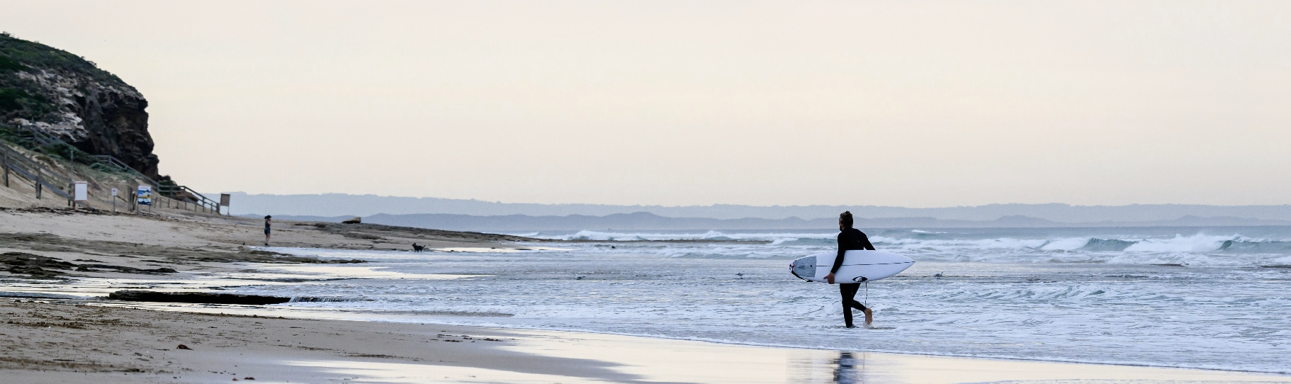

Introduction

Background and Objectives

Victoria has 2,512 km of coastline and approximately 10,000 square kilometres of marine waters. For many Victorians, marine and coastal environments underpin a way of life, providing immense environmental, cultural, social and economic benefits, in addition to their intrinsic natural values.
Unlike many parts of Australia and the world, 96 per cent of our coast is public land¹. This provides a strong starting point to manage and protect these areas for future generations to enjoy. It also ensures that the coast is largely accessible to everyone. It creates a wide range of experiences, from the bustling city beaches to smaller seaside settlements and untouched coastline in remote areas.
However, coasts are coming under increasing pressure for a variety of uses, which can result in land use conflicts and the degradation of coastal habitat. The challenge is to ensure that the many attributes of these environments are managed in a sustainable fashion and that decisions about competing uses are balanced in the interests of all Victorians.
It is therefore of critical importance to understand how all Victorians are thinking, feeling and acting on this topic.
The history of this research program
This ‘Wave’ series of social research surveys has been undertaken since 1996 when the first Wave was conducted. Since then, Wave 2 was conducted in 2000, Wave 3 in 2007, Wave 4 in 2011, and most recently Wave 5 was conducted in 2018. This iteration of the research is Wave 6.
This research was used to build a long-term understanding of community values and behaviours in relation to marine and coastal use and management. Previous wave surveys were instrumental in setting the policy and strategic direction for management of Victoria’s marine and coastal environment.
While Wave 6 contributes to the broader longitudinal dataset, it was intended as a smaller, more focused iteration. Its key purpose is to provide current, relevant insights into how communities are using, valuing, and interacting with the coast and marine environments today. As such, this research was not bound to previous lines of questioning which were no longer aligned with the current context and objectives of Wave 6.

Research objectives
The core objective of this research was to measure Victorians’ experience, use, attitudes, and concerns regarding the Victorian coast and marine environments.
In particular:
- Identify and measure current community views, as well as issues and concerns relating to the Victorian marine and coastal environment, including their relative importance and how they affect residents, tourism, and recreation.
- Understand usage and behaviours associated with the marine and coastal environment
- Explore community perceptions, expectations, and priorities regarding marine and coastal planning management and opportunities in Victoria
- Explore community perceptions of the appropriateness and success of marine and coastal management
- Explore contemporary, future and emerging issues, such as tourism and recreation, the role of local industries and businesses, climate change, sea level rise and community adaptation
Residents and visitors in this research
For the purposes of this research, the following definitions for residents and visitors have been used:
Residents: Victorians who live within <5km of a Victorian coast.
Visitors: Victorians who live more than 10km+ away from a Victorian coast, and have travelled to a coastal region in the past 12 months.

Coastal visitation and experience
Setting the scene: How and why Victorians visit the coast.
Page Break

Coastal visitation and experience
- Eight in ten have visited a Victorian coastal or marine area in the past 12 months.
- Victorians were more likely to have undertaken a day trip in the past 12 months than an overnight trip.
- Six in ten Victorians prioritise natural beauty and untouched environments over tourism and recreation activities.
- Top decision factors for visiting coastal and marine areas include natural beauty, peace and quiet, and access to core amenities such as car parking, food, and toilet/shower blocks.

Coastal visitation
The coast is a major part of life in Victoria, with almost four in five (79%) Victorians having visited a Victorian coastal area in the past 12 months (on par with 77% in Wave 5). Those most likely to have visited a coastal area in the past 12 months were:
- Younger Victorians (86% of 18-39 year olds had visited the coast)
- Those living in metropolitan areas (81% of metropolitan residents had visited the coast)
- Households with children (89% of households with children had visited the coast)
- Those with household incomes of $100k+ (87% of household incomes of $100k+ had visited the coast)
The differences above suggest that Victoria’s coastal and marine environment plays a key part in many people’s lifestyles.
One in five (21%) Victorians had not visited the coast in the past 12 months. Primary reasons for not visiting a coastal area revolved around the coast not being top of mind as a destination, difficulty getting to the coast, or difficulty generally taking holidays (Figure 1).
This suggests that lack of coastal visitation is not due to coastal-specific issues, but due to it not being top of mind.

Figure 1. Barriers to visitation of the coastal area
Q8. Which of the following best describes why you have not visited a coastal area in Victoria in the past 12 months? (Multiple response)
Base: Those who have not visited coastal area in the past 12 months n=404
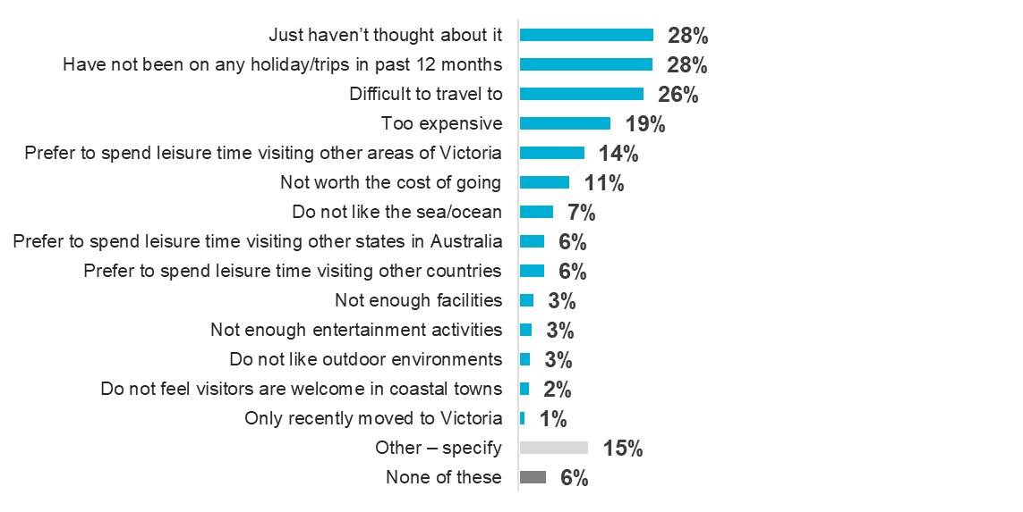

Coastal destinations visited

Geelong was the most visited coastal destination (46%). This was followed by St Kilda (39%), and Phillip Island (34%).
Figure 2. Location of coastal areas visited in the past 12 months
Q9. Which of the following coastal areas in Victoria have you visited in the past 12 months? (Multiple response)
Base: Those who have visited coastal areas in the past 12 months n=1,579
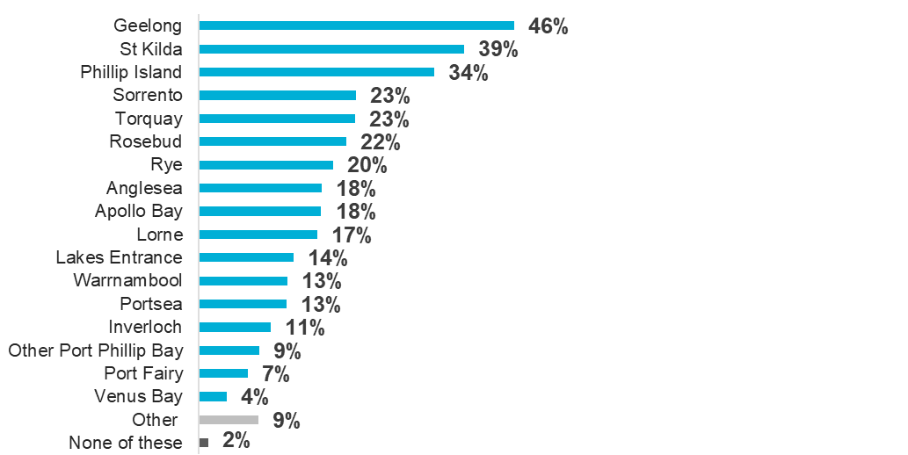
A second tier included established beachside towns such as Sorrento (23%), Torquay (23%), Rosebud (22%), and Rye (20%), followed by Anglesea (18%), Apollo Bay (18%) and Lorne (17%). Focus groups uncovered that people tend to choose destinations within easy driving distance from their homes, that still offer a genuine coastal feel. This pattern is consistent with findings from Wave 5.
“If we’re making a day of it, we want somewhere more peaceful. But if we’re looking for somewhere to stay for a few days it will probably be somewhere like Rye which has something to do at night.”
Coastal visitor

“Some beaches are almost like a surf beach, near Bells Beach and then you’ve got a caravan park. And then if you go around the bend towards Melbourne, there’s palm trees and picnic areas, and that’s really nice. It’s two different atmospheres.”
Coastal visitor

“An hour’s drive and you’re in Torquay. We definitely get down there or to Geelong quite a bit.”
Coastal resident

Coastal visitation – day trips

Over the past year, almost all Victorians who had visited the coast in the past 12 months, have taken a day trip to the coast (93%). Indicatively, this is higher than in Wave 5.
Figure 3. Average number of day trips to Victoria’s coastal areas in the past 12 months
Q10. How many trips have you made to coastal areas in Victoria in the past 12 months for…? (Open entry)
Base: Those who have visited coastal area in the past 12 months n=1,579
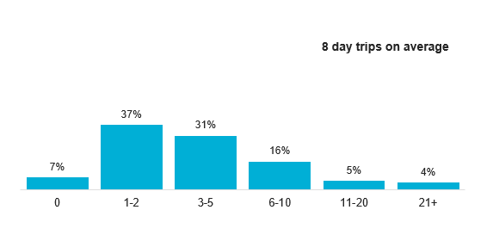

Victorians averaged 8 coastal day trips in the past year (Figure 3).

Figure 4. Average hours spent in a coastal area on a day trip
Q.11 On an average day trip, approximately how many hours do you spend in the coastal area? (Open entry)
Base: Those who did a day trip in the past 12 months n=1,475
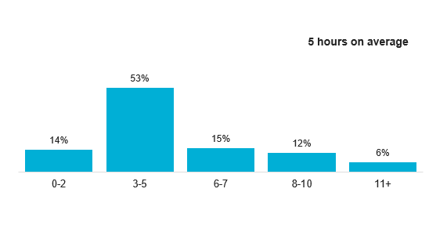
The average time spent on a day trip was 5 hours (Figure 4), and $159 was spent on each trip (Q11, not charted). This suggests Victorians are making a calculated trade-off between hours in the car and hours at the destination. Further exploration in focus groups uncovered that people calculated based on a ~9 hour day: 4 hours in the car (i.e. a 2-hour drive to the destination, and a 2-hour drive home, and 5 hours at the destination.
“If it’s a day trip, we want to keep [the travel] to be an hour and a half to two hours max. Because you know, for a return 4 hour trip you probably spend about that amount at the beach or less.”
Coastal visitor

“If I’m going for a day trip, I don’t just want to drive there and drive back because then there’s no time to relax. You wouldn’t get the relaxing portion.”
Coastal visitor

Figure 5. Average number of day trips by proximity of residence to the coast
Q10. How many trips have you made to coastal areas in Victoria in the past 12 months for…? (Open entry)
Base: <1km of the Victorian coast n=154, between1-5km of the coast n=296, between 5-10km of the coast n=304, 10+km from the coast n=794
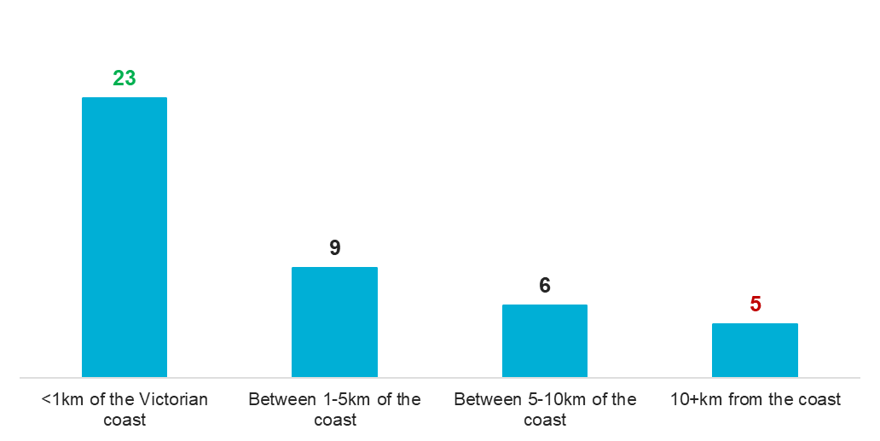
Those who live within 1km of the coast average 23 day trips a year, compared with just 5 day trips per year for those who live 10km or more away (
Figure 5). This indicates that when the coast is close, it is more likely to be part of everyday life, but distance makes it more of a dedicated occasion.

Coastal visitation – overnight trips

Seven in ten Victorians who had visited the coast in the past 12 months, took an overnight trip in the past 12 months. This is indicatively higher than in Wave 5.
Figure 6. Average number of overnight trips to Victoria’s coastal areas in the past 12 months
Q10. How many trips have you made to coastal areas in Victoria in the past 12 months for…? (Open entry) |
Base: Those who have visited coastal area in the past 12 months n= 1,579
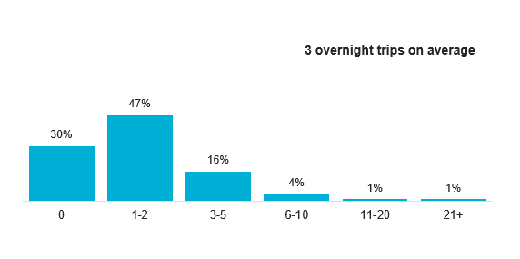
Victorians averaged 3 overnight coastal trips in the past year (Figure 6).
In the past year, Victorians averaged 3 overnight coastal trips, staying on average 5 nights (Figure 7) and spending around $519 each time (Q12, not charted).
Figure 7. Average number of nights spent on an overnight trip
Q.12 On an average overnight trip, approximately how many nights do you spend in the coastal area? (Open entry)
Base: Those did an overnight trip in the past 12 months n= 1,099
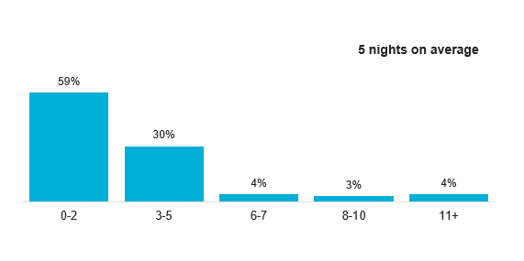
The longer duration and higher spend of overnight trips suggests that Victorians are choosing the coast as a significant holiday destination, as well as the quick escape that day trips satisfy. Relatively, day trips have more money spent ($159 per day), than overnight trips ($104 per day).

Who are Victorians visiting the coast with

Most Victorians visit the coast with a partner (65%). Friends (30%), and children (29%) are also common company. One in four (25%) go alone (Figure 8).
35% residents go alone, whereas only 21% of visitors go alone.
Figure 8. Company when visiting the coast
Q13. Who do you typically visit coastal areas in Victoria with? (Multiple response)
Base: Those who have visited a coastal area in the past 12 months n=1,579
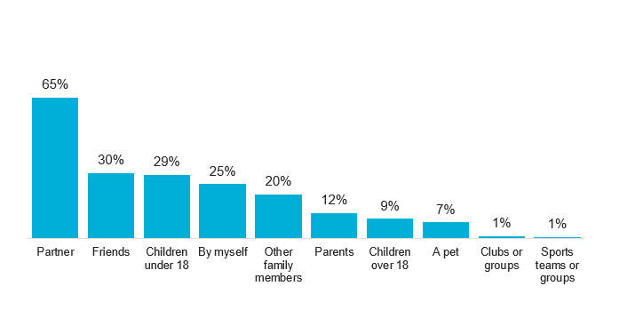
While the coast is primarily a shared experience, it also plays an important role as a place for personal time – particularly for residents.

“My wife and I, we just took a day off. There weren’t a lot of cars on the road, and it was a beautiful drive all the way [to George Bass coastal walk]. It’s a relaxing walk along the coast, and the scenery is just amazing. Because the two of us took a day off, the kids were at school. It was more relaxing, then afterwards we went into town to have brunch.”
Coastal visitor
“It’s normally me, and the kids. They’re older now, but they still like to come and get to the coast. Or sometimes, it’s just me. When I want to do certain hikes they might not come.”
Coastal visitor

“My husband and I are always going down there together. I mean I go by myself to, or with the dog. But my husband and I love walking down there in the evening.”
Coastal resident

Natural tourism

Decisions about visiting or living by Victoria’s coast vary with residential proximity to the coast, but some factors matter to all Victorians.
Visitors who live 10km or more from the coast
Visitors to the coast want natural beauty first, with just enough local amenities to feel comfortable without losing authenticity.
Figure 9. Importance of tourism and recreation activities, or natural beauty for visitors
Q29. When thinking about what is most important to you about Victoria’s marine and coastal environments, where would you place yourself on the below scale? (Single response)
Base: Those residing 10km+ from the coast n=1,102
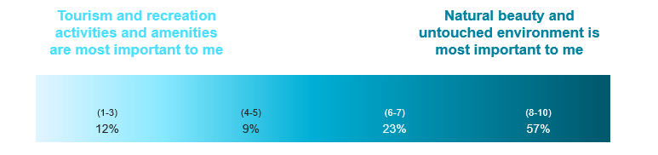
Almost six in ten (57%) visitors prioritised natural beauty, but recognised that essential amenities for comfort can compromise the ‘untouched’ feel (Figure 9). In focus groups, discussions uncovered that clean toilets and changing rooms (especially for families), plenty of rubbish bins, and nearby parking were essential amenities for visitors. Visitors also valued having a local fish and chip shop and ice cream shop within walking distance, though this was less critical in their decision to visit an area. These amenities mattered less for overnight stays, where visitors have their own base for food and facilities.
For visitors, who often described being drawn to the ‘charm’ of small coastal towns, certain changes in a coastal area were seen as off-putting. This involved the building of new housing developments, presence of chain restaurants or large chain supermarkets.
Smaller local stores were seen as acceptable, as visitors expressed a desire to support the community, rather than purchasing from big corporations they have ready access to in larger towns and near to their homes.
Ultimately, visitors want the coast to feel natural and unspoiled, but they still expect a base level of comfort. The challenge is providing these amenities while maintaining the look and feel of a small, coastal town.
“It’s whether you’ve got change rooms, like showers and all that, because obviously you don’t want kids to be screaming about a wet bottom all the way back.”
Coastal visitor

“I definitely tip towards the natural and the beauty, that’s what our coast is. But the reason I’m not right at the end is because I know I want toilets and car parks, and when I think of untouched environment, that means just a strip of sand with nothing else.”
Coastal visitor

“We want somewhere to get some food. Not like a Coles or a Woolies. A corner store, or a Foodworks is okay. I don’t want it to have the things I have at home. But I want it to have something small.”
Coastal visitor

Residents who live 1- 5km of the coast
Almost two in three (60%) residents viewed ‘natural beauty’ as most important in marine and coastal environments. Fewer (9%) viewed tourism and recreation activities and amenities as most important (Figure 10).
Figure 10. Importance of tourism and recreation activities, or natural beauty for residents within 1-5km of the coast
Q29. When thinking about what is most important to you about Victoria’s marine and coastal environments, where would you place yourself on the below scale? (Single response)
Base: Those residing 1-5km from the coast n=339
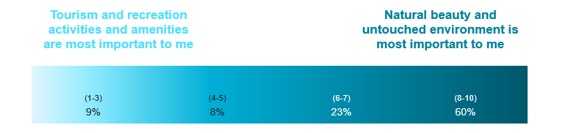

Residents were largely supportive of recreational tourism, as well as local businesses and even industrial developments. They viewed all of these as important to supporting the local community, and providing work and financial opportunities.

Residents who within 1km of the coast
Residents who live within 1km of the coast chose their home due to the proximity of the coast.
Figure 11. Importance of tourism and recreation activities, or natural beauty for residents within 1km of the coast
Q29. When thinking about what is most important to you about Victoria’s marine and coastal environments, where would you place yourself on the below scale? (Single response)
Base: Those residing within <1km from the coast n=166
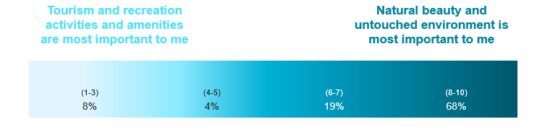
Over two in three (68%) residents living close to the coast saw ‘natural beauty’ as most important (Figure 11). While many chose their location for proximity to the water, they also want local services that support everyday life. They were supportive of tourism, local business and industry, provided these were well-regulated, and did not compromise the coastal experience.
This illustrates that while natural beauty is what close residents value most, they also see tourism, local business and even industry as important for supporting community jobs and the local economy. This means protecting the environment must go hand-in-hand with enabling sustainable economic activity.
“If it’s bringing you know, 100, 150, 500 new jobs, brilliant. Is it in the industrial estate or is it smack bang on the foreshore? Very different questions. Has it gone through the right checks and balances?”
Coastal resident

“Everyone keeps saying no, because they love Portland how it is. And I get that. But then they also complain there’s no money. And I’m not sure we can have both anymore.”
Coastal resident

Activities undertaken at coastal and marine environments

Most Victorians took part in relaxing, leisure-based activities when at the coast. These findings are consistent with Wave 5.
Figure 12. Activities undertaken over the past 12 months in coastal areas
Q15. Over the past 12 months, which of the following activities have you done in coastal areas / your local foreshore? Please select all that apply?
Base: Those who have visited a coastal area in the past 12 months, or live within 5km of the coast n=1,606
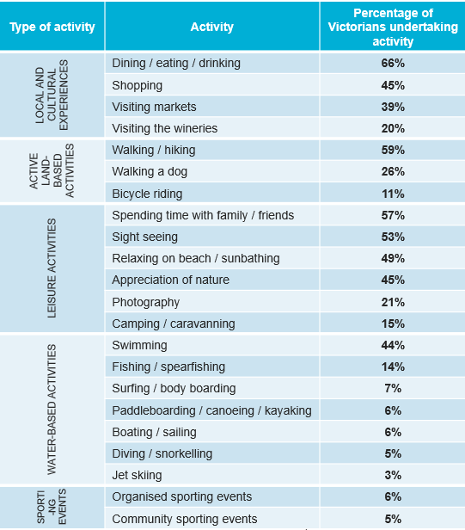

Residents were significantly more likely to have done the following activities, compared to visitors:
- Walking a dog (35% vs. 22%)
- Bicycle riding (17% vs. 8%)
- Surfing / body boarding (9% vs. 6%)
- Paddleboarding / canoeing / kayaking (9% vs. 5%)
- Organised sporting events (10% vs.4%)
- Community sporting events (8% vs. 3%)
Some Victorians sought higher-energy coastal activities (Figure 12), but this was more common among residents within 5km of the coast. Visitors were more likely to want immersion in nature, favouring slower-paced, low-energy activities.
“Walking bare feet in the water. Walking along the beach when it’s quiet. Looking at rock pools.”
Coastal visitor

“We just want to go for a walk, sit on the beach, watch the kids play in sand. I don’t want to run, I don’t want to do anything other than relax.”
Coastal visitor

Activities like paddle boarding, fishing, boating, etc. are thought to be adventurous rather than nature-based for visitors.
“Generally not for us. They sound more adventurous than nature [based] to me.”
Coastal visitor
This demonstrates that investments in higher-energy activities (e.g. paddle boarding, boating) are more relevant for local communities than for attracting visitors. Visitors require investment into slower-paced, quieter activities that support their immersion into nature.

Coastal experience

Figure 13. Satisfaction with coastal experience
Q20. Thinking about your overall experience while visiting coastal areas in Victoria over the past 12 months, how satisfied were you with your visit? (Single response)
Base: Those who have visited coastal area in the past 12 months n= 1,579
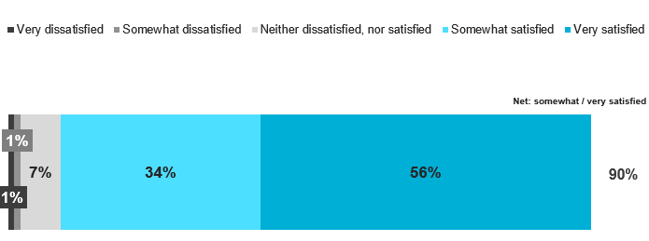
There were several significant differences in satisfaction:
- 18-24 year olds were less likely to be satisfied (83%)
- Women were more likely to be satisfied (93% vs. 88% of men)
- Those with children under 18 were more likely to be satisfied (92% vs. 89% of those without children under 18)
- Those with household incomes of $125k-$175k were more likely to be satisfied (94%)

The coastal and marine experience delivers strongly, with nine in ten (90%) Victorians left satisfied with their coastal visits over the past 12 months.
Satisfaction was driven by the beauty of the coastal and marine environment, which was often connected to a lack of visible litter/rubbish.
It was also driven by a chance to enjoy a day out spending time with loved ones, appreciating the scenery, and relaxing in nature (Figure 14). Maintaining a clean, scenic environment is key to sustaining positive experiences. These drivers of satisfaction were consistent with the findings from Wave 5.

Figure 14. Top 5 reasons for satisfaction with coastal experience
Q21. What was it that made you feel [satisfied / dissatisfied]? Note: This question was an open-ended question with key themes coded.
Base: Those who were satisfied with their coastal visit n=1,427
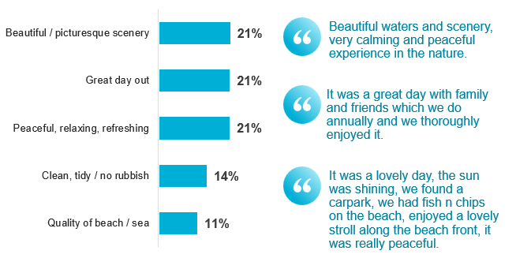
Only 2% were dissatisfied with their experience, suggesting that the below reasons for dissatisfaction are not widespread experiences.
Figure 15. Top 5 reasons for dissatisfaction with coastal experience
Q21. What was it that made you feel [satisfied / dissatisfied]? Note: This question was an open-ended question with key themes coded.
Base: Those who were dissatisfied with their coastal visit n=32
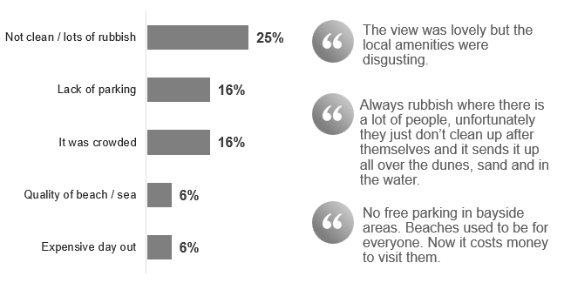
Dissatisfaction stemmed from elements that people thought of as critical and not being met (e.g. cleanliness, availability of parking) (Figure 15). Therefore, while satisfaction is extremely high, getting the essentials right is critical to creating positive coastal experiences.

Importance of, and satisfaction with individual aspects of the experience

Positively, four of the five aspects considered to be important also had the highest level of satisfaction, the exception being toilets / showers.
Figure 16. Importance x Satisfaction of individual aspects of the coastal experience
Q22. When deciding which coastal area in Victoria to visit, how important are each of the following aspects in your decision? (Single response per attribute) | Q23. And thinking about all your visits to coastal areas in Victoria over the past 12 months, how satisfied were you with each of the following aspects? (Single response per attribute)
Base: Those who have visited coastal area in the past 12 months n= 1,579
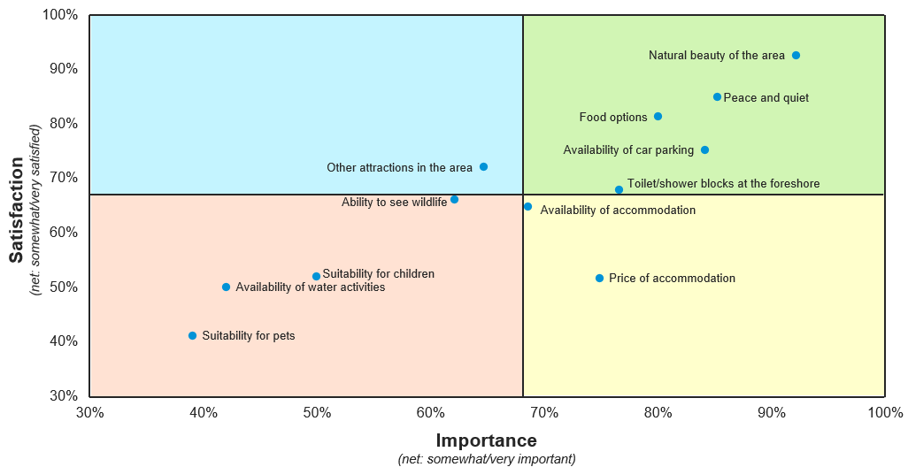
The top 5 most important individual aspects of the coastal experience were:
- Natural beauty of the area (92%)
- Peace and quiet (85%)
- Availability of car parking (84%)
- Food options (80%)
- Toilets / shower blocks at the foreshore (76%)
Least importance aspects were:
- Suitability for pets (40%)
- Suitability for children (30%)
- Availability of water activities (28%)
- Availability of accommodation (13%)
- Ability to see wildlife (12%)
Elements with highest satisfaction were:
- Natural beauty of the area (93%)
- Peace and quiet (85%)
- Food options (81%)
- Availability of car parking (75%)
- Other attractions in the area (72%)
Elements with greatest dissatisfaction were:
- Price of accommodation (10%)
- Availability of car parking (8%)
- Toilets / shower blocks at the foreshore (7%)
- Ability to see wildlife (4%)
- Food options (4%)
Car parking showed the high satisfaction and notable dissatisfaction, suggesting an inconsistent experience. That was often driven by paid parking and busy beaches. Toilets/showers were critical but only mid-range on satisfaction, making them a clear opportunity for improvement and to encourage repeat visitation (Figure 16).
Ultimately, unlocking high satisfaction in each of the top 5 most important areas will lead to the greatest experience for the broadest number of Victorians.
“The best day for us is when it’s an easy drive. A short walk from the car so we don’t have to lug all of our stuff. There’s only a few other people around. We can grab fish and chips for lunch, get an ice cream on the way home. And have an easy drive back. That’s a great day.”
Coastal visitor

“It’s frustrating when you can’t get a park. When it’s all full, then you can’t go, you can’t visit. And I hate paying for parking, why am I paying for something that we should be able to access for free? I try to avoid those beaches.”
Coastal visitor

“I don’t care about tourists coming if there were enough bins for people to put rubbish in, if there are enough facilities, if there’s no dog poo. Every time you go down to the local beaches after a hot day in summer, there are tourists who very clearly have left rubbish. And they leave things like gazebos, chairs, paddleboards, like all over the beach. Come tourists, fine, but the cleanliness needs to maintain.”
Coastal resident

Likelihood to visit the coast or marine environment

The coast remains firmly in Victorians’ future plans, with four in five expecting to visit in the year ahead. Only 6% of Victorians said they are unlikely to do so (Figure 17).

Figure 17. Likelihood to visit any coastal area in Victoria in the next 12 months
Q24. How likely are you to visit any coastal area (e.g. beach, bay or ocean) in Victoria in the next 12 months? (Single response)
Base: Total respondents n=2,000
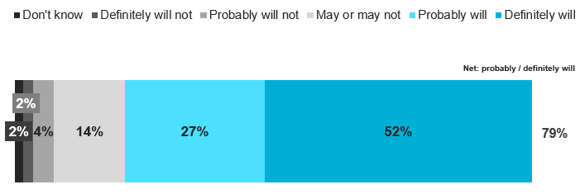

There were several significant differences in likelihood to visit the coast in the next 12 months:
- 50-59 year olds were more likely to visit (87%), whereas 70+ year olds were less likely (66%)
- Residents were more likely to visit the coast (84% vs. 77% of visitors)
- Those who had visited the coast in the past 12 months were more likely to visit again (89% vs. 39% of those who had not visited the coast in the last 12 months)
- Those with children under 18 were more likely to visit (86% vs. 75% of those who did not have children under 18)
- Those with higher household incomes ($125k+) were more likely to visit (87% vs. 64% of those with a household income of less than $50k)
Driving more frequent coastal visits relies on demonstrating affordability (Figure 18 and Figure 19).
Figure 18. Top 5 factors that could make those likely to revisit, stay longer or visit more frequently
Q26. Aside from the weather and having more time available, what would make you stay longer or visit Victoria’s coastal areas more frequently? Note: This question was an open-ended question with key themes coded.
Base: People likely to re-visit the coast in the next 12 months n=1,571
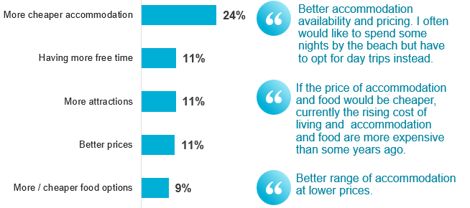

Quantum’s AustraliaNow highlights that when Victorians feel financially constrained, they focus spending on essentials like mortgage/rent payments, utilities, and groceries. In turn, they cut back on discretionary items such as travel. If the core costs of a coastal trip (accommodation, parking, food) cannot be reduced, the overall value and affordability need to be communicated.
If affordability isn’t addressed, many Victorians will visit less often. But by showcasing the coast as an accessible, good-value option, then even during times of financial pressure visitation can be maintained and encouraged.
“Long trips are harder. They’re so expensive, particularly with accommodation. So we’re trying to find other ways to do it.”
Coastal visitor

“The diversity of accommodation options [is important]. Affordable caravan parks, campgrounds etc.”
Coastal visitor

“I feel lucky I’ve lived here so long. I get to walk to the water all the time. I know many others aren’t going to get that chance now.”
Coastal resident

Figure 19. Top 5 factors that could encourage visitation among those unlikely to visit in the next 12 months
Q25. What could encourage you to visit a coastal area (e.g. beach, bay or ocean) in Victoria in the next 12 months? Note: This question was an open-ended question with key themes coded.
Base: People unlikely to re-visit the coast in the next 12 months n=119

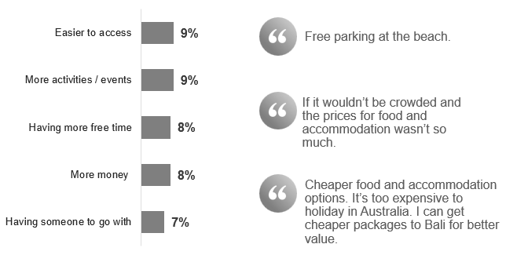

Page Break

Attitudes towards, and concerns about, Victoria’s coastal environment
How Victorians feel about the coastal environment, and their awareness and understanding of environmental concerns and impacts.

Attitudes towards, and concerns about, Victoria’s coastal environment
- The majority of Victorians agree coastal and marine environments are the state's most important natural feature.
- Seven in ten Victorians agree more must be done to help coastal and marine environments adapt to climate change.
- However, awareness of specific environmental issues were limited, with visible impacts such as litter/microplastics viewed as the most important issue to address.

Coastal attitudes
Victorians value both the natural and recreational aspects of the coast. Three in four Victorians agreed that ‘coastal and marine environments are Victoria’s most important natural feature’ (75%), while two in three agreed that ‘being able to use Victoria’s coastal and marine environment for recreational activities is just as important as enjoyment of the natural environment’ (64%) (Figure 20).
Figure 20. Agreement with key coastal attitudes
Q27. To what extent do you agree with the following statements? (Single response per attribute) Note: Data labels <5% not shown.
Base: Total respondents n=2,000
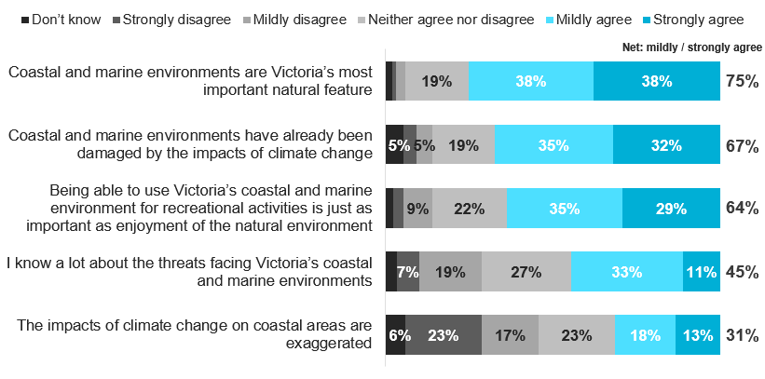
These results suggest overlap, with many Victorians valuing both pristine environments and recreational opportunities highlighting the need for both to fit harmoniously together.

Importance of coastal and marine functions

This overlap seen in Figure 20 was reflected in aspects Victorians rated as the most important functions of Victoria’s marine and coastal environment.
‘Providing a habitat for coastal and marine flora and fauna’ was rated as most important (by 59% of respondents), and this was closely followed by ‘providing a place for people to spend leisure time such as walking and holidaying’ (54%) (Figure 21). This pattern of results is indicatively consistent with Wave 5.
Figure 21. Coastal and marine functions viewed as important (‘very important’)
Q28. How important are each of the following aspects of Victoria’s marine and coastal environments to you personally? (Single response per attribute)
Base: Total respondents n=2,000
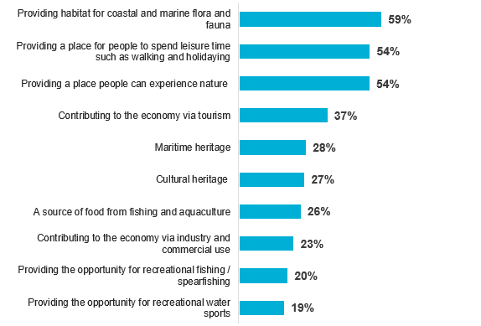
Notably though, it was the more ‘leisure based’ activities that were of higher importance to Victorians, with the higher-energy activities like water sports, recreational fishing etc. lower down in terms of personal importance. This aligns with commonly mentioned reasons why the coast is currently used.
There were several significant differences in perceived importance of coastal and marine functions:
- Those aged 18-24 were significantly less likely to think almost all functions were very important, compared to those aged 50+
- Gendered differences are shown in the following table

Importance of coastal and marine function | Women | Men
Providing habitat for coastal and marine flora and fauna | 52% | 65%
Providing a place for people to spend leisure time such as walking and holidaying | 49% | 59%
Providing a place people can experience nature (including coastal views) | 48% | 59%
Contributing to the economy via tourism | 36% | 37%
Maritime heritage | 27% | 29%
Cultural heritage | 24% | 31%
A source of food from fishing and aquaculture | 28% | 23%
Contributing to the economy via industry and commercial use | 24% | 21%
Providing the opportunity for recreational fishing / spearfishing | 23% | 18%
Providing the opportunity for recreational water sports | 21% | 17%

Issues and concerns
Environmental concerns among Victorians are largely limited to what they can see.
Victorians have limited awareness and perceived importance of coastal and marine environmental issues. Pollution was the main concern raised (indicatively comparable to Wave 5), but few saw broader risks as relevant to them unless they lived in areas directly affected by climate impacts (e.g. McCrae) or right on the coast.
“Plastic and rubbish is a big one. Those places where everyone actually takes their rubbish away with them, they just seem to still be how they were years ago.”
Coastal resident

“But [coastal erosion]’s not a huge concern for me. I don’t live right on the beach and it’s kind of the ultra-wealthy who do. And it’s a bit like, oh well that is kind of their problem.”
Coastal resident
Pollution remains the strongest perceived threat, with four in ten Victorians believing it to have the highest impact on the coastal and marine environment.
Figure 22. Perceived ‘very high impact’ of aspects on Victoria’s marine and coastal environment
Q30. How much impact do you believe each of the following are on Victoria’s marine and coastal environment? (Single response per attribute)
Base: Total respondents n=2,000
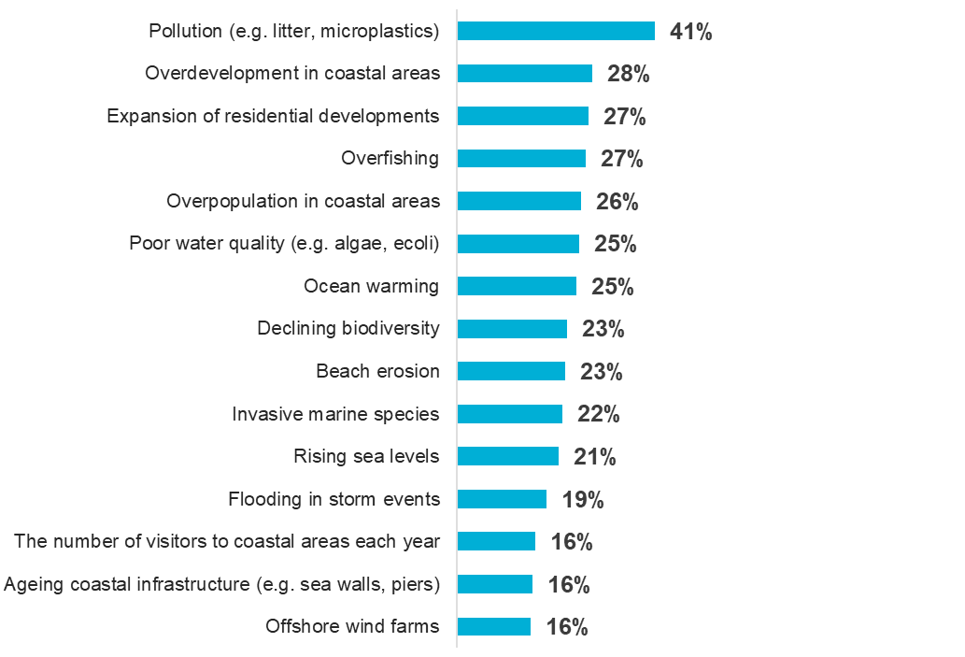
Pollution likely stands out as it is the most familiar, the most understood, and the most visible to Victorians in their everyday lives.
All other environmental concerns are clustered together (Figure 23), with only minor differences in perceived impact. This suggests Victorians lack the depth of understanding needed to distinguish the severity of different issues, instead, they hold a generalised sense that everything is equally bad.
Women were more likely to agree that all issues, except offshore wind farms, would have a ‘very high impact’ compared to men.
“Rubbish and plastic in the water. It makes it all yuck, and it would be bad for the fish too.”
Coastal resident

What Victorians view as most important to address, mirrors what they view as most damaging to the coast and marine environment.
Figure 23. Perceived importance of addressing each issue
Q31. Which of these issues do you believe are most important to address to protect Victoria’s marine and coastal environment? Note: Could select up to 3 issues
Base: Total respondents n=2,000
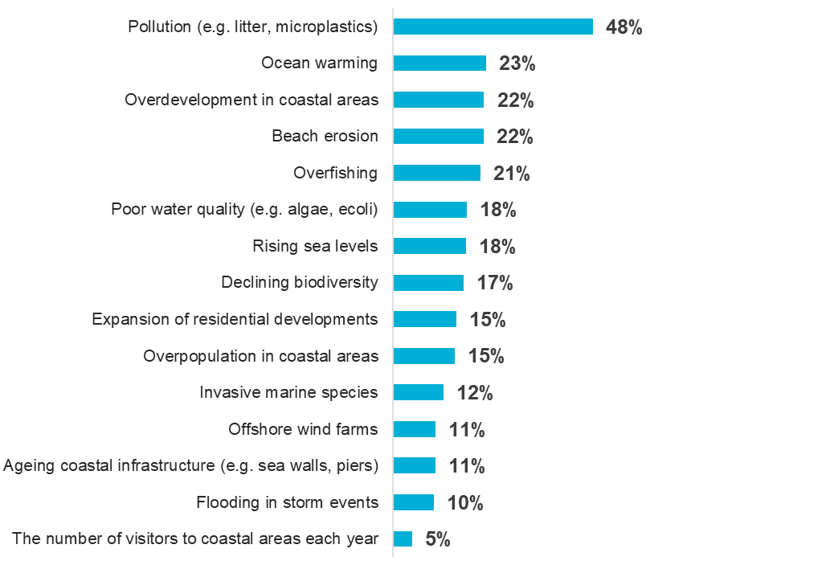
Victorians saw pollution (e.g. litter, microplastics) as the most important issue to address (Figure 23), likely because it is top of mind, highly visible, and directly impacts their everyday coastal experience, whereas they don’t see the other factors in the same way.
Residents who lived within 1km of the coast placed significantly greater importance on ocean warming (30%) and beach erosion (29%) than other Victorians.

Visitation and awareness of Marine Protected Areas (MPAs)

Almost half of recent coastal visitors had been to a Marine Protected Area (MPA), even if they didn’t realise it.
Figure 24. Prompted awareness of visiting a MPA
Q18. Below is a map of Marine Protected Areas in Victoria. In the past 12 months, have you visited any of these Marine Protected Areas (MPAs)? (Single response)
Base: Those who have visited coastal area in the past 12 months n= 1,579
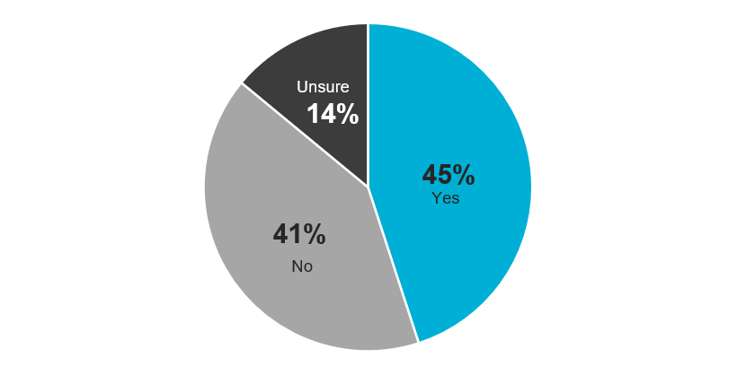
41% of Victorians had not visited a MPA in the past year (Figure 24). Of those who had (45%), over half (52%) were unaware they had done so (Figure 25).
While in Wave 5, 71% of Victorians said they were aware of MPAs and Marine Sanctuaries, this current data highlighted that most don’t realise when they have actually visited one. This shows that awareness is superficial, and true understanding of MPAs is low.
Figure 25. Previous knowledge that they had visited a MPA
Q19. Before today, did you know that where you visited was a Marine Protected Area? (Single response)
Base: Those who had visited a MPA n= 714
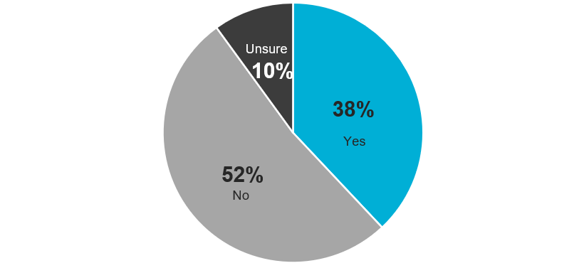

Support for methods to adapt to environmental challenges

A combination of prevention and policy/planning methods are thought to be most effective in helping coastal and marine environments adapt to environmental challenges.
Figure 26. Support of methods to adapt to environmental concerns
Q32. To what extent do you support or oppose each of the following ways of adapting to these challenges? (Single response per attribute) Note: Data labels <5% not shown.
Base: Total respondents n=2,000
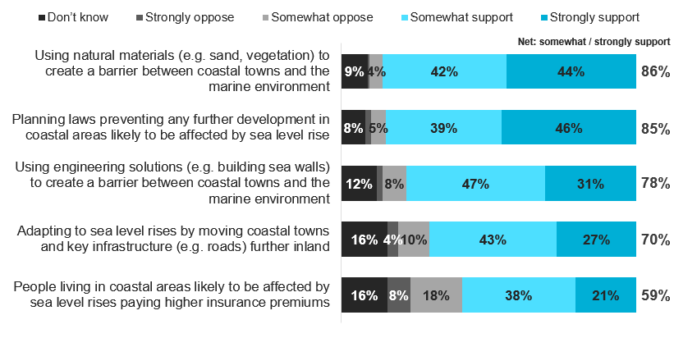
Sea walls and planning laws had the strongest support (Figure 26). Most Victorians (70%) also backed moving coastal towns inland, though many questioned its practicality. Visitors were more supportive than residents of all solutions except ‘using engineering solutions’.
Victorians were sceptical that policy and planning alone would work, fearing big organisations or wealthy individuals could bypass them. They saw physical measures like sea walls as an important backup if policies failed to deliver.
“I think organisations will just get around it. It’s still worth doing, make their lives difficult because we’ll lose 10%, 20% of the ones that don’t want to try. But you’re right, money does kind of buy whatever you want, unfortunately.”
Coastal resident

“Sea walls feel like they’ll actually protect the communities. It’s a physical barrier.”
Coastal visitor

Planning and management of Victoria’s coastal environment
How Victorians view potential planning opportunities

Planning and management of Victoria’s coastal environment
How Victorians view potential planning opportunities
Page Break

Planning and management of Victoria’s coastal environment
- The majority of Victorians felt that more needs to be done to help marine and coastal environments adapt to the impacts of climate change.
- Victorians believe that state, local and federal government should all have responsibility for managing coastal adaptation.
- Most Victorians are supportive of coastal and marine environments being used for tourism activities, and around half are supportive of commercial and industrial activities.
- Support for housing developments is limited, as they are thought to negatively impact the character and ‘charm’ of coastal areas.

Perceptions of management

Seven in ten (72%) Victorians agreed that ‘more must be done to help Victoria’s marine and coastal environments adapt to the impacts of climate change’. Just 6% of Victorians disagreed with that statement (Figure 27).
Figure 27. Perceptions of management of Victoria’s coastal and marine environments
Q33. To what extent do you agree or disagree with the following statements? (Single response per attribute) Note: Data labels <5% not shown.
Base: Total respondents n=2,000
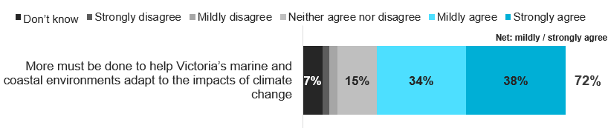
This, together with the importance people place on Victoria’s coastal and marine environment as an essential part of Victoria’s landscape, indicates that there is license among the Victorian community for action to be taken to protect Victoria’s coasts.
“I’m not sure what is being done really. I’m sure something is, but I can’t tell you what. I can’t tell you if it’s enough.”
Coastal visitor

“Our coast is so important. It’s why we live here. We have to look after it.”
Coastal resident

Around half of Victorians agreed that Victoria’s coast and marine environments are well managed (48% and 44% agreed, respectively). Indicatively, this is lower than in Wave 5. A third (35%) agreed that coastal and marine managers are doing enough to manage risks to those environments (Figure 28).
Figure 28. Perceptions of management of Victoria’s coastal and marine environments
Q33. To what extent do you agree or disagree with the following statements? (Single response per attribute) Note: Data labels <5% not shown.
Base: Total respondents n=2,000
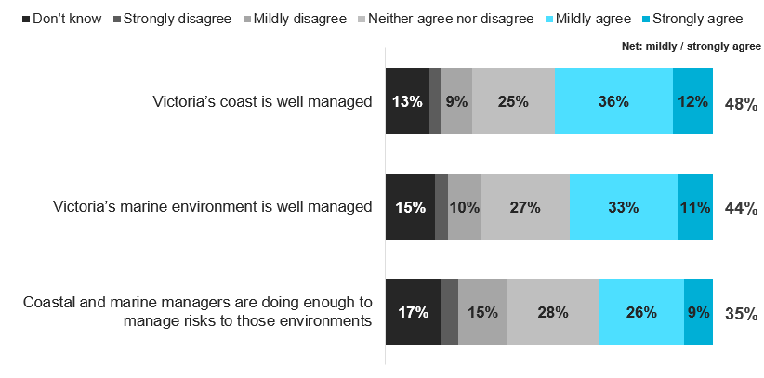
However, a relatively low proportion of Victorians actively disagreed with those statements. Around one in eight disagreed the coast and the marine environment are well managed (13% and 14%, respectively), and two in ten (20%) disagreed that coastal and marine managers are doing enough.
Rather, a large proportion answered these questions with either a ‘don’t know’ or a neutral response. This indicates that a large proportion of Victorians did not feel they knew enough about the management of coastal and marine environments to provide an informed response to these statements.

There were several significant differences in agreement:
- Those aged 25-29 were significantly more likely to agree with all statements.
- Those aged 30-39 were significantly more likely to agree with all statements except ‘coastal and marine managers are doing enough to manage risk to those environments’
- Men were significantly more likely to agree with every statement except ‘more must be done to help Victoria’s marine and coastal environments to adapt to climate change’ compared to women
- Those living in metropolitan areas were significantly more likely to agree with all statements compared to those in rural areas, except ‘coastal and marine managers are doing enough to manage risk to those environments’
- Residents were more likely to agree with statements than visitors, with the exception of ‘more must be done to help Victoria’s marine and coastal environments to adapt to climate change’ and ‘local communities generally have enough say…’
- Households with incomes of $125k+ were more likely to agree with all statements compared to households with incomes under $50,000

Belief in responsibility to manage

Victorians saw the responsibility of helping communities and systems adapt to changes in Victoria’s marine and coastal environment as being shared across multiple entities.
Figure 29. Who is believed to be responsible for helping communities adapt to concerns for coastal and marine environments
Q34. Who do you believe should be responsible for helping communities and systems adapt to changes in Victoria’s marine and coastal environments caused by climate change, population growth and tourism? (Multiple response)
Base: Total respondents n=2,000
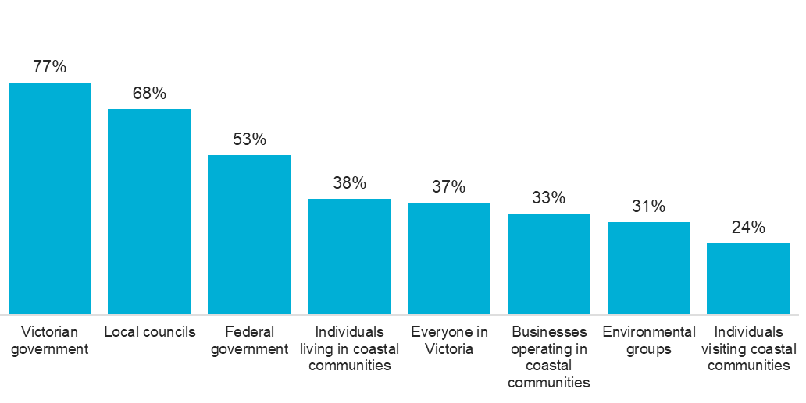
On average, survey respondents selected four of the answer options provided at this question. There were no differences in responses between residents and visitors.
The most commonly selected response was the Victorian government, followed by local councils and the federal government, with more than half of Victorians selecting those organisations as being responsible (Figure 29). This indicates that Victorians expect to see and hear about actions being taken by local, state and federal governments.

Support of usage of coastal and marine environments

The majority of Victorians supported Victoria’s marine and coastal environment being used for protected areas for marine animals and plants. In fact, six in ten strongly supported this use.
Figure 30. Support for usages of Victoria’s marine and coastal environment
Q35. To what extent do you support or oppose Victoria’s marine and coastal environment being used in the following ways? (Single response per attribute)
Base: Total respondents n=2,000
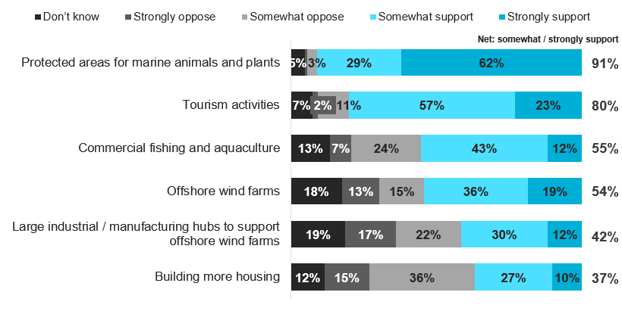
The next most supported use of the coast was for tourism activities. Although eight in ten (80%) either somewhat or strongly supported this use, only around two in ten (23%) strongly supported this activity – much lower than the strength of support for protecting the marine animals and plants (Figure 30).
Commercial and industrial activities had lower levels of support, and higher levels of opposition. However, almost one in five Victorians said they ‘don’t know’ whether they supported or opposed offshore wind farms and large industrial/manufacturing hubs to support offshore wind farms, suggesting that some Victorians have limited knowledge of what these activities involve and their impact on coastal areas, in order to make an informed decision.
Support for activities did not differ by how close Victorians live to the coast. However, Victorian residents were significantly more likely to oppose commercial fishing and aquaculture (38% opposed this activity, compared to 29% visitors), and tourism activities (16% opposed this, compared to 11% of visitors).
Overall, areas with weakest support, and highest opposition were:
- Commercial fishing and aquaculture (55% support, 31% oppose)
- Large industrial / manufacturing hubs to support offshore wind farms (42% support, 40% oppose)
- Building more housing (37% support, 52% oppose)
Opposition to new housing depended on style, scale, and proximity to the coast. Both residents and visitors opposed developments that lacked individuality or clashed with local character, but were more accepting if homes retained the ‘charm’ of coastal communities. Large-scale, uniform developments signalled suburban sprawl, making visitors feel they were in ‘just another suburb’ rather than a true coastal town.
“Housing estates. I really hate housing estates. I think they completely and utterly obliterate coastal communities. We’ve just had our first [brand] showroom installed down here, it’s always a bad sign.”
Coastal resident

“How much housing development has started around the coastal town. Once you see that start taking off, you know it’s changing into something else. It’s just becoming more of a suburban kind of vibe.”
Coastal visitor

“I mean it’s great if you see wildlife when you’re there. It’s their home first and foremost, that’s what the area is meant to be,”
Coastal visitor

Appendix

Methodology
The research was comprised of a quantitative online survey and explorative qualitative phase. The qualitative research was used to further elaborate the robust, quantitative findings, with these findings woven together in the report. The methodology used in each phase is summarised below.  Quantitative online survey  In collaboration with VMaCC, Quantum Market Research designed a bespoke quantitative survey to explore usage, sentiment, attitudes, and concerns about the Victorian coast and marine environment.  Prior to the survey being delivered to Victorians, five cognitive testing interviews were conducted to ensure the questionnaire was clear and answerable for everyday Victorians.  To reduce respondent fatigue and maintain high quality data, the survey was designed to take no longer than 15 minutes on average to complete; the average survey completion time was 14 minutes. Fieldwork was conducted between 6th – 21st August 2025.  The total sample size was n=2,000 Victorians. Interlocking age and gender quotas were applied over location (metropolitan/regional), ensuring a state representative sample in terms of age, gender and location (as defined by ABS census data).The data was then weighted to the same quotas to ensure state representation.  Where significance testing has been shown, results are significant at the 95% significance level of confidence.  Where possible, indicative results to Wave 5 have been highlighted in the report, noting this data is not directly comparable. | Qualitative explorative phase  The qualitative component of this study involved four online focus groups to further discuss attitudes, behaviours and concerns about the Victorian costal and marine environment.  Each focus group ran for 90 minutes, and was conducted online to ensure a geographical spread of Victorians were included. A total of n=24 Victorians participated. This was comprised of:  - n=12 Victorians who live within 5km of the coast  - n=12 Victorians who live 10km+ from the coast, but who have visited a coastal region in the past 12 months  Focus group participants were recruited on the basis of meeting specific demographic criteria (age, gender, location, etc), in order to ensure a good cross-section of Victorians were represented in the groups. Further detail on sample breakdown can be found in the ‘Sampling and Recruitment’ section.  Topics covered in the discussion guide arose from topline findings from the quantitative survey. Key topics in the discussion guide covered usage and behaviours of the coast, awareness and understanding of climate and sustainability issues impacting the coast, and a specific deep dive for residents, and a specific deep dive for visitors.  The project was carried out in line with the Market Research International Standard, ISO 20252.

Sampling and Recruitment

Quantitative sample frame
The online sample was sourced by PureProfile, an ISO-accredited online panel partner.
Triple interlocking quotas on age, gender and location (metropolitan vs. regional areas) were applied, to ensure that the profile of those invited to complete the survey was representative of the Victorian population on those factors.
 | Target quotas |  |  |  |  | Quotas achieved
Age | Metro |  | Regional |  | Total | Metro |  |  | Regional |  |  |  |  | Total
Age | Male | Female | Male | Female | Total | Male | Female | Non-binary/other | Male | Female |  | Non-binary/other |  | Total
18-24 | 88 | 84 | 23 | 21 | 216 | 87 | 84 | 1 | 15 |  | 21 |  | 0 | 208
25-29 | 75 | 75 | 18 | 18 | 186 | 75 | 75 | 0 | 18 |  | 18 |  | 0 | 186
30-39 | 153 | 160 | 35 | 37 | 385 | 153 | 160 | 0 | 34 |  | 37 |  | 1 | 385
40-49 | 127 | 133 | 35 | 37 | 332 | 127 | 133 | 0 | 35 |  | 38 |  | 0 | 333
50-59 | 112 | 119 | 39 | 42 | 312 | 114 | 120 | 0 | 39 |  | 43 |  | 0 | 316
60-69 | 87 | 96 | 41 | 43 | 267 | 88 | 96 | 0 | 42 |  | 44 |  | 0 | 270
70+ | 92 | 114 | 45 | 51 | 302 | 92 | 114 | 0 | 45 |  | 51 |  | 0 | 302
Total | 734 | 781 | 236 | 249 | 2000 | 736 | 782 | 1 | 228 |  | 252 |  | 1 | 2000

Note: At the last census (2021) ABS did not publish figures for non-binary / other gender, so it was not possible to set quotas on this group.
The sampling for this survey met almost all the quotas that were set to achieve a representative sample across Victoria. However, online panels tend to have less representation of younger, male and regional areas, and so the quota for regional males aged 18-24 was not met.
The data has been weighted by age, gender and region to adjust any discrepancies and ensure that findings are adequately representative of the Victorian population. When weighting the data, non-binary / other respondents were assigned a weight of 1 for gender, and the remainder of the sample was weighted to ABS statistics.
Once the final sample had been weighted, the proportion of respondents in each region, gender and age group was reflective of the total population of Victoria, as shown in the table below.
Age | Metro |  |  | Regional |  |  | Total
Age | Male | Female | Non-binary/ other | Male | Female | Non-binary/ other | Total
18-24 | 4.38% | 4.18% | 0.05% | 1.15% | 1.05% | 0.00% | 10.80%
25-29 | 3.75% | 3.75% | 0.00% | 0.90% | 0.90% | 0.00% | 9.30%
30-39 | 7.65% | 8.00% | 0.00% | 1.73% | 1.83% | 0.05% | 19.25%
40-49 | 6.35% | 6.65% | 0.00% | 1.75% | 1.85% | 0.00% | 16.60%
50-59 | 5.60% | 5.95% | 0.00% | 1.95% | 2.10% | 0.00% | 15.60%
60-69 | 4.35% | 4.80% | 0.00% | 2.05% | 2.15% | 0.00% | 13.35%
70+ | 4.60% | 5.70% | 0.00% | 2.25% | 2.55% | 0.00% | 15.10%
Total | 36.68% | 39.03% | 0.05% | 11.78% | 12.43% | 0.05% | 100.00%

The breakdown of demographic of the total n=2,000 Victorians can be seen below:
Sub-Group | % of respondents | Base size  (n=) |  | Sub-Group | % of respondents |  |  | Base size  (n=)
GENDER |  |  |  | HOUSEHOLD INCOME
Male | 48% | 964 |  | <$25k |  | 5% | 90
Female | 51% | 1,034 |  | $25k-$49.9k |  | 14% | 287
Non-binary | <1% | 2 |  | $50k-$74.9k |  | 13% | 257
 |  |  |  | $75k-$99.9k |  | 14% | 280
AGE |  |  |  | $100k-$124.9k | 11% |  |  | 223
18-24 | 11% | 208 |  | $125k-$149.9k |  | 10% | 192
25-29 | 9% | 186 |  | $150k-$174.9k |  | 6% | 124
30-39 | 19% | 385 |  | $175k-$199.9k |  | 6% | 113
40-49 | 17% | 333 |  | $200k+ |  | 9% | 175
50-59 | 16% | 316 |  | Not sure / prefer not to say |  | 13% | 259
60-69 | 13% | 270
70+ | 15% | 302 |  | ABORIGINAL AND/OR TORRES STRAIT ISLANDER
 |  |  |  | Yes | 2% |  |  | 37
LOCATION |  |  |  | No | 96% |  |  | 1,930
Metropolitan | 76% | 1,519 |  | Prefer not to answer |  | 2% | 33
Regional | 24% | 481
 |  |  |  | SPEAK A LANGUAGE OTHER THAN ENGLISH AT HOME
PROXIMITY OF HOME TO COAST |  |  |  | Yes (CALD) | 15% |  |  | 302
Within 1km | 8% | 166 |  | No |  | 85% | 1,698
Between 1-5km | 17% | 339
Between 5-10km | 17% | 333 |  | COUNTRY OF BIRTH
More than 10km | 55% | 1,102 |  | Australia |  | 78% | 1,551
 |  |  |  | Other country | 22% |  |  | 449
HOUSEHOLDS WITH CHILDREN
Have children under 18 at home | 30% | 603
Do not have children under 18 at home | 70% | 1,397

The maximum margin of error (at the 95% confidence interval) on the total sample size is +/-2.2%. This means that there is high confidence that if a survey result is 50%, the actual result seen if the whole population of Victoria were surveyed would lie between 47.8% and 52.2%.
The overall sample size, application of triple interlocking quotas, and high-quality sample source ensures that the research study is large, robust, and representative of Victoria.

Qualitative recruitment
Professional recruiters, Research Connections, were engaged to recruit participants for the focus groups. Participants were sourced via a panel of Victorian residents who expressed interest in participating in the qualitative research. The groups consisted of members of the public and were made up of the below. Important to note that the exclusion of the suburbs outlined below was due to these areas often being chosen for their proximity to the city rather than for coastal reasons, meaning their inclusion may not reflect the same drivers and experiences as other coastal communities.
Residents
- Locations
  - Maximum of 2 people from the Great Ocean Road region
  - Maximum of 2 people from the Mornington Peninsula region
  - Excluding residents of:
    - Bayside City Council
    - Port Phillip Council
    - City of Hobsons Bay
    - Geelong & inner areas + western & northern areas of City of Greater Geelong (e.g. Geelong, Geelong West, East Geelong, South Geelong, North Geelong, Drumcondra, and Newtown, Lara, Corio, Norlane, North Shore, and Whittington)
- Within each group, a mixture of:
  - Age
  - Gender
  - Location (in line with the above)
  - Households with / without children
Visitors
- Locations
  - Excluding people who had only visited:
    - Bayside City Council
    - Port Phillip Council
    - City of Hobsons Bay
    - Geelong & inner areas + western & northern areas of City of Greater Geelong (e.g. Geelong, Geelong West, East Geelong, South Geelong, North Geelong, Drumcondra, and Newtown, Lara, Corio, Norlane, North Shore, and Whittington)
- Within each group, a mixture of:
  - Age
  - Gender
  - Location
  - Households with / without children
  - Reasons for visiting the coast
  - Intention to re-visit and not re-visit the coast

Marine and Coastal Council – https://www.marineandcoastalcouncil.vic.gov.au/victorias-coast-and-marine-areas/learn-about-victorias-coast-and-marine-environments
AustraliaNow is Quantum Market Research’s national monthly sentiment and cultural trends tracker

