Cape to Cape Resilience Project
FACTSHEET 4 Coastal models

This fact sheet provides a summary of how we can use coastal models and measurements to understand natural coastal processes and the suitability of different adaptation options.
We recommend reading Factsheet #3 Coastal processes and hazards before reading this factsheet

Improving our understanding of coastal processes and hazards
Having a better understanding of coastal processes and expected changes in climate allows us to be better informed to make decisions and plan for the future.
Using the best available science and evidence-based understanding provides more certainty in the decisions we are making.
We can increase our understanding of these natural processes though monitoring and modelling.

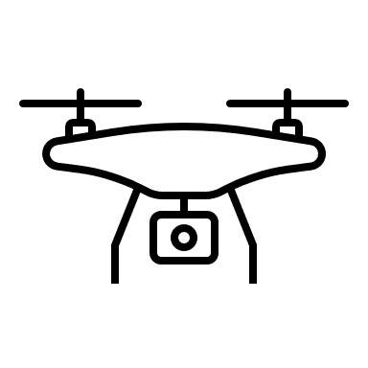 | Monitoring  Monitoring of wind, water levels, waves and climate patterns, along with shoreline changes, helps us understand relationships between these factors and the changes we see on our coast (i.e. drivers of change, trends, fluctuations, seasonality).  This can include using data collected from buoys, gauges, weather stations, site visits, and field, aerial or drone surveys.
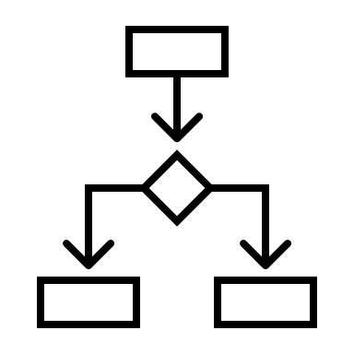 | Modelling  A model, which can be a physical or computer model, is a simplified replica of real-world processes and a tool we can use to test what changes we might see in the future under different scenarios. Models rely on good quality monitoring data.

What is a coastal model?
Models come in many shapes, sizes and types. A coastal model is a simplified and/or scaled-down representation of the real world that we can use to better understand complex natural systems.
We can also test adaptation options in a model, before implementing these in real life. Coastal models can be physical, numerical or a combination.

A physical coastal model is often a scaled-down replica of the coastal environment. They can be quite simple, like a wave tank or flume, or very complex, representing an entire bay or estuary.
Complex physical models are generally built in laboratories. They can be expensive to build and run, so may only model a small area of the coastal zone, such as a beach or structure rather than the entire system. Physical models can also be set up in the ‘real world’ (e.g. on the beach or dune).
A wave tank is a simple physical model
As technology has advanced, we are now able to ‘build’ digital models of our coastal environment and simulate a range of conditions (scenarios) for larger areas.
Therefore, for landscape investigations, technical teams now use computer models.

A computer (or numerical) coastal model can be used to simulate coastal processes such as waves, water levels, currents, and sand movement. These models use mathematical calculations to represent complex physical processes. They have:
- inputs (based on measured or estimated data)
- processes (rules and equations applied to the inputs), and
- outputs (estimated results) which are produced when the model is ‘run’.

Inputs
Measured or estimated data and information

Validation and Calibration
Checking results against observations, and making adjustments to improve the model
Outputs
Predicted / estimated outcomes or results
Processes
Rules or equations by which input data is transformed

Using computer models

Why do we use them?
Computer models can be used to understand how the coastline may change or areas that may be inundated or erode. A model can be set up to represent different conditions, such as storm events, rising sea levels, or possible management options (e.g. changes to the landscape, or adding/removing engineering structures).
We use models to replicate weather conditions and changes we have already experienced, but also to understand events that we have never seen before, including larger storms and higher sea levels.
We can also trial various management (adaptation) options in the model, to see if they are effective solutions. Options to manage complex coastal processes in the short and long term can require major investment, and can have signicant adverse impacts on coastal values (if the wrong option is implemented). Modelling of the options is a best practice appraoch to ensuring the right decisions are made for the short and longer term.

How accurate are computer models?
Coastal model outputs can be compared with past measurements and other models to ‘validate’ the model. We make adjustments to ‘calibrate’ the model to make results more accurate. It takes time and a good understanding of coastal processes to develop and check models, their setup, and the input data, to ensure we get quality modelling results.
The coastal models we use have been developed based on extensive scientific knowledge and research. However, they can only provide a simplified representation of the real world. While there are some uncertainties in model results, computer models help to improve our understanding and fill knowledge gaps.

The Cape to Cape coastal models
The Cape to Cape project team are building and running models for the region. We are using information about:
- The local landscape, including ground elevation, geology and sediments from ground and aerial survey
- Local and regional conditions such as water levels, wind, waves, catchment flows and rainfall from various gauges and monitoring stations
- Past changes to the coast, from historic imagery, photographs and drone and beach surveys from the Victorian Coastal Monitoring Program
- Structures and infrastructure located in and near the coastal zone, from stakeholder knowledge and surveys.

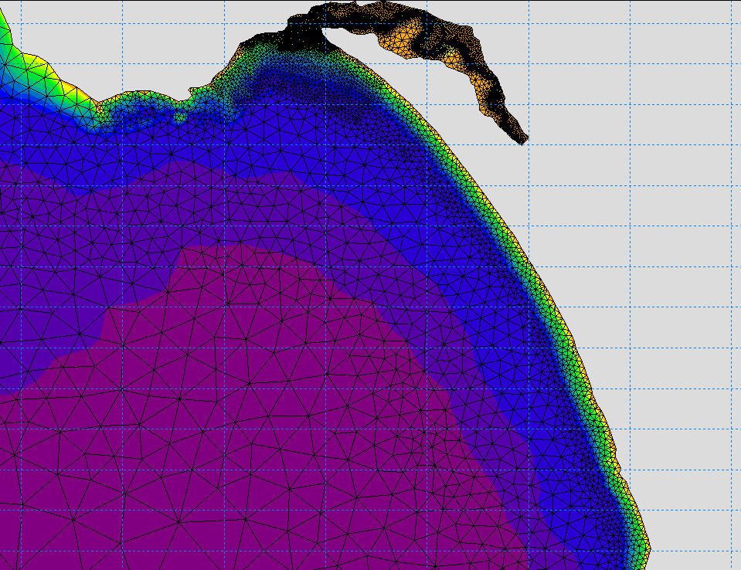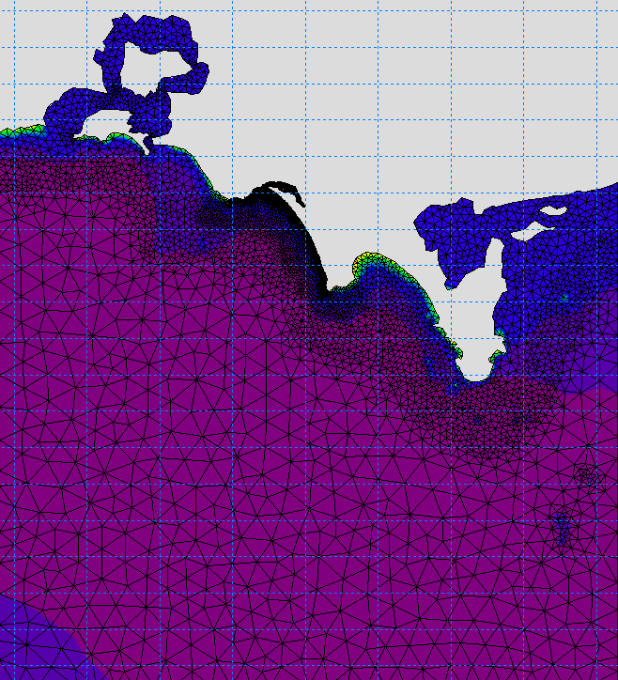
The model grid for the broader Bass Coast (bottom left) and Cape to Cape region (top right).
The models will include a range of conditions including frequently occurring storm conditions, rarer / more extreme storm events, various sea level rise projections, and different catchment flows.
Modelling will examine current and future conditions for:
- Storm-tide
- Waves
- Sediment transport
- Shoreline response (erosion / accretion).

Model outputs
The model results will help us to understand areas along the Cape to Cape coastline that may be exposed to coastal inundation and erosion, and how the coastline might respond if these conditions occur.
Working with the community, we will use this important information that will help make decisions on coastal management options for the region.
Our models can also be used to test the performance and suitability of different management (adaptation) options. We will be testing up to five adaptation options for the Inverloch shoreline, which will be guided by community and stakeholder consultation.
The next fact sheet in this series will provide further information on assessing coastal hazard risk and evaluating adaptation options.

© The State of Victoria Department of Environment, Land, Water and Planning 2021  This work is licensed under a Creative Commons Attribution 4.0 International licence. You are free to re-use the work under that licence, on the condition that you credit the State of Victoria as author. The licence does not apply to any images, photographs or branding, including the Victorian Coat of Arms, the Victorian Government logo and the Department of Environment, Land, Water and Planning (DELWP) logo. To view a copy of this licence, visit http://creativecommons.org/licenses/by/4.0/  ISBN 978-1-76105-797-7 (pdf/online/MS word) Disclaimer  This publication may be of assistance to you but the State of Victoria and its employees do not guarantee that the publication is without flaw of any kind or is wholly appropriate for your particular purposes and therefore disclaims all liability for any error, loss or other consequence which may arise from you relying on any information in this publication. | Accessibility  If you would like to receive this publication in an alternative format, please telephone the DELWP Customer Service Centre on 136186, email customer.service@delwp.vic.gov.au, or via the National Relay Service on 133 677 www.relayservice.com.au. This document is also available on the internet at www.delwp.vic.gov.au.

How can I get involved in the project?
To ensure you keep up to date with the Cape to Cape Resilience Project and upcoming events and activities:
- Visit the project website at marineandcoasts.vic.gov.au/coastal-programs/cape-to-cape-resilience-project
- Sign-up to receive progress updates and notifications – email capetocape.project@delwp.vic.gov.au
- Read our latest project updates at the website
- Ask us a question – email capetocape.project@delwp.vic.gov.au

