delwp.vic.gov.au

Coastcare Victoria School Kit

Ecosystem and Edible Urchins
  - Teacher Guide

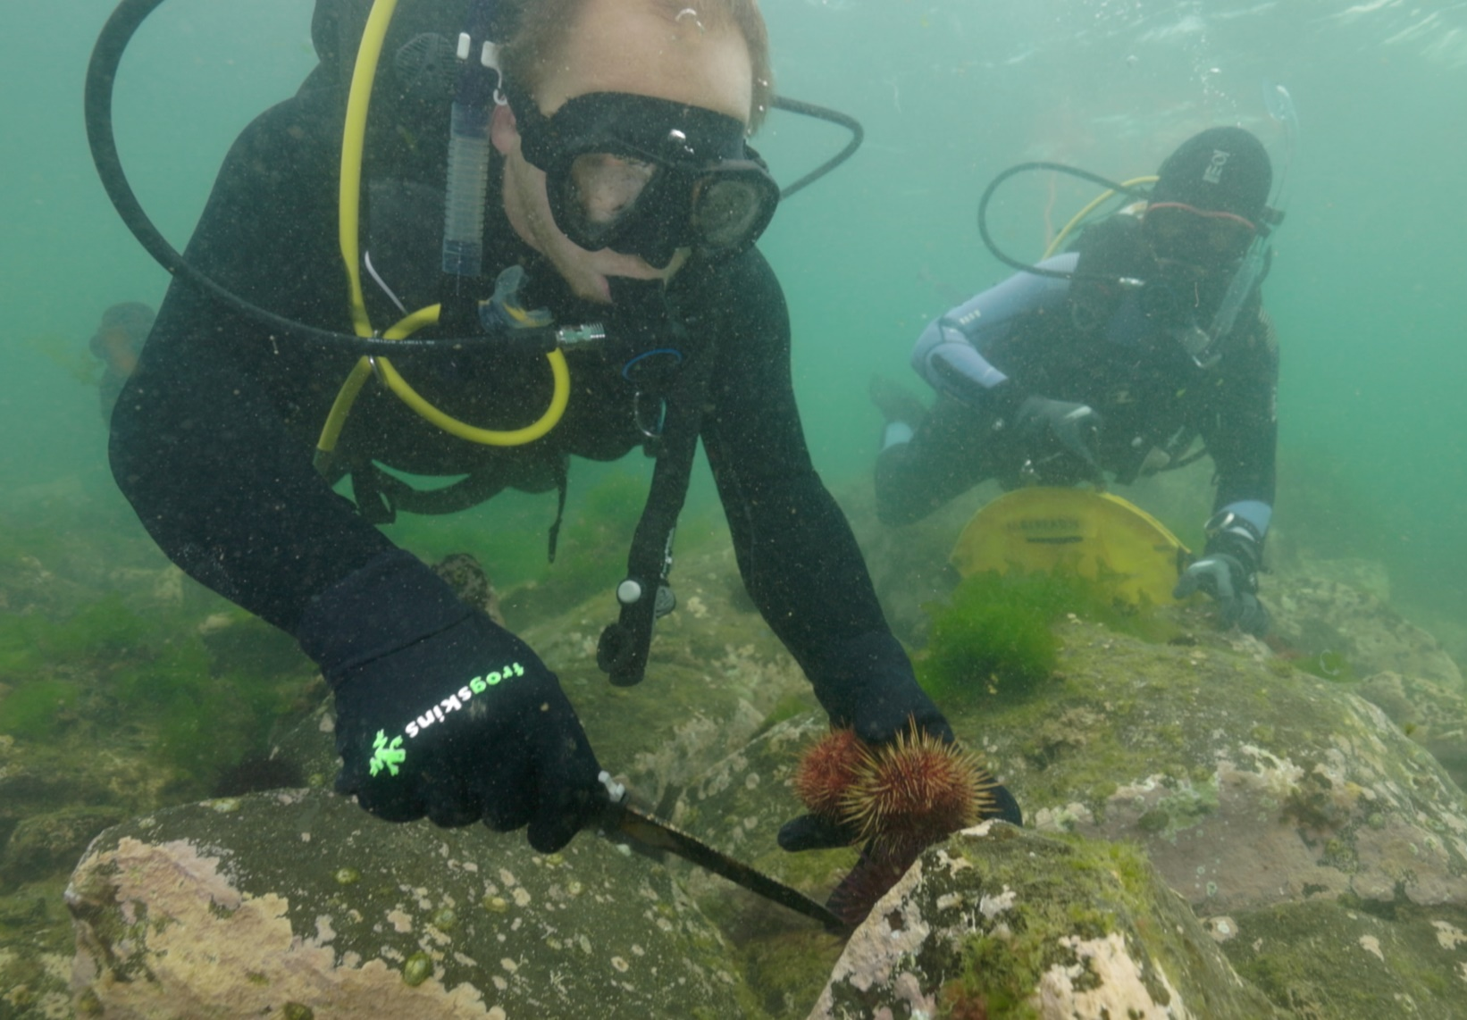
 | 

Acknowledgements

Coastcare Victoria would like to acknowledge all our video presenters and individuals who reviewed or assisted with the creation of the Coastcare Victoria School Kit.
Author
Coastcare Victoria and Ocean Imaging.
Photo credit
Ocean Imaging.
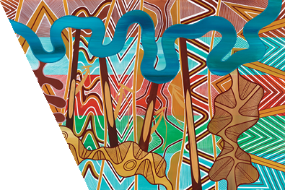
Acknowledgment
We acknowledge and respect Victorian Traditional Owners as the original custodians of Victoria's land and waters, their unique ability to care for Country and deep spiritual connection to it. We honour Elders past and present whose knowledge and wisdom has ensured the continuation of culture and traditional practices.
We are committed to genuinely partner, and meaningfully engage, with Victoria's Traditional Owners and Aboriginal communities to support the protection of Country, the maintenance of spiritual and cultural practices and their broader aspirations in the 21st century and beyond.
© The State of Victoria Department of Energy, Environment, and Climate Action 2026
This work is licensed under a Creative Commons Attribution 4.0 International licence. You are free to re-use the work under that licence, on the condition that you credit the State of Victoria as author. The licence does not apply to any images, photographs or branding, including the Victorian Coat of Arms, the Victorian Government logo and the Department of Energy, Environment, and Climate Action (DEECA) logo. To view a copy of this licence, visit http://creativecommons.org/licenses/by/4.0/
ISBN 978-1-76136-089-3 (pdf/ online/ MS word)
Disclaimer
This publication may be of assistance to you but the State of Victoria and its employees do not guarantee that the publication is without flaw of any kind or is wholly appropriate for your particular purposes and therefore disclaims all liability for any error, loss or other consequence which may arise from you relying on any information in this publication.
Accessibility
If you would like to receive this publication in an alternative format, please telephone the DEECA Customer Service Centre on 136186, email customer.service@deeca.vic.gov.au, or via the National Relay Service on 133 677 www.relayservice.com.au. This document is also available on the internet at www.deeca.vic.gov.au.

Contents
Curriculum links 1
Key themes 6
Lessons overview 7
Learning intentions 8
Success criteria 8
Background 8
Resources 9
Other useful links 9
Lesson plan 1
Activity 1: Quiz 1
Activity 2: What’s causing the problem? 3
Activity 3: Urchin Population – Comic Strip 3
Activity 4: Urchin population sampling 5
Investigation 1: Urchin adaptations 6
Investigation 2: Sustainable seafood 8
Review questions 10
Glossary 11

Curriculum links

Year 5 and 6 curriculum | Curriculum code | Content description | Topic covered – link to Learning Intentions
Science – Science as a Human Endeavour – Use and influence of science | VC2S6H02 | Scientific knowledge, skills and data can be used by individuals and communities to identify problems, consider responses and make decisions | Sea urchins are natural herbivores in kelp forest ecosystems but population explosions can be negative consequences.  Removal of sea urchins may help control the balance of the kelp forest ecosystem.
Science – Science Understanding – Biological sciences | VC2S6U01 | Habitats can be described by their physical conditions; changing the physical conditions of a habitat, including by human activity, may affect the growth and survival of organisms | Sea urchin populations may be affected by abiotic and biotic factors in the environment.  Removal of sea urchins may help control the balance of the kelp forest ecosystem.
Science – Science Understanding – Biological sciences | VC2S6U02 | Organisms have evolved over time, as seen in fossils and scientific records; the structural features and behaviours of living organisms enable them to thrive in their environments | Living things have structural features and adaptations that help them to survive in their environment.
Science – Science Inquiry – Planning and conducting | VC2S6I02 | Repeatable scientific investigations to answer questions can be planned and conducted, including, as appropriate, deciding the variables to be changed, measured and controlled in fair tests, considering potential risks, planning for the safe and ethical use of equipment and materials, and obtaining permissions for investigations conducted on Country and Place or in protected areas | The basic principles of scientific sampling to estimate population size using a quadrat.
Science – Science Inquiry – Evaluating | VC2S6I05 | Methods and findings can be compared with those of others to identify sources of error, to select evidence in support of reasoned explanations and conclusions, and to develop further questions for investigation | The basic principles of scientific sampling to estimate population size using a quadrat.
Humanities – Geography – Geographical Knowledge and Understanding – Management of places | VC2HG6K01 | How places and environmental are changed and managed by people | Sea urchins are natural herbivores in kelp forest ecosystems but population explosions can be negative consequences.  Removal of sea urchins may help control the balance of the kelp forest ecosystem.
Mathematics – Number | VC2M5N09 | Use mathematical modelling to solve practical problems involving additive and multiplicative situations, including simple financial planning contexts; formulate the problems, choosing operations and efficient mental and written calculation strategies, and using digital tools where appropriate; interpret and communicate solutions in terms of the situation | The basic principles of scientific sampling to estimate population size using a quadrat.
Mathematics – Number | VC2M6N09 | Use mathematical modelling to solve practical problems involving rational numbers and percentages, including in financial contexts; formulate the problems, choosing operations and using efficient mental and written calculation strategies, and using digital tools where appropriate; interpret and communicate solutions in terms of the situation, justifying the choices made | The basic principles of scientific sampling to estimate population size using a quadrat.
Mathematics – Statistics | VC2M5ST03 | Plan and conduct statistical investigations by posing questions or identifying a problem and collecting relevant data; choose appropriate displays and interpret the data; communicate findings within the context of the investigation | The basic principles of scientific sampling to estimate population size using a quadrat.
Mathematics – Statistics | VC2M6ST03 | Plan and conduct statistical investigations by posing and refining questions to collect categorical or numerical data by observation or survey, or identifying a problem and collecting relevant data; analyse and interpret the data and communicate findings within the context of the investigation | The basic principles of scientific sampling to estimate population size using a quadrat.
Critical and Creative Thinking – Reasoning | VC2CC6R04 | The use of criteria to support analysis and evaluation when reasoning | Sea urchin populations may be affected by abiotic and biotic factors in the environment.  Removal of sea urchins may help control the balance of the kelp forest ecosystem.  The basic principles of scientific sampling to estimate population size using a quadrat.

Year 7 and 8 curriculum | Curriculum code | Content description | Topic covered – link to Learning Intentions
Science – Science as a Human Endeavour – Nature and development of science | VC2S8H01 | Scientific knowledge, including models and theories, can change because of new evidence | Sea urchins are natural herbivores in kelp forest ecosystems but population explosions can be negative consequences.  Removal of sea urchins may help control the balance of the kelp forest ecosystem.
Science – Science as a Human Endeavour – Use and influence of science | VC2S8H04 | Communication of scientific knowledge has a role in informing individual viewpoints, and community policies and regulations | Removal of sea urchins may help control the balance of the kelp forest ecosystem.
Science – Science Understanding – Biological sciences | VC2S8U04 | Matter and energy flow through ecosystems and can be represented using models, including food webs and food pyramids; populations will be affected by changing biotic and abiotic factors in an ecosystem including habitat loss, climate change, seasonal migration and introduction or removal of species | Sea urchins are natural herbivores in kelp forest ecosystems but population explosions can be negative consequences.  Sea urchin populations may be affected by abiotic and biotic factors in the environment.  Removal of sea urchins may help control the balance of the kelp forest ecosystem.
Science – Science Inquiry – Processing, modelling and analysing | VC2S8I04 | Data and information can be organised and processed by selecting and constructing representations including tables, graphs, keys, models and mathematical relationships | The basic principles of scientific sampling to estimate population size using a quadrat.
Science – Science Inquiry – Processing, modelling and analysing | VC2S8I05 | Information and processed data can be analysed to show patterns, trends and relationships, and to identify anomalies | The basic principles of scientific sampling to estimate population size using a quadrat.
Science – Science Inquiry – Evaluating | VC2S8I06 | Scientific methods, conclusions and claims can be analysed to identify assumptions, possible sources of error, conflicting evidence and unanswered questions | The basic principles of scientific sampling to estimate population size using a quadrat.
Humanities – Geography – Geographical Knowledge and Understanding – Landforms and landscapes | VC2HG8K15 | The human causes of landform change and ways of managing it, including the study of a local landform | Sea urchins are natural herbivores in kelp forest ecosystems but population explosions can be negative consequences.  Removal of sea urchins may help control the balance of the kelp forest ecosystem.
Mathematics – Number | VC2M7N10 | Use mathematical modelling to solve practical problems involving rational numbers and percentages, including financial contexts such as ‘best buys’; formulate problems, choosing representations and efficient calculation strategies, designing algorithms and using digital tools as appropriate; interpret and communicate solutions in terms of the situation, justifying choices made about the representation | The basic principles of scientific sampling to estimate population size using a quadrat.
Mathematics – Number | VC2M8N06 | Use mathematical modelling to solve practical problems involving rational numbers and percentages, including financial contexts involving profit and loss; formulate problems, choosing efficient mental and written calculation strategies and using digital tools where appropriate; interpret and communicate solutions in terms of the context, reviewing the appropriateness of the model | The basic principles of scientific sampling to estimate population size using a quadrat.
Mathematics – Statistics | VC2M7ST03 | Plan and conduct statistical investigations for issues involving discrete and continuous numerical data, and data collected from primary and secondary sources; analyse and interpret distributions of data and report findings in terms of shape and summary statistics | The basic principles of scientific sampling to estimate population size using a quadrat.
Mathematics - Statistics | VC2M8ST02 | Analyse and report on the distribution of data from primary and secondary sources using random and non-random sampling techniques | The basic principles of scientific sampling to estimate population size using a quadrat.
Mathematics - Statistics | VC2M8ST04 | Plan and conduct statistical investigations involving samples of a population; use ethical and fair methods to make inferences about the population and report findings, acknowledging uncertainty | The basic principles of scientific sampling to estimate population size using a quadrat.
Critical and Creative Thinking – Reasoning | VC2CC8R01 | Ways to identify, structure and communicate a conclusion and its justification where competing claims, and grounds for claims, are analysed and evaluated | Sea urchin populations may be affected by abiotic and biotic factors in the environment.  Removal of sea urchins may help control the balance of the kelp forest ecosystem.  The basic principles of scientific sampling to estimate population size using a quadrat.

Key themes
Food webs, marine ecology, bottom up vs top down controls of ecosystems, scientific research, sampling techniques.

Lessons overview
Activity | Time | Difficulty | Topic & Skills
1: Quiz | 5 min video  15 min quiz | Simple | Rocky reef and kelp forest ecosystems, sea urchins, sustainable seafood practices, impacts of nutrient changes on reef ecosystems, and linking ecosystem management to food systems and environmental stewardship.  - Listening comprehension and understanding.
2: What’s causing the problem? | 60 min | Moderate: Multiple step activity. | Causes of sea urchin overpopulation, ecosystem imbalance, abiotic and biotic factors, human impact, cause and effect in ecosystems.  - Listening comprehension, text analysis, systems thinking, visual literacy, scientific reasoning, and critical thinking.
3: Urchin population - comic strip | 60 min | Moderate: Multiple step activity. | Trophic levels and energy flow, food webs, sea urchins, role of producers and consumers in food webs, and impact of ecosystem imbalance.  - Scientific understanding, concept application, visual storytelling, critical thinking, reading comprehension, creative expression, and linking theory to real-world examples.
4: Urchin population sampling | 60 min | Moderate: Multiple step activity. | Scientific sampling methods, population estimate techniques, random variation, and experimental design.  - Data collection and recording, numeracy and estimation, scientific reasoning, critical thinking, analysis and comparison, evaluation, collaboration and communication.
Investigation 1: Urchin adaptations | 60 min+ | Complex: Multi-step instructions. Independent learning. | Adaptations of sea urchins, how adaptations help survival and reproduction.  - Observation, classification, scientific reasoning, understanding of cause-and-effect in biology, connecting structure and function in organisms, and critical thinking.
Investigation 2: Sustainable seafood | 60 min+ | Complex: Using external resources. Independent learning. | Sustainable fishing practices, marine food webs, trophic levels, human impacts, ecological role, and sustainability of seafood.  - Research skills, data interpretation, critical thinking, use of digital tools, classification, ecological reasoning, written reflection, and communication.

Learning intentions
Students will understand:
- Sea urchins are natural herbivores in kelp forest ecosystems but population explosions can have negative consequences.
- Living things have structural features and adaptations that help them to survive in their environment.
- Sea urchin populations may be affected by biotic and abiotic factors in the environment.
- Removal of sea urchins may help control the balance of a kelp forest ecosystem.
- The basic principles of a simple scientific investigation to estimate population size using a quadrat.

Success criteria
Students are able to:
- Distinguish between a local and international kelp forest ecosystem.
- Using sampling techniques to make population estimates.
- Illustrate and/or describe how factors in the environment led to high urchin numbers in Port Phillip Bay.
- Use simple food chain diagrams to compare how marine ecosystems may be controlled by top down and bottom up processes.
- Outline problems with a basic scientific investigation and provide suggestions for improvement.
- Make predictions about the sustainability of local seafood species.
- Use the GoodFish website or app to determine the sustainability of local seafood species.

Background
Sea urchins are spiny echinoderms (a phylum including starfish, brittle stars and sea cucumbers) that live in all oceans of the planet. Sea urchins are herbivores. In regular numbers they play an important role in the ecosystem, maintaining algae growth. However, when numbers are too high they can damage kelp habitats through overgrazing and preventing recruitment of seaweeds. Urchins are capable of devastating their environments, creating what biologists call an “urchin barren”. Loss of the habitat and nutrients provided by kelp forests leads to a wide range of negative consequences on the resulting low productivity and low biodiversity marine ecosystem created by the barrens.
There are two problematic sea urchin species in Australian temperate waters. The short spined sea urchin Heliocidaris erythrogramma and the long spined sea urchin Centrostephanus Rodgersii. Populations of the long spined sea urchin have been expanding southward down the east coast as far as Tasmania as the water has been warming but are only an issue in the eastern part of Victoria.
Short spined sea urchins are normally found in the waters of Port Phillip Bay and other sheltered waters along Victoria’s coast. Research scientist Dr. Paul Carnell from Deakin University first realised there was a sea urchin problem in Port Phillip Bay during his PhD. After 12 years of research, Paul and his team have started to understand the historic cause of the issue and are also responsible for the ongoing monitoring of reefs.
This video investigates the cause of the urchin problem in Port Phillip Bay and follows Paul on a dive to survey a reef at Williamstown and investigate some of the solutions to the problem. Licensed recreational fishers are allowed to catch up to 40 sea urchins per person per day (note: urchins must be caught below 2m depth). However, for most Australians, sea urchin is not a commonly eaten seafood. The video also introduces Chef Johnson from Melbourne urchin restaurant Uni Boom Boom, who is out to change people’s perceptions of the seafood, a delicacy in many Asian countries. Johnson shares the preparation methods for the urchin and an insight into what could be a highly lucrative sustainable industry in the country.
However the solution isn’t as straightforward as it may sound. Urchins collected from barrens are usually low quality and contain small roe (the edible part of the sea urchin) because they are living in a low food environment. Research from the University of Melbourne and Deakin University has shown after 12 weeks of feeding sea urchins, they are actually good enough to be able to eat or sell back into the market.
There are other introduced species in Port Phillip Bay which are also causing a problem for ecosystems. One of these is the Northern Pacific Kelp - Undaria. Another is the North Pacific Sea Star which loves eating shellfish. When they get in really large numbers they can go through and clear a lot of shellfish in an area.

Resources
- Ecosystem and Edible Urchins video
- Video transcript
- Presentation slides
- Answers
- Quiz
- What’s causing the problem? worksheet
- Urchin population – comic strip worksheet
- Urchin population sampling worksheet
- Quadrat reefs: A-E worksheets
- Investigation: Urchin adaptations worksheet
- Investigation: Sustainable seafood worksheet
- Review questions
- Glossary

Other useful links
The Roe (formally Uni Boom Boom)
- At The Roe Australia, dining is a commitment to ocean conservation. By supporting regenerative practices, we create dishes that honour the ocean’s bounty while protecting its future. Every bite is a step toward kelp restoration.
NBC News video: Sea otters are helping protect California kelp forests
- A news report from California, showing how sea otters protect kelp forests by eating sea urchins – this is an example of trophic interactions.
Animated video: Who’s eating all the kelp?
- An informative video for students to understand how trophic interactions in Australian ecosystems led to the formation of urchin barrens.
Sampling with Quadrats
Use this video as an introduction to quadrat sampling Malmesbury Science: Sampling with Quadrats – GCSE Biology Practical
Further reading for teachers: https://www.nps.gov/articles/000/what-are-transects.htm
GoodFish - Sustainable Seafood Guide

Lesson plan

Activity 1: Quiz
Use this 10-question quiz to assess comprehension and understanding of the video. This could be run as a Kahoot quiz, online form or worksheet.

1. For how many years have Paul and his colleagues been surveying this reef at Williamstown?
- 2
- 4
- 6
- 12

2. What three things were the divers measuring in the surveys?
- Urchin diversity, fish densities and kelp cover
- Kelp cover, seaweed diversity and urchin densities
- Rock distance, seaweed height and number of urchins removed
- Distance from shore, ocean temperature, food abundance

3. Which urchin species was being collected on the dive?
- Long spined sea urchin
- Short spined sea urchin
- Black spikey sea urchin
- Rough edged sea urchin

4. What do sea urchins usually eat?
- Zooplankton
- Phytoplankton
- Drifting seaweed
- Small starfish

5. What factor caused the seaweeds to grow prolifically in the 1950’s and 1960’s?
- Temperature
- Sunlight
- Nutrients
- Currents

6. What helped the urchin populations increase so dramatically?
- Lack of predators
- Abundance of food
- Lack of seaweed
- Warm temperatures

7. Why did the urchins change from ’couch potato’ mode to ‘army mode’?
- Less seaweed around so they needed to fight for it
- Chemicals in the water
- Huge appetite brought on by temperature
- Battle with the other urchin species

8. How many short spined urchins can a recreational fisher with a license catch in a day?
- 20
- 30
- 40
- 80

9. What part of the sea urchin is eaten?
- The short spines
- The mouth muscle
- The eyes
- The roe (eggs)

10. What rule needs to be considered when catching urchins?
- Must be caught below 2m deep
- Must be caught with gloves
- Must be cooked within 2 hours
- Must be taken from a sanctuary zone

Activity 2: What’s causing the problem?
This activity helps students understand how both biotic and abiotic factors interact to affect ecosystems, using the sea urchin population boom in Port Phillip Bay as a case study. Students develop observation and analytical skills by identifying and classifying factors in the video transcript, linking nutrient levels, species interactions, and environmental changes to real-world ecological outcomes. It also encourages critical thinking, as students consider how multiple factors combine to influence species populations and ecosystem health.

The sea urchin problem in Port Phillip Bay was caused by a mixture of biotic (living) and abiotic (non-living) factors in the ecosystem. Use the slides 5-8 to introduce your class to this concept and practice together by labelling each desert ecosystem factor in the table (answers appear one by one on the animated slide).
Test students’ understanding, have them underline biotic factors and circle abiotic factors in the video transcript in their What’s causing the problem? worksheet (below).
You can rewatch this portion of the video from 1:50 and listen to the scientists discuss what caused the sea-urchin population boom.

- As the video plays students can underline biotic (living) factors and circle abiotic (non-living factors).
“What we think has happened over time is a combination of all of the nutrients actually coming into Port Phillip Bay, with all of the sewerage wastewater that's been coming in, in here since the 50s and 60s. And that has basically driven a change in this ecosystem from the bottom up.
And all of those excess nutrients in the water actually drove a whole lot of other weedy seaweed species to massively proliferate. And when you have a whole lot of food, then other species will come along and make the most of that. And so sea urchins love to sit there on a rock and eat whatever drifting bits of seaweed are coming by, and so with all this extra seaweed that was now out there and floating around it built a larger sea urchin population in the bay.
But then what happened, we got to the Millennium drought, which was from the end of the 1990s, and through the 2000s. So, a long period of increased temperatures, but also reduced nutrients that were actually now coming into the bay. And so, now all of a sudden, we had less nutrients in the bay, and less seaweed that was now growing and proliferating because of it.
And that meant we had way more urchins. So, we had really high urchin numbers. And the seaweed populations were down here. So, they switched from couch potato mode to actually active foraging, kind of army mode. And instead (of waiting for food), moving around and eating and clearing all of the seaweeds and the kelps off the reef.”

Activity 3: Urchin Population – Comic Strip
This activity helps students understand food webs and trophic levels by exploring how energy flows from primary producers to top predators, and how populations are controlled through bottom-up and top-down processes. Using the sea urchin population in Port Phillip Bay as a case study, students analyse how abiotic factors (nutrients, temperature) and biotic interactions (herbivores, predators) influence ecosystems.
By creating comic strips, students develop sequencing, storytelling, and visual communication skills while demonstrating understanding of ecological principals. Comparing mainland Australian, Tasmanian, and Californian kelp forest examples encourages critical thinking, helping students identify similarities and differences in population control across ecosystems.

Use the presentation slides 9-11 to introduce your students to the population (trophic) pyramid, which illustrates how a lot of plants are needed to support just a few large predators. Primary producers are the bottom of the population pyramid, plants which produce their own ‘food’ by photosynthesising. Primary consumers are herbivores, like the sea urchins, which feed on plants to grow their bodies. Secondary consumers are mid-sized predators which feed on prey-animals. At the top of the food chain are tertiary consumers, large predators which feed on medium sized predators.

The scientists in the video refer to ‘bottom-up’ change in Port Phillip Bay. There are two different ways that food-chains may interact and control plant and animal populations. The bottom-up control is driven by the presence or absence of the producers in the ecosystem. Bottom-up processes are generally driven by the abiotic conditions required for primary producers to grow, such as availability of light and nutrients. You can Observe an example of top-down population control in the video link below: sea otters helping protect California’s kelp forests. In California, sea otters (which are secondary consumers in the population pyramid) feed on sea urchins, therefore the urchins do not overpopulate, and the kelp is able to grow large and abundant.

Refer to slide 12. Using the Urchin population – Comic strip worksheet, students will cut out the comic strip pictures from the bottom of their worksheet page and stick them back onto the text in the correct order. Students need to work out if a bottom-up or top-down processes are controlling the populations in Port Phillip Bay: the change in the urchin ecosystem was driven from the bottom-up. Slide 13 shows the correct order.

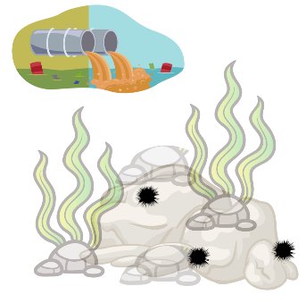 | 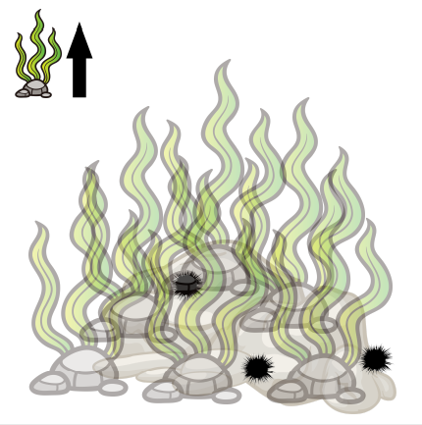 | 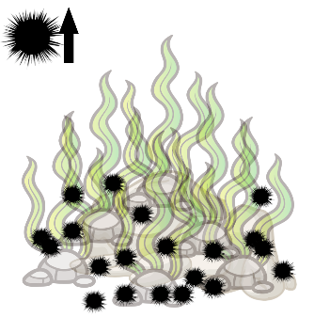 | 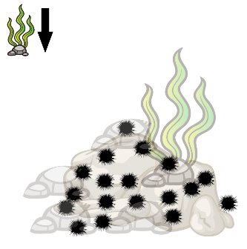
What we think has happened over time is a combination of all of the nutrients actually coming into Port Phillip Bay, with all of the sewerage wastewater that's been coming in here since the 50s and 60s. And that has basically driven a change in this ecosystem from the bottom up | All of those excess nutrients in the water actually drove a whole lot of other weedy seaweed species to massively proliferate. | And when you have a whole lot of food, then other species will come along and make the most of that. And so sea urchins love to sit there on a rock and eat whatever drifting bits of seaweed are coming by, and so with all this extra seaweed that was now out there and floating around it built a larger sea urchin population in the bay | Then what happened, we got to the Millennium drought, which was from the end of the 1990s, and through the 2000s. So a long period of increased temperatures but also reduced nutrients that were actually now coming into the bay. And so, now all of a sudden, we had less nutrients in the bay, and less seaweed that was now growing and proliferating because of it.
Challenge your students to create their own four-panel comic strip about urchin populations. They can watch either the news report about sea otters, or the animated video about urchins in Tasmania (links below and on presentation slide 14).

While watching, students should listen for the four key parts of their story: First (how things began), But (there was an issue), Then (there was a solution), and Now (things are different).

Can they include both biotic and abiotic factors from their ecosystem? Can they illustrate either top-down or bottom-up population control?

Animated video: Who’s eating all the kelp?. Have students watch and compare the similarities and differences between the urchin problem in Tasmania versus Port Phillip Bay.

NBC News: Sea otters are helping protect California kelp forests. Have students watch and compare the similarities and differences between a Californian and Australian kelp forest.

Activity 4: Urchin population sampling
This activity helps students learn scientific methods for population monitoring by practicing sampling and estimating sea urchin populations on simulated rockpool environment. Students develop data collection, random sampling, and calculation skills, using quadrats to estimate population size rather than counting every individual.
This activity encourages critical thinking as students compare estimates to actual counts, explore sources of bias, and investigate how sample size affects accuracy. The extension task reinforces these concepts by having students calculate populations using smaller sample percentages, deepening their understanding of statistical sampling in ecology.

First watch this educational video from Malmesbury Science: Sampling with Quadrats – GCSE Biology Practical (link provided on presentation slide 15). It explains how and why we estimate populations, and how to count species using a quadrat square.
Students use the Urchin population sampling worksheets for this activity. Presentation slides 16-18 offer an introduction and a worked example of each reef to either use for checking student answers or to guide their working out.
 | Reef A | Reef B | Reef C | Reef D | Reef E
Total Urchin Count | 306 | 552 | 289 | 299 | 297
It’s your turn to collect data on urchin populations, just like Paul and the other marine biologists. You have five different paper reefs to sample [slides 18-22 – Reef A is the example].
Counting every urchin on a reef is very difficult – so scientists use a 1m square, called a quadrat, to help them count a sub-set of the total population. Research shows that if we sample 10% of our population, we can correctly estimate the total population.
Calculate the total area of the reef so that we can calculate 10% of the area.
- Each small grid square is 20cm x 20cm (a 20cm square)
- How many grid squares together make a 1m square? __5__
- How many meters square is each reef? _10_meters long X _8_meters wide = __80__ m²
- Calculate 10% of the 80m² reef sheet: 80m² / _10_ = _8m²_
- We need to count the urchins in __8__ x 1m² quadrats to estimate our population

Random sampling
If we choose where to put our survey squares, we might pick the ‘best looking’ locations. This will make our data biased and create inaccurate results. It is impossible not to be biased, it’s just how the human brain works. Therefore, scientists use a random number generator.
- Random coordinates have been generated to help you place your quadrats on your paper reefs.
- Use your ruler to outline the quadrats you are going to sample.
- Count the urchins inside each quadrat and record them next to your coordinates.
Population calculation
- Calculate the average of your eight quadrat counts – this tells you how many urchins are living on an average 1m² of this reef.
- Multiply the urchin average by the total area of the reef – this is an estimate of how many urchins are living on the reef.
Discussion
- Why were the population estimates not the same as the total urchin counts?
- Why were some estimates more accurate than others? [slide 23]
- What would happen to the estimate if you counted 20% of each reef?
- Extension – recalculate population averages and estimates using only 5% (half of the results).

Investigation 1: Urchin adaptations
This activity helps students investigate the adaptations of sea urchins and understand how these features allow them to survive and thrive in diverse marine environments. Students explore behavioural, physiological, and structural adaptations, developing skills in observation, classification, and scientific reasoning.
The activity also encourages comparative analysis by having students research another ocean animal, linking adaptations to survival strategies. Additional research questions and drawing tasks strengthen research skills, comprehension of anatomy, and visual communication.

Urchins are highly successful animals that can be found in all of the world’s oceans, to depths as deep at 5000m! There are more than 950 different species worldwide. Only an animal highly suited (adapted) to their environment could be so successful [slides 24-26]. In this investigation students can investigate the various adaptations of sea urchins using the Urchin adaptations investigation worksheet. For younger students this investigation may be run as a simple activity using the Urchin adaptation worksheet (answers below).
Scientists classify adaptations in three main categories. But some adaptations may fit multiple categories.
- Behavioural: Things organisms do to survive/reproduce.
- Physiological: A body process that helps an organism survive/reproduce.
- Structural: A physical feature that helps an organism survive/reproduce.
Sea urchin adaptations

- They can survive in a low food environment by shrinking their shell size (if you are smaller you need less food). Physiological/structural
- They put less investment in reproduction in low food environments. Less energy in the roe (eggs and gonads). Behavioural
- Spines - protects them from predators and they can also use them to catch bits of seaweed as they float past. They also use the spines to pass food to the underneath side where their mouth is. Structural/behavioural
- Mouth on bottom - this means they can graze along the rock and eat anything that’s attached there. Mouth is called an Aristotle’s lantern and looks a bit like a beak. Structural
- Sea urchins move by walking, using their many flexible tube feet. Structural

Students can choose another ocean animal to research and record some of their adaptations: For example:
- Behavioural: Whales migrate to follow their ideal temperatures and food cycles through the year
- Physiological: Whales have developed the ability to echolocate which helps them to ‘see’ and ‘hear’ underwater
- Structural: Whales have thick layers of blubber fat which help keep them warm in the water and helps them float

Use the internet to research the following urchin questions
- What characteristics do all sea urchins have in common?
Sea urchins belong to the class Echinoidea. They are distinguished by their spiny, globular tests (shells).
- What Sea creatures are sea urchins closely related to?
Sea urchins are classified within the phylum Echinodermata, which also includes starfish, sea cucumbers, and sand dollars.
- How do sea urchins move?
Sea urchins can walk using their spines, or their tube-feet, these are soft suckers a bit like octopuses’ suckers or caterpillar pseudopods.
- How do sea urchins reproduce?
Sea urchins have separate male and female sexes.
Sea urchins reproduce by sending clouds of eggs and sperm into the water where fertilisation takes place.
Millions of larvae are formed, but only a handful make it back to the shoreline to grow into adults.
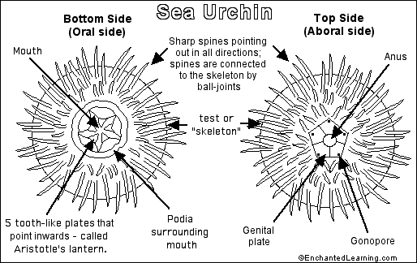
- In the space below, draw a labelled diagram of a sea urchin.

Investigation 2: Sustainable seafood
This activity helps students investigate marine species, their diets, and trophic levels to make predictions about the sustainability of seafood. Students develop research, analysis, and critical thinking skills by comparing their predictions with data from the GoodFish website and evaluating how sustainability can vary by location. The activity encourages students to communicate their understanding by summarising their findings in a paragraph, reinforcing links between food webs, human impacts, and responsible seafood choices.

Students will use the Investigation 2: Sustainable seafood worksheet to research some marine species to determine their trophic level and make predictions on their sustainability [slides 27-30]. Students will use the internet to research the diet of the marine species, prey size, pyramid (trophic) level, the students’ sustainability prediction and sustainability of the seafood. Emphasise to students that a general rule is the smaller the prey of the organism, the lower they are in the food chain and the more sustainable they are likely to be. They can use a traffic light system (green = sustainable, orange = eat less, red = say no) and use the Goodfish website to determine the sustainability of the fisheries, and to compare their prediction. Students will notice that the sustainability classification may depend on the location.

Slides 30-33 highlight the work of researcher, Dr Paul Carnell and chef, Johnson Teoh.

At the conclusion of the lesson, or for an extension, have students write a paragraph about what they have learned in this investigation.

Marine species | Species name | Diet | Prey size | Pyramid Level | Sustainability prediction | Sustainability
Blacklip abalone | Haliotis rubra | Seaweed | small | Herbivore |  | Green
Sea Urchin | Heliocidaris erythrogramma | Seaweed | small | Herbivore |  | Green
Luderick | Girella tricuspidata | Seagrass and Algae | small | Herbivore |  | Green
Australian Sardine | Sardinops sagax | Phytoplankton and zooplankton | small | Omnivore |  | Green
Southern Calamari | Sepioteuthis australia | Small fish and crustaceans | medium | Carnivore |  | Green
Australian Salmon | Arripis trutta | Small fish | medium | Carnivore |  | Orange
Southern Rock Lobster | Jasus edwardsii | Mussels, abalone, urchins. | small | Carnivore |  | Orange
Yellowfin Tuna | Thunnus albacares | Fish, crabs | large | Carnivore |  | Red
Gummy Shark | Mustelus antarcticus | Octopus, cuttlefish, small fish. | large | Carnivore |  | Red

Review questions
- Match the labels with the correct letter in the population pyramid: (4 marks)
primary consumer, primary producer, secondary consumer, tertiary consumer
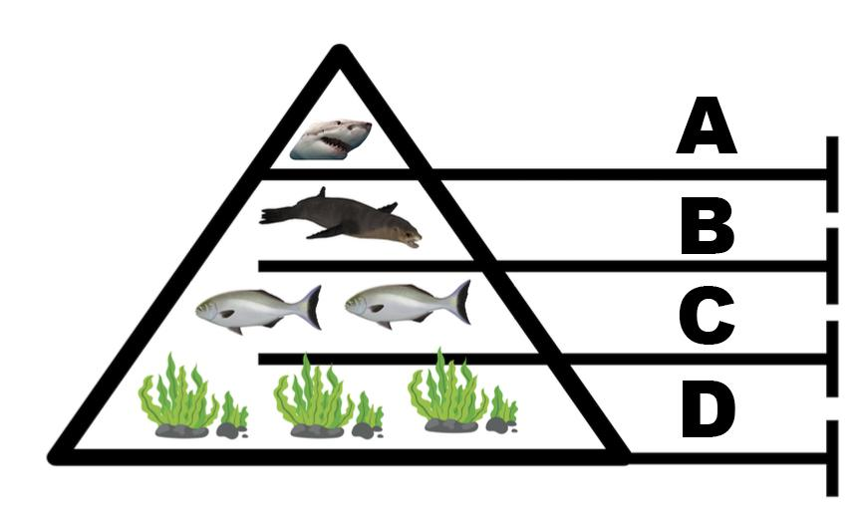

A = Tertiary consumer

B = Secondary consumer

C = Primary consumer

D = Primary producer

- The above diagram shows a top-down control. Which species control the sea lion population numbers? (1 mark)
Sharks control the sea lion population (from the top down) by eating/consuming them.
- In a top-down ecosystem, what may happen if there were not enough sea lions? (2 marks)
The fish would not get eaten by sea lions, their population would increase, they would eat more seaweed and the seaweed might decline.
- Finish this sentence: (1 mark)
In the diagram below, the ecosystem is controlled from: The bottom-up.
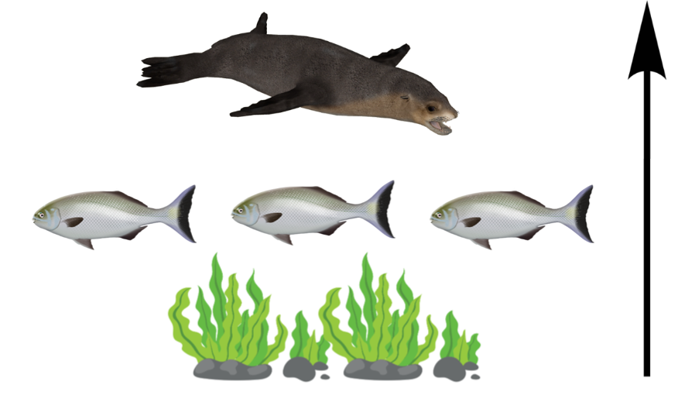

- What is likely to control the number of fish that may be able to live in this trophic system? (1 mark)
The abundance of seaweed as a primary food for fish controls their population.
- Name one factor that may impact the amount of seaweed that is able to grow in this ecosystem. (1 marks)
Nutrient inputs from land or sea animals, sunlight (distance of the seabed to the surface), water temperature, species of seaweed, presence of herbivores/pests like sea urchins, pollution, human disturbance (trawling).

Glossary
Adaptation: A special way that an organism is suited to survive and reproduce in an environment.
Barren: A low productivity and low biodiversity area where urchins have eaten down the vegetation.
Density: A measure of how many (organisms) are in a particular space.
Echinoderm: A marine animal with radiating arrangement of parts and a body that may protrude as spines and including the sea stars, sea urchins, brittle stars, sea cucumbers, etc.
Ecosystem: A community of interacting organisms and their environment.
Foraging: Searching for food.
Intertidal: Coastal spaces between high and low tides.
Millennium drought: An extended period of low rainfall affecting most of southern Australia from 2001 to 2009.
Nutrient: A substance that an organism must obtain from its surroundings for life and growth.
Organism: Any living thing.
Overabundant: Being beyond what is needed.
Population: The number of organisms of the same species that live in an area at the same time.
Predator: An animal that lives mostly by killing and eating other animals.
Prey: An animal that is hunted or killed by another animal for food.
Proliferate: Increase rapidly in number, reproduce and multiply at a rapid rate.
Producer: An organism that is able to use light energy from the sun to create their own food.
Recreational fishing licence: A licence required to take seafood from Victoria's marine, estuarine or inland waters.
Roe: Edible part of the sea urchin, specifically the animal’s gonads which produce its eggs.
Sea urchin: A marine echinoderm having a spherical or flattened shell covered in mobile spines, with a mouth on the underside.
Survey: Examine and record an area and features.
Sustainable seafood: Seafood that has been caught in a way that means there’s plenty more fish in the sea now and in the future.
Trophic level: The position an organism is in a food chain/population pyramid.
Uni: Japanese name for the edible part of the sea urchins.

