deeca.vic.gov.au

Coastcare Victoria School Kit

Sanctuaries and Sea Creature Worksheets

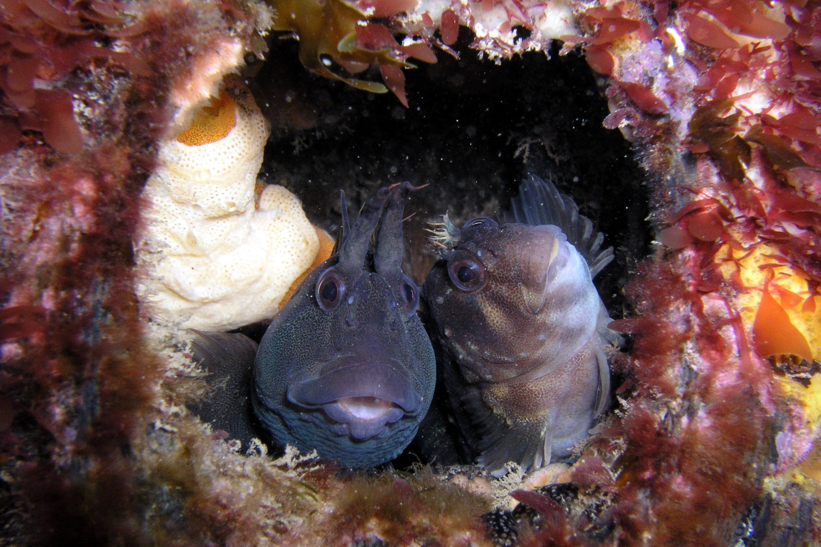

Acknowledgements

Coastcare Victoria would like to acknowledge all our video presenters and individuals who reviewed or assisted with the creation of the Coastcare Victoria School Kit.
Author
Coastcare Victoria and Ocean Imaging.
Photo credit
Ocean Imaging.

Contents
Ricketts Point Quiz 2
Habitat and Adaptations 4
Marine Sanctuaries Investigations 5
Marine Sanctuaries Investigation 6
Part II: Pamphlet Planning 6
Ricketts Point Review Quiz Year 5-6 7
Rickett Point Lesson Review Year 7-8 8

Ricketts Point Quiz
1.What year was the sanctuary established?
- 1999
- 2002
- 2005
- 2013

2. How many sanctuaries are there in Port Phillip Bay?
- 2
- 3
- 4
- 5

3. What type of rock are the rocky reefs made of?
- Granite
- Sandstone
- Limestone
- Metamorphic

4. How large can the banjo ray grow?
- 0.5m
- 1m
- 1.5m
- 2m

5. What animals migrate to Ricketts point at the beginning of summer?
- Birds
- Fish
- Sharks
- Turtles

6. Why do these animals migrate to Ricketts Point?
- To mate
- To lay eggs
- Both a and b
- Neither a nor b
7. Which fish were shown as juveniles in the video?
- Dusky morwong and sea sweep
- Banjo rays and Port Jackson sharks
- Leatherjackets and moonlighters
- Magpie perch and hulafish

8. The flathead is ‘top dog’ in which habitat?
- Rocky reef
- Kelp forest
- Seagrass
- Caves

9. Which of these fish were not mentioned in the video?
- Hulafish
- Magpie Perch
- King George Whiting
- Sweep

10. The plants and animals at Ricketts point are part of an interconnected reef system known as?
- The Great Barrier Reef
- The Great Ocean Road
- The Great Southern Reef
- The kelp forest highway.

Habitat and Adaptations

1. Ricketts Point Marine Sanctuary offers a diverse range of habitats - places that animals live. Which of your bingo cards are habitats?

2. How do other organisms benefit from the habitat?

3. Living things have special features called adaptations that help them to survive in their environment. Choose two more species featured in the video. What features might help these organisms survive in this environment?

A) Marine Life Name:
Adaptations:

B) Marine Life Name:
Adaptations:

4. There are three different categories for adaptations. Write a definition for each type of adaptation below:
Behavioural

Physiological

Structural

5. Put a letter (B, P, or S) next to your answers in Q3 to identify the type of adaptation. e.g., B for Behavioural.

Marine Sanctuaries Investigations
Use the Marine Parks and Sanctuaries Fact Sheet or other resources on the internet to research the following questions:

- What activities are not permitted in a marine sanctuary? [2 marks]

- What activities are permitted in a marine sanctuary? [2 marks]

- Why are marine sanctuaries important areas? [2 marks]

- What is the difference between a marine park and a marine sanctuary? [2 marks]

- How many other marine parks and sanctuaries are in Victoria? [2 marks]

Marine Sanctuaries Investigation

Part II: Pamphlet Planning
Your task is to create a pamphlet to promote one of Victoria’s marine sanctuaries. The pamphlet must include a map and may use information from questions answered above but should also focus on the following:
- Marine sanctuary name and location [2 marks]

- What is unique about this marine sanctuary? [3 marks]

- How big is it? What does this size compare to? [2 marks]

- What facilities are in the area and what are good activities to do here? [2 marks]

- Are there any ecotourism operators / opportunities? If not is there potential for some? [2 marks]

- What are the local threats to this area? [2 marks]

- What marine species can be found in this sanctuary? [2 marks]

Ricketts Point Review Quiz Year 5-6

- What is a habitat? (1 mark)

- Why do organisms need a habitat? (2 marks)

- What is an adaptation? (1 mark)

- Behavioural adaptations are things organisms do to survive or reproduce. For example - a cuttlefish may release a cloud of ink to escape from a predator. Give one other example of a behavioural adaptation and describe how it benefits the organism. (2 marks)

- A physiological adaptation is a body process that helps an organism survive / reproduce. For example - a blue ringed octopus makes venom. Give one other example of a structural adaptation and describe how it benefits the organism (2 marks)

- A structural adaptation is a physical feature that helps an organism survive / reproduce. For example - a rock lobster has a hard exoskeleton and long antenna for protection. Give one other example of a physiological adaptation and describe how it benefits the organism (2 marks)

- Name two biotic factors that may impact marine life (2 marks)

- Name two abiotic factors that may impact marine life (2 marks)

Rickett Point Lesson Review Year 7-8

- What is a habitat? (1 mark)

- Why do organisms need a habitat? (2 marks)

- What is an adaptation? (1 mark)

- Behavioural adaptations are things organisms do to survive or reproduce. For example - a cuttlefish may release a cloud of ink to escape from a predator. Give one other example of a behavioural adaptation and describe how it benefits the organism. (2 marks)

- A physiological adaptation is a body process that helps an organism survive / reproduce. For example - a blue ringed octopus makes venom. Give one other example of a structural adaptation and describe how it benefits the organism (2 marks)

- A structural adaptation is a physical feature that helps an organism survive / reproduce. For example - a rock lobster has a hard exoskeleton and long antenna for protection. Give one other example of a physiological adaptation and describe how it benefits the organism (2 marks)

- Name two biotic factors that may impact marine life (2 marks)

- Name two abiotic factors that may impact marine life (2 marks)

- You are a marine park manager and creating a guide for visiting researchers learning to identify marine life in the area. Describe some of the unique physical characteristics of each species
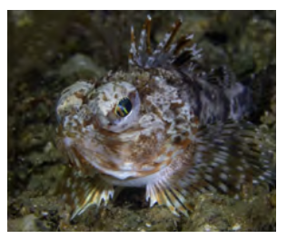
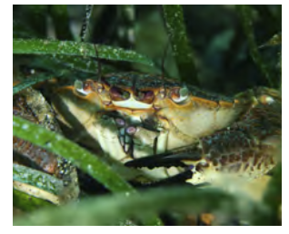
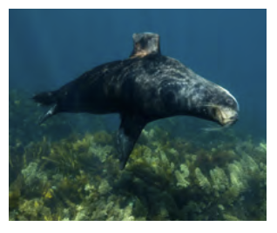
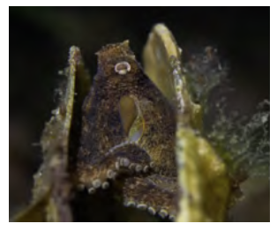
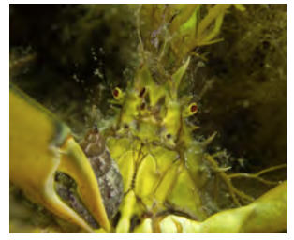
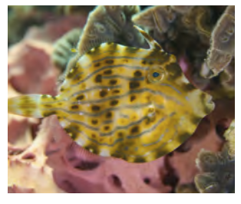

10. Create a classification key for these species using yes/no questions and draw the flowchart.

11. Describe how classification may be useful to marine park managers and researchers?

