Islands and
Invasive Species

Worksheets
Coastcare Victoria School Kit

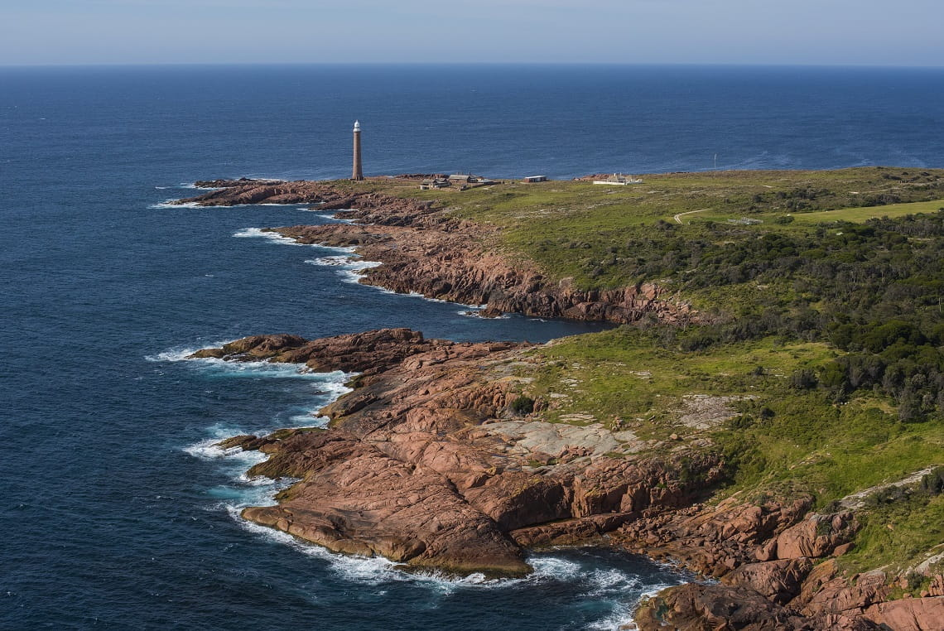

Acknowledgements
Coastcare Victoria would like to acknowledge all our video presenters and individuals who reviewed or assisted with the creation of the Coastcare Victoria School Kit.
Author
Coastcare Victoria and Ecolinc Science and Technology Innovations Centre.
Photo credit
Parks Victoria (David Paul/ Museum Victoria). https://www.parks.vic.gov.au/news/2021/06/07/23/30/protecting-shorebirds-on-important-islands

Contents

Activity 1: Quiz 3
Activity 2: My favourite place 5
Activity 3: Mirror Bush identification 7
Activity 4: Mirror Bush weed map 8
Investigation 1: What makes a species invasive? 9
Investigation 2: Island ecosystems 11
Review questions 13

Activity 1: Quiz
Use this 10-question quiz to assess comprehension and understanding of the video. This could be run as a Kahoot quiz, online form or worksheet.

1. What is the goal of the volunteers?
- To remove every trace of humans from Gabo Island
- The chance to see wildlife
- To make Gabo Island weed free
- To pick up all the litter on Gabo Island

2. What type of rock is Gabo Island?
- Oceanic
- Granite
- Sandstone
- Basalt

3. Where did the Mirror Bush weed come from?
- Seeds dropped by birds
- Escaped from gardens
- Sealers introduced it

4. What is the scientific name of Mirror Bush?
- Diosma
- Woody weed
- Coprosma
- None of the above

5. Mirror Bush competes with native ________ for space on Gabo Island?
- Plants
- Mammals
- Birds
- Rocks

6. How often does weeding on Gabo Island need to be done?
- Once every ten years
- Just once
- Three times a year
- All the time

7. What is another reason that the volunteers were weeding on Gabo Island?
- To make it beautiful
- To watch whales
- To protect native plants
- All of the above

8. Can Gabo Island ever be free of Mirror Bush?
- Yes
- No
- Maybe
- I don’t know

9. Which of these is a native plant which belongs on Gabo Island?
- Feather fern
- Cutting grass
- Downy zieria
- Mirror bush

10. Which of these weeding techniques did you NOT see the volunteers using?
- Weeding by hand
- Covering weeds with matting
- Cutting branches with secateurs (snips)
- Cutting branches with power tools

Activity 2: My favourite place
Everyone is different. We all like different things. We can even have different reasons for liking the same things! In the video, the Friends of Gabo Island volunteers described some reasons that they loved volunteering on the island.
- Define the quotes: Write out an explanation of what you think each quote means.
- Rank these quotes from 1 to 10: Imagine you are going to Gabo Island to do the weeding. Rank these quotes according to you: 1 most important – 10 least important.
- Share your answers with a buddy. Are your reasons for volunteering the same or different?
Rank | Quote
 | - “have a good social time”
 | - “getting to watch whales, birds and seals”
 | - “it’s good for the soul, seeing the rugged beauty that poets would write about”
 | - “helping the island to return to its natural state”
 | - “making space so that native plants can survive”
 | - “making a difference somewhere that can be saved”
 | - “being the only people on the island for 8 days at a time”
 | - “using power tools to rip out weeds”
 | - “removing litter before it enters the ocean”

Think of a place which makes you feel the same way that the Coastcare volunteers feel about Gabo Island. It might be your backyard, favourite park, beach or National Park. It does not have to be a natural place. People also feel connected to their home, school, neighbourhood, or places like the museum. Connection to a place makes people feel good about being there and responsible for protecting and improving their favourite place.

What is your place called?

Where is your place?

Is it natural or man-made (or both)?

Why do you love it?

What work do people do to keep this place the way you love it?
And, which of those jobs would you like to do?

What are three words that you would use to describe your place?
1.
2.
3.

Use these words to write quotes that you would say to share how you feel about your favourite place.

Activity 3: Mirror Bush identification
Could you spot Mirror Bush if it was growing at your favourite beach? It has green leaves – like most plants do. You will need to learn some of its unique traits before you can tell it apart from other weeds and native plants.
Study the photo of Mirror Bush and answer the questions below. You can include sketches if that helps.

- How are the leaves arranged on the stem?

- What size are the leaves?

- What shape are the leaves?

- What colour are the leaves?

- What texture are the leaves?

- What do the veins look like?

- Do the leaves look the same or different on either side?

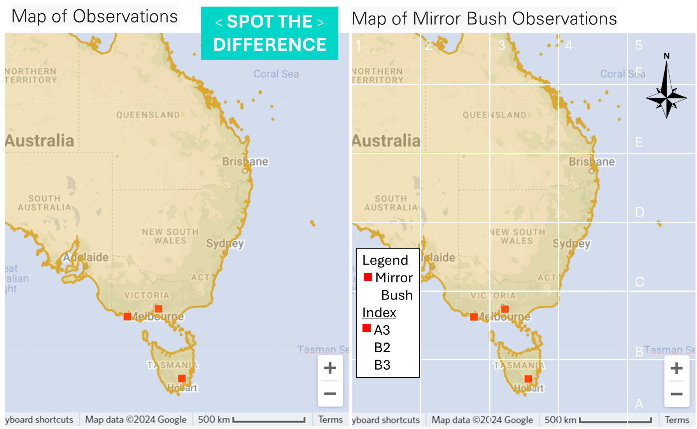
Activity 4: Mirror Bush weed map

Investigation 1: What makes a species invasive?
Table 1: Life history traits
Research the life history traits of Mirror Bush. Go to the iNaturalist Coastcare School Kit Mirror Bush Map and find observations made by user ‘MirrorBushMaster’. Read the notes in these observations and see if you can complete the table below.
Life History Trait | Mirror Bush
Reproduction
Growth rate
Damage

Food
Habitat
Other
Table 2: Create a new weed species

Select ‘weediness’ for each Life History Trait.
Flip a coin: Heads - circle H (high) in weediness; Tails – circle L (low) in weediness.

Describe/sketch your species using the ‘Life History Traits’ and the selected ‘Weediness’.
Name your species.

Life History Trait | Weediness | Species name:
Reproduction | H  L | Species description/sketch
Growth rate | H  L | Species description/sketch
Damage | H  L | Species description/sketch
Food | H  L | Species description/sketch
Habitat | H  L | Species description/sketch

Is there a weak link which would stop your new plant from being a successful invading weed?
Would your weed species invade an island like Gabo Island?

Investigation 2: Island ecosystems
Island ecosystems are different from main-lands or continents due to their small size and isolation.
These are some other ecosystems which are isolated like islands.
Use a search engine to learn what these geographic terms mean and fill in the blanks below:
Island Similes
A lake is like an island of | in an ocean of
A cave is like an island of | in an ocean of
A mountain is like an island of | in an ocean of
An oasis is like an island of | in an ocean of
A nunatak is like an island of | in an ocean of

Just for fun: Use Google Maps to visit Yathkyed Lake, on the Inuit lands of Nunavut, Canada.
Here you can zoom in on an island, which has a lake on it, which has an island in it, which has a lake on it.
What is the geographical term for these islands and lakes?

Species Distribution Mapping (on the next page)
Test your understanding of life history traits and island ecosystems by drawing each species distribution on your blank map.

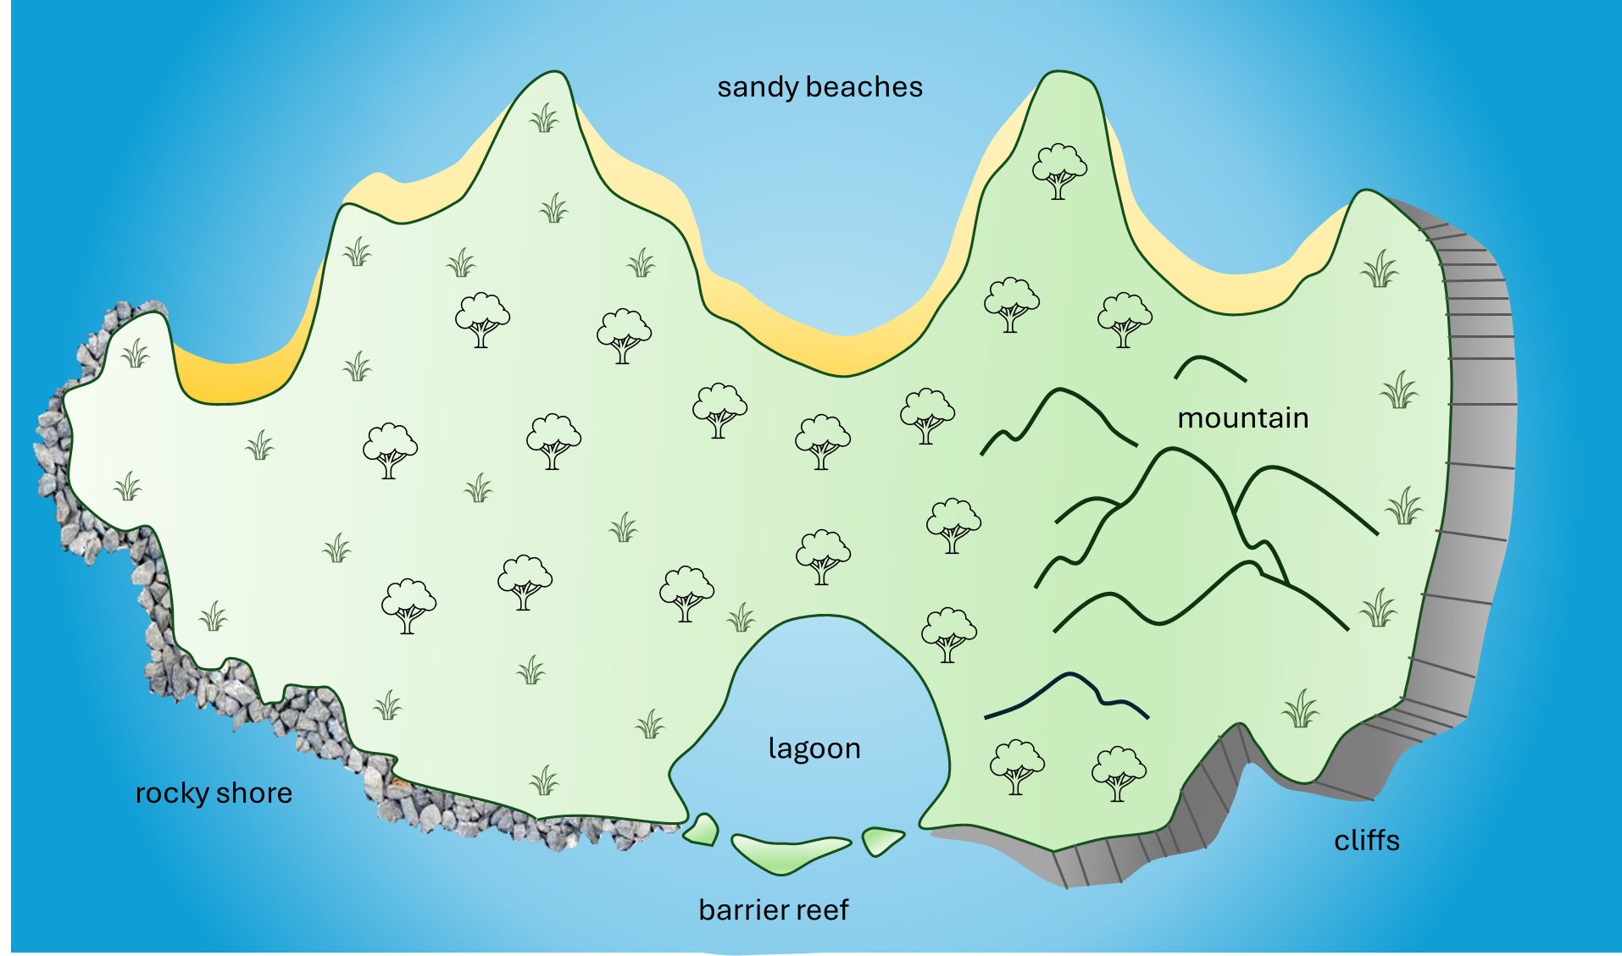

Review questions

- Write a one sentence definition of stewardship. (3 marks)

- Describe a life history trait which makes a species more likely to be invasive? (4 marks)

- List two of the features which make an accurate map [DOGSTAILS]. (2 marks)

- Describe a trait of islands and how it impacts plants or animals in the island ecosystem? (4 mark)

- Why is an island the best place to do a weed eradication program? (2 marks)

