Coastcare Victoria School Kit

|  |
| --- |
| School Kit Answers |

|  |  |
| --- | --- |
|  |  |

Acknowledgements

|  |  |  |  |
| --- | --- | --- | --- |
|  |  |  |  |

Coastcare Victoria would like to acknowledge all our video presenters and individuals who reviewed or assisted with the creation of the Coastcare Victoria School Kit.

Author

Coastcare Victoria and Ocean Imaging.

Photo credit

Ocean Imaging.

|  |
| --- |
| Acknowledgment  We acknowledge and respect Victorian Traditional Owners as the original custodians of Victoria's land and waters, their unique ability to care for Country and deep spiritual connection to it. We honour Elders past and present whose knowledge and wisdom has ensured the continuation of culture and traditional practices.  We are committed to genuinely partner, and meaningfully engage, with Victoria's Traditional Owners and Aboriginal communities to support the protection of Country, the maintenance of spiritual and cultural practices and their broader aspirations in the 21st century and beyond. |
| © The State of Victoria Department of Energy, Environment, and Climate Action 2022  LogoThis work is licensed under a Creative Commons Attribution 4.0 International licence. You are free to re-use the work under that licence, on the condition that you credit the State of Victoria as author. The licence does not apply to any images, photographs or branding, including the Victorian Coat of Arms, the Victorian Government logo and the Department of Energy, Environment, and Climate Action (DEECA) logo. To view a copy of this licence, visit <http://creativecommons.org/licenses/by/4.0/>  ISBN 978-1-76136-062-6 (pdf/ online/ MS word)  Disclaimer  This publication may be of assistance to you but the State of Victoria and its employees do not guarantee that the publication is without flaw of any kind or is wholly appropriate for your particular purposes and therefore disclaims all liability for any error, loss or other consequence which may arise from you relying on any information in this publication.  Accessibility  If you would like to receive this publication in an alternative format, please telephone the DEECA Customer Service Centre on 136186, email [customer.service@delwp.vic.gov.au](mailto:customer.service@delwp.vic.gov.au), or via the National Relay Service on 133 677 [www.relayservice.com.au](http://www.relayservice.com.au). This document is also available on the internet at [www.delwp.vic.gov.au](http://www.delwp.vic.gov.au). |

Contents

Action and Innovation: Litter Stopper Answers 1

Action and Innovation: Litter Stopper Quiz 1

Rock Lobster Pot Experiment Results 3

Pinpointing the Problem Investigation 5

Litter Stopper Review Questions 7

Ecosystems and Edible Urchins Answers 8

Ecosystems and edible urchins Quiz 8

What’s the Problem? Activity 10

Urchin Comic Strip Pictures 11

Sustainable Seafood Worksheet 15

Urchin Adaptation Investigation 17

Urchin Adaptation Types Investigation 19

Top-Down System 20

Volunteering for Threatened Flora 22

Volunteering for Threatened Flora Quiz 22

Binomial Nomenclature Activity 24

Natives and Weeds Investigation 26

Traditional Use of Native Plants 29

Volunteering for Threatened Flora Review Questions 30

Seaweed Solutions for Sustainable Futures Answers 31

Seaweed Solutions for Sustainable Futures Quiz 31

Modern Uses of Seaweed 33

International Use of Seaweed 34

Seaweed Review Questions 35

Sanctuaries and Sea Creatures: Ricketts Point Answers 36

Ricketts Point Quiz 36

Marine Life Bingo 38

Habitats and Adaptations 40

Classification Worksheet 41

Marine Sanctuaries Investigation 43

Ricketts Point Review Answers 44

# Action and Innovation: Litter Stopper Answers

## Action and Innovation: Litter Stopper Quiz

1. Whose traditional lands was this video filmed?

1. Wadawurrung
2. Maribyrnong
3. **Peek Whurrong and Gunditjmara**
4. Wurundjeri

2. What is a problem with plastic on beaches?

1. It may harm birds and marine life
2. It keeps breaking down into smaller pieces
3. It doesn't look nice and can accumulate toxic chemicals
4. **All of the above**

3. What plastic issue first caught Colleen’s attention on local beaches?

1. Fishing debris
2. **Plastic stemmed cotton buds**
3. Red plastic from lobster pots
4. Cigarette Butts

4. Which app were the students using to document the rubbish?

1. Rubbish Racer
2. **Litter Stopper**
3. Trash Trender
4. Waste Watcher

5. How many main item categories are on the frontpage of the App?

1. 15
2. **20**
3. 25
4. 30

6. What did Colleen say were the most common types of plastics found on local beaches?

1. Cigarette Butts
2. Fishing Waste
3. Plastic Bottles
4. **Hard Plastic Remnants**

7. What was the source of the red pieces of plastic from the video?

1. Shopping Trolleys
2. Shopping Baskets
3. **Rock Lobster Pots**
4. Fishing Nets

8. What did fisher Gary do with his rock lobster pots?

1. **Designed new ones with less plastic**
2. Designed new ones with more plastic
3. Sold them to other fishermen
4. Made them cheaper

9. Where does the data from the Litter Stopper app go?

1. A private secret database
2. **A public statewide database**
3. Directly to policy makers
4. Nowhere, it stays on the app.

10. What is the most powerful way to find out what are the most common litter items in your area?

1. **Collect data**
2. Reduce waste
3. More recycling
4. Protests

## Rock Lobster Pot Experiment Results

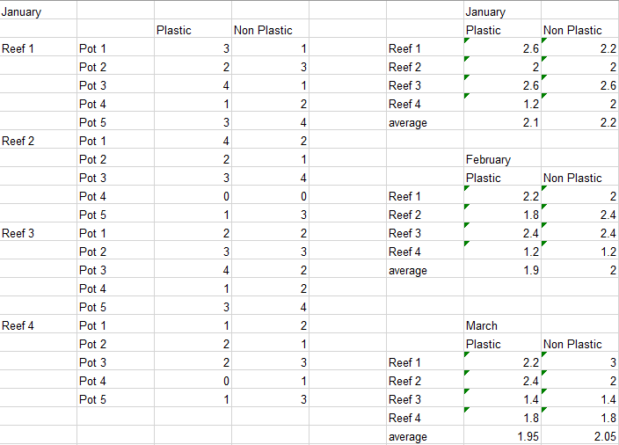

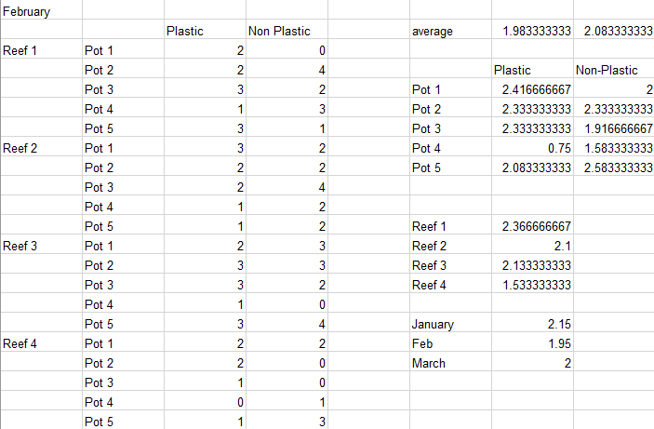

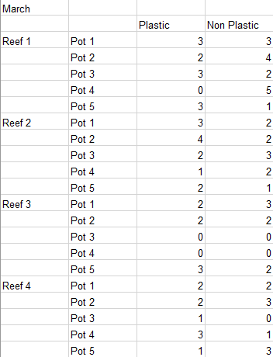

## Pinpointing the Problem Investigation

1. Over what period was the data collected? How long is this?

*From July 2016 to April 2021. 4 years and 9 months*

1. From all of the materials collected, what percentage was plastic? Tip: Look in “Basic Stats.”

*82%*

1. What was the most common item?

*Plastic bits & pieces hard & solid, over 54%*

1. What percentage did sanitary items make of the total number of items?

*7%*

1. How many cigarette lighters were found?

*210*

1. Out of the foreign items (click the foreign item tab) what was the most common item?

*Plastic bottles*

1. Out of the foreign items (click the foreign item tab) what was the most common country that items came from?

*China*

1. What brand was the most common Chinese plastic bottle?

*Nongfu*

1. Out of recreational fishing items, what was the trend in fishing lures being found? (Click the selected items tab)

*Each year there were consistently more lures being found.*

1. Which commercial fishing items were the biggest problem?

*Rope & net scraps less than 1 metre*

1. What year was commercial rope & net scraps less than 1 metre the highest?

*2020*

1. How many wooden fishing items were found over the whole period?

*5*

1. Why do you think this number (in response to q12) was so high or low?

*So low because wood decomposes, plastic doesn’t. Not many fishing items made from wood anymore.*

1. Were more plastic bottles or plastic lids found?

*Plastic lids*

1. Why do you think this was the case? (Relating to answer to question 14)

*Plastic lids float and the bottles don’t.*

*Plastic lids don’t turn into smaller plastics as fast as the bottles*

## Litter Stopper Review Questions

1. Describe how plastic may affect marine and coastal animals.

*Animals might confuse plastic for food, plastic may suffocate animals, stomachs may fill animals with plastic, and they starve, plastic may cause entanglement.*

1. A local clean up group were finding lots of plastic toothbrushes on their local beach. Describe what steps could be taken by the group to help drive change in their community.

*Collect data about how many they are finding, find out the common types and where they are coming from, raise awareness about the issue by presenting the data in an impactful way, promote plastic free alternatives such as wooden toothbrushes.*

1. Describe how the Litter Stopper app works.

*Groups clean up an area, categorise the find, use the app to tap on the icon that best represents each category, take a photo of the litter, add details about how many people were involved and how much distance was covered etc. Data goes into a big database.*

1. Describe what happens to a lot of large pieces of plastic over time if they aren’t collected.

*The plastic breaks down into smaller pieces of plastic. This makes them harder to find and collect.*

1. Describe an event by a local volunteer group that you could contribute to help make the place more liveable, or briefly describe a made-up event that may help make your local place more liveable.

*Answers may vary.*

*Example answer:*

*Event: #SeaToSource, a project powered by Conservation Volunteers Australia*

*Purpose: Conducting monitoring of litter load to find out common items of ocean litter.*

*Date and location: Event on 8th of June, 2pm at Werribee River.*

Ecosystems and Edible Urchins Answers

## Ecosystems and edible urchins Quiz

1. For how many years have Paul and his colleagues been surveying this reef at Williamstown?

1. 2
2. 4
3. 6
4. **12**

2. What three things were the divers measuring in the surveys?

1. Urchin diversity, fish densities and kelp cover
2. **Kelp cover, seaweed diversity and urchin densities**
3. Rock distance, seaweed height and number of urchins removed
4. Distance from shore, ocean temperature, food abundance.

3.  Which urchin species was being collected on the dive?

1. Long spined sea urchin
2. **Short spined sea urchin**
3. Black spikey sea urchin
4. Rough edged sea urchin

4. What do sea urchins usually eat?

1. Zooplankton
2. Phytoplankton
3. **Drifting seaweed**
4. Small starfish

5. What factor caused the seaweeds to grow prolifically in the 1950’s and 1960’s?

1. Temperature
2. Sunlight
3. **Nutrients**
4. Currents

6. What helped the urchin populations increase so dramatically?

1. Lack of predators
2. **Abundance of food**
3. Lack of seaweed
4. Warm temperatures

7. Why did the urchins change from ’couch potato’ mode to ‘army mode’?

1. **Less seaweed around so they needed to fight for it**
2. Chemicals in the water
3. Huge appetite brought on by temperature
4. Battle with the other urchin species

8. How many short spined urchins can a recreational fisher with a license catch in a day?

1. 20
2. 30
3. **40**
4. 80

9. What part of the sea urchin is eaten?

1. The short spines
2. The mouth muscle
3. The eyes
4. **The roe (eggs)**

10. What rule needs to be considered when catching urchins?

1. **Must be caught below 2m deep**
2. Must be caught with gloves
3. Must be cooked within 2 hours
4. Must be taken from a sanctuary zone.

## What’s the Problem? Activity

As the video plays underline biotic (living) factors and **circle abiotic (non-living factors)**

What we think has happened over time is a combination of all of the nutrients actually coming into Port Phillip Bay, with all of the **sewerage wastewater** that's been coming in, in here since the 50s and 60s. And that has basically driven a change in this ecosystem from the bottom up.

And all of those **excess nutrients in the water** actually drove a whole lot of other weedy seaweed species to massively proliferate. And when you have a whole lot of food, then other species will come along and make the most of that. And so sea urchins love to sit there on a rock and eat whatever drifting bits of seaweed are coming by, and so with all this extra seaweed that was now out there and floating around it built a larger sea urchin population in the bay.

But then what happened, we got to the Millennium drought, which was from the end of the 1990s, and through the 2000s. So, a long period **of increased temperatures**, but also **reduced nutrients** that were actually now coming into the bay. And so, now all of a sudden, we had **less nutrients** in the bay, and less seaweed that was now growing and proliferating because of it.

And that meant we had way more urchins. So, we had really high urchin numbers. And the seaweed populations were down here. So, they switched from couch potato mode to actually active foraging, kind of army mode. And instead (of waiting for food), moving around and eating and clearing all of the seaweeds and the kelps off the reef.”

## Urchin Comic Strip Pictures

|  |
| --- |
|  |
| What we think has happened over time is a combination of all of the nutrients actually coming into Port Phillip Bay, with all of the sewerage wastewater that's been coming in here since the 50s and 60s. And that has basically driven a change in this ecosystem from the bottom up |

|  |
| --- |
|  |
| All of those excess nutrients in the water actually drove a whole lot of other weedy seaweed species to massively proliferate. |

|  |
| --- |
|  |
| And when you have a whole lot of food, then other species will come along and make the most of that. And so sea urchins love to sit there on a rock and eat whatever drifting bits of seaweed are coming by, and so with all this extra seaweed that was now out there and floating around it built a larger sea urchin population in the bay |

|  |
| --- |
|  |
| Then what happened, we got to the Millennium drought which was from the end of the 1990s, and through the 2000s. So a long period of increased temperatures, but also reduced nutrients that were actually now coming into the bay. And so, now all of a sudden, we had less nutrients in the bay, and less seaweed that was now growing and proliferating because of it. |

## Sustainable Seafood Worksheet

|  |  |  |  |  |  |  |
| --- | --- | --- | --- | --- | --- | --- |
| **Marine species** | **Species name** | **Diet** | **Prey size** | **Trophic Level** | **Sustainability prediction** | **Sustainability** |
| Blacklip abalone | *Haliotis rubra* | Seaweed | small | Herbivore |  | Green |
| Sea Urchin | *Heliocidaris erythrogramma* | Seaweed | small | Herbivore |  | Green |
| Bluethroat wrasse | *Notolabrus tetricus* | Crustaceans and mollusks | small | Carnivore |  | Green |
| Blue Mussel | *Mytilus planulatus* | Phytoplankton | small | Herbivore |  | Green |
| Oysters | *Saccostrea glomerata* | Phytoplankton | small | Herbivore |  | Green |
| Luderick | *Girella tricuspidata* | Seagrass and Algae | small | Herbivore |  | Green |
| Australian Sardine | *Sardinops sagax* | Phytoplankton and zooplankton | small | Omnivore |  | Green |
| Southern Calamari | *Sepioteuthis australia* | Small fish and crustaceans | medium | Carnivore |  | Green |
| King George Whiting | *Siliagnodes punctata* | Crustaceans and worms | medium | Carnivore |  | Green |
| Australian Salmon | *Arripis trutta* | Small fish | medium | Carnivore |  | Orange |
| Southern Rock Lobster | *Jasus edwardsii* | Mussels, abalone, urchins. | small | Carnivore |  | Orange |
| Snapper | *Pagrus auratus* | Crustaceans, urchins, shellfish | medium | Carnivore |  | Red |
| Yellowfin Tuna | *Thunnus albacares* | Fish, crabs | large | Carnivore |  | Red |
| Gummy Shark | *Mustelus antarcticus* | Octopus, cuttlefish, small fish. | large | Carnivore |  | Red |
| Swordfish | *Xiphias gladius* | fish | large | Carnivore |  | Red |

## Urchin Adaptation Investigation

Urchins are highly successful animals that can be found in all of the world’s oceans. There are 950+ species worldwide. Only an animal highly suited (adapted) to its environment could be so successful. In this activity you will investigate the various adaptations of sea urchins and their adaptations.

Use the internet to research the following questions

1. What characteristics do all sea urchins have in common that make them well suited to their environment?

*spherical in shape, hard shells, spiny, tube feet,*

1. In the space below, draw a labelled diagram of a sea urchin. (if doing online, create, save and paste an image in space below).

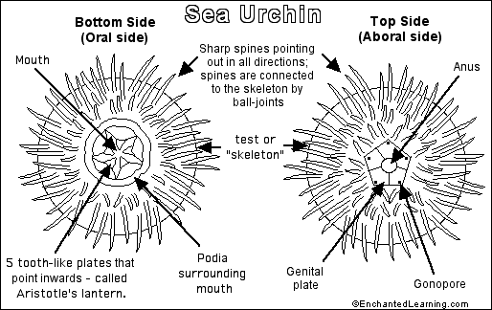

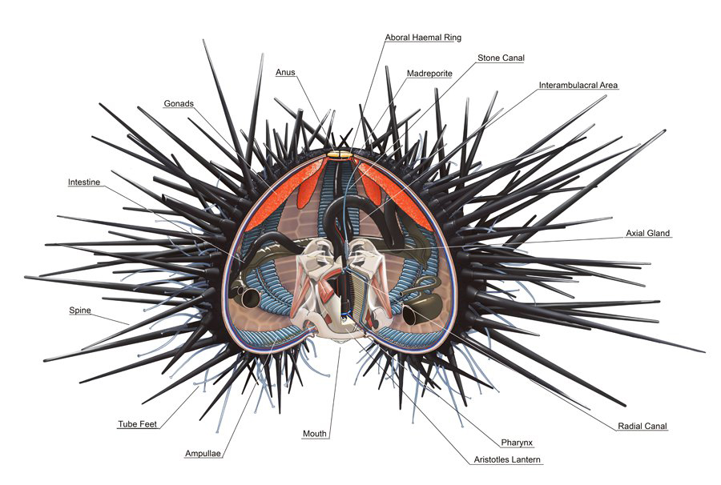

1. What sea creatures are sea urchins closely related to?

*Echinoderms - sea stars, brittle stars, feather stars, sea cucumbers, sand dollars*

1. How do sea urchins move?

*Sea urchins move slowly, crawling with tube feet, and also propel themselves with their spines.*

1. How do sea urchins reproduce?

*Sea urchins have separate male and female sexes.*

*Sea urchins reproduce by sending clouds of eggs and sperm into the water where fertilisation takes place. Millions of larvae are formed, but only a handful make it back to the shoreline to grow into adults.*

1. Choose another ocean animal. Record and compare their adaptations to the sea urchin in the space below.

*Answers may vary*

## Urchin Adaptation Types Investigation

Record the category(s) of adaptation in the space below: Note some adaptations may have multiple categories.

1. They can survive in low food environments by shrinking their shell size (if you are smaller, you need less food)

*Physiological/ Structural*

1. They put less investment in reproduction in low food environments. Less energy in the roe (eggs and gonads)

*Behavioural*

1. Spines - protects them from predators and they can also use them to catch bits of seaweed as they float past. They also use the spines to pass food to the underneath side where their mouth is.

*Structural/ Behavioural*

1. Mouth on the bottom - this means they can graze along the rock and eat anything that’s attached there. The mouth is called an Aristotle’s lantern and looks a bit like a beak.

*Structural*

1. Sea urchins move by walking, using their many flexible tube feet.

*Structural*

## Top-Down System

Trophic levels are an organism's position in the food web. In the top-down control, the populations of the organisms at lower trophic levels (bottom of the pyramid) are controlled by the organisms at the top.

Use the following words to match the letters with the correct trophic levels below:

primary consumer, primary producer, secondary consumer, tertiary consumer

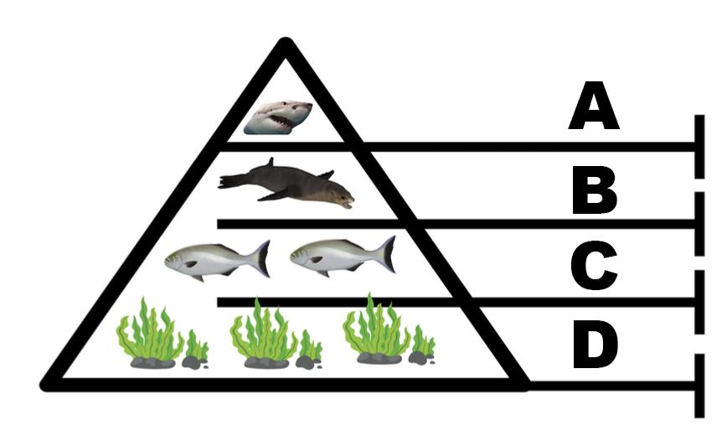

A = *Tertiary Consumer*

B = *Secondary Consumer*

C = *Primary Consumer*

D = *Primary Producer*

(4 marks)

The top-down control of an ecosystem is also called the predator-controlled food web. Explain why. (2 marks)

*Populations of the organisms with lower trophic levels (bottom of the pyramid) are controlled by the organisms at the top.*

In a top-down controlled ecosystem like the one above, what might happen if predator numbers go down? (3 marks)

*More sea lions may mean less herbivorous fish and more seaweed.*

*Less sea lions or less sharks may mean more herbivorous fish and less seaweed.*

4. Finish this sentence: (1 mark)

In the diagram below, the ecosystem is controlled from *The bottom up.*

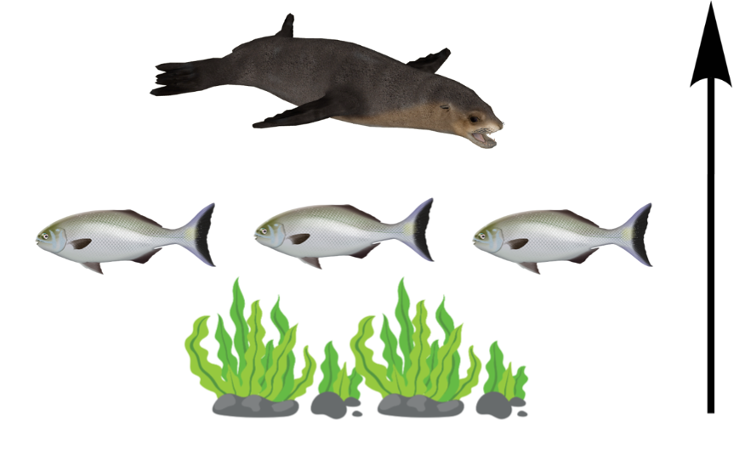

5. What is likely to control the number of fish that may be able to live in this ecosystem? (1 mark)

*The amount of seaweed*

6. Name three factor that may impact the amount of seaweed that is able to grow in this ecosystem? (1 marks)

*Accept any 3 of:*

*Sunlight, temperature, number of herbivores, space, oxygen, nutrients, pollution.*

7. What might happen if the amount of seaweed was to be reduced in this ecosystem? (1 mark)

*Less food available for fish. The ecosystem wouldn’t be able to support as many fish*

# Volunteering for Threatened Flora

## Volunteering for Threatened Flora Quiz

1. Which of these wasn’t a step Naomi gave to protect the habitat?

1. Always stick to paths
2. Leave only footprints
3. **Always go in a large group**
4. Consider volunteering to help

2.  Coastal Moonah woodland is a ___________plant community

1. Large
2. **Threatened**
3. Resilient
4. Critically endangered

3.  What are one of the biggest threats that the Moonah woodland faces?

1. **Invasive woody weeds**
2. Invasive birds
3. Pollution
4. Poor soil quality

4. Polygala myrtifolia is a

1. Native species
2. Non- invasive species
3. **Woody weed**
4. None of the above

5. *Polygala myrtifolia* drops how many seeds each year?

1. Hundreds
2. **Thousands**
3. Millions
4. Billions

6. Invasive weeds compete with natives for

1. Soil and Water
2. Fruits and seeds
3. Carbon Dioxide and Air
4. **Light, Nutrients and Space**

7.  What were the volunteers doing in the video?

1. **Removing weeds**
2. Removing native plants
3. Planting native plants
4. Planting weeds

8. What did volunteer Marvyn see once the Polygala was removed?

1. Small native trees and shrubs coming through
2. In season orchids
3. More weeds
4. **Both a and b**

9. Why is this work especially important in this area?

1. **A lot of land clearing in the area so not much native vegetation left.**
2. Few animals live in the area
3. Remote and hard to get to.
4. The area is regularly visited by many people

10. What was one of the other benefits of volunteering that was mentioned?

1. Takes a lot of time
2. Can be hard work
3. **Good for mental health**
4. Make a lot of money

## Binomial Nomenclature Activity

|  |  |  |
| --- | --- | --- |
| Species Name | Common name(s) | Native or introduced? |
| *Melaleuca lanceolata* | black paperbark,  Moonah,  Rottnest Island tea tree  western black tea tree | *Native* |
| *Spinifex sericeus* | hairy spinifex,  rolling spinifex,  beach spinifex  coastal spinifex, | *Native* |
| *Tetragonia implexicoma* | bower spinach | *Native* |
| *Alyxia buxifolia* | sea box  dysentery bush | *Native* |
| *Polygala myrtifolia* | myrtle-leaf milkwort | *Introduced* |
| *Aparagus asparagoides* | bridal creeper,  bridal-veil creeper,  Gnarboola,  Smilax  smilax asparagus | *Introduced* |
| *Chrysanthemoides monilifera* | boneseed | *Introduced* |
| *Ulex europaeus* | *Gorse*  *common gorse*  *Furze*  *whin* | *Introduced* |

2. What is one advantage of using binomial nomenclature? (1 mark)

It is consistent and used everywhere

It avoids having the same common name for different species

The names are unique - one name for one species

3. What are two problems with using common names only? (2 marks)

*Different species may have the same common names*

*Common names often have a very local distribution*

*A single species may be known my several common names*

*Language difference in different countries*

*May cause confusion*

*Many rare species do not have a common name*

4. What does the first name in binomial nomenclature stand for? (1 mark)

*Genus*

5. True or false, a genus can include more than one species. (1 mark)

*Tr*

## Natives and Weeds Investigation

|  |  |  |  |  |  |  |
| --- | --- | --- | --- | --- | --- | --- |
| **Common name** | **Scientific name** | **Native or Weed** | **Plant type** | **Plant size** | **Flowering Season** | **Unique features** |
| **Moonah** | *Melaleuca lanceolata* | Native | Tree | 10m high  6m wide | September to  December | -creamy flower-spikes  -seeds are contained within woody capsules |
| **Hairy Spinifex** | *Spinifex sericeus* | Native | Ground Cover | 60cm high  4m wide | February | -long flat leaves  -erect orange brown flowers  -clustered flowers that resemble tumbleweeds |
| **Bower Spinach** | *Tetragonia implexicoma* | Native | Creeper / Climber | 3m high  2m wide | August - November | -red berries  -fragrant yellow flowers |
| **Sea Box** | *Alyxia buxifolia* | Native | Shrub | 3m high | Spring - Autumn  Ie. Sep - May | -smooth leathery leaves  -dense shrub  -white flowers |
| **Myrtle-leaf Milk-wort** | *Polygala myrtifolia* | Weed | Shrub | 4m high | Year round but mainly late winter to spring Aug - Oct | -pea-like flowers with spreading wings  -clustered leaves on outer branches |
| **Bridal Creeper** | *Aparagus asparagoides* | Weed | Creeper /  Climber | 3m high | July to September | -white to pale green flowers  -dense root system |
| **Boneseed** | *Chrysanthemoides monilifera* | Weed | Shrub | 3m high  3m wide | Year round but mostly cooler late autumn and winter ie. May - Aug | -small shrub  -yellow flowers  -green, thick and soft leathery flowers |
| **Gorse** | *Ulex europaeus* | Weed | Shrub | 2.5m high | Year round but mostly late winter early spring ie. Aug-Oct | -dense shrub  -spiral arranged leaves with waxy coating  -yellow, pea-like flowers |

|  |  |  |  |  |  |  |  |  |  |  |  |  |
| --- | --- | --- | --- | --- | --- | --- | --- | --- | --- | --- | --- | --- |
| Moonah |  |  |  |  |  |  |  |  |  |  |  |  |
| Hairy Spinifex |  |  |  |  |  |  |  |  |  |  |  |  |
| Bower Spinach |  |  |  |  |  |  |  |  |  |  |  |  |
| Sea Box |  |  |  |  |  |  |  |  |  |  |  |  |
| Myrtle-leaf Milk-wort |  |  |  |  |  |  |  |  |  |  |  |  |
| Bridal Creeper |  |  |  |  |  |  |  |  |  |  |  |  |
| Boneseed |  |  |  |  |  |  |  |  |  |  |  |  |
| Gorse |  |  |  |  |  |  |  |  |  |  |  |  |
|  | Jan | Feb | Mar | April | May | Jun | Jul | Aug | Sep | Oct | Nov | Dec |

## Traditional Use of Native Plants

|  |  |  |  |  |
| --- | --- | --- | --- | --- |
| **Plant Name** | **Food/Drink** | **Medicine** | **Tools** | **Ceremony** |
| Blackwood | ✅ | ✅ | ✅ |  |
| Water Plantain |  | ✅ |  |  |
| Sea Celery | ✅ |  |  |  |
| Silver Banksia | ✅ |  | ✅ | ✅ |
| Hop Bush |  | ✅ | ✅ |  |
| Coastal Manna-gum | ✅ | ✅ | ✅ |  |
| Burgan |  |  | ✅ |  |
| Native Raspberry | ✅ | ✅ |  |  |
| Bower Spinach | ✅ | ✅ |  |  |
| Seaweed | ✅ | ✅ | ✅ | ✅ |

## Volunteering for Threatened Flora Review Questions

1. What makes a good botanical illustration? (3 marks)

Aim to draw as accurately as possible so that every detail of the object is represented.

A true and lifelike representation of a plant.

Highlight a plant's particular distinguishing features which enable botanists to tell one plant from another.

Reveal a plant's physical structure such as the arrangement of reproductive parts, leaves, and stems with a three-dimensional quality.

1. What are the four main categories of the traditional uses of native plants by Indigenous Australians? (4 marks)

Food, medicine, tools, ceremony.

1. What makes invasive weeds a problem in native habitats? (2 marks)

*They compete with natives for light, space, and nutrients. They may reproduce and spread rapidly.*

1. What can volunteers do to help threatened flora? (2 mark)

Volunteer to plant more natives, remove weeds and pest species, educate themselves and their community about threatened flora and why they are threatened.

1. Describe the benefits of a native garden (4 marks)

Native plants support native animal species, native gardens may use less water, reduce garden maintenance costs, decrease gardening, and time commitments.

# Seaweed Solutions for Sustainable Futures Answers

## Seaweed Solutions for Sustainable Futures Quiz

1. Aunty Judy explained that seaweeds were important because they
2. Provide food for fish
3. Feed the environment
4. Clean the waterways
5. **All of the above**
6. Zoe talks about Aboriginal uses of seaweeds. Which of these was not listed?
7. Food and medicine
8. Building houses
9. **Packaging products**
10. Clothing and ceremony
11. What animals were fed seaweeds in the video?
12. Chickens
13. **Cows**
14. Pigs
15. Horses
16. Aunty Judy’s knowledge was passed on through her
17. **Ancestors**
18. Friends
19. Grandpa
20. Connection to country
21. What advantage might there be in using seaweed instead of plastic?
22. Cheaper
23. **Biodegrades faster**
24. Faster to make
25. All of the above
26. Finish this sentence from the video. “Each piece of land has a unique ______”
27. Smell
28. Taste
29. **Culture**
30. Temperature
31. What did Zoe think wasn’t already a big part of the Australian identity?
32. Being beach lovers
33. **Having lots of seaweed**
34. Surfing fans
35. Beautiful natural clean environment

1. Why did Lichen Kelp start the portable seaweed library?
2. To keep fit
3. There wasn’t much information on the internet
4. She wasn’t much of a reader
5. **Research as a group would be more fun**
6. Lichen Kelp liked to think of her portable seaweed library as a
7. **Ocean portal**
8. Wormhole
9. Fast ride
10. Seafood database
11. What type of food was being made from seaweed in the video?
12. **Seaweed pasta**
13. Seaweed pizza
14. Seaweed burger
15. Seaweed fries

## Modern Uses of Seaweed

|  |  |  |  |
| --- | --- | --- | --- |
| **Organisation** | **Seaweed Type** | **Products** | **Benefits** |
| [Sea Forest](https://www.seaforest.com.au/) | Red (asparagopsis) | * Feed supplement for cows | * Captures carbon * Reduces methane production in cows |
| [Phyco Health](https://www.phycohealth.com/blogs/news/seaweed-for-the-planet) | Green (ulva 84) | * Skin care * Supplements * Food | * Reduce pressure of land crops * Captures carbon * Health benefits |
| [Notpla](https://www.notpla.com/frequently-asked-questions/) | Brown Seaweed | * Seaweed packaging for food * Seaweed packaging for other products * Seaweed paper | * Biodegradable * Reduces need for plastics and plastic waste |

## International Use of Seaweed

|  |  |  |  |
| --- | --- | --- | --- |
| **Seaweed Name** | **Food Uses** | **Country of Origin** | **Seaweed type and species name** |
| **Nori** | Dried edible seaweed used to wrap sushi | Japan | Red: *P. yezonesis* and *P. tenera.* |
| **Wakame** | Often served in soups like Miso soup and salads | Japan | Brown kelp: *Undaria pinnatifida* |
| **Kombu** | Dried of picked in ginger or make tea | Japan | Various Brown kelp |
| **Dulse** | Baking, flakes, powder, drinks | North American | Red: *Palmaria palmata* |
| **Irish Moss** | Ingredient in puddings, ice cream, beer. | Europe, North American | Red: *Chondrus crispus* |
| **Cochayuyo** | Stews and soups | Chille | Brown kelp: *Durvillaea antarctica* |

## Seaweed Review Questions

1. What are the three main seaweed groups? (3 marks)

*Brown, Green and Red*

1. What are three things that all seaweeds have in common? (3 marks)

*Get energy from the sun, they photosynthesise, they make their own energy, they are producers, they are algae, they produce oxygen, they require nutrients to grow.*

1. Which species of seaweed grows right across southern Australia and helps form the Great Southern Reef? (1 mark)

*Golden Kelp*

1. Describe two ways that Aboriginal Australians traditionally used seaweed. (2 marks)

*Food, Medicine, Shelter, Clothing, Spiritual Ceremony.*

1. Describe three ways that seaweeds are being used in emerging modern industries in Australia. (3 marks)

*Food for cows to reduce methane emissions, making seaweed plastic, food for humans, moisturiser, pharmaceuticals.*

# Sanctuaries and Sea Creatures: Ricketts Point Answers

## Ricketts Point Quiz

1.  What year was the sanctuary established?

1. 1999
2. **2002**
3. 2005
4. 2013

2.  How many sanctuaries are there in the north of Port Phillip Bay?

1. Granite
2. Sandstone
3. **Limestone**
4. Metamorphic

3.  What type of rock are the rocky reefs made of?

1. Granite
2. Sandstone
3. **Limestone**
4. Metamorphic

4. How large can the banjo ray grow?

1. .5m
2. 1m
3. **1.5m**
4. 2m

5.  What animals migrate to Ricketts point at the beginning of summer?

1. Birds
2. Fish
3. **Sharks**
4. Turtles

6.  Why do these animals migrate to Ricketts Point?

1. To mate
2. To lay eggs
3. **Both a and b**
4. Neither a or b

7. Which fish were shown as juveniles in the video?

1. Dusky morwong and sea sweep
2. Banjo rays and Port Jackson sharks
3. **Leatherjackets and moonlighters**
4. Magpie perch and hulafish

8. The flathead is ‘top dog’ in which habitat?

1. Rocky reef
2. Kelp forest
3. **Seagrass**
4. Caves

9. Which of these fish were not mentioned in the video?

1. Hulafish
2. Magpie Perch
3. **King George Whiting**
4. Sweep

10. The plants and animals at Ricketts point are part of an interconnected reef system known as?

1. The Great Barrier Reef
2. The Great Ocean Road
3. **The Great Southern Reef**
4. The kelp forest highway.

## Marine Life Bingo

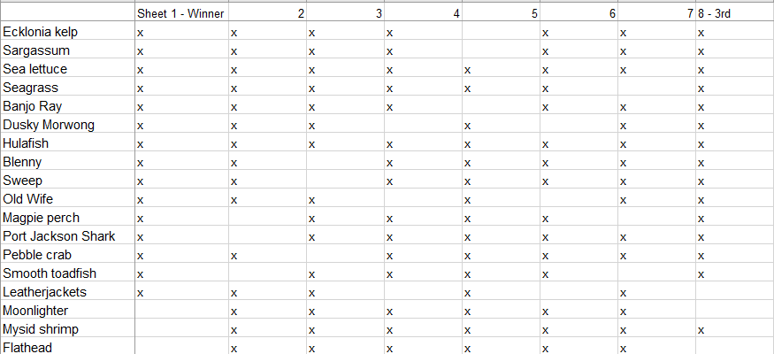

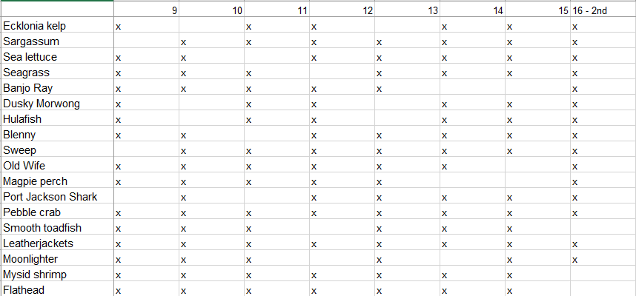

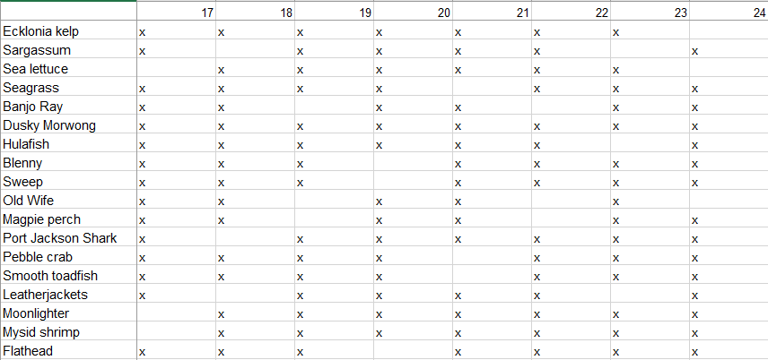

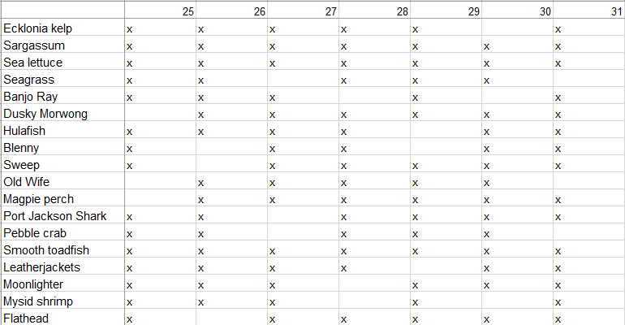

## Habitats and Adaptations

1. Which of your bingo cards are habitats?

*Habitat cards are Ecklonia, Sargassum, Sea Lettuce and Seagrass*

1. How do other organisms benefit from the habitat?

*Food, a place to lay eggs, a place to hide from predators, a place to get out of the strong current / waves, provides oxygen in the water.*

1. Living things have special features called adaptations that help them to survive in their environment. For example, a cuttlefish may release a cloud of ink to escape from a predator. Choose two more species featured in the video. What features might help these organisms survive in this environment?

*Various answers but could include things like:*

1. *Banjo Ray - flattened body for gliding over sandy sea floor in search of prey*
2. *Pebble Crab - large pincer claw for breaking open shells.*
3. *Ecklonia kelp - broad flattened leaves for large surface area to capture sunlight*
4. *Port Jackson Shark - thick skin for protection. Strong jaw and molar like teeth for crushing prey.*

1. There are three different categories for adaptations. Write a definition for each type in the space below:

*Behavioural - responses made by an organism that help it to survive/reproduce.*

*Physiological - a body process that helps an organism to survive/reproduce.*

*Structural - a feature of an organism's body that helps it to survive/reproduce.*

1. Put a letter B, P or S next to your answers in Q3 to identify the type of adaptation e.g., B for behavioural.

## Classification Worksheet

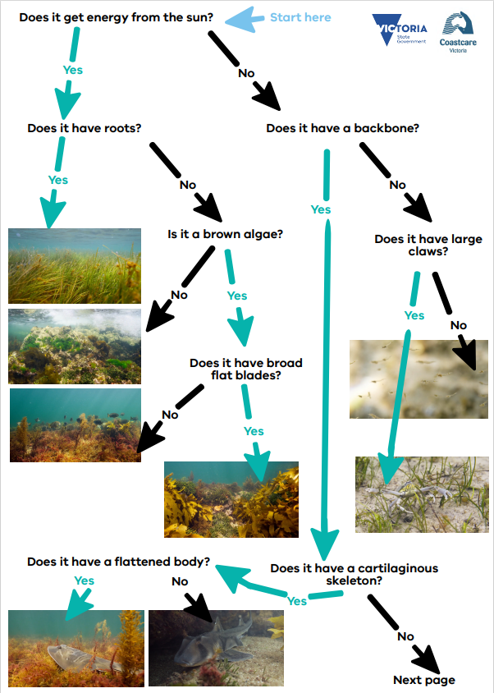

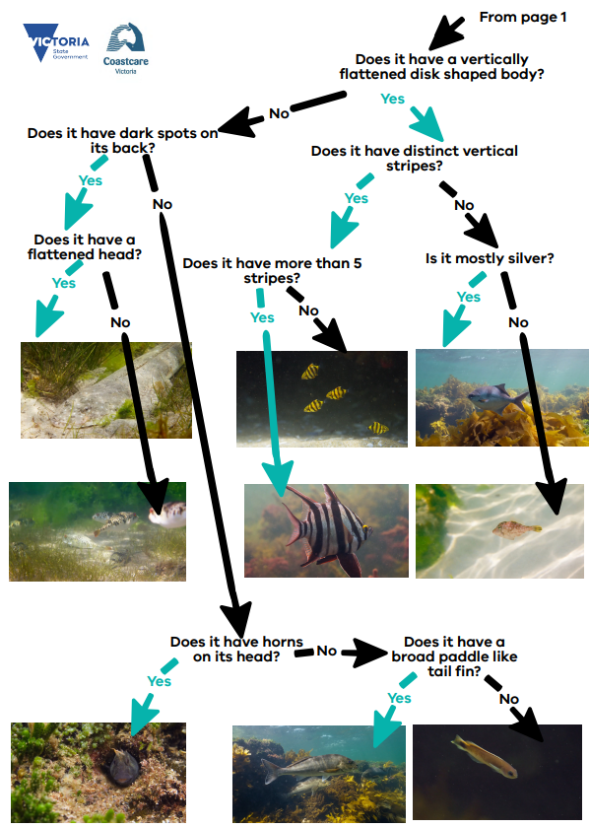

## Marine Sanctuaries Investigation

1. What activities are not permitted in a marine sanctuary? [2 marks]

* *Catching or attempting to catch fish - i.e., fishing lines in water.*
* *Taking any marine life*
* *Being in the water with a spear gun*
* *Extractive or damaging uses*
* *aquaculture*
* *exploration drilling*
* *oil and gas extraction*
* *Dredging*
* *waste disposal*

1. What activities are permitted in a marine sanctuary? [2 marks]

* *Recreation*
* *Tourism*
* *Snorkelling and scuba diving*
* *Education*
* *Research*

*Note that some activities such as research or filming may require a permit.*

1. Why are marine sanctuaries important areas? [2 marks]

* *act as nursery areas for small fish to grow*
* *provide a safe place for fish to breed*
* *provides a place for large fish and animals to grow. These large individually may be ‘super breeders’*
* *creates a baseline for scientists to compare other areas and monitor impact*
* *takes care of the habitat*
* *Acts an educational tool*

1. What is the difference between a marine park and a marine sanctuary? [2 marks]

* *All marine sanctuaries are marine parks but not all marine parks are sanctuaries.*
* *Marine parks have multiple zones - some of these allow various activities like fishing.*
* *In sanctuaries no fishing or extractive activities are allowed*

1. How many other marine parks and sanctuaries are in Victoria? [2 marks]

* *Victoria has 13 marine parks and 11 marine sanctuaries*

## Ricketts Point Review Answers

1. What is a habitat? (1 mark)

*A place where a plant or animal lives.*

1. Why do organisms need a habitat? (2 marks)

*The habitat may provide food, shelter, a place to lay eggs, a place to live*

1. What is an adaptation? (1 mark)

*A special skill or characteristic which helps an animal to survive.*

1. Behavioural adaptations are things organisms do to survive or reproduce. For example - a cuttlefish may release a cloud of ink to escape from a predator. Give one other example of a behavioural adaptation and describe how it benefits the organism. (2 marks)

*Answers may vary.*

1. A physiological adaptation is a body process that helps an organism survive / reproduce. For example - a blue ringed octopus makes venom. Give one other example of a structural adaptation and describe how it benefits the organism (2 marks)

*Answers may vary.*

1. A structural adaptation is a physical feature that helps an organism survive / reproduce. For example - a rock lobster has a hard exoskeleton and long antenna for protection. Give one other example of a physiological adaptation and describe how it benefits the organism (2 marks)

*Answers may vary.*

1. Name two biotic factors that may impact marine life (2 marks)

*Any two or more of: Abundance of predators / prey, abundance of food, parasites, competition for space and food*

1. Name two abiotic factors that may impact marine life (2 marks)

*Any two or more of: Sunlight, salinity, pH, nutrients, water movement, temperature, oxygen, carbon dioxide.*

1. You are a marine park manager and creating a guide for visiting researchers learning to identify marine life in the area. Describe some of the unique physical characteristics of each species

|  |  |
| --- | --- |
|  | ***Gurnard Perch***  *Large eyes*  *Large dorsal spines*  *Large head*  *Shiny, mottled skin* |
|  | ***Brown crab***  *Large claws*  *Horizontally flattened body* |
|  | ***Seal***  *Whiskers*  *Flippers*  *Mostly grey body* |
|  | ***Octopus***  *Camouflaged body*  *Flexible body*  *Tentacles with suckers* |
|  | ***Golden decorator Crab***  *Yellow body*  *Large claws*  *Red eyes* |
|  | ***Leatherjacket***  *Vertically flattened body*  *Disk / dinner plate shaped body*  *Spots and lines*  *Disproportionately small tail*  *Spike on head* |

10. Create a classification key for these species using yes/no questions and draw the flowchart.

Answers may vary. One example as follows

1. *Flattened body?*

*Yes*

1. *Vertically flattened?*

*Yes -* ***Leatherjacket fish***

*No -* ***Brown crab***

*No - go to 2.*

1. *Tentacles with suckers?*

*Yes -* ***Octopus***

*No go to 3.*

1. *Mostly grey body?*

*Yes -****Seal***

*No go to 4.*

1. *Yellow body?*

*Yes -* ***Golden decorator crab***

*No - go to 5.*

1. *Large eyes*

*Yes -* ***Gurnard perch***

11. Describe how classification may be useful to marine park managers and researchers?

*Answers may vary. Example answers such as:*

*Helps researchers know which species there may be more / less of and monitor trends.*

*Park managers will be able to know which species live in the park and help manage them.*

*It will help managers and researchers know if other new species arrive in the area.*

*It helps to create laws and rules around fishing regulations for example.*

*Researchers will be able to focus their studies on specific species and understand them better.*