Frequently Asked Questions (FAQs)
Inverloch Dune Reconstruction and Beach Nourishment Works Community Information Session, Part 1 issued 17 February 2026






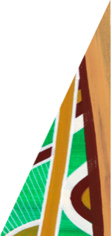


deeca.vic.gov.au

- When will the dune reconstruction and beach nourishment works start and finish?

Mobilisation of equipment and site setup for the dune reconstruction and beach renourishment project will begin in February, followed by the start of dredging works, including the arrival of the dredge at Inverloch, in April. The pumping of sand onto the beach is also scheduled to begin in April, with all works planned to be completed by the end of June 2026, subject to favourable conditions.

- What impacts are expected on beach access and usage during the construction period?

During the construction period, sections of the beach will be closed in stages to minimise disruption to the public and enable continued use and access to the beach. Appropriate fencing and barriers will be installed to prevent public access into the construction site. A fenced construction compound will be set-up for larger equipment including the sand dredge, booster pump and bulldozer.
Effective noise barriers will be in place. An Environmental Management Plan in accordance with EPA noise protocol provisions will outline site specific noise limits, with suitable controls to achieve those limits.
The works have been designed and engineered by independent coastal engineers to protect the dune from further coastal erosion whilst also increasing the beach area. A cutter suction dredge will be used to recover sand from within Anderson Inlet, the sand will then be pumped along the beach to nourishment locations.
- Will the grassed area of Lija Lookout be available for public use on evenings of 20/21 March?

No, this site will be closed due to the construction of the pipeline.

- Could the pipeline be left in place for future renourishment?
Anderson Inlet has been selected as the sand source for this dune reconstruction following an extensive study of offshore and land-based sand options. The Inlet's sand bars contain coarser sand that is better able to hold the designed dune shape and resist storm erosion, which is why this location is suitable for the current nourishment work.
The pipeline used for this project is a temporary working asset designed to operate in very specific conditions. While it is suitable for transferring sand from Anderson Inlet to this project site, its placement and configuration are tailored to the current construction footprint, access constraints and environmental approvals. These factors mean the same pipeline alignment may not be appropriate or necessarily effective for other future renourishment works, which may require different sand sources, different access points, or modified environmental conditions.
For these reasons, all equipment, including the pipeline, will be removed once the project is complete. The pipeline is also needed for use in other locations and cannot remain permanently installed at this site.

- How long will the works offer protection?

The dune reconstruction and sand nourishment works are designed to provide protection for approximately a 10% Annual Exceedance Probability (AEP) coastal event - meaning a storm event with about a 1-in-10 chance of occurring in any given year. While this approach offers an effective short- to medium-term buffer against erosion and storm impacts, the placed sand will naturally adjust to ongoing wave and tidal conditions, gradually reducing over time. This is expected and reflects how nourishments function within dynamic coastal systems. The design accounts for this adjustment by using coarser sand that holds its position better and by building a dune that can be reprofiled as conditions change, providing a natural buffer in front of the existing dune. The nourishment is designed to reduce the rate of erosion of the existing shoreline.

- Have you considered high tides (such as those experienced around Easter time) and storm surges when determining the location of the pipeline?

In most instances, dredging work can continue through storm events, however there are wave height limitations on the vessel where it may be unsafe to operate. In these instances, work may pause for a short time and there may be a reduction in beach plant and machinery. The contractor will be following detailed designs for the beach renourishment, taking high tides into consideration. Information about the design of the sand renourishment and dune reconstruction works can be found in Water Technology’s video from our previous engagement session, held in October 2025, on our website.
- Considering that 100,000 m³ is less than the total amount of sand lost over time, what warranty or performance period is associated with this project?

The aim of the dune renourishment is to inhibit further erosion of the existing shoreline; it will not be returned to a previous state. Sand renourishments do not have warranty periods however the dune reconstruction and sand nourishment works are designed to provide protection for approximately a 10% Annual Exceedance Probability (AEP) coastal event - meaning a storm event with about a 1-in-10 chance of occurring in any given year. While this approach offers an effective short- to medium-term buffer against erosion and storm impacts, the placed sand will naturally adjust to ongoing wave and tidal conditions, gradually reducing over time. This is expected and reflects how nourishments function within dynamic coastal systems. The design accounts for this adjustment by using coarser sand that holds its position better and by building a dune that can be reprofiled as conditions change, maintaining a natural buffer in front of the existing dune. The nourishment is designed to reduce the rate of erosion of the existing shoreline.

- How far out from the dune to water’s edge will width of the sand be?

The nourishment varies in width and height along the extent of the beach. The width of the renourishment typically varies between 20-40m although it may be wider at the western end where the existing dune is setback further. The dune will be narrower on the eastern side of the surf lifesaving club.

Information about the design of the sand renourishment and dune reconstruction works can be found in Water Technology’s video from our previous engagement session, held in October 2025, on our website.

- I can’t visualise what 100,000 cubic metres looks like. How high will the sand be, how much wider will the beach become, and what section of the beach will be renourished?

At the western end of the project area, the rebuilt dune will reach about 4 metres above sea level, tapering gradually to 3–3.5 metres towards the eastern end. The width of the nourishment will vary along the beach, generally between 20 and 40 metres, with the widest area expected at the western end. The dune will narrow near the Surf Life Saving Club and will be placed from near the bend on Cape Paterson–Inverloch Road in the west through to Ozone Street in the east.

Information about the design of the sand renourishment and dune reconstruction works can be found in Water Technology’s video from our previous engagement session, held in October 2025, on our website.

The image below gives an idea of what the rebuilt dunes could look like once the project is finished.

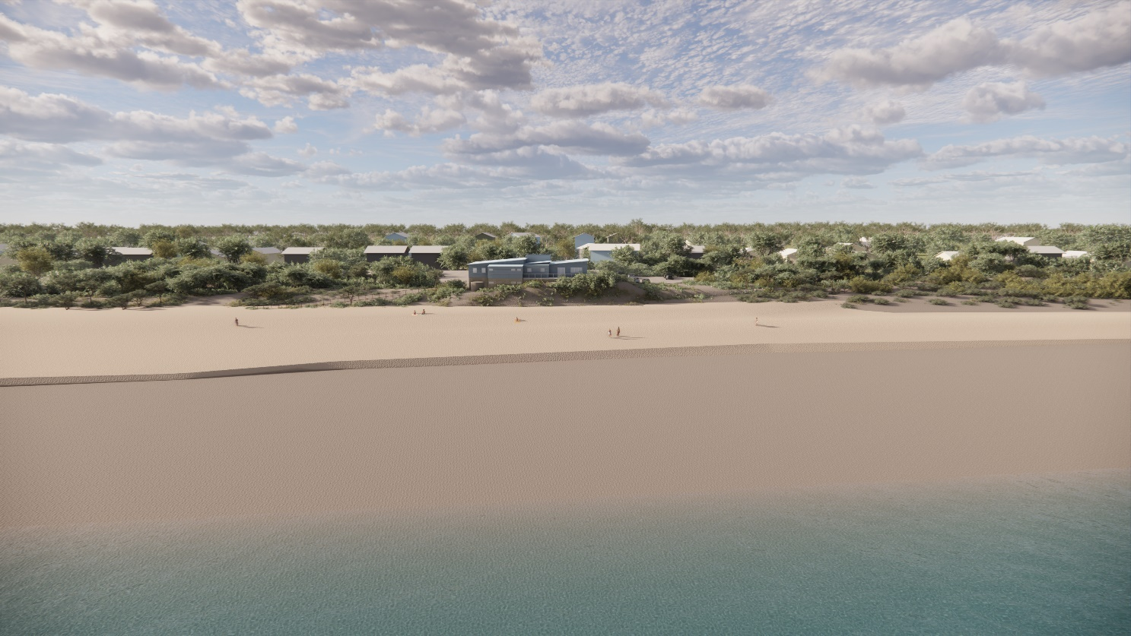
Figure 1: Rendered image of the dune reconstruction and beach nourishment works, Water Technology (2025)

- What are the plans to revegetate the dunes?

DEECA has been working with Bass Coast Shire Council (BCSC) to plan the dune revegetation which will occur once the dune renourishment has had time to settle. Dune revegetation will include local species with the aim to stabilise the renourished dune and enhance biodiversity. DEECA and BCSC have also been working with the South Gippsland Conservation Society and local nurseries to plan for the dune revegetation. Bass Coast Shire Council will provide further information on the dune revegetation project as the project progresses.

Dune vegetation plays a crucial role in stabilising dunes by reducing wind erosion, trapping sand to build and maintain dune structure, and supporting natural recovery after storms. It also provides habitat for native fauna and can adapt to gradual dune movement over time.

- What arrangements are being made to water the plants over summer?

Dune revegetation will include local species suited to the local conditions, with the aim to stabilise the renourished dune and enhance biodiversity. Plant species are likely to be planted in holes with water crystals initially to provide a source of moisture and to assist them with establishing. Plants will be planted in late spring when rainfall is higher, and they will have a few months to establish before the summer heat. Bass Coast Shire Council will provide further information on the dune revegetation project as the project progresses.

- What will happen in the event the profile of the sand (i.e. too large) does not suit the beach it's being pumped onto?

This is very unlikely to occur as a qualified coastal engineer has designed the dune renourishment and beach profile using accurate data and modelling. Further survey work prior to works beginning and oversight by the superintendent, a qualified coastal engineer, will occur throughout the project.

Information about the design of the sand renourishment and dune reconstruction works can be found in Water Technology’s video from our previous engagement session, held in October 2025, on our website.

- Will the western end of renourishment go to the existing rock wall?

The western end of the renourishment begins near the corner of Cape Paterson Inverloch Road and Surf parade.
Information about the design of the sand renourishment and dune reconstruction works can be found in Water Technology’s video from our previous engagement session, held in October 2025, on our website.
- Will the dredged sand cover the sandbags?

Yes, the dredged sand will cover the sandbag seawall once complete with the sandbag seawall providing a secondary layer of defence.

Information about the design of the sand renourishment and dune reconstruction works can be found in Water Technology’s video from our previous engagement session, held in October 2025, on our website.

- How far will the sandbag seawall be extended?

The sandbag seawall extension project managed by Bass Coast Shire Council, includes constructing approximately 110 metres of new sandbag wall to the east and west of the existing structure, repairing existing bags and access tracks, extracting and transporting sand from Point Norman to fill the sandbags, and undertaking reinstatement works including shrub planting where they have been disturbed by the works. For more information visit Bass Coast Shire Council’s Inverloch Coastal Management webpage.

- Will the creek opening still be maintained for Wreck Creek? The current outlet under the Cape Paterson/Inverloch Road is regularly backed up with sand. Also, a dune is forming on that intersection there and is posing a safety hazard
The Wreck Creek entrances have been considered in the design. Drainage allowances have been made through the Wreck Creek entrances to allow flow from these creeks to occur.
Wreck Creek’s outlet and nearby drainage are managed by the West Gippsland Catchment Management Authority in collaboration with Bass Coast Shire Council and Parks Victoria. Both branches of Wreck Creek have been considered during the nourishment design which has been developed to mitigate coastal flood risks. Conditions will be monitored to reduce flood risk during and after the works.
For more information:
- https://ew-data.waterwatch.org.au/estuary/wgcma/304
- https://wgcma.vic.gov.au/explore-the-catchment/estuaries/
- Why aren’t structures such as groynes, seawalls or rock bags being considered as permanent solutions, including the idea of burying small groynes under the sand to stop it moving from west to east?

While structures like groynes, seawalls or rock bags can slow sand movement, they also significantly change how a beach looks, functions and can be used. Even short groynes buried under the sand would eventually become exposed as the beach erodes, altering beach access, safety and recreation. Community engagement has consistently told us that keeping Inverloch Beach as natural and usable as possible is a high priority.
The Cape to Cape Resilience Plan assessed a range of engineering options—including groynes, seawalls and rock bag structures—alongside nature-based approaches. Large-scale beach renourishment, dune rebuilding and vegetation restoration were selected as the preferred actions because they maintain the natural character of the beach while still improving its resilience to erosion and storms.
More detail on the options assessment can be found in:

- The Coastal Adaptation Actions Technical Assessment Report Summary
- Section 4.6 of the Cape to Cape Resilience Plan Deciding on Adaptation, which explains why nature-based options were prioritised over hard engineering structures at this stage.

