Coastcare Victoria School Kit

|  |
| --- |
| Volunteering For Threatened Flora  Teacher Guide |

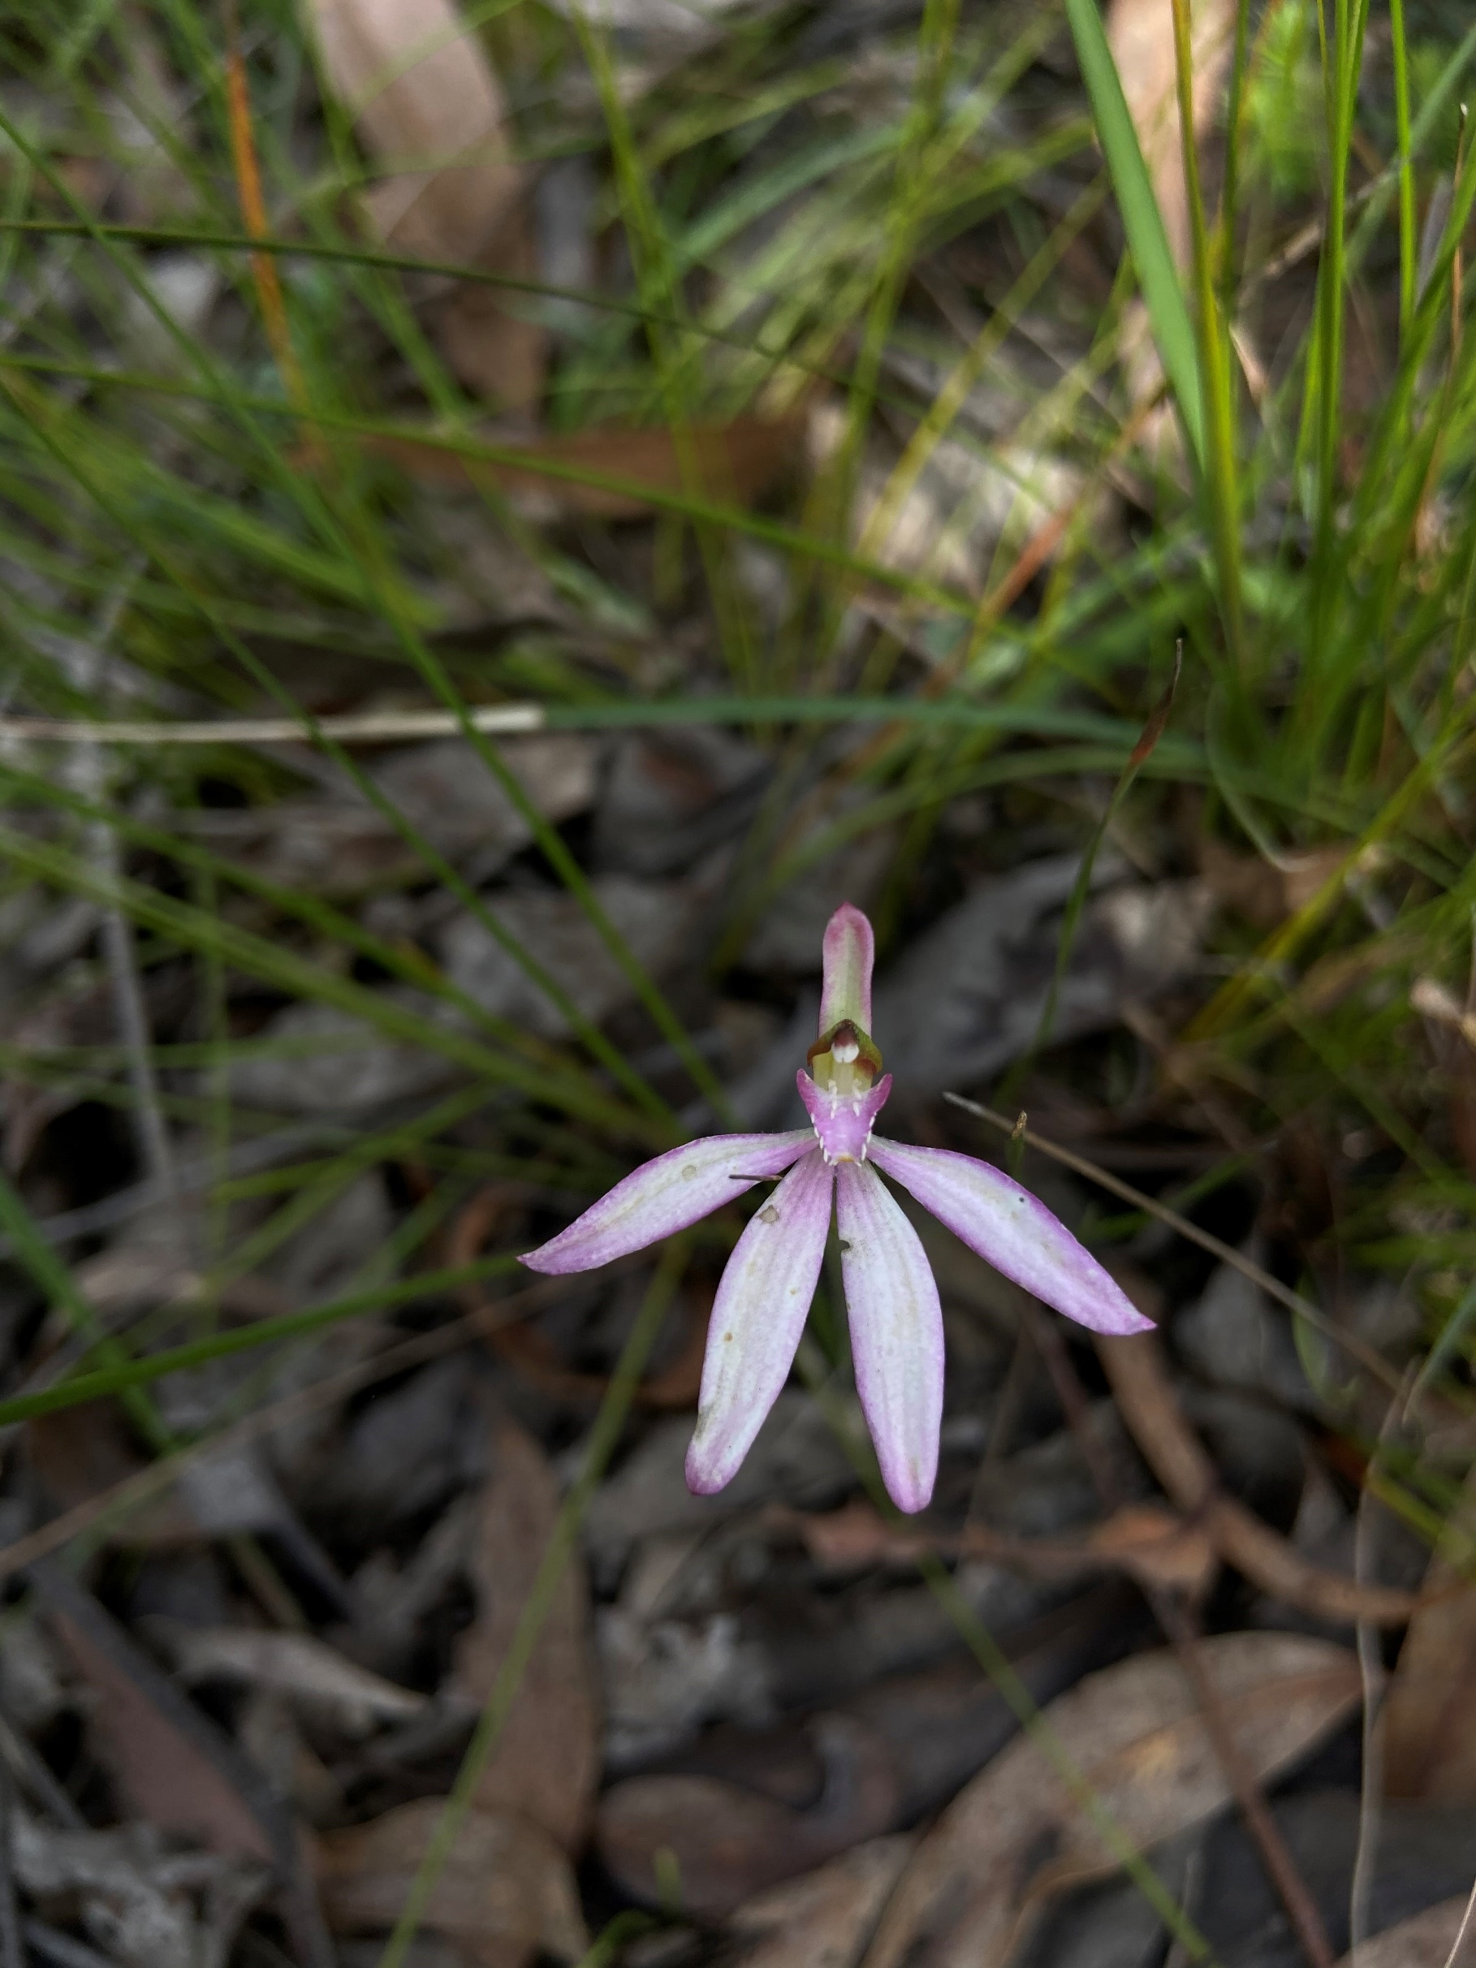

|  |  |
| --- | --- |
|  |  |

Acknowledgements

|  |  |  |  |
| --- | --- | --- | --- |
|  |  |  |  |

Coastcare Victoria would like to acknowledge all our video presenters and individuals who reviewed or assisted with the creation of the Coastcare Victoria School Kit.

Author

Coastcare Victoria and Ocean Imaging.

Photo credit

Ocean Imaging.

|  |
| --- |
| DELWP Pupangarli Marnmarnepu ArtworkAcknowledgment  We acknowledge and respect Victorian Traditional Owners as the original custodians of Victoria's land and waters, their unique ability to care for Country and deep spiritual connection to it. We honour Elders past and present whose knowledge and wisdom has ensured the continuation of culture and traditional practices.  We are committed to genuinely partner, and meaningfully engage, with Victoria's Traditional Owners and Aboriginal communities to support the protection of Country, the maintenance of spiritual and cultural practices and their broader aspirations in the 21st century and beyond. |
| © The State of Victoria Department of Energy, Environment, and Climate Action 2022  LogoThis work is licensed under a Creative Commons Attribution 4.0 International licence. You are free to re-use the work under that licence, on the condition that you credit the State of Victoria as author. The licence does not apply to any images, photographs or branding, including the Victorian Coat of Arms, the Victorian Government logo and the Department of Energy, Environment, and Climate Action (DEECA) logo. To view a copy of this licence, visit <http://creativecommons.org/licenses/by/4.0/>  ISBN 978-1-76136-062-6 (pdf/ online/ MS word)  Disclaimer  This publication may be of assistance to you but the State of Victoria and its employees do not guarantee that the publication is without flaw of any kind or is wholly appropriate for your particular purposes and therefore disclaims all liability for any error, loss or other consequence which may arise from you relying on any information in this publication.  Accessibility  If you would like to receive this publication in an alternative format, please telephone the DEECA Customer Service Centre on 136186, email [customer.service@delwp.vic.gov.au](mailto:customer.service@delwp.vic.gov.au), or via the National Relay Service on 133 677 [www.relayservice.com.au](http://www.relayservice.com.au). This document is also available on the internet at [www.delwp.vic.gov.au](http://www.delwp.vic.gov.au). |

Contents

Curriculum links 1

Key Themes 3

Learning intentions 3

Success Criteria 3

Background 3

Resources 4

Extra links: 4

Lesson Plan 5

Activity 1: Quiz 5

Activity 2: Binomial Nomenclature Activity 5

Activity 2: Native and Weeds Investigation 5

Activity 3: Botanical Illustration 5

Activity 4: Memory Game 5

Activity 5: Flyer Activity 6

Investigation 1: Traditional Uses of Native Plants 6

Investigation 2: Gardens for Wildlife 6

Review Questions 7

Glossary 8

# Curriculum links

|  |  |  |  |
| --- | --- | --- | --- |
| Year 5 and 6 Curriculum Area | C/ Code | Content Description | Elaboration / Link to this lesson/ Learning intentions. |
| Geography /Geographical Knowledge | VCGGK082 | Types of natural vegetation and the significance of vegetation to the environment, the importance of environments to animals and people, and different views on how they can be protected; the use and management of natural resources and waste, and different views on how to do this sustainably | Weeds have major economic, environmental and social impacts in Australia  Native plants and gardens support other native species’ growth. |
| Visual Arts / Present and Perform | VCAVAP031 | Create and display artwork considering how ideas can be expressed to an audience | Creating a flyer to help people understand the threats of introduced weeds |
| Victorian Aboriginal Languages / Communicating / Informing | VCLVC155 | Gather, record and classify information from a range of sources from Country/Place, historical documents and contemporary resources | Aboriginal Australians have a close relationship to native plants and have long utilised them for a variety of functions. |

|  |  |  |  |
| --- | --- | --- | --- |
| Year 7 and 8 Curriculum Area | C/ Code | Content Description | Elaboration / Link to this lesson/ Learning intentions. |
| Science Understanding / Biological science | VCSSU091 | There are differences within and between groups of organisms; classification helps organise this diversity | Classification is a useful tool to help organise the diversity of organisms.  Binomial nomenclature is a "two-part name" referring to the genus and species respectively. |
| Geography /Geographical Knowledge | VCGGK094 | Influence of people, including the influence of Aboriginal and Torres Strait Islander peoples, on the environmental characteristics of Australian places | Aboriginal Australians have a close relationship to native plants and have long utilised them for a variety of functions. |
| Visual Arts / Present and Perform | VCAVAP03 | Create and display artwork considering how ideas can be expressed to an audience | Creating a flyer to help people understand the threats of introduced weeds  Botanical illustration helps reveal a plant's physical structure and distinguish from other species. |
| History / Historical Knowledge / Aboriginal and Torres Strait Islander peoples and cultures | VCHHK107 | The nature of sources of evidence about ancient Australia and what they reveal about Australia’s ancient past, such as the use of resources. | Aboriginal Australians have a close relationship to native plants and have long utilised them for a variety of functions. |

|  |  |  |  |
| --- | --- | --- | --- |
| Cross Curriculum Priorities | C/ Code | Content Description | Elaboration / Link to this lesson/ Learning intentions. |
| Sustainability > Futures |  | Sustainable futures result from actions designed to preserve and/or restore the quality and uniqueness of environments. | Demonstrate the benefits of planting a native garden and removing weeds.  Demonstrate how locally native species may be implemented into a well thought out garden design. |
| Sustainability > Futures |  | Actions for a more sustainable future reflect values of care, respect and responsibility, and require us to explore and understand environments. | Demonstrate the benefits of planting a native garden and removing weeds.  Demonstrate how locally native species may be implemented into a well thought out garden design. |

## Key Themes

Species identification, invasive species awareness and action, native species and habitat conservation, plant illustration, Aboriginal use of native plants.

## Learning intentions

Students will understand:

* Classification is a useful tool to help organise the diversity of organisms.
* Binomial nomenclature is a "two-part name" referring to the genus and species respectively.
* Botanical illustration helps reveal a plant's physical structure and distinguish from other species.
* Aboriginal Australians have a close relationship to native plants and have long utilised them for a variety of functions.
* Weeds have major economic, environmental, and social impacts in Australia.
* Native plants and gardens support other native species’ growth.

## Success Criteria

Students are able to:

* Research species using scientific names to find common names to demonstrate the benefits of binomial nomenclature and challenges of using common names.
* Investigate the flowering season and unique features of several native plants and weeds.
* Use botanical illustration to sketch several native plants and weeds.
* Create a flyer to help people understand the threats of introduced weeds.
* Demonstrate how locally native species may be implemented into a well thought out garden design.
* Demonstrate the benefits of planting a native garden.

## Background

This video and lesson features **Naomi Wells,** Communications and Community Engagement Coordinator from the Bellarine Catchment Network. The Bellarine Catchment Network (BCN) comprises representatives from key catchment and coastal organisations with an integrated catchment management focus.

The lesson structure begins by focusing on the importance of identifying native plants and weeds and classification. In biology, binomial nomenclature is how species are named. The name of a species is made of two parts: one indicating the genus and one indicating the species. Binomial nomenclature means "two-part name" or "system of two-part names". The first word is the genus name, the second word is the species name.

Botany, a branch of biology, is the scientific study of plant life and development. Botanical illustrators aim to draw a picture of a leaf or a flower, so that every detail of the object is copied as accurately as possible. Botanical illustration is always a true and lifelike representation of a plant and the emphasis of botanical illustration is on science rather than visual art. It should highlight a plant's particular distinguishing features which enable botanists to tell one plant from another. These illustrations reveal a plant's physical structure such as the arrangement of reproductive parts, leaves, and stems with a three-dimensional quality.

Aboriginal Australians have a close relationship to native plants. In many Aboriginal societies making objects from plant fibres was an important activity. Items needed for hunting, as well as for carrying and collecting food, were made along with ritual objects for use in religious ceremonies. Note: a permit is required to collect native plant material from public land.

Establishing a natural habitat garden helps you encourage native animals like birds, bats, lizards, frogs, butterflies and other insects to your garden. Native gardens can also help reduce garden maintenance costs, decrease gardening and time commitments, conserve local native plants and animals and make our urban areas more ecologically sustainable.

## Resources

* Video: Volunteering for Threatened Fauna
* Presentation Slides: Volunteering for Threatened Fauna
* Quiz questions
* Binomial Nomenclature activity worksheet
* Coastal Plants drawing worksheet with sketches
* Coastal Plants drawing worksheet without sketches
* Memory matching game worksheet
* Native and Weeds investigation worksheet
* Traditional Uses of Native Plants Investigation worksheet
* Gardens for Wildlife Investigation worksheet
* Coastal Plants Review Questions
* Coastal Plants Glossary

## Extra links:

* [Supplementary Video: Identifying coastal plants](https://www.youtube.com/watch?v=lyWrXRE5o58&ab_channel=BellarineCatchmentNetwork)
* [Indigenous Coastal Plants information booklet](https://www.environmentbellarine.org.au/resources/BCN_Booklet_Coastal_Plants.pdf)
* [Weeds of Australia website](https://weeds.org.au/)
* [Weed Australia: Information about weeds](https://weeds.org.au/overview/)
* [Gardens for Wildlife video](https://www.youtube.com/channel/UCQVgsNuet51p_kD6kmab4oA?feature=emb_ch_name_ex)
* [Supplementary Video 2:  “Make your garden wildlife friendly” video](https://www.youtube.com/watch?v=6iUod0IKfk4&list=PLYdRxE9m5LdlZsSbe2I48uR1tWED30X_t&index=1&ab_channel=GardeningAustralia)
* [Make your garden a wildlife haven -](https://www.vic.gov.au/our-10-diy-hacks-make-your-garden-wildlife-haven) online article
* [Creating a wildlife friendly garden PDF](https://cdn.environment.sa.gov.au/landscape/docs/hf/creating-wildlife-friendly-garden.pdf)
* [Bellarine Catchment Network website](http://www.environmentbellarine.org.au/)
* [Indigenous plant use booklet](https://research.unimelb.edu.au/research-updates/indigenous-plant-use)

# Lesson Plan

## Activity 1: Quiz

After watching the video complete the Volunteering for Threatened Flora Quiz.

## Activity 2: Binomial Nomenclature Activity

In biology, binomial nomenclature is how species are named. The name of a species is made of two parts: one indicating the genus and one indicating the species. Binomial nomenclature means "two-part name" or "system of two-part names". The first word is the genus name, the second word is the species name.

Watch the second video. Naomi takes us through the coastal ecosystem identifying plants using both the common and scientific names. Go through the presentation slides with students to emphasise the key points about binomial nomenclature.

In this activity, students will use the scientific names of eight plant species to research the common name or names and if they are native or introduced to Australia. The idea is that they will find out that many of these species are known by multiple common names. Use the Binomial Nomenclature Activity worksheet.

## Activity 2: Native and Weeds Investigation

1. This investigation works as an extension from the binomial nomenclature activity.
2. Print or distribute the Native and Weeds investigation worksheet
3. Students can use the [Indigenous Coastal Plants information booklet](https://www.environmentbellarine.org.au/resources/BCN_Booklet_Coastal_Plants.pdf) to find the plant size, flowering season and other unique features of the native plants.
4. Students can use the [weeds of Australia](https://weeds.org.au/) website to research the flowering season of the invasive plants. Note that three of these flower year-round but there are seasons when flowering is more common and this information is readily available online.

## Activity 3: Botanical Illustration

Botany, a branch of biology, is the scientific study of plant life and development. Botanical illustrators aim to draw a picture of a leaf or a flower as accurately as possible, so that every detail of the object is perfectly copied. Botanical illustration is always a true and lifelike representation of a plant, and the emphasis of botanical illustration is on science rather than visual art. It should highlight a plant's particular distinguishing features which enable botanists to tell one plant from another. These illustrations reveal a plant's physical structure such as the arrangement of reproductive parts, leaves, and stems with a three-dimensional quality.

In this activity students will use the Coastal Plants drawing worksheet without sketches to do their own botanical illustrations. If students need further support they may like to use the Coastal Plants drawing worksheet with sketches. A good first step is to have students describe the unique features of each plant.

## Activity 4: Memory Game

Now the students have had an opportunity to sketch the flowers, it’s time to play a game. The Memory matching game worksheet can be used in a variety of ways depending on time and ability levels of your students. Pages 1 and 2 have the sketches with common and scientific names, pages 3 and 5 have both photos and sketches, pages 4 and 6 have blank squares for the students to do their own sketches. The idea with this game is to test students’ ability to differentiate between different plants and understand the importance of accurately drawing the physical features well enough to be able to distinguish between different species.

Have students cut out the squares and place them face down on the table. With a partner students will take it in turns flipping two cards over. The idea is to match either a sketch with the image, a sketch with the correct common name and so on. Students can use their filled-out worksheets from the botanical illustration activity as a ‘cheat sheet’.

## Activity 5: Flyer Activity

Weeds have major economic, environmental, and social impacts in Australia, causing damage to natural landscapes, agricultural lands, waterways and coastal areas. They are among the most serious threats to Australia’s natural environment and primary production industries.

In this activity students will create a warning flyer about a weed of their choice. They can use this [old flyer](https://www.vgls.vic.gov.au/client/en_AU/search/asset/1010447/0) as an example using the headings on the example flyer as a guide, including details such as identification, distribution, look-a-likes, management, extra facts, replacement plants, etc. There is a lot of excellent extra information at this link: [Weed Australia: Information about weeds](https://weeds.org.au/overview/).

## Investigation 1: Traditional Uses of Native Plants

Aboriginal Australians have a close relationship to native plants. In many Aboriginal societies making objects from plant fibres was an important activity. Items needed for hunting as well as for carrying and collecting food were made along with ritual objects for use in religious ceremonies. Note: a permit is required to collect native plant material from public land.

In this activity students will use the Traditional Uses of Native Plants worksheet  and the [Uses for native plants of the Mornington Peninsula](https://advance.vic.edu.au/wp-content/uploads/2014/10/Uses-for-Native-Plants-of-the-Mornington-Peninsula.pdf) PDF to research the uses of some indigenous plants. The students will need to search for the plant in the PDF, read the description of the uses and then choose which category or categories these uses fall under.

In the final box the students will see (seaweed) and if students have also done the seaweed lesson in this unit hopefully will remember from the video in the previous lesson that it was used by Aboriginal groups in all four categories listed.

Use the Traditional Uses of Native Plants answer sheet for help.

## Investigation 2: Gardens for Wildlife

Establishing a natural habitat garden helps you encourage native animals like birds, bats, lizards, frogs, butterflies, and other insects to your garden. Native gardens can also help reduce garden maintenance costs, decrease gardening and time commitments, conserve local native plants and animals, and make our urban areas more ecologically sustainable.

Watch the video [“Make your garden wildlife friendly”](https://www.youtube.com/watch?v=6iUod0IKfk4&list=PLYdRxE9m5LdlZsSbe2I48uR1tWED30X_t&index=1&ab_channel=GardeningAustralia) by Gardening Australia. Students should create a short list of tips to make a garden more wildlife-friendly. There are other videos in the playlist which also may help with the task.

Native groundcovers and grasses - food and shelter

Dense shrubbery - protection for creatures

Planting natives and a diverse range of plants

Variety of habitats and layers

Water source

Visit the [Gardens for Wildlife Victoria website](https://gardensforwildlifevictoria.com/) and click on [Elements of a Wildlife Garden](https://gardensforwildlifevictoria.com/welcome/elements-of-a-wildlife-garden/) as well as the online article [Make your garden a wildlife haven](https://www.vic.gov.au/our-10-diy-hacks-make-your-garden-wildlife-haven). Your task is to research locally native species in your area and design a native garden for your school or home. Use the basic ingredients listed on the site and create a plan for your garden. For extra inspiration on a design students may also like to view the [Creating a wildlife friendly garden PDF](https://cdn.environment.sa.gov.au/landscape/docs/hf/creating-wildlife-friendly-garden.pdf).

Use the 6 Ds for this lesson. 

1. Define - What is your challenge? Read your brief carefully and write a definition of the tasks and challenges.
2. Discover - What makes a good garden for native wildlife? Which species could be selected?
3. Dream - What features would the ultimate garden have?
4. Design - How will the components of the garden come together? How might the garden look?
5. Deliver - Draw a plan for your garden. Label the sections and describe the features and benefits.
6. Debrief - What have you learned from this task? How did your garden compare to others?

## Review Questions

Use the Coastal Plants Review Questions.

# Glossary

**Creeper**: a plant with a low-growing or creeping habit.

**Endemic**: native to a particular locality, region, state or country.

**Exotic**: not native; from another part of the world (i.e., foreign).

**Fauna:** the animal life in an ecosystem.

**Flora:** the plant life in an ecosystem.

**Indigenous**: originating or occurring naturally in a particular place; native; not introduced.

**Introduced:** something new that has been brought into an environment.

**Native:** a kind of plant or animal that originally grew or lived in a particular place.

**Perennial**: a plant which requires more than two years to complete its life cycle; living for longer than two years.

**Scientific name**: a name used consistently to identify an organism consisting of two words; genus followed by a species name.

**Species**: the basic unit of classification which sorts plants and animals into groupings based on similarities. Each species is a group of individuals able to breed among themselves, but not breed with the organisms of another species.

**Shrub**: a many-stemmed, woody, perennial plant of relatively low height; a bush.

**Threatened**: at risk, having an uncertain chance of continued survival.

**Tree:** a woody perennial plant of considerable size when fully grown and usually with a single main trunk in evidence.

**Weed**: a plant existing in a place and/or at a time in which it is considered undesirable or troublesome.

**Wildlife:** wild plants and/or animals that live free of humans.